Vanessa Espino CSD-420 Module 1.2
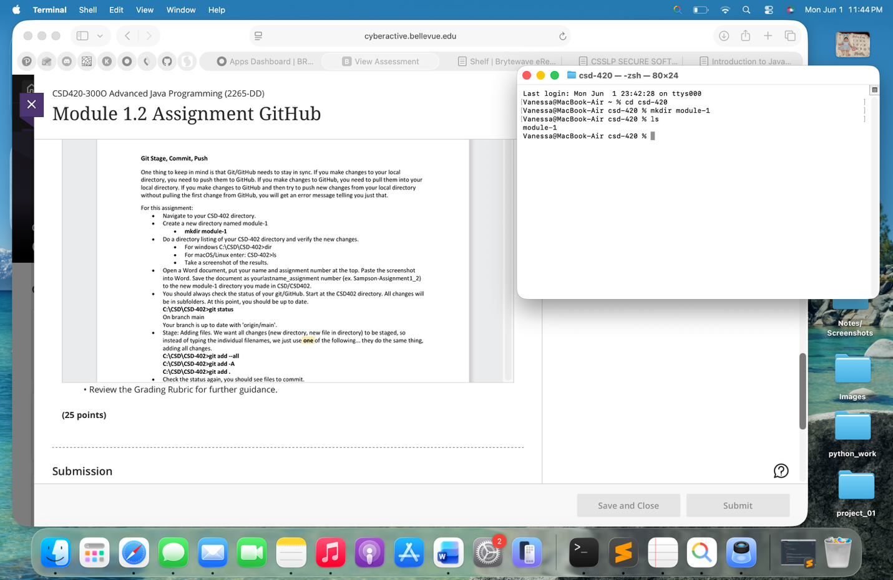
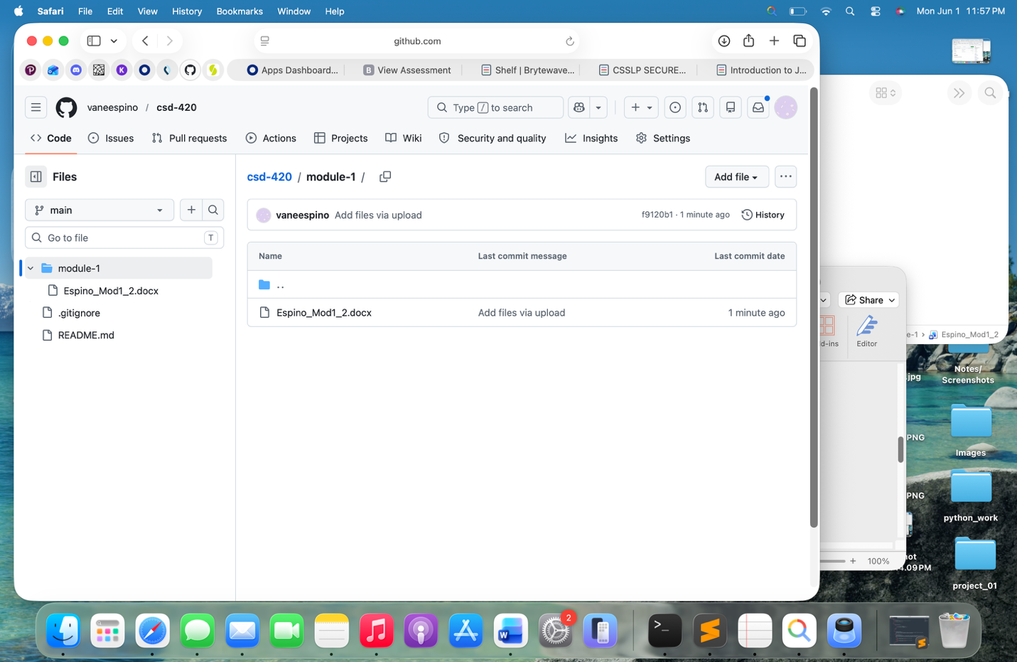
https://github.com/vaneespino/csd-420.git

