Espino-modul44_csd420
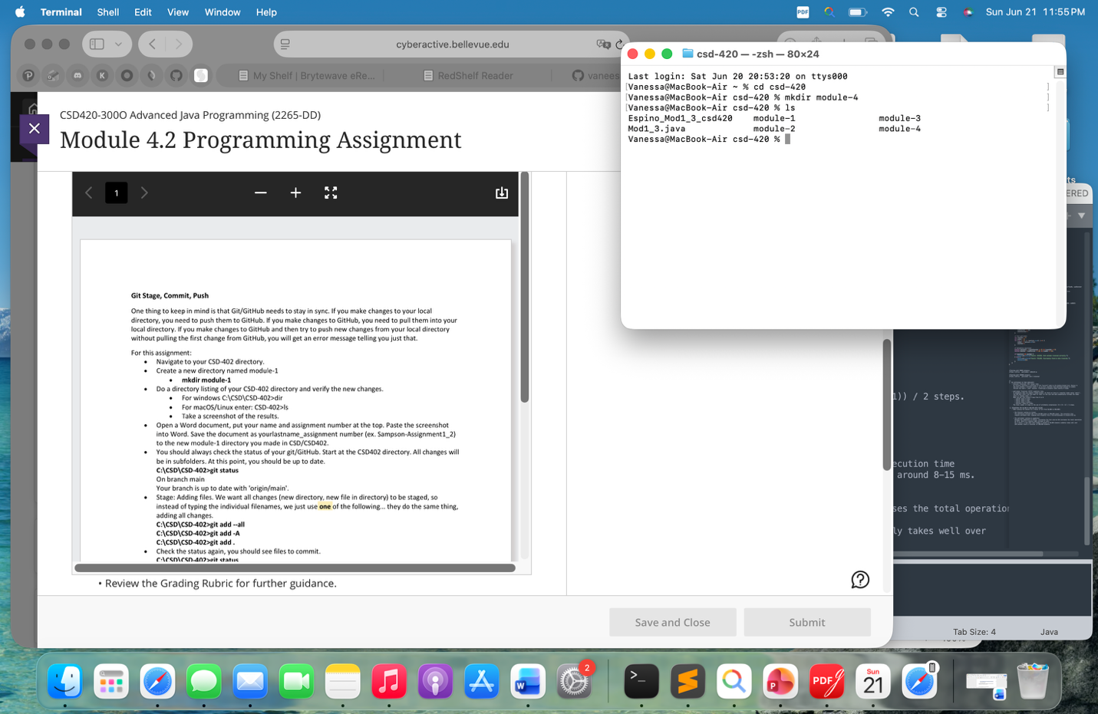
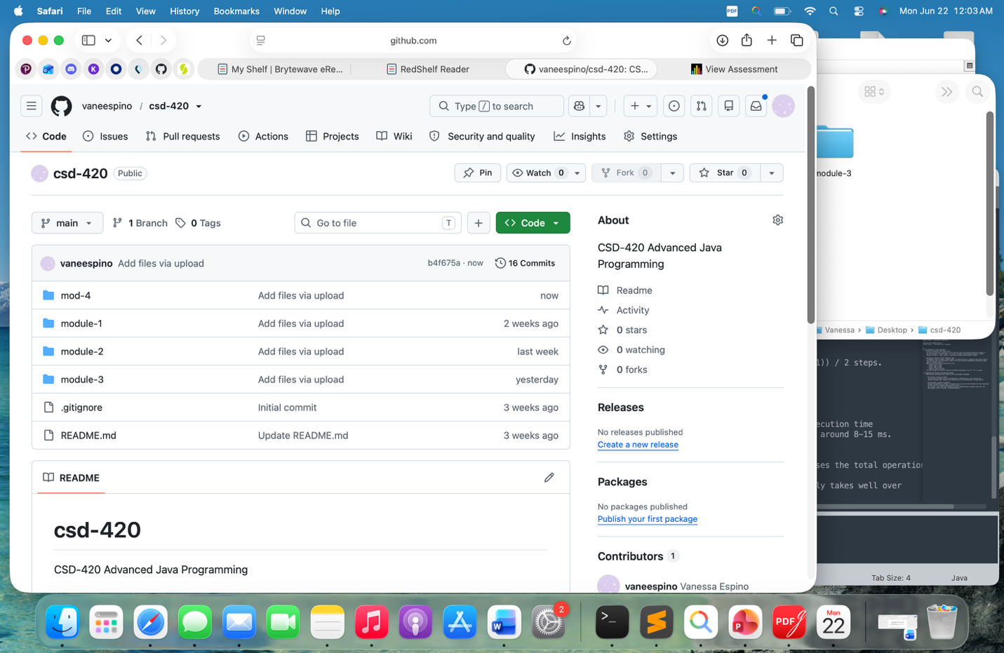
https://github.com/vaneespino/csd-420.git

