

**2nd Simulation Project**

Control Engineering

Enrique Aguayo Lara

Perla Vanessa Jaime Gaytán

ITE

A00344428

Instituto Tecnológico de Estudios Superiores de Monterrey Campus Guadalajara.

Zapopan, Jalisco, México.

April 24th, 2020.

**General Parameters.**

**Date of Birth:** May 10, 1999.

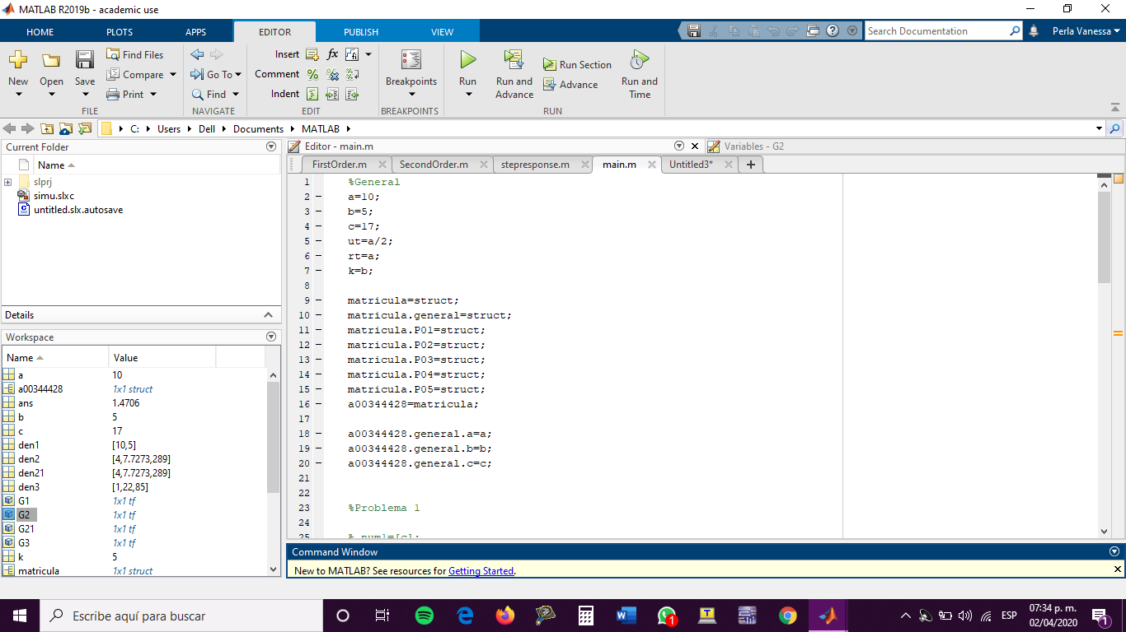

**System 1.**

=

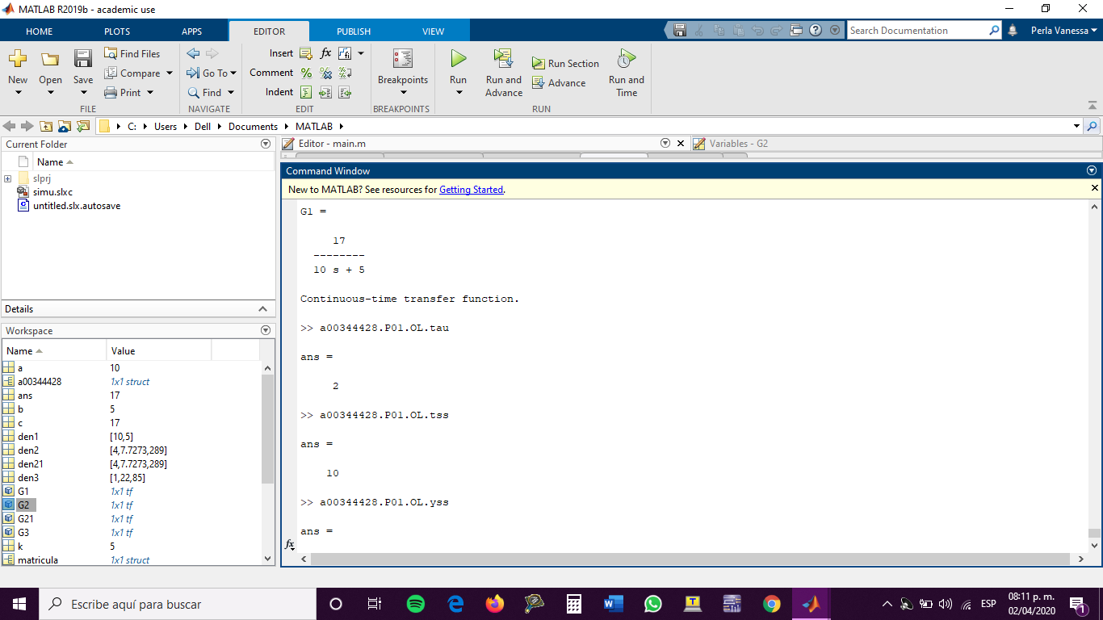

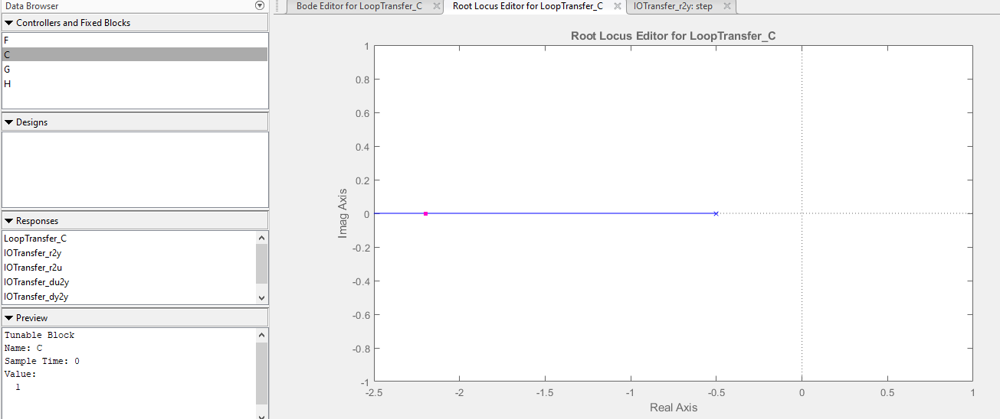

1. **Proportional Control Design.**

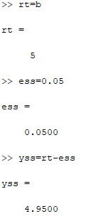



Despejando para k:

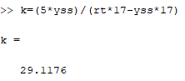

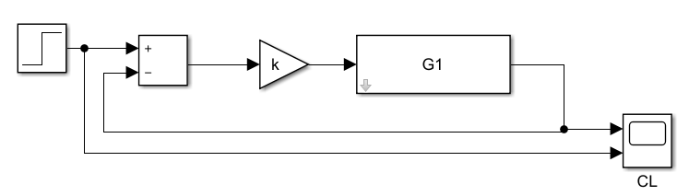

Final value: 4.95 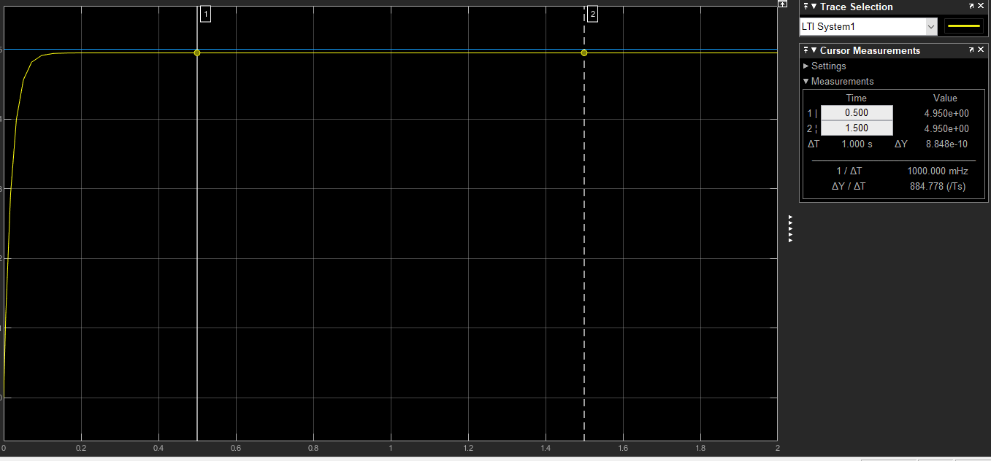

1. **PID Design: Sustained Oscillations Method.**

This method cannot be done in this system. In order to do this method in any of the systems it must be at least 2nd order and have branches of its root locus diagram that crosses through the right side of the plane.

1. **PID Design: Damped Oscillations Method.**

This method cannot be done in this system. In order to perform this method, the system must show oscillations, and, in this case, it does not show them. It also must have a damping ratio greater than 0.21 in Open Loop.

1. **PID Design: Algebraic Method.**

1 Pole at zero and adding 2 zeros at -0.971 and -0.833.

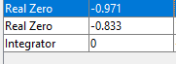

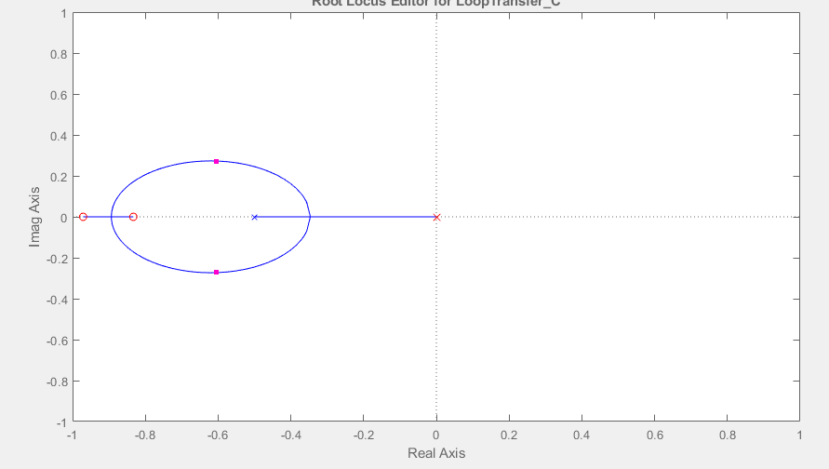

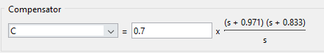

Gain = 0.7

= 0.971 = 0.833

k = 0.7

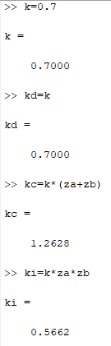



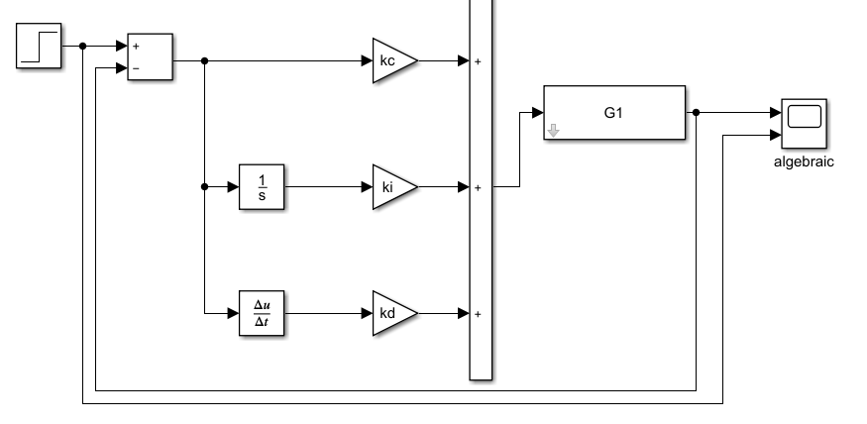

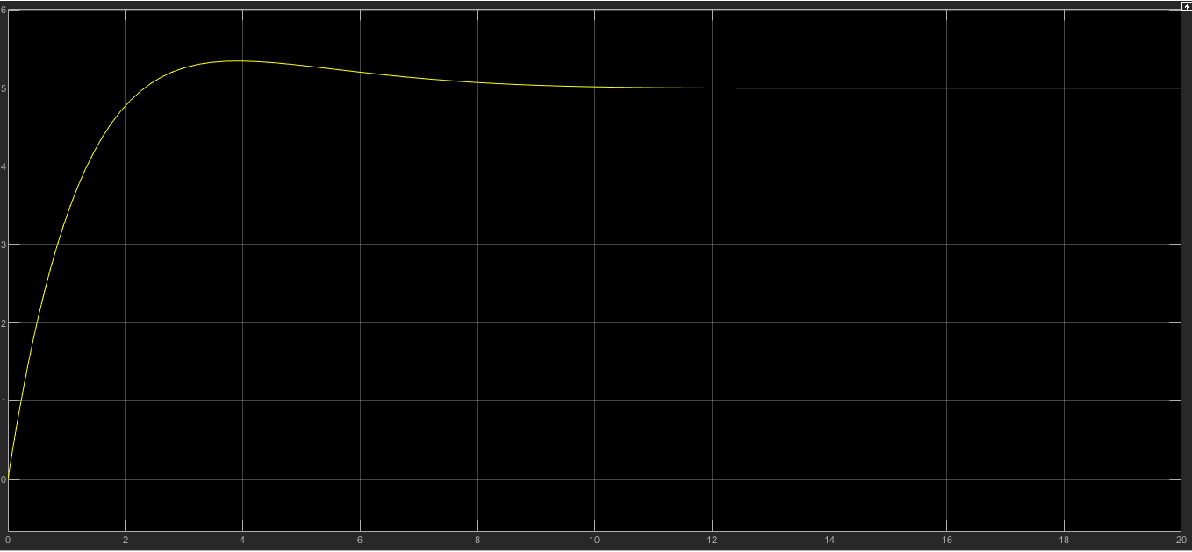

1. **PID Design: Ramp.**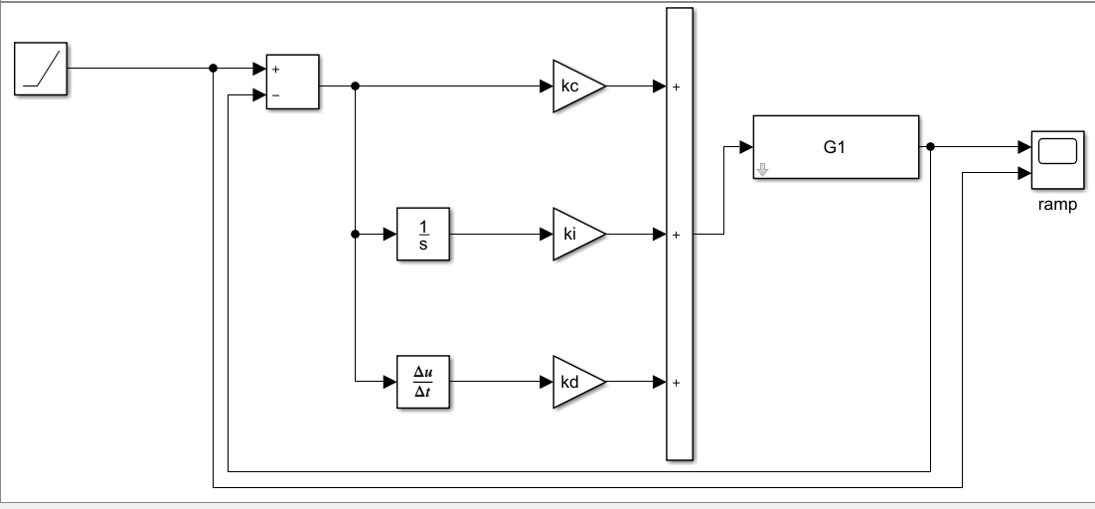

Then we obtain the following graphs:

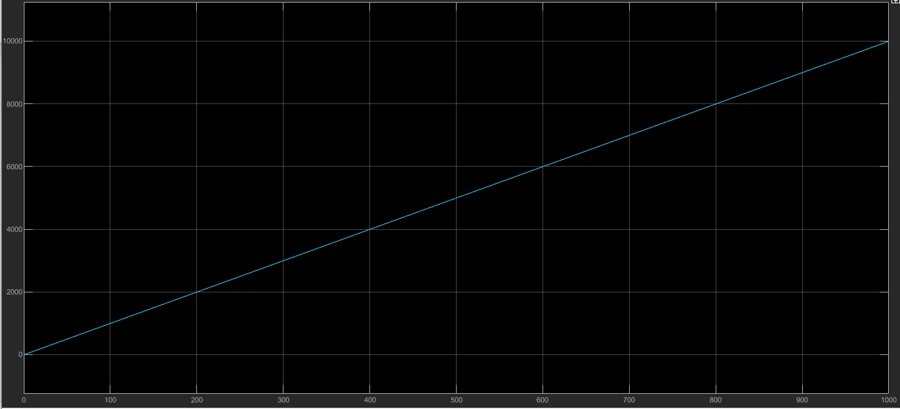

After zoom in it:

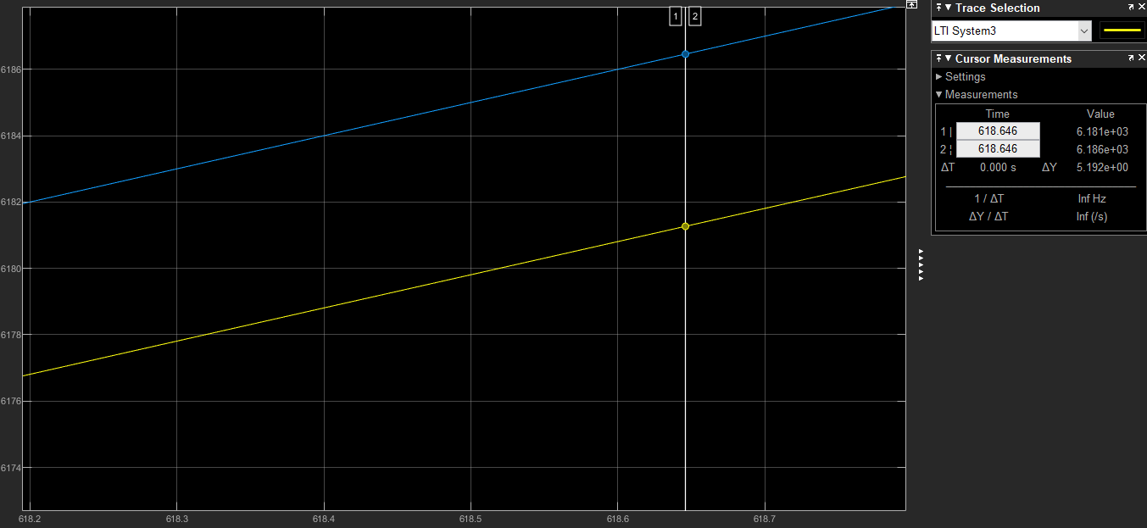

We obtain a difference of 5.192 from the reference and our system, therefore:

**System 2.**

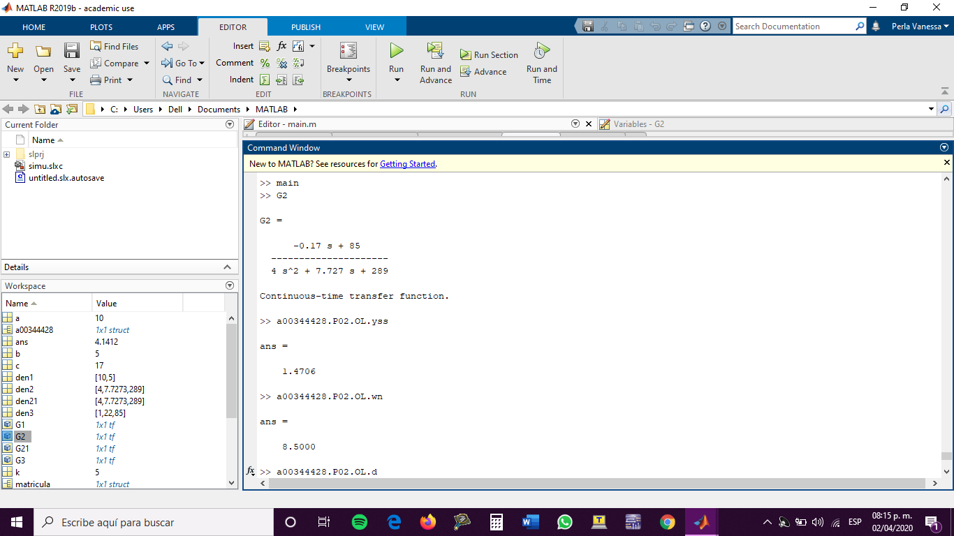

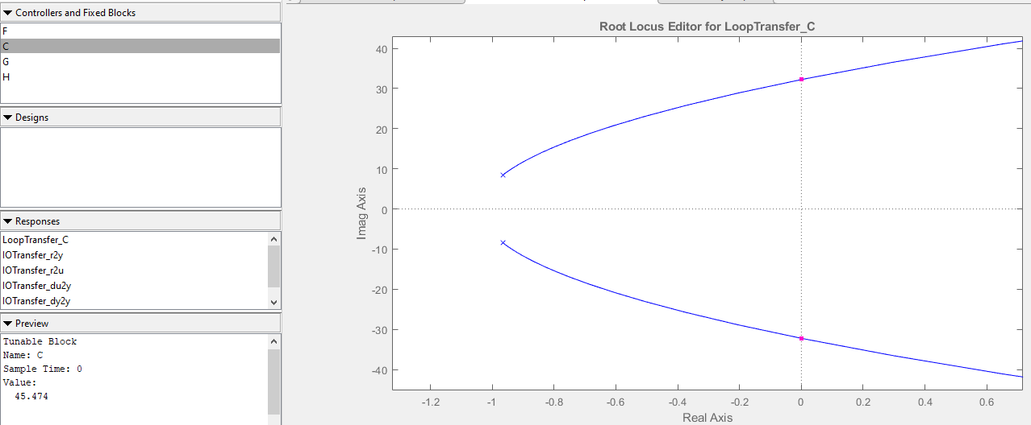

As we can see, maximum gain is 45.474.

1. **Proportional Control Design.**





Despejando para k:

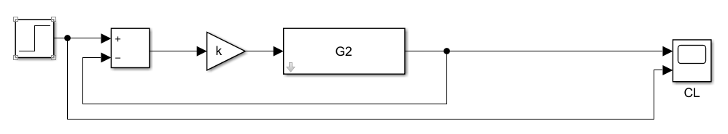

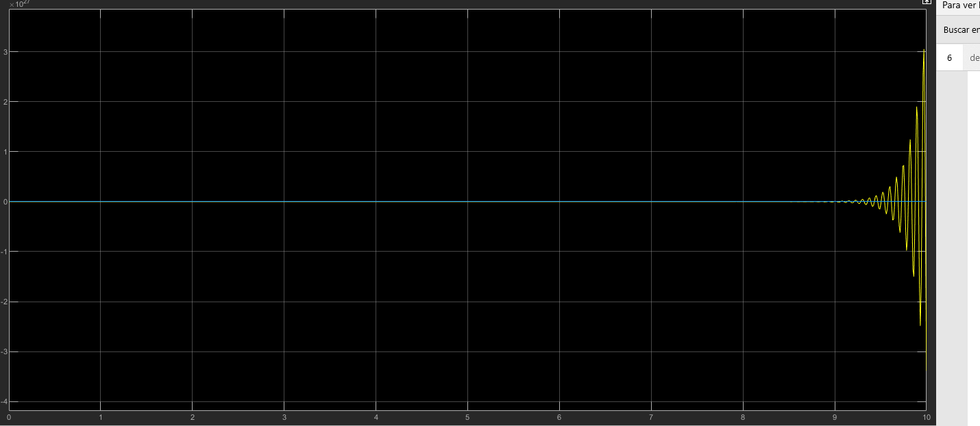

This system is unstable; therefore I picked another gain to make it stable.

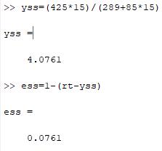

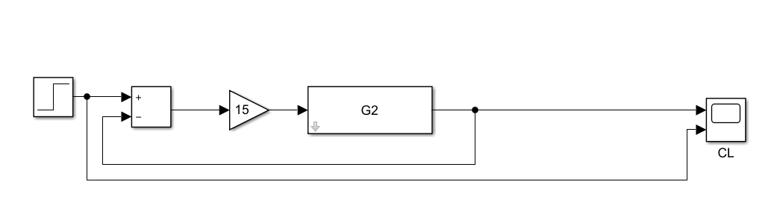

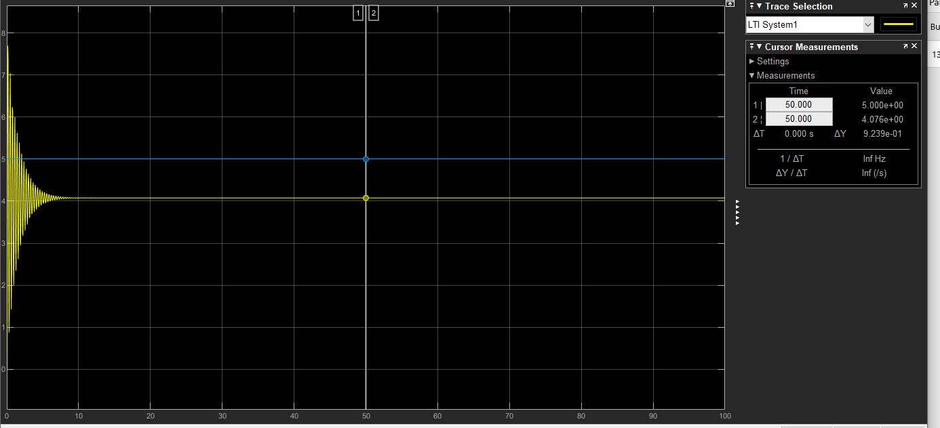

As we can see from the graph, the difference between my system and the step is 0.9239.

1. **PID: Design: Sustained Oscillations.**

In order to place the pole closer to 0, zoom in and check the critical gain.

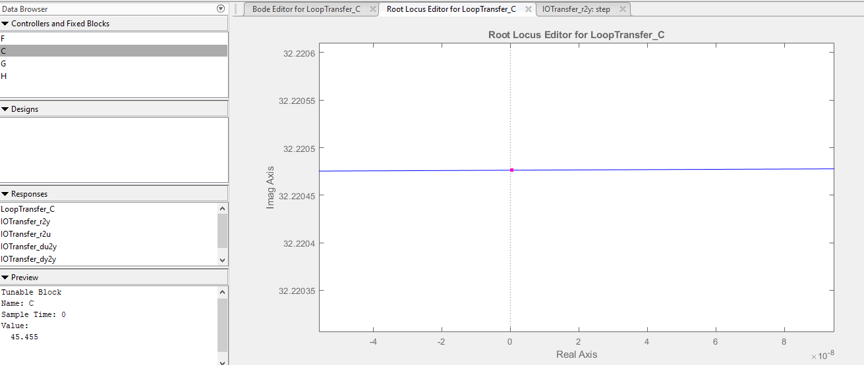

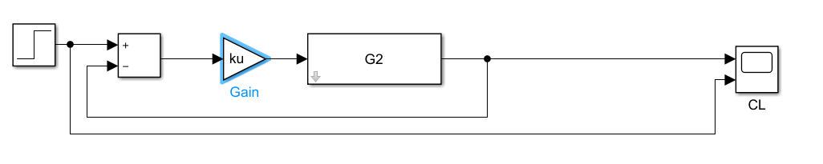

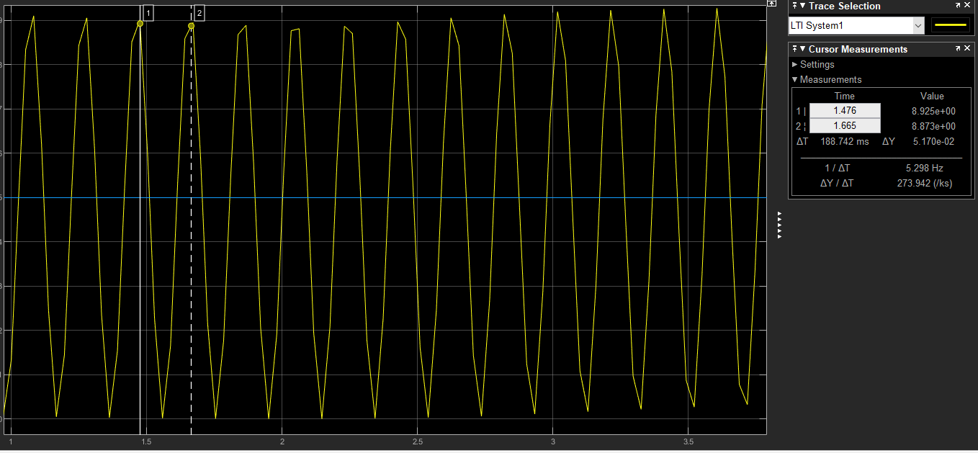

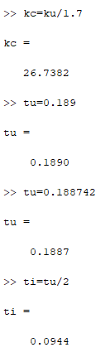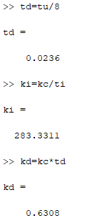

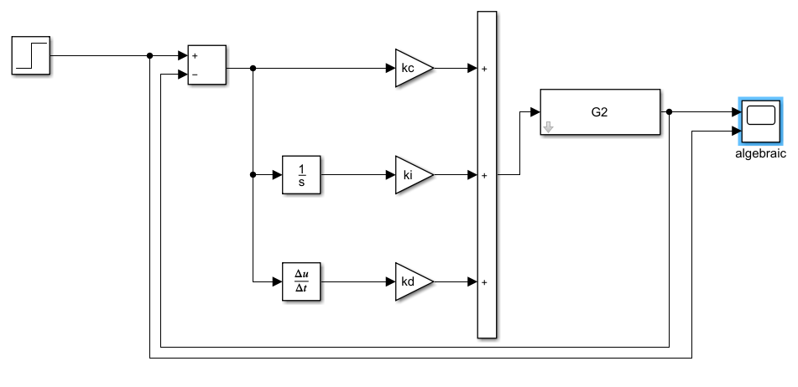

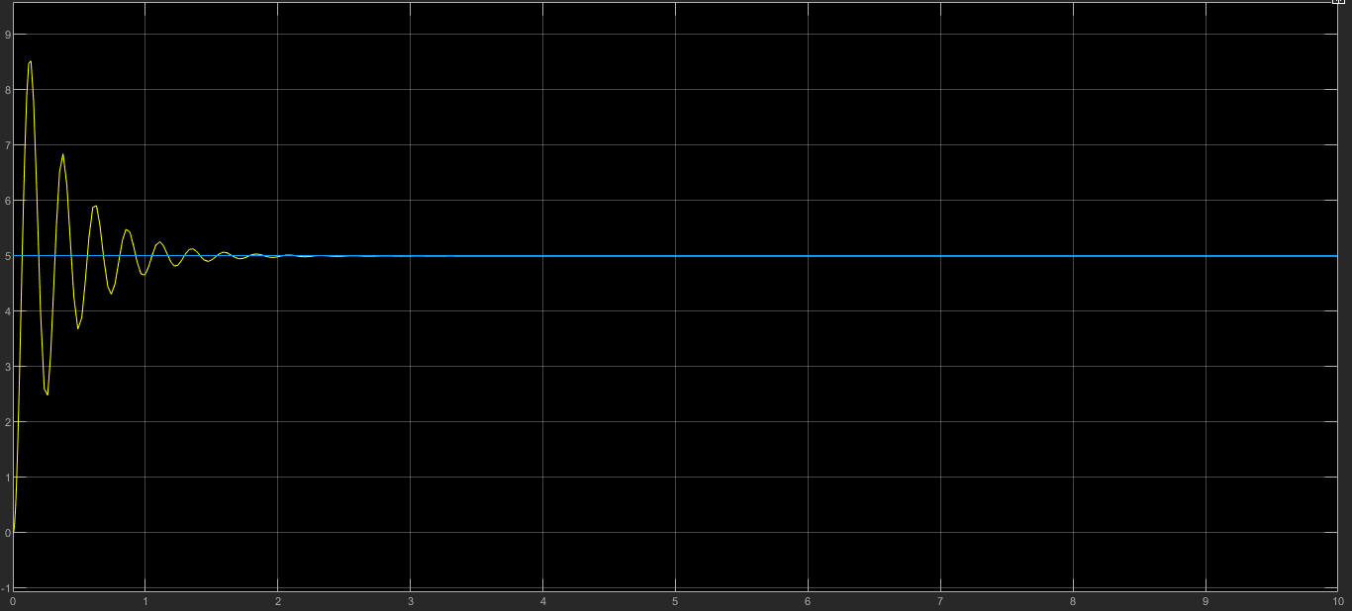

1. **PID: Damped Oscillations.**

In order to perform this method, the system must have a damping ratio greater or equal than 0.21 in Open Loop.

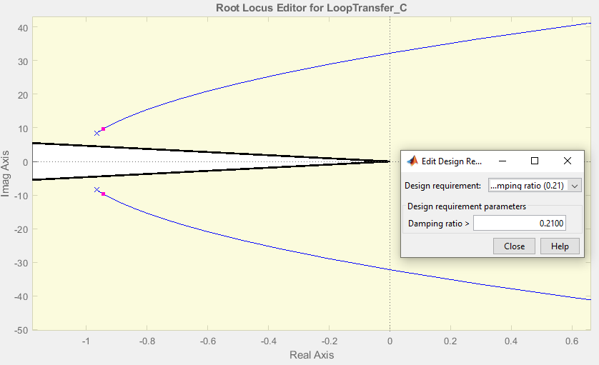

Since the branches are not inside the damping radio, this method cannot be done.

1. **PID: Algebraic.**

Add 1 Pole at zero and adding 2 zeros at -23 and -8.

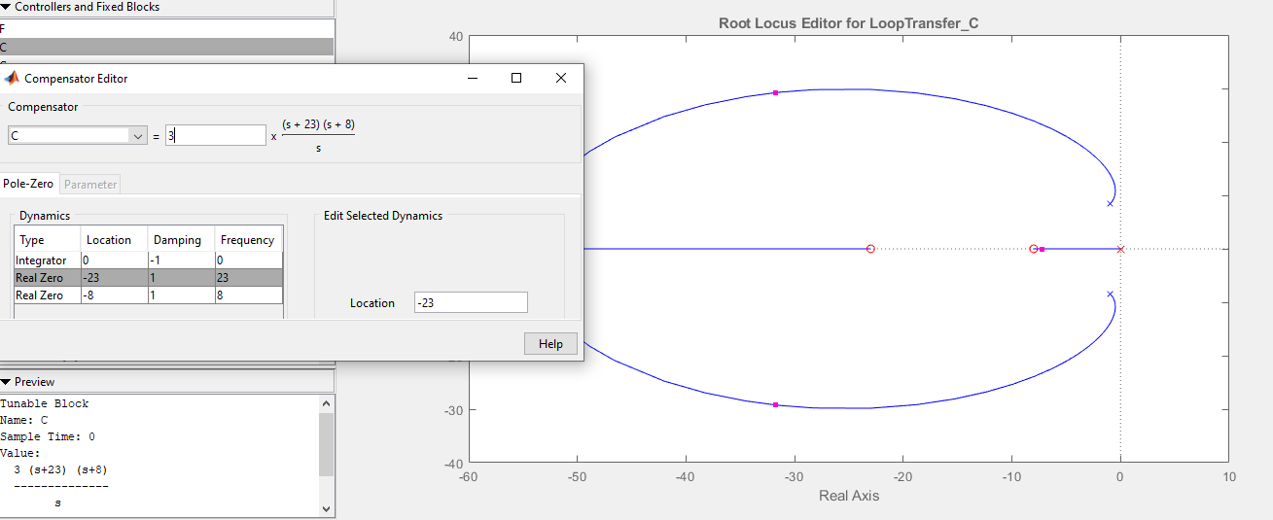

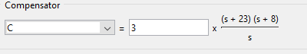

Gain = 3

= 23 = 8

k = 3

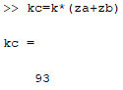

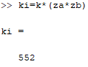

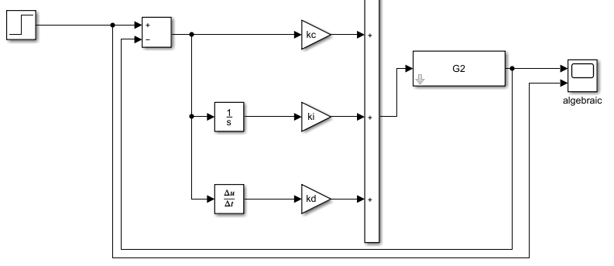

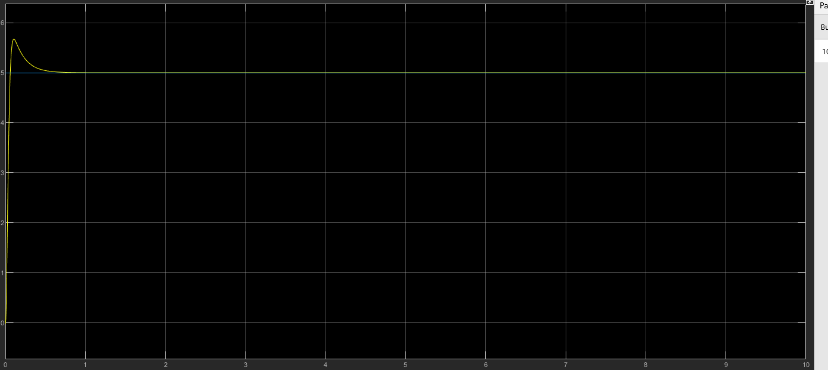

1. **PID: Ramp.**

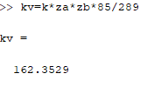

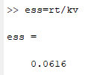

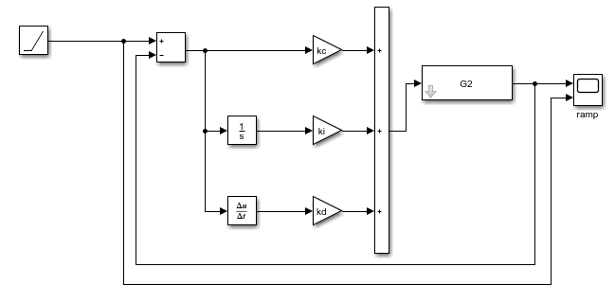

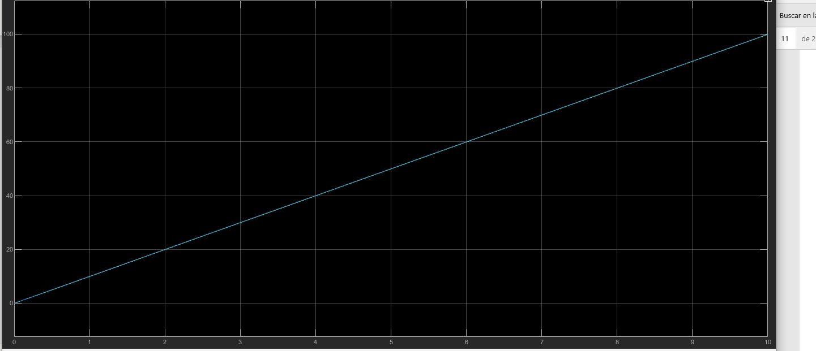

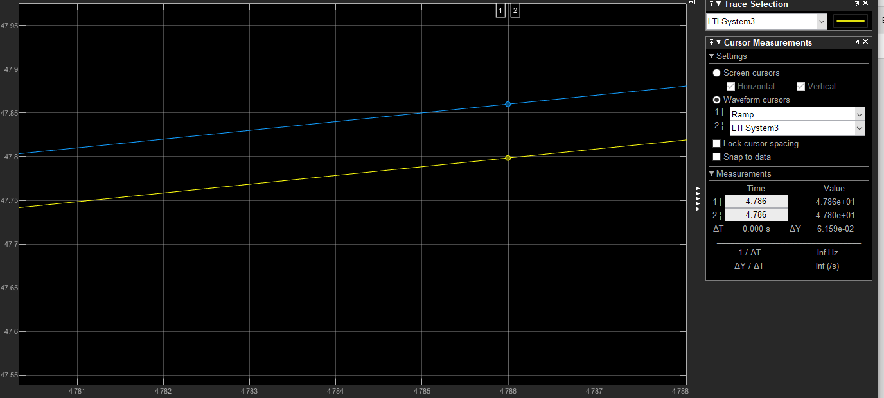

The difference from my system and the references is 0.00616 which is 6.16% of error.

**System 3.**

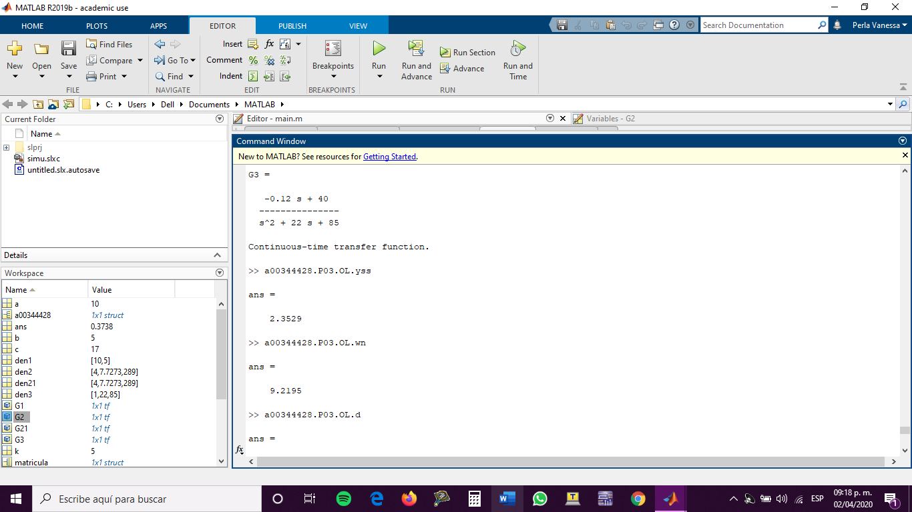

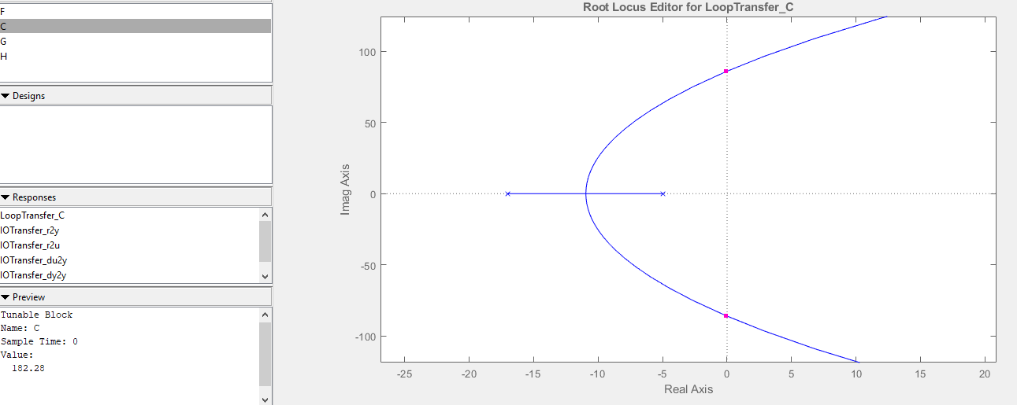

Maximum Gain: 182.28

1. **Proportional Control Design.**



Despejando para k:

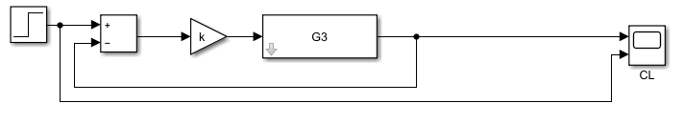

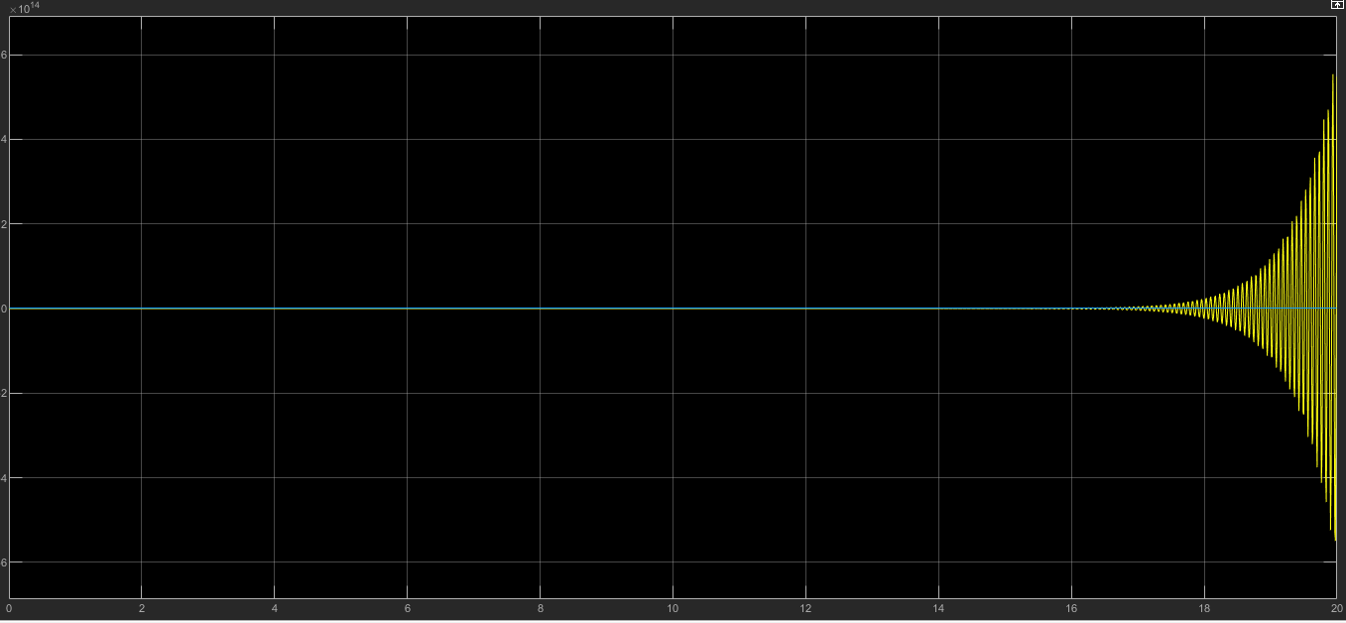

This system is unstable; therefore, I picked another gain to make it stable.

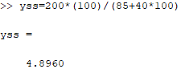

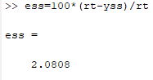

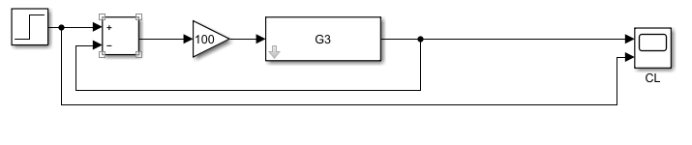

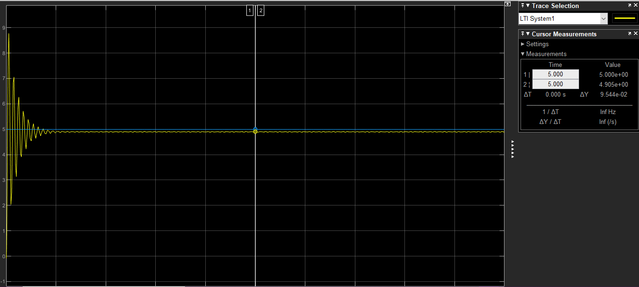

1. **PID: Design: Sustained Oscillations.**

In order to place the pole closer to 0, zoom in and check the critical gain.

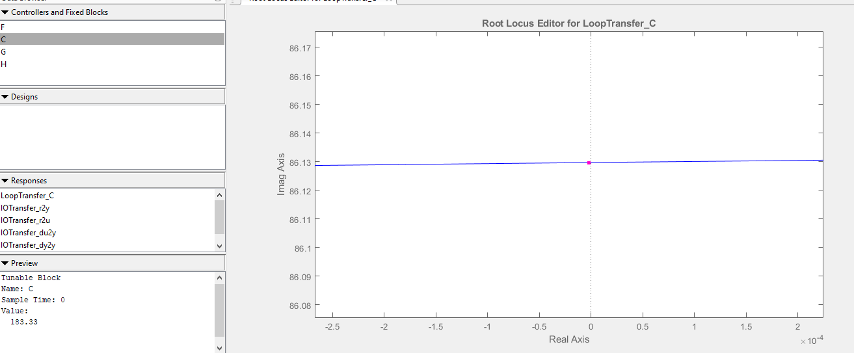

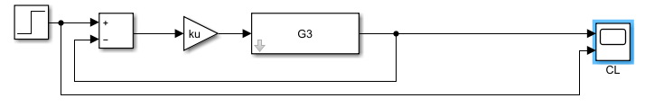

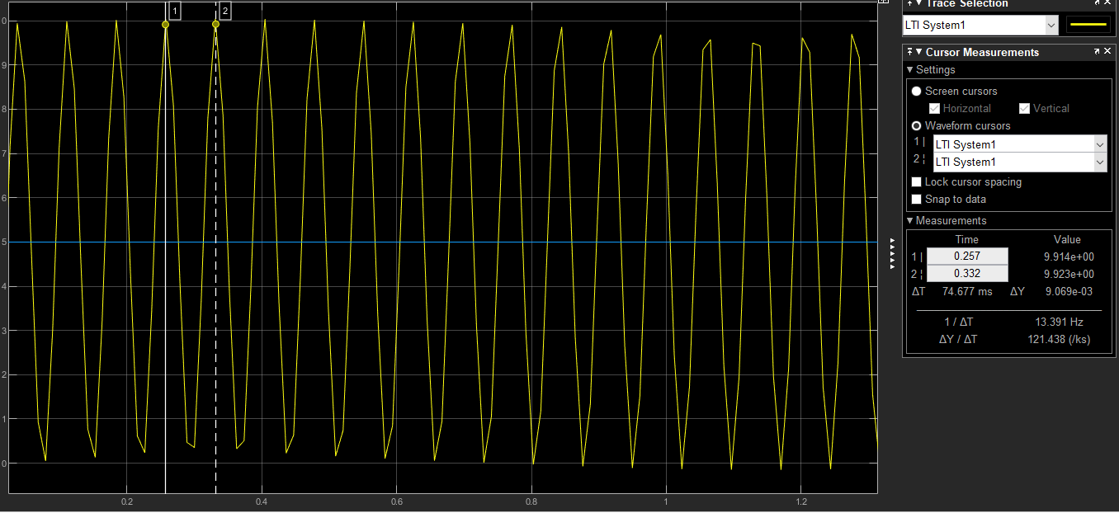

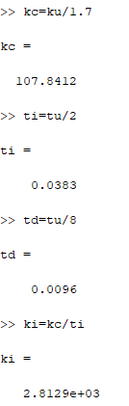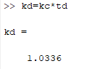

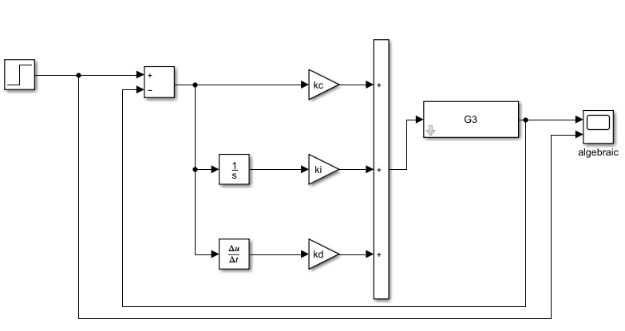

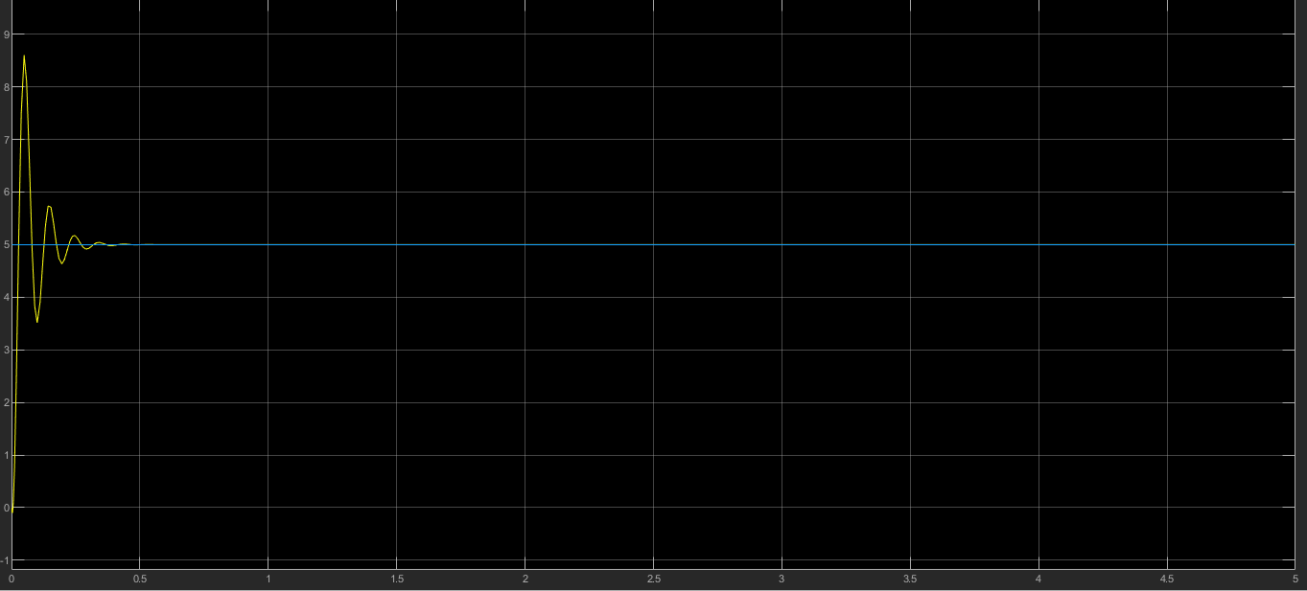

1. **PID: Damped Oscillations.**

In order to perform this method, the system must have a damping ratio greater or equal than 0.21 in Open Loop.

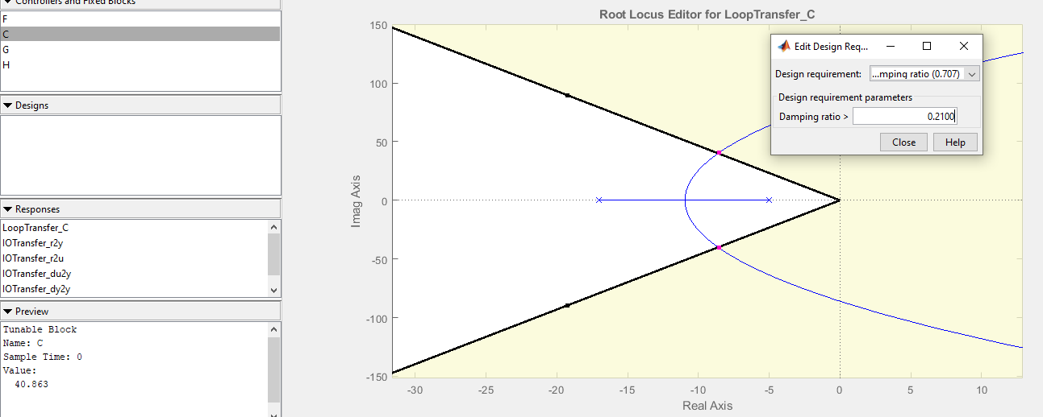

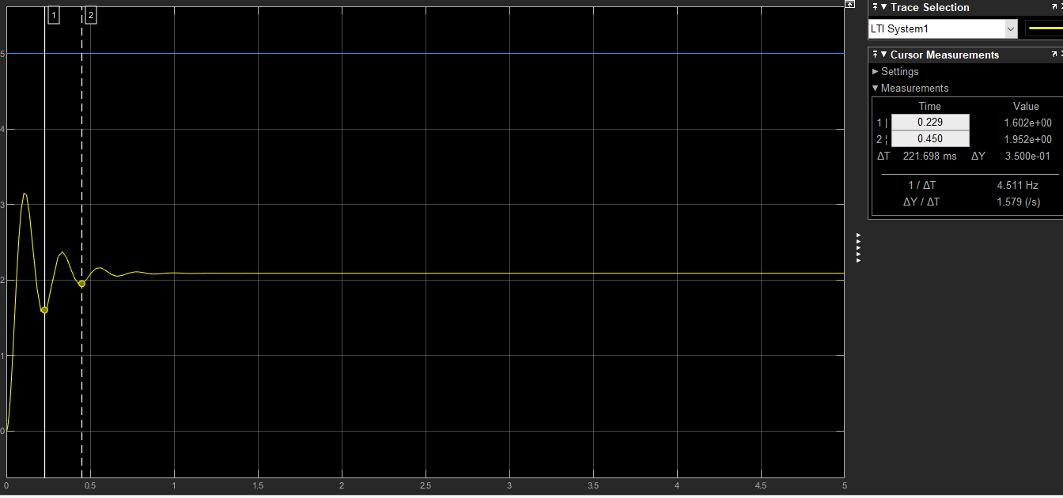

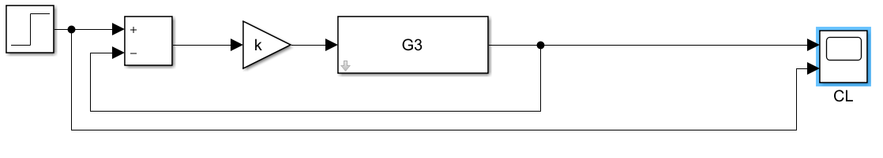

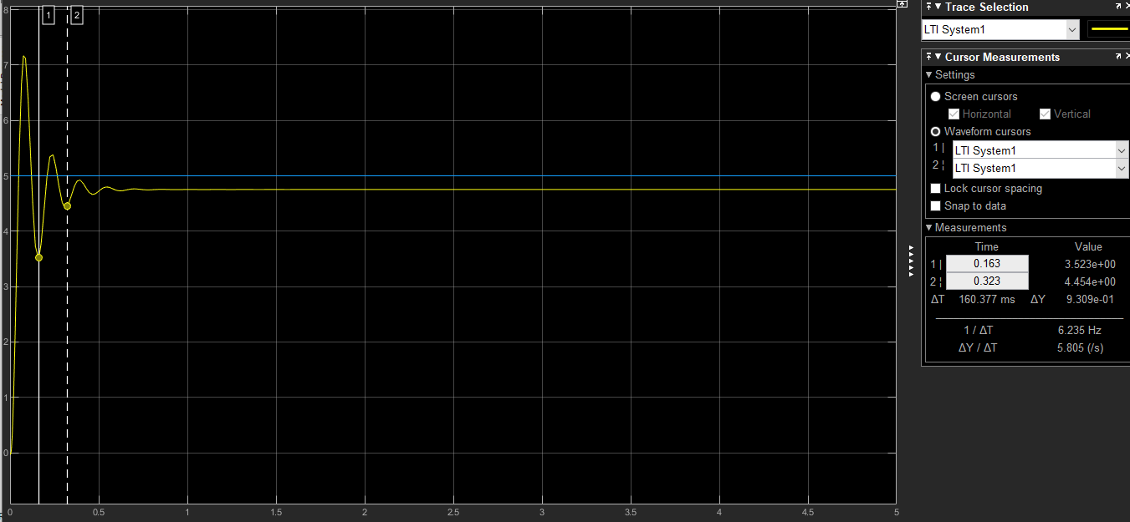

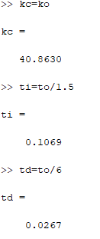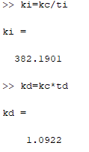

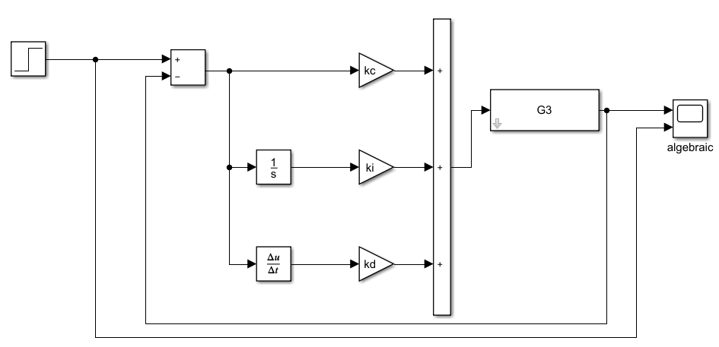

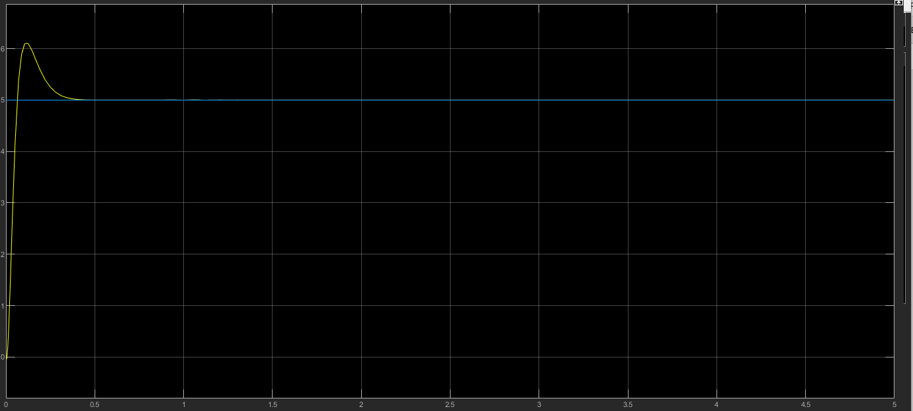

1. **PID: Algebraic.**

Add 1 Pole at zero and adding 2 zeros at -23 and -8.

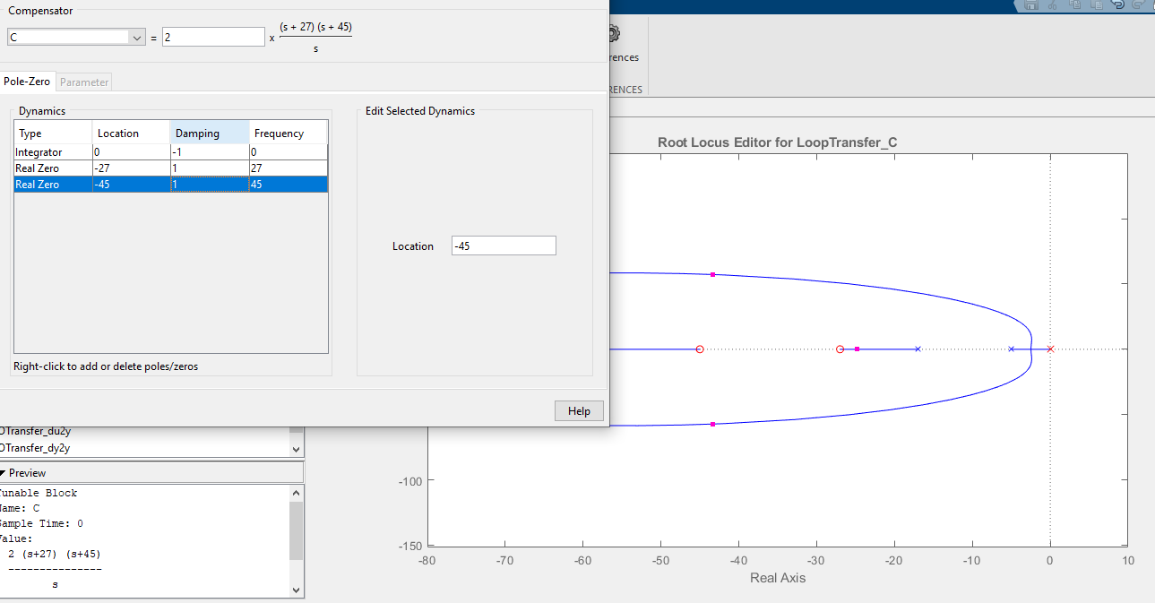

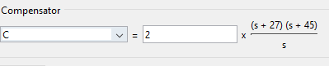

Gain = 2

= 27 = 45

k = 2

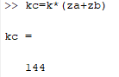

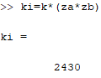

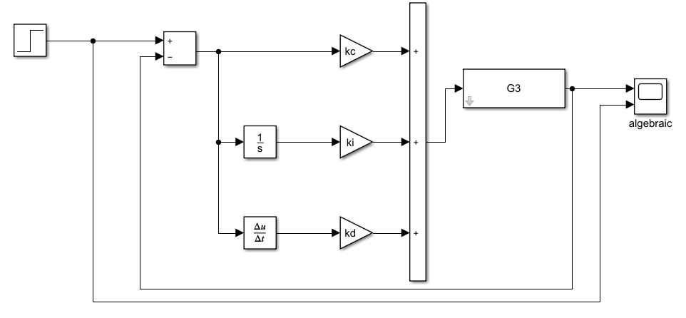

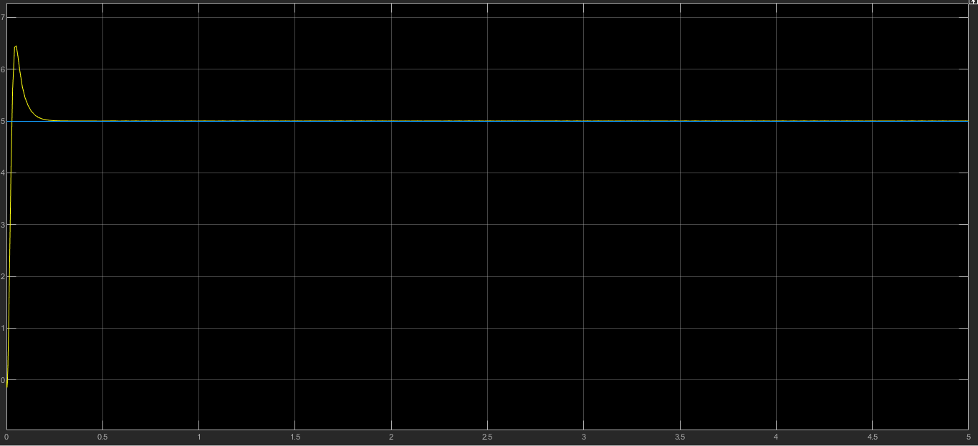

1. **PID: Ramp.**

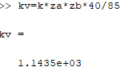

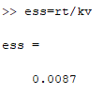

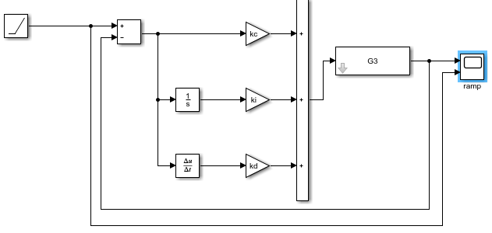

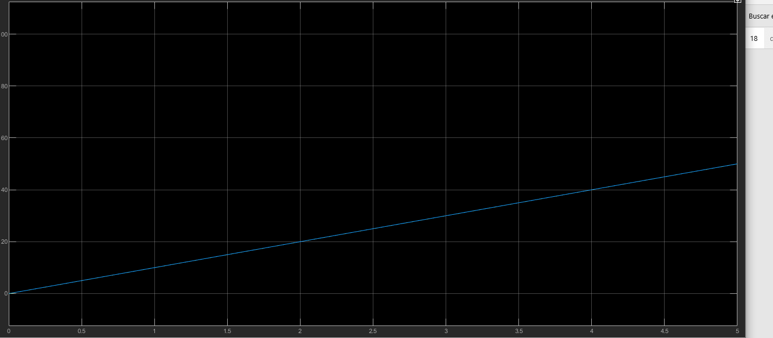

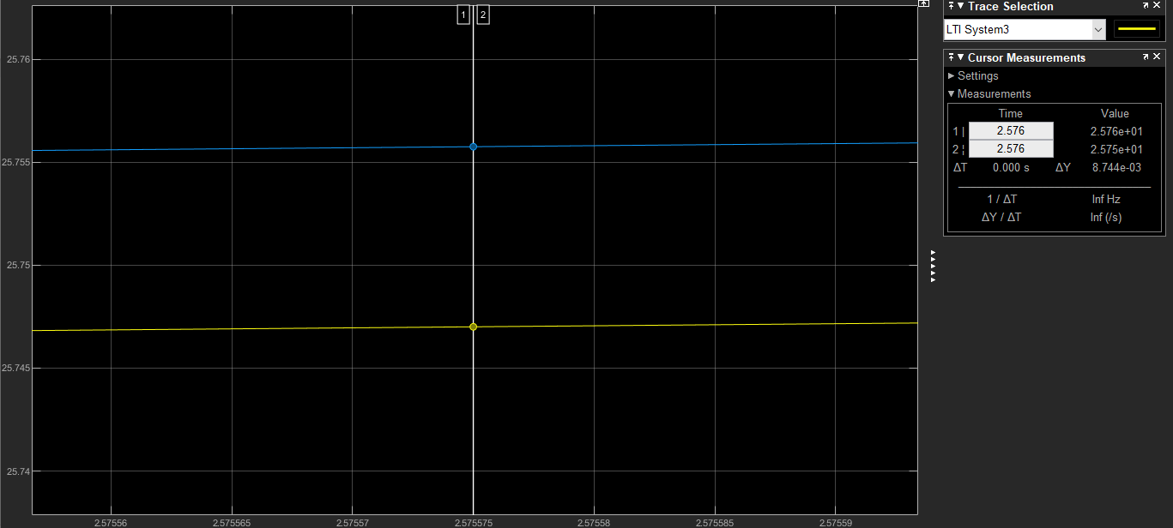

The difference from my system and the references is 0.008744 which is 0.874% of error.

**System 4.**

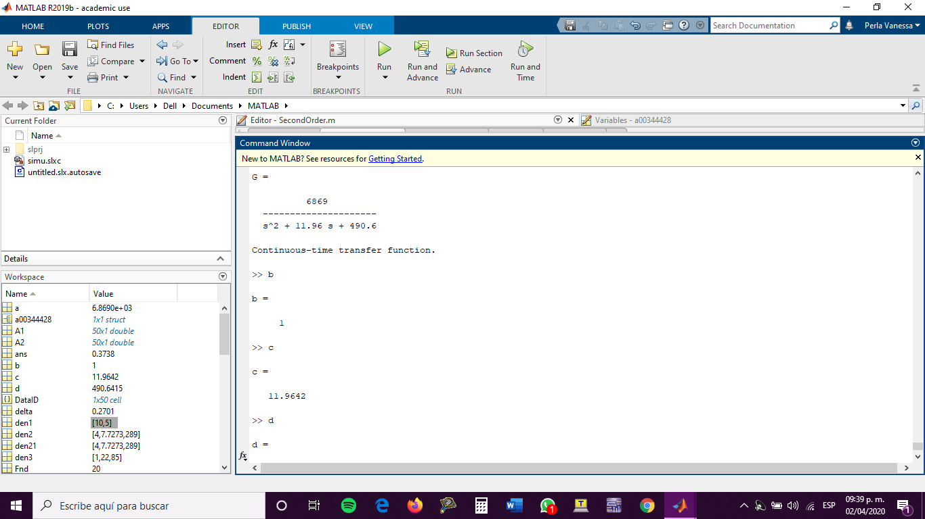

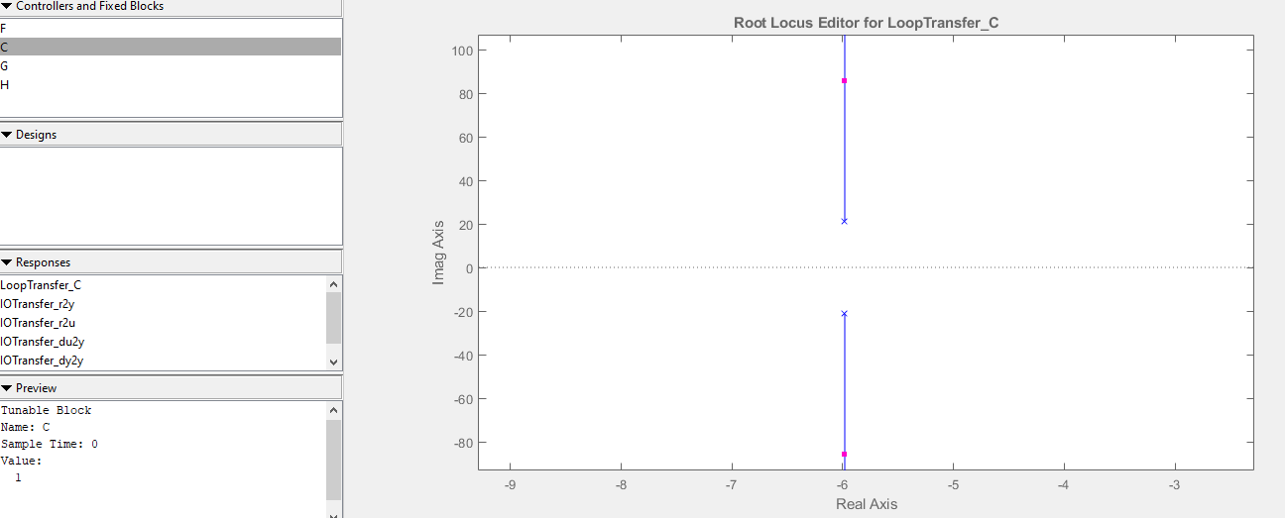

Since there are not branches crossing the imaginary axis, the maximum gain is infinity.

1. **Proportional Control Design.**





Despejando para k:

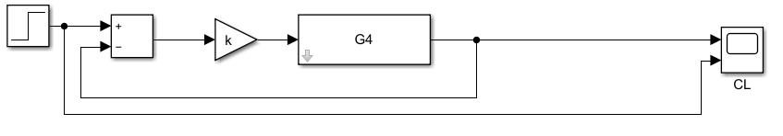

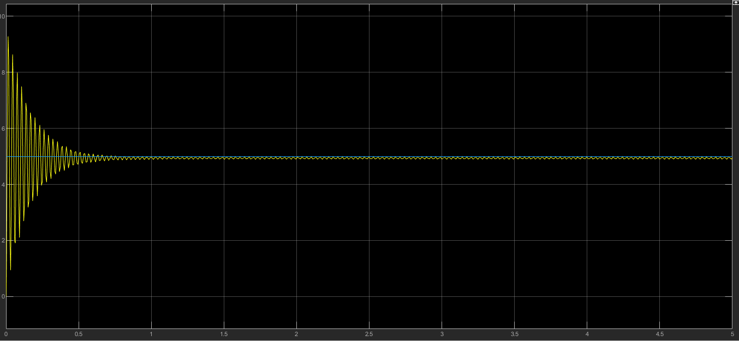

1. **PID: Design: Sustained Oscillations.**

This method cannot be done in this system, because in order to do it the system must have branches of its root locus diagram that crosses through the Right-Hand Plane.

1. **PID: Damped Oscillations.**

In order to perform this method, the system must have a damping ratio greater or equal than 0.21 in Open Loop.

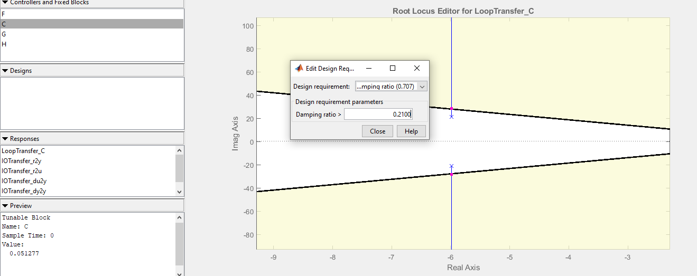

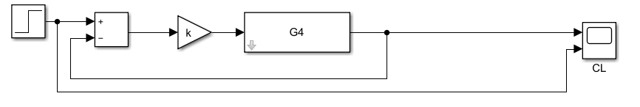

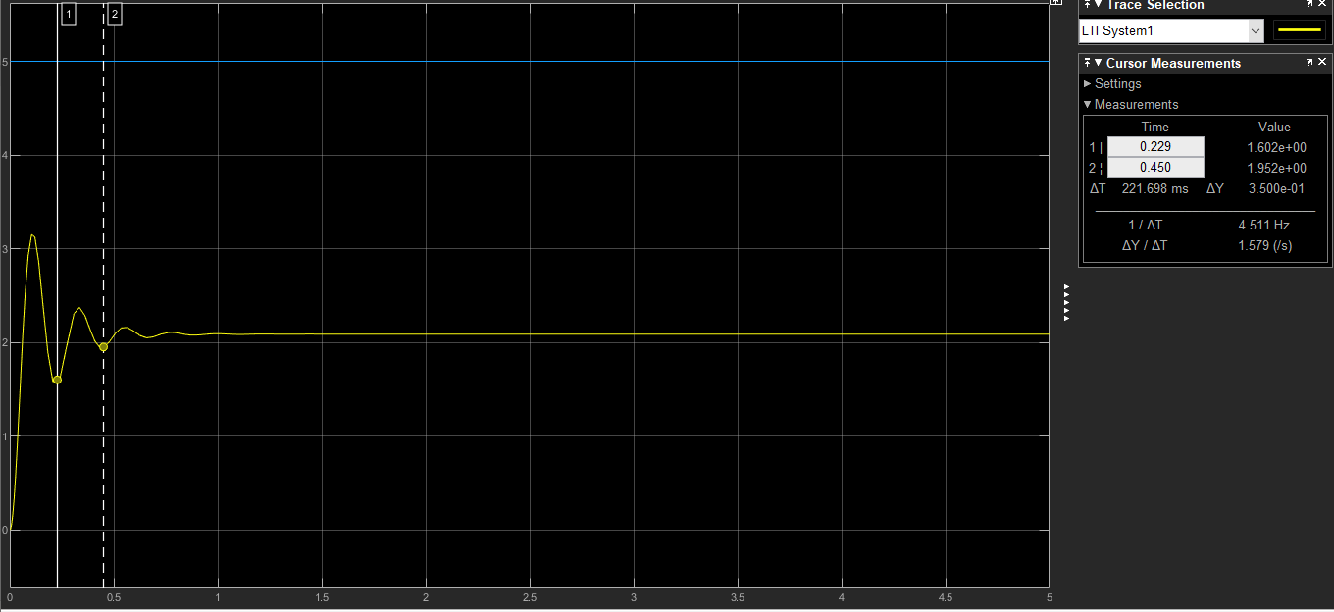

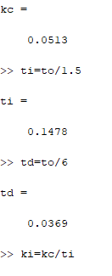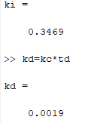

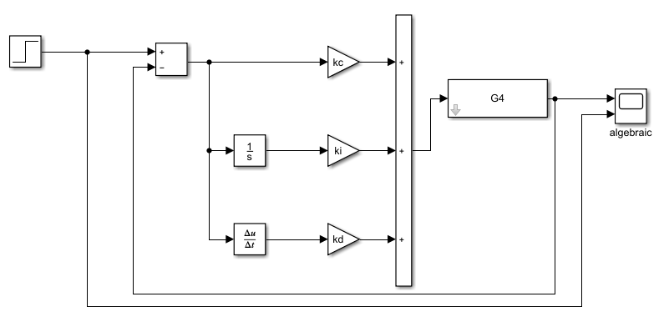

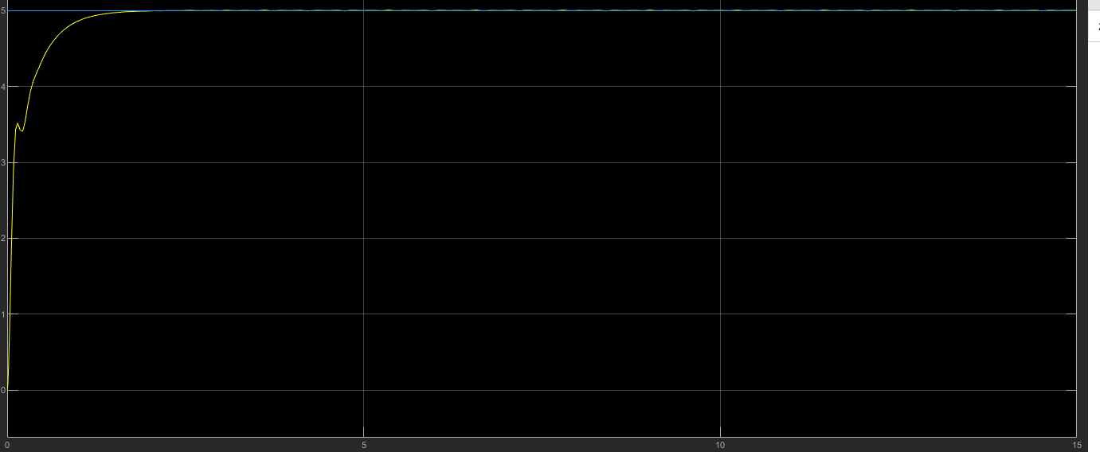

1. **PID: Algebraic.**

Add 1 Pole at zero and adding 2 zeros at -23 and -8.

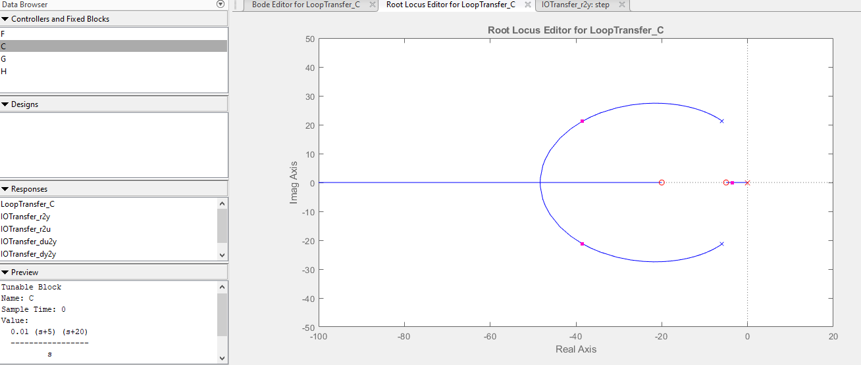

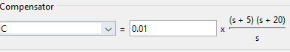

Gain = 0.01

= 5 = 20

k = 0.01

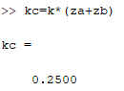

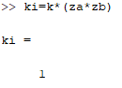

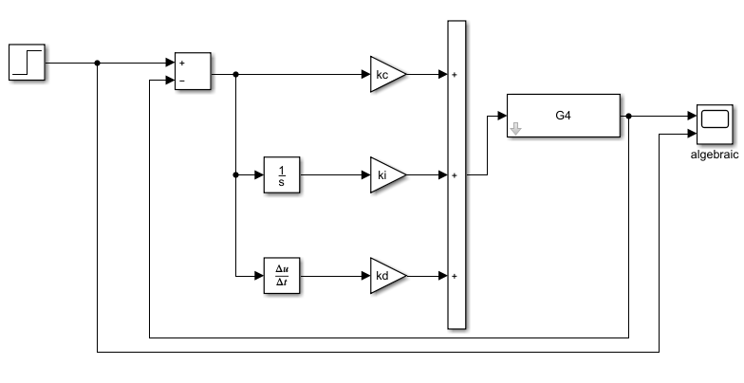

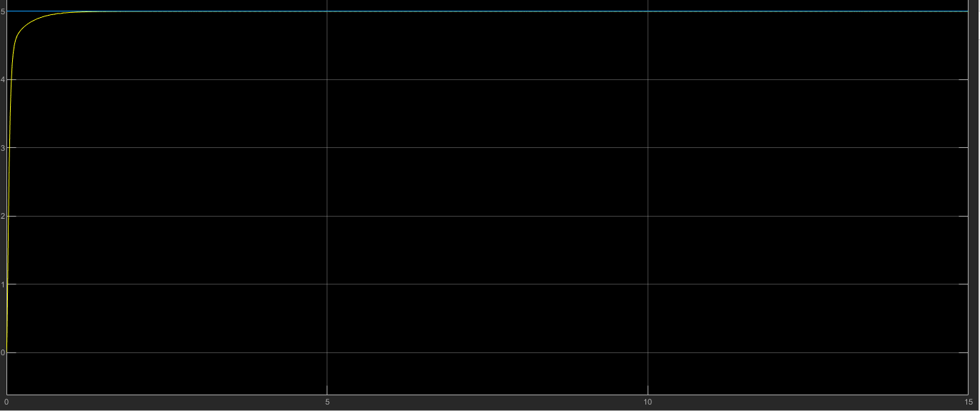

1. **PID: Ramp.**

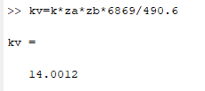

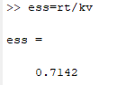

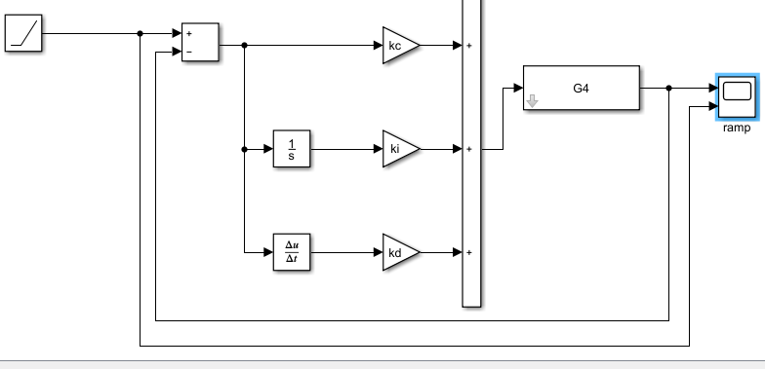

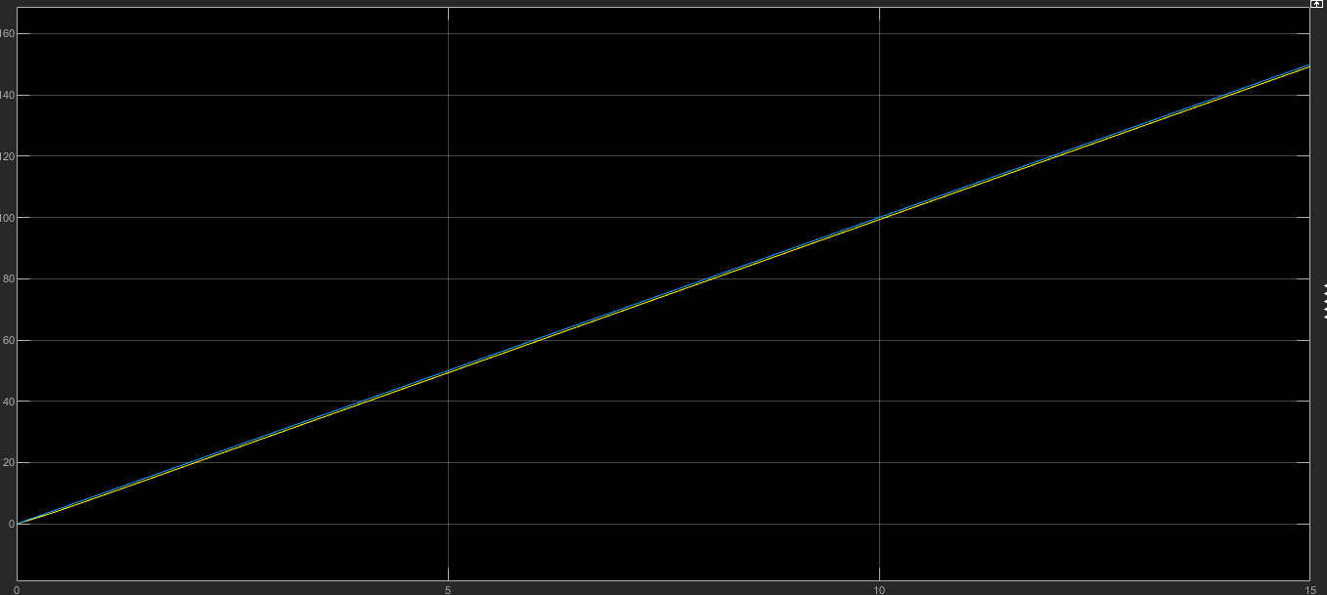

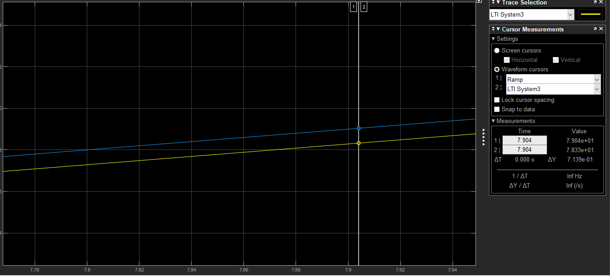

The difference from my system and the references is 0.7139 which is the same as calculated.

**System 5.**

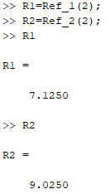

1. 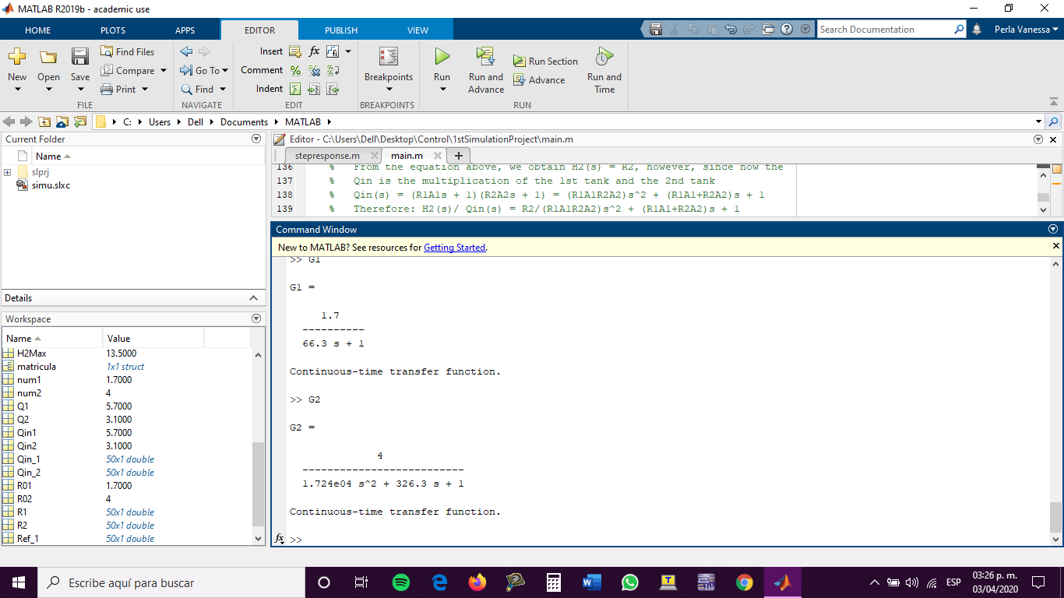
2. 
3. **Design a proportional controller for H1 with the assigned reference Ref_1. The steady state error should be less than 10%. Compute and simulate.**

)-

Despejando para k:

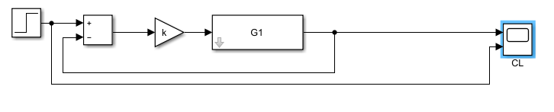

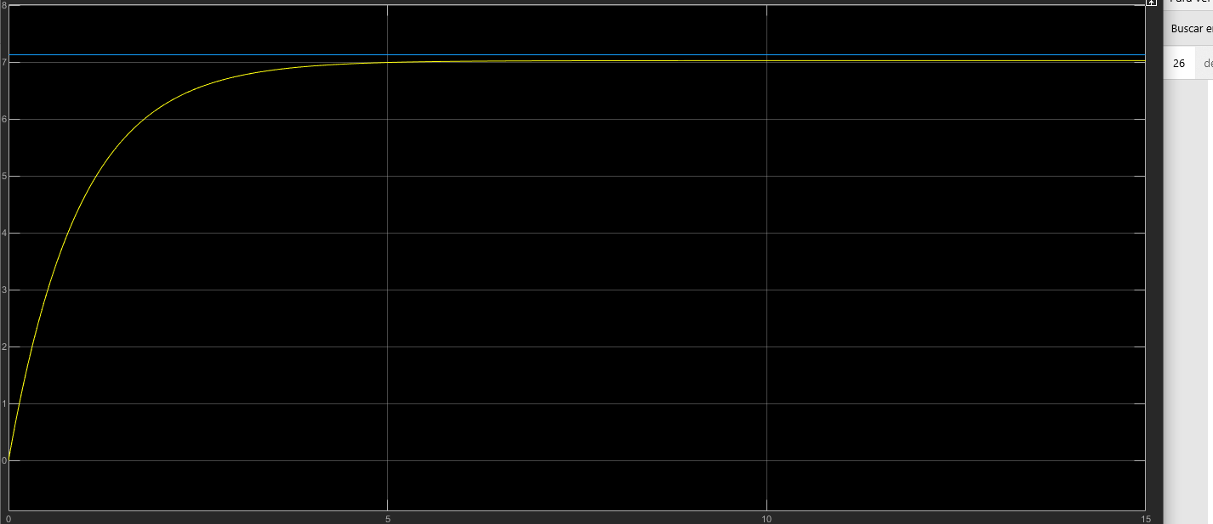

1. **Design a proportional controller for H2 with the assigned reference Ref_2. The steady state error should be less than 10%. Compute and simulate.**

)-

Despejando para k:

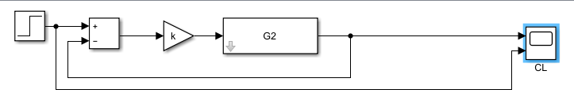

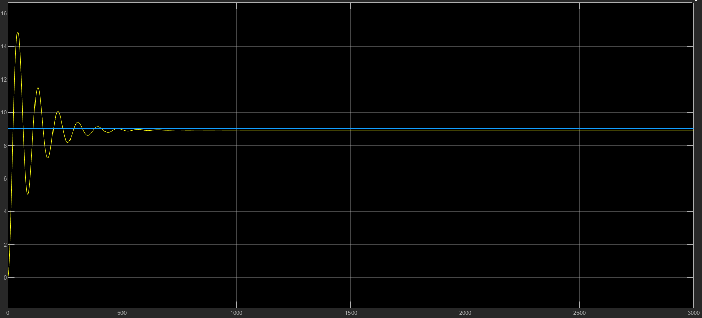

1. **Design a PID controller for H1 with the assigned reference Ref_1. Compute and simulate.**

Using the algebraic method.

Add 1 Pole at zero and adding 2 zeros at -3 and -0.5.

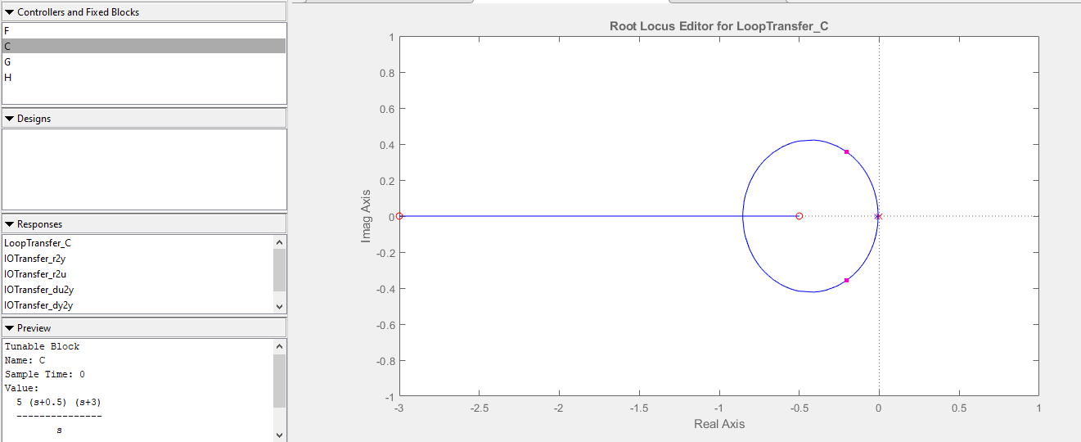

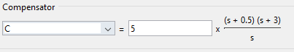

Gain = 5

= 0.5 = 3

k = 5

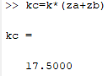

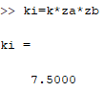

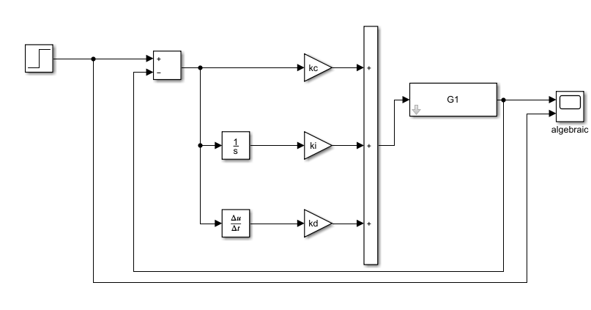

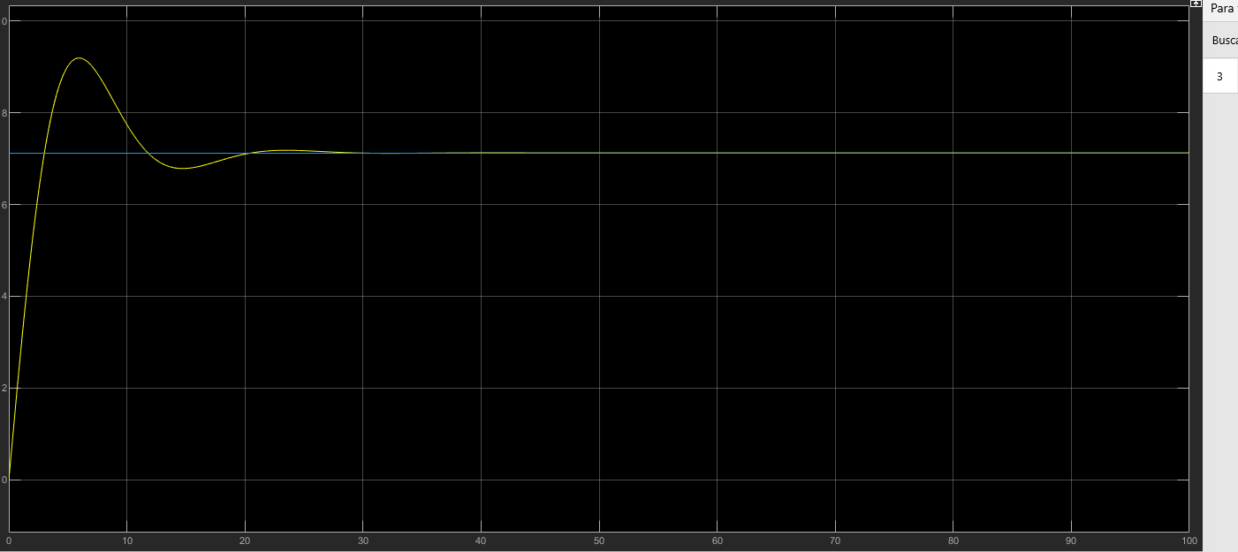

1. **Design a PID controller for H2 with the assigned reference Ref_2. Compute and simulate.**

Using the algebraic method.

Add 1 Pole at zero and adding 2 zeros at -0.5 and 2.

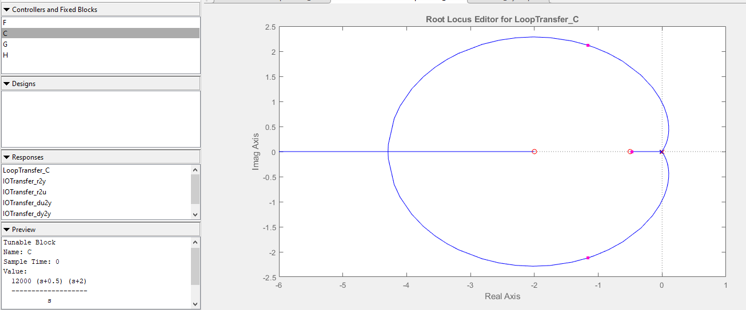

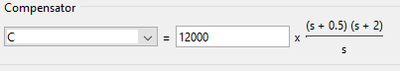

Gain = 12 000

= 0.5 = 2

k = 12 000

