

**3rd Simulation Project**

Control Engineering

Enrique Aguayo Lara

Perla Vanessa Jaime Gaytán

ITE

A00344428

Instituto Tecnológico de Estudios Superiores de Monterrey Campus Guadalajara.

Zapopan, Jalisco, México.

May 12, 2020.

**General Parameters.**

**Date of Birth:** May 10, 1999.

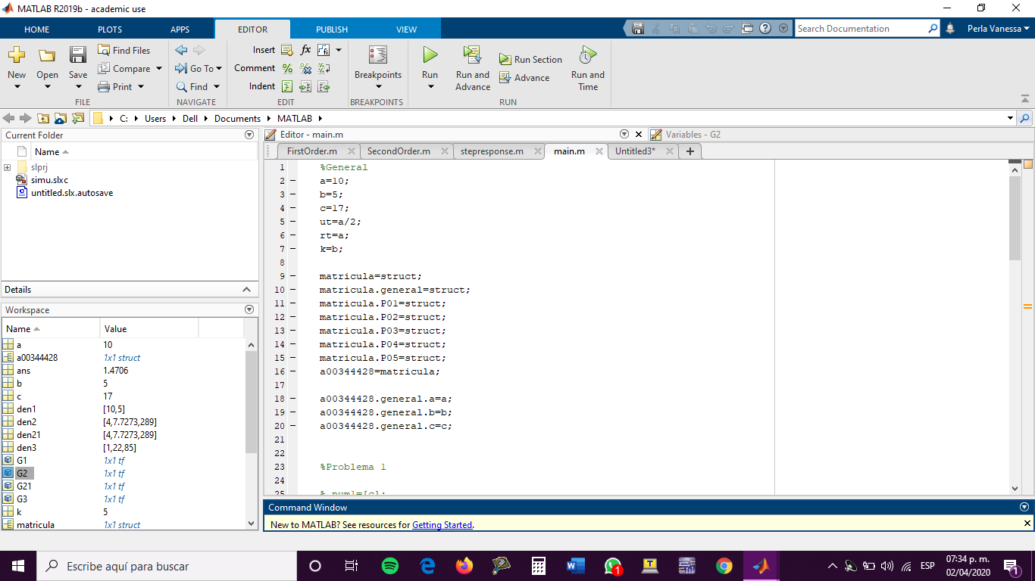

**System 1.**

=

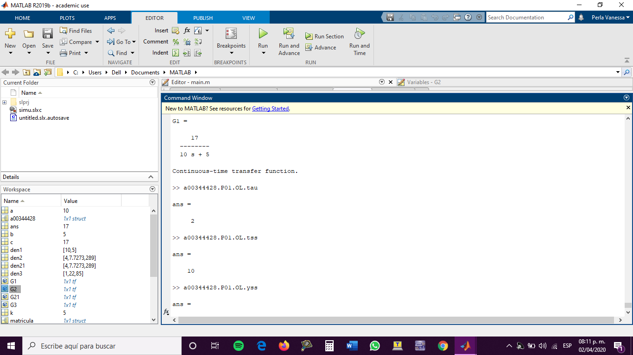

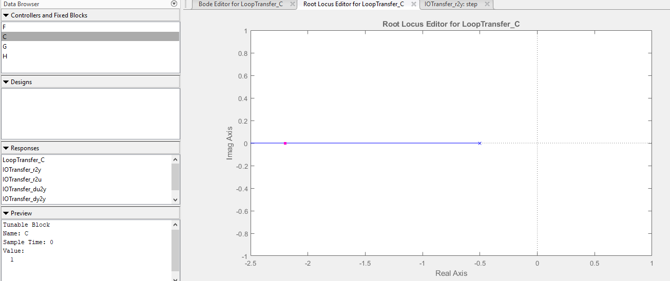

1. **Lead Compensator. Design a Lead compensator with e(t)=10%. Reference r(t)=a.**

Therefore G(s)C(s) is type 0 and unit step.

From the diagram of root locus, I decided that y , therefore:

Root Locus diagram:

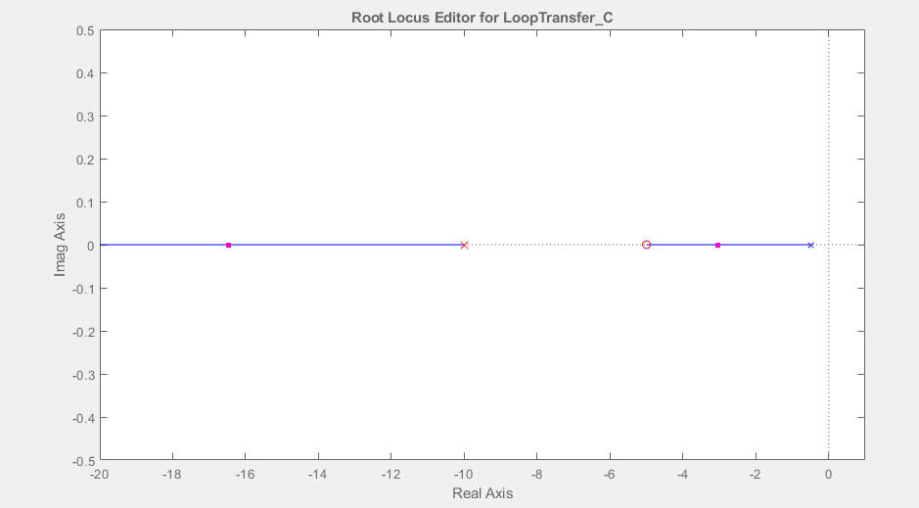

Simulink Diagram:

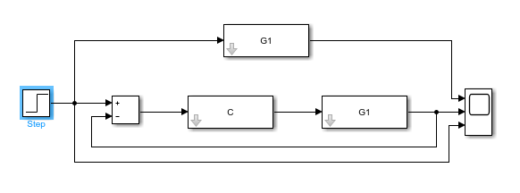

Simulink response:

Yellow = transfer function. Orange = step function Blue= transfer function with controller.

Final Value = 9

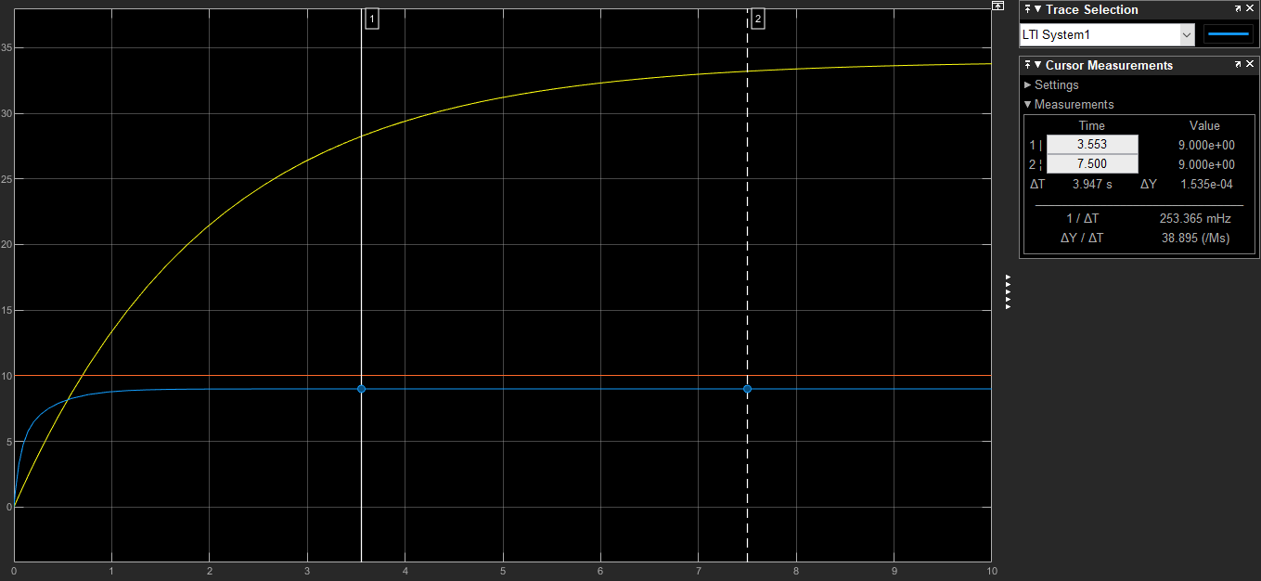

1. **Lead-Lag Compensator. Design a Lead Lag compensator with e(t)=5%. Reference r(t)=b. Make assumptions about the maximum static gain on the Lead and improve it.**

To obtain this compensator I am using , as the lead, and making as the lag and both together make the Lead-Lag Compensator.

Therefore G(s)C(s) is type 0 and unit step.

From the diagram of root locus, I decided that y , therefore:

Root Locus Diagram:

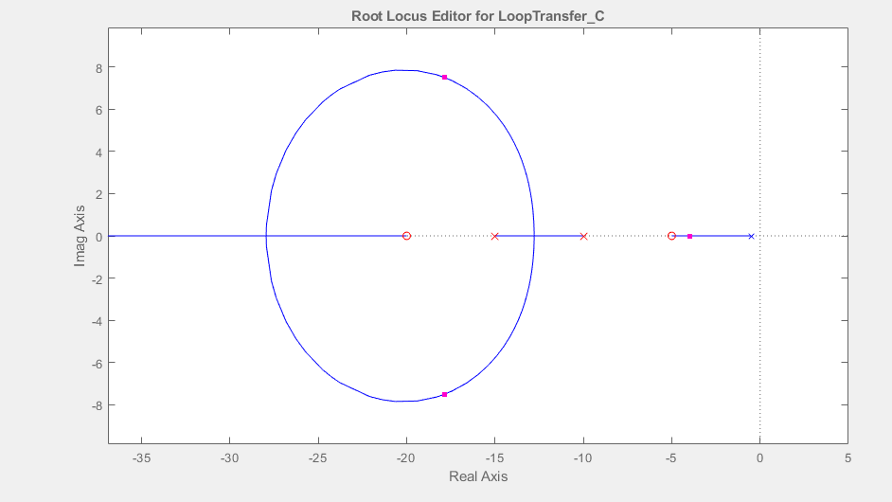

Simulink Diagram:



Simulink response:

Yellow = transfer function. Orange = step function Blue= transfer function with controller.

Final Value theorical = Actual Final Value = 4.75

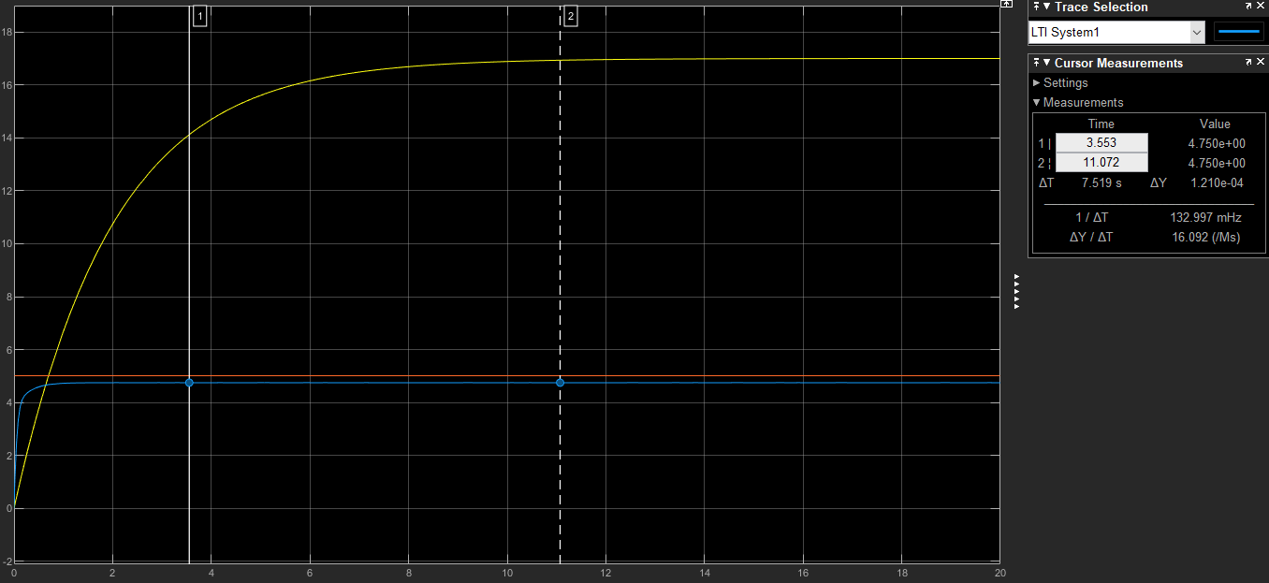

**System 2**

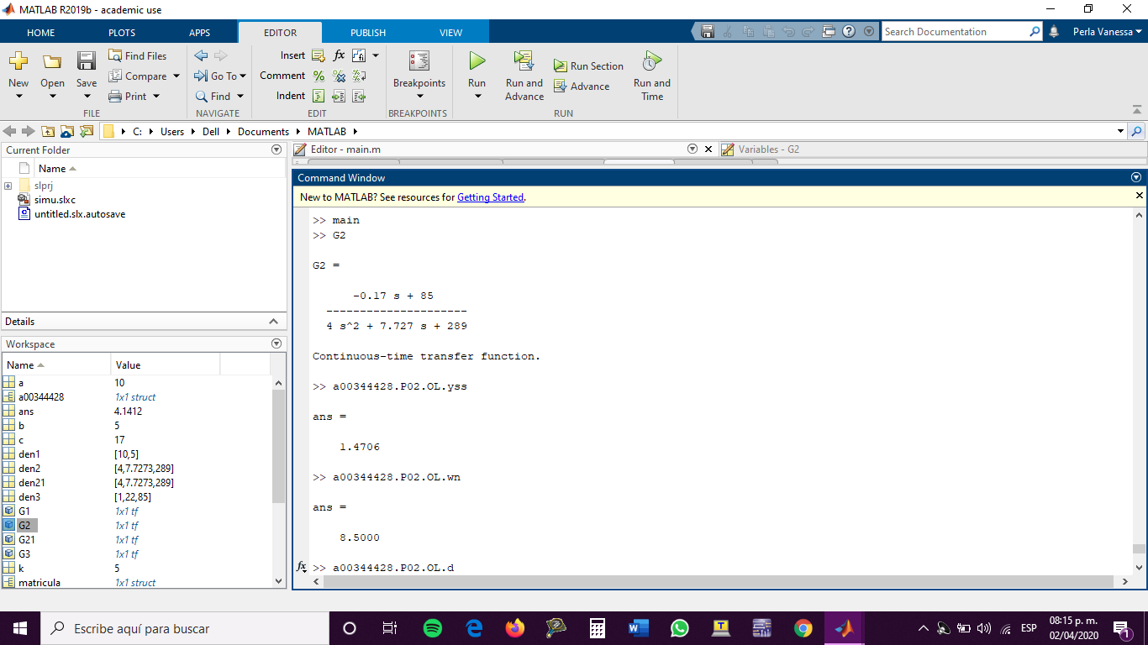

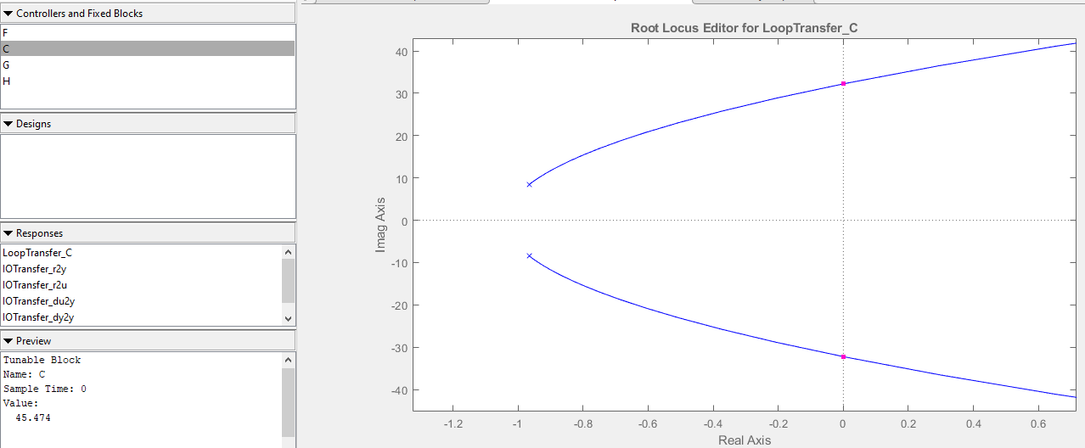

As we can see, maximum gain is 45.474.

1. **Lead Compensator. Design a Lead compensator with e(t)=10%. Reference r(t)=a.**

Therefore G(s)C(s) is type 0 and unit step.

From the diagram of root locus, I decided that y , therefore:

Root Locus diagram:

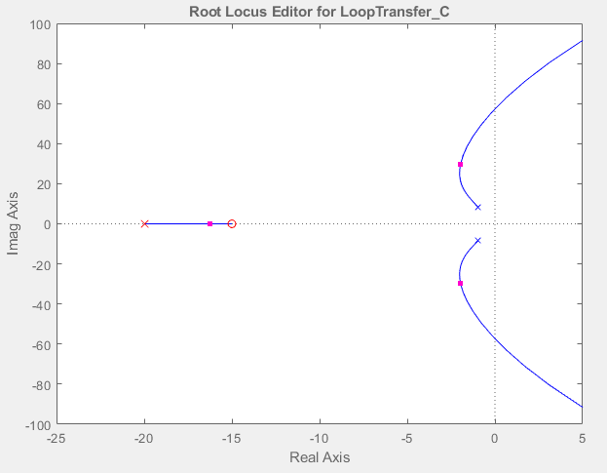

Simulink Diagram:

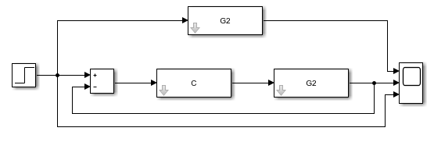

Simulink response:

Yellow = transfer function. Orange = step function Blue= transfer function with controller.

Final Value = 9

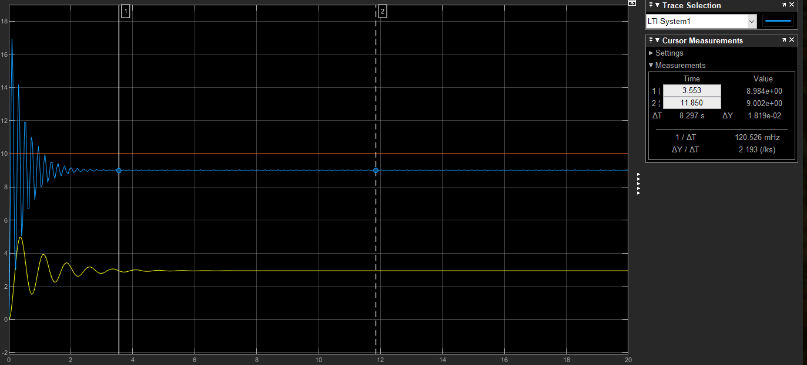

1. **Lead-Lag Compensator. Design a Lead Lag compensator with e(t)=5%. Reference r(t)=b. Make assumptions about the maximum static gain on the Lead and improve it.**

To obtain this compensator I am using , as the lead, and making as the lag and both together make the Lead-Lag Compensator.

Therefore G(s)C(s) is type 0 and unit step.

From the diagram of root locus, I decided that y , therefore:

Root Locus Diagram:

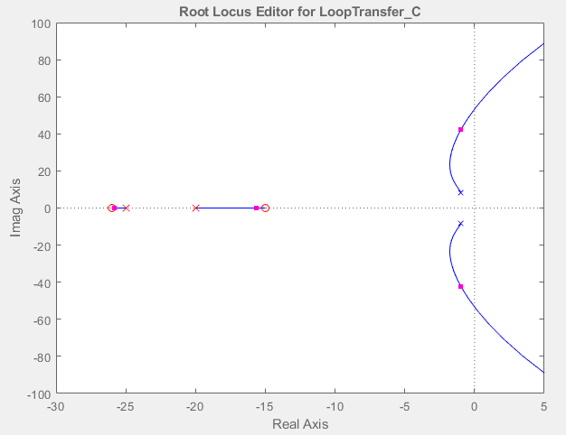

Simulink Diagram:



Simulink response:

Yellow = transfer function. Orange = step function Blue= transfer function with controller.

Final Value theorical = Actual Final Value = 4.75

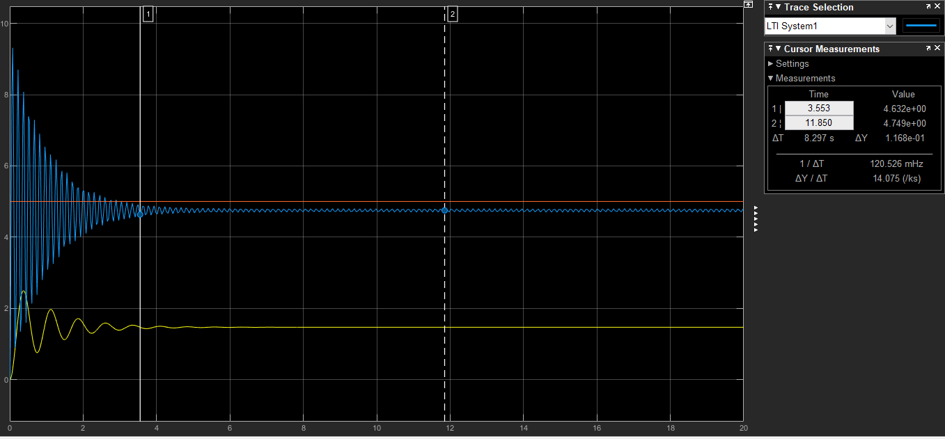

**System 3**

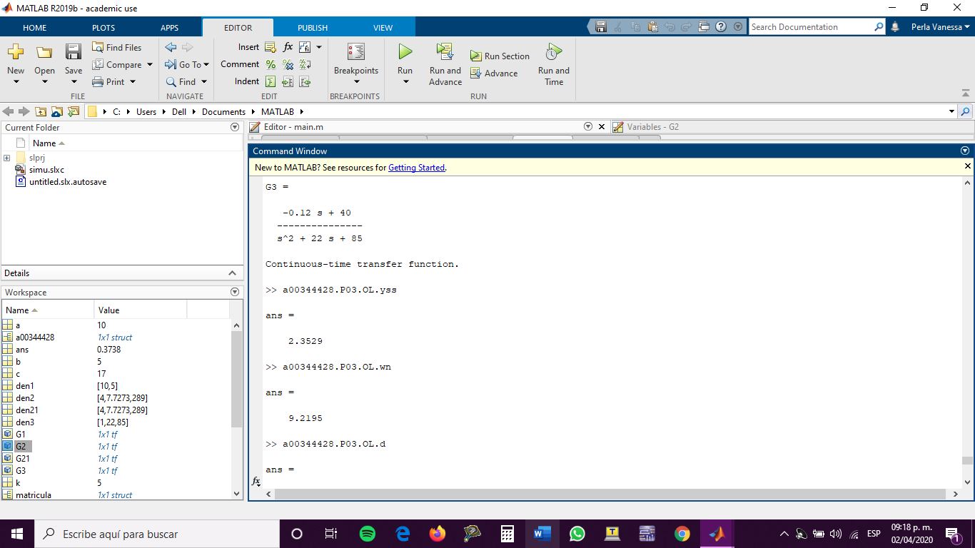

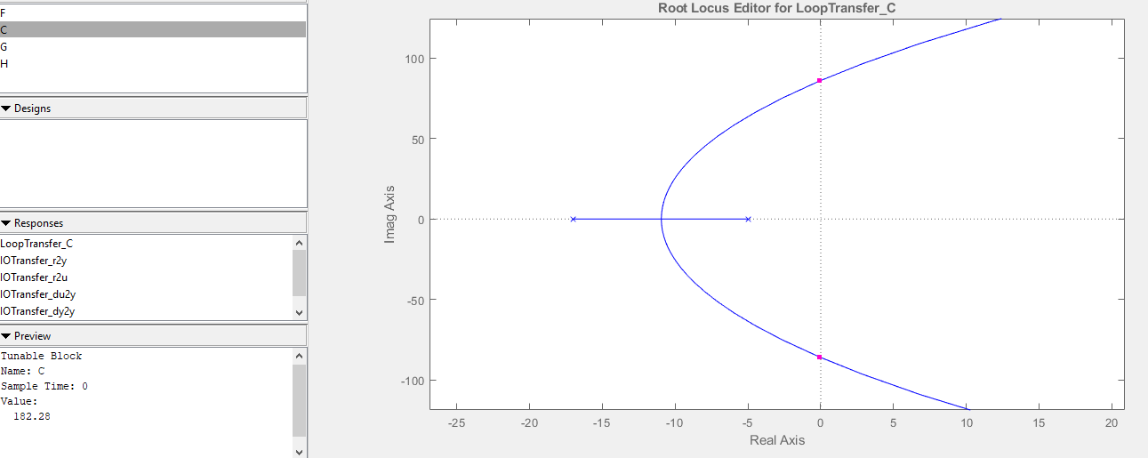

Maximum Gain: 182.28

1. **Lead Compensator. Design a Lead compensator with e(t)=10%. Reference r(t)=a.**

Therefore G(s)C(s) is type 0 and unit step.

From the diagram of root locus, I decided that y , therefore:

Root Locus diagram:

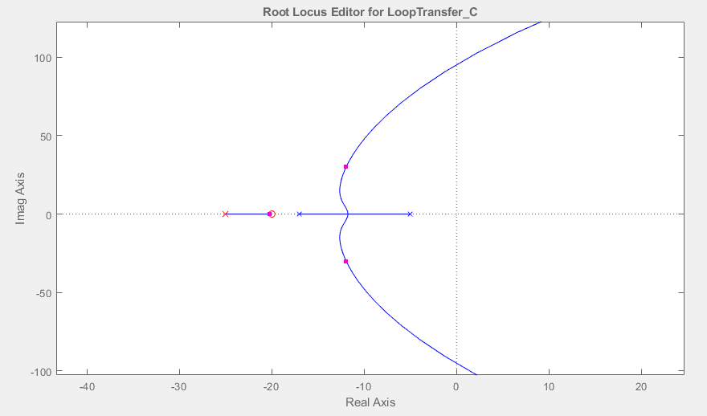

Simulink Diagram:

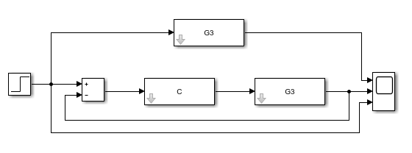

Simulink response:

Yellow = transfer function. Orange = step function Blue= transfer function with controller.

Final Value = 9

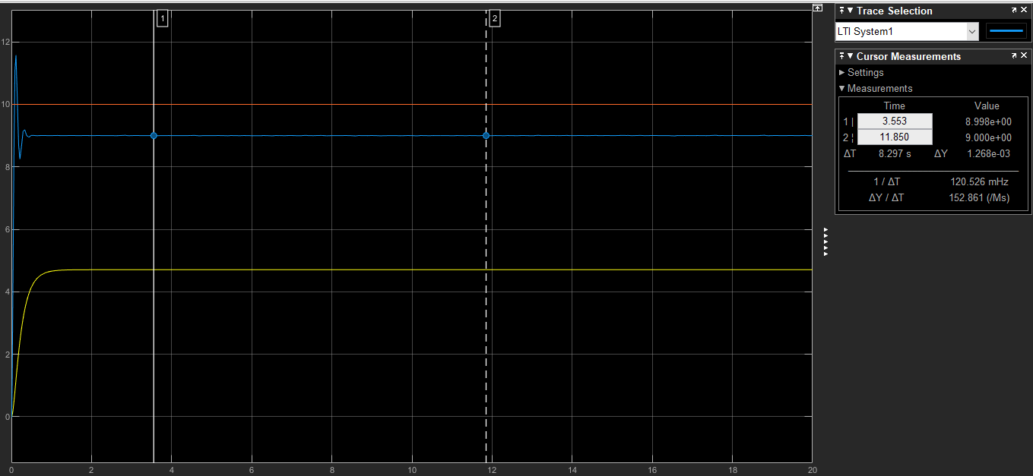

1. **Lead-Lag Compensator. Design a Lead Lag compensator with e(t)=5%. Reference r(t)=b. Make assumptions about the maximum static gain on the Lead and improve it.**

To obtain this compensator I am using , as the lead, and making as the lag and both together make the Lead-Lag Compensator.

Therefore G(s)C(s) is type 0 and unit step.

From the diagram of root locus, I decided that y , therefore:

Root Locus Diagram:

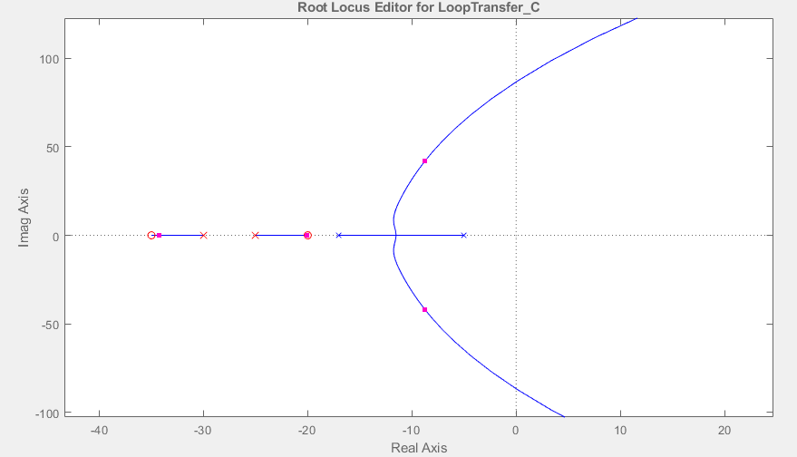

Simulink Diagram:



Simulink response:

Yellow = transfer function. Orange = step function Blue= transfer function with controller.

Final Value theorical = Actual Final Value = 4.75

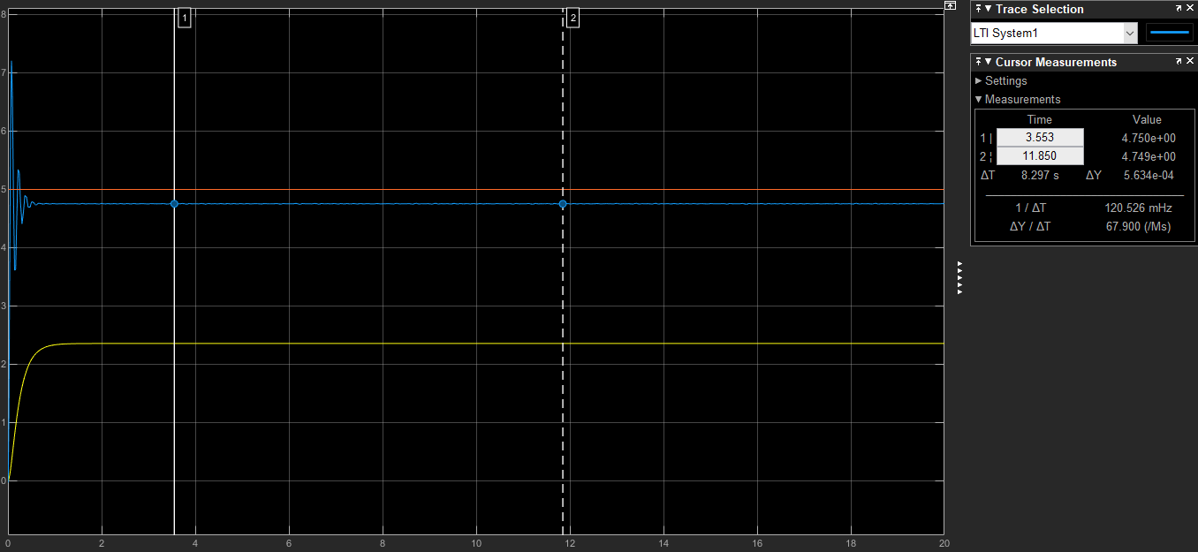

**System 4**

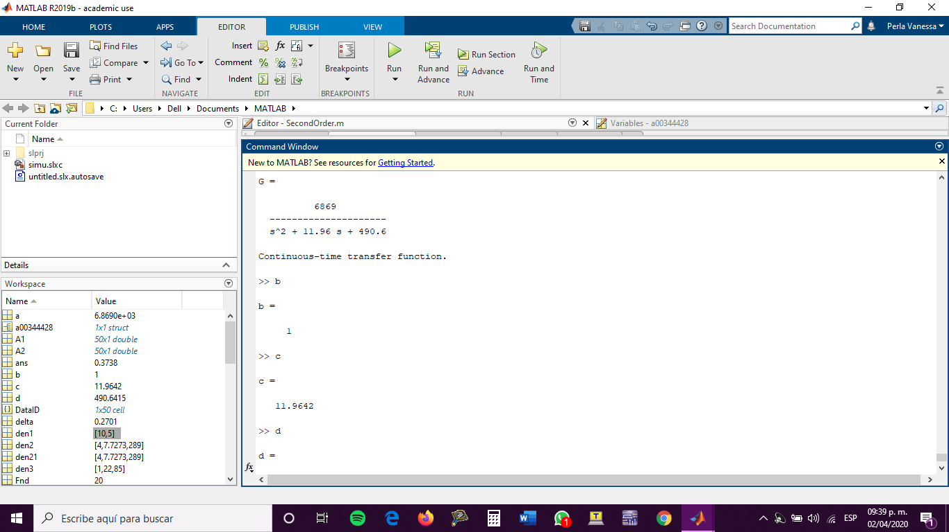

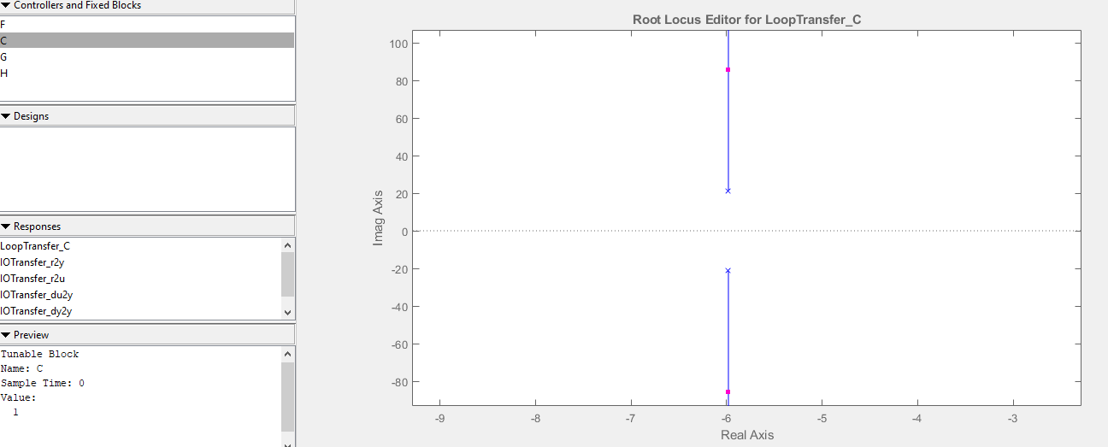

Since there are not branches crossing the imaginary axis, the maximum gain is infinity.

1. **Lead Compensator. Design a Lead compensator with e(t)=10%. Reference r(t)=a.**

Therefore G(s)C(s) is type 0 and unit step.

From the diagram of root locus, I decided that y , therefore:

Root Locus diagram:

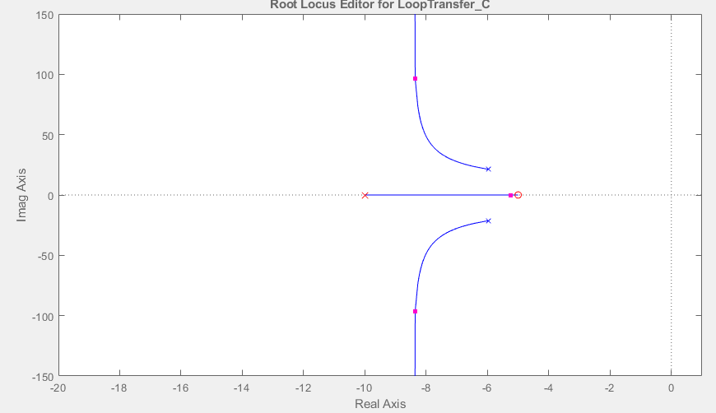

Simulink Diagram:



Simulink response:

Yellow = transfer function. Orange = step function Blue= transfer function with controller.

Final Value = 9

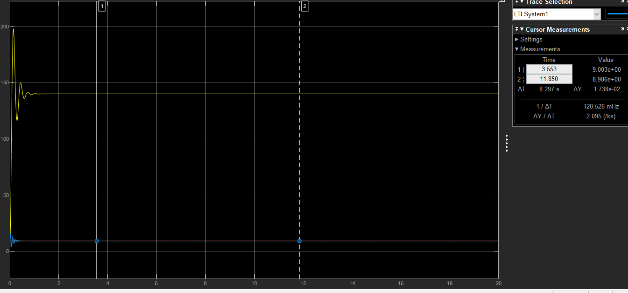 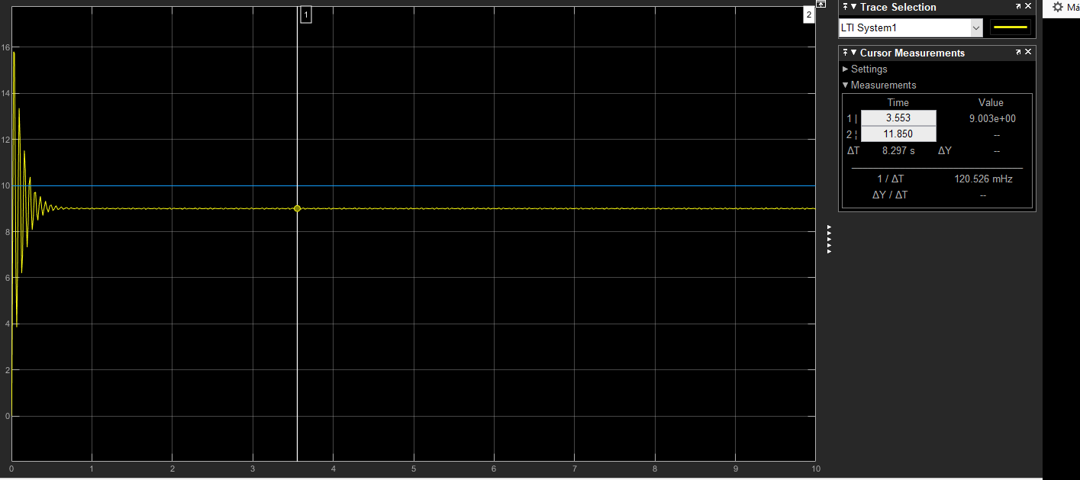

1. **Lead-Lag Compensator. Design a Lead Lag compensator with e(t)=5%. Reference r(t)=b. Make assumptions about the maximum static gain on the Lead and improve it.**

To obtain this compensator I am using , as the lead, and making as the lag and both together make the Lead-Lag Compensator.

Therefore G(s)C(s) is type 0 and unit step.

From the diagram of root locus, I decided that y , therefore:

Root Locus Diagram:

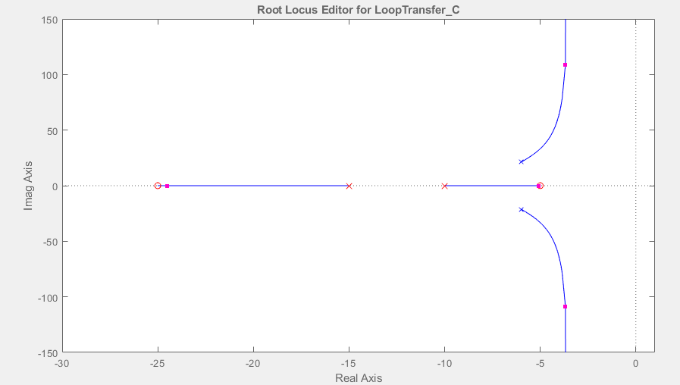

Simulink Diagram:

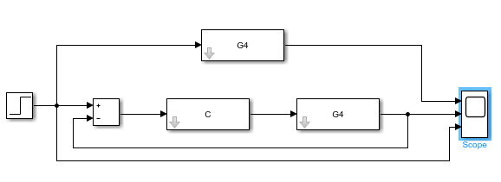

Simulink response:

Yellow = transfer function. Orange = step function Blue= transfer function with controller.

Final Value theorical = Actual Final Value = 4.75

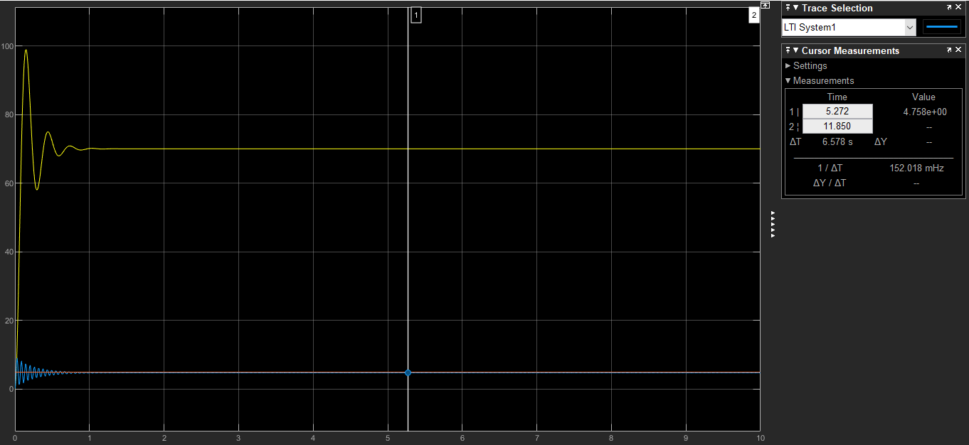

Blue = step function Yellow = transfer function with controller

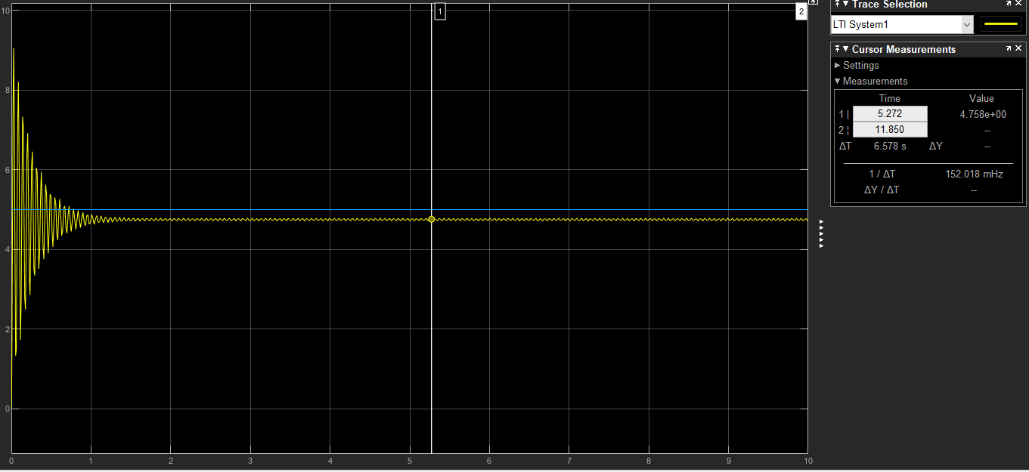

**System 5**

1. **DONE**
2. **a.** 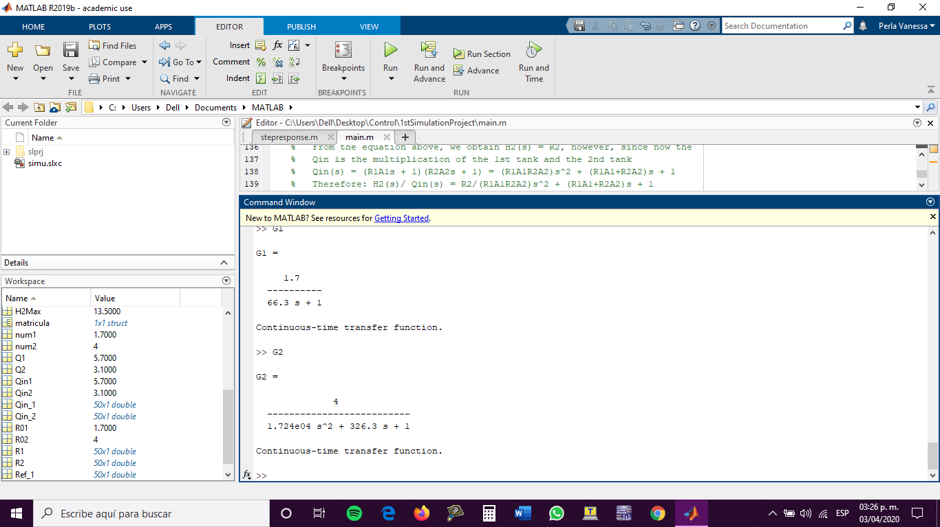

**b.** 

1. **For H1(s)/Qin(s) = G1 Design a Lead Compensator. Target: 10% error**

Therefore G(s)C(s) is type 0 and unit step.

From the diagram of root locus, I decided that y , therefore:

Root Locus diagram:

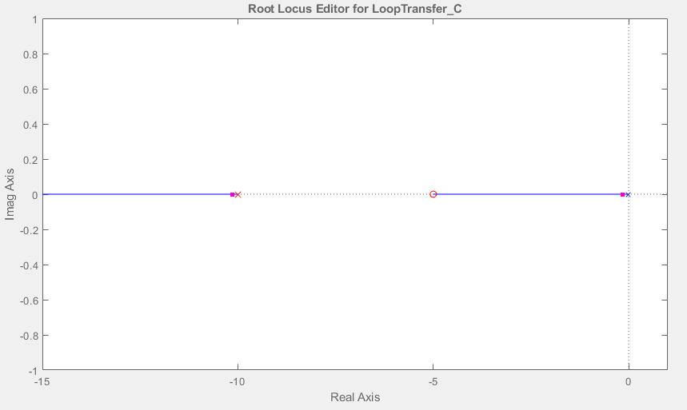

Simulink Diagram:

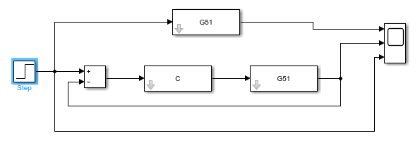

Simulink response:

Yellow = transfer function. Orange = step function Blue= transfer function with controller.

Final Value = 9

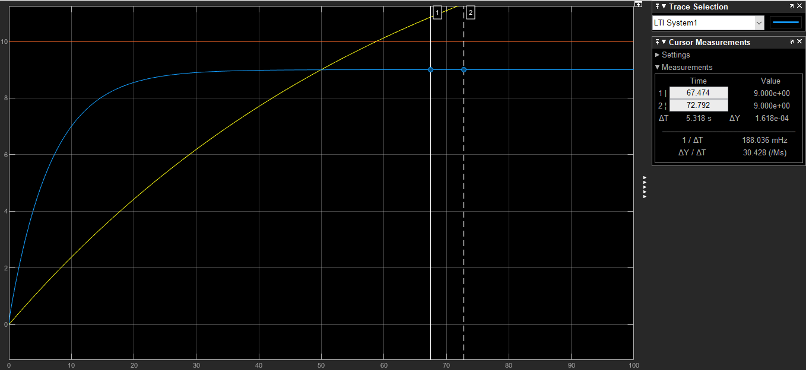

1. **For H2(s)/Qin(s) Design a Lead-Lag Compensator. Target: 3% error and a pre-defined maximum input (selected by you).**

To obtain this compensator I am using , as the lead, and making as the lag and both together make the Lead-Lag Compensator.

Therefore G(s)C(s) is type 0 and unit step.

For the Lead Compensator, I decided that , and .

Then for the Lag Compensator:

From the diagram of root locus, I decided that y , therefore:

Root Locus Diagram:

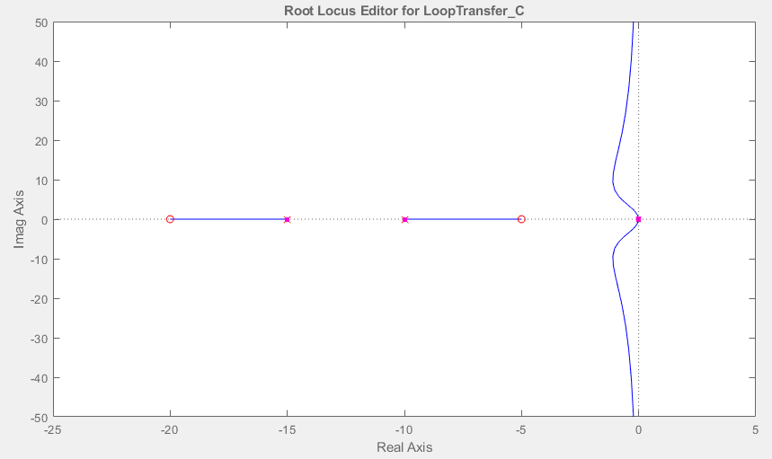

Simulink Diagram:

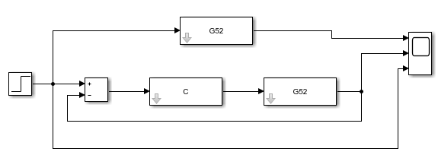

Simulink response:

Yellow = transfer function. Orange = step function Blue= transfer function with controller.

Final Value theorical = Actual Final Value = 9.7

