a = 0.7

b = 0.2

c = 0.1

th = 20

CIdx (t) = 0.7 x Cint (t) + (0.2) x Cneg (t) + (0.1) x Cpub(t)

Kondisi internal menurut Nawangpalupi :

* Perceived Opportunities = 0.47
* Perceived Capabilites = 0.62
* Entrepreneurial Intention = 0.35
* Fear of Failure = 0.35

E = E1,E2 dan E3.

E1 : male, nascent, 19th.

E2 : male, new_bm, 24th

E3 : female, new_bm, 30th

Atribut Ketetanggaan :

1. Alpha 1 = level usaha :

* potential = 7.0 (asumsi)
* nascent= 7.4 (asumsi)
* new_bm= 7.6 (asumsi)
* est_bm = 7.8 (asumsi)

1. Alpha 2 = Umur :

* (18-24 tahun) = 7.0 (asumsi)
* (25 – 34 tahun) = 7.5 (asumsi)
* (35-44 tahun) = 7.8 (asumsi)

1. Alpha 3 = Gender :

* Male = 0.6 (asumsi)
* Female = 0.4 (asumsi)

Kondisi publik : Financial environment related with entrepreneurship (3.06) ; Cultural, social norms and society support (3.29)

t=0

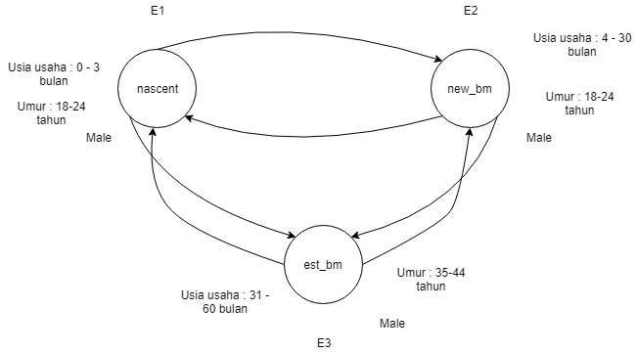

E1 -> CIdx (t=0) = 0.7 x (0.47+0.62+0.35+0.35)+ (0.2 x (7.4 + 7.4 + 0.6) + 0.2 x (8.2 + 8.2 + 0.6)) + (0.1 x (3.06) + 0.1 x (3.29)) = 12.53+ 6.48 + 0.635 = 19.645

E2 -> CIdx (t=0) = 0.7 (0.47+0.62+0.35+0.35)+ x (+ (0.2 x (6.2 + 6.5 + 0.6) + 0.2 x (8.2 + 8.2 + 0.6)) + (0.1 x (3.06) + 0.1 x (3.29)) = 12.53 + 6.06 + 0.635 = 19.225

E3 -> CIdx (t=0) = 0.7 x (0.47+0.62+0.35+0.35)+ (0.2 x (6.2 + 6.5 + 0.6) + 0.2 x (7.4+7.4+0.6)) + (0.1 x (3.06) + 0.1 x (3.29)) = 12.53+ 5.74 + 0.635 = 18.905

Bobot dan Fungsi ketetanggaan (t = 0)

Untuk gender

|  |  |  |  |
| --- | --- | --- | --- |
|  | E1 | E2 | E3 |
| E1 | 0 | 1 | 1 |
| E2 | 1 | 0 | 1 |
| E3 | 1 | 1 | 0 |

Rho : Financial environment related with entrepreneurship dan cultural, social norms and society support

t=1

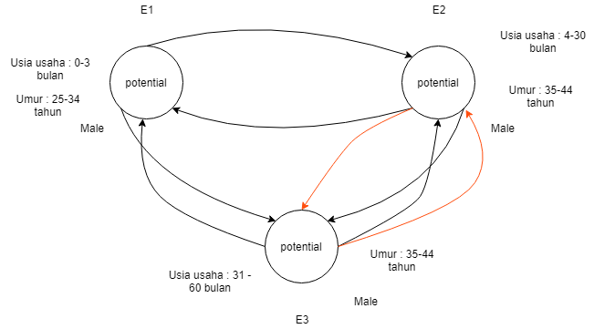

Zigma = perubahan umur utk E2 menjadi 35 tahun.

E1 -> CIdx (t=1) = 0.7 x (0.47+0.62+0.35+0.35) + (0.2 x (7.4 + 8.2 + 0.6) + 0.2 x (8.2 + 8.2 + 0.6)) + (0.1 x (3.06) + 0.1 x (3.29)) = 12.53 + 6.64 + 0.635 = 19.805

E2 -> CIdx (t=1) = 0.7 x (0.47+0.62+0.35+0.35) + (0.2 x (6.2 + 6.5 + 0.6) + 0.2 x (8.2 + 8.2 + 0.6)) + (0.1 x (3.06) + 0.1 x (3.29)) = 12.53 + 6.06 + 0.635 = 19.225

E3 -> CIdx (t=1) = 0.7 x (0.47+0.62+0.35+0.35) + (0.2 x (6.2 + 6.5 + 0.6) + 0.2 x (7.4+8.2+0.6)) + (0.1 x (3.06) + 0.1 x (3.29)) = 12.53 + 5.9 + 0.635 = 19.065

Bobot dan Fungsi ketetanggaan (t = 1)

Untuk gender

|  |  |  |  |
| --- | --- | --- | --- |
|  | E1 | E2 | E3 |
| E1 | 0 | 1 | 1 |
| E2 | 1 | 0 | 1 |
| E3 | 1 | 1 | 0 |

Untuk umur

|  |  |  |  |
| --- | --- | --- | --- |
|  | E1 | E2 | E3 |
| E1 | 0 | 0 | 0 |
| E2 | 0 | 0 | 1 |
| E3 | 0 | 1 | 0 |

Rho : Financial environment related with entrepreneurship dan cultural, social norms and society support

t=2



Zigma = perubahan umur E1 menjadi 25 tahun.

E1 -> CIdx (t=2) = 0.7 x (0.47+0.62+0.35+0.35) + (0.2 x (7.4 + 8.2 + 0.6) + 0.2 x (8.2 + 8.2 + 0.6)) + (0.1 x (3.06) + 0.1 x (3.29)) = 12.53 + 6.64 + 0.635 = 19.805

E2 -> CIdx (t=2) = 0.7 x (0.47+0.62+0.35+0.35)+ (0.2 x (6.2 + 7.4 + 0.6) + 0.2 x (8.2 + 8.2 + 0.6)) + (0.1 x (3.06) + 0.1 x (3.29)) = 12.53 + 6.24 + 0.635 = 19.405

E3 -> CIdx (t=2) = 0.7 x (0.47+0.62+0.35+0.35) + (0.2 x (6.2 + 7.4 + 0.6) + 0.2 x (7.4+8.2+0.6)) + (0.1 x (3.06) + 0.1 x (3.29)) = 12.53+ 6.08 + 0.635 = 19.245

Bobot dan Fungsi ketetanggaan (t = 2)

Untuk gender

|  |  |  |  |
| --- | --- | --- | --- |
|  | E1 | E2 | E3 |
| E1 | 0 | 1 | 1 |
| E2 | 1 | 0 | 1 |
| E3 | 1 | 1 | 0 |

Untuk umur

|  |  |  |  |
| --- | --- | --- | --- |
|  | E1 | E2 | E3 |
| E1 | 0 | 0 | 0 |
| E2 | 0 | 0 | 1 |
| E3 | 0 | 1 | 0 |

Rho : Financial environment related with entrepreneurship dan cultural, social norms and society support

t=3

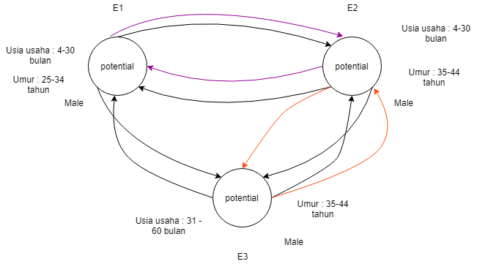

Zigma = perubahan usia usaha E1 menjadi 4 bulan.

E1 -> CIdx (t=3) = 0.7 x (0.47+0.62+0.35+0.35)+ (0.2 x (7.4 + 8.2 + 0.6) + 0.2 x (8.2 + 8.2 + 0.6)) + (0.1 x (3.06) + 0.1 x (3.29)) = 12.53 + 6.64 + 0.635 = 19.805

E2 -> CIdx (t=3) = 0.7 x (0.47+0.62+0.35+0.35) + (0.2 x (7.4 + 7.4 + 0.6) + 0.2 x (8.2 + 8.2 + 0.6)) + (0.1 x (3.06) + 0.1 x (3.29)) = 12.53 + 6.48 + 0.635 = 19.645

E3 -> CIdx (t=3) = 0.7 x (0.47+0.62+0.35+0.35) + (0.2 x (7.4 + 7.4 + 0.6) + 0.2 x (7.4+8.2+0.6)) + (0.1 x (3.06) + 0.1 x (3.29)) = 12.53 + 6.32 + 0.635 = 19.485

Bobot dan Fungsi ketetanggaan (t = 3)

Untuk gender

|  |  |  |  |
| --- | --- | --- | --- |
|  | E1 | E2 | E3 |
| E1 | 0 | 1 | 1 |
| E2 | 1 | 0 | 1 |
| E3 | 1 | 1 | 0 |

Untuk umur

|  |  |  |  |
| --- | --- | --- | --- |
|  | E1 | E2 | E3 |
| E1 | 0 | 0 | 0 |
| E2 | 0 | 0 | 1 |
| E3 | 0 | 1 | 0 |

Untuk usia usaha

|  |  |  |  |
| --- | --- | --- | --- |
|  | E1 | E2 | E3 |
| E1 | 0 | 1 | 0 |
| E2 | 1 | 0 | 0 |
| E3 | 0 | 0 | 0 |

Rho : Financial environment related with entrepreneurship dan cultural, social norms and society support

t=4

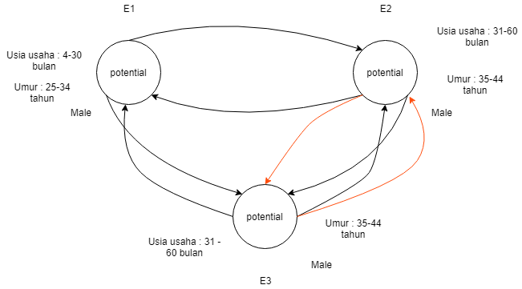

Zigma = perubahan usia usaha e2 jadi 31 bulan

E1 -> CIdx (t=4) = 0.7 x (0.47+0.62+0.35+0.35) + (0.2 x (8.2 + 8.2 + 0.6) + 0.2 x (8.2 + 8.2 + 0.6)) + (0.1 x (3.06) + 0.1 x (3.29)) = 12.53 + 6.8 + 0.635 = 19.965

E2 -> CIdx (t=4) = 0.7 x (0.47+0.62+0.35+0.35) + (0.2 x (7.4 + 7.4 + 0.6) + 0.2 x (8.2 + 8.2 + 0.6)) + (0.1 x (3.06) + 0.1 x (3.29)) = 12.53 + 6.48 + 0.635 = 19.645

E3 -> CIdx (t=4) = 0.7 x (0.47+0.62+0.35+0.35) + (0.2 x (7.4 + 7.4 + 0.6) + 0.2 x (8.2+8.2+0.6)) + (0.1 x (3.06) + 0.1 x (3.29)) = 12.53 + 6.48 + 0.635 = 19.645

Bobot dan Fungsi ketetanggaan (t = 4)

Untuk gender

|  |  |  |  |
| --- | --- | --- | --- |
|  | E1 | E2 | E3 |
| E1 | 0 | 1 | 1 |
| E2 | 1 | 0 | 1 |
| E3 | 1 | 1 | 0 |

Untuk umur

|  |  |  |  |
| --- | --- | --- | --- |
|  | E1 | E2 | E3 |
| E1 | 0 | 0 | 0 |
| E2 | 0 | 0 | 1 |
| E3 | 0 | 1 | 0 |

Adanya tambahan kondisi publik Physical infrastructures and services access (3.45) dan internal market dynamic (3.92)

t=5

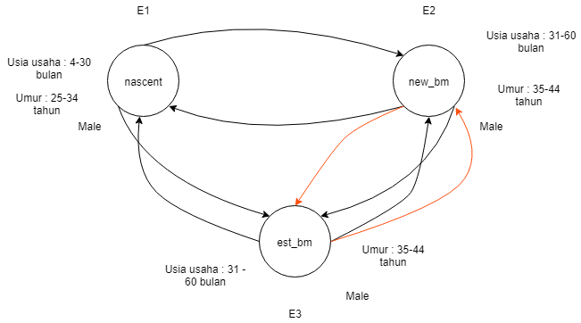

E1 -> CIdx (t=5) = 0.7 x ((0.47+0.62+0.35+0.35) + (0.2 x (8.2 + 8.2 + 0.6) + 0.2 x (8.2 + 8.2 + 0.6)) + (0.1 x (3.06) + 0.1 x (3.29) + 0.1 x (3.45) + 0.1 x (3.92)) = 12.53 + 6.8 + 1.372 = 20.702

E2 -> CIdx (t=5) = 0.7 x (0.47+0.62+0.35+0.35) + (0.2 x (7.4 + 7.4 + 0.6) + 0.2 x (8.2 + 8.2 + 0.6)) + (0.1 x (3.06) + 0.1 x (3.29) + 0.1 x (3.45) + 0.1 x (3.92)) = 12.53 + 6.48 + 1.372 = 20.382

E3 -> CIdx (t=5) = 0.7 x (0.47+0.62+0.35+0.35)+ (0.2 x (7.4 + 7.4 + 0.6) + 0.2 x (8.2+8.2+0.6)) + (0.1 x (3.06) + 0.1 x (3.29)) = 12.53 + 6.48 + 1.372 = 20.382

Bobot dan Fungsi ketetanggaan (t = 5)

Untuk gender

|  |  |  |  |
| --- | --- | --- | --- |
|  | E1 | E2 | E3 |
| E1 | 0 | 1 | 1 |
| E2 | 1 | 0 | 1 |
| E3 | 1 | 1 | 0 |

Untuk umur

|  |  |  |  |
| --- | --- | --- | --- |
|  | E1 | E2 | E3 |
| E1 | 0 | 0 | 0 |
| E2 | 0 | 0 | 1 |
| E3 | 0 | 1 | 0 |

Rho : Financial environment related with entrepreneurship ; cultural, social norms and society support ; physical infrastructures and services access ; internal market dynamic.