**Manual Test Plan for Data Visualization**

For version on 03/03/2019

Vanessa YIN

**Menu**

1. General Look

1. Zoom in and out
2. Hide nodes or edges
3. Suspend to see detail info
4. Resizable
5. Random generated node positions
6. **General Look**
   1. Yellow point: movies
   2. Blue point: actors
   3. Grey line: connections
   4. Will show up in local file visualization.html
   5. The graphs used in this manual test plan would all be this size just for convenience. However, it can be resized. See part 5 for more examples.

1. **Zoom in and out**
   1. Use mouse to drag an area to zoom in on the screen

Below is the result:

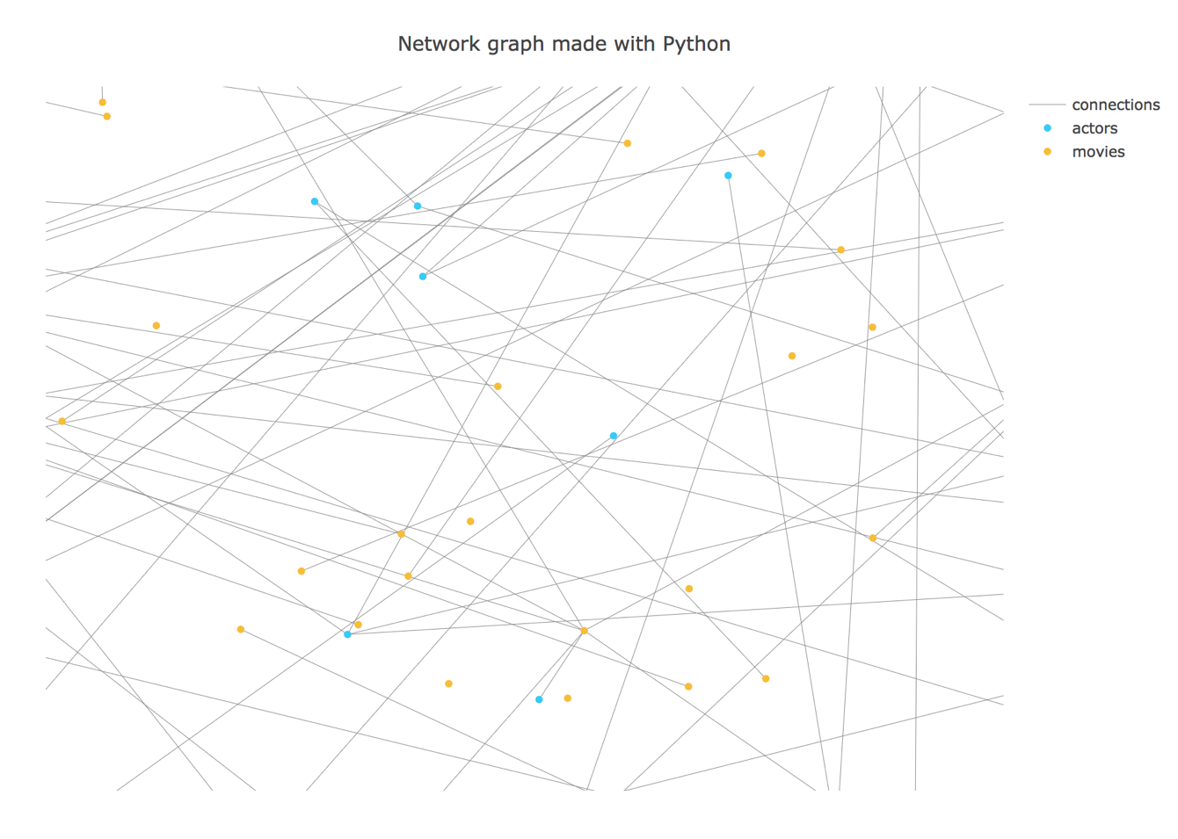

* 1. Double click to cancel zoom in

1. **Hide nodes or edges**
   1. Click on the connections tag on the right to hide connections

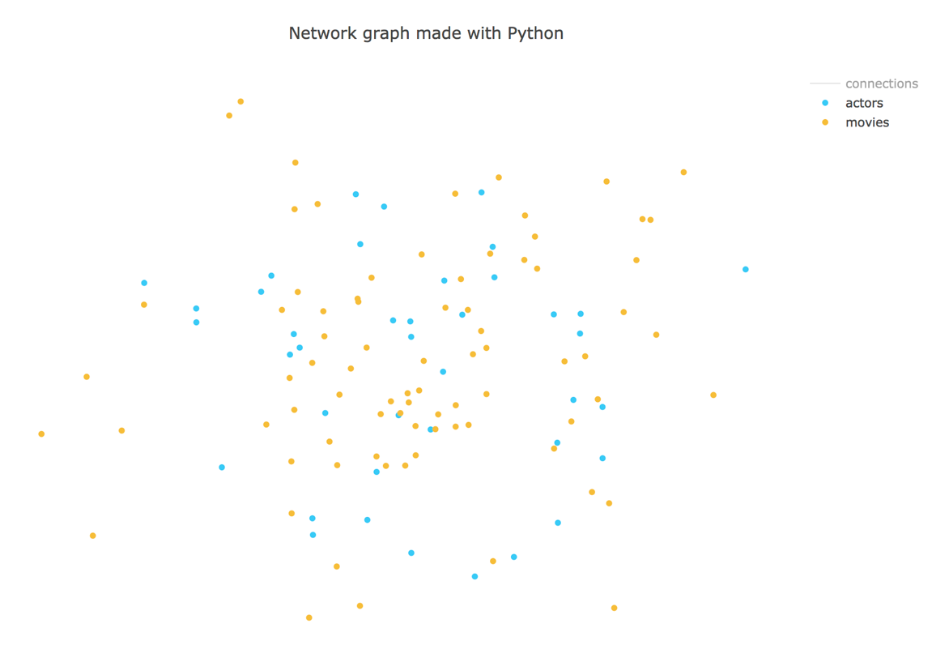

* 1. Click again to cancel (same for nodes)

* 1. Click on the actors tag on the right to hide connections

* 1. Click on the movies tag on the right to hide connections

1. **Suspend to see detail info**
   1. Click on actor node

* 1. Click on movie node

1. **Resizable**

See examples below:

1. **Random generated positions**
   1. The nodes and node info are fixed
   2. The node positions are random

See another graph generated below:

