Masterthesis

Project Documentation

**Benjamin Aigner (Supervisor), Vanessa Prankl (Student)**

# Prerequisits

This masterthesis is part of the ASTERICS-Project funded by the European Union.

**Prerequisites:**

* SW stack: ASTERICS-project “Mouse/Keyboard for BLE HID” (<https://github.com/asterics/esp32_mouse_keyboard> )

# Reference Product Testing

GlassousePro has been tested to set some usability benchmarks. It has a well thought out design which enables the user to simply plug-and-play when turned on. The following observations have been made during testing its features:

* **Startup:** The device needs to be calibrated after startup. This requires to place it on a flat surface and wait a few seconds. Otherwise the mouse always drifts.
* **Power source:** 250 mAh battery
* **Connection types with host device:** Bluetooth only
* **4 connectors for individual external buttons** that are used to enable right- and left-click as well as scrolling and switching the connected device.
* **1 button** for switching the connected device (PC, TV, Tablet, …)
* **1 button** for switching the mouse pointer sensitivity (3 sensitivities available)
* **1 LED** for battery charge status
* **3 LEDs** to show, which device is connected

Figure 1: https://glassouse.com/wp-content/uploads/2022/03/GlassOuse-Pro-user-manual-english.pdf

Furthermore, Glassouse uses a 9-DOF IMU, which includes a magnetometer in order to reduce mouse pointer drift.

# Device Feature Definition

The HeadMouse device shall support the following features:

* Bluetooth communication
* Battery powered (rechargeable)
* UI:
  + 1 LED for device status
  + 1 LED for battery status
  + 3 jacks for user input buttons (left-,right-click, scroll)
  + Sip & puff sensor input for alternative control mechanism
* 6+9 axis IMU for comparison

# Hardware Documentation

The goal is to implement a cost effective HeadMouse Design which supports all necessary features a computer mouse has.

## Schematic Design V1

**Power Management and Battery Charging**

The device shall be powered either by USB-C connector or a battery. If both are attached, the device shall continue operation. The voltage regulator TC1262 ensures a constant voltage source for the hardware components on the PCB.

Figure 2: Power management schematic

Currently, a 500 mAh battery is implemented. The duration until the battery needs to be recharched shall be evaluated during the project. The design is based on the board design from ESP32Thing from Sparkfun (<https://cdn.sparkfun.com/assets/learn_tutorials/5/0/7/esp32-thing-schematic.pdf>)

Figure 3: Battery management schematic

The battery charge level as well as the charging status are measured by the microcontroller, in order to give the user some feedback about the device status.

**Microcontroller**

Basic requirements for the microcontroller are:

* Bluetooth support
* Arduino compatible due to existing Arduino code
* 32 Bit architecture to ensure a modern and lasting design for the next years
* USB support (not only UART as early on)

Several microcontrollers fulfill these requirements at the moment. I chose an ESP32-S3-WROOM which is a hardware module including the newest generation of ESP32 and a Bluetooth antenna. This makes the implementation of the microcontroller easier and is one of the cheapest currently available modules.

Some sources for the decision:

* Discussion about alternatives to ESP32 (Arduino support is required so currently only RPPico W is an option): <https://www.espboards.dev/blog/esp32-alternatives/>
* Note: ESP32 first generation is not recommended for new designs by ESP and needs USB-UART converter. S2 generation does not have bluetooth support => Use S3 generation
* Difference between old ESP32 and new ESP32-S2 and ESP8266 (ESP-S3 missing): <https://maker.pro/esp8266/tutorial/a-comparison-of-the-new-esp32-s2-to-the-esp32>
* ESP-S3-WROOM Documentation: <https://www.espressif.com/sites/default/files/documentation/esp32-s3-wroom-1_wroom-1u_datasheet_en.pdf>

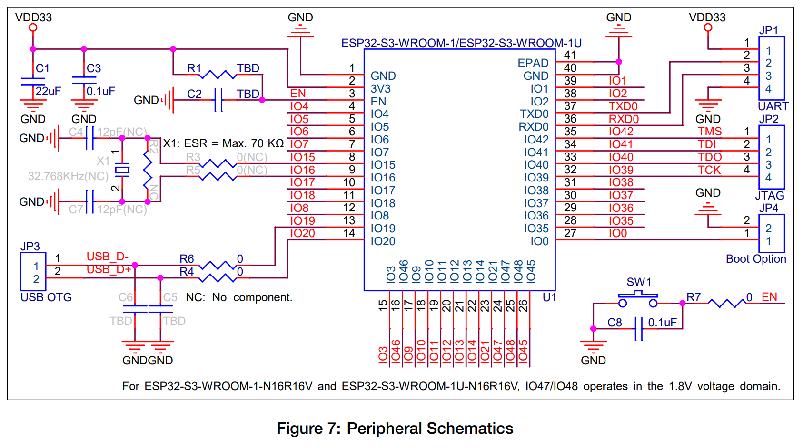

Figure 4: Peripheras schematics of ESP32-S3-WROOM

To enable communication over USB on the HeadMouse board, a USB-C connector is placed on the board.

Figure 5: USB-C connector schematic

**User Interface**

Two low power (<10 mA) bi-color-LED for side surface mount were chosen (<https://www.mouser.at/ProductDetail/Wurth-Elektronik/155124RV73200?qs=5aG0NVq1C4yQQzqaqWGYAg%3D%3D> )

Figure 6: LED schematic

Auxillary button jacks are used to enable external buttons to connect.

Figure 7: Button jack for external buttons schematic

**IMUs**

In order to make some benchmark tests, two different 6-axis IMUs and one 9-axis IMU are implemented on the first prototype. Currently, most 9-axis IMUs are not available at the market which reduced the number of options to a single IMU type.

Source of IMU comparison: <https://oscarliang.com/flight-controller-explained/#Gyro>

1. **6-Axis IMU:** MC6470

Figure 8: IMU MCP6470 schematic

1. **6-Axis IMU:** LSM6DS (same as on Arduino Nano RP2040 Connect) <https://content.arduino.cc/assets/ABX00053-schematics.pdf>)

Figure 9: IMU LSM6DS schematic

1. **9-Axis IMU:** BNO55

Figure 10: IMU BNO55 schematic

## 

## PCB Testing V1

A simple peripheral test program was written for Arduino and flashed on the HeadMouse board V1. Three boards are assembled and tested. For each board a test-report was generated.

The test program includes:

* I2C port scan
* Read out all button inputs
* Read out battery charging status
* Measure battery voltage

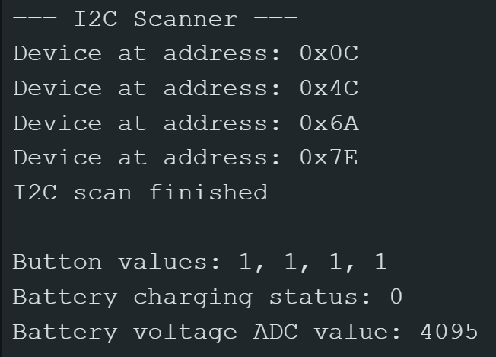

Figure 11: Example for peripheral test program output

**General observation notes**

* The battery poles are swapped on pcb and must be corrected.
* The battery voltage measurement needs to be done with an adjustable voltage source to benchmark the ADC-measurements.
* The I2C bus-scan results in 4 instead of 3 (assumed) found devices. Nevertheless, only 3 out of 4 IMUs are found. It needs to be determined, why 2 more devices show up (and not only 1) and why the third IMU cannot be found.
* Bluetooth testing is still open and will be implemented later on.

**BNO055 I2C Debugging (Board V1-pcb1)**

1. Internal pull-ups of ESP32-S3 connected to SCL and SDA bus wires.
2. Reduced bus speed to 10 kHz, did not make a difference compared to 400 kHz.
3. Cut off I2C connections from BNO055. Nevertheless, 4 I2C addresses are shown during port-scan. => Probably BNO055 is not working due to missing GND connections at pin 15 and 16. Must be fixed and tested again.
4. Cut off I2C connections from MC6470. This results in I2C addresses 0x4C and 0x0C not shown anymore => Datasheet says, 0x4C is accelerometer sensor and 0x0C is magnetometer.

This also implies that LSM6DSO has two I2C-addresses (0x6A and 0x7E).

**Test Report Board V1-pcb1-test1**

|  |  |  |
| --- | --- | --- |
| **Hardware Component** | **Status** | **Notes** |
| **ON/OFF switch** | tested - ok |  |
| **Manual boot over button** | tested - ok |  |
| **Manual reset over buttons** | tested - ok |  |
| **uC flashing** | tested - ok |  |
| **Autonomous reboot after flashing** | tested - ok |  |
| **Communication uC-PC over USB-C** | tested - ok |  |
| **Communication uC-PC over Bluetooth** | TBD | Will be tested later on |
| **uC powered by battery** | tested - does not work | Battery connectors are swapped on PCB -> Killed battery management chip. Chip needs to be replaced |
| **Battery charging** | tested - does not work | According chip is dead |
| **LED (battery status)** | tested - ok |  |
| **LED (device status)** | tested - does not work | Always keeps dark -> Soldering issue needs to be solved |
| **Button 1** | tested - ok |  |
| **Button 2** | tested - ok |  |
| **Button 3** | tested - ok |  |
| **Button 4** | tested - ok |  |
| **IMU-BNO55 addressing over I2C** | tested - does not work | Should have I2C addr.: 0x28 but does not show up. |
| **IMU-LSM6DS addressing over I2C** | tested - ok | I2C addr.: 0x6A, 0x7E |
| **IMU-MCP5479 addressing over I2C** | tested - ok | I2C addr.: 0x4C, 0x0C |

**Test Report Board V1-pcb2-test1**

|  |  |  |
| --- | --- | --- |
| **Hardware Component** | **Status** | **Notes** |
| **ON/OFF switch** | tested - ok |  |
| **Manual boot over button** | tested - ok |  |
| **Manual reset over button** | tested - ok |  |
| **uC flashing** | tested - ok |  |
| **Autonomous reboot after flashing** | tested - ok |  |
| **Communication uC-PC over USB-C** | tested - ok |  |
| **Communication uC-PC over Bluetooth** | TBD | Will be tested later on |
| **uC powered by battery** | tested - does not work | uC does not boot if powerd by battery. Issue source needs to be determined |
| **Battery charging status measurement** | tested - ok | Tested with battery connected and not attached |
| **Battery voltage measurement** | TBD | Could not be tested yet due to missing adjustable voltage source. |
| **LED (battery status)** | tested - ok |  |
| **LED (device status** | tested - ok |  |
| **Button 1** | tested - ok |  |
| **Button 2** | tested - ok |  |
| **Button 3** | tested - does not work | Input pin of uC always stays high - Soldering issue is likely and needs to be determined and fixed |
| **Button 4** | tested - ok |  |
| **IMU-BNO55 addressing over I2C** | tested - does not work | Should have I2C addr.: 0x28 but only 0x0C and 0x7E show up. Source of issue needs to be determined |
| **IMU-LSM6DS addressing over I2C** | tested - ok | I2C addr.: 0x6A |
| **IMU-MCP6470 addressing over I2C** | tested - ok | I2C addr.: 0x4C |

**Test Report Board V1-pcb3-test1**

|  |  |  |
| --- | --- | --- |
| **Hardware Component** | **Status** | **Notes** |
| **ON/OFF switch** | tested - ok |  |
| **Manual boot over button** | tested - ok |  |
| **Manual reset over buttons** | tested - ok |  |
| **uC flashing** | tested - does not work | uC does not mount -> Soldering issue very likely and needs to be resolved |
| **Autonomous reboot after flashing** | TBD |  |
| **Communication uC-PC over USB-C** | TBD |  |
| **Communication uC-PC over Bluetooth** | TBD |  |
| **uC powered by battery** | TBD |  |
| **Battery charging** | TBD |  |
| **LED (battery status)** | TBD |  |
| **LED (device status** | TBD |  |
| **Button 1** | TBD |  |
| **Button 2** | TBD |  |
| **Button 3** | TBD |  |
| **Button 4** | TBD |  |
| **IMU-BNO55 addressing over I2C** | TBD |  |
| **IMU-LSM6DS addressing over I2C** | TBD |  |
| **IMU-MCP5479 addressing over I2C** | TBD |  |