**Sample User interface - command driven screenshots:**

Screenshot 1:

Enter your selection: 1

Enter path (directory) where to load from: blah

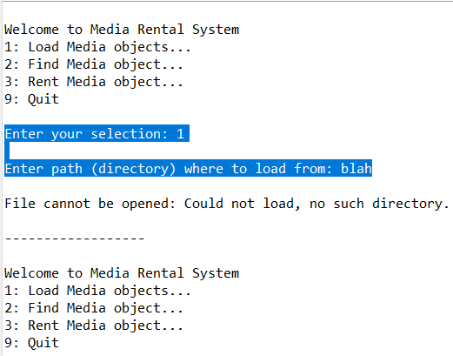

Screenshot 2:

Enter your selection: 1

Enter path (directory) where to load from: C:/Week9

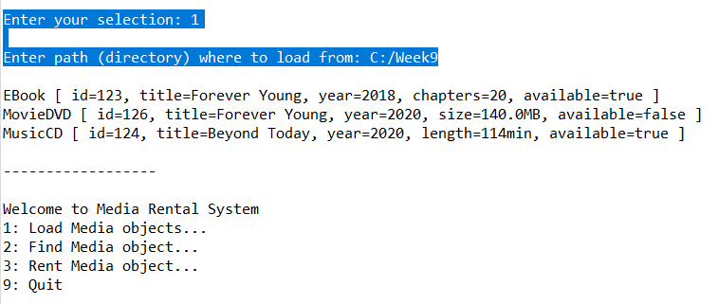

Screenshot 3:

Enter your selection: 2

Enter the title: blah

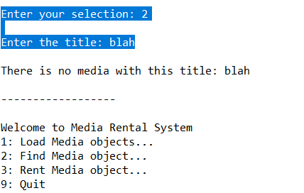

Screenshot 4:

Enter your selection: 3

Enter the id: 123

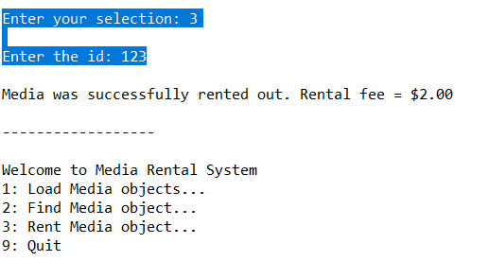

Screenshot 5:

Enter your selection: 2

Enter the title: Forever Young

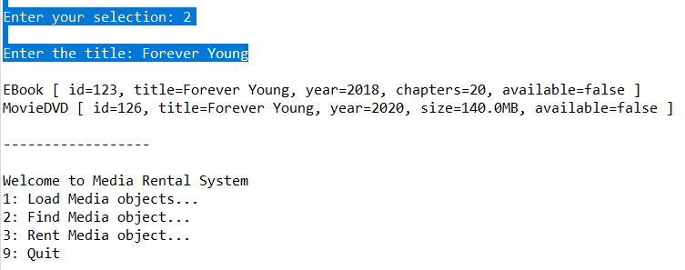

Screenshot 6:

Enter your selection: 3

Enter the id: 999

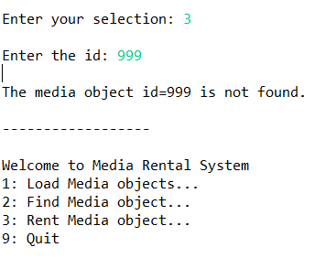

Screenshot 7: Exit program

