Extra Features | Proposal
ELEC 391
Team B5
The rationale behind these extra features is to improve the requirements and constraints given for this project such that the robot becomes more effective in solving additional tasks. Some of the extra features will be additive, while some will build on existing features to be more efficient.
1. Features
- Light sensor
- Turn signal
- Speed
- Retractable platform
- Speaker
- OLED display
2. Goal
The primary goal of these features is to mimic the functionality of an “ice cream machine”. Additional tasks would be based on this functionality and include working automatic headlights, app-activated turn signals, a jingle, and platform that can hold items (such as treats). The secondary goal is to achieve these functions at a basic level while improving the existing requirements and constraints of the original 2-wheel balancing robot.
3. Requirements
3-1. The robot must be able to discern between a well-lit and unlit environment and adjust its lights accordingly.
3-2. Headlight turn signals can be accessed and controlled from the user-side interface.
3-3. Multiple speed adjustments available for the robot.
3-4. The robot must be able to fold down and retract a platform from the user-side interface while being stable enough to steadily hold items on the platform.
3-5. The speaker function must be able to play music and controlled by user.
3-6. OLED display to display additional information (e.g. menu of ice cream machine).
4. Constraints
4-1. May be difficult to strictly define the range that is considered as “well-lit” and “unlit”.
4-2. Speed adjustments may affect the self-balancing aspect of the robot.
4-3. Time constraints due to team member’s individual schedules.
4-4. Monetary aspects that may fall out of the budget limit.
5. Accomplishments
Refer to image below for an expected finished robot design with all extra features included.
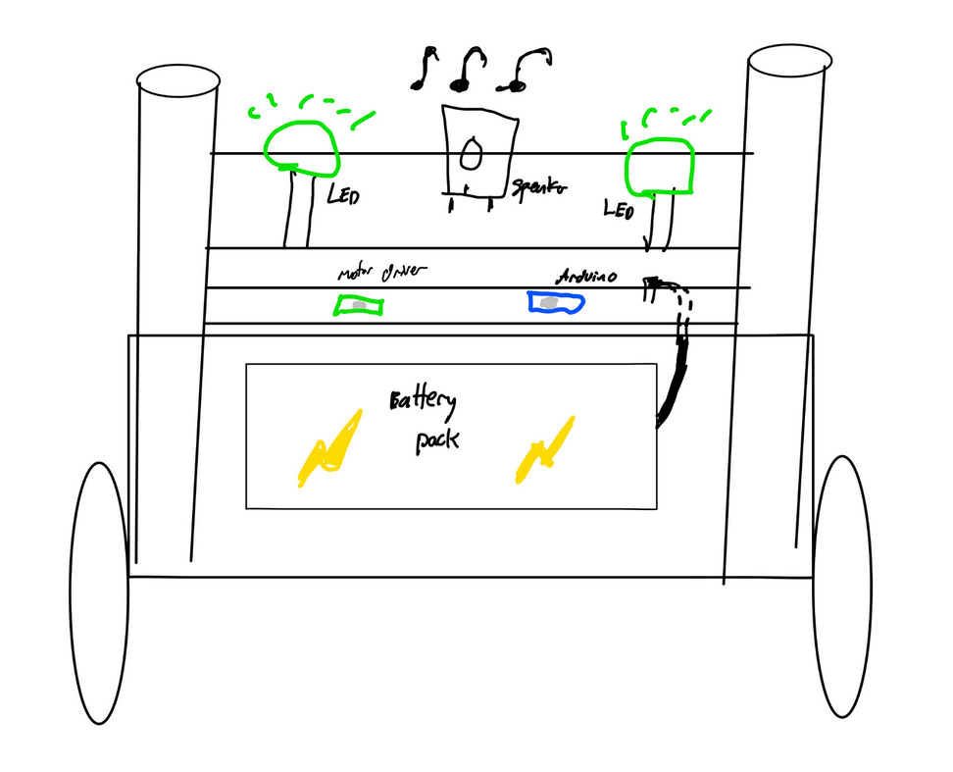
6. High-level functional diagram
See below attached image for a block diagram of inputs and outputs of the Arduino and corresponding components for the robot (including extra feature components).
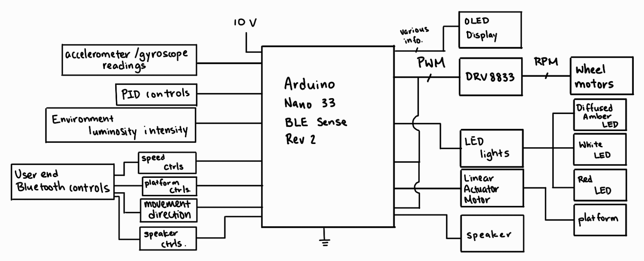
7. Achieving Success
7-1. Multiple speed settings on the robot.
7-2. Light sensor able to discern between light intensities and adjust LEDs accordingly.
7-3. Turn signals on headlights work accordingly.
7-4. Retractable platform folds down and retracts smoothly without dropping objects on top.
7-5. The robot can self-balance while motor speed changes.
7-6. Speaker to play audio files accessed from SD card.
7-7. User-controlled interface is Bluetooth controlled, neat, and user-friendly.
7-8. Users can control retractable platform, audio speaker, turn signals/movement direction, and speed through controller.
8. How will it be demonstrated
The extra features outlined for the robot will be demonstrated physically to the teaching staff. The robot will ideally demonstrate self-balancing features while speed is changed through user control. The light sensor will be demonstrated through dimming the lights in the demonstration area, while speakers and retractable platform will be controlled through the user interface.
9. Accompanying documentation
A final report will be handed in along with the final demonstration of the completed robot project. Also, there will be weekly scrum meeting updates that will document the progress of the project.
10. Budget
$65 CAD (excluding tax, shipping)
11. BOM
See attached BOM sheet for more details. Below is a list of the components to-be-purchased:
Quantity | Component
1 | 0.96” OLED display
1 | SD card reader
1 | Class AB audio amplifier
6 | Amber THT LEDs
3 | White THT LEDs
3 | Red THT LEDs
2 | Linear actuator motors

