Food Data Pipeline – Data Cleaning Overview
This document provides a polished overview of the food data-cleaning pipeline used in the ISER Food Pricing Data Pipeline. It includes color-coded explanations and a visual infographic illustrating the full data flow.

Infographic: Data Cleaning Flow
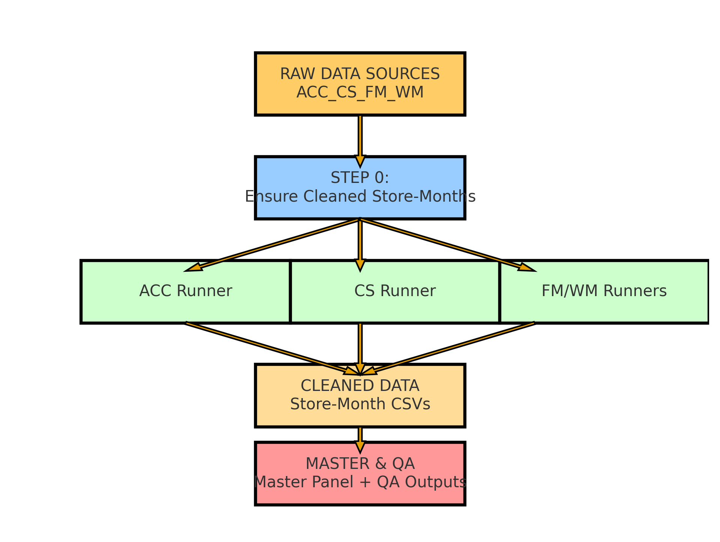

Summary of Cleaning Steps

1. RAW Data Inputs
All store sources (ACC, CS, FM, WM) are ingested in their original JSON/CSV formats.

2. Step 0 – Safety Net Cleaning
The pipeline ensures that every store-month appearing in RAW_DATA has a corresponding cleaned CSV in CLEANED_DATA. Missing months are auto-generated using schema normalization.

3. Store-Specific Runners
Each retailer has its own cleaning logic:
• ACC: Merges multiple CSVs per month, normalizes taxes and item fields.
• CS: Handles mixed folder/loose files and constructs STORE_IDs.
• FM/WM: Extracts latest JSON per month and maps deeply nested fields.

4. Master Assembly
All cleaned store-month files are merged. Keys (PRIMARY_KEY and PRIMARY_STORE_KEY) are rebuilt, timestamps normalized, and three master outputs are created: long panel, latest-by-key, and wide monthly price panel.

5. Quality Assurance (QA)
Generates missingness tables, record counts, and an HTML QA dashboard with visualizations.

