Vanessa Lobo
180905316
Roll No: 37
CSE-A

LAB-3

Q1:
#include <mpi.h>
#include <stdio.h>
#include <string.h>
#include <stdlib.h>

int fact(int val){
int f=1;
for(int i=2; i<=val; i++)
f=f*i;
return f;
}
int main(int argc, char *argv[])
{
int rank, size, n;
MPI_Init(&argc, &argv);
MPI_Comm_rank(MPI_COMM_WORLD, &rank);
MPI_Comm_size(MPI_COMM_WORLD, &size);
int arr[100], res[100];
int val;
if(rank==0){
n=size;
printf("Enter values:\n");
for(int i=0; i<n; i++){
scanf("%d", &arr[i]);
}
}
MPI_Scatter(arr, 1, MPI_INT, &val, 1, MPI_INT, 0, MPI_COMM_WORLD);
printf("Rank: %d, Value: %d\n", rank, val);
fflush(stdout);
int f=fact(val);
MPI_Gather(&f, 1, MPI_INT, res, 1, MPI_INT, 0, MPI_COMM_WORLD);
if(rank==0){
int sum=0;
for(int i=0; i<n; i++){
sum+=res[i];
}
printf("Sum=%d\n", sum);
}
MPI_Finalize();

return 0;
}

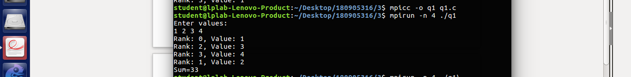

Q2:
#include <mpi.h>
#include <stdio.h>
#include <string.h>
#include <stdlib.h>

int main(int argc, char *argv[])
{
int rank, size;
int n, m;
MPI_Init(&argc, &argv);
MPI_Comm_rank(MPI_COMM_WORLD, &rank);
MPI_Comm_size(MPI_COMM_WORLD, &size);
float arr[100], res[100], final, avg, sum;
float dest[100];
if(rank==0){
printf("Enter m:\n");
scanf("%d", &m);
n=size;
printf("Enter the values: \n");
for(int i=0; i<n*m; i++)
scanf("%f", &arr[i]);

}
MPI_Bcast(&m, 1, MPI_INT, 0, MPI_COMM_WORLD);
MPI_Scatter(arr, m, MPI_FLOAT, res, m, MPI_FLOAT, 0, MPI_COMM_WORLD);

sum=0.0;
for(int i=0; i<m; i++){

sum+=res[i];

}
avg=(float)sum/m;
printf("Rank: %d, Average: %f\n", rank, avg);

MPI_Gather(&avg, 1, MPI_FLOAT, dest, 1, MPI_FLOAT, 0, MPI_COMM_WORLD);

fflush(stdout);
if(rank==0){
final=0.0;
for(int i=0; i<n; i++){
final+=dest[i];
}
final=(float)final/n;
printf("The total average is %f\n", final);
}
MPI_Finalize();
return 0;
}

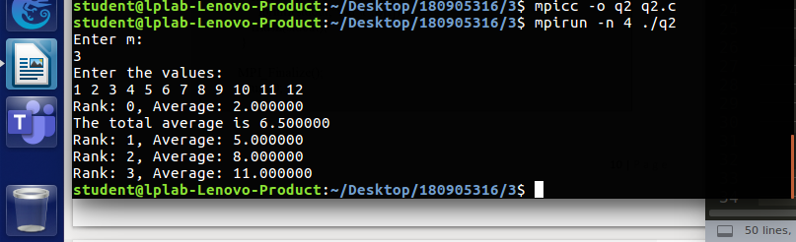

Q3:
#include <mpi.h>
#include <stdio.h>
#include <string.h>

int main(int argc, char *argv[])
{
int rank, size;
int m, n;
int sum;
MPI_Init(&argc, &argv);
MPI_Comm_rank(MPI_COMM_WORLD, &rank);
MPI_Comm_size(MPI_COMM_WORLD, &size);

char str1[100], str2[100];
int dest[100];
if(rank==0){
n=size;
printf("Enter a string\n");
scanf("%s", str1);
m=strlen(str1)/n;

}
MPI_Bcast(&m, 1, MPI_INT, 0, MPI_COMM_WORLD);
MPI_Scatter(str1, m, MPI_CHAR, str2, m, MPI_CHAR, 0, MPI_COMM_WORLD);

int nvowels=0;
for(int i=0; i<m; i++){
if(strchr("AEIOUaeiou", str2[i])==NULL)
nvowels++;
}

printf("Rank: %d, Non vowels: %d\n", rank, nvowels);
MPI_Gather(&nvowels, 1, MPI_INT, dest, 1, MPI_INT, 0, MPI_COMM_WORLD);

fflush(stdout);
if(rank==0){
sum=0;

for(int i=0; i<n; i++){
sum+=dest[i];
}
printf("Rank: %d, The sum of all non vowels=%d\n", rank, sum);
}
MPI_Finalize();
return 0;
}

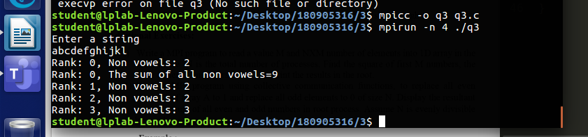

Q4:

#include "mpi.h"
#include <stdio.h>
#include <stdlib.h>
#include <string.h>

int main (int argc, char * argv[]) {

int rank, size;

MPI_Init(&argc, &argv);
MPI_Comm_rank(MPI_COMM_WORLD, &rank);
MPI_Comm_size(MPI_COMM_WORLD, &size);

char str1[100],str2[100],recv[100];
char recv1[100],final[100],buf[100];
int i,n,len,m;

if(rank==0)
{
n=size;
printf("Enter string 1\n");
scanf("%s",str1);
printf("Enter string 2\n");
scanf("%s",str2);
m=strlen(str1)/n;

}
MPI_Bcast(&m,1,MPI_INT,0,MPI_COMM_WORLD);
MPI_Scatter(str1, m, MPI_CHAR, recv, m, MPI_CHAR, 0, MPI_COMM_WORLD);
MPI_Scatter(str2, m, MPI_CHAR, recv1, m, MPI_CHAR, 0, MPI_COMM_WORLD);
for(i=0; i<m; i++)
{
final[i*2]=recv[i];
final[i*2 +1]=recv1[i];

}
MPI_Gather(final, 2*m,MPI_CHAR,buf,2*m,MPI_CHAR,0,MPI_COMM_WORLD);
if(rank==0)
{
buf[2*m*n]='\0';
printf("Final string is %s\n",buf);

}
MPI_Finalize();
return 0;

}

