Vanessa Lobo
180905316
CSE-A
Roll No: 37

LAB 1

Q1:
#include <mpi.h>
#include <stdio.h>
#include <math.h>
int main(int argc, char *argv[])
{
int rank;
int x=4;
MPI_Init(&argc, &argv);
MPI_Comm_rank(MPI_COMM_WORLD, &rank);
printf("For process with rank %d: %f\n", rank, pow(x, rank));
return 0;
}

Output:
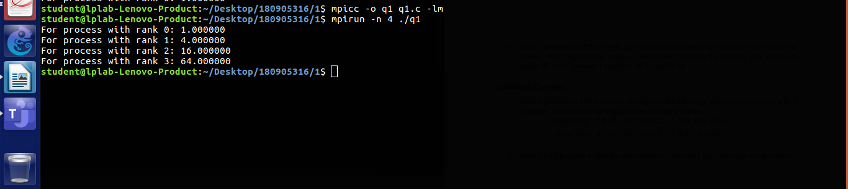

Q2:
#include <mpi.h>
#include <stdio.h>
#include <math.h>
int main(int argc, char *argv[])
{
int rank, size;
MPI_Init(&argc, &argv);
MPI_Comm_rank(MPI_COMM_WORLD, &rank);
MPI_Comm_size(MPI_COMM_WORLD, &size);

if(rank%2==0){
printf("Rank: %d, Hello\n", rank);
}
else{
printf("Rank: %d, World\n", rank);
}
MPI_Finalize();
return 0;
}
Output:
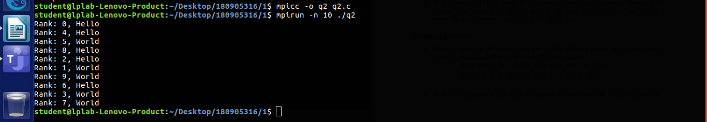

Q3:
#include <mpi.h>
#include <stdio.h>
int main(int argc, char *argv[])
{
int rank, size;
MPI_Init(&argc, &argv);

MPI_Comm_rank(MPI_COMM_WORLD, &rank);

float a=15.0;
float b=4.0;
printf("The two numbers are %f and %f\n", a, b);

if(rank==0){
printf("Rank: %d, Addition: %f\n", rank, a+b);
}
else if(rank==1){
printf("Rank: %d, Subtraction: %f\n", rank, a-b);
}
else if(rank==2){
printf("Rank: %d, Multiplication: %f\n", rank, a*b);

}
else{
printf("Rank: %d, Division: %f\n", rank, (float)a/b);
}
MPI_Finalize();

return 0;
}

Output:
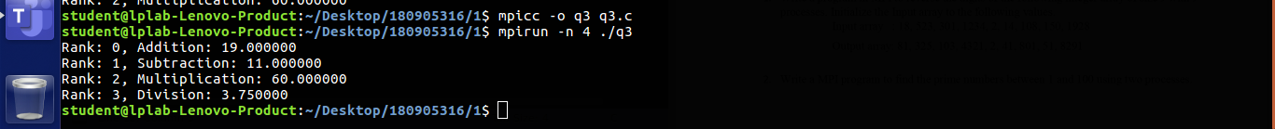

Q4:
#include <mpi.h>
#include <stdio.h>
#include <string.h>
#include <stdlib.h>
int main(int argc, char *argv[])
{
int rank, size;
MPI_Init(&argc, &argv);

MPI_Comm_rank(MPI_COMM_WORLD, &rank);
char* str="HeLlO";

if(str[rank]>='a' && str[rank]<='z'){
char x=str[rank]-32;
printf("Rank: %d, Toggling %c to %c\n", rank, str[rank], x);

}
else if(str[rank]>='A' && str[rank]<='Z'){
char x=str[rank]+32;
printf("Rank: %d, Toggling %c to %c\n", rank, str[rank], x);

}
MPI_Finalize();
return 0;
}

Output:
