class04.R

vane

2024-10-11

#My first Rscript  
x <- 1:50  
plot(x)

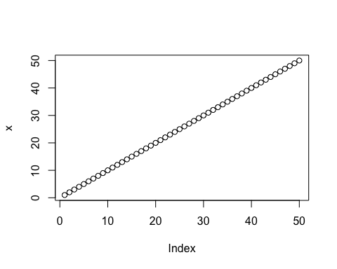

plot(x, sin(x), type = "l", col="blue")

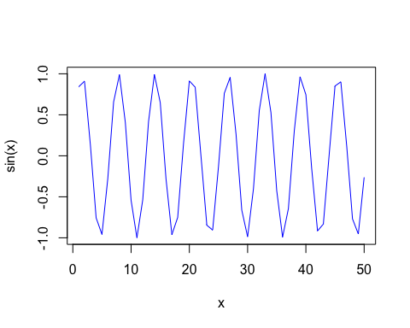

plot(x=x, y=sin(x), type = "l", col="red", typ="l", lwd=3)

## Warning in plot.window(...): "typ" is not a graphical parameter

## Warning in axis(side = side, at = at, labels = labels, ...): "typ" is not a  
## graphical parameter  
## Warning in axis(side = side, at = at, labels = labels, ...): "typ" is not a  
## graphical parameter

## Warning in box(...): "typ" is not a graphical parameter

## Warning in title(...): "typ" is not a graphical parameter

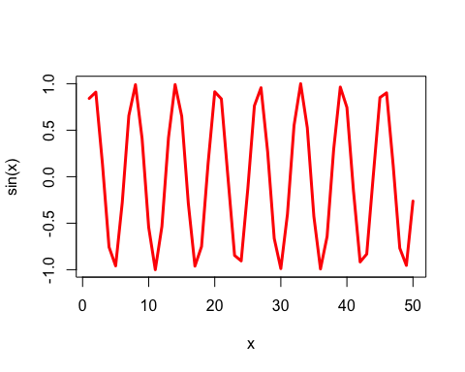

log(10,base=2)

## [1] 3.321928