**Chong Vang**

Homework – Stock Data Screenshot

Screenshot Year 2014

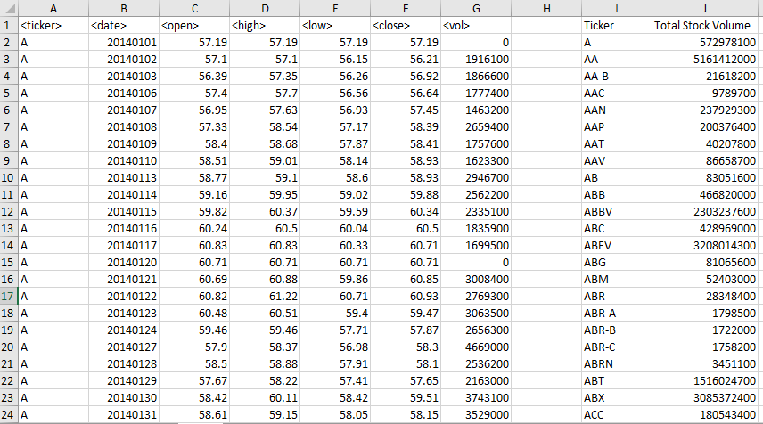

Screenshot Year 2015

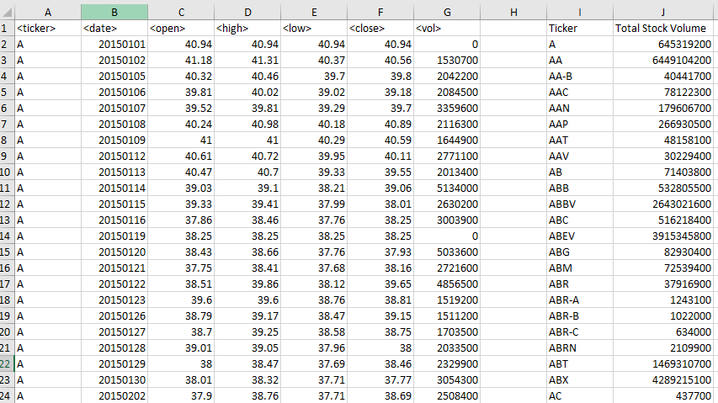

Screenshot Year 2016

