Machine Learning Architecture for Heart Disease Prediction
Akanksha
Heart Disease Prediction Project
India
Abstract - Heart disease prediction from tabular clinical data can support early risk assessment when model development is evaluated carefully. This work presents a leakage-safe machine learning pipeline that performs data understanding, stratified splitting, training-only preprocessing, feature-engineering comparison, feature selection, hyperparameter tuning, and ensemble-model evaluation. The study uses a cleaned dataset of 1,190 records; 272 duplicate rows are removed before an 80:20 stratified train-test split. PowerTransformer and L1 model-based feature selection are selected through training-fold validation. Four candidate architectures are compared, including Random Forest, soft voting with Random Forest and SVM, and stacking ensembles with XGBoost and LightGBM. The selected Random Forest, SVM, and XGBoost stacking model attains 90.22% test accuracy, 90.38% precision, 92.16% recall, 91.26% F1-score, and 93.64% ROC-AUC on the held-out test partition.
Keywords - heart disease prediction, machine learning, leakage-safe pipeline, feature selection, ensemble learning, ROC-AUC

I. INTRODUCTION
Heart disease remains a major clinical concern, and structured clinical records provide an opportunity to estimate the likelihood of disease from demographic, symptom, and examination variables. A prediction model should be treated as a decision-support component rather than a substitute for clinical judgment. Its practical value depends on transparent evaluation, stable preprocessing, and a separation between model-development data and final test data.
This paper develops a reproducible classification workflow for heart disease prediction. The workflow compares transformations, feature-selection methods, and ensemble architectures under stratified cross-validation, then reports the final hold-out results. The design emphasizes prevention of data leakage by fitting imputation, encoding, scaling, engineering, and selection steps within the model pipelines.
II. RELATED WORK
Tree ensembles, support vector machines, and gradient-boosting methods are established supervised-learning approaches for clinical tabular data. Random Forest aggregates diverse decision trees to reduce variance [1], while support vector machines learn maximum-margin decision boundaries [2]. XGBoost and LightGBM provide efficient gradient-boosted tree implementations that can model nonlinear interactions in structured data [3], [4]. This study compares these methods as individual and ensemble components using one consistent validation protocol.
III. MOTIVATION
A strong score obtained after uncontrolled preprocessing can be misleading when transformations learn from data that should remain unseen. The motivation for this work is to construct a compact, auditable pipeline in which the modelling choices are made using training data and cross-validation. The approach also evaluates complementary feature representations and ensembles instead of assuming that one algorithm is optimal for all clinical variables.
IV. CONTRIBUTION
The contribution is a complete heart-disease prediction workflow with three main properties: training-only transformations, systematic comparison of feature engineering and feature selection strategies, and final reporting with accuracy, precision, recall, F1-score, ROC-AUC, and a labelled confusion matrix. The workflow also produces interpretable artefacts for comparing feature-selection performance and for diagnosing the final selected model.
V. METHODOLOGY
A. Data Understanding and Leakage-Safe Preprocessing
The supplied dataset contains 1,190 observations with 11 predictor variables and a binary target. The workflow checks column types, missing values, duplicate rows, target distribution, categorical values, and numerical summaries. Duplicate records are removed before splitting, leaving 918 unique observations. Numerical features use median imputation and standard scaling; categorical features use most-frequent imputation and one-hot encoding. These operations are fitted inside the pipelines so that cross-validation and test data do not influence training transforms.
B. Stratified Split and Feature Engineering
The data are divided into 734 training samples and 184 testing samples using an 80:20 split stratified by the target label. Clinical feature construction adds age_group, hr_ratio, and chol_age when the required input columns are present. General feature engineering compares degree-2 polynomial expansion with a Yeo-Johnson PowerTransformer through five-fold stratified cross-validation. PowerTransformer is selected for the reported run.
C. Feature Selection and Hyperparameter Tuning
Mutual Information, Recursive Feature Elimination, and L1 model-based selection are compared using the transformed training data. The selected feature subset is then passed to the tuning stage. RandomizedSearchCV evaluates candidate parameter settings for Random Forest, calibrated SVM, XGBoost, and LightGBM using five-fold stratified cross-validation and accuracy as the search objective.

V. SYSTEM ARCHITECTURE
Figure 1 summarizes the complete flow from clinical data inspection to final held-out evaluation. Comparison stages branch into alternative transformations, selectors, and ensemble configurations, then converge to the selected path.
Fig. 1. Leakage-safe machine learning architecture for heart disease prediction.

D. Model Development and Ensemble Comparison
Four candidate architectures are trained after tuning. Model 1 is a Random Forest baseline. Model 2 combines Random Forest and calibrated SVM probabilities using soft voting. Model 3 stacks Random Forest, SVM, and XGBoost with Logistic Regression as the meta-classifier. Model 4 adds LightGBM to the stacking ensemble. All candidates produce probabilities for ROC analysis, while their class predictions support the remaining metrics.
E. Final Evaluation
After fitting the candidate pipelines on the training partition, predictions and probabilities are obtained for the test partition. Accuracy, precision, recall, F1-score, ROC-AUC, and the confusion matrix are computed from the test labels and predictions. The reported evaluation should be interpreted as a held-out comparison for this run; future experiments should select the final architecture using cross-validation before a single final test evaluation.
F. Pseudocode
1. Load the clinical dataset and identify the binary target column.
2. Remove duplicates and create a stratified 80:20 train-test split.
3. Add deterministic clinical features to each partition.
4. Compare Polynomial Features and PowerTransformer using five-fold CV.
5. Compare Mutual Information, RFE, and L1 model-based selection.
6. Tune base learners with RandomizedSearchCV on training folds.
7. Fit four candidate model and ensemble architectures.
8. Evaluate predictions on the held-out test partition and report metrics.
VI. EXPERIMENTAL SETUP
The implementation uses Python with pandas, NumPy, scikit-learn, XGBoost, LightGBM, and Matplotlib. A fixed random state of 42 is used for the stratified split and cross-validation. The feature-engineering and feature-selection comparisons use a Logistic Regression classifier inside the corresponding pipelines so that the comparison isolates the transformation or selection decision. The final model set uses tuned versions of the same preprocessing, engineering, and selection sequence.

VI. DATASET AND CONFIGURATION
Component | Configuration or observed value
Original dataset | 1,190 clinical records and 11 predictor variables
Duplicate handling | 272 duplicate rows removed before splitting
Modelling dataset | 918 unique observations
Train-test split | 734 training samples; 184 testing samples; target-stratified
Validation | Five-fold StratifiedKFold with shuffle=True and random_state=42
Preprocessing | Median or most-frequent imputation, one-hot encoding, StandardScaler
Search | RandomizedSearchCV, 3 sampled configurations per learner, accuracy objective

Table I. Dataset and experimental configuration.
VII. RESULTS AND DISCUSSION
PowerTransformer produced the best feature-engineering validation performance, with 84.75% accuracy and 86.40% F1-score. The three feature-selection strategies achieved closely clustered scores, so Figure 2 uses a zoomed scale to make their practical differences visible. The L1 model-based selector was used in the subsequent tuning and ensemble stage for the reported run.
Selection strategy | Accuracy | Precision | Recall | F1-score
Mutual Information | 84.88% | 85.82% | 87.45% | 86.54%
RFE | 84.47% | 85.69% | 86.70% | 86.11%
L1 Model-Based | 84.88% | 85.96% | 87.20% | 86.51%

Table II. Cross-validated feature-selection comparison.
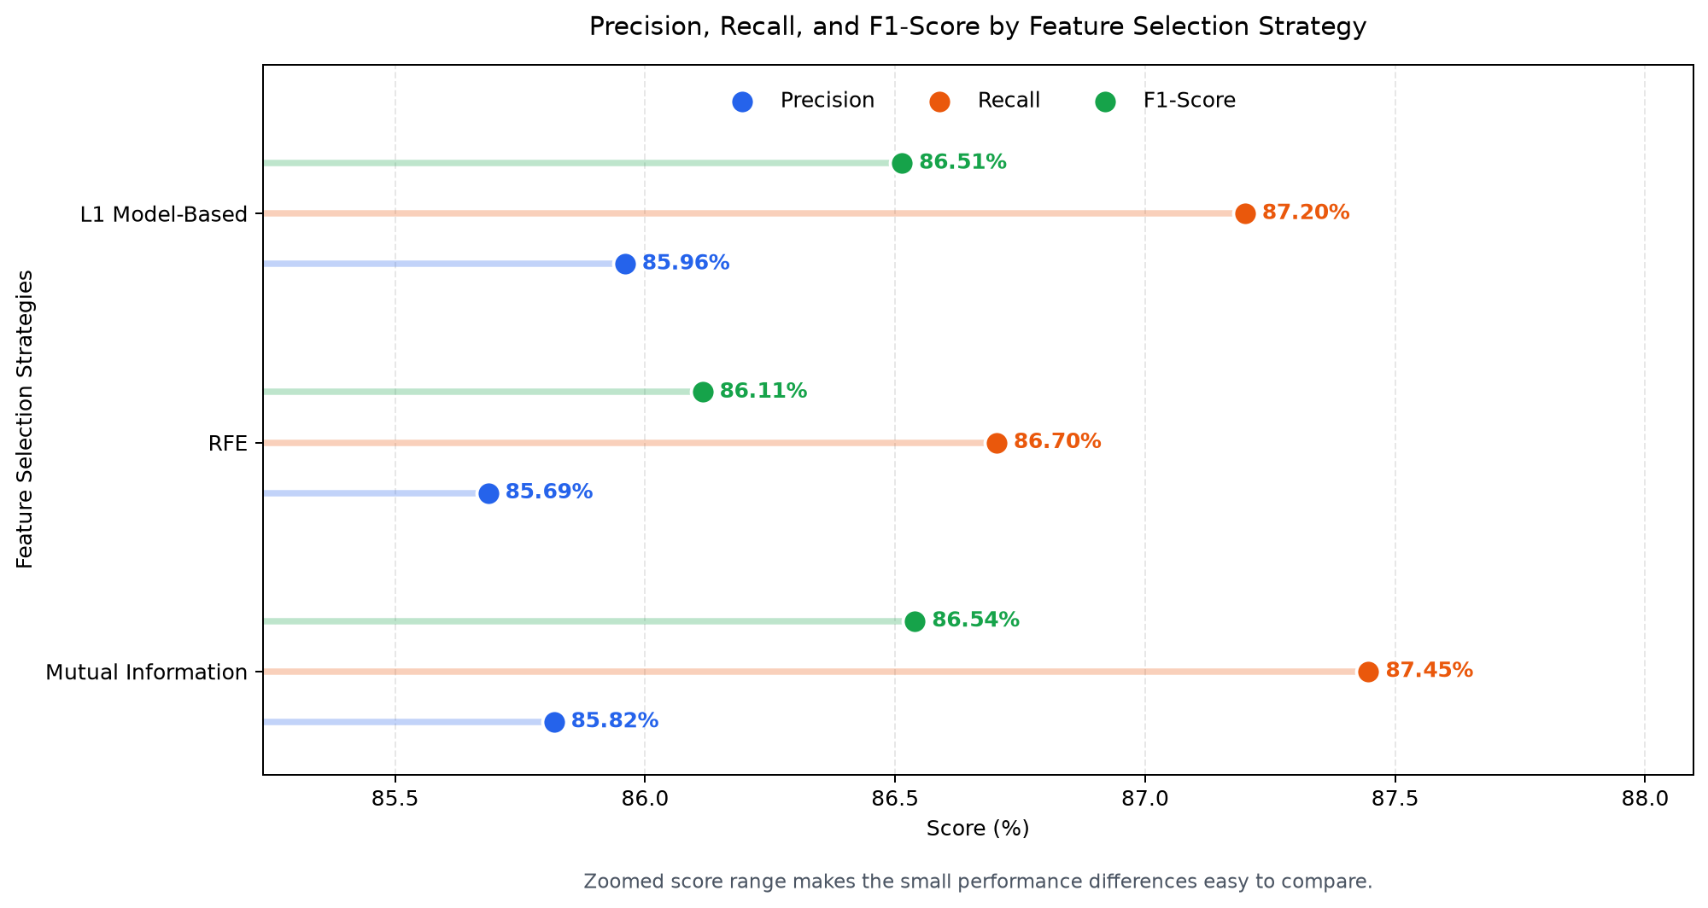
Fig. 2. Precision, recall, and F1-score across feature-selection strategies.

VII. FINAL MODEL COMPARISON
Model | Accuracy | Precision | Recall | F1-score
Model 1: Random Forest | 87.50% | 86.24% | 92.16% | 89.10%
Model 2: RF + SVM soft voting | 89.67% | 90.29% | 91.18% | 90.73%
Model 3: RF + SVM + XGBoost stacking | 90.22% | 90.38% | 92.16% | 91.26%
Model 4: RF + SVM + XGBoost + LightGBM stacking | 89.67% | 90.29% | 91.18% | 90.73%

Table III. Final held-out test-set model comparison.
Model 3 achieved the highest measured accuracy and F1-score. Its precision and recall are also balanced, with recall reaching 92.16%. The ROC-AUC of 93.64% indicates useful ranking separation for this held-out partition. The confusion matrix contains 72 true negatives, 94 true positives, 10 false positives, and 8 false negatives.
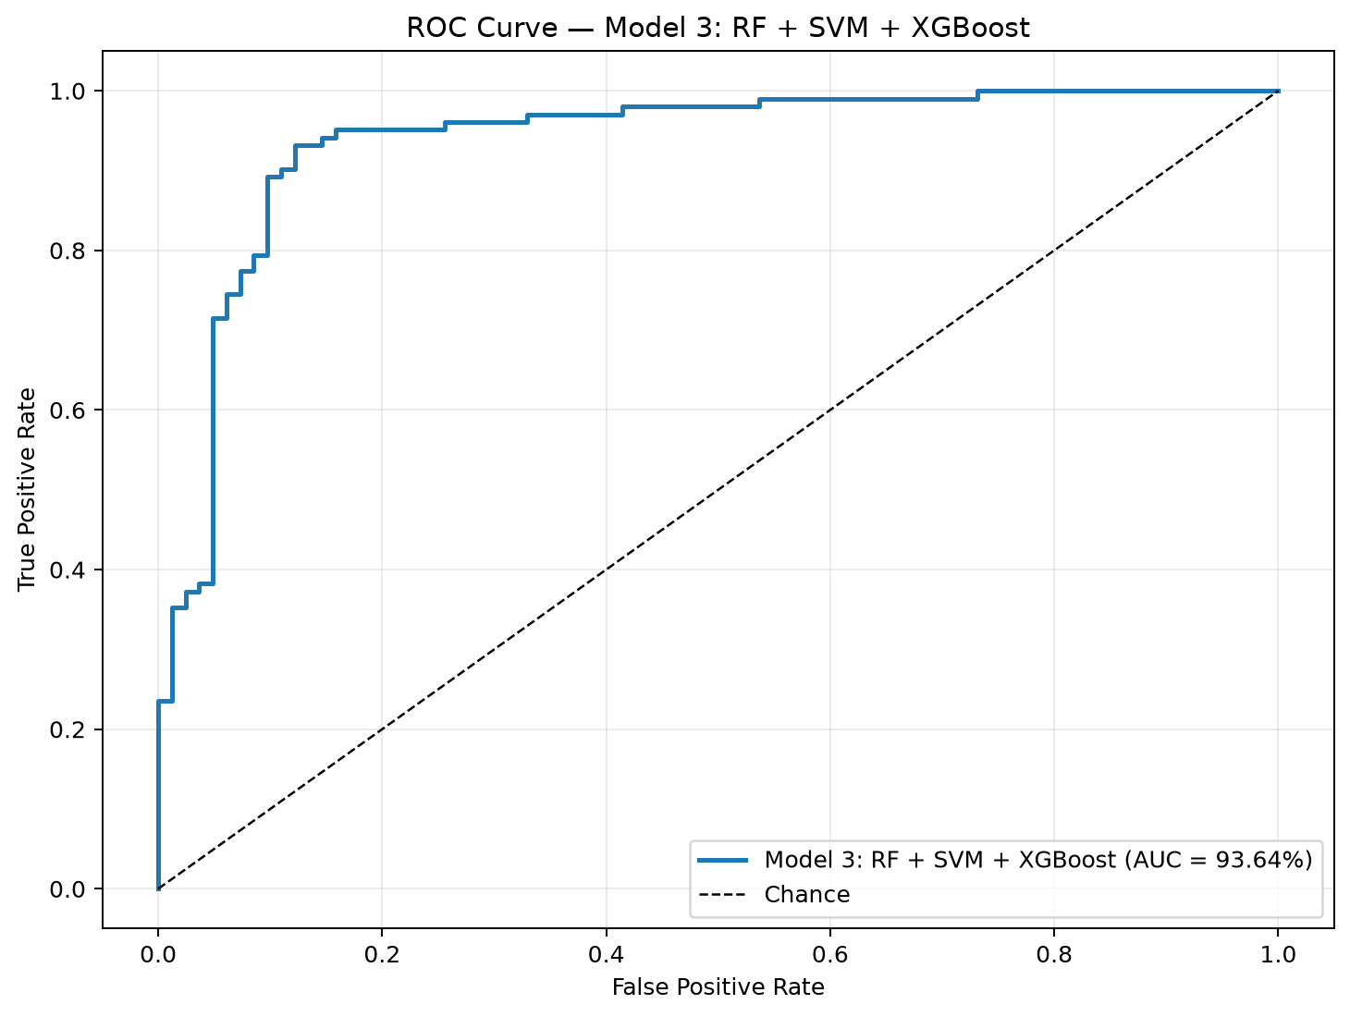 | 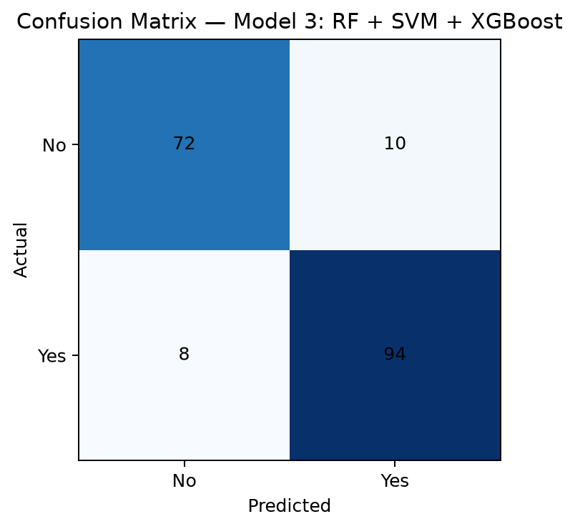
Fig. 3. ROC curve and confusion matrix for the best measured model.

VIII. CONCLUSION
This work presents a heart-disease prediction pipeline that separates exploratory inspection, training-only transformation, method comparison, and final evaluation. The measured results show that the Random Forest, SVM, and XGBoost stacking architecture achieved the strongest held-out performance among the four assessed candidates. The workflow also makes feature-selection differences and final diagnostic measures visible through a dedicated comparison chart, ROC curve, and confusion matrix.
The study is limited by the size and provenance of the supplied dataset and by the use of one fixed test split. The scores describe this experimental setting only and should not be interpreted as evidence of clinical deployment readiness.
IX. FUTURE WORK
Future work should validate the workflow on independent cohorts, quantify confidence intervals, examine calibration, and assess fairness across relevant demographic groups. A stricter final-evaluation design would select the winning architecture solely through cross-validation and reserve the test set for one terminal evaluation. Additional model-interpretation methods, such as permutation importance or SHAP analysis, could help clinicians review the relationship between input variables and predicted risk.
X. REFERENCES
[1] L. Breiman, "Random Forests," Machine Learning, vol. 45, pp. 5-32, 2001.
[2] C. Cortes and V. Vapnik, "Support-vector networks," Machine Learning, vol. 20, pp. 273-297, 1995.
[3] T. Chen and C. Guestrin, "XGBoost: A Scalable Tree Boosting System," Proceedings of the 22nd ACM SIGKDD International Conference on Knowledge Discovery and Data Mining, pp. 785-794, 2016.
[4] G. Ke et al., "LightGBM: A Highly Efficient Gradient Boosting Decision Tree," Advances in Neural Information Processing Systems, vol. 30, 2017.
[5] F. Pedregosa et al., "Scikit-learn: Machine Learning in Python," Journal of Machine Learning Research, vol. 12, pp. 2825-2830, 2011.

