Decision tree visualization for German Credit Dataset

step 1: Open weka Explorer
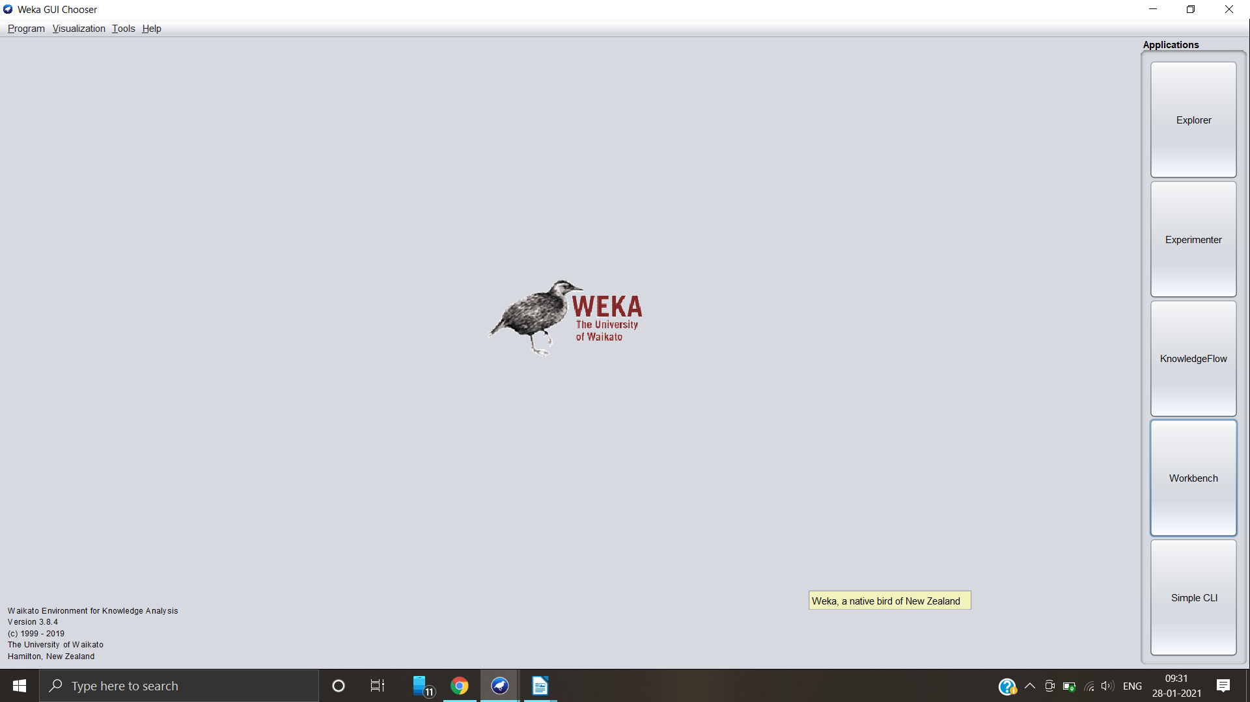
Step 2: Load the dataset into Weka

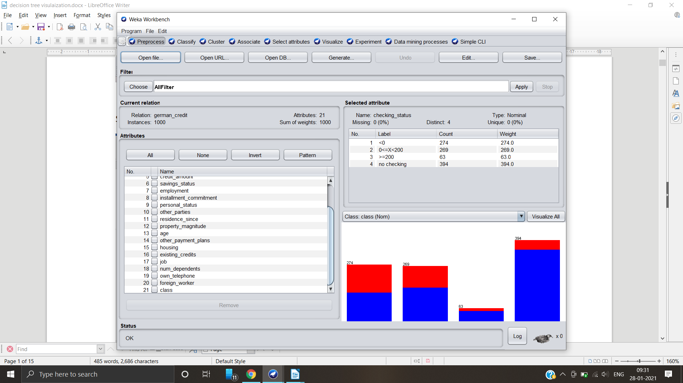
Step 3: Select Class attribute

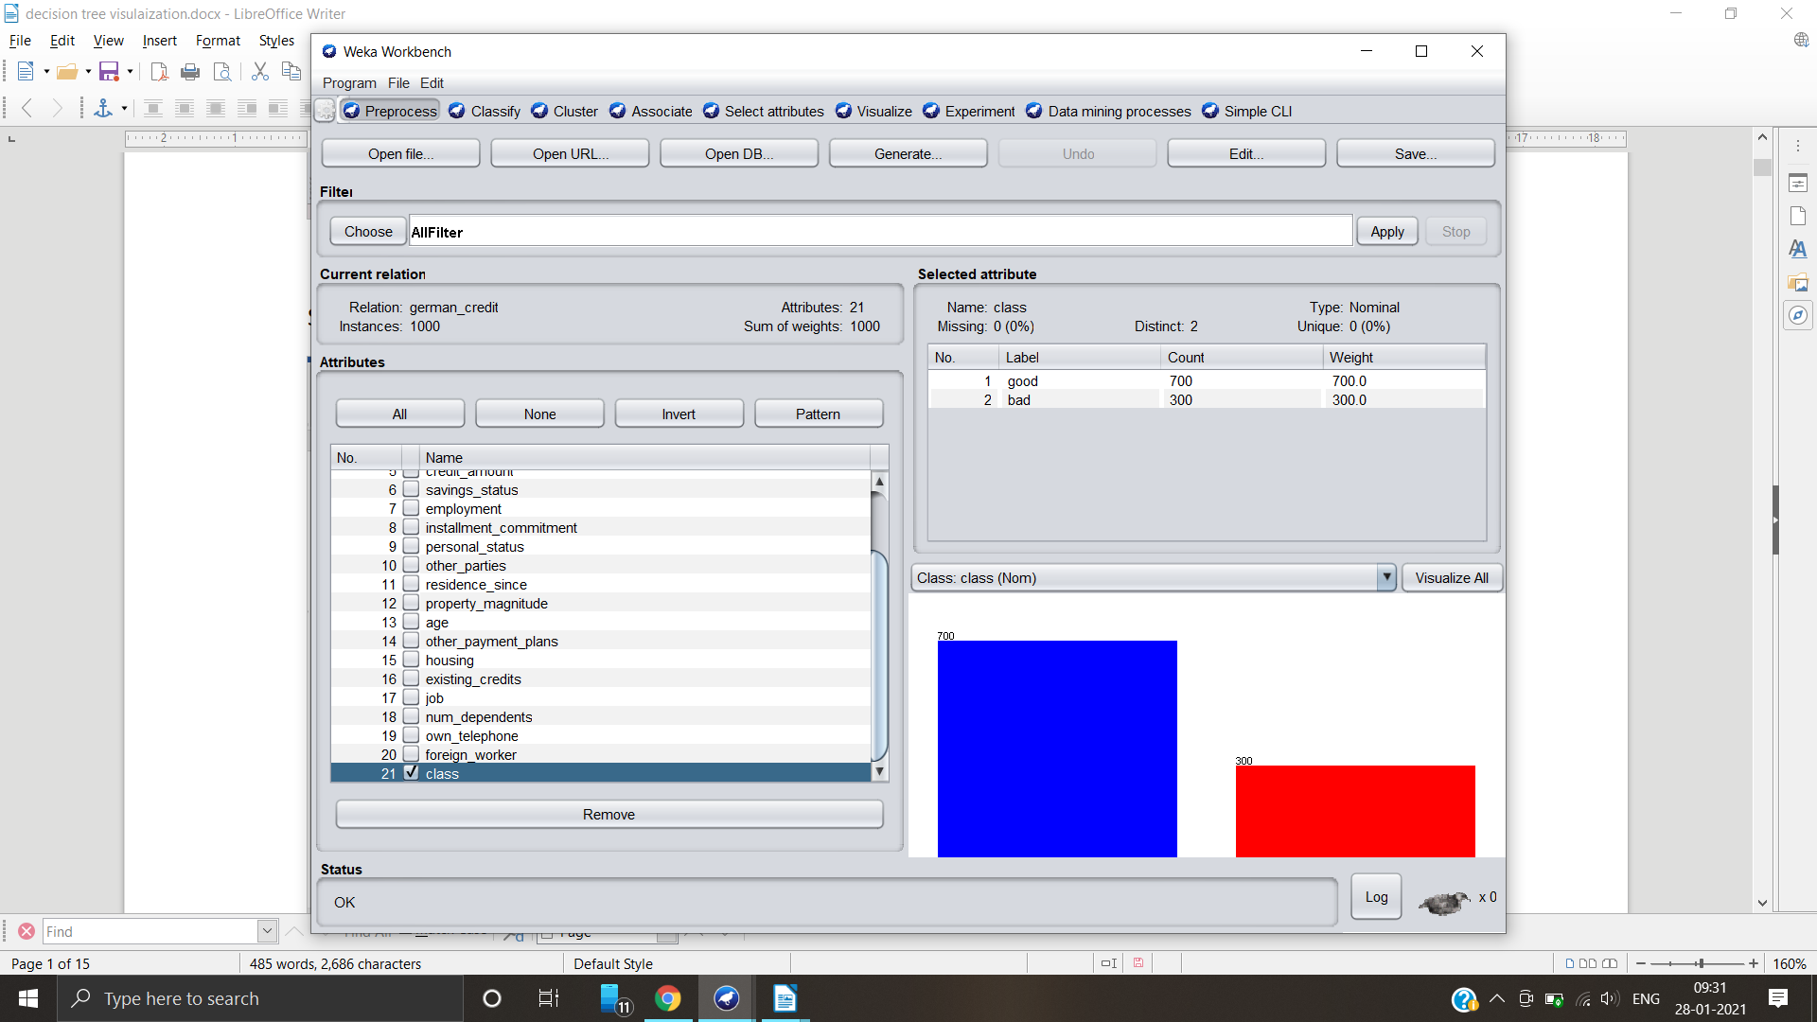
Step 4: Go to “Classify” tab and select “use training set” and select choose button and select J-48 in the tree section, to generate a decision tree . Hit the start button

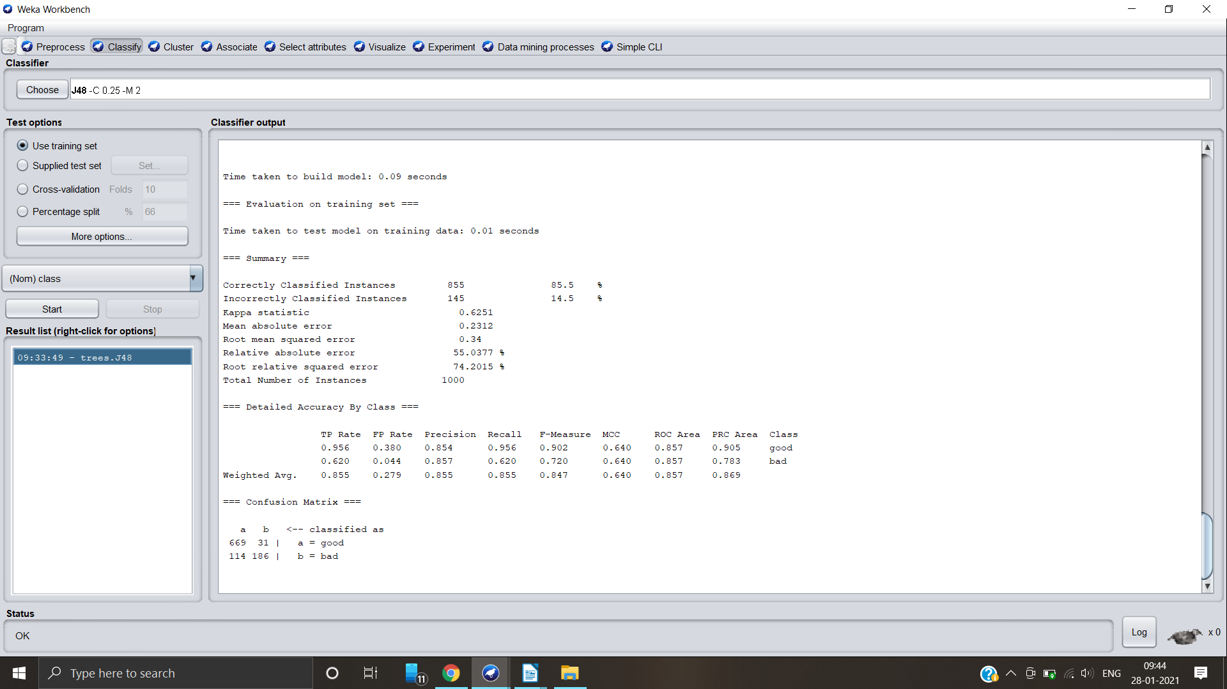
Step 5: Check the characteristics of tree generated
Case 1: For application of J-48

Number of leaves: 103
Size of the tree: 140
Time taken :0.09 seconds
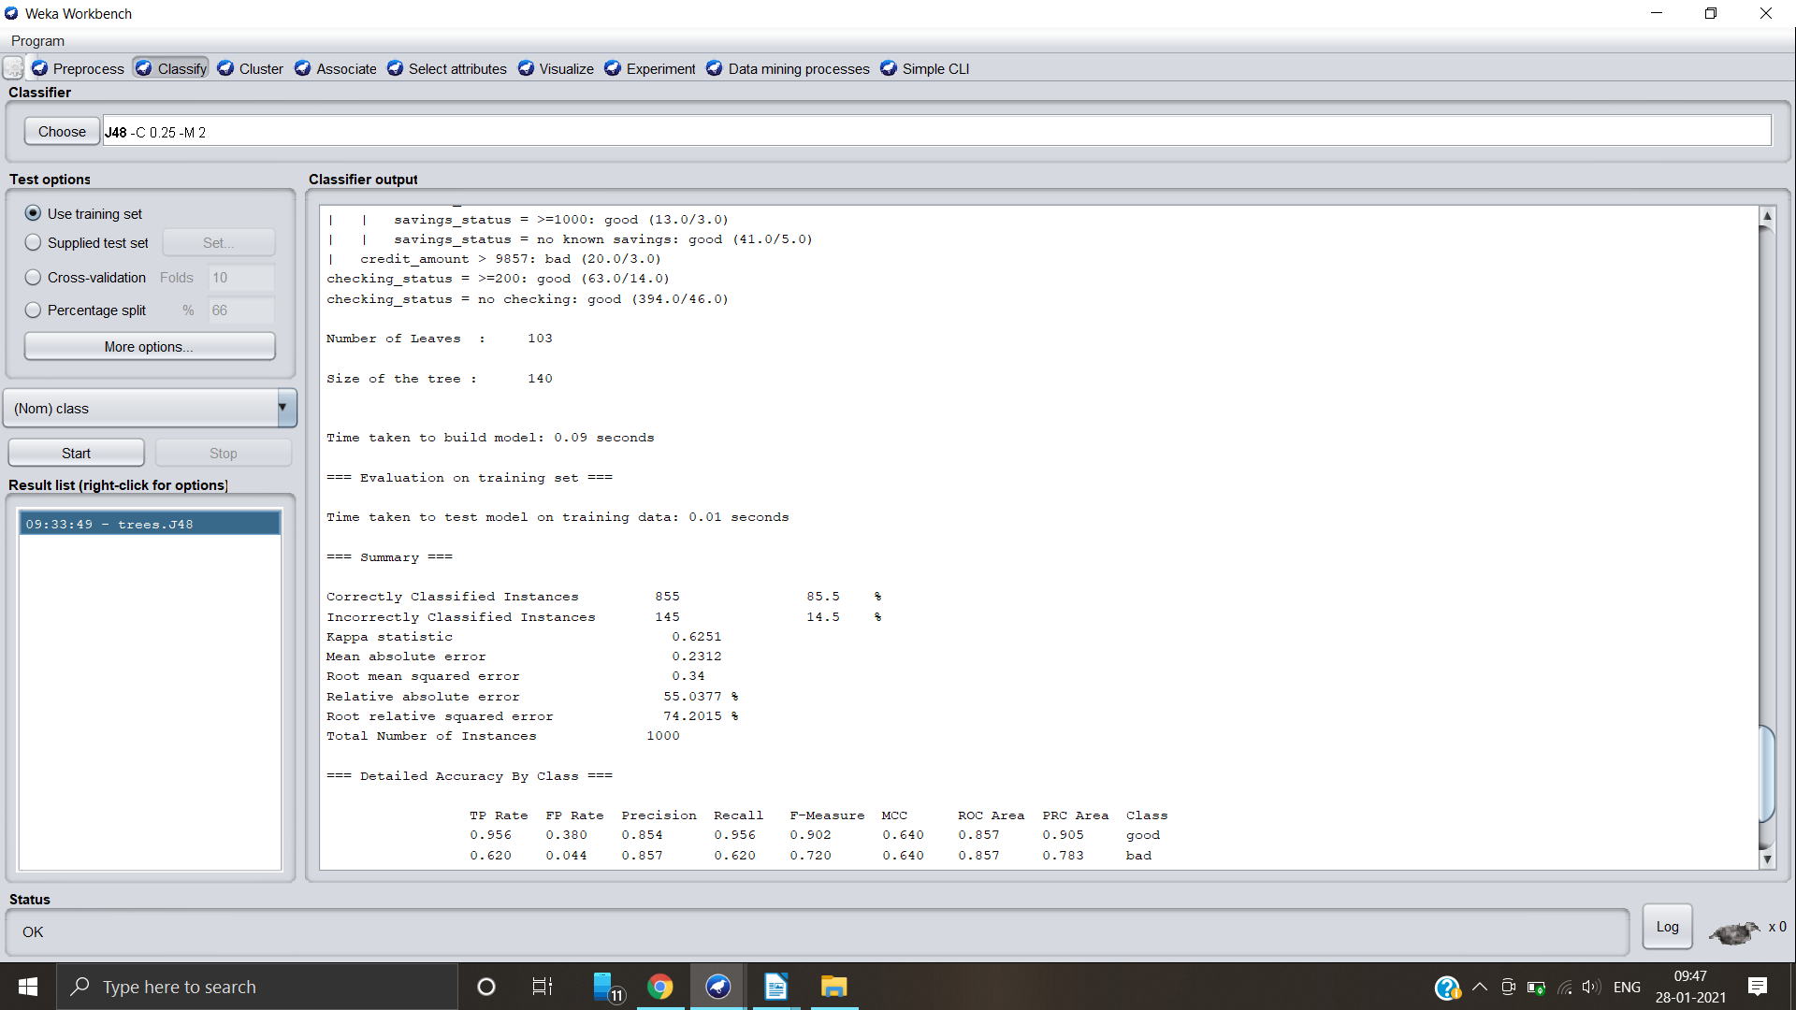
Confusion matrix and accuracy of the decision tree:
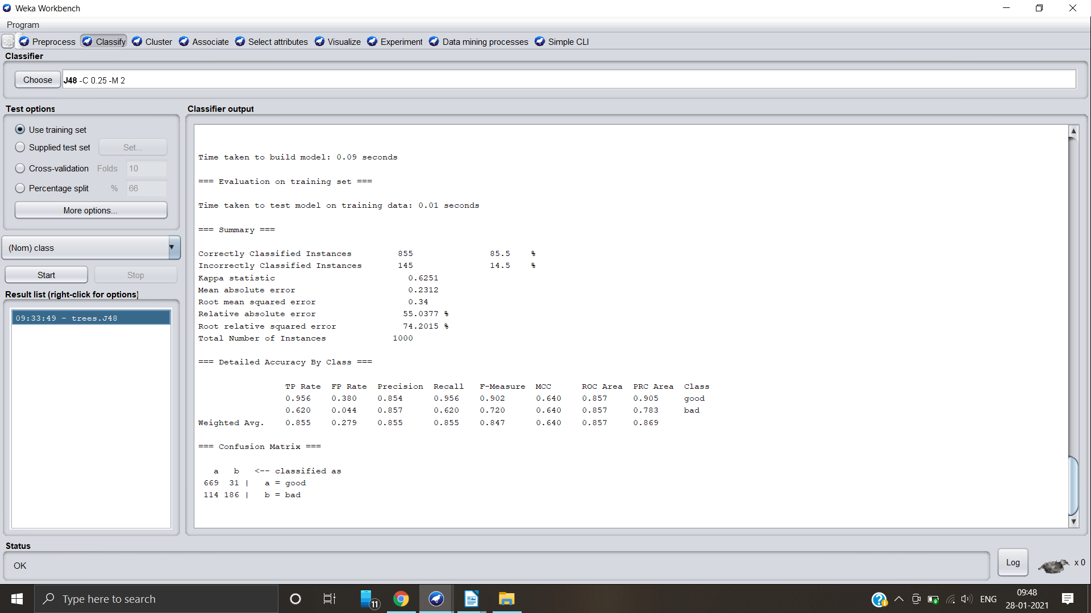
Visualization of decision tree:
Double click on the option in result list and select “visualize tree”

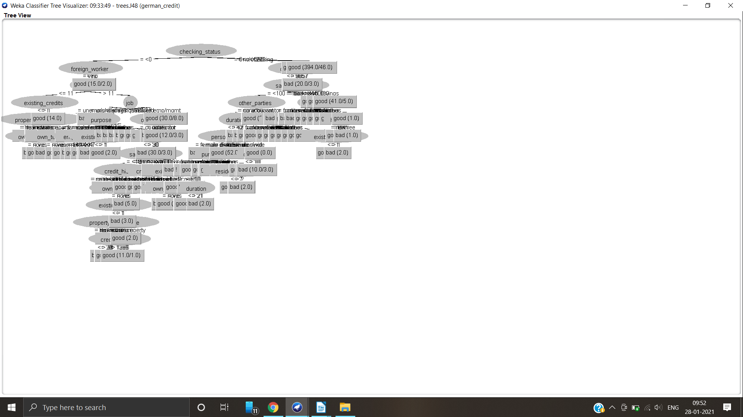
Application of cross-validation
Case 1: Number of folds = 10
Step 1: Select cross validation option and in number of folds, give 10 and hit start button

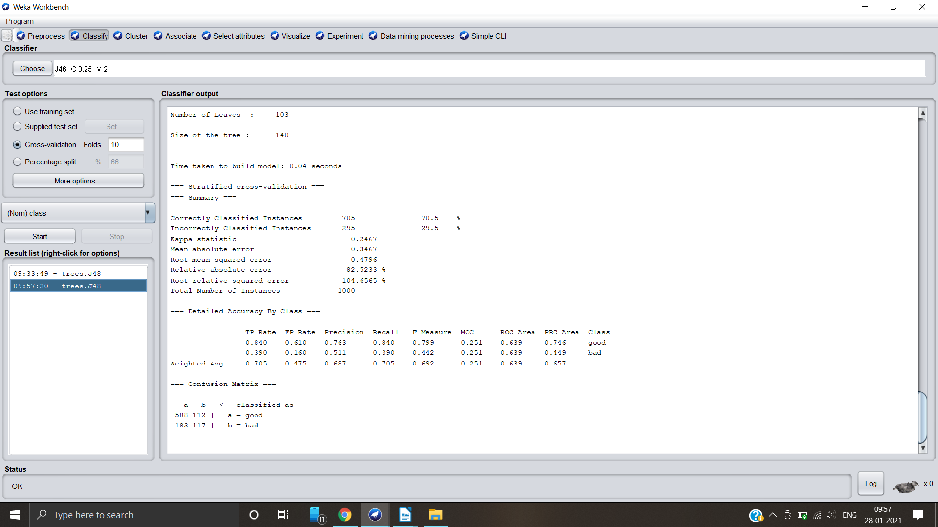

Step 2: Understand the characteristics of the tree generated

Number of leaves : 103
Size of tree :140
Time taken: 0.04 seconds

Confusion matrix and accuracy:
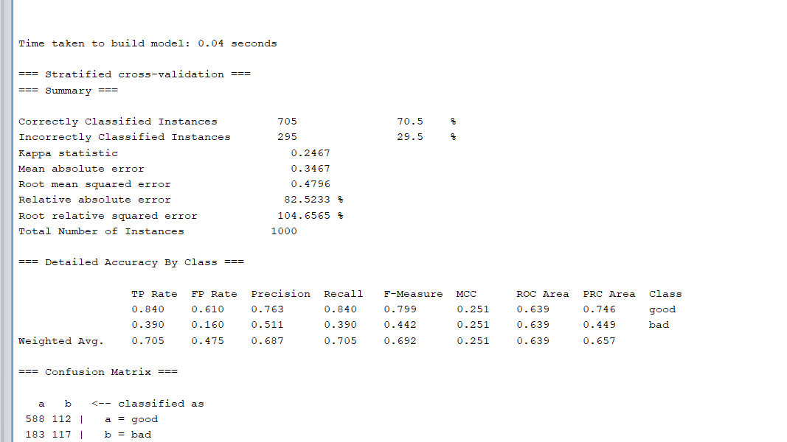

Step 3: Visualize the decision tree
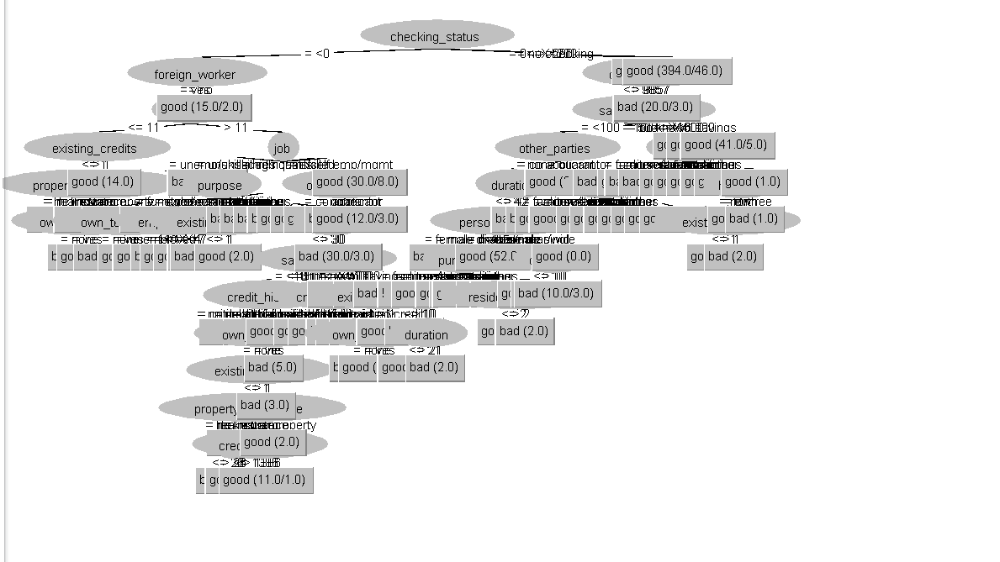

Case 2: Number of folds = 8

Specify the number of folds as 8

Accuracy and confusion matrix:
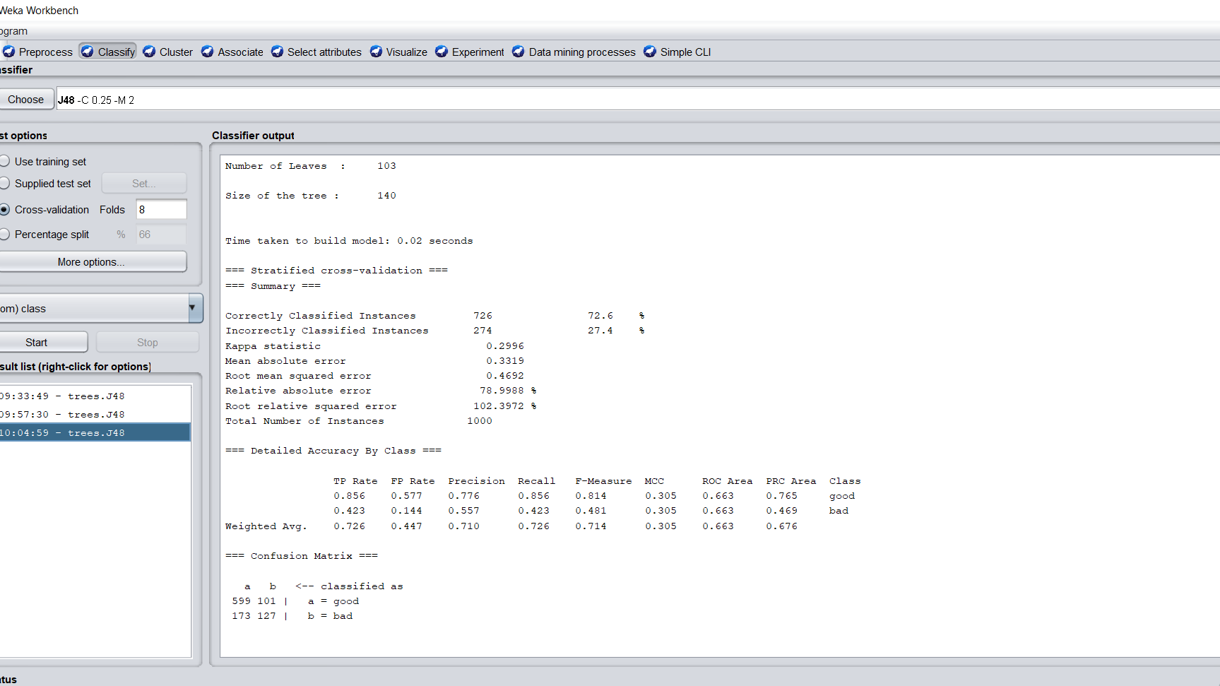

Number of leaves : 103
Size of tree: 140
Time taken:0.02 seconds

Visualize the tree:

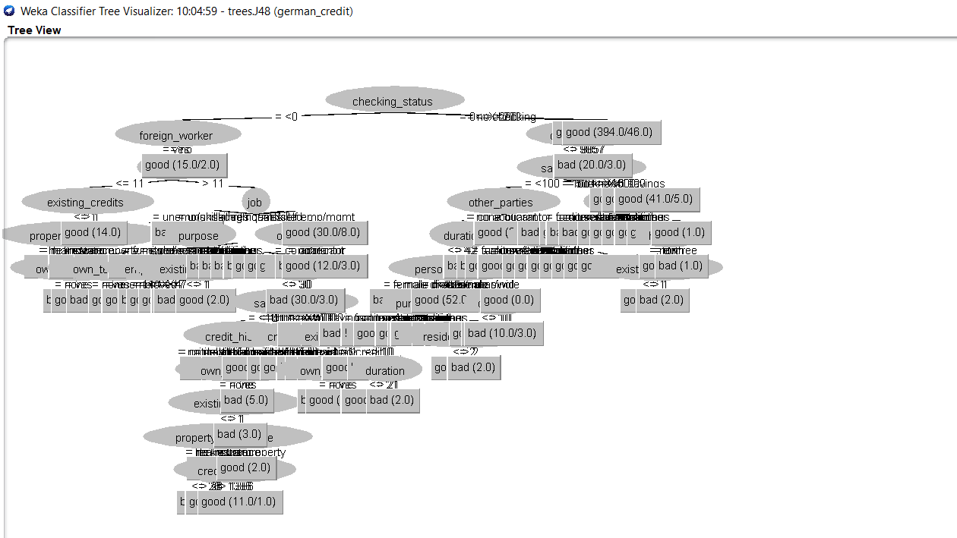
Application of percentage split
Case 1: When the split percentage is 70%

Step 1: Select the percentage split and specify 70 and hit start button

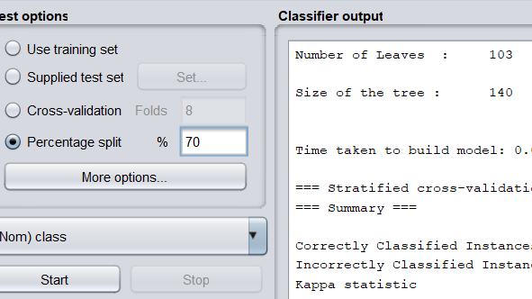

Characteristics :
Number of leaves: 103
Size of tree: 140
Time taken:0.01 seconds
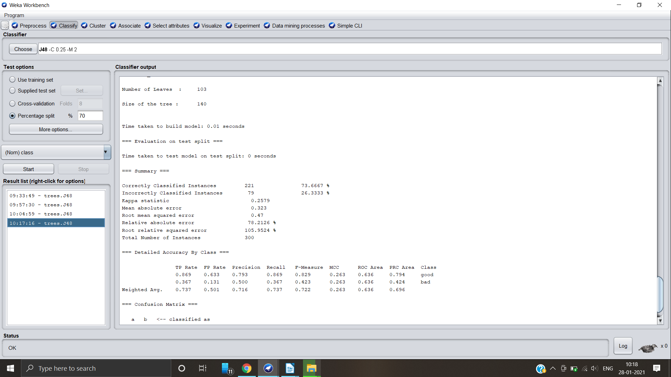

Confusion matrix:
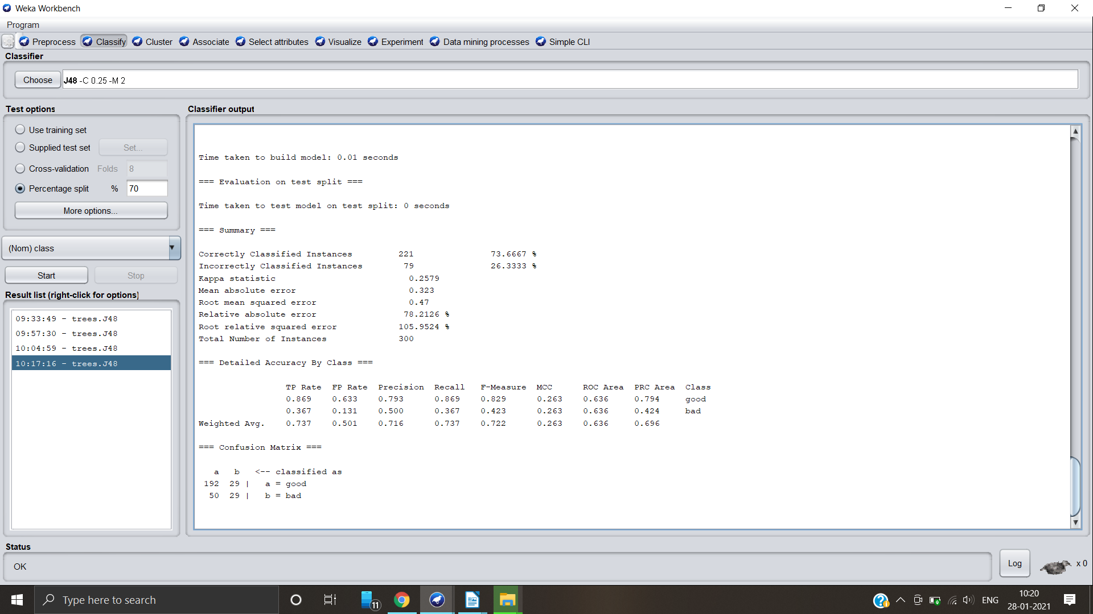

Visualize the tree:
