Attribute exploration of German credit dataset

1.List of attributes and their types
- Checking_status-Normal
- Duration – Numeric
- Credit_history – Nominal
- Purpose – Nominal
- Credit_amount – Numeric
- Serving_status – Nominal
- Employment – Nominal
- Istallment_commitment – Numeric
- Personal_status – Nominal
- Other_parties – Nominal
- Residence_since – Numeric
- Property_magnitude – Nominal
- Age – Numeric
- Other_payment_plans – Nominal
- Housing – Nominal
- Exizting_credits – Numeric
- Job – Nominal
- Num_dependents – Numeric
- Own_telephone – Nominal
- Foreign_worker – Nominal
- Class – Nominal
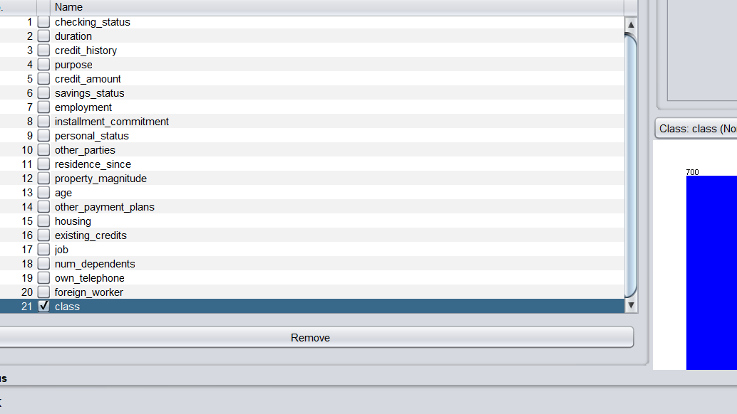
2. Number of attributes in the data set:21
and number of records/instances in the data set:1000

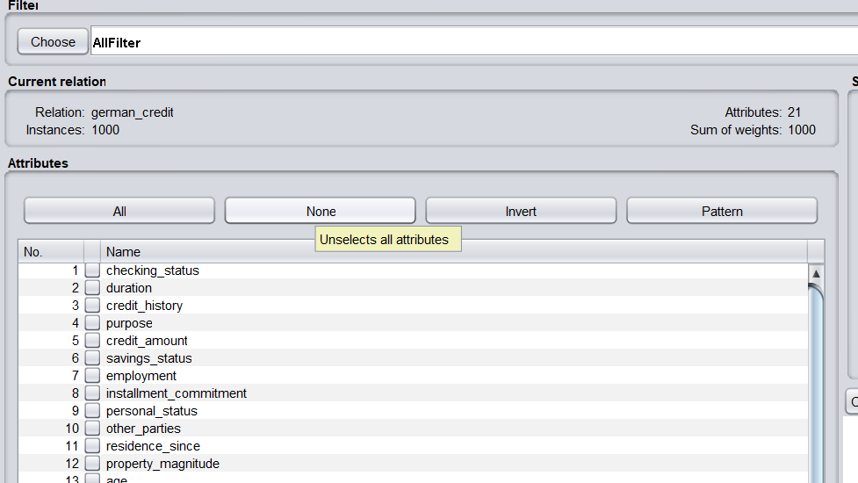

3. Class attribute in the data set:class

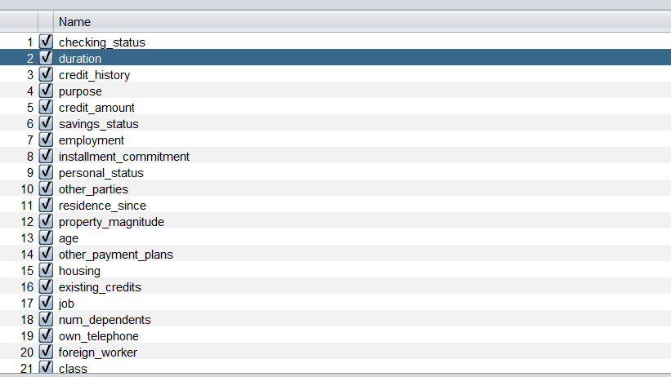
4. Number of attributes of each class:
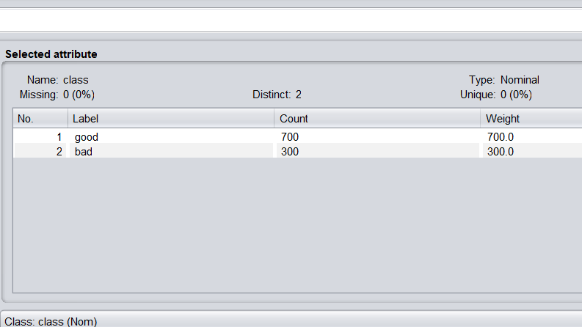
5. Graphical representation of all attributes against class attribute:
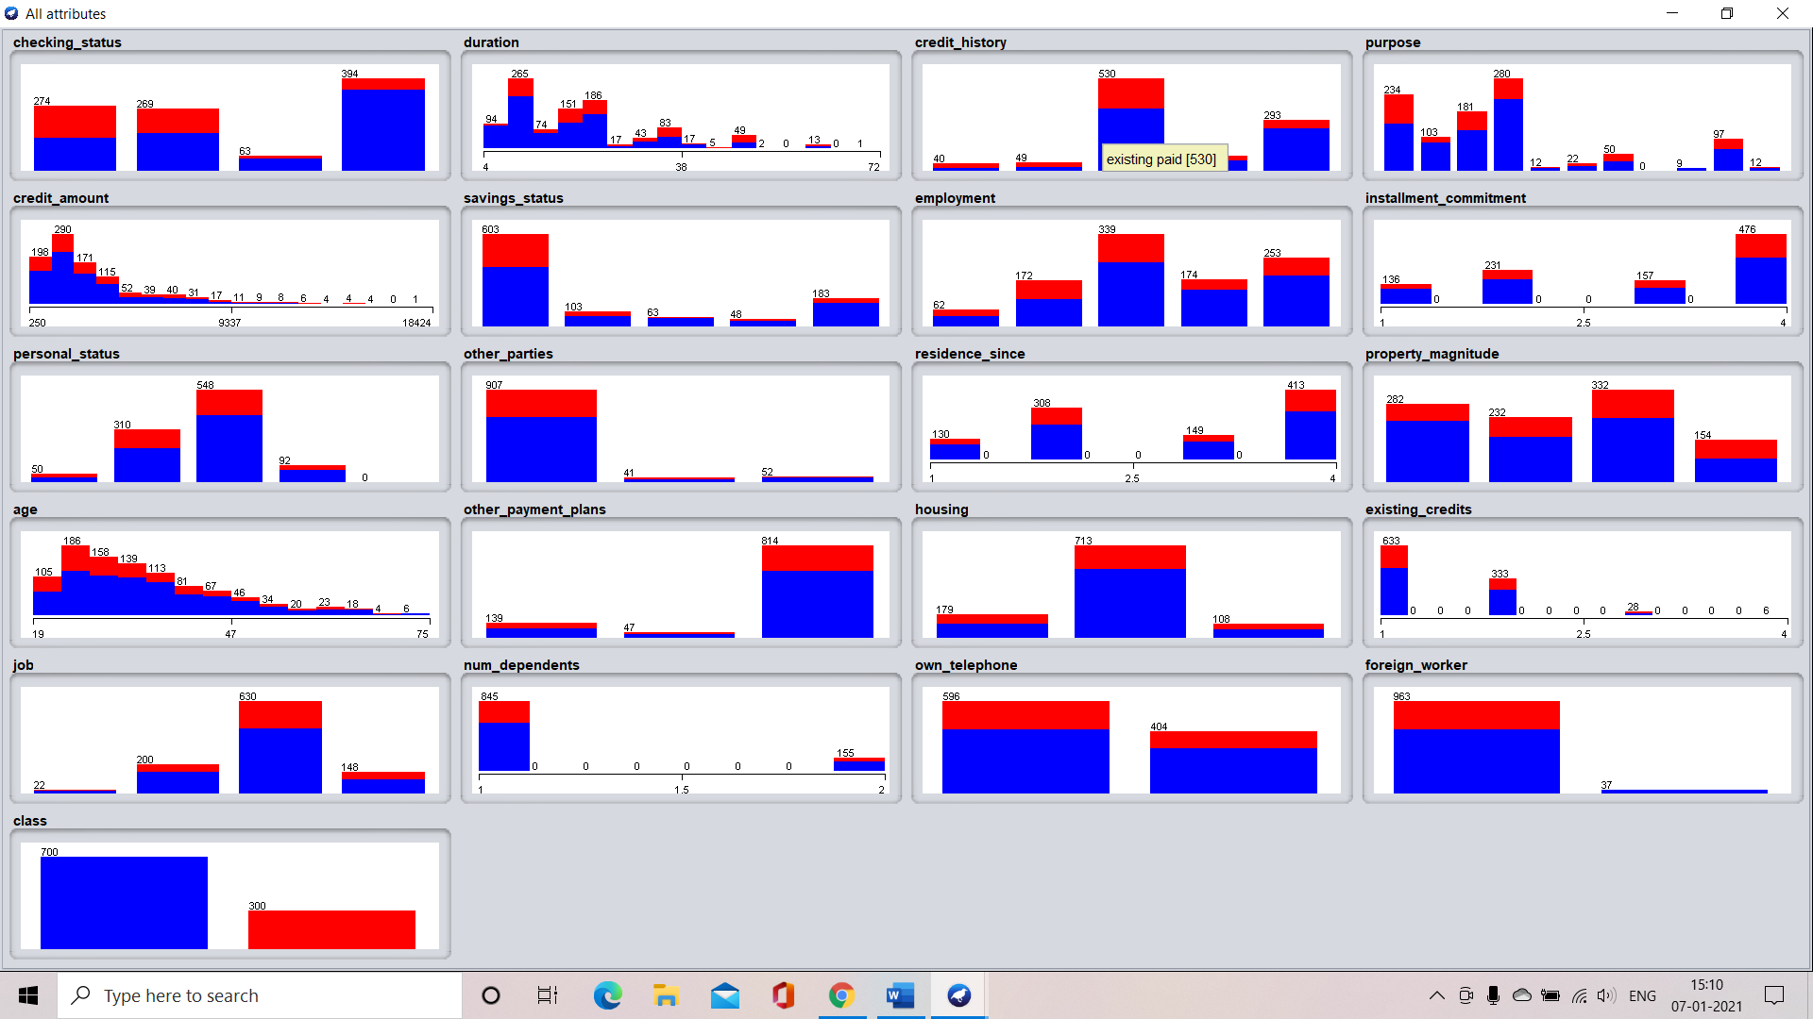

Attribute exploration of IRIS data set

1. List of attributes and their types
- Sepal length – Numeric
- Sepal width – Numeric
- Petal length – Numeric
- Petal width – Numeric
- Class – Nominal

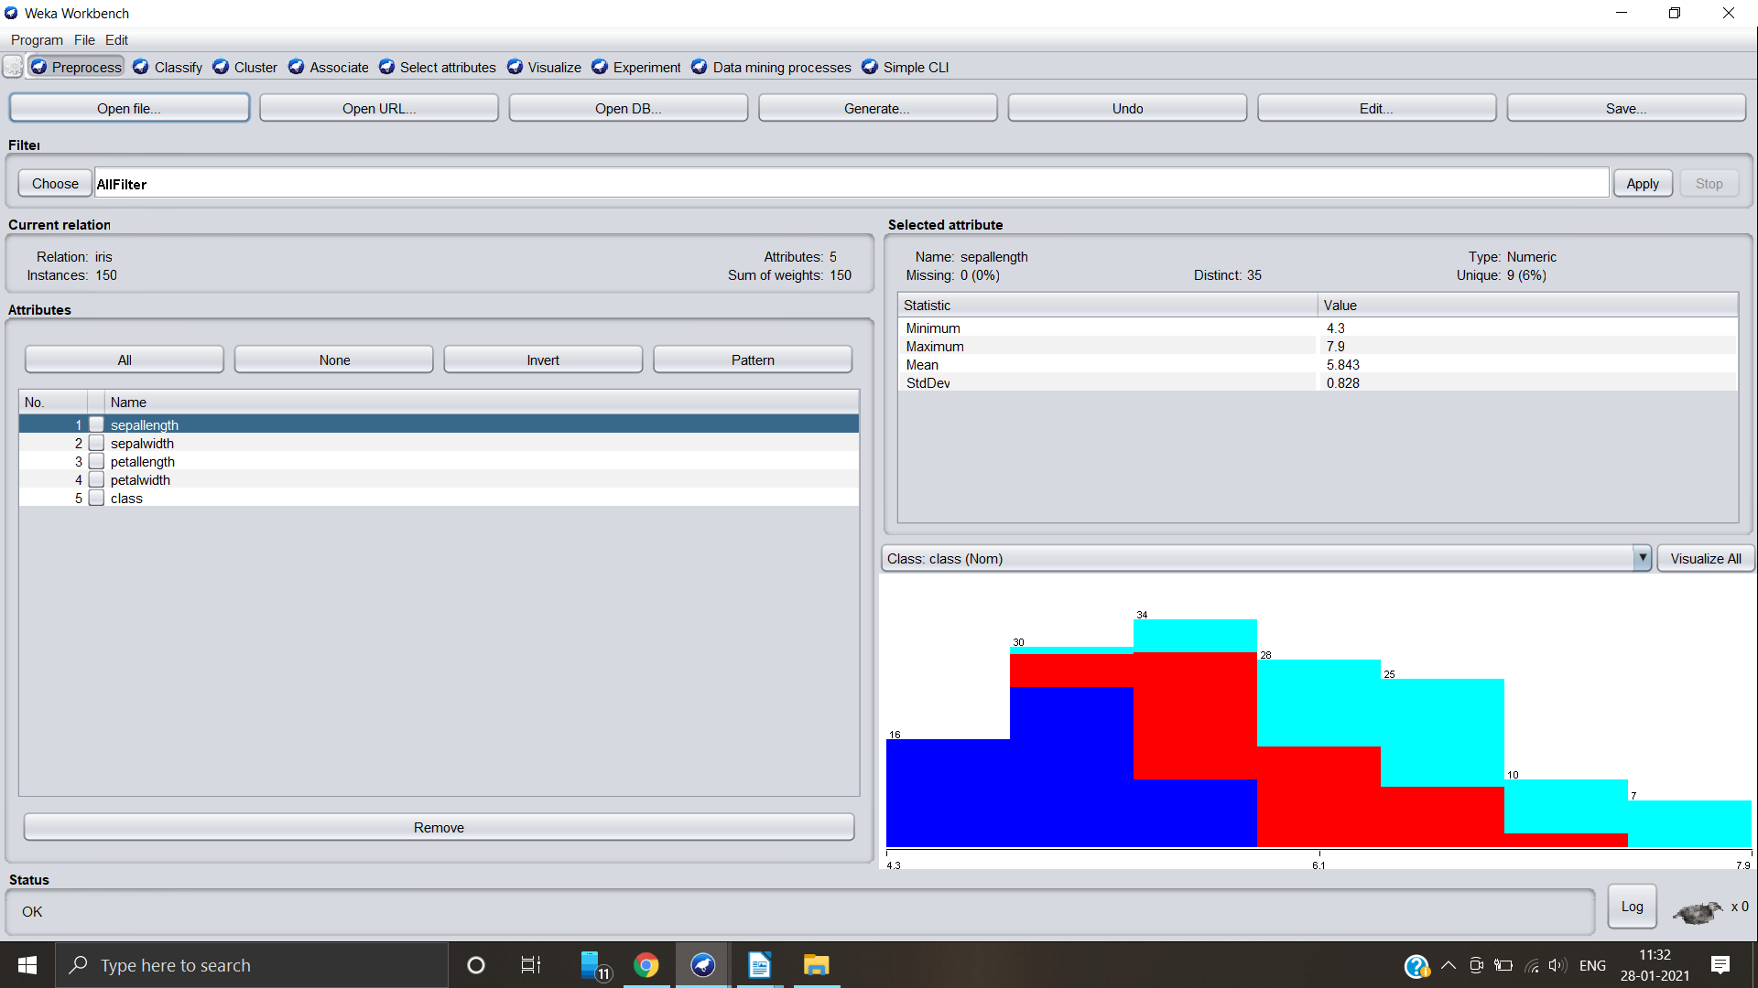

2. Number of attributes in the data set: 5
Number of records in the data set:150

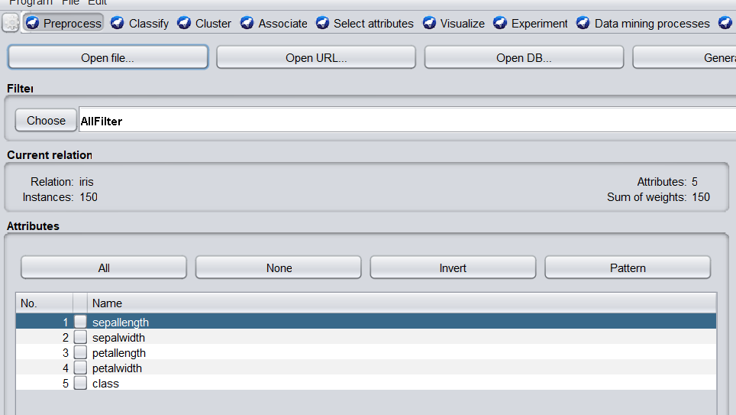

3. Class attribute in the data set: class

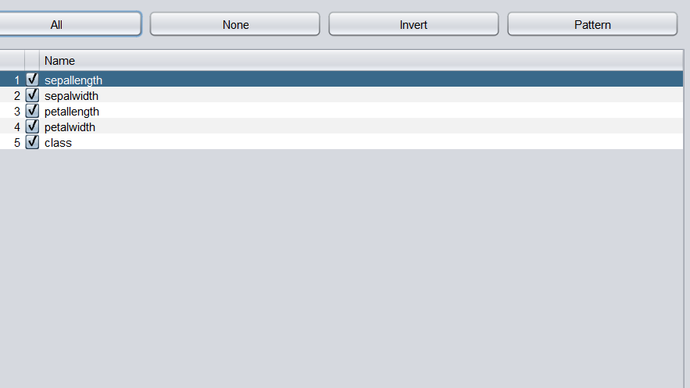
4. Number of records for each class:
- Iris-setosa – 50
- Iris-versicolor – 50
- Iris-verginica – 50
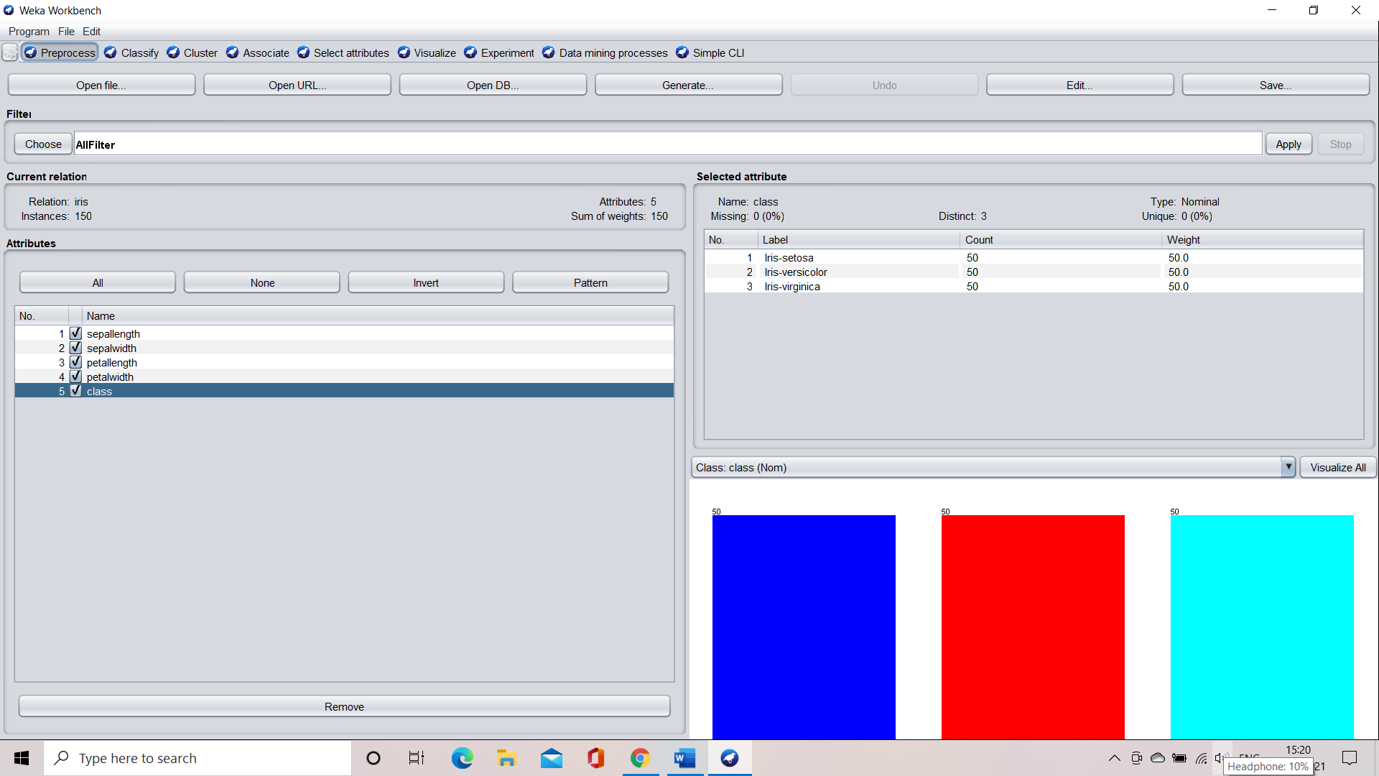

5. Graphical representation of all attributes against class attribute

