RAM CHARAN VANGA
RA2511027010164
Sub ject : DSA

Fill in the blanks
- A structure in C is defined using the struct keyword.
- The syntax to define a structure is:
struct StructName { members };
- To declare a structure variable at the time of definition:
struct StructName { members } variable;
- Structure members are accessed using the . (dot) operator when using a structure variable.
- When using a pointer to a structure, members are accessed using the -> (arrow) operator.
- To declare a structure variable separately:
struct StructName variable;
- To create a pointer to a structure:
struct StructName *ptr;
⚠️ The worksheet shows *struct StructName ____;, which is technically reversed. The correct C syntax is:
struct StructName *ptr;
- To assign the address of a structure variable:
ptr = &variable;
- Structures group different types of variables into a user-defined type.
- Structure definitions usually end with a semicolon ;
Answers :

1.
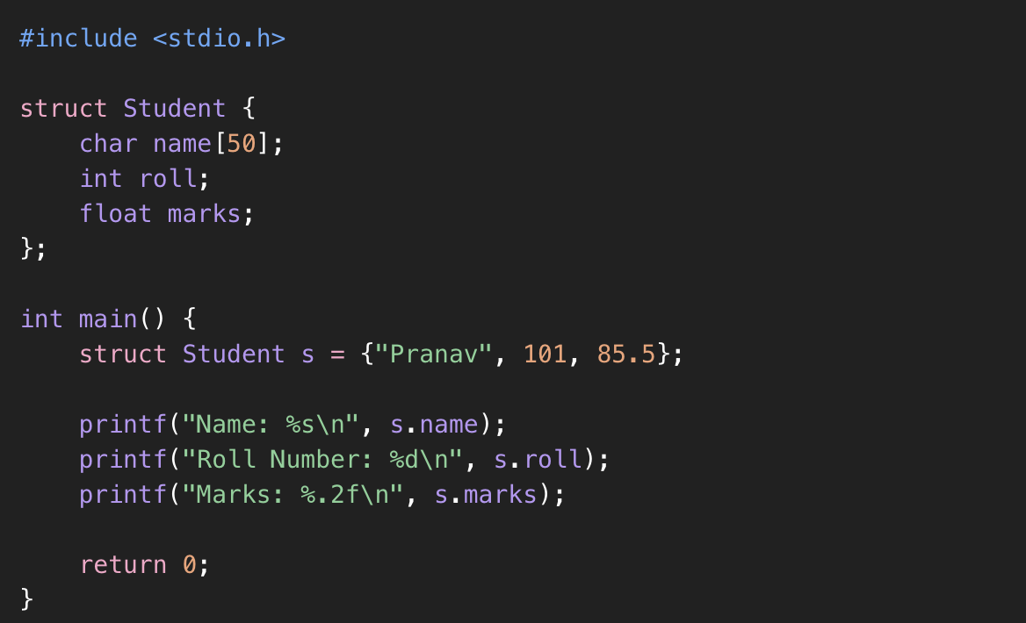
2.
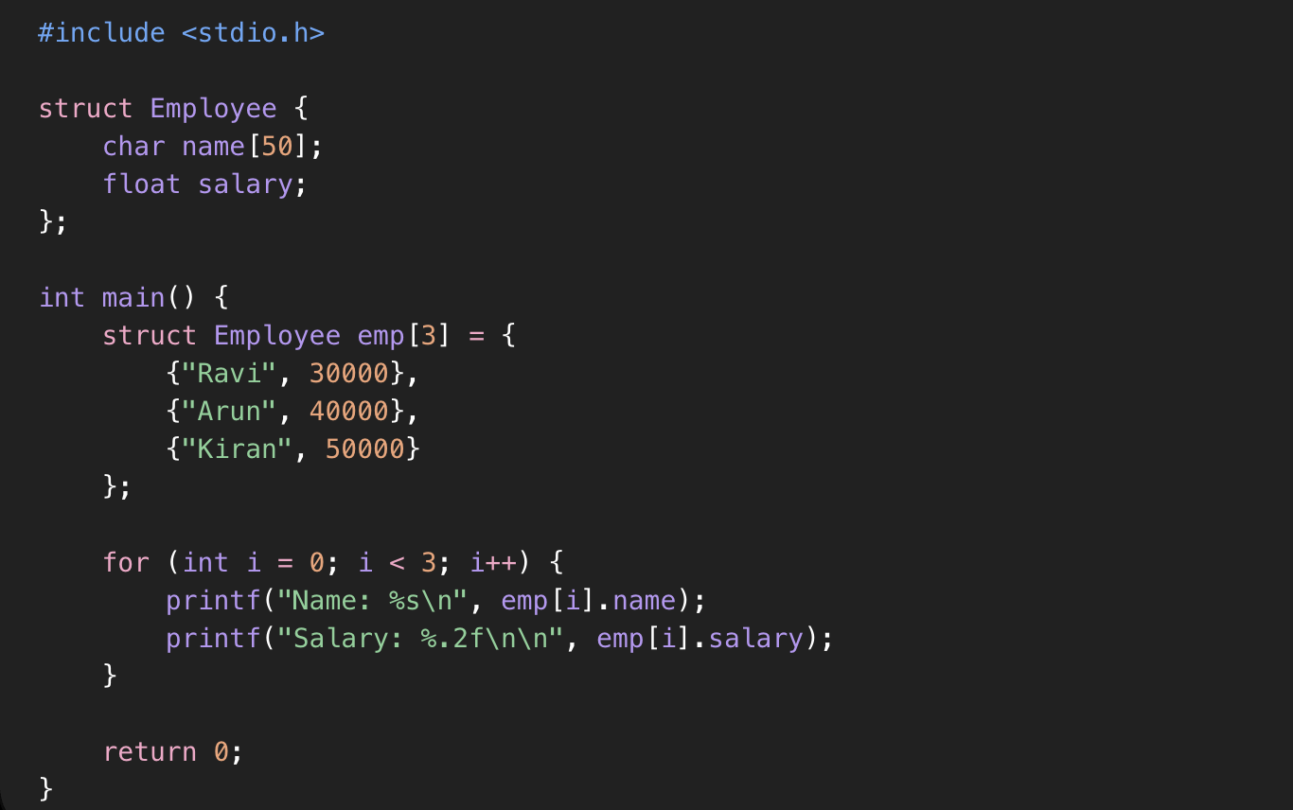

3.
