Unit 1 session 3 slot 1
RAM CHARAN VANGA
RA2511027010164
AR2
Fill in the blanks
1 . inside
2 . struct
3.memeber
4.2 times
5.nested structure
6. structure variable declaration
7 . nested structure
8.realeted sets of information
9 . false
10.using (.) dot operator
Activity
1 .
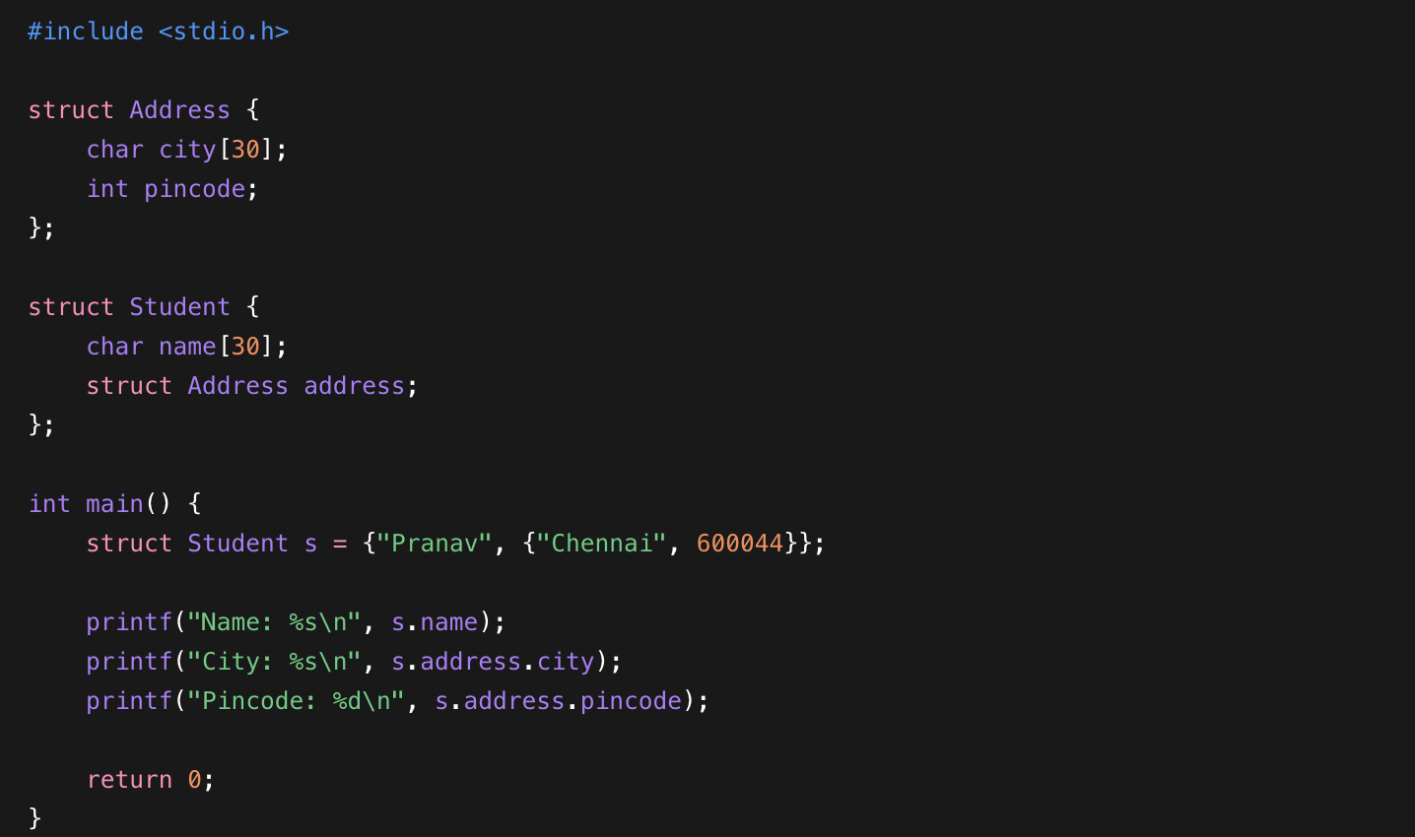
2 .
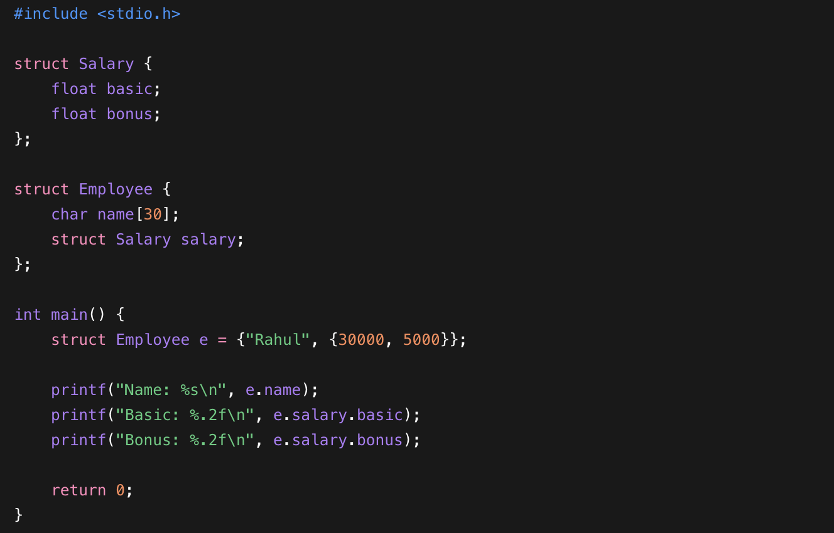
3 .
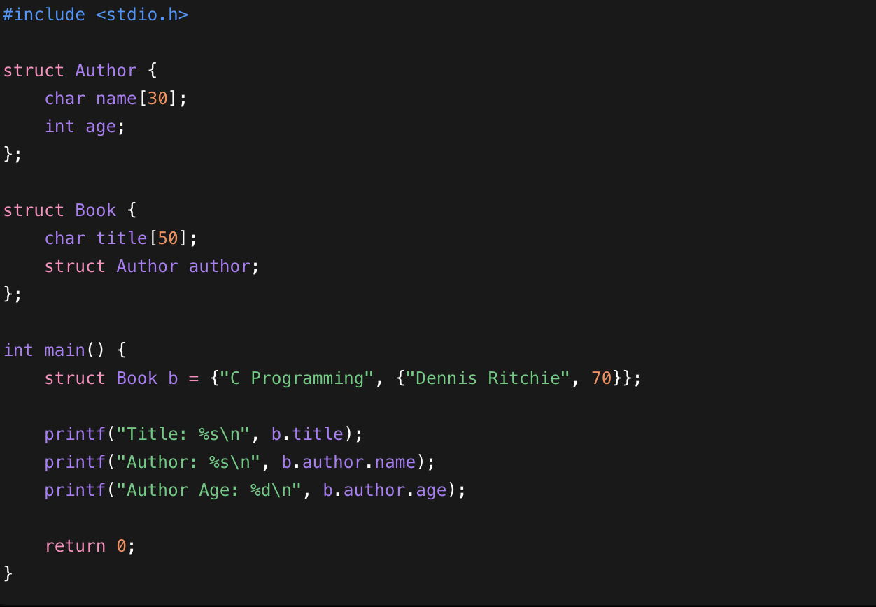

4.
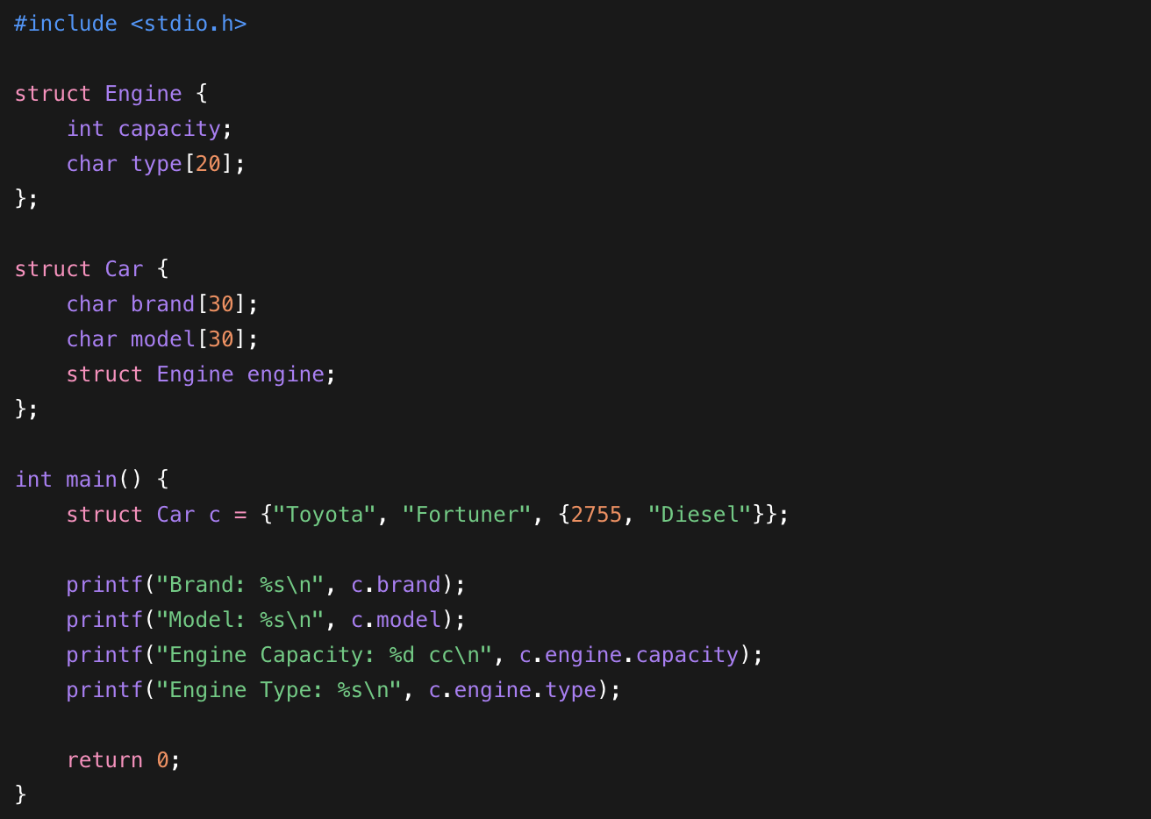
5.
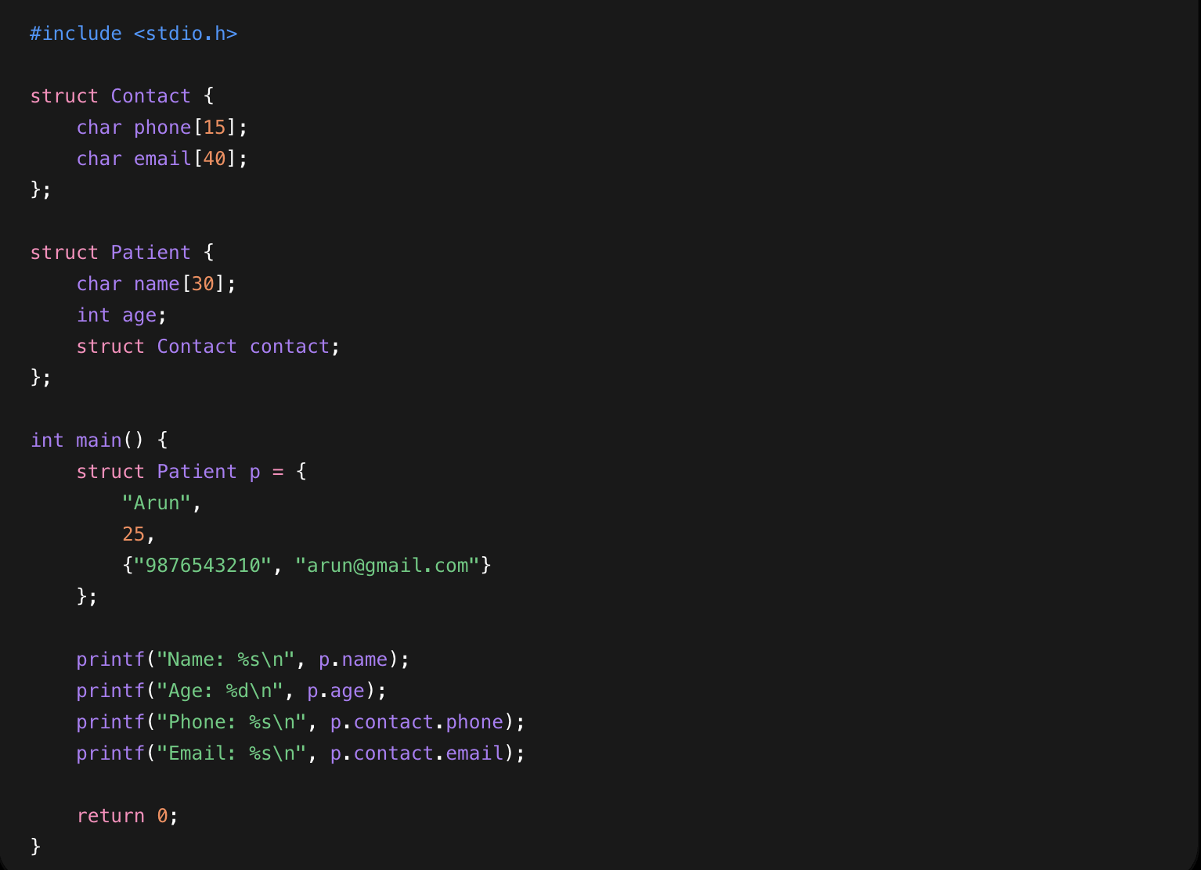
Activity :
