Unit 1 session 6 slot 1
RAM CHARAN VANGA
RA2511027010164
AR2
Code snippets
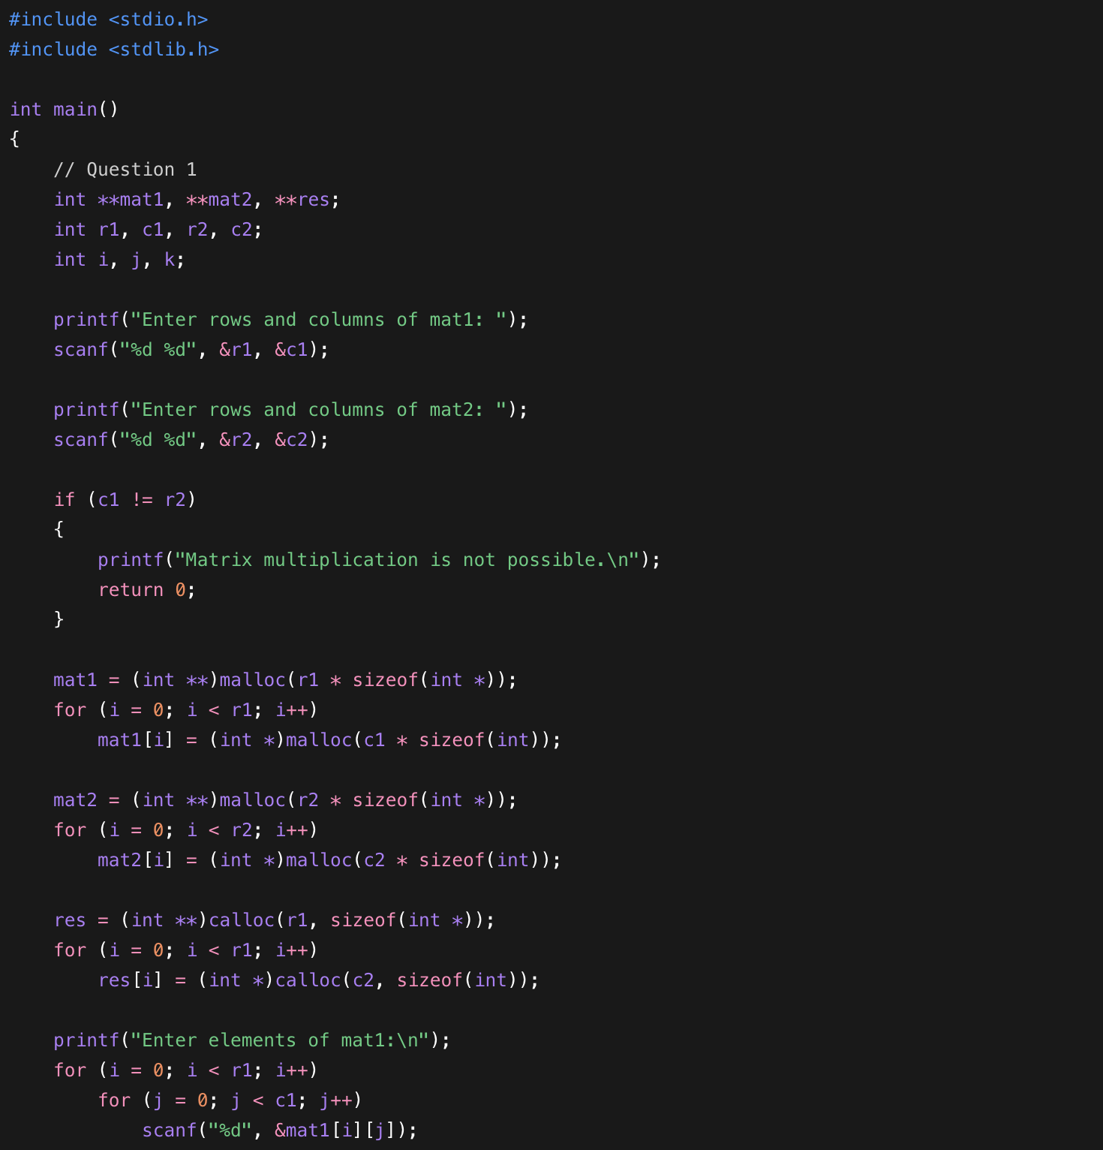
Cont..

