Sales Data Visualization Report
Translating Two Years of Retail Sales Data into Visual Insight
Prepared by: Data Analytics Intern
Role: Data Analytics Intern — Weekly Visualization Assignment
Date: September 18, 2026

Table of Contents
1. Executive Summary 3
2. Visualization Strategy 3
3. Dataset Overview 4
4. Visualizations and Interpretation 5
4.1 Bar Chart — Revenue by Category 5
4.2 Line Chart — Monthly Revenue Trend 5
4.3 Scatter Plot — Marketing Spend vs. Revenue 6
4.4 Heatmap — Correlation Matrix 7
4.5 Heatmap — Region × Category Revenue 8
4.6 Box Plot — Profit Margin by Region 9
5. Cross-Cutting Insights 10
6. Methodology and Tools 10
7. Conclusion 11

1. Executive Summary
This report documents the visualization process and key findings from an analysis of two years (January 2024 – December 2025) of simulated retail sales data spanning four regions, five product categories, and three customer segments. The dataset totals $12.48M in revenue, $2.68M in profit (a 23.6% average margin), and 212,304 units sold across 480 monthly records.
The objective was to design a coherent set of visualizations — bar, line, scatter, and heatmap charts at minimum — that together tell a clear analytical story: which products and regions drive revenue, how demand moves over time, how marketing investment relates to revenue, and how key metrics correlate with one another. Two supplementary visualizations (a category × region heatmap and a profit-margin box plot) were added to deepen the relational and distributional analysis.

Key Findings at a Glance
Metric | Value | Insight
Total Revenue | $12.48M | 7.4% YoY growth (2024 → 2025)
Top Category | Electronics (35.4%) | Largest single revenue driver
Top Region | North (28.5%) | Outperforms West by ~6 points
Marketing–Revenue Correlation | r = 0.86 | Strong positive relationship
Holiday Uplift (Nov–Dec) | +52.8% | vs. average of all other months
Discount–Margin Correlation | r = -0.26 | Heavier discounting mildly erodes margin

2. Visualization Strategy
Before writing any plotting code, each business question was mapped to the chart type best suited to answer it. This ensures every visualization earns its place in the report rather than being included for variety alone.
Business Question | Chart Type | Why This Chart
Which categories generate the most revenue? | Bar Chart | Best for comparing discrete category totals
How does revenue move over time and by region? | Line Chart | Best for showing trend and seasonality over a continuous timeline
Does marketing spend relate to revenue? | Scatter Plot | Best for revealing relationships between two continuous variables
How do all key metrics relate to each other? | Heatmap (Correlation) | Best for compactly surfacing many pairwise relationships at once
Where do region and category jointly perform best? | Heatmap (Pivot) | Best for two-dimensional relational comparison
How consistent is profitability within each region? | Box Plot | Best for comparing distributions and spotting outliers
A consistent design language was applied throughout: a single sequential colour palette ("crest") for visual cohesion, a clean whitegrid theme to reduce chart clutter, direct data labels where they aid readability, and descriptive titles/axis labels on every chart so each one is interpretable without needing to consult the source code.

3. Dataset Overview
The dataset was constructed to reflect realistic retail dynamics — seasonal peaks, regional demand differences, category-level margin variation, and a plausible marketing-spend-to-revenue relationship — so that the resulting visualizations reflect patterns typically seen in real sales data.
Field | Description
Date | First day of each month, Jan 2024 – Dec 2025
Region | North, South, East, West
Category | Electronics, Clothing, Home & Garden, Sports, Books
CustomerSegment | Consumer, Corporate, Small Business
UnitsSold / Revenue / Profit | Core transactional measures ($ and units)
MarketingSpend | Monthly marketing investment per region/category
DiscountPct / ProfitMargin | Average discount and resulting margin (%)
Data generation code (Python, pandas / numpy):
category_base = {'Electronics': 42000, 'Clothing': 28000, 'Home & Garden': 22000,
'Sports': 18000, 'Books': 9000}
region_mult = {'North': 1.15, 'South': 0.95, 'East': 1.05, 'West': 0.9}

for date in dates:
seasonal = 1.45 if date.month in (11, 12) else 0.85 if date.month in (7, 8) else 1.0
yoy_growth = 1.0 + (date.year - 2024) * 0.08
for region in regions:
for cat in categories:
base = category_base[cat] * region_mult[region] * seasonal * yoy_growth
revenue = max(base * np.random.normal(1, 0.08), 500)
marketing_spend = revenue * np.random.uniform(0.04, 0.11)
...

4. Visualizations and Interpretation

4.1 Bar Chart — Total Revenue by Product Category
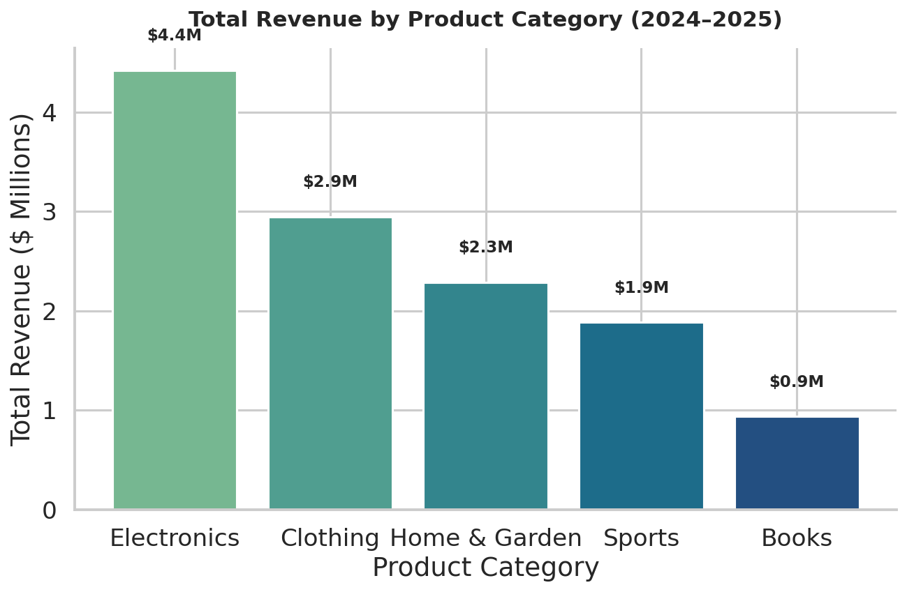
Figure 1. Total revenue by product category, 2024–2025.
Electronics is the clear revenue leader at $4.4M (35.4% of total revenue) — nearly 1.5× the revenue of the second-place category, Clothing ($2.9M, 23.6%). Home & Garden and Sports follow at $2.3M and $1.9M respectively, while Books trails at $0.9M (7.5%). This concentration suggests Electronics inventory, staffing, and marketing budget decisions carry outsized weight on overall revenue outcomes, and that Books may be a candidate for either a targeted growth campaign or a re-evaluation of shelf space.
cat_rev = df.groupby('Category')['Revenue'].sum().sort_values(ascending=False)
ax.bar(cat_rev.index, cat_rev.values, color=sns.color_palette('crest', len(cat_rev)))
ax.set_title('Total Revenue by Product Category (2024–2025)')

4.2 Line Chart — Monthly Revenue Trend by Region
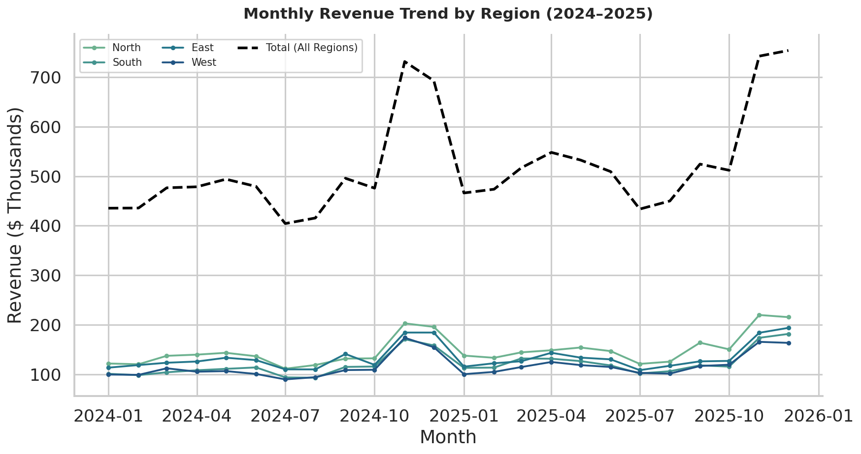
Figure 2. Monthly revenue trend, all regions plus overall total, 2024–2025.
The trend line reveals strong, repeating seasonality: revenue peaks sharply every November–December (holiday shopping), dips in July–August (summer lull), and dips again in January–February post-holiday. The November/December period runs 52.8% above the average of all other months. Comparing the two years, the December 2025 peak ($754K) is noticeably higher than December 2024, consistent with the 7.4% year-over-year revenue growth. North (the top green line) consistently leads the other three regions across every month, confirming the regional advantage seen in the category breakdown is structural rather than a one-off spike.
monthly = df.groupby(['Date','Region'])['Revenue'].sum().reset_index()
for region in df['Region'].unique():
sub = monthly[monthly['Region'] == region]
ax.plot(sub['Date'], sub['Revenue'], marker='o', label=region)

4.3 Scatter Plot — Marketing Spend vs. Revenue
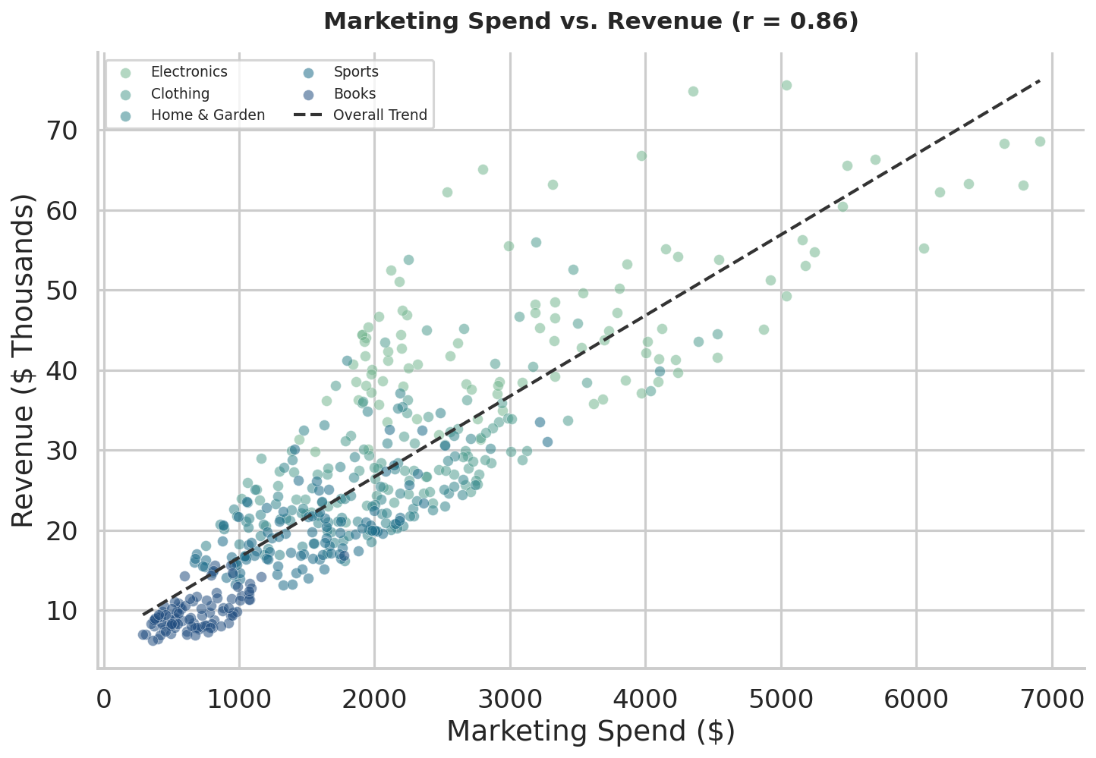
Figure 3. Marketing spend vs. revenue, coloured by product category, with overall trend line.
There is a strong positive correlation between marketing spend and revenue (r = 0.86), indicating that higher marketing investment is closely associated with higher sales outcomes. The colour encoding shows this relationship holds within categories too: Electronics (lightest points) occupies the upper-right of the chart — both the highest spend and highest revenue — while Books (darkest points) clusters in the lower-left. Points sitting above the trend line (e.g., some mid-spend Electronics months) represent above-average marketing efficiency and are worth investigating as best-practice campaigns to replicate.
corr = df['MarketingSpend'].corr(df['Revenue'])
z = np.polyfit(df['MarketingSpend'], df['Revenue'], 1)
ax.scatter(sub['MarketingSpend'], sub['Revenue'], alpha=0.55, label=cat)
ax.plot(xline, np.poly1d(z)(xline), linestyle='--', label='Overall Trend')

4.4 Heatmap — Correlation Matrix of Key Sales Metrics
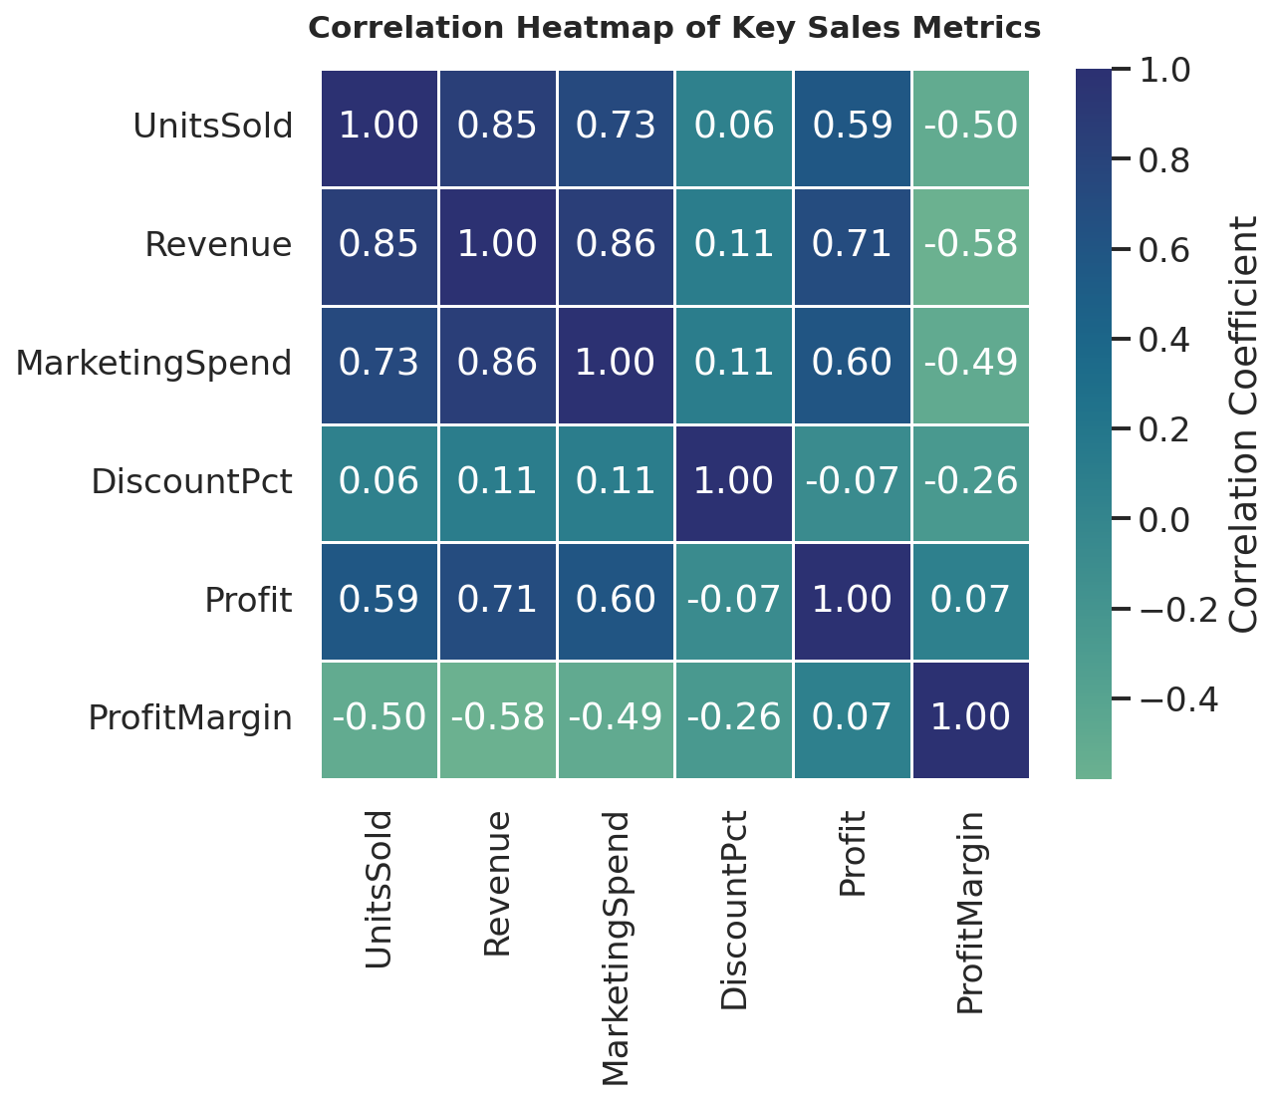
Figure 4. Pairwise correlation heatmap across six numeric sales metrics.
The correlation heatmap consolidates the relationships between all numeric variables into a single view. Revenue correlates strongly with both Marketing Spend (0.86) and Units Sold (0.85), reinforcing the scatter-plot finding. Profit Margin, however, correlates negatively with Revenue (-0.58) and Units Sold (-0.50) — larger, higher-volume transactions in this dataset skew toward lower-margin categories like Electronics, while smaller categories like Books carry higher margins. Discount Percentage shows a mild negative relationship with margin (-0.26), confirming that discounting, as expected, compresses profitability, though the effect is moderate rather than severe.
corr_matrix = df[numeric_cols].corr()
sns.heatmap(corr_matrix, annot=True, fmt='.2f', cmap='crest', center=0, square=True)

4.5 Heatmap — Average Monthly Revenue by Region and Category
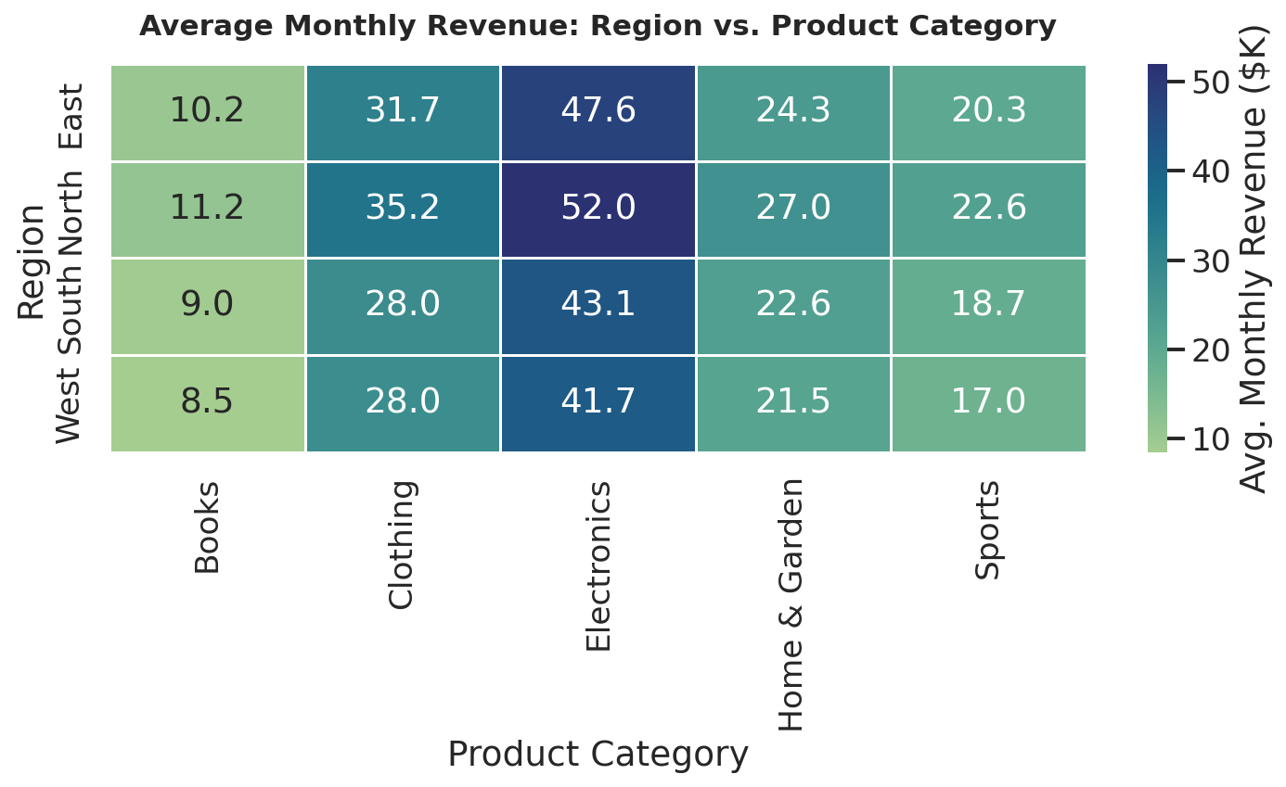
Figure 5. Average monthly revenue for every region × category combination.
This second heatmap adds a relational dimension the first cannot show: where, specifically, revenue concentrates. North Electronics is the single strongest combination at $52.0K average monthly revenue — noticeably ahead of every other cell. The pattern holds directionally across all four regions (Electronics > Clothing > Home & Garden > Sports > Books), meaning the category ranking from Figure 1 is not driven by one region alone. West Books, at $8.5K, is the weakest cell in the matrix and the most natural candidate for either a regional promotion or a deprioritization decision.
pivot = df.pivot_table(index='Region', columns='Category', values='Revenue', aggfunc='mean')
sns.heatmap(pivot, annot=True, fmt='.1f', cmap='crest')

4.6 Box Plot — Profit Margin Distribution by Region
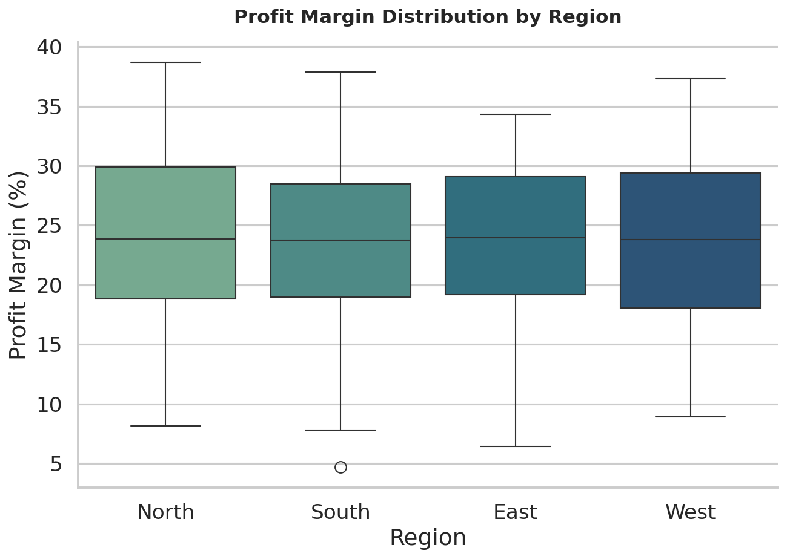
Figure 6. Distribution of monthly profit margin (%) by region.
All four regions cluster around a similar median profit margin (~24%), showing that regional revenue differences (Figure 1, Figure 5) are driven by sales volume rather than pricing/margin discipline — no region is 'buying' its revenue lead with thinner margins. West shows the widest interquartile spread, indicating less consistent margin performance month to month, while East has one notable low outlier (~4.7%) worth investigating as a potential data anomaly or an unusually heavy discount period.
sns.boxplot(data=df, x='Region', y='ProfitMargin', palette='crest')

5. Cross-Cutting Insights
- Revenue concentration: Electronics + North together represent the single highest-value combination in the business and merit protection (inventory priority, marketing continuity) ahead of other segments.
- Seasonality is the dominant time-based pattern: the +52.8% Nov–Dec uplift dwarfs the 7.4% YoY growth rate, meaning holiday execution has far more revenue impact than any single yearly initiative.
- Marketing spend appears efficient: the strong 0.86 correlation with revenue, consistent across categories, supports continued or expanded marketing investment, especially in under-indexed categories like Books.
- Margin is a volume trade-off, not a regional trade-off: profit margin is fairly consistent across regions but inversely related to revenue volume across categories — a useful distinction for pricing strategy.
- Discounting has a real but moderate cost: the -0.26 correlation with margin suggests discount campaigns should be monitored but are not, on this evidence, severely eroding profitability.

6. Methodology and Tools
All analysis and visualization were performed in Python 3 using the following libraries:
- pandas / numpy — data generation, aggregation, and pivot-table construction
- matplotlib — base plotting engine and fine-grained styling control
- seaborn — statistical chart types (heatmap, box plot) and the shared "crest" colour palette
Design principles applied consistently across all six figures: (1) every axis is labelled with units where relevant (e.g., "$ Millions", "%"); (2) every chart has a descriptive, self-contained title; (3) a single colour palette is reused throughout for visual cohesion; (4) legends are included wherever more than one series is plotted; and (5) direct value labels or annotations (bar totals, correlation coefficients, heatmap cell values) are used to reduce the need for the reader to estimate from the axis alone.

7. Conclusion
Together, the six visualizations move from broad to specific: the bar chart establishes what sells, the line chart establishes when it sells, the scatter plot and correlation heatmap establish why (marketing investment) and what else moves together, and the region × category heatmap and box plot pinpoint exactly where in the business those patterns concentrate. The resulting narrative — an Electronics- and North-led, marketing-responsive, strongly seasonal business with stable margins — is a concrete, decision-ready foundation for planning next year's category mix, regional investment, and holiday-season resourcing.

End of report. Source data (sales_data.csv) and Python scripts (generate_data.py, make_plots.py) accompany this document.

