The Exploratory Data Analysis and Data Quality Assessment section of your completed written report should include the following:

* All the steps should be explained, (including but not limited to):
  + Exploratory data analysis - any notable findings?
  + In data preparation and data cleaning steps:
    - What steps do you take to get it into a format amenable to analysis?
    - Are there missing variables or outliers?
    - Was there a need for smoothing, differencing, or transformation?

In this draft, EDA has sufficient plots to show rigorous exploration and should include some data quality discussion.

Data preprocessing.

Data was pulled by calling yahoo finance library. It has a daily ticker information without any missing values during market days. Missing values occur on weekend and holiday dates. Therefore, the data is imputed and fill it forward.

Data Exploration

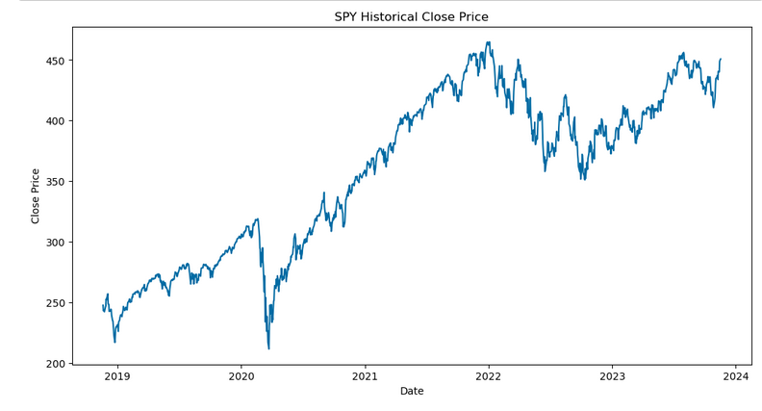

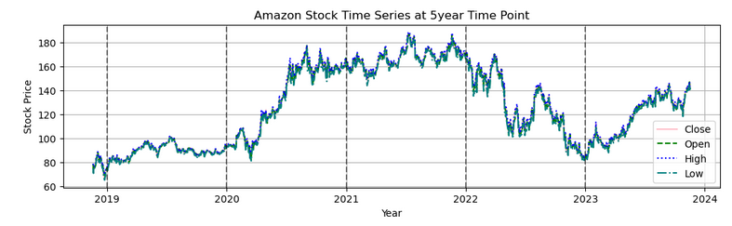

Both of line chart show a positive trend for the past 5 years. As the data was decomposed, we found there is a seasonality as well

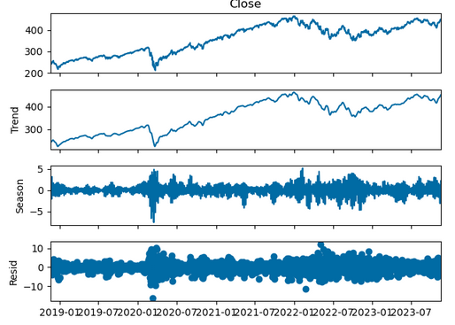

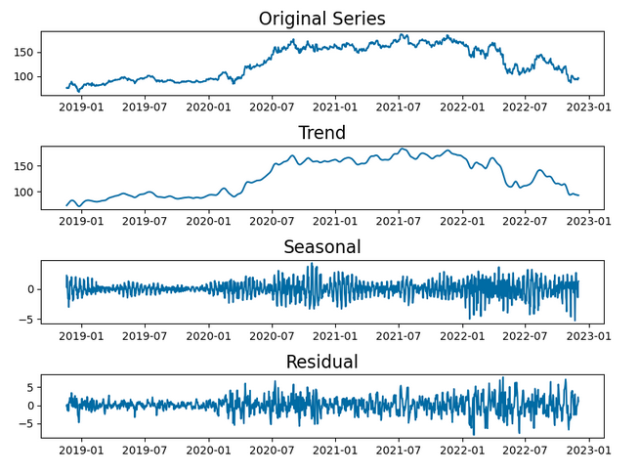

In order to confirm if the stationary exists, Augmented Dickey-Fuller test was checked. The result shows p-value >0.05, which indicates that time series is not stationary. A stationary was also looked at before applying ARIMA model.

Since the data is not stationary, a couple of differencing (difference lag 1 and lag 14) was looked at. Based on PACF plot, we may want to do AR model with lags 1 and 14 periods.

