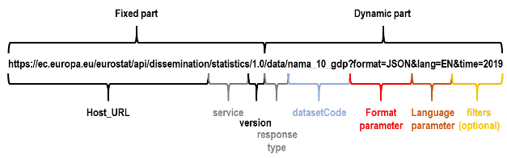

The structure to build the REST request is a URL: {host_url}/{service}/{version}/{response_type}/{datasetCode}?{format}&{lang}&{filters}

**Filter parameters**

Filters start after the question mark ("?") in the URL. They are separated by an ampersand ("&") if there are several filters.

The structure of a filter parameter: <DIMENSION_CODE>=<VALUE>

* DIMENSION_CODE: the code of the dimension used to filter data
  + - The dimension code must be present in the data product
    - It is not necessary that the order of the filters correspond to the order of the dimensions in the data product
* VALUE: value of the filter is the position in the dimension i.e.
  + time=2019
  + geo=FR
* DIMENSION_CODE and VALUE are case-insensitive; they can be written in lower or uppercase in the URL request.

**Time parameter**

Both "time" and "time_period" parameters are accepted in the URL. Both address the TIME_PERIOD dimension.

Below are other Time parameters that can be used:

* untilTimePeriod – the specific TIME_PERIOD value to filter the returned file until this value
* sinceTimePeriod – the specific TIME_PERIOD value to filter the returned file since this value
* lastTimePeriod – a numeric value counting down until the TIME_PERIOD dimension values are included in the returned file

The “format” parameter’s only possible value is "JSON".

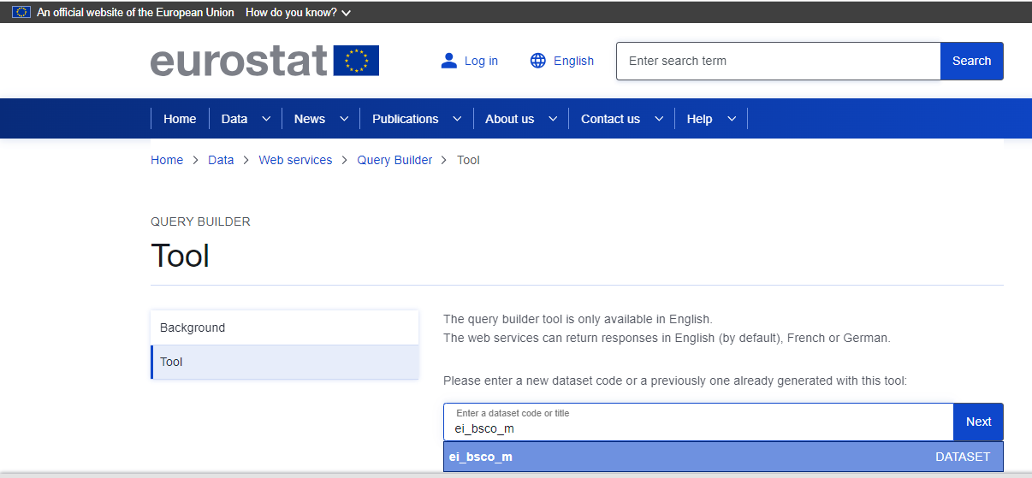

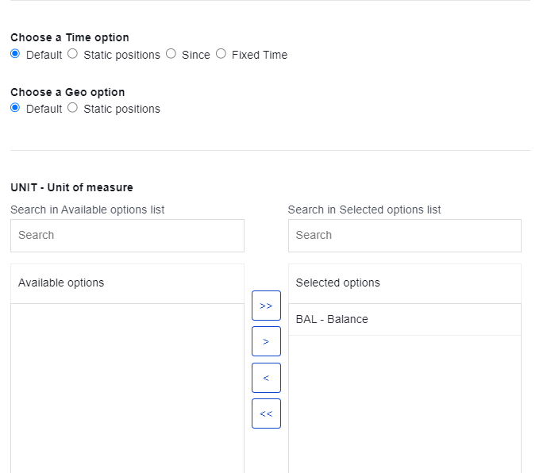

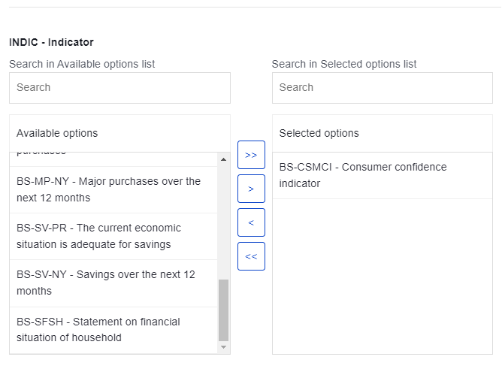

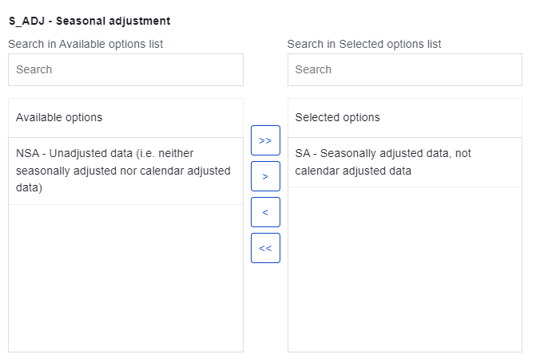

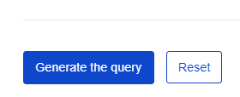

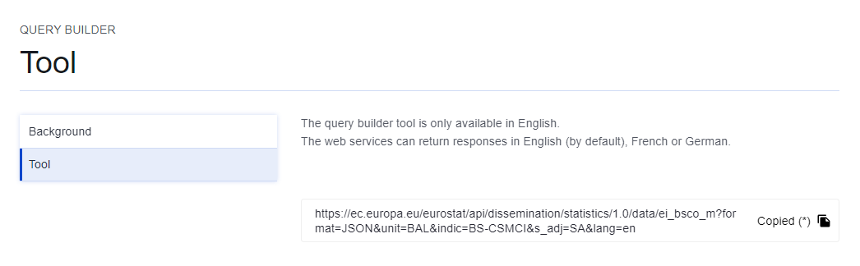

**Query copied**

<https://ec.europa.eu/eurostat/api/dissemination/statistics/1.0/data/ei_bsco_m?format=JSON&unit=BAL&indic=BS-CSMCI&s_adj=SA&lang=en>

Falta añadir el time. Como es monthy:

* Para todos los meses de 2022: &sinceTimePeriod=2022-01&untilTimePeriod=2022-12
* Para los últimos 5 años: &sinceTimePeriod=2018-09&untilTimePeriod=2023-09

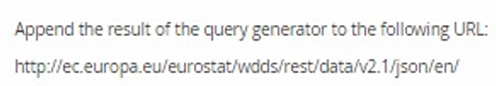

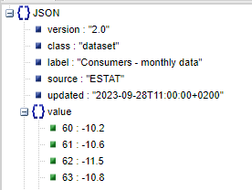

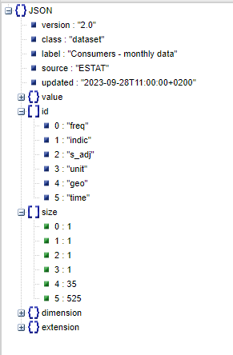

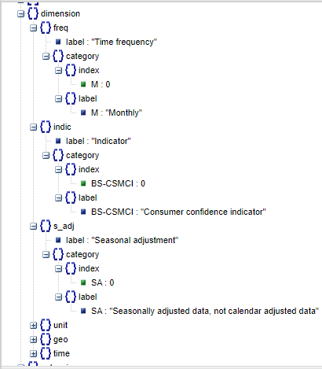

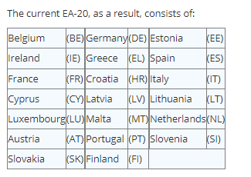

**BIBLIOGRAFÍA**

<https://wikis.ec.europa.eu/display/EUROSTATHELP/API+Statistics+-+data+query>

<https://ec.europa.eu/eurostat/web/query-builder/tool>