1. Upload file – POST method

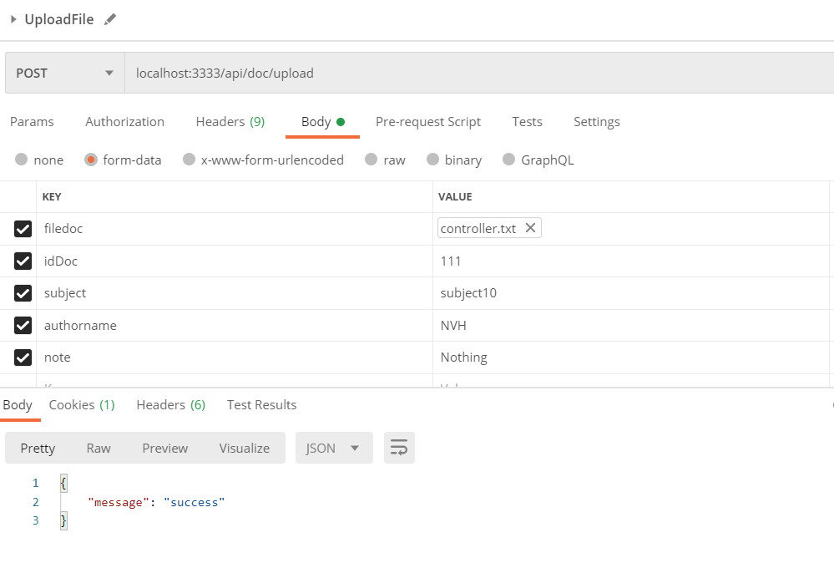

API upload file

|  |  |  |  |  |
| --- | --- | --- | --- | --- |
| Route | Method | Request JSON | Respone JSON | Usage |
| “/api/doc/upload” | POST | * Filedoc: File (requied) * idDoc: Number * subject: String * authorname: String * note: String | Return message is “success” | Upload the document file to the common database |

Description for API upload file

1. Get all document – GET method

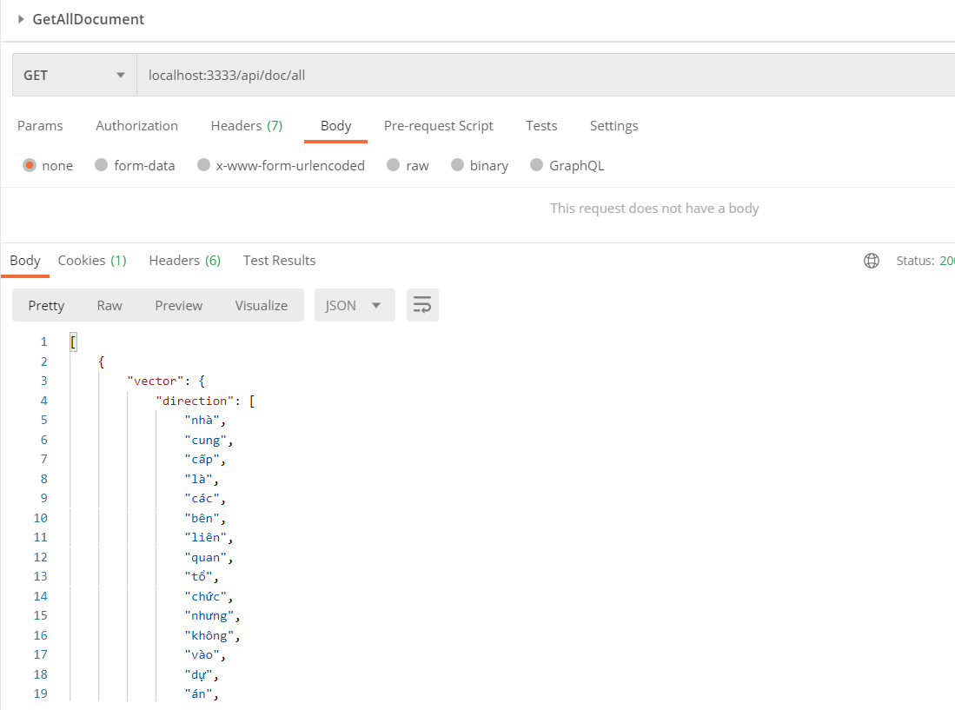

|  |  |  |  |  |
| --- | --- | --- | --- | --- |
| Route | Method | Request JSON | Respone JSON | Usage |
| “/api/doc/all” | GET | No request | Return all document in database | Get all document in database |

1. Search document – POST method

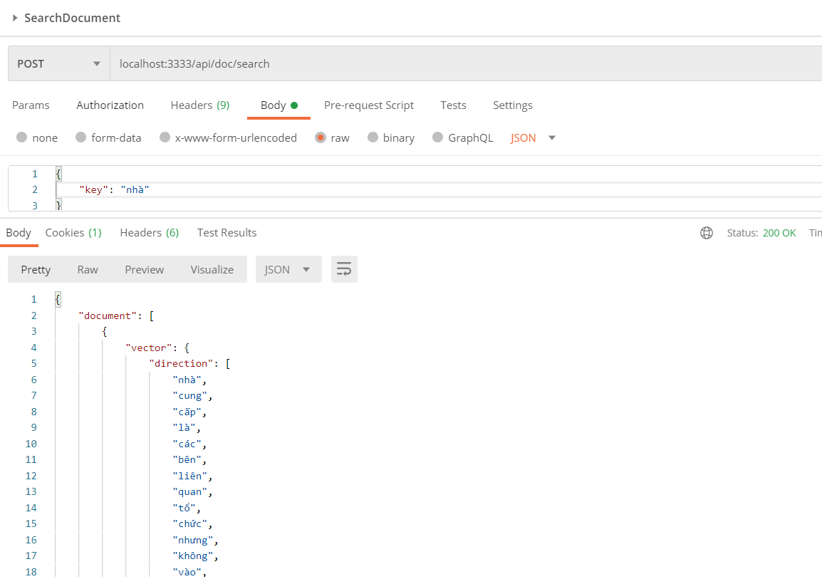

|  |  |  |  |  |
| --- | --- | --- | --- | --- |
| Route | Method | Request JSON | Respone JSON | Usage |
| “/api/doc/search” | POST | * Key: String | Return document contain key | Get document contain key in database |

1. Add theme – POST method

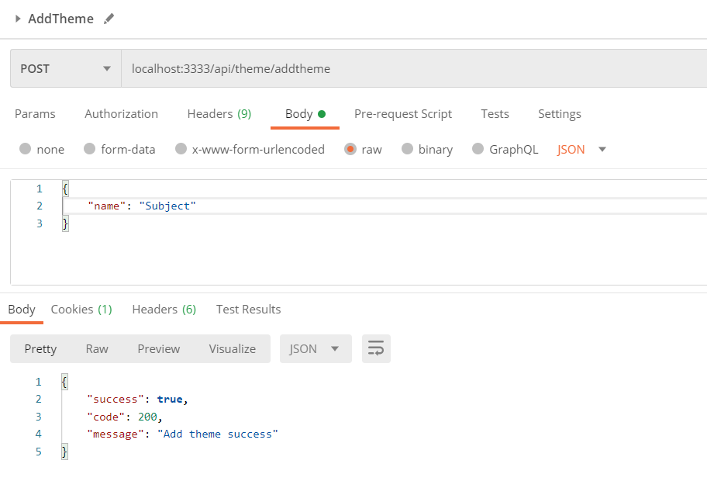

|  |  |  |  |  |
| --- | --- | --- | --- | --- |
| Route | Method | Request JSON | Respone JSON | Usage |
| “/api/theme/addtheme” | POST | * name: String | return json is successful | Add new theme |

1. Get all theme – GET method

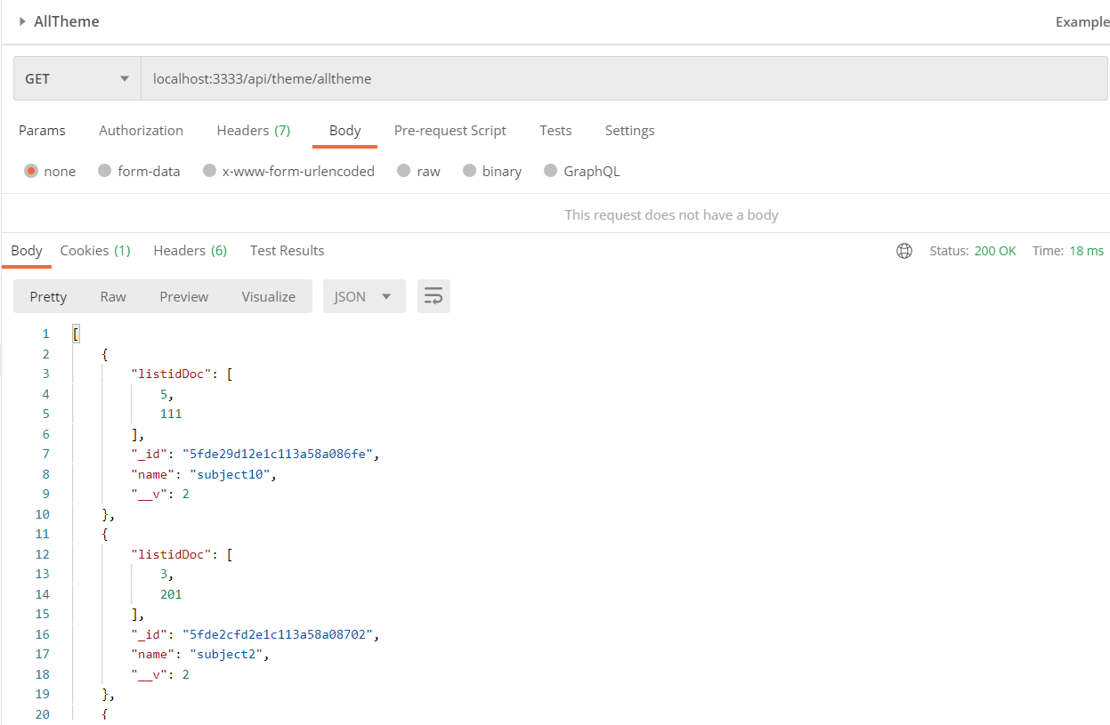

|  |  |  |  |  |
| --- | --- | --- | --- | --- |
| Route | Method | Request JSON | Respone JSON | Usage |
| “/api/theme/alltheme” | GET | No request | Return all themes in database | Get all themes in database |

1. Edit theme – POST method

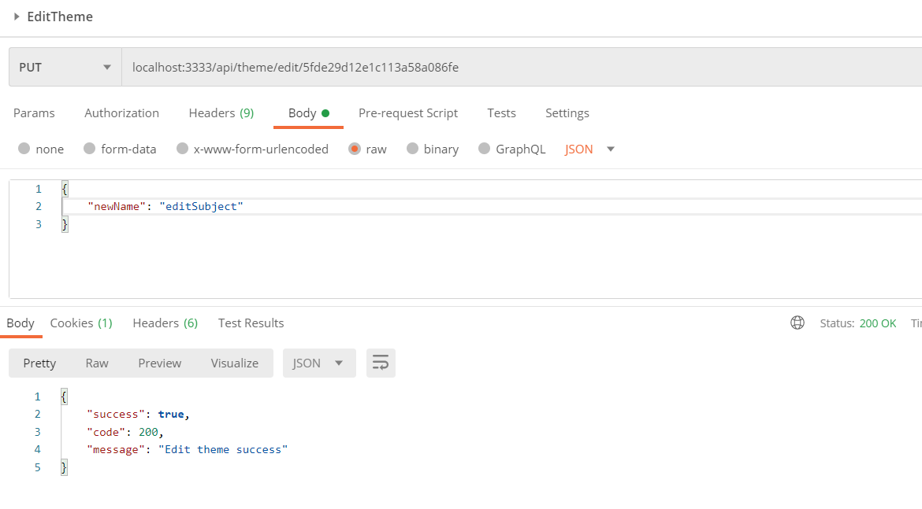

|  |  |  |  |  |
| --- | --- | --- | --- | --- |
| Route | Method | Request JSON | Respone JSON | Usage |
| “/api/theme/edit:idtheme” | POST | * Idtheme: ObjectId * newName: String | Return json is successful | Edit theme in database |