Design algorithm

1. Delete special characters

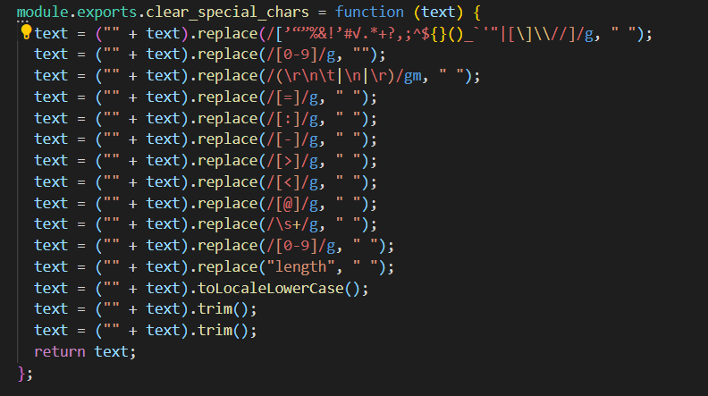

//Hình: Function clear_special_chars

|  |  |  |
| --- | --- | --- |
| Input | Output | Usage |
| * Text: String | * Text (has filtered out special characters): String | * Used to delete the special characters of an passed string |

// Bảng: Description function clear_special_chars

1. Filter stopword

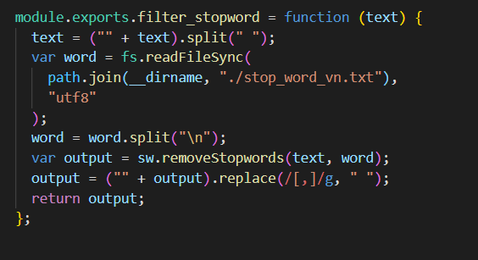

// Hình: Function filter_stopword

|  |  |  |
| --- | --- | --- |
| Input | Output | Usage |
| * Text: String | * output: String | * Used to filter words is stopword |

//Bảng: Description function filter_stopword

1. TF-IDF algorithm

Count the Number of words in a document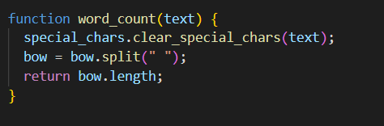

// Hình: Function word_count

|  |  |  |
| --- | --- | --- |
| Input | Output | Usage |
| * Text: String | * Bow.length: Number | * Used to calculate the Number of words in a paragraph |

// Bảng: Description function word_count

* Counts the Number of occurrences of words in a document

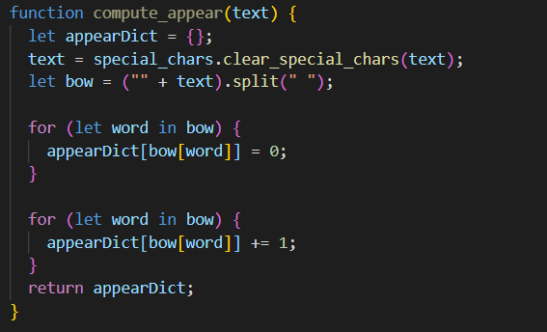

// Hình: Function compute_appear

|  |  |  |
| --- | --- | --- |
| Input | Output | Usage |
| * Text: String | * appearDict: List | * Used to calculate the Number of occurrences of words |

* Compute term frequency (TF)

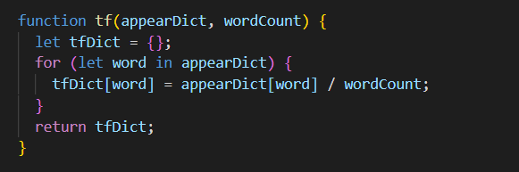

// Hình: Function tf

|  |  |  |
| --- | --- | --- |
| Input | Output | Usage |
| * appearDict: List * wordCount: Number | * tfDict: List | * Used to calculate term frequency |

* Compute inverse document frequency (IDF)

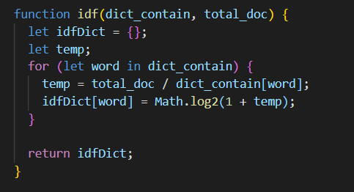

//HÌnh: Function idf

|  |  |  |
| --- | --- | --- |
| Input | Output | Usage |
| * Dict_contain: List * Total_doc: Number | * idfDict: List | * Used to calculate inverse document frequency |

* Calculates the Number of documents containing words

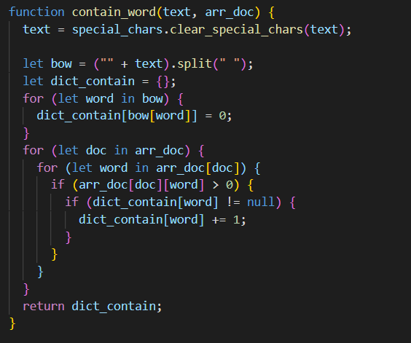

// Hình: Function contain_word

|  |  |  |
| --- | --- | --- |
| Input | Output | Usage |
| * text: String * arr_doc: Array | * dict_contain: List | * Used to calculate the Number of documents containing words |

//Bảng: Description function contain_word

1. Create vector

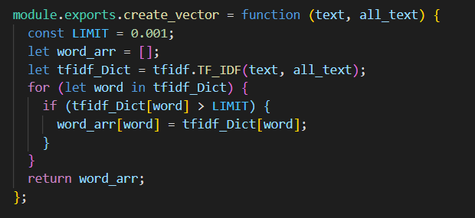

// Hình: Function create_vector

|  |  |  |
| --- | --- | --- |
| Input | Output | Usage |
| * text: String * arr_text: Array | * word_arr: Array | * Used to create a vector of a document |

// Bảng: Description function create_vector

1. Calculate the distance between two vectors using euclidean algorithm

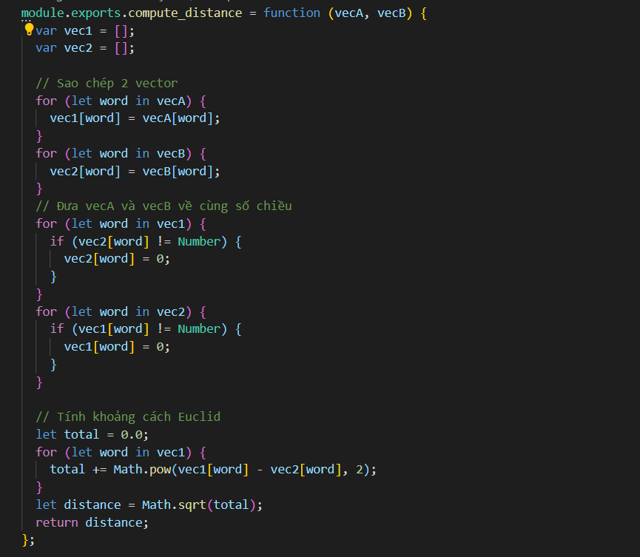

// Hình: Function compute_distance

|  |  |  |
| --- | --- | --- |
| Input | Output | Usage |
| * vecA: Array * VecB: Array | * distance: Number | * Used to calculate the distance between 2 vectors |