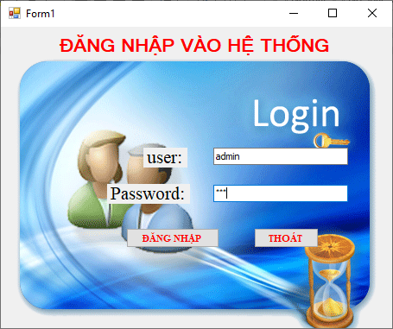

Form đăng nhập

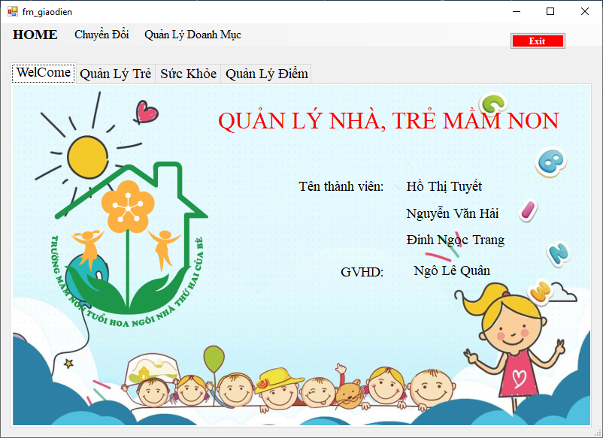

Form giao diện chính

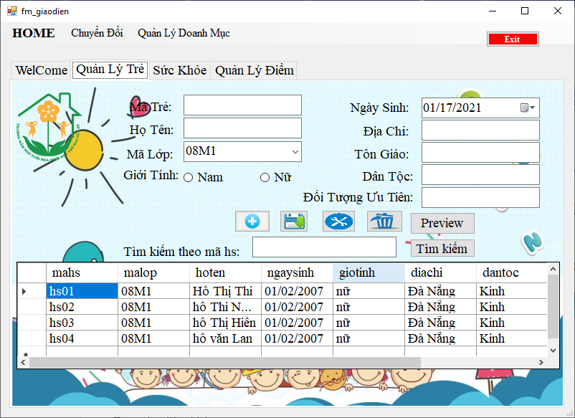

Tag quản lý trẻ

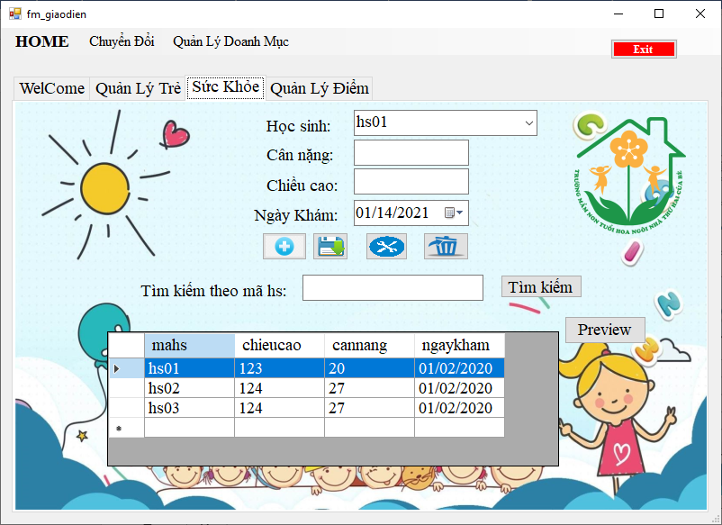

Tag quản lý sức khỏe



Quản lý điểm

Code cho class class1

using System.Data;

using System.IO;

using System.Windows.Forms;

using System.Data.SqlClient;

using System.Xml;

using System.Xml.Xsl;

using System.Xml.XPath;

using System;

namespace baiqlmn.Class

{

class Class1

{

string strCon = "Data Source=DESKTOP-26IQ342\\SQLEXPRESS;Initial Catalog=QLNHATRE3;Integrated Security=True";

//Data Source=DESKTOP-26IQ342\SQLEXPRESS;Initial Catalog=QLNHATRE63;Integrated Security=True

public void TaoXML(string bang)

{

SqlConnection con = new SqlConnection(strCon);

con.Open();

string sql = "Select* from " + bang;

SqlDataAdapter ad = new SqlDataAdapter(sql, con);

DataTable dt = new DataTable("'" + bang + "'");

ad.Fill(dt);

dt.WriteXml(Application.StartupPath + "\\" + bang + ".xml", XmlWriteMode.WriteSchema);

}

public DataTable HienThi(string file)

{

DataTable dt = new DataTable();

string FilePath = Application.StartupPath + "\\" + file;

if (File.Exists(FilePath))

{

FileStream fsReadXML = new FileStream(FilePath, FileMode.Open);

dt.ReadXml(fsReadXML);

fsReadXML.Close();

}

else

{

MessageBox.Show("File XML '" + file + "' không tồn tại");

}

return dt;

}

public bool KTMa(string _FileXML, string cotMa, string ma)

{

bool kt = true;

DataTable dt = new DataTable();

dt = HienThi(_FileXML);

for (int i = 0; i < dt.Rows.Count; i++)

{

if (dt.Rows[i][cotMa].ToString().Trim().Equals(ma))

{

kt = false;

}

else

{

kt = true;

}

}

return kt;

}

public void Them(string FileXML, string xml)

{

try

{

XmlTextReader textread = new XmlTextReader(FileXML);

XmlDocument doc = new XmlDocument();

doc.Load(textread);

textread.Close();

XmlNode currNode;

XmlDocumentFragment docFrag = doc.CreateDocumentFragment();

docFrag.InnerXml = xml;

currNode = doc.DocumentElement;

currNode.InsertAfter(docFrag, currNode.LastChild);

doc.Save(FileXML);

}

catch

{

MessageBox.Show("lỗi");

}

}

public void Sua(string duongDan, string tenFile, string suaTheoTruong, string giaTriTruong, string noiDung)

{

XmlTextReader reader = new XmlTextReader(duongDan);

XmlDocument doc = new XmlDocument();

doc.Load(reader);

reader.Close();

XmlNode oldHang;

XmlElement root = doc.DocumentElement;

oldHang = root.SelectSingleNode("//" + tenFile + "[./" + suaTheoTruong + "/text()='" + giaTriTruong + "']");

XmlElement newhang = doc.CreateElement(tenFile);

newhang.InnerXml = noiDung;

root.ReplaceChild(newhang, oldHang);

doc.Save(duongDan);

}

public void Xoa(string duongDan, string tenFile, string suaTheoTruong, string giaTriTruong)

{

string fileName = Application.StartupPath + "\\" + duongDan;

XmlDocument doc = new XmlDocument();

doc.Load(fileName);

XmlNode nodeCu = doc.SelectSingleNode("//" + tenFile + "[./" + suaTheoTruong + "/text()='" + giaTriTruong + "']");

doc.DocumentElement.RemoveChild(nodeCu);

doc.Save(fileName);

}

public void TimKiem(string _FileXML, string xml, DataGridView dgv)

{

XmlDocument xDoc = new XmlDocument();

xDoc.Load(Application.StartupPath + _FileXML);

string xPath = xml;

XmlNode node = xDoc.SelectSingleNode(xPath);

DataSet ds = new DataSet();

DataTable dt = new DataTable();

XmlNodeReader nr = new XmlNodeReader(node);

ds.ReadXml(nr);

dgv.DataSource = ds.Tables[0];

nr.Close();

}

public string LayGiaTri(string duongDan, string truongA, string giaTriA, string truongB)

{

string giatriB = "";

DataTable dt = new DataTable();

dt = HienThi(duongDan);

int soDongNhanVien = dt.Rows.Count;

for (int i = 0; i < soDongNhanVien; i++)

{

if (dt.Rows[i][truongA].ToString().Trim().Equals(giaTriA))

{

giatriB = dt.Rows[i][truongB].ToString();

return giatriB;

}

}

return giatriB;

}

public bool KiemTra(string _FileXML, string truongKiemTra, string giaTriKiemTra)

{

DataTable dt = new DataTable();

dt = HienThi(_FileXML);

dt.DefaultView.RowFilter = truongKiemTra + " ='" + giaTriKiemTra + "'";

if (dt.DefaultView.Count > 0)

return true;

return false;

}

public void InsertOrUpDateSQL(string sql)

{

SqlConnection con = new SqlConnection(strCon);

con.Open();

SqlCommand cmd = new SqlCommand(sql, con);

cmd.ExecuteNonQuery();

con.Close();

}

}

}

Code cho class tạo file xml

using System;

using System.Collections.Generic;

using System.Data;

using System.Linq;

using System.Text;

using System.Threading.Tasks;

namespace baiqlmn.Class

{

class tao

{

Class1 Fxml = new Class1();

public void TaoXML()

{

Fxml.TaoXML("giaovien");

Fxml.TaoXML("hocsinh");

Fxml.TaoXML("suckhoe");

Fxml.TaoXML("ketqua");

Fxml.TaoXML("dangnhap");

Fxml.TaoXML("lophoc");

}

}

}

Code cho class hs

using System;

using System.Collections.Generic;

using System.Data;

using System.Linq;

using System.Text;

using System.Threading.Tasks;

using System.Windows.Forms;

using System.Xml;

namespace baiqlmn.Class

{

class hs

{

Class1 Fxml = new Class1();

public DataTable LoadMahs()

{

DataTable dt = new DataTable();

dt = Fxml.HienThi("hocsinh.xml");

return dt;

}

public bool kiemtrahs(string mahs)

{

XmlTextReader reader = new XmlTextReader("hocsinh.xml");

XmlDocument doc = new XmlDocument();

doc.Load(reader);

XmlNode node = doc.SelectSingleNode("//_x0027_hocsinh_x0027_[./mahs/text()='" + mahs + "']");

reader.Close();

bool kq = true;

if (node != null)

{

return kq = true;

}

else

{

return kq = false;

}

}

public void themH(string mahs, string malop, string hoten,string ngaysinh, string giotinh, string diachi, string dantoc, string tongiao, string dtut)

{

string noiDung = "<_x0027_hocsinh_x0027_>" +

"<mahs>" + mahs + "</mahs>" +

"<malop>" + malop + "</malop>" +

"<hoten>" + hoten + "</hoten>" +

"<ngaysinh>" + ngaysinh + "</ngaysinh>" +

"<giotinh>" + giotinh + "</giotinh>" +

"<diachi>" + diachi + "</diachi>" +

"<dantoc>" + dantoc + "</dantoc>" +

"<tongiao>" + tongiao + "</tongiao>" +

"<doituonguutien>" + dtut + "</doituonguutien>" +

"</_x0027_hocsinh_x0027_>";

Fxml.Them("hocsinh.xml", noiDung);

}

public void suahs(string mahs, string malop, string hoten, string ngaysinh, string giotinh, string diachi, string dantoc, string tongiao, string dtut)

{

string noiDung =

"<mahs>" + mahs + "</mahs>" +

"<malop>" + malop + "</malop>" +

"<hoten>" + hoten + "</hoten>" +

"<ngaysinh>" + ngaysinh + "</ngaysinh>" +

"<giotinh>" + giotinh + "</giotinh>" +

"<diachi>" + diachi + "</diachi>" +

"<dantoc>" + dantoc + "</dantoc>" +

"<tongiao>" + tongiao + "</tongiao>" +

"<doituonguutien>" + dtut + "</doituonguutien>" ;

Fxml.Sua("hocsinh.xml", "_x0027_hocsinh_x0027_", "mahs", mahs, noiDung);

}

public void xoahs(string mahs)

{

Fxml.Xoa("hocsinh.xml", "_x0027_hocsinh_x0027_", "mahs", mahs);

}

}

}

Code cho class sk

using System;

using System.Collections.Generic;

using System.Linq;

using System.Text;

using System.Threading.Tasks;

using System.Xml;

namespace baiqlmn.Class

{

class sk

{

Class1 Fxml = new Class1();

public bool kiemtrask(string mahs)

{

XmlTextReader reader = new XmlTextReader("suckhoe.xml");

XmlDocument doc = new XmlDocument();

doc.Load(reader);

XmlNode node = doc.SelectSingleNode("//_x0027_suckhoe_x0027_[./mahs='" + mahs + "']");

reader.Close();

bool kq = true;

if (node != null)

{

return kq = true;

}

else

{

return kq = false;

}

}

public void themsk(string mahs, string cc, string cn, string ngaykham)

{

string noiDung = "<_x0027_suckhoe_x0027_>" +

"<mahs>" + mahs + "</mahs>" +

"<chieucao>" + cc + "</chieucao>" +

"<cannang>" + cn + "</cannang>" +

"<ngaykham>" + ngaykham + "</ngaykham>" +

"</_x0027_suckhoe_x0027_>";

Fxml.Them("suckhoe.xml", noiDung);

}

public void suask(string mahs, string cc, string cn, string ngaykham)

{

string noiDung =

"<mahs>" + mahs + "</mahs>" +

"<chieucao>" + cc + "</chieucao>" +

"<cannang>" + cn + "</cannang>" +

"<ngaykham>" + ngaykham + "</ngaykham>";

Fxml.Sua("suckhoe.xml", "_x0027_suckhoe_x0027_", "mahs", mahs, noiDung);

}

public void xoask(string mahs)

{

Fxml.Xoa("suckhoe.xml", "_x0027_suckhoe_x0027_", "mahs", mahs);

}

}

}

Code cho class diem

using System;

using System.Collections.Generic;

using System.Linq;

using System.Text;

using System.Threading.Tasks;

using System.Xml;

namespace baiqlmn.Class

{

class diem

{

Class1 Fxml = new Class1();

public bool kiemtrad(string mahs)

{

XmlTextReader reader = new XmlTextReader("ketqua.xml");

XmlDocument doc = new XmlDocument();

doc.Load(reader);

XmlNode node = doc.SelectSingleNode("//_x0027_ketqua_x0027_[./mahs/text()='" + mahs + "']");

reader.Close();

bool kq = true;

if (node != null)

{

return kq = true;

}

else

{

return kq = false;

}

}

public void themd(string mahs, string tongdiem, string hocluc)

{

string noiDung = "<_x0027_ketqua_x0027_>" +

"<mahs>" + mahs + "</mahs>" +

"<tongdiem>"+tongdiem+"</tongdiem>"+

"<hocluc>" + hocluc + "</hocluc>" +

"</_x0027_ketqua_x0027_>";

Fxml.Them("ketqua.xml", noiDung);

}

public void suad(string mahs, string tongdiem, string hocluc)

{

string noiDung =

"<mahs>" + mahs + "</mahs>" +

"<tongdiem>" + tongdiem + "</tongdiem>" +

"<hocluc>" + hocluc + "</hocluc>";

Fxml.Sua("ketqua.xml", "_x0027_ketqua_x0027_", "mahs", mahs, noiDung);

}

public void xoad(string mahs)

{

Fxml.Xoa("ketqua.xml", "_x0027_ketqua_x0027_", "mahs", mahs);

}

}

}

Code cho class lop

using System;

using System.Collections.Generic;

using System.Data;

using System.Linq;

using System.Text;

using System.Threading.Tasks;

namespace baiqlmn.Class

{

class lop

{

Class1 Fxml = new Class1();

public DataTable LoadMalop()

{

DataTable dt = new DataTable();

dt = Fxml.HienThi("lophoc.xml");

return dt;

}

}

}

Code form giao diện

using baiqlmn.Class;

using System;

using System.Collections.Generic;

using System.ComponentModel;

using System.Data;

using System.Drawing;

using System.Linq;

using System.Text;

using System.Threading.Tasks;

using System.Windows.Forms;

using System.Xml;

namespace baiqlmn

{

public partial class fm_giaodien : Form

{

diem d = new diem();

Class1 Fxml = new Class1();

hs H = new hs();

tao HT = new tao();

lop lop = new lop();

sk SK = new sk();

//các tag trên header

private void bt_thoat_Click(object sender, EventArgs e)

{

if (MessageBox.Show("bạn chắc chắn muốn thoát không ", "Thông báo", MessageBoxButtons.YesNo, MessageBoxIcon.Question) == DialogResult.Yes)

this.Close();

}

private void homeToolStripMenuItem_Click(object sender, EventArgs e)

{

controltag.SelectTab(tabPage1);

}

private void quảnLýTrẻToolStripMenuItem_Click(object sender, EventArgs e)

{

controltag.SelectTab(tabPage2);

}

private void quảnLýSứcKhỏeToolStripMenuItem_Click(object sender, EventArgs e)

{

controltag.SelectTab(tabPage3);

}

private void quảnLýĐiểmToolStripMenuItem_Click(object sender, EventArgs e)

{

controltag.SelectTab(tabPage4);

}

public fm_giaodien()

{

InitializeComponent();

}

//tạo xml

private void sqlxmlToolStripMenuItem_Click(object sender, EventArgs e)

{

try

{

HT.TaoXML();

MessageBox.Show("Tạo XML thành công");

}

catch (Exception ex)

{

MessageBox.Show("" + ex);

}

}

//tag quản lý trẻ

private void tabPage2_Click(object sender, EventArgs e)

{

hienthihs();

}

public void hienthihs() //hiển thị trên datagridview

{

DataTable dt = new DataTable();

dt = Fxml.HienThi("hocsinh.xml");

dataGridView1.DataSource = dt;

}

private void dataGridView1_CellContentClick(object sender, DataGridViewCellEventArgs e)

{//click dataview hiển thị lên textbox

int d = dataGridView1.CurrentRow.Index;

T_mahs.Text = dataGridView1.Rows[d].Cells[0].Value.ToString();

T_hoten.Text = dataGridView1.Rows[d].Cells[2].Value.ToString();

cbb_malop.Text = dataGridView1.Rows[d].Cells[1].Value.ToString();

date_ngaysinh.Text= dataGridView1.Rows[d].Cells[3].Value.ToString();

T_diachi.Text = dataGridView1.Rows[d].Cells[5].Value.ToString();

T_dantoc.Text = dataGridView1.Rows[d].Cells[6].Value.ToString();

T_tongiao.Text = dataGridView1.Rows[d].Cells[7].Value.ToString();

T_dtut.Text = dataGridView1.Rows[d].Cells[8].Value.ToString();

if (dataGridView1.Rows[d].Cells[4].Value.ToString().Trim() == "nam")

RadioButton1.Checked = true;

else

RadioButton2.Checked = true;

}

private void Bt_them_Click(object sender, EventArgs e)//thêm học sinh

{

T_mahs.Text = "";

T_hoten.Text = "";

cbb_malop.Text = "";

T_diachi.Text = "";

T_tongiao.Text = "";

T_dantoc.Text = "";

T_dtut.Text = "";

RadioButton1.Checked = true;

}

private void Bt_luu_Click(object sender, EventArgs e)//lưu học sinh

{

String gt;

if (RadioButton1.Checked == true)

gt = "nam";

else

gt = "nữ";

if (T_mahs.Text == ""|| T_hoten.Text==""||cbb_malop.Text==""||T_tongiao.Text==""||T_dantoc.Text==""||T_dtut.Text=="")

{

MessageBox.Show("bạn chưa điền đủ thông tin");

}

else

{

if (H.kiemtrahs(T_mahs.Text) == true)

{

MessageBox.Show("Mã học sinh đã tồn tại");

}

else

{

H.themH(T_mahs.Text.Trim(), cbb_malop.Text, T_hoten.Text, date_ngaysinh.Text, gt, T_diachi.Text, T_dantoc.Text, T_tongiao.Text, T_dtut.Text);

MessageBox.Show("Ok");

hienthihs();

}

}

}

private void Bt_sua_Click(object sender, EventArgs e)// sửa học sinh

{

String gt;

if (RadioButton1.Checked == true)

gt = "nam";

else

gt = "nữ";

if (T_mahs.Text == "") { MessageBox.Show("bạn chưa chọn"); }

else

{

H.suahs(T_mahs.Text, cbb_malop.Text, T_hoten.Text, date_ngaysinh.Text, gt, T_diachi.Text, T_dantoc.Text, T_tongiao.Text, T_dtut.Text);

MessageBox.Show("sửa thành công");

hienthihs();

}

}

private void bt_xoa_Click(object sender, EventArgs e)//xóa học sinh

{

if (T_mahs.Text == "") { MessageBox.Show("bạn chưa chọn"); }

else

{

if (MessageBox.Show("bạn chắc chắn muốn xóa không ", "Thông báo", MessageBoxButtons.YesNo, MessageBoxIcon.Question) == DialogResult.Yes)

{

H.xoahs(T_mahs.Text);

MessageBox.Show("xóa thành công");

hienthidiem();

hienthisk();

hienthihs();

}

}

}

private void bt_preview_Click(object sender, EventArgs e)//show xml

{

string path = Application.StartupPath + "\\hocsinh.xml";

try

{

System.Diagnostics.Process.Start("Explorer.exe", path);

}

catch (Exception)

{

MessageBox.Show(this, "Chưa có file cần mở trong bin/debug", "thông báo", MessageBoxButtons.OK, MessageBoxIcon.Warning);

}

}

private void bt_timkiem_Click(object sender, EventArgs e)//tiềm kiếm theo mã hs

{

XmlTextReader reader = new XmlTextReader("hocsinh.xml");

DataSet ds = new DataSet();

ds.ReadXml(reader);

DataView dv = new DataView(ds.Tables[0]);

dv.Sort = "mahs";

reader.Close();

int index = dv.Find(t_tk.Text);

if (index == -1)

{

MessageBox.Show("Không tìm thấy");

t_tk.Text = "";

t_tk.Focus();

}

else

{

DataTable dt = new DataTable();

dt.Columns.Add("mahs");

dt.Columns.Add("hoten");

dt.Columns.Add("malop");

dt.Columns.Add("ngaysinh");

dt.Columns.Add("giotinh");

dt.Columns.Add("diachi");

dt.Columns.Add("tongiao");

dt.Columns.Add("dantoc");

dt.Columns.Add("doituonguutien");

object[] list = { dv[index]["mahs"], dv[index]["hoten"], dv[index]["malop"], dv[index]["ngaysinh"], dv[index]["giotinh"], dv[index]["diachi"], dv[index]["tongiao"], dv[index]["dantoc"], dv[index]["doituonguutien"] };

dt.Rows.Add(list);

dataGridView1.DataSource = dt;

t_tk.Text = "";

}

}

//tag quản lý sức khỏe

public void hienthisk()

{

DataTable dt = new DataTable();

dt = Fxml.HienThi("suckhoe.xml");

dataGridView2.DataSource = dt;

}

private void dataGridView2_CellContentClick(object sender, DataGridViewCellEventArgs e)

{

int d = dataGridView2.CurrentRow.Index;

cbb_mahs.Text = dataGridView2.Rows[d].Cells[0].Value.ToString();

T_cc.Text = dataGridView2.Rows[d].Cells[1].Value.ToString();

T_cn.Text = dataGridView2.Rows[d].Cells[2].Value.ToString();

Datengaykham.Text = dataGridView2.Rows[d].Cells[3].Value.ToString();

}

private void button4_Click(object sender, EventArgs e)//thêm sức khỏe

{

cbb_mahs.Text = "";

T_cn.Text = "";

T_cc.Text = "";

}

private void button3_Click(object sender, EventArgs e)//lưu sức khỏe

{

if (cbb_mahs.Text == ""||T_cc.Text==""||T_cn.Text=="") { MessageBox.Show("bạn chưa điền đủ thông tin"); }

else

{

if (SK.kiemtrask(cbb_mahs.Text) == true)

{

MessageBox.Show("Mã học sinh đã tồn tại");

}

else

{

SK.themsk(cbb_mahs.Text.Trim(), T_cc.Text, T_cn.Text, Datengaykham.Text);

MessageBox.Show("Ok");

hienthisk();

}

}

}

private void button2_Click(object sender, EventArgs e)//sửa sức khỏe

{

if (cbb_mahs.Text == ""||T_cc.Text==""||T_cn.Text=="") { MessageBox.Show("bạn chưa chọn"); }

else

{

SK.suask(cbb_mahs.Text, T_cc.Text, T_cn.Text, Datengaykham.Text);

MessageBox.Show("Ok");

hienthisk();

}

}

private void button1_Click(object sender, EventArgs e)//xóa sức khỏe

{

if (cbb_mahs.Text == "") { MessageBox.Show("bạn chưa chọn"); }

else

{

if (MessageBox.Show("bạn chắc chắn muốn xóa không ", "Thông báo", MessageBoxButtons.YesNo, MessageBoxIcon.Question) == DialogResult.Yes)

{

SK.xoask(cbb_mahs.Text);

MessageBox.Show("xóa thành công");

hienthisk();

}

}

}

private void button6_Click(object sender, EventArgs e)// show xml sức khỏe

{

string path = Application.StartupPath + "\\suckhoe.xml";

try

{

System.Diagnostics.Process.Start("Explorer.exe", path);

}

catch (Exception)

{

MessageBox.Show(this, "Chưa có file cần mở trong bin/debug", "thông báo", MessageBoxButtons.OK, MessageBoxIcon.Warning);

}

}

private void bt_tksk_Click(object sender, EventArgs e)// tìm kiếm sk

{

XmlTextReader reader = new XmlTextReader("suckhoe.xml");

DataSet ds = new DataSet();

ds.ReadXml(reader);

DataView dv = new DataView(ds.Tables[0]);

dv.Sort = "mahs";

reader.Close();

int index = dv.Find(t_tksk.Text);

if (index == -1)

{

MessageBox.Show("Không tìm thấy");

t_tk.Text = "";

t_tk.Focus();

}

else

{

DataTable dt = new DataTable();

dt.Columns.Add("mahs");

dt.Columns.Add("chieucao");

dt.Columns.Add("cannang");

dt.Columns.Add("ngaykham");

object[] list = { dv[index]["mahs"], dv[index]["chieucao"], dv[index]["cannang"], dv[index]["ngaykham"] };

dt.Rows.Add(list);

dataGridView2.DataSource = dt;

t_tk.Text = "";

}

}

// tag quản lý điểm

public void hienthidiem()

{

DataTable dt = new DataTable();

dt = Fxml.HienThi("ketqua.xml");

dataGridView3.DataSource = dt;

}

//load điểm lên datagridview

private void dataGridView3_CellContentClick(object sender, DataGridViewCellEventArgs e)

{

int d = dataGridView3.CurrentRow.Index;

Cbb_mhs.Text = dataGridView3.Rows[d].Cells[0].Value.ToString();

T_td.Text = dataGridView3.Rows[d].Cells[1].Value.ToString();

}

private void button7_Click(object sender, EventArgs e)//thêm điểm

{

Cbb_mhs.Text = "";

T_td.Text = "";

}

private void bt_luudiem_Click(object sender, EventArgs e)//lưu điểm

{

float tg; string hl;

if (Cbb_mhs.Text == ""|| T_td.Text=="") { MessageBox.Show("bạn điền đủ thông tin"); }

else

{

tg = int.Parse(T_td.Text);

if (tg >= 8.5)

hl = "giỏi";

else

if (tg >= 6.5)

hl = "khá";

else

if (tg >= 5)

hl = "trung bình";

else

hl = "yếu";

if (d.kiemtrad(Cbb_mhs.Text) == true)

{

MessageBox.Show("Mã hs đã tồn tại");

}

else

{

d.themd(Cbb_mhs.Text, T_td.Text, hl);

hienthidiem();

}

}

}

private void bt_suadiem_Click(object sender, EventArgs e)//sửa điểm

{

float tg; string hl;

tg = int.Parse(T_td.Text);

if (tg >= 8.5)

hl = "giỏi";

else

if (tg >= 6.5)

hl = "khá";

else

if (tg >= 5)

hl = "trung bình";

else

hl = "yeu";

if (Cbb_mhs.Text == ""||T_td.Text=="") { MessageBox.Show("bạn chưa chọn"); }

else

{

d.suad(Cbb_mhs.Text, T_td.Text, hl);

MessageBox.Show("sửa thành công");

hienthidiem();

}

}

private void bt_xoad_Click(object sender, EventArgs e)//xóa điểm

{

if (Cbb_mhs.Text == "") { MessageBox.Show("bạn chưa chọn"); }

else

{

if (MessageBox.Show("bạn chắc chắn muốn xóa không ", "Thông báo", MessageBoxButtons.YesNo, MessageBoxIcon.Question) == DialogResult.Yes)

{

d.xoad(Cbb_mhs.Text);

MessageBox.Show("xóa thành công");

hienthidiem();

}

}

}

private void bt_pr_diem_Click(object sender, EventArgs e)//show xml quản lý điểm

{

string path = Application.StartupPath + "\\ketqua.xml";

try

{

System.Diagnostics.Process.Start("Explorer.exe", path);

}

catch (Exception)

{

MessageBox.Show(this, "Chưa có file cần mở trong bin/debug", "thông báo", MessageBoxButtons.OK, MessageBoxIcon.Warning);

}

}

private void bt_tkd_Click(object sender, EventArgs e)//tìm kiếm điểm học sinh theo mã

{

XmlTextReader reader = new XmlTextReader("ketqua.xml");

DataSet ds = new DataSet();

ds.ReadXml(reader);

DataView dv = new DataView(ds.Tables[0]);

dv.Sort = "mahs";

reader.Close();

int index = dv.Find(t_diem.Text);

if (index == -1)

{

MessageBox.Show("Không tìm thấy");

t_tk.Text = "";

t_tk.Focus();

}

else

{

DataTable dt = new DataTable();

dt.Columns.Add("mahs");

dt.Columns.Add("tongdiem");

dt.Columns.Add("hocluc");

object[] list = { dv[index]["mahs"], dv[index]["tongdiem"], dv[index]["hocluc"] };

dt.Rows.Add(list);

dataGridView3.DataSource = dt;

}

}

//load form

private void fm_giaodien_Load(object sender, EventArgs e)

{

cbb_malop.DataSource = lop.LoadMalop();

cbb_malop.DisplayMember = "malop";

cbb_malop.ValueMember = "malop";

cbb_mahs.DataSource = H.LoadMahs();

cbb_mahs.DisplayMember = "mahs";

cbb_mahs.ValueMember = "mahs";

Cbb_mhs.DataSource = H.LoadMahs();

Cbb_mhs.DisplayMember = "mahs";

Cbb_mhs.ValueMember = "mahs";

hienthihs();

hienthisk();

hienthidiem();

}

private void tabPage3_Click(object sender, EventArgs e)//load tag sức khỏe

{

cbb_mahs.DataSource = H.LoadMahs();

cbb_mahs.DisplayMember = "mahs";

cbb_mahs.ValueMember = "mahs";

hienthisk();

cbb_mahs.Text = "";

}

private void tabPage4_Click(object sender, EventArgs e)//load tag điểm

{

Cbb_mhs.DataSource = H.LoadMahs();

Cbb_mhs.DisplayMember = "mahs";

Cbb_mhs.ValueMember = "mahs";

hienthidiem();

}

private void Datengaykham_ValueChanged(object sender, EventArgs e)

{

}

private void Label17_Click(object sender, EventArgs e)

{

}

private void cbb_malop_SelectedIndexChanged(object sender, EventArgs e)

{

}

}

}

Code form đăng nhập

using System;

using System.Collections.Generic;

using System.ComponentModel;

using System.Data;

using System.Drawing;

using System.Linq;

using System.Text;

using System.Threading.Tasks;

using System.Windows.Forms;

namespace baiqlmn

{

public partial class Form1 : Form

{

public Form1()

{

InitializeComponent();

}

private void bt_thoat_Click(object sender, EventArgs e)

{

if (MessageBox.Show("bạn chắc chắn muốn hủy bỏ ", "Thông báo", MessageBoxButtons.YesNo, MessageBoxIcon.Question) == DialogResult.Yes)

this.Close();

}

private void bt_dangnhap_Click(object sender, EventArgs e)

{

if (t_user.Text.Equals("") || t_pass.Text.Equals(""))

{

MessageBox.Show("Không được bỏ trống các trường!", "Lỗi!", MessageBoxButtons.OK, MessageBoxIcon.Stop);

t_user.Focus();

}

else

{

if ((t_user.Text == "admin") & (t_pass.Text == "123"))

{

MessageBox.Show("đăng nhập thành công");

fm_giaodien gd = new fm_giaodien();

gd.ShowDialog();

this.Close();

}

//this.Close()

else

MessageBox.Show("đăng nhập không thành công sai pass hoặc user!", "Lỗi!", MessageBoxButtons.OK, MessageBoxIcon.Stop);

t_user.Focus();

}

}

private void Form1_Load(object sender, EventArgs e)

{

}

}

}