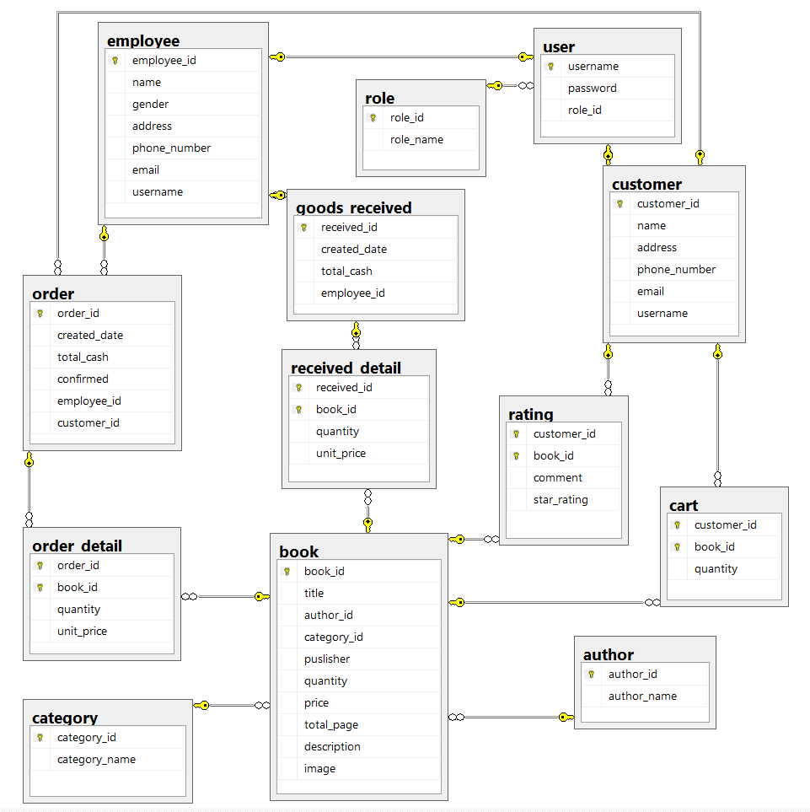

EMPLOYEE (EMPLOYEE_ID, NAME, GENDER, ADDRESS, PHONE_NUMBER, EMAIL, **USERNAME**)

CUSTOMER (CUSTOMER_ID, NAME, ADDRESS, PHONE_NUMBER, EMAIL, **USERNAME**)

AUTHOR (AUTHOR_ID, AUTHOR_NAME)

ROLE (ROLE_ID, ROLE_NAME)

USER (USERNAME, PASSWORD, **ROLE_ID**)

BOOK (BOOK_ID, BOOK_TITLE, **AUTHOR_ID, CATEGORY_ID**, PUBLISHER, INVENTORY, PRICE, TOTAL_PAGES, DESCRIPTION, IMAGE)

ORDER (ORDER_ID, CREATED_DATE, TOTAL_CASH, CONFIRMED, **EMPLOYEE_ID, CUSTOMER_ID**)

CATEGORY (CATEGORY_ID, CATEGORY_NAME)

GOODS_RECEIVED (RECEIVED_ID, CREATED_DATE, TOTAL_CASH, **EMPLOYEE_ID**)

CART (**CUSTOMER_ID**, **BOOK_ID**, QUANTITY)

RATING_DETAIL (**CUSTOMER_ID**, **BOOK_ID**, COMMENT, STAR_RATING)

ORDER_DETAIL (**ORDER_ID**, **BOOK_ID**, QUANTITY, UNIT_PRICE)

RECEIVED_DETAIL (**RECEIVED_ID**, **BOOK_ID**, QUANTITY, UNIT_PRICE)