**Multi-layer neural networks**

In this exercise, you'll write code to do forward propagation for a neural network with 2 hidden layers. Each hidden layer has two nodes. The input data has been preloaded as input_data. The nodes in the first hidden layer are called node_0_0 and node_0_1. Their weights are pre-loaded as weights['node_0_0'] and weights['node_0_1'] respectively.

The nodes in the second hidden layer are called node_1_0 and node_1_1. Their weights are pre-loaded as weights['node_1_0'] and weights['node_1_1'] respectively.

We then create a model output from the hidden nodes using weights pre-loaded as weights['output'].

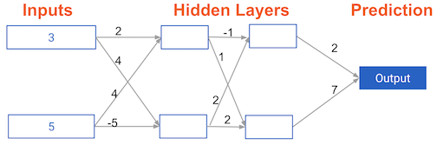

* Calculate node_0_0_input using its weights weights['node_0_0'] and the given input_data. Then apply the relu() function to get node_0_0_output.
* Do the same as above for node_0_1_input to get node_0_1_output.
* Calculate node_1_0_input using its weights weights['node_1_0'] and the outputs from the first hidden layer - hidden_0_outputs. Then apply the relu() function to get node_1_0_output.
* Do the same as above for node_1_1_input to get node_1_1_output.
* Calculate model_output using its weights weights['output'] and the outputs from the second hidden layer hidden_1_outputs array. Do not apply the relu() function to this output.