

CLINIC SYSTEM

Software Design Document

– Hanoi, January 2022 –

Table of Contents

I. Overview 8

1. Code Packages/Namespaces 8

2. Coding Conventions 9

II. Code Designs 9

1. Common/Login 9

a. Class Diagram 9

b. Class Specifications 9

c. Sequence Diagram 10

2. Common/Register 11

Class Diagram 11

Class Specification 11

Sequence Diagram 12

Database queries 12

3. Admin/Setting List 13

Class Diagram 13

Class Specification 13

Sequence Diagram 14

4. Admin/Setting Details 15

Class Diagram 15

Class Specification 15

Sequence Diagram 15

Database queries 17

5. Admin/Account List 17

Class Diagram 17

Class Specification 17

Sequence Diagram 18

Database queries 18

6. Admin/Account Detail 19

Class Diagram 19

Class Specification 19

Sequence Diagram 19

Database queries 20

7. Marketing/Patient Details 21

Class Diagram 21

Class Specification 21

Sequence Diagram 21

Database queries 22

8. Marketing/Patient edit 23

Class Diagram 23

Class Specification 23

Sequence Diagram 23

Database queries 24

8. Common/Forgot Password 25

Class Diagram 25

Class Specification 25

Sequence Diagram 26

Database queries 26

10. Common/ChangeChange Password 27

Class Diagram 27

Class Specification 27

Sequence Diagram 27

Database queries 28

11. Common/Web Blog List 29

Class Diagram 29

Class Specification 29

Sequence Diagram 29

Database queries 30

12. Common/Web Blog Details 31

Class Diagram 31

Class Specification 31

Sequence Diagram 31

Database queries 32

13. Marketing/Doctor List 33

Class Diagram 33

Class Specification 33

Sequence Diagram 34

Database queries 34

14. Marketing/Doctor Details 36

Class Diagram 36

Class Specification 36

Sequence Diagram 37

Database queries 37

cl15. Marketing/Doctor Edit 38

Class Diagram 38

Class Specification 38

Sequence Diagram 39

Database queries 39

16. Common/ User profile 39

17. Marketing/Patients list 42

18. Marketing/Service List 44

18. Marketing/Service Details 46

Class Diagram 46

Class Specification 47

Sequence Diagram 47

Database queries 49

19. Marketing/Service Feedbacks 50

Class Diagram 50

Class Specification 50

Sequence Diagram 50

Database queries 51

20. Marketing/Blog List 52

Class Diagram 52

Class Specification 52

Sequence Diagram 53

Database queries 53

21. Marketing/Blog Detail 55

Class Diagram 55

Class Specification 55

Sequence Diagram 55

Database queries 56

22. Public/Web Doctor List 57

Class Diagram 57

Class Specification 57

Sequence Diagram 58

Database queries 58

23. Public/Web Doctor Detail 60

Class Diagram 60

Class Specification 60

Sequence Diagram 61

Database queries 61

24. Staff/Appointments List 62

Class Diagram 62

Class Specification 62

Sequence Diagram 63

Database queries 63

25. Staff/Appointments Detail 65

bClass Diagram 65

Class Specification 65

Sequence Diagram 65

Database queries 66

26. Staff/Reservation List 67

Class Diagram 67

Class Specification 67

Sequence Diagram 68

Database queries 68

27. Staff/Reservation Detail 69

28. Public/Services List 72

Class Diagram 72

Class Specification 72

Sequence Diagram 73

29. Public/Service detail 75

Class Diagram 75

Class Specification 75

Sequence Diagram 75

30. Doctor/My Patients 77

Class Diagram 77

Class Specification 77

Sequence Diagram 77

Database queries 78

31. Doctor/My Patient Details 79

Class Diagram 79

Class Specification 79

Sequence Diagram 79

Database queries 80

32. Doctor/My Feedback 80

Class Diagram 80

33. Admin/Dashboard 81

Class Diagram 81

III. Database Design 81

1. Database Schema 81

2. Table Description 81

​​RECORD OF CHANGE

*A - ADDED M - MODIFIED D - DELETED

|  |  |  |  |  |
| --- | --- | --- | --- | --- |
| Effective Date | Changed Items | A*  M, D | Change Description | New Version |
| 12/1/2021 | Create new SRS | A | Create new | 1.0 |
| 17/01/2022 | Khương Văn Hùng | A | Home Page | 1.1 |
| 17/01/2022 | Phan Trương Thảo | A | User Login | 1.1 |
| 17/01/2022 | Trần Thành Lam | A | User Register | 1.1 |
| 17/01/2022 | Hà Hữu Việt | A | Settings List | 1.1 |
| 17/01/2022 | Nguyễn Văn Trung | A | Setting Details | 1.1 |
| 30/01/2022 | Khương Văn Hùng | M | Home Page | 1.2 |
| 30/01/2022 | Phan Trương Thảo | M | User Login | 1.2 |
| 30/01/2022 | Trần Thành Lam | M | User Register | 1.2 |
| 30/01/2022 | Hà Hữu Việt | M | Settings List | 1.2 |
| 30/01/2022 | Nguyễn Văn Trung | M | Setting Details | 1.2 |
| 30/01/2022 | Trần Thành Lam | A | Web Blogs List | 1.2 |
| 30/01/2022 | Trần Thành Lam | A | Web Blog Details | 1.2 |
| 30/01/2022 | Phan Trương Thảo | A | Forgot Password | 1.2 |
| 30/01/2022 | Phan Trương Thảo | A | Change Password | 1.2 |
| 30/01/2022 | Hà Hữu Việt | A | User Profile | 1.2 |
| 30/01/2022 | Hà Hữu Việt | A | Patients List | 1.2 |
| 30/01/2022 | Nguyễn Văn Trung | A | Patient Details | 1.2 |
| 30/01/2022 | Nguyễn Văn Trung | A | Patient Edit | 1.2 |
| 30/01/2022 | Đinh Thị Tươi | A | Accounts List | 1.2 |
| 30/01/2022 | Đinh Thị Tươi | A | Account Details | 1.2 |
| 30/01/2022 | Khương Văn Hùng | A | Doctors List | 1.2 |
| 30/01/2022 | Khương Văn Hùng | A | Doctor Details | 1.2 |
| 30/01/2022 | Khương Văn Hùng | A | Doctor Edit | 1.2 |
| 25/2/2022 | Phan Trương Thảo | A | Web Doctors List | 1.3 |
| 25/2/2022 | Phan Trương Thảo | A | Web Doctor Details | 1.3 |
| 25/2/2022 | Hà Hữu Việt | A | Web Services List | 1.3 |
| 25/2/2022 | Hà Hữu Việt | A | Web Service Details | 1.3 |
| 25/2/2022 | Khương Văn Hùng | A | Appointments List | 1.3 |
| 25/2/2022 | Khương Văn Hùng | A | Appointment Details | 1.3 |
| 25/2/2022 | Khương Văn Hùng | A | Reservations List | 1.3 |
| 25/2/2022 | Đinh Thị Tươi | A | Reservation Details | 1.3 |
| 25/2/2022 | Đinh Thị Tươi | A | Services List | 1.3 |
| 25/2/2022 | Nguyễn Văn Trung | A | Service Details | 1.3 |
| 25/2/2022 | Nguyễn Văn Trung | A | Service Feedbacks | 1.3 |
| 25/2/2022 | Trần Thành Lam | A | Blogs List | 1.3 |
| 25/2/2022 | Trần Thành Lam | A | Blog Details | 1.3 |
| 10/03/2022 | Phan Trương Thảo | A | User Authorization | 1.4 |
| 10/03/2022 | Khương Văn Hùng | A | Dashboard | 1.4 |
| 10/03/2022 | Hà Hữu Việt | A | My Appointments | 1.4 |
| 10/03/2022 | Hà Hữu Việt | A | My Appointment Details | 1.4 |
| 10/03/2022 | Nguyễn Văn Trung | A | My Patients | 1.4 |
| 10/03/2022 | Nguyễn Văn Trung | A | My Patient Details | 1.4 |
| 10/03/2022 | Phan Trương Thảo | A | My Feedbacks | 1.4 |
| 10/03/2022 | Trần Thành Lam | A | Book Appointment | 1.4 |
| 10/03/2022 | Trần Thành Lam | A | Reserve a Service | 1.4 |
| 10/03/2022 | Đinh Thị Tươi | A | Appointment History | 1.4 |
| 10/03/2022 | Đinh Thị Tươi | A | Reservation History | 1.4 |
| 10/03/2022 | Khương Văn Hùng | A | Appointment,Reservation payment | 1.4 |

# I. Overview

## 1. Code Packages/Namespaces

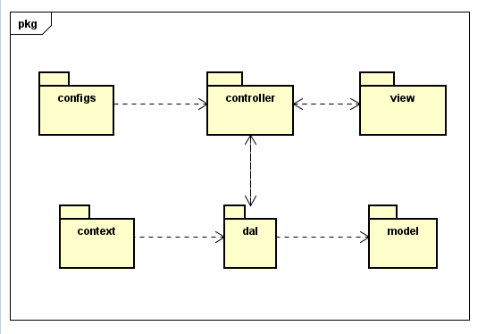

*Package descriptions & package class naming conventions*

|  |  |  |
| --- | --- | --- |
| No | Package | Description |
| 1 | controller | Acts as a go-between for the service layer and the Front-end, passing on different input requests |
| 2 | dal | This component is used to get data directly FROM the database |
| 3 | configs | This component helps define configuration |
| 4 | context | This component helps connect database |
| 5 | model | This component includes interfaces used to receive data retrieved FROM the database and classes used to receive data |
| 6 | view | This component display front-end. |

# II. Code Designs

## 1. Common/Login

### a. Class Diagram

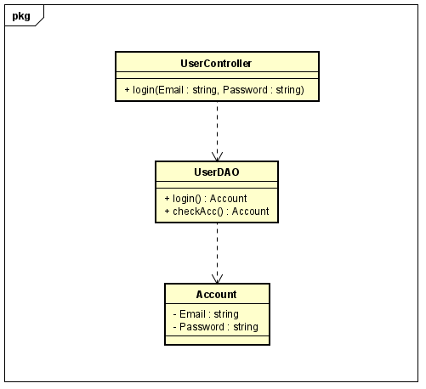

### b. Class Specifications

#### 

|  |  |  |
| --- | --- | --- |
| No | Method | Description |
| 01 | login | Using to login into the system |
|  | checkAcc | Using to check account in database |

### c. Sequence Diagram

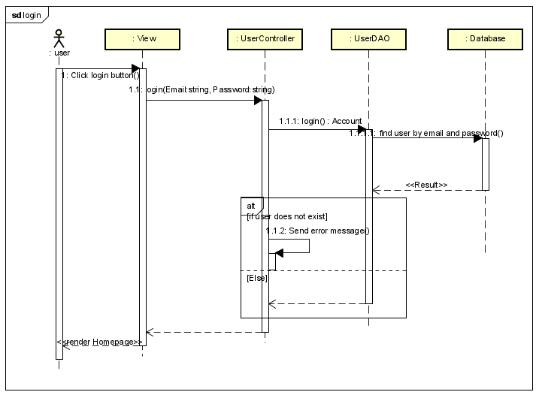d.

d. Database queries

String sql = "SELECT * FROM users where email=? or username=?"

## 2. Common/Register

### Class Diagram

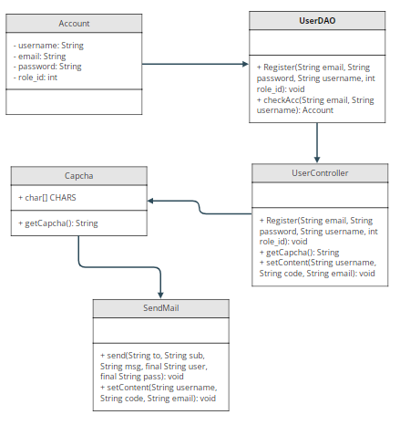

### Class Specification

|  |  |  |
| --- | --- | --- |
| No | Method | Description |
| 1 | Register | use to create new user |
| 2 | checkAcc | use to check username or email exist |
| 3 | getCapcha | get a random string |
| 4 | send | send mail to user |
| 5 | setContent | set email and username that user use to register to send |

### Sequence Diagram

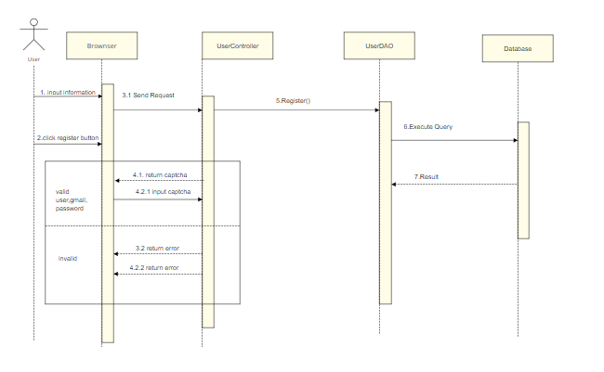

### Database queries

* SELECT * FROM users WHERE email=? OR username=?
* INSERT INTO `doctris_system`.`users` (`username`, `password`, `email`, `role_id`) VALUES (?, ?, ?, ?)

## 3. Admin/Setting List

## Class Diagram

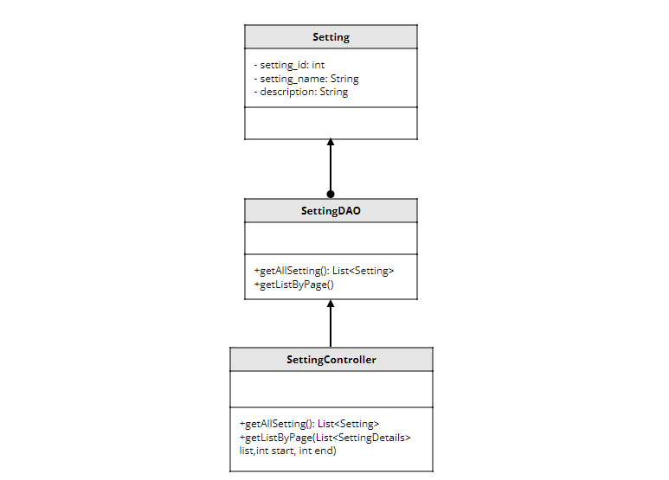

### Class Specification

|  |  |  |
| --- | --- | --- |
| No | Method | Description |
| 1 | getAllSetting | use to list setting |
| 2 | getListByPage | use to pagination |

### Sequence Diagram

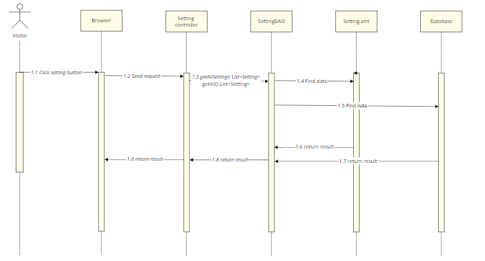

1. Database queries

* SELECT * FROM setting
* SELECT * FROM doctris_system.role

UNION

SELECT * FROM doctris_system.category_blog

UNION

SELECT * FROM doctris_system.category_service

## 4. Admin/Setting Details

### Class Diagram

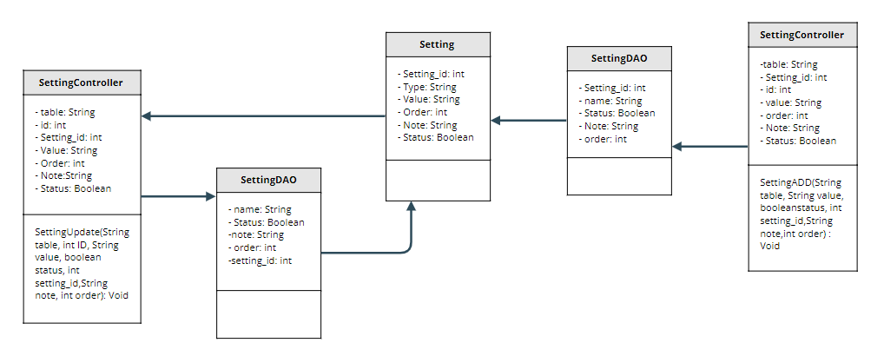

### Class Specification

|  |  |  |
| --- | --- | --- |
| No | Method | Description |
| 1 | SettingADD | use to create new setting |
| 2 | SettingUpdate | use to update setting |

### Sequence Diagram

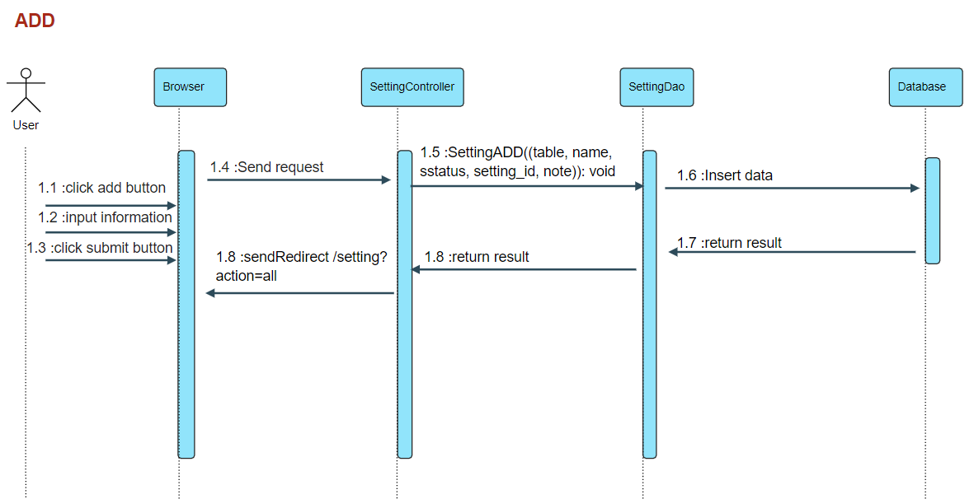

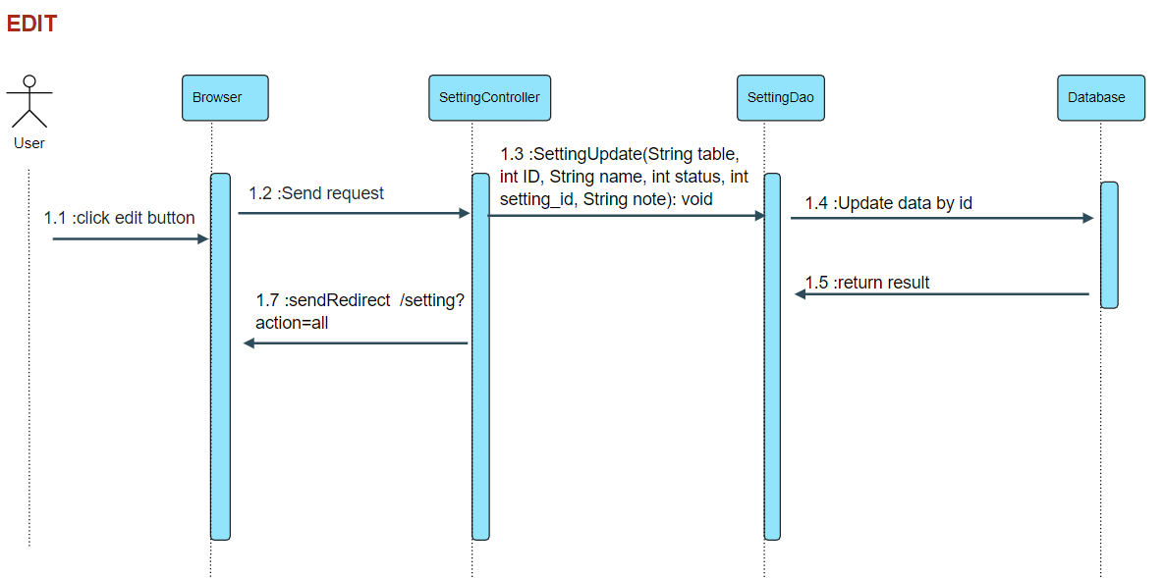

### Database queries

* INSERT INTO category_blog `name`, `setting_id`, `status`, `note`, `status` VALUES (?, ?, ?, ?)
* INSERT INTO category_service `name`, `setting_id`, `status`, `note` , `status`VALUES (?, ?, ?, ?)
* INSERT INTO role `name`, `setting_id`, `status`, `note` , `status`VALUES (?, ?, ?, ?)
* UPDATE category_blog SET name = ?, setting_id = ?, status = ?, note = ? , r.order = ? WHERE (id = ?)
* UPDATE category_service SET name = ?, setting_id = ?, status = ?, note = ? , r.order = ? WHERE (id = ?)
* UPDATE role SET name = ?, setting_id = ?, status = ?, note = ? , r.order = ? WHERE (id = ?)

## 5. Admin/Account List

### Class Diagram

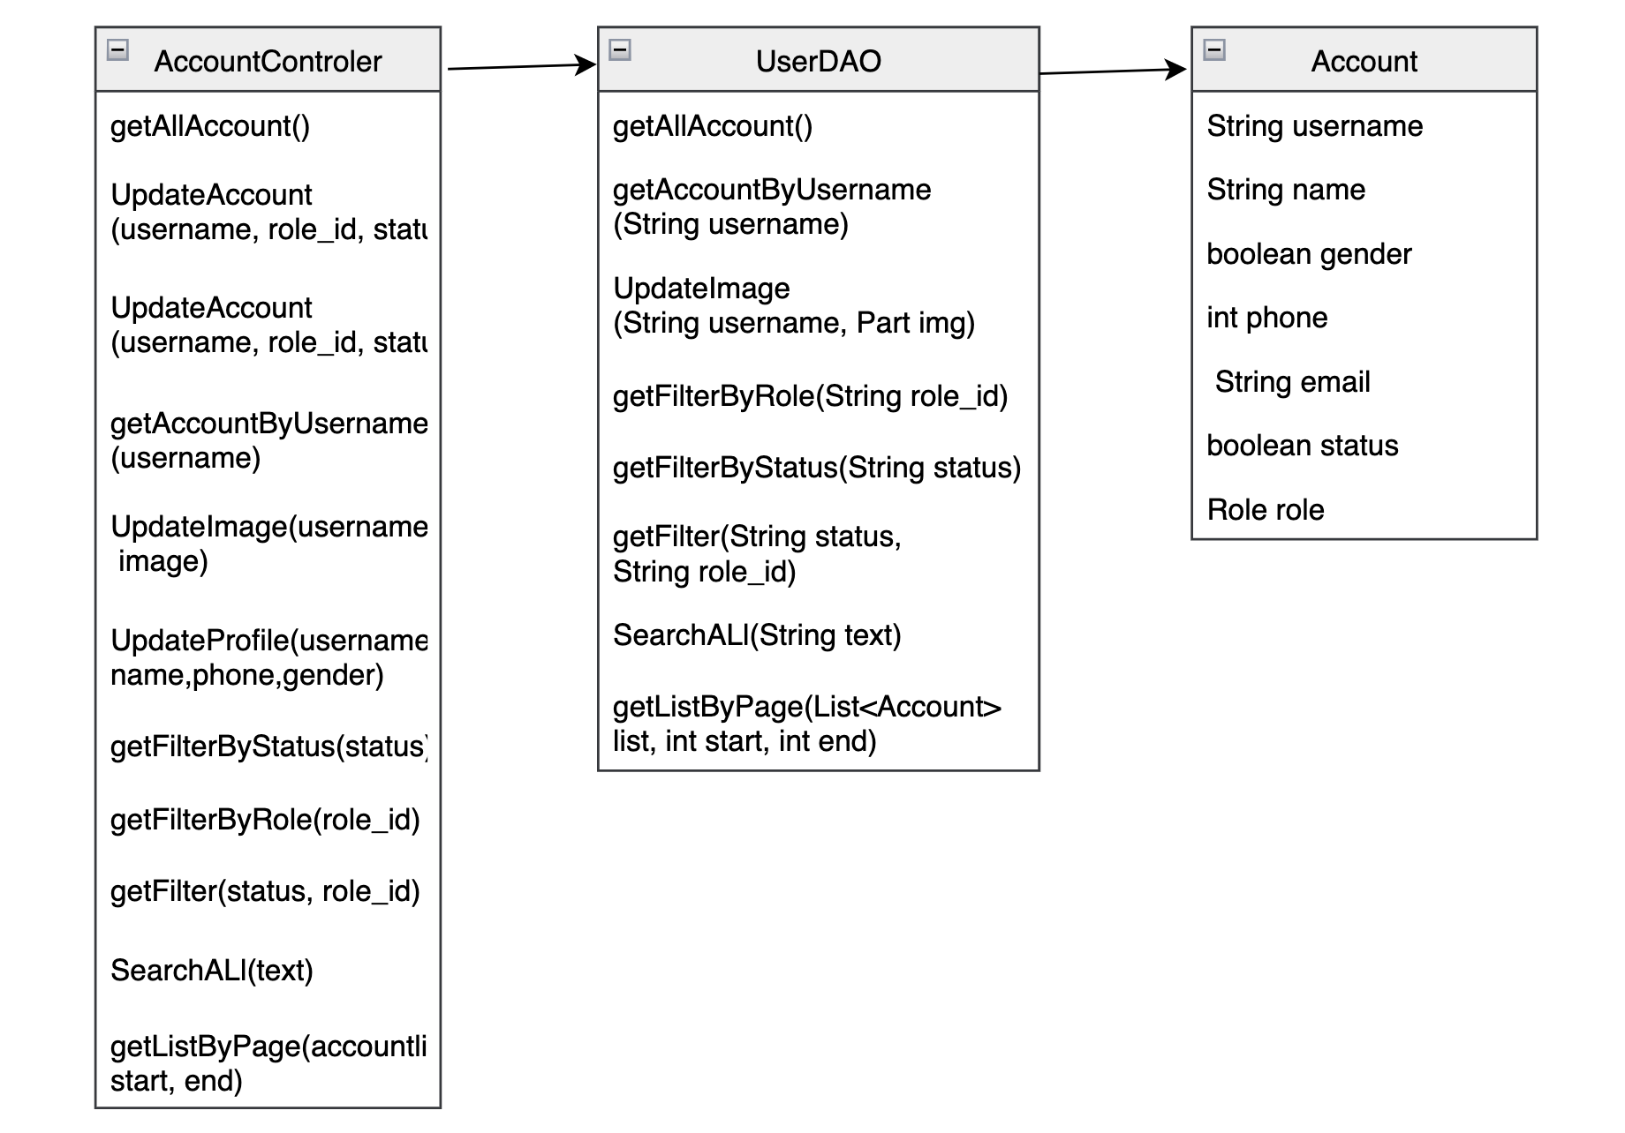

### Class Specification

|  |  |  |
| --- | --- | --- |
| No | Method | Description |
| 1 | getAllAccount | Show list account of user |
| 2 | getAccountByUseName | Search account by username |
| 3 | getListByPage | Show 8 row in a page |

### Sequence Diagram

Show all account in Account list function

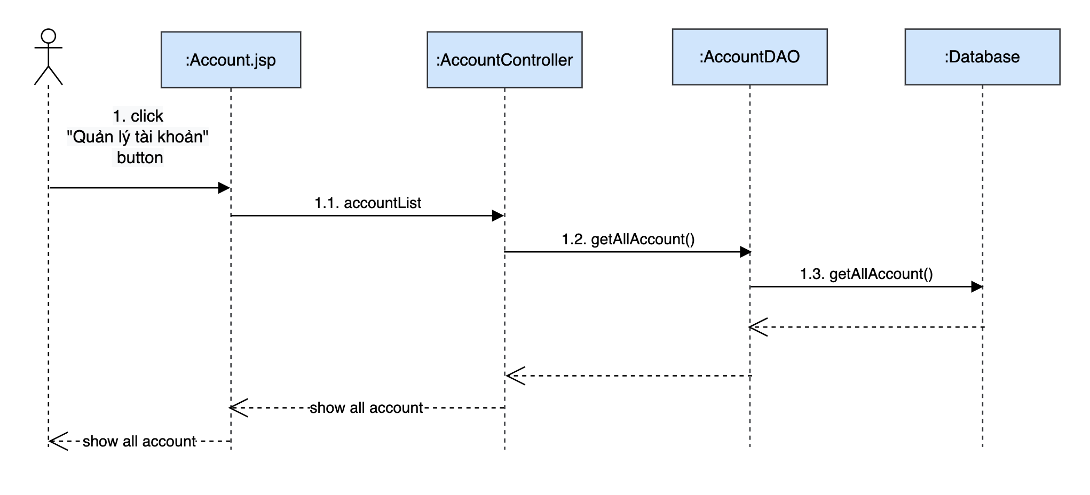

### Database queries

* SELECT u.username,u.name,u.gender,u.email,u.phone,r.name,u.status,u.img FROM doctris_system.users u inner join doctris_system.role r on u.role_id = r.id
* SELECT u.username,u.name,u.gender,u.email,u.phone,r.name,u.status,u.img FROM doctris_system.users u inner join doctris_system.role r on u.role_id = r.id where u.role_id = ?
* SELECT u.username,u.name,u.gender,u.email,u.phone,r.name,u.status,u.img FROM doctris_system.users u inner join doctris_system.role r on u.role_id = r.id where u.status = ?SE
* SELECT u.username,u.name,u.gender,u.email,u.phone,r.name,u.status,u.img FROM doctris_system.users u inner join doctris_system.role r on u.role_id = r.id
* SELECT u.username,u.name,u.gender,u.email,u.phone,r.name,u.status,u.img FROM doctris_system.users u inner join doctris_system.role r on u.role_id = r.id where u.role_id = ?
* SELECT u.username,u.name,u.gender,u.email,u.phone,r.name,u.status,u.img FROM doctris_system.users u inner join doctris_system.role r on u.role_id = r.id where u.status = ?SE
* SELECT DISTINCT u.username,u.name,u.gender,u.email,u.phone,r.name,u.status,u.img FROM doctris_system.users u inner join doctris_system.role r on u.role_id = r.id where u.name LIKE ? OR u.email LIKE ? OR u.phone LIKE ? OR u.username LIKE ?
* UPDATE `doctris_system`.`users` SET `role_id` = ?, `status` = ? WHERE (`username` = ?)

## 6. Admin/Account Detail

### Class Diagram

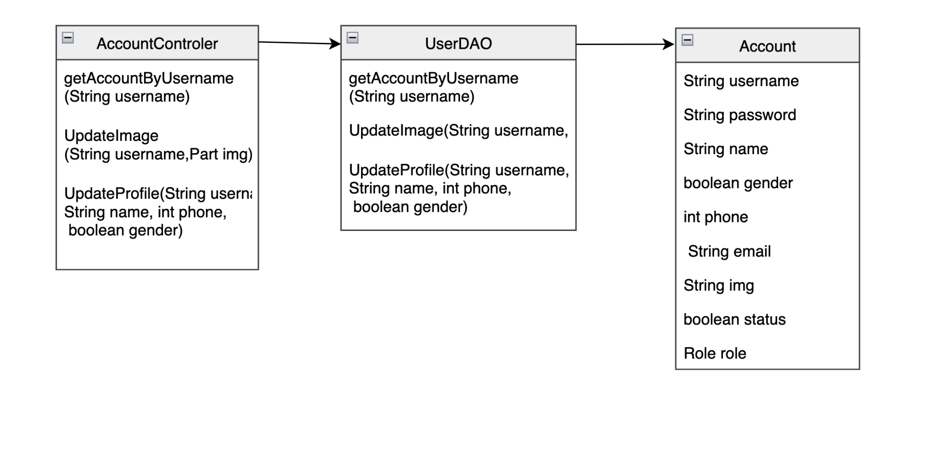

### Class Specification

|  |  |  |
| --- | --- | --- |
| No | Method | Description |
| 1 | getAccountByUseName | Search account by username |
| 2 | UpdateImage | Update image of user |
| 3 | Updateprofile | Update profile of user in account detail |

### Sequence Diagram

show detail profile of user on “Quản lý tài khoản” function

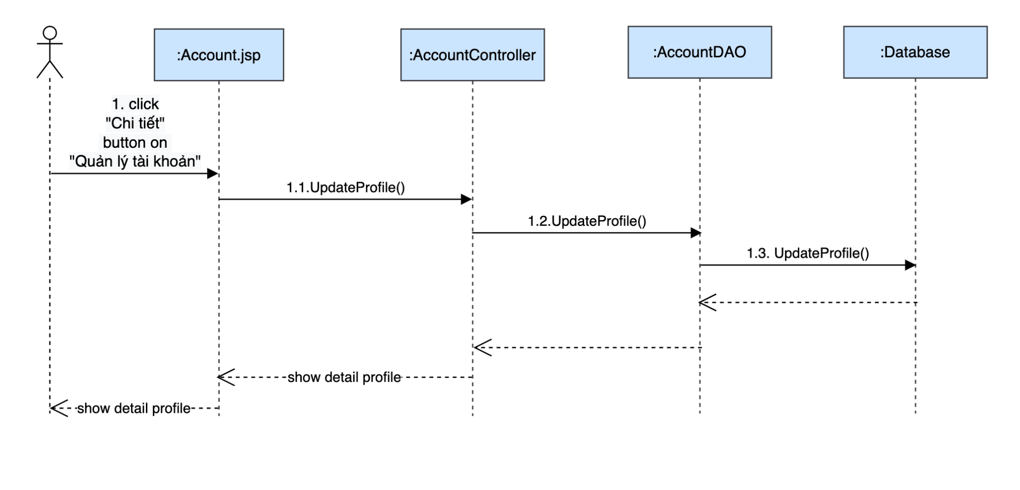

Perform update image user profile

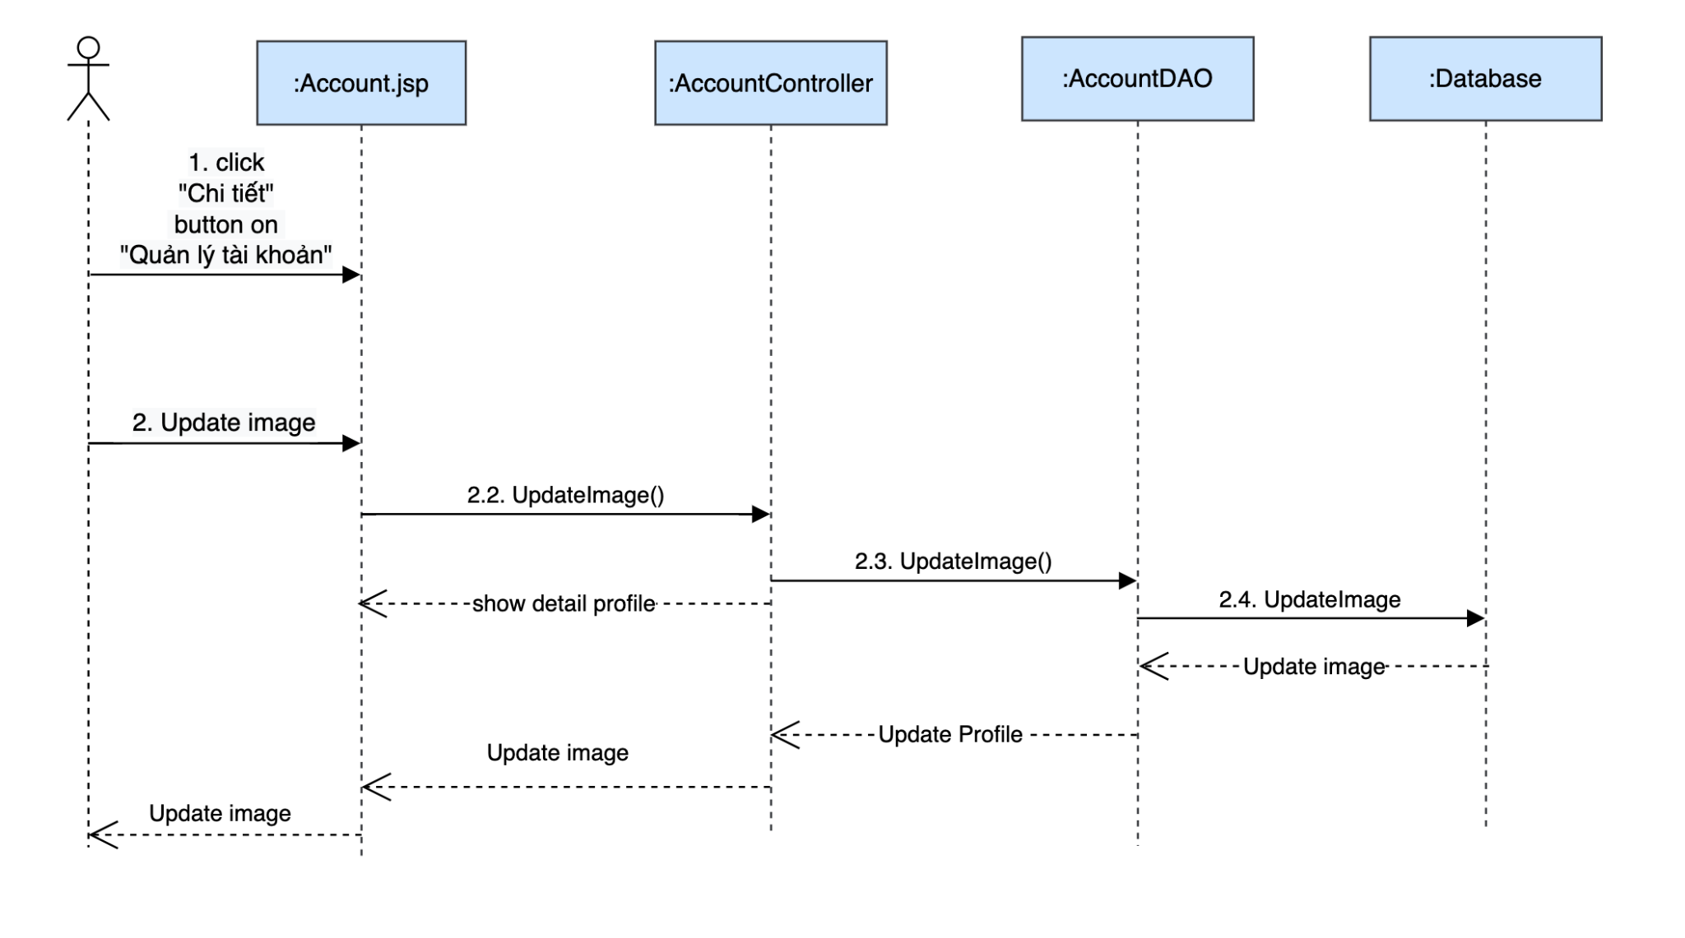

### Database queries

* UPDATE `doctris_system`.`users` SET `img` = ? WHERE (`username` = ?)
* UPDATE `doctris_system`.`users` SET `name` = ?, `phone` = ?, `gender` = ? WHERE (`username` = ?)

## 7. Marketing/Patient Details

### Class Diagram

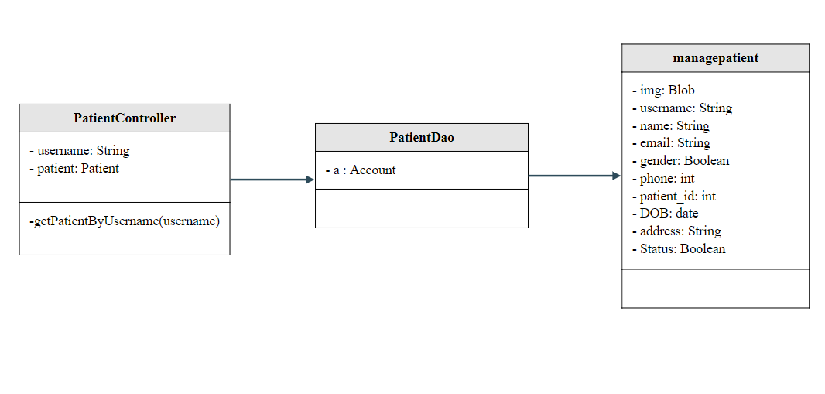

### Class Specification

|  |  |  |
| --- | --- | --- |
| No | Method | Description |
| 1 | getPatientByUsername | used to list the details of that exact patient |

### Sequence Diagram

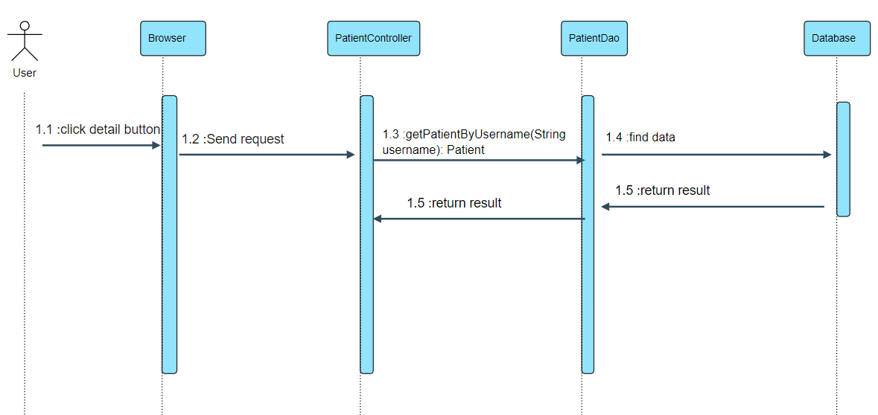

### Database queries

* SELECT u.img, u.username,u.name,u.email,u.gender,u.phone,p.patient_id,p.DOB,p.address,p.status FROM patient p inner join users u

on p.username = u.username

where u.username = ?

## 8. Marketing/Patient edit

### Class Diagram

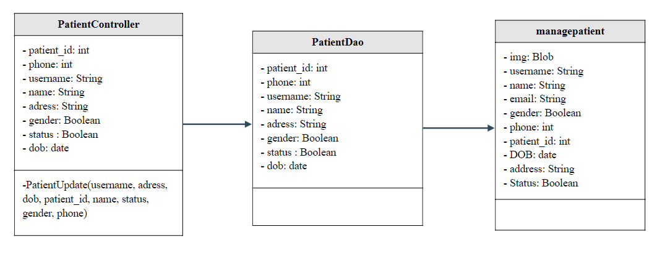

### Class Specification

|  |  |  |
| --- | --- | --- |
| No | Method | Description |
| 1 | PatientUpdate | use to update Patient |

### Sequence Diagram

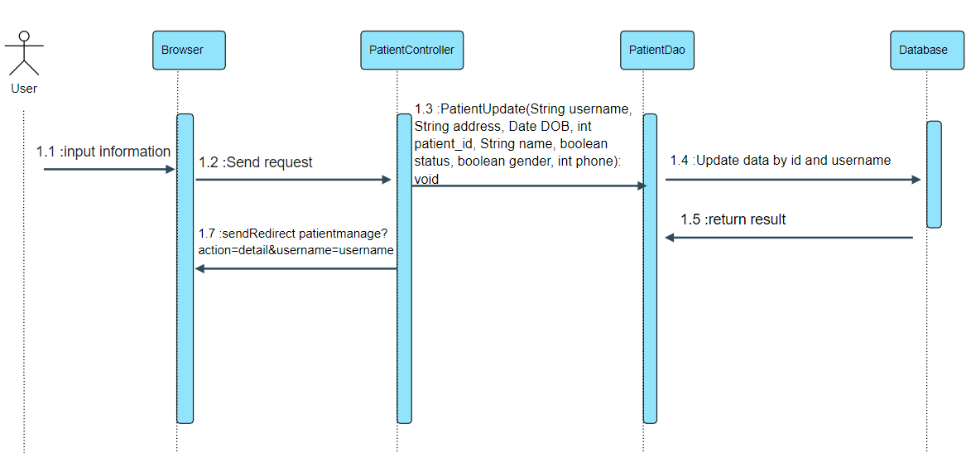

### Database queries

* UPDATE `doctris_system`.`patient`

SET

`address` = ?,

`DOB` = ?,

`status` = ?

WHERE `patient_id` = ?

* UPDATE `doctris_system`.`users`

SET

`name` = ?,

`gender` = ?,

`phone` = ?

WHERE `username` = ?

## 8. Common/Forgot Password

### Class Diagram

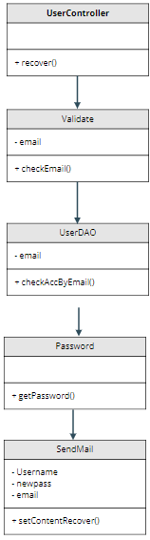

### Class Specification

|  |  |  |
| --- | --- | --- |
| No | Method | Description |
| 1 | recover | using to forgot password |
| 2 | checkEmail | using to check validate email |
| 3 | checkAccByEmail | using to check exist email |
| 4 | getPassword | using to create password randomrandom |
| 5 | setContentRecover | using to send newpassword |

### Sequence Diagram

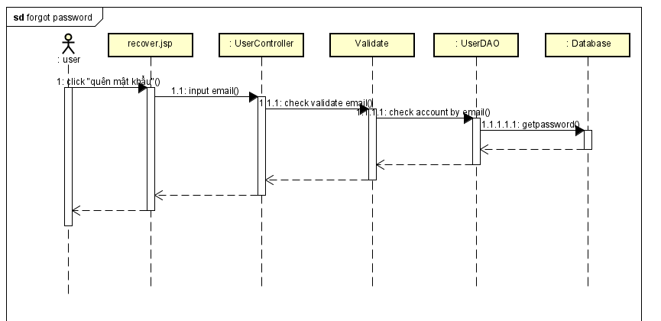

### Database queries

* String sql = "UPDATE `doctris_system`.`users` SET `password` = ? WHERE (`username` = ?)";
* String sql = "SELECT * FROM users where email=?";

## 10. Common/ChangeChange Password

### Class Diagram

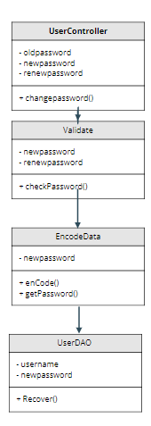

### Class Specification

|  |  |  |
| --- | --- | --- |
| No | Method | Description |
| 1 | changepassword | using to change password |
| 2 | checkPassword | using to check validate passwordpassword |
| 3 | enCode | using to encode password |
| 4 | getPassword | using to update password |
| 5 | Recover | using to save password |

### Sequence Diagram

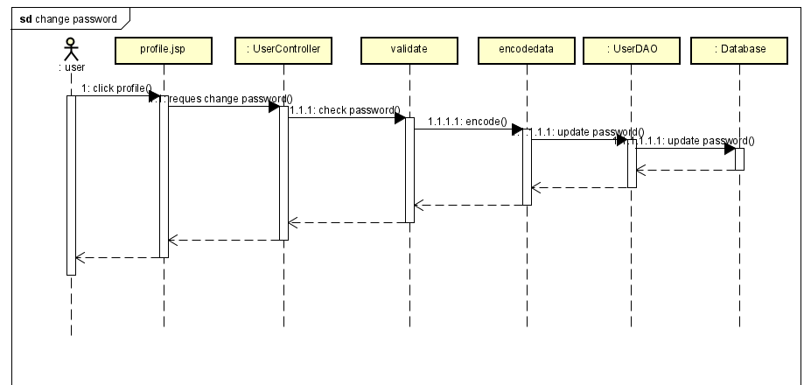

### Database queries

* String sql = "UPDATE `doctris_system`.`users` SET `password` = ? WHERE (`username` = ?)";

## 11. Common/Web Blog List

### Class Diagram

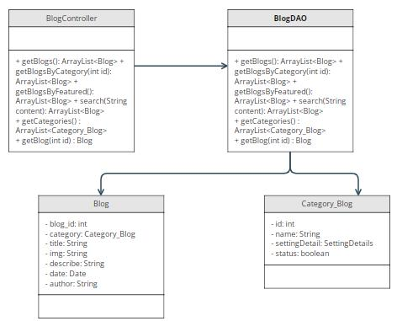

### Class Specification

|  |  |  |
| --- | --- | --- |
| No | Method | Description |
| 1 | getBlogs | get all blog in database order by date |
| 2 | getCategories | get all categories in database |
| 3 | getBlog | get blog by blog id |
| 4 | getBlogBy Featured | get blog which featured |
| 5 | search | get blog that having or contain keyword in its title |
| 6 | getBlogByCategory | get blog in the same category |

### Sequence Diagram

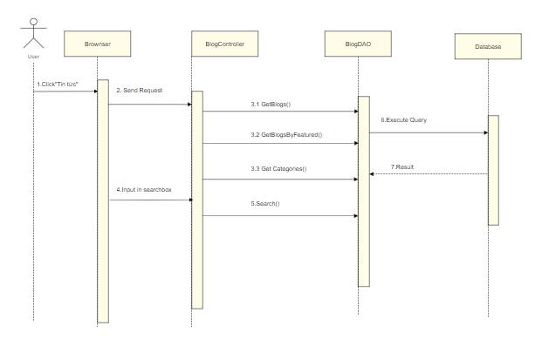

### Database queries

* SELECT blog.*, category_blog.name FROM blog

inner join category_blog

on blog.category_id = category_blog.id

order by date desc

* SELECT blog.*, category_blog.name FROM blog

inner join category_blog

on blog.category_id = category_blog.id

where blog_id = ?

order by date desc

* SELECT blog.*, category_blog.name FROM blog

inner join category_blog

on blog.category_id = category_blog.id

where category_id = ?

order by date desc

* Select * FROM blog where featured = 1 ;
* SELECT * FROM blog WHERE title LIKE ? ORDER BY date desc
* SELECT * FROM category_blog;

## 12. Common/Web Blog Details

### Class Diagram



### Class Specification

|  |  |  |
| --- | --- | --- |
| No | Method | Description |
| 1 | getCategories | get all categories in database |
| 2 | getBlog | get blog by blog id |
| 3 | getBlogBy Featured | get blog which featured |
| 4 | search | get blog that having or contain keyword in its title |
| 5 | getBlogByCategory | get blog in the same category |

### Sequence Diagram

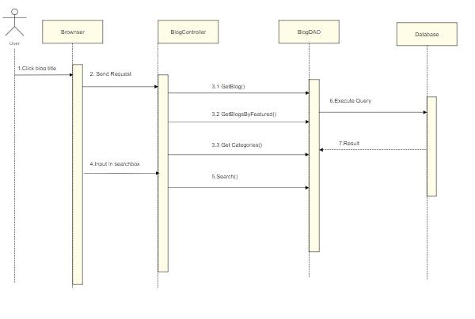

### Database queries

* SELECT blog.*, category_blog.name FROM blog

inner join category_blog

on blog.category_id = category_blog.id

where blog_id = ?

order by date desc

* SELECT blog.*, category_blog.name FROM blog

inner join category_blog

on blog.category_id = category_blog.id

where category_id = ?

order by date desc

* Select * FROM blog where featured = 1 ;
* SELECT * FROM blog WHERE title LIKE ? ORDER BY date desc
* SELECT * FROM category_blog;

## 13. Marketing/Doctor List

### Class Diagram

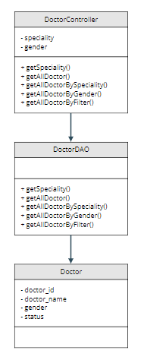

### Class Specification

|  |  |  |
| --- | --- | --- |
| No | Method | Description |
| 1 | getSpeciality |  |
| 2 | getAllDoctor |  |
| 3 | getAllDoctorBySpeciality |  |
| 4 | getAllDoctorByGender |  |
| 5 | getAllDoctorByFilter |  |

### Sequence Diagram

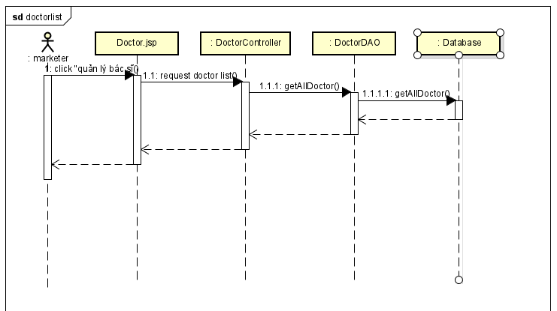

### Database queries

* String sql = "select * from doctris_system.category_service";
* String sql = "select cs.name, d.doctor_id,d.doctor_name,d.gender,d.status "

from doctris_system.doctor d "

inner join doctris_system.category_service cs "

on d.category_id = cs.id";

* String sql = "select cs.name, d.doctor_id,d.doctor_name,d.gender,d.status "

from doctris_system.doctor d "

inner join doctris_system.category_service cs "

on d.category_id = cs.id where d.category_id = ?";

* String sql = "select cs.name, d.doctor_id,d.doctor_name,d.gender,d.status "

from doctris_system.doctor d "

inner join doctris_system.category_service cs "

on d.category_id = cs.id where d.gender = ?";

* String sql = "select cs.name, d.doctor_id,d.doctor_name,d.gender,d.status "

from doctris_system.doctor d "

inner join doctris_system.category_service cs "

on d.category_id = cs.id where d.gender = ? and d.category_id = ?";

## 14. Marketing/Doctor Details

### Class Diagram

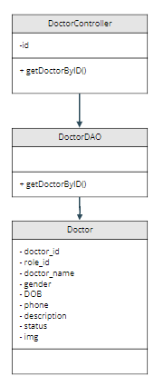

### Class Specification

|  |  |  |
| --- | --- | --- |
| No | Method | Description |
|  | getDoctorByID |  |

### Sequence Diagram

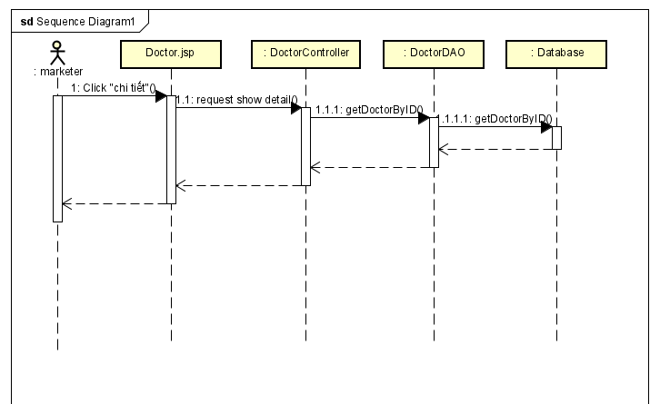

### Database queries

String sql = "select cs.name,d.doctor_id,d.role_id,d.doctor_name,d.username,"

d.gender,d.DOB,d.phone,d.description,d.status,d.img,u.email "

from doctris_system.doctor d "

inner join doctris_system.category_service cs on d.category_id = cs.id "

inner join doctris_system.users u on d.username = u.username "

where d.doctor_id = ?";

## cl15. Marketing/Doctor Edit

### Class Diagram

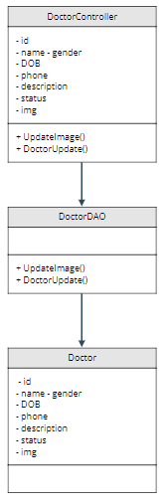

### Class Specification

|  |  |  |
| --- | --- | --- |
| No | Method | Description |
| 1 | UpdateImage |  |
| 2 | DoctorUpdate |  |

### Sequence Diagram

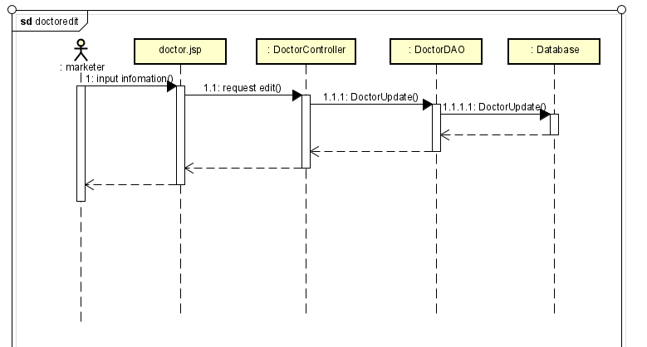

### Database queries

## 16. Common/ User profile

1. Class diagram

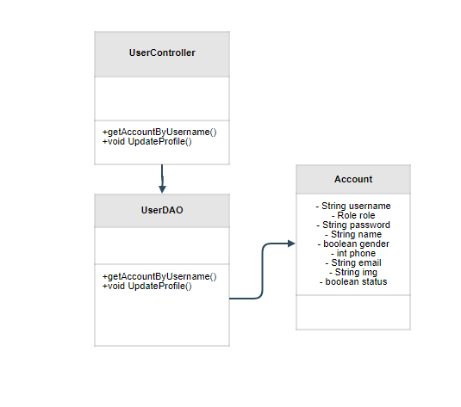

1. Class Specification

|  |  |  |
| --- | --- | --- |
| No | Method | Description |
| 1 | getAccountByUsername | use to find account profile by it’s username |
| 2 | UpdateProfile | use to update user’s profile |

1. Sequence diagram

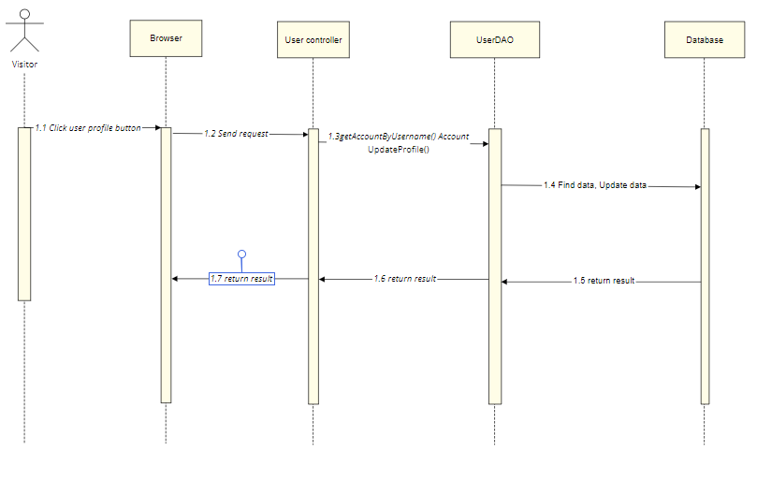

1. Database queries

* UPDATE `doctris_system`.`users` SET `role_id` = ?, `status` = ?

WHERE (`username` = ?)

* SELECT u.username,u.name,u.gender,u.email,u.phone,r.name,u.status,u.img

FROM doctris_system.users u

inner join doctris_system.role r

on u.role_id = r.id where u.username = ?

## 17. Marketing/Patients list

1. Class diagram

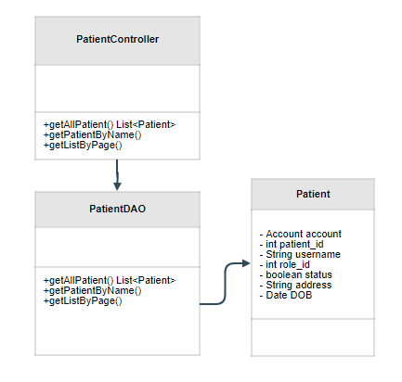

1. Class Specification

|  |  |  |
| --- | --- | --- |
| No | Method | Description |
| 1 | getAllPatient | use to list Patients |
| 2 | getPatientByName | use to find Patient by name |
| 3 | getListByPage | use to pagination |

1. Sequence diagram

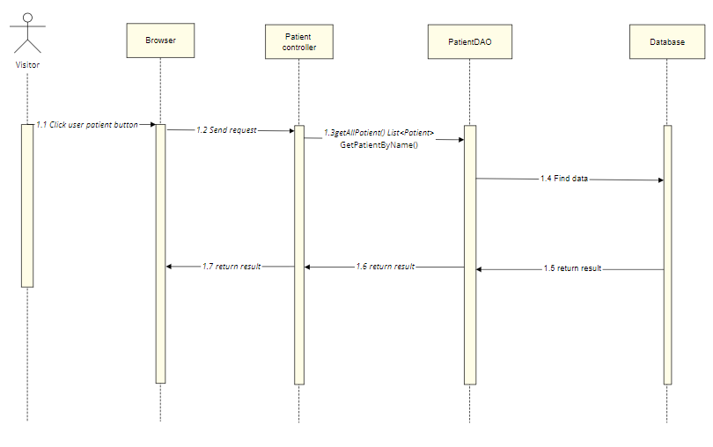

1. Database queries

* SELECT p.patient_id,u.username,u.name,u.gender,p.DOB,p.status

FROM doctris_system.patient p

INNER JOIN doctris_system.users u

ON p.username = u.username

* SELECT u.img, u.username, u.name, u.email, u.gender, u.phone, p.patient_id, p.DOB, p.address, p.status

FROM patient p

INNER JOIN users u

ON p.username = u.username

WHERE u.username = ?

## 18. Marketing/Service List

1. Class Diagram

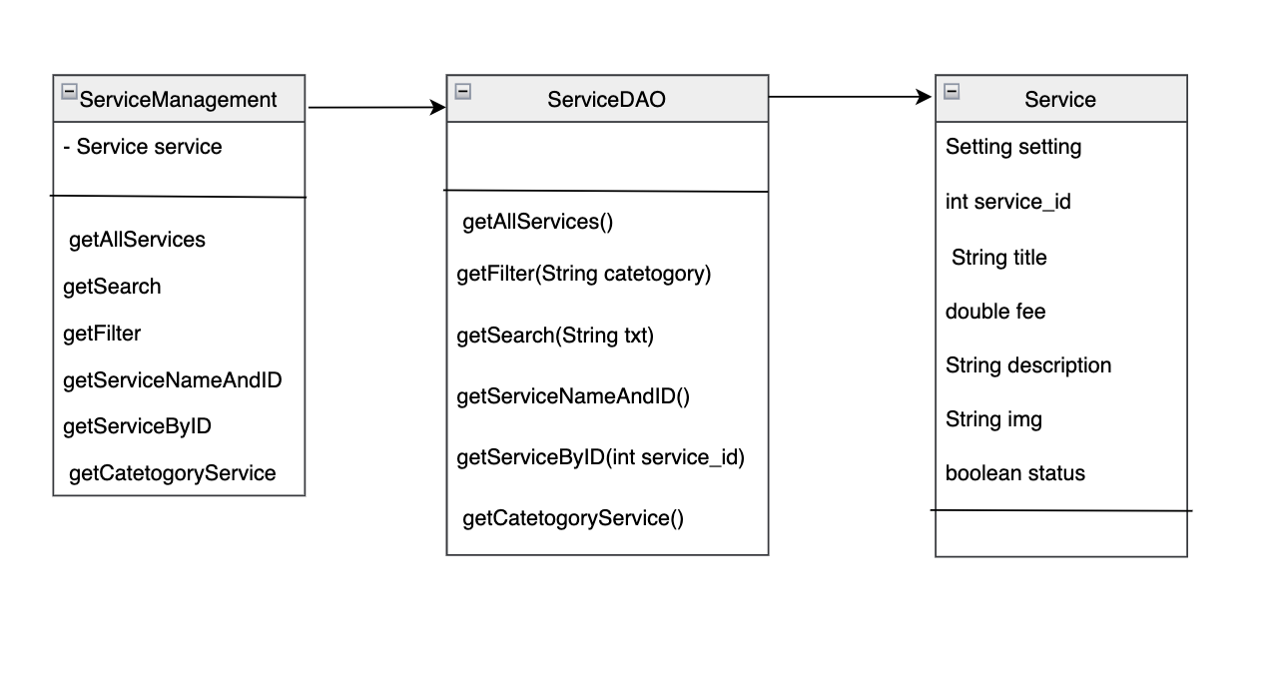

1. Class Specification

|  |  |  |
| --- | --- | --- |
| No | Method | Description |
| 1 | getAllServices | show list service in system includes: ID, ServiceName, type, cost, status |
| 2 | getFilter | Perform search service by category |
| 3 | getSearch | User input to search box |
| 4 | getServiceNameAndID | Search service by name |
| 5 | getServiceByID | Search service by id |
| 6 | getCatetogoryService | Search service by catefory |

1. Sequence Diagram

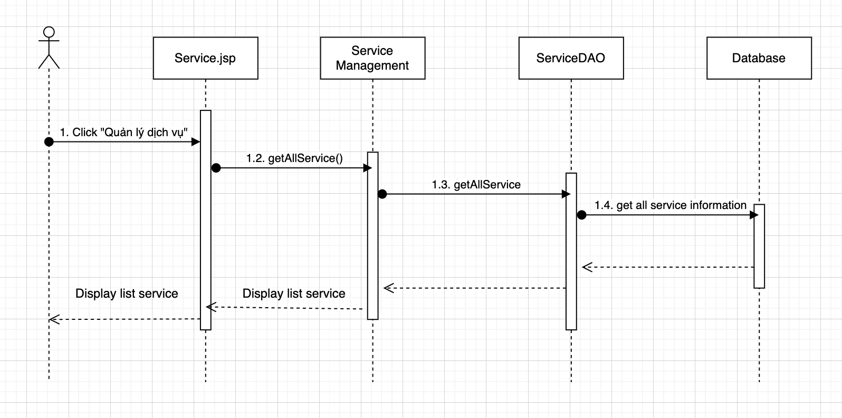

1. Database Query

SELECT service.service_id, service.title, category_service.name,

service.fee, service.status FROM service inner join

category_service on service.category_id = category_service.id

order by service.service_id asc

SELECT service.service_id, service.title, category_service.name,

service.fee, service.status FROM service inner join "

category_service on service.category_id = category_service.id where service.category_id = ?

order by service.service_id asc

SELECT service.service_id, service.title, category_service.name,

service.fee, service.status FROM service inner join

category_service on service.category_id = category_service.id where service.title like ?

order by service.service_id asc

select * from doctris_system.category_service

UPDATE `doctris_system`.`service` SET `status` = ? WHERE (`service_id` = ?)

## 18. Marketing/Service Details

### Class Diagram

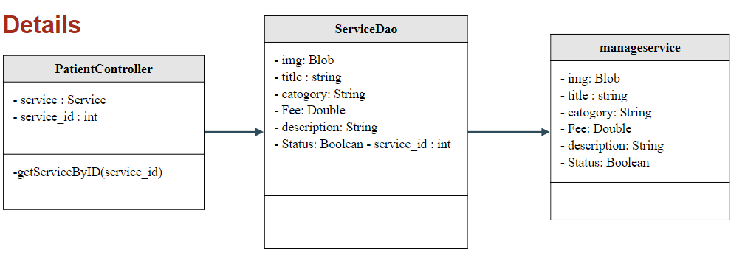

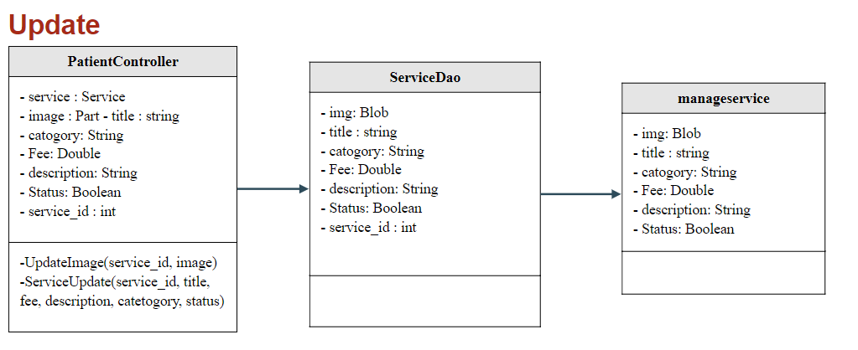

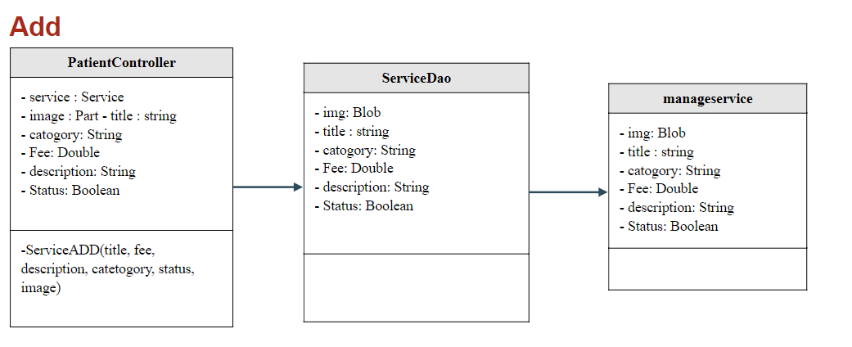

### Class Specification

|  |  |  |
| --- | --- | --- |
| No | Method | Description |
| 1 | getServiceByID | using to view detail service |
| 2 | getCategory Service | using to view category service |
| 3 | ServiceUpdate | using to update information service |
| 4 | ServiceADD | using to add new service |
| 5 | UpdateImage | using to update image service |

### Sequence Diagram

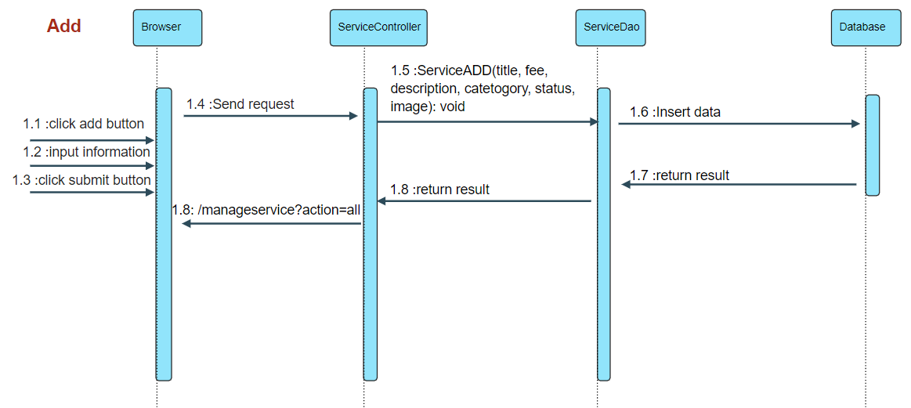

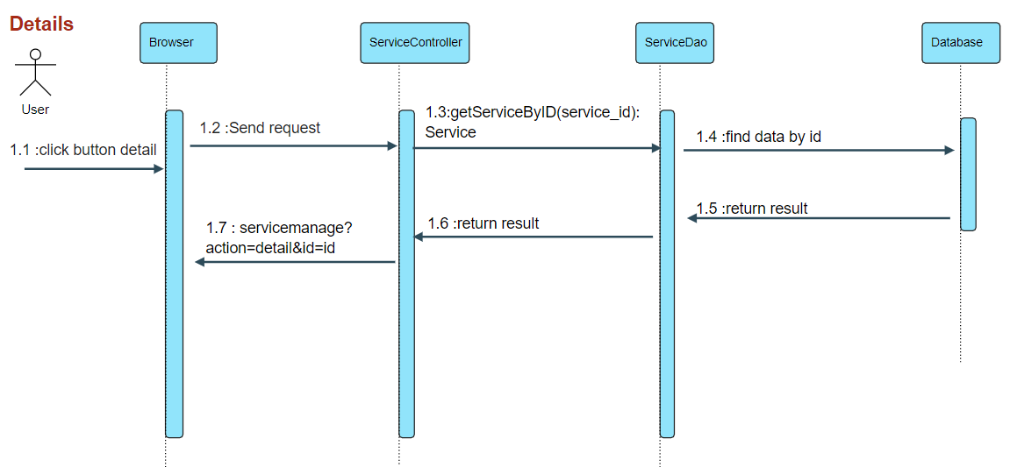

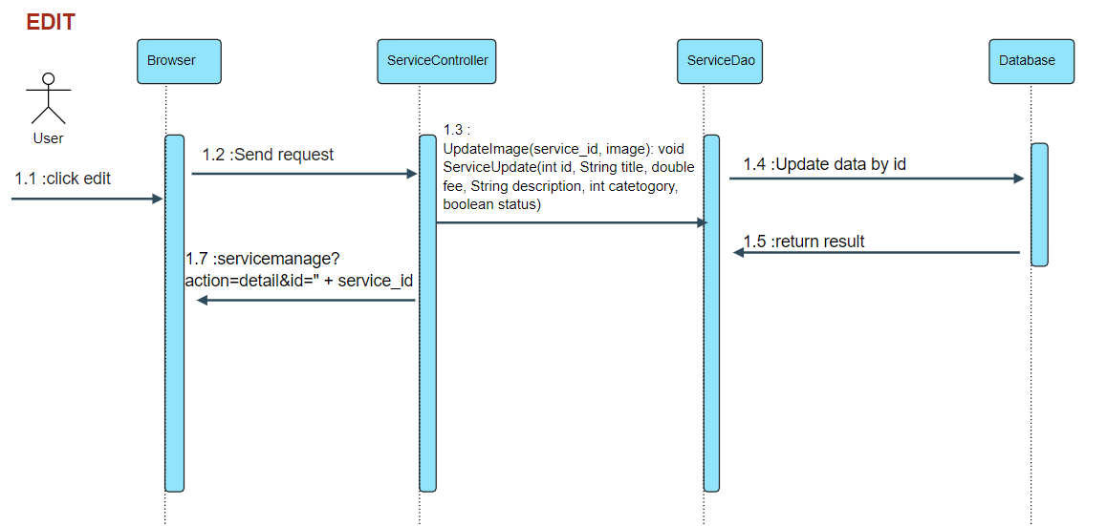

### Database queries

* SELECT c.name,s.status,s.service_id,s.title, s.fee,s.description,s.img FROM service s inner join category_service c

on s.category_id = c.id

where s.service_id = ?

* select * from doctris_system.category_service
* UPDATE `doctris_system`.`service` set

`img` = ?

WHERE `service_id` = ?

* UPDATE `doctris_system`.`service` set

`category_id` = ?,

`title` = ?,

`fee` = ?,

`description` = ?,

`status` = ?

WHERE `service_id` = ?

* INSERT INTO `doctris_system`.`service`

(`category_id`,`title`,`fee`,`description`,`img`,`status`)

VALUES(?,?,?,?,?,?)

## 19. Marketing/Service Feedbacks

### Class Diagram

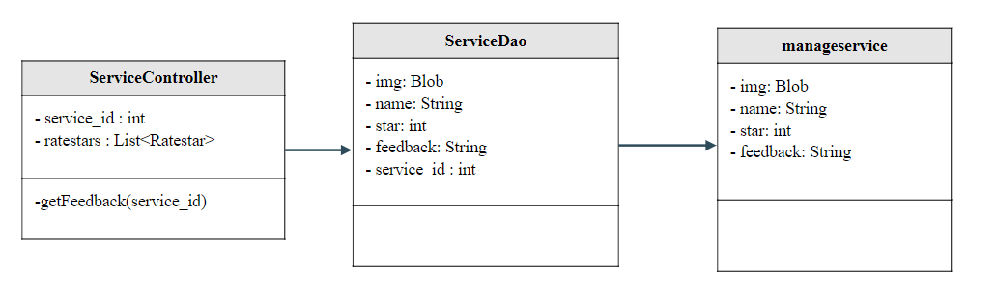

### Class Specification

|  |  |  |
| --- | --- | --- |
| No | Method | Description |
| 1 | getFeedback | View feedbacks from patients to the service |

### Sequence Diagram

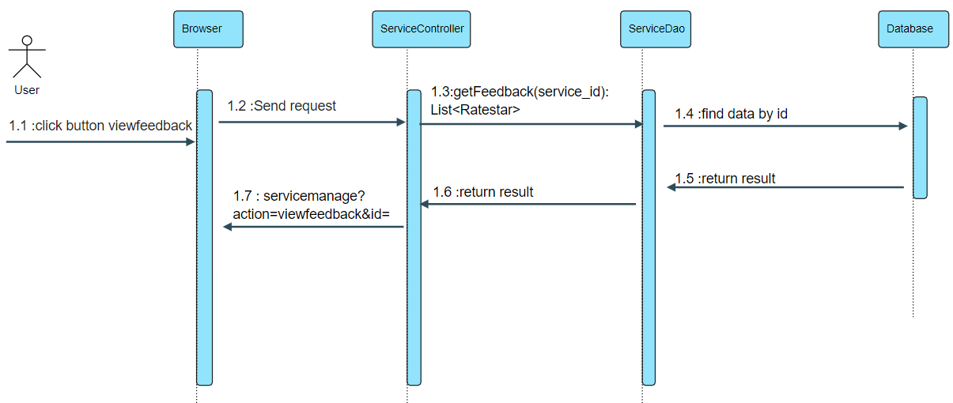

### Database queries

* SELECT u.img, u.name, r.star,r.feedback,r.datetime FROM doctris_system.ratestar r

inner join doctris_system.users u on r.username = u.username where r.service_id = ? ORDER BY r.datetime DESC

## 20. Marketing/Blog List

### Class Diagram

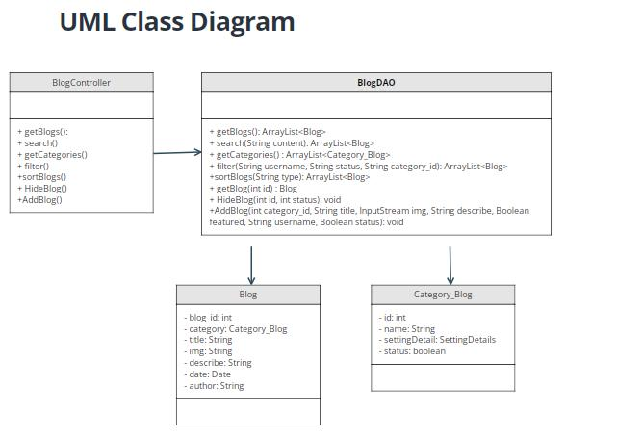

### Class Specification

|  |  |  |
| --- | --- | --- |
| No | Method | Description |
| 1 | getBlogs | get all blog in database order by date |
| 2 | getCategories | get all categories in database |
| 3 | getBlog | get blog by blog id |
| 4 | filter | The user can filter the post by category, author, status |
| 5 | search | get blog that having or contain keyword in its title |
| 6 | HideBlog | change blog’s status to disable or active |
| 7 | AddBlog | Add new blog contain all attribute without blog_id |

### Sequence Diagram

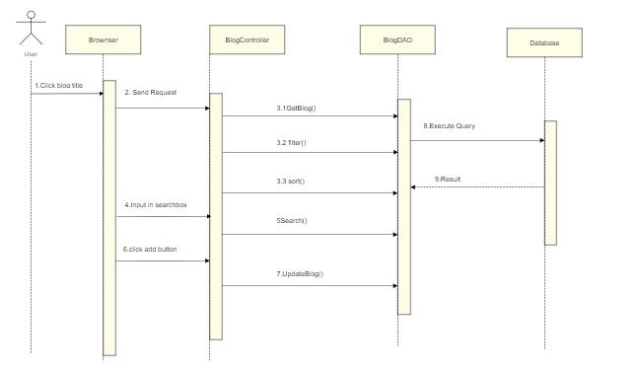

### Database queries

* SELECT blog.*, category_blog.name FROM blog

inner join category_blog

on blog.category_id = category_blog.id

order by date desc

* Select b.*, u.name as author, c.name as category_name

from blog as b

Inner join users as u on b.username = u.username

inner join category_blog c on b.category_id = c.id

where

(1=1)

and b.category_id = ?

and b.username = ?

and b.status = ?

order by b.date desc;

* UPDATE `doctris_system`.`blog`

SET

`status` = ?

WHERE `blog_id` = ?;

* INSERT INTO `doctris_system`.`blog`

(`blog_id`,

`category_id`,

`title`,

`img`,

`describe`,

`date`,

`featured`,

`username`,

`status`)

VALUES

(<{category_id: }>,

<{title: }>,

<{img: }>,

<{describe: }>,

<{date: }>,

<{featured: }>,

<{username: }>,

<{status: }>);

* SELECT * FROM blog WHERE title LIKE ? ORDER BY date desc

## 21. Marketing/Blog Detail

### Class Diagram

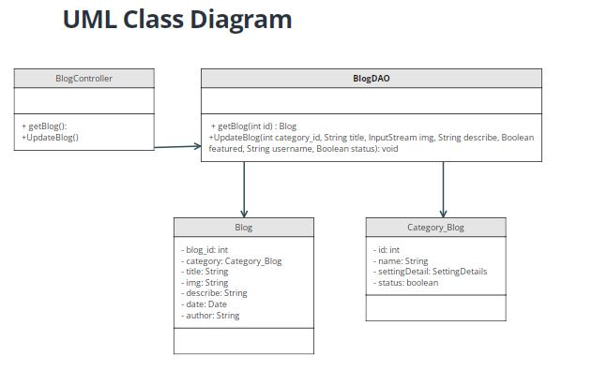

### Class Specification

|  |  |  |
| --- | --- | --- |
| No | Method | Description |
| 1 | getBlog | get blog by blog id |
| 2 | UpdateBlog | change blog information like title, describe, image, category |

### Sequence Diagram

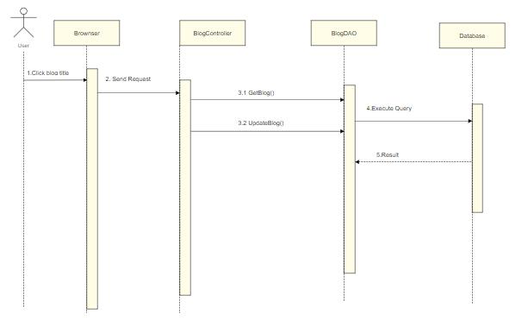

### Database queries

* UPDATE `doctris_system`.`blog`

SET

`category_id` = <{category_id: }>,

`title` = <{title: }>,

`img` = <{img: }>,

`describe` = <{describe: }>,

`date` = <{date: }>,

`featured` = <{featured: }>,

`status` = <{status: }>

WHERE `blog_id` = <{expr}>;

* Select b.*, u.name as author, c.name as category_name

from blog as b

Inner join users as u on b.username = u.username

inner join category_blog c on b.category_id = c.id

where b.blog_id = ?

order by b.date desc

## 22. Public/Web Doctor List

### Class Diagram

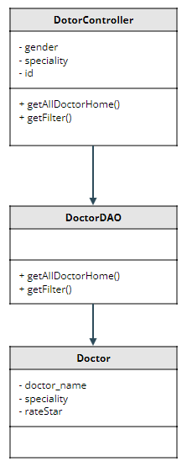

### Class Specification

|  |  |  |
| --- | --- | --- |
| No | Method | Description |
| 1 | getAllDoctorHome | show all doctor |
| 2 | getFilter | show doctor by gender or speciality |

### Sequence Diagram

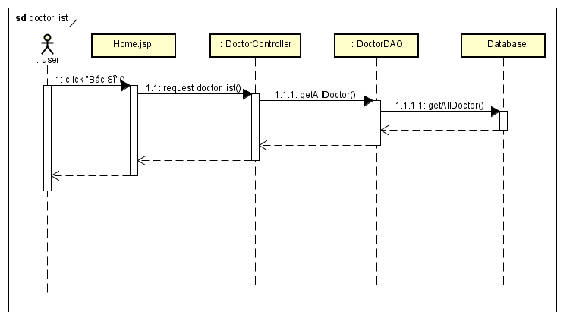

### Database queries

String sql = "select concat_ws(cs.id,d.category_id)id,"

cs.name, cs.setting_id ,cs.status,"

d.doctor_id,d.role_id,d.doctor_name,d.username,"

d.gender,d.DOB,d.phone,d.description,d.status,d.img,d.fee "

from doctris_system.doctor d "

inner join doctris_system.category_service cs "

on d.category_id = cs.id";

String spec = "select concat_ws(cs.id,d.category_id)id,"

cs.name, cs.setting_id ,cs.status,"

d.doctor_id,d.role_id,d.doctor_name,d.username,"

d.gender,d.DOB,d.phone,d.description,d.status,d.img,d.fee "

from doctris_system.doctor d "

inner join doctris_system.category_service cs "

on d.category_id = cs.id where d.category_id = ?";

String gen = "select concat_ws(cs.id,d.category_id)id,"

cs.name, cs.setting_id ,cs.status,"

d.doctor_id,d.role_id,d.doctor_name,d.username,"

d.gender,d.DOB,d.phone,d.description,d.status,d.img,d.fee "

from doctris_system.doctor d "

inner join doctris_system.category_service cs "

on d.category_id = cs.id where d.gender = ?";

String filter = "select concat_ws(cs.id,d.category_id)id,"

cs.name, cs.setting_id ,cs.status,"

d.doctor_id,d.role_id,d.doctor_name,d.username,"

d.gender,d.DOB,d.phone,d.description,d.status,d.img,d.fee "

from doctris_system.doctor d "

inner join doctris_system.category_service cs "

on d.category_id = cs.id where d.gender = ? AND d.category_id = ?";

## 23. Public/Web Doctor Detail

### Class Diagram

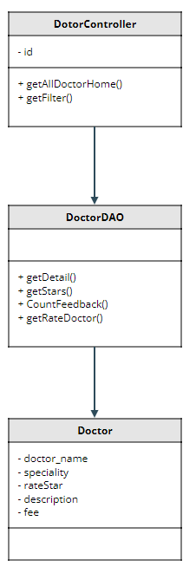

### Class Specification

|  |  |  |
| --- | --- | --- |
| No | Method | Description |
| 1 | getDetail | show detail doctor |
| 2 | getStars | show star of doctor |
| 3 | CountFeedback | show number of feedback |
| 4 | getRateDoctor | show feedback of patient |

### Sequence Diagram

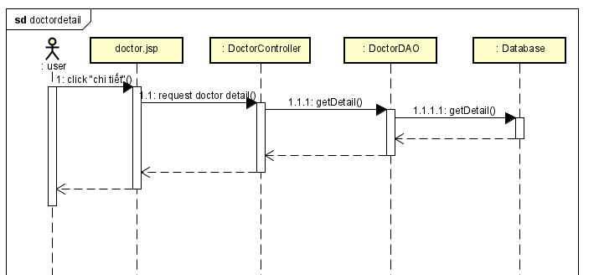

### Database queries

String getdoctor = "select concat_ws(cs.id,d.category_id)id,"

cs.name, cs.setting_id ,cs.status,"

d.doctor_id,d.role_id,d.doctor_name,d.username,"

d.gender,d.DOB,d.phone,d.description,d.status,d.img,d.fee "

from doctris_system.doctor d "

inner join doctris_system.category_service cs "

on d.category_id = cs.id where d.doctor_id = ?";

String sql = "SELECT (SUM(star) / COUNT(*)) as star from ratestar where doctor_id = ?";

String sql = "SELECT COUNT(*) from ratestar where doctor_id = ?";

String sql = "SELECT users.name, users.img, ratestar.star, ratestar.feedback, "

ratestar.datetime FROM ratestar inner join users "

on ratestar.username = users.username where ratestar.doctor_id = ? order by ratestar.id desc";

## 24. Staff/Appointments List

### Class Diagram

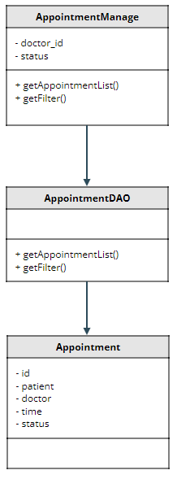

### Class Specification

|  |  |  |
| --- | --- | --- |
| No | Method | Description |
| 1 | getAppointmentList | show list appointment |
| 2 | getFilter | show list appointment by name or status |

### Sequence Diagram

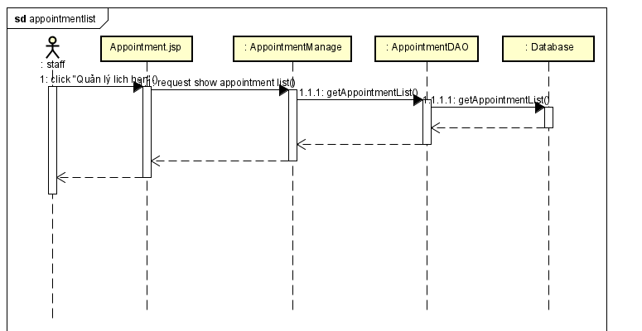

### Database queries

String sql = "Select appointments.appointment_id , doctor.doctor_name, users.name , appointments.date ,appointments.time, appointments.status from appointments inner join doctor on appointments.doctor_id = doctor.doctor_id inner join patient on appointments.patient_id = patient.patient_id inner join users on patient.username = users.username";

String filterStatus = "Select appointments.appointment_id , doctor.doctor_name, users.name , appointments.date ,"

appointments.time, appointments.status from appointments "

inner join doctor on appointments.doctor_id = doctor.doctor_id "

inner join patient on appointments.patient_id = patient.patient_id "

inner join users on patient.username = users.username where appointments.status = ?";

String filterDoctor = "Select appointments.appointment_id , doctor.doctor_name, users.name , appointments.date ,"

appointments.time, appointments.status from appointments "

inner join doctor on appointments.doctor_id = doctor.doctor_id "

inner join patient on appointments.patient_id = patient.patient_id "

inner join users on patient.username = users.username where appointments.doctor_id = ?";

String filter = "Select appointments.appointment_id , doctor.doctor_name, users.name , appointments.date ,"

appointments.time, appointments.status from appointments "

inner join doctor on appointments.doctor_id = doctor.doctor_id "

inner join patient on appointments.patient_id = patient.patient_id "

inner join users on patient.username = users.username where appointments.doctor_id = ? AND appointments.status = ?";

## 25. Staff/Appointments Detail

### bClass Diagram

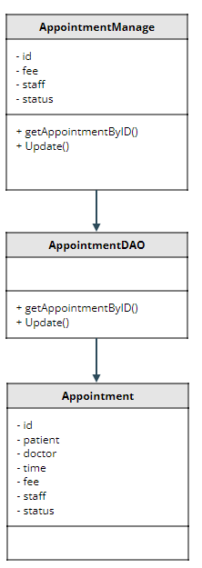

### Class Specification

|  |  |  |
| --- | --- | --- |
| No | Method | Description |
| 1 | getAppointmentByID | show detail appointment |
| 2 | Update | update detail appointment |

### Sequence Diagram

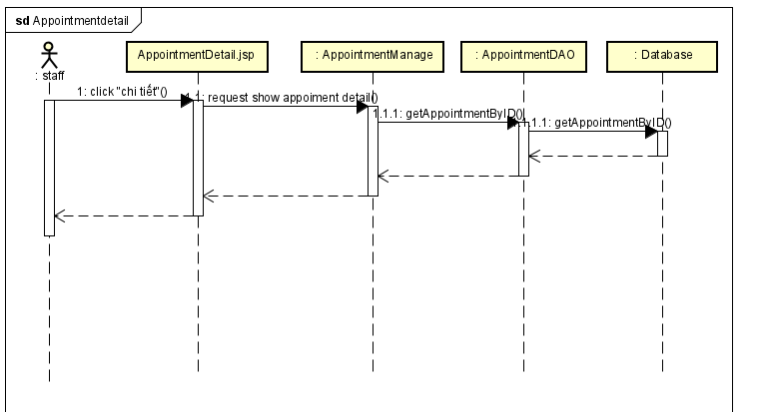

### Database queries

String sql = "select doctor.img, doctor.doctor_name, doctor.phone, doctor.gender, "

category_service.name , users.img, users.name, users.phone, "

users.gender, patient.DOB, appointments.date ,appointments.time, "

appointments.status, appointments.description, staff.name, "

appointments.fee, appointments.appointment_id from appointments inner join doctor "

on appointments.doctor_id = doctor.doctor_id "

inner join patient on appointments.patient_id = patient.patient_id "

inner join users on patient.username = users.username "

inner join users staff on appointments.staff = staff.username "

inner join category_service on doctor.category_id = category_service.id "

where appointments.appointment_id = ?";

String sql = "UPDATE `doctris_system`.`appointments` SET `staff` = ?, `status` = ?, `fee` = ? WHERE (`appointment_id` = ?)";

## 26. Staff/Reservation List

### Class Diagram

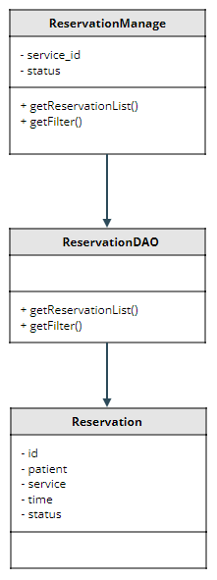

### Class Specification

|  |  |  |
| --- | --- | --- |
| No | Method | Description |
| 1 | getReservationList | show list Reservation |
| 2 | getFilter | show list Reservation by service_id or status |

### Sequence Diagram

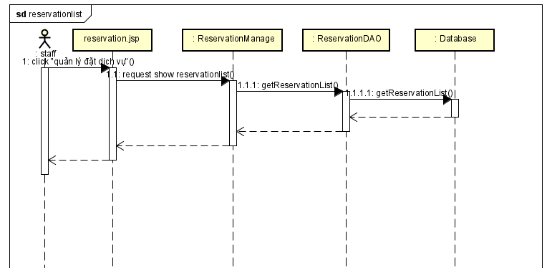

### Database queries

String sql = "SELECT reservations.reservation_id, users.name, service.title, "

reservations.date, reservations.time, reservations.status FROM reservations

inner join service on reservations.service_id = service.service_id

inner join patient on reservations.patient_id = patient.patient_id

inner join users on patient.username = users.username";

String filterStatus = "SELECT reservations.reservation_id, users.name, service.title, "

reservations.date, reservations.time, reservations.status FROM reservations

inner join service on reservations.service_id = service.service_id

inner join patient on reservations.patient_id = patient.patient_id

inner join users on patient.username = users.username where reservations.status = ?";

String filterDoctor = "SELECT reservations.reservation_id, users.name, service.title, "

reservations.date, reservations.time, reservations.status FROM reservations

inner join service on reservations.service_id = service.service_id

inner join patient on reservations.patient_id = patient.patient_id

inner join users on patient.username = users.username where reservations.service_id = ?";

String filter = "SELECT reservations.reservation_id, users.name, service.title, "

reservations.date, reservations.time, reservations.status FROM reservations

inner join service on reservations.service_id = service.service_id

inner join patient on reservations.patient_id = patient.patient_id

inner join users on patient.username = users.username where reservations.service_id = ? AND reservations.status = ?";

## 27. Staff/Reservation Detail

a, Class Diagram

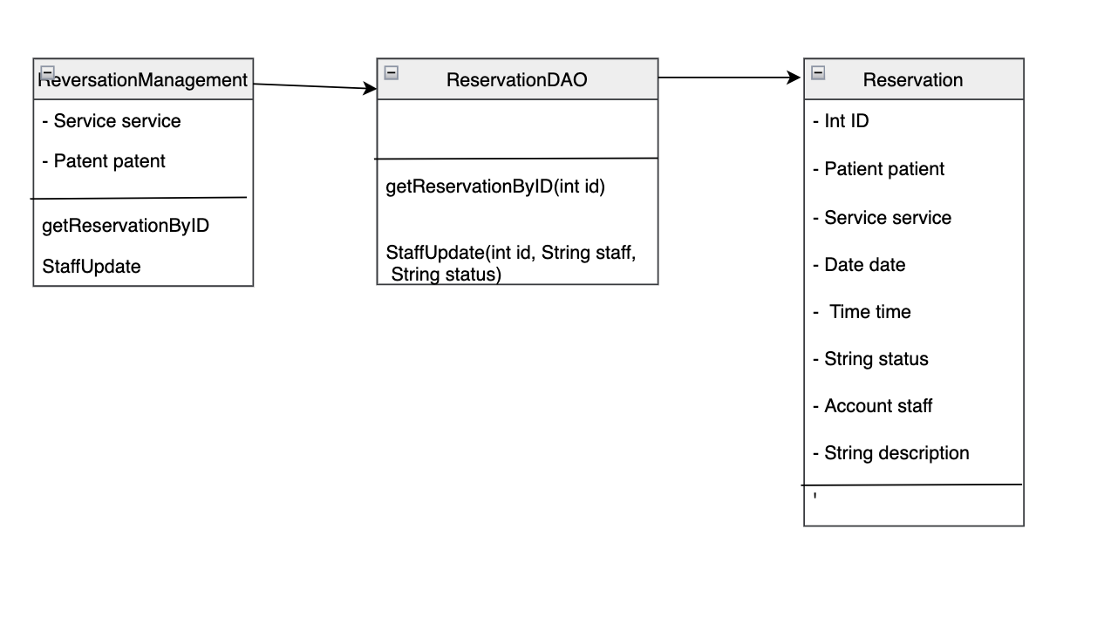

b. Class Specification

|  |  |  |
| --- | --- | --- |
| No | Method | Description |
| 1 | getReservationByID | show reservation information detail |
| 2 | StaffUpdate | Update staff information in reservation |

c. Sequence Diagram

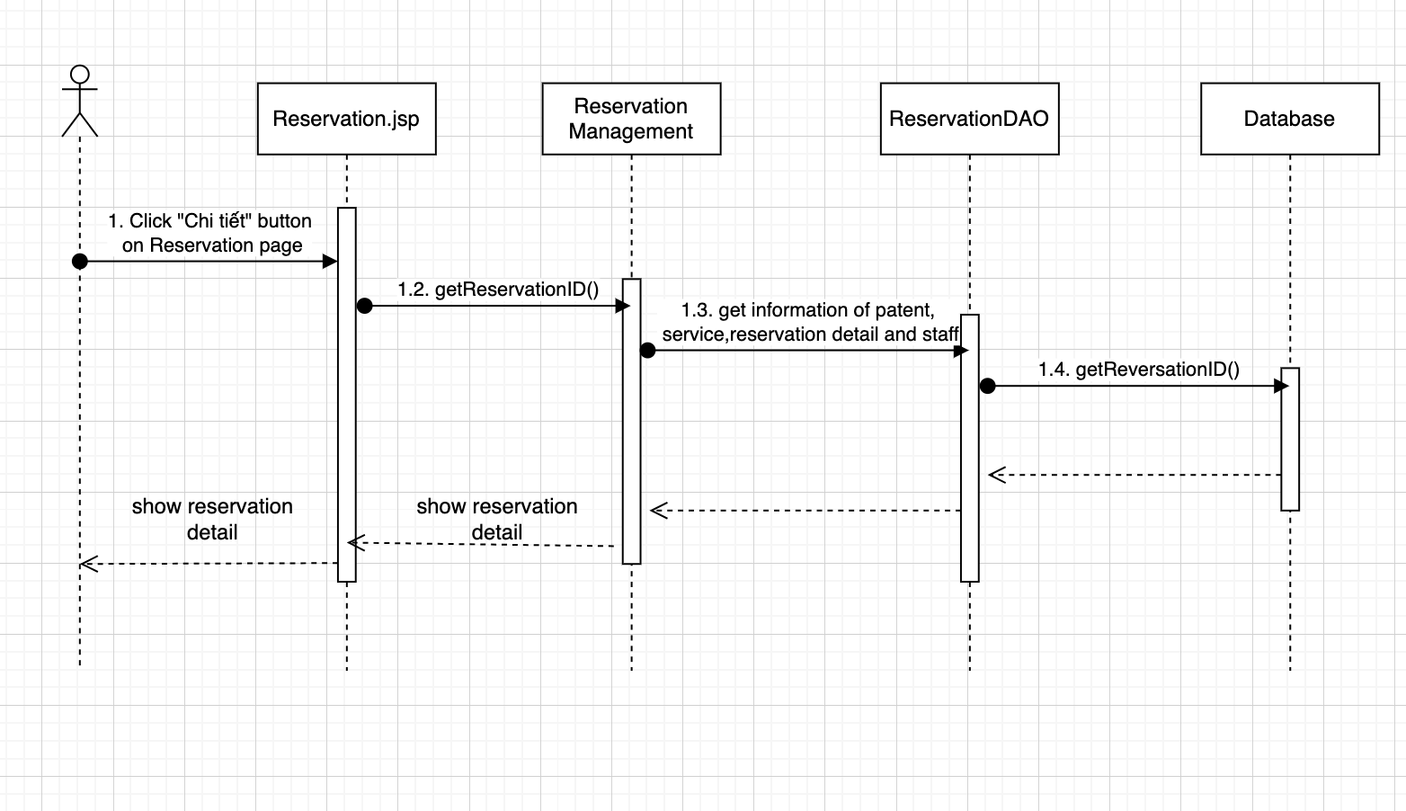

d. Database queries

SELECT reservations.reservation_id, users.img , users.name, users.phone, users.gender,

patient.DOB, service.img, service.title, category_service.name, service.fee ,reservations.date,

reservations.time, reservations.status, staff.name, reservations.description

FROM reservations

inner join service on reservations.service_id = service.service_id

inner join patient on reservations.patient_id = patient.patient_id

inner join users on patient.username = users.username

inner join category_service on service.category_id = category_service.id

inner join users staff on reservations.staff = staff.username where reservations.reservation_id = ?

UPDATE `reservations` SET `staff` = ?, `status` = ? WHERE (`reservation_id` = ?)

SELECT username,name FROM doctris_system.users where role_id = 4

## 28. Public/Services List

### Class Diagram

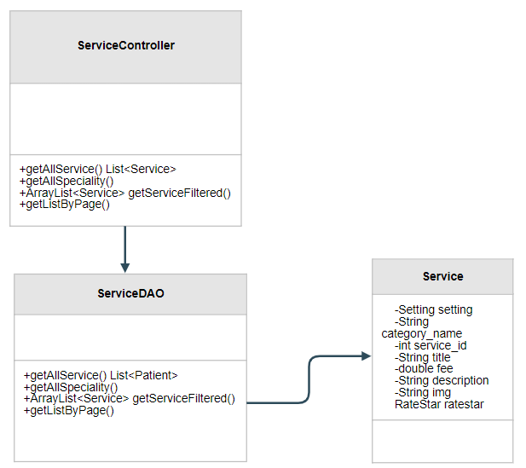

### Class Specification

|  |  |  |
| --- | --- | --- |
| No | Method | Description |
| 1 | getAllService | use to list Services |
| 2 | getServiceById | use to find Service by Id |
| 3 | getListByPage | use to pagination |
| 4 | getAllSpeciality | use to list Speciality |

### Sequence Diagram

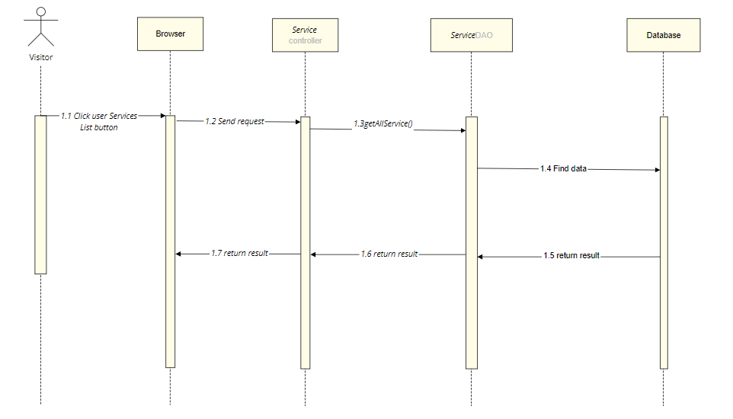

1. Database Diagram

-SELECT s.title, cs.name, sum(r.star)/count(r.star), count(r.feedback), s.fee, s.description, s.service_id FROM doctris_system.service s

left join doctris_system.ratestar r

on s.service_id = r.service_id

inner join doctris_system.category_service cs

on cs.id = s.category_id

group by s.title, cs.name, s.fee, s.description, s.service_id

-SELECT s.title, cs.name, sum(r.star)/count(r.star), count(r.feedback), s.fee, s.description, s.service_id FROM doctris_system.service s

left join doctris_system.ratestar r

on s.service_id = r.service_id

inner join doctris_system.category_service cs

on cs.id = s.category_id

group by s.title, cs.name, s.fee, s.description, s.service_id

Having s.service_id = ?

-SELECT cs.name, cs.id FROM doctris_system.service s

inner join doctris_system.category_service cs

on cs.id = s.category_id

group by cs.name, cs.id

## 29. Public/Service detail

### Class Diagram

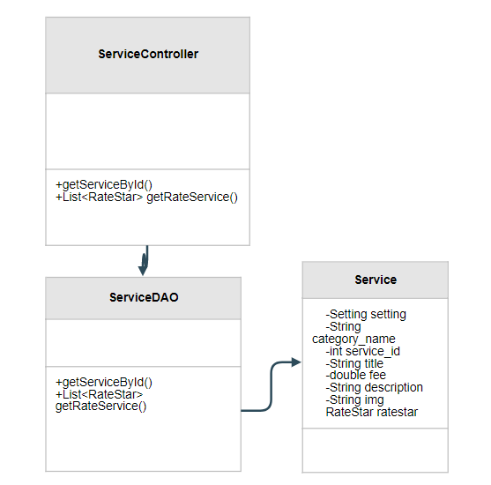

### Class Specification

|  |  |  |
| --- | --- | --- |
| No | Method | Description |
| 1 | getServiceById | use to find Service by Id |
| 2 | getRateService | use to get user rate about the service |

### Sequence Diagram

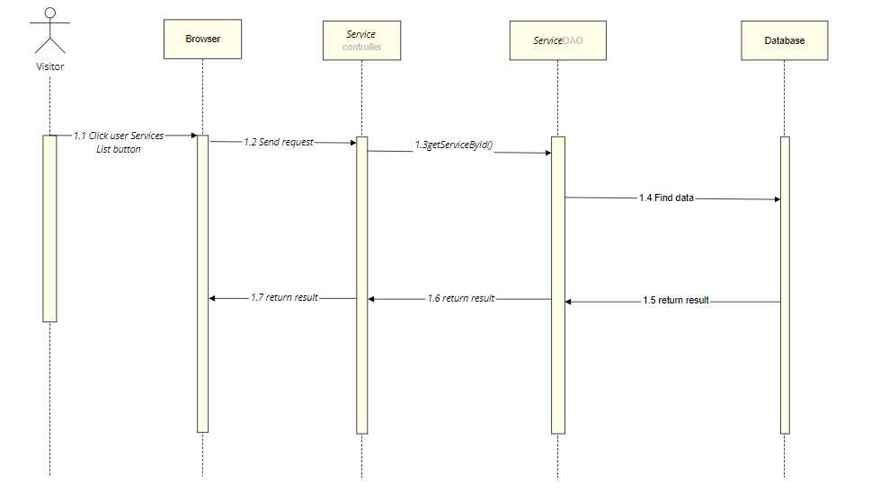

1. Database Diagram

-SELECT s.title, cs.name, sum(r.star)/count(r.star), count(r.feedback), s.fee, s.description, s.service_id FROM doctris_system.service s

left join doctris_system.ratestar r

on s.service_id = r.service_id

inner join doctris_system.category_service cs

on cs.id = s.category_id

group by s.title, cs.name, s.fee, s.description, s.service_id

Having s.service_id = ?

-SELECT users.name, users.img, ratestar.star, ratestar.feedback, ratestar.datetime

FROM ratestar inner join users

on ratestar.username = users.username

where ratestar.service_id = ?

order by ratestar.id desc

## 30. Doctor/My Patients

### Class Diagram

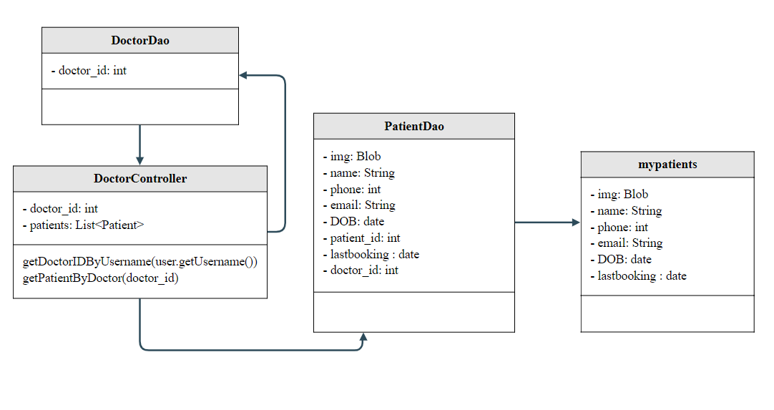

### Class Specification

|  |  |  |
| --- | --- | --- |
| No | Method | Description |
| 1 | getDoctorIDByUsername | use to find doctor_id |
| 2 | getPatientByDoctor | show list of doctor's patients includes: avatar, name, last booking date, date of birth, email, phone |

### Sequence Diagram

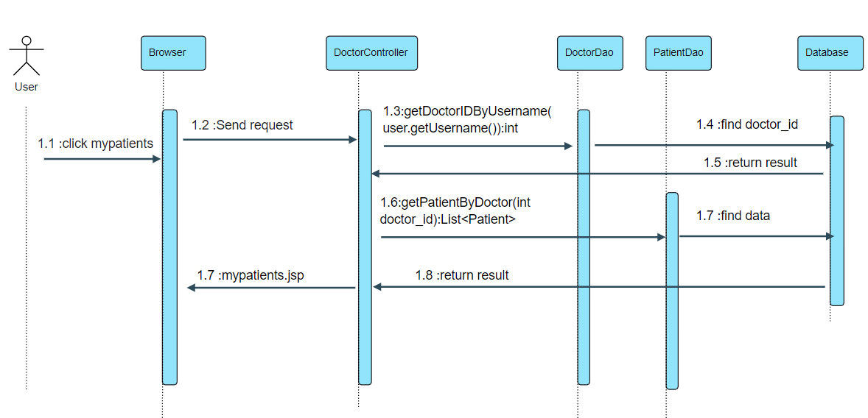

### Database queries

* select doctor_id from doctor where username = ?
* select distinct users.img, users.name, users.phone, users.email,patient.DOB,patient.patient_id ,a.pdate as lastbooking from appointments

inner join patient on appointments.patient_id = patient.patient_id

inner join users on patient.username = users.username inner join (

select patient_id as pid , max(date) as pdate from appointments group by patient_id

) as a on a.pid = appointments.patient_id where appointments.doctor_id = ?

## 31. Doctor/My Patient Details

### Class Diagram

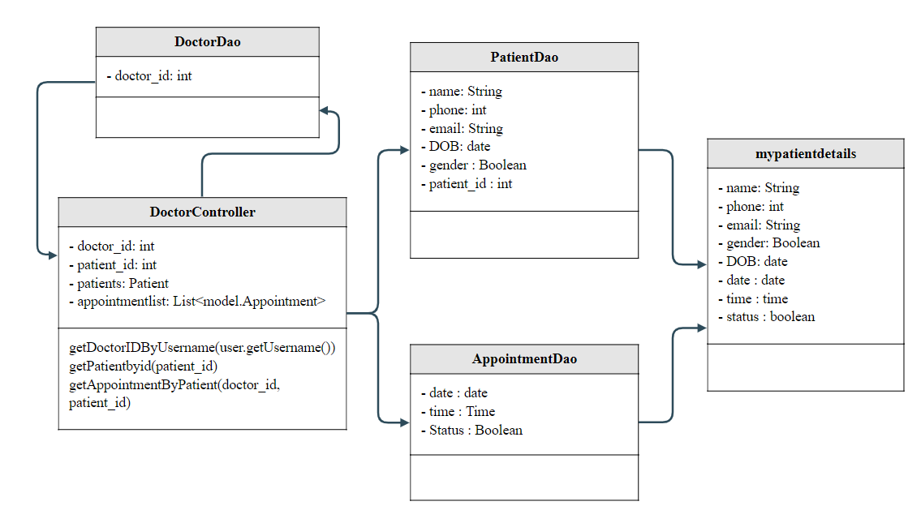

### Class Specification

|  |  |  |
| --- | --- | --- |
| No | Method | Description |
| 1 | getDoctorIDByUsername | use to find doctor_id |
| 2 | getPatientbyid | show detailed information of the doctor's patient includes: name, email, mobile, gender, date of birth |
| 3 | getAppointmentByPatient | show list appointments with him/her |

### Sequence Diagram

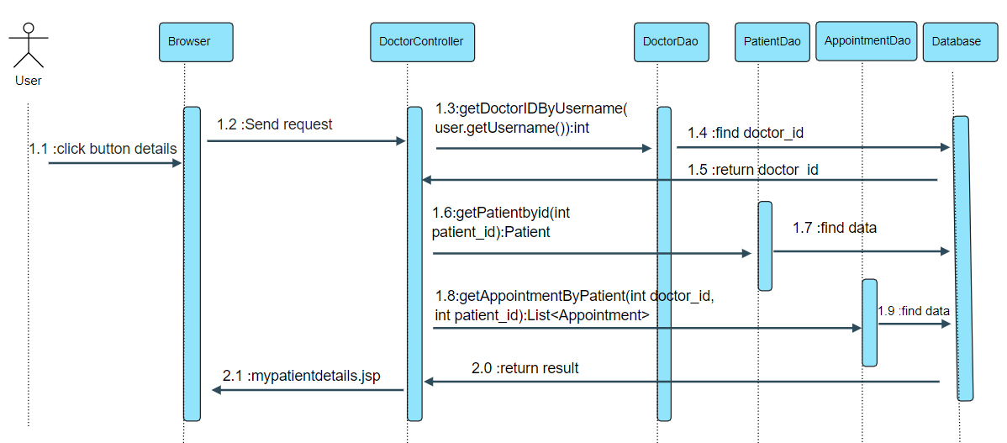

### Database queries

* select doctor_id from doctor where username = ?
* SELECT u.name,u.email,u.phone,u.gender,p.DOB FROM users u inner join patient p

on u.username = p.username

where p.patient_id = ? ;

* select a.date,a.time,a.status from appointments a inner join patient p

on a.patient_id = p.patient_id

where a.doctor_id = ? and p.patient_id = ?

ORDER BY a.date ASC

## 32. Doctor/My Feedback

### Class Diagram

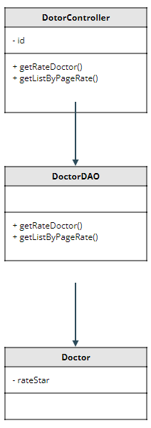

### Class Specification

|  |  |  |
| --- | --- | --- |
| No | Method | Description |
| 1 | getRateDoctor | show feedback of doctor |
| 2 | getListByPageRate | pagination feedback |

### Sequence Diagram

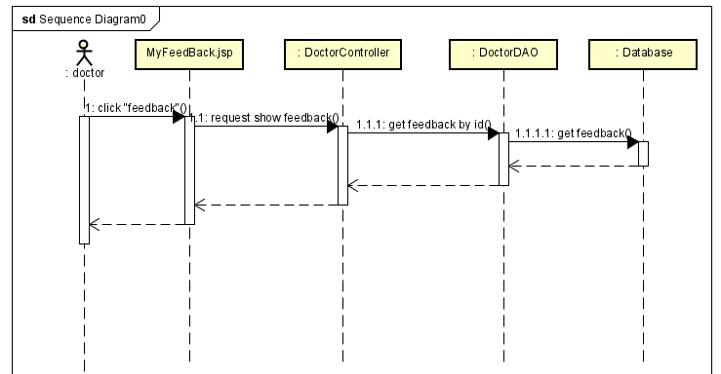

### Database queries

String sql = "SELECT users.name, users.img, ratestar.star, ratestar.feedback, "

+ "ratestar.datetime FROM ratestar inner join users "

+ "on ratestar.username = users.username where ratestar.doctor_id = ? order by ratestar.id desc";

v

## 33. Admin/Dashboard

### Class Diagram

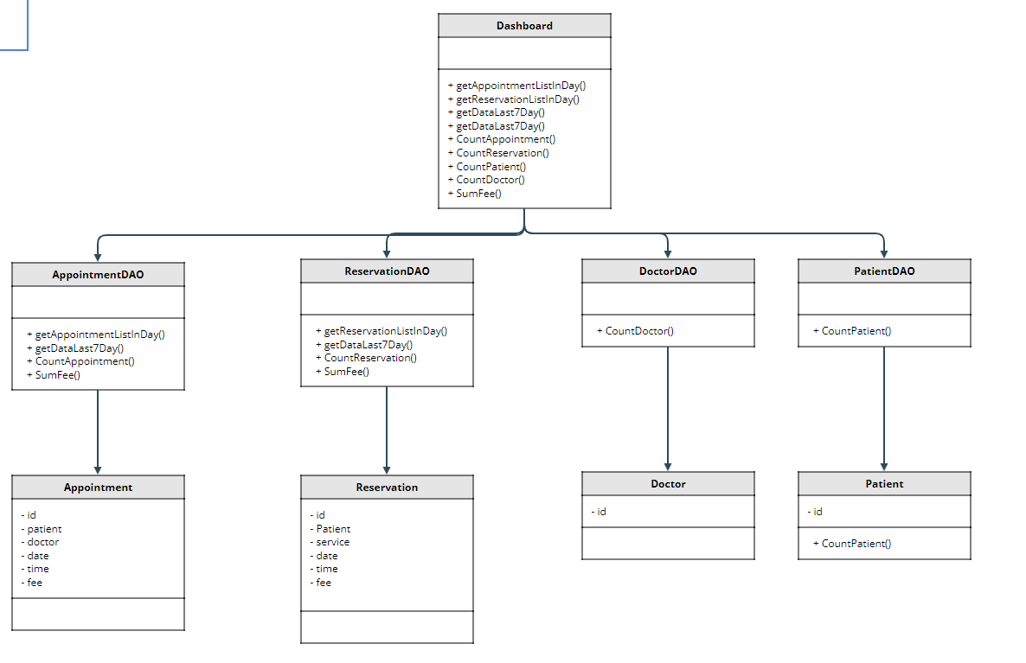

### Class Specification

|  |  |  |
| --- | --- | --- |
| No | Method | Description |
| 1 | getAppointmentListInDay | Get the doctor's appointment for the day |
| 2 | getReservationListInDay | Get service appointment of the day |
| 3 | getDataLast7Day | statistics in 7 days |
| 4 | CountAppointment | Count the number of appointments in the latest month |
| 5 | CountReservation | Count the number of service in the latest month |
| 6 | CountPatient | number of patient active |
| 7 | CountDoctor | number of doctors active |
| 8 | SumFee | get total revenue |

### Sequence Diagram

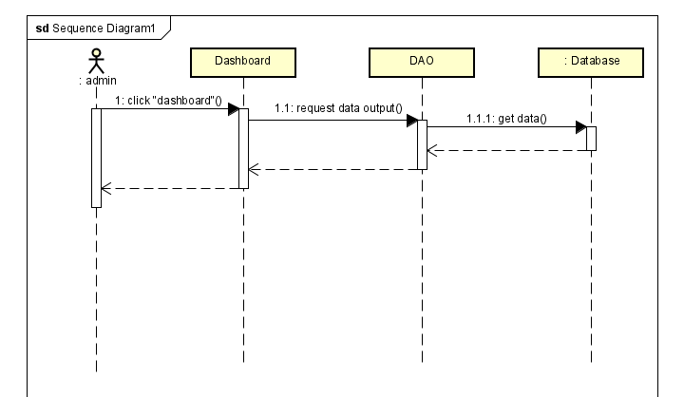

### Database queries

String sql = "Select appointments.appointment_id , doctor.doctor_name, users.name , \n"

+ "appointments.date ,appointments.time, appointments.status from appointments \n"

+ "inner join doctor on appointments.doctor_id = doctor.doctor_id inner join patient on \n"

+ "appointments.patient_id = patient.patient_id inner join users on patient.username = users.username where appointments.date = cast(CURDATE() as Date);";

String sql = "SELECT reservations.reservation_id, users.name, service.title, "

+ "reservations.date, reservations.time, reservations.status FROM reservations \n"

+ "inner join service on reservations.service_id = service.service_id \n"

+ "inner join patient on reservations.patient_id = patient.patient_id \n"

+ "inner join users on patient.username = users.username where reservations.date = cast(CURDATE() as Date)";

String sql = " \n"

+ " Select p.day , coalesce(count(u.appointment_id), 0) as count from (\n"

+ " Select curdate() as day\n"

+ " union\n"

+ " Select date_sub(Curdate(),interval 1 day)\n"

+ " union\n"

+ " Select date_sub(Curdate(),interval 2 day)\n"

+ " union\n"

+ " Select date_sub(Curdate(),interval 3 day)\n"

+ " union\n"

+ " Select date_sub(Curdate(),interval 4 day)\n"

+ " union\n"

+ " Select date_sub(Curdate(),interval 5 day)\n"

+ " union\n"

+ " Select date_sub(Curdate(),interval 6 day))as p\n"

+ "left join appointments as u on p.day = u.date group by p.day order by p.day asc";

String sql = "Select p.day , coalesce(count(u.reservation_id), 0) as count from (\n"

+ " Select curdate() as day\n"

+ " union\n"

+ " Select date_sub(Curdate(),interval 1 day)\n"

+ " union\n"

+ " Select date_sub(Curdate(),interval 2 day)\n"

+ " union\n"

+ " Select date_sub(Curdate(),interval 3 day)\n"

+ " union\n"

+ " Select date_sub(Curdate(),interval 4 day)\n"

+ " union\n"

+ " Select date_sub(Curdate(),interval 5 day)\n"

+ " union\n"

+ " Select date_sub(Curdate(),interval 6 day))as p\n"

+ "left join reservations as u on p.day = u.date group by p.day order by p.day asc";

String sql = "select count(*) from appointments";

String sql = "select count(*) from reservations";

String sql = "select count(*) from patient";

String sql = "select count(*) from doctor";

String sql = "select sum(service.fee) from reservations inner join service on reservations.service_id = service.service_id where reservations.status = 'Assigned'";

String sql = "select sum(fee) from appointments where status = 'Assigned'";

## 34. Patient/Book Appointment

### Class Diagram

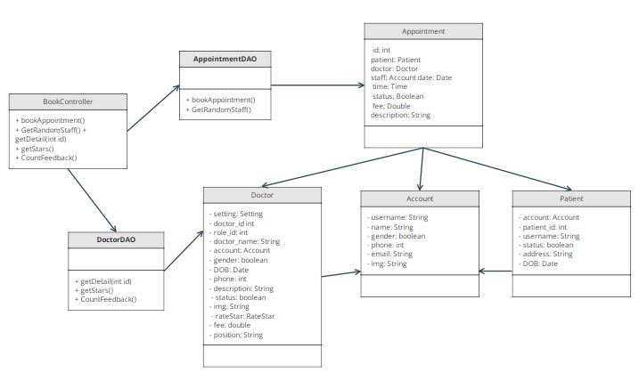

### Class Specification

|  |  |  |
| --- | --- | --- |
| No | Method | Description |
| 1 | bookAppointment | create appointment and add it to later in list |
| 2 | GetRandomStaff | get a account that have role staff |
| 3 | getDetail | get a doctor information by doctor id |
| 4 | getStar | get stars of a doctor by doctor id |
| 5 | CountFeedback | get number of feedback of a doctor by doctor id |

### Sequence Diagram

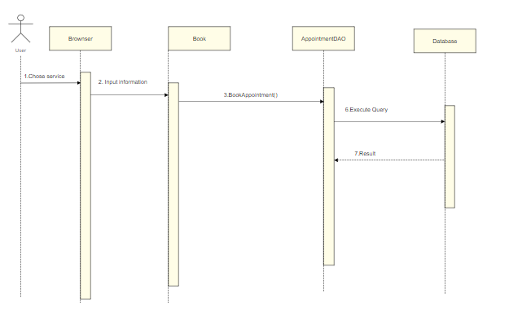

### Database queries

* INSERT INTO `appointments` (`doctor_id`, `patient_id`, `staff`, `date`, `time`, `description`, `status`, `fee`, `payment`)

VALUES (?, ?, ?, STR_TO_DATE(?,'%d/%m/%Y'), ?, ?, ?, ?, ?)

* select concat_ws(cs.id,d.category_id)id,

cs.name, cs.setting_id ,cs.status,

d.doctor_id,d.role_id,d.doctor_name,d.username,

d.gender,d.DOB,d.phone,d.description,d.status,d.img,d.fee,d.position

from doctris_system.doctor d

inner join doctris_system.category_service cs

on d.category_id = cs.id where d.doctor_id = ?

* SELECT (SUM(star) / COUNT(*)) as star from ratestar where doctor_id = ?
* SELECT COUNT(*) from ratestar where doctor_id = ?
* select username from users where role_id = 4 AND status = 1 ORDER BY RAND() LIMIT 1

## 35. Patient/Reserve a Service

### Class Diagram

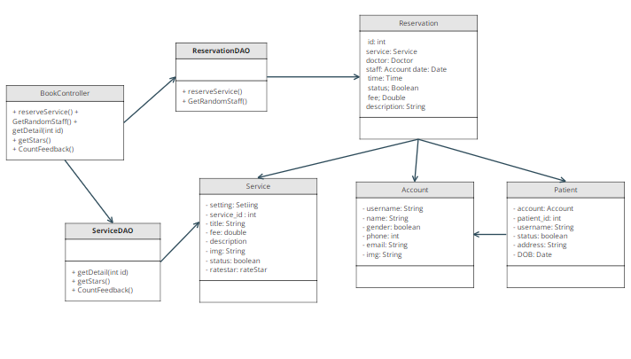

### Class Specification

|  |  |  |
| --- | --- | --- |
| No | Method | Description |
| 1 | reverseService | create reservation and add it to later in list |
| 2 | GetRandomStaff | get a account that have role staff |
| 3 | getDetail | get a service information by servicer id |
| 4 | getStar | get stars of a doctor by service id |
| 5 | CountFeedback | get number of feedback of a service by service id |

### Sequence Diagram

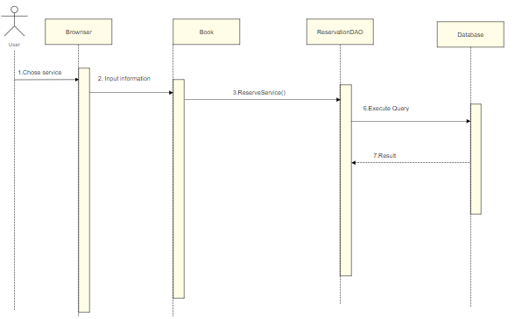

### Database queries

* select username from users where role_id = 4 AND status = 1 ORDER BY RAND() LIMIT 1
* INSERT INTO `reservations` (`patient_id`, `service_id`,

`staff`, `date`, `time`, `status`, `description`, `payment`) VALUES

(?, ?, ?, STR_TO_DATE(?,'%d/%m/%Y'), ?, ?, ?, ?)

* SELECT s.title, cs.name, sum(r.star)/count(r.star), count(r.feedback), s.fee, s.description, s.service_id, s.img FROM doctris_system.service s

left join doctris_system.ratestar r

on s.service_id = r.service_id

inner join doctris_system.category_service cs

on cs.id = s.category_id

group by s.title, cs.name, s.fee, s.description, s.service_id

Having s.service_id = ?

* SELECT (SUM(star) / COUNT(*)) as star from ratestar where service_id = ?
* SELECT COUNT(*) from ratestar where service_id = ?

## 36. Doctor/My Appointments

### Class Diagram

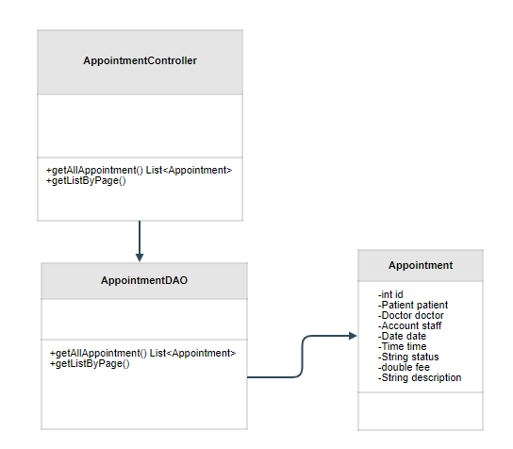

### Class Specification

|  |  |  |
| --- | --- | --- |
| No | Method | Description |
| 1 | getAllAppointment | to get all appointments of a doctor |
| 2 | getListByPageRate | pagination the list |

### Sequence Diagram

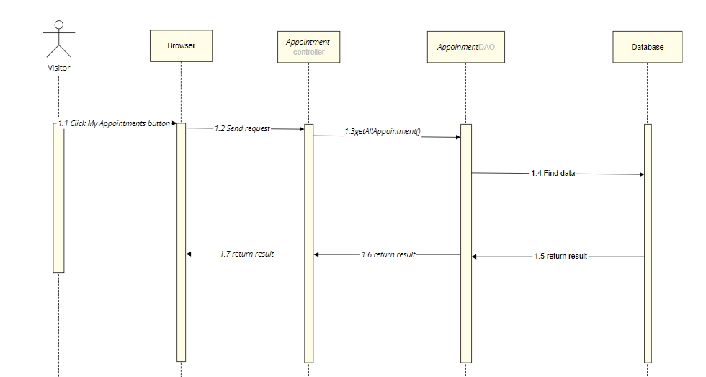

### Database queries

SELECT a.appointment_id, p.patient_id, u.name,a.date, a.time,a.status from appointments a

INNER JOIN patient p

ON a.patient_id = p.patient_id

INNER JOIN users u

ON p.username = u.username

WHERE a.doctor_id = ?

group by a.appointment_id, p.patient_id, u.name,a.date, a.time,a.status

order by CAST(a.date AS DATETIME) + CAST(a.time AS DATETIME) desc

## 37. Doctor/My Appointment Details

### Class Diagram

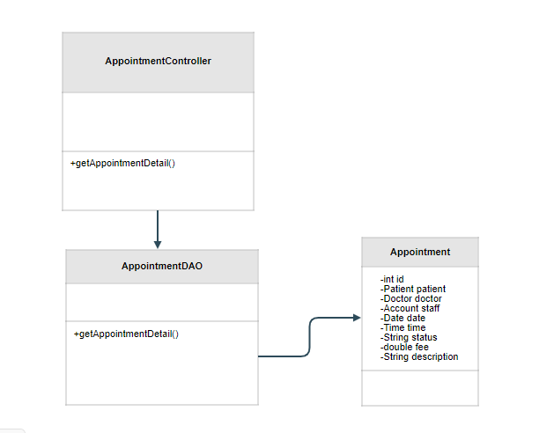

### Class Specification

|  |  |  |
| --- | --- | --- |
| No | Method | Description |
| 1 | getAppointmentDetail | to get detailed information of an Appointment |

### Sequence Diagram

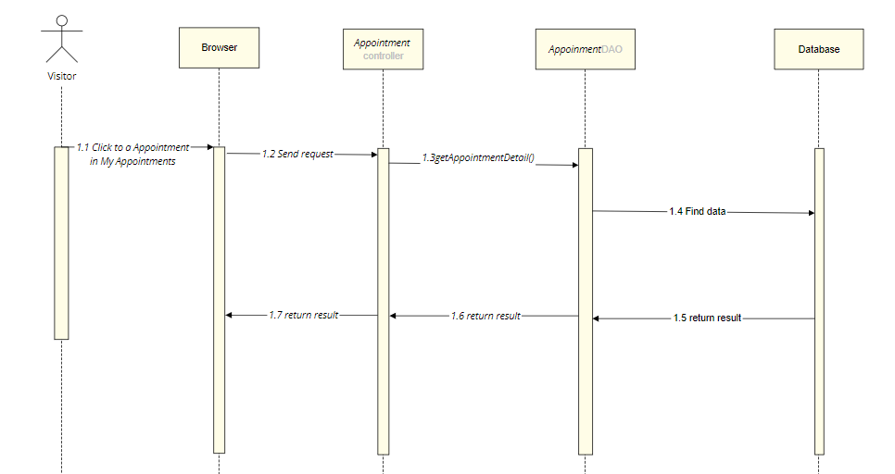

### Database queries

SELECT a.appointment_id, p.patient_id, u.name,a.date, a.time,a.status from appointments a

INNER JOIN patient p

ON a.patient_id = p.patient_id

INNER JOIN users u

ON p.username = u.username

WHERE a.appointment_id = ?

## 38. Patient/ Appointment History

### Class Diagram

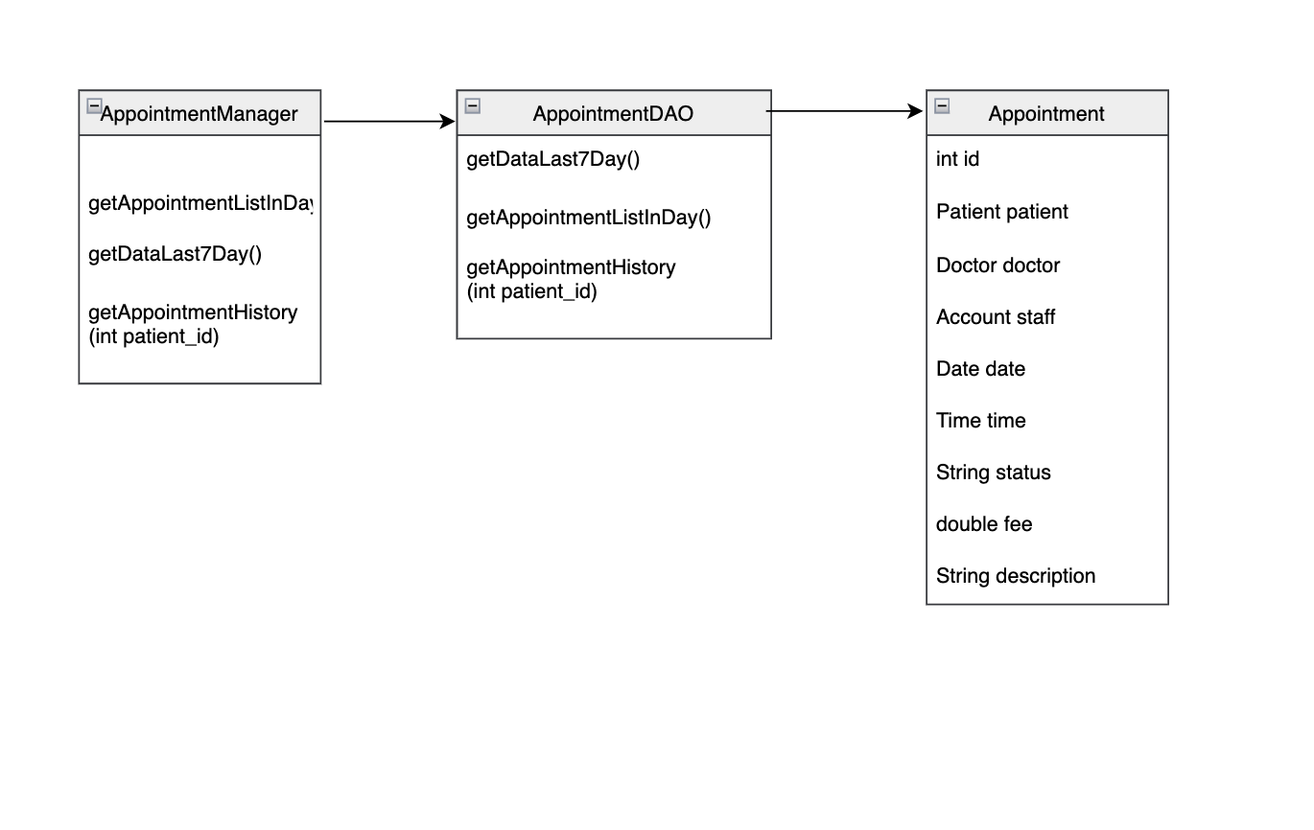

### Class Specification

|  |  |  |
| --- | --- | --- |
| No | Method | Description |
| 1 | getAppointmentListInDay | Display appointment list in to day |
| 2 | getDataLast7Day | Display appointment in a week |
| 3 | getAppointmentHistory | Display all appointment list |

### Sequence Diagram

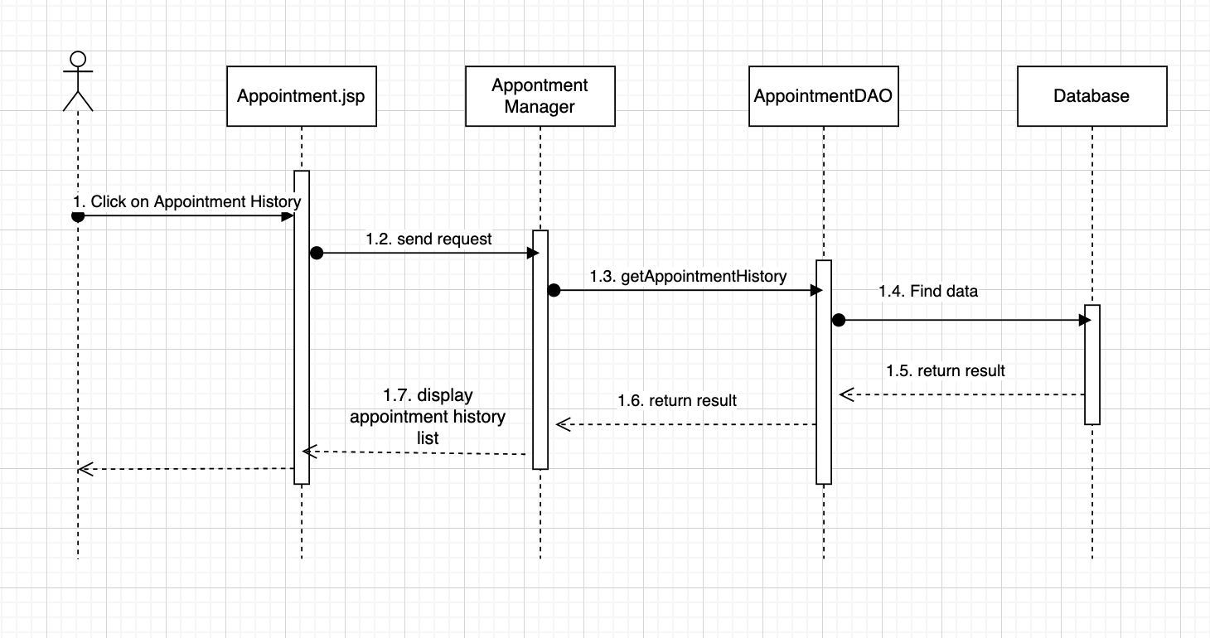

### Database queries

Select appointments.appointment_id, doctor.doctor_id, doctor.img,

doctor.doctor_name, users.name , appointments.date ,appointments.time,

appointments.status from appointments inner join doctor

on appointments.doctor_id = doctor.doctor_id inner join patient

on appointments.patient_id = patient.patient_id inner join users

on patient.username = users.username where appointments.patient_id = ?

select patient_id from patient where username =

## 39. Patient/ Reservation History

### Class Diagram

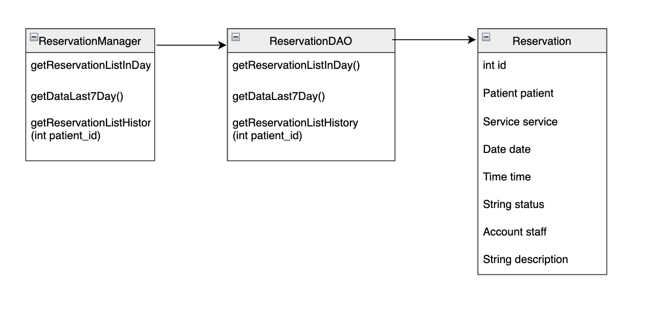

### Class Specification

|  |  |  |
| --- | --- | --- |
| No | Method | Description |
| 1 | getReservationListInDay | Display reservation list in to day |
| 2 | getDataLast7Day | Display reservation in a week |
| 3 | getReservationListHistory | Display all reservation list |

### Sequence Diagram

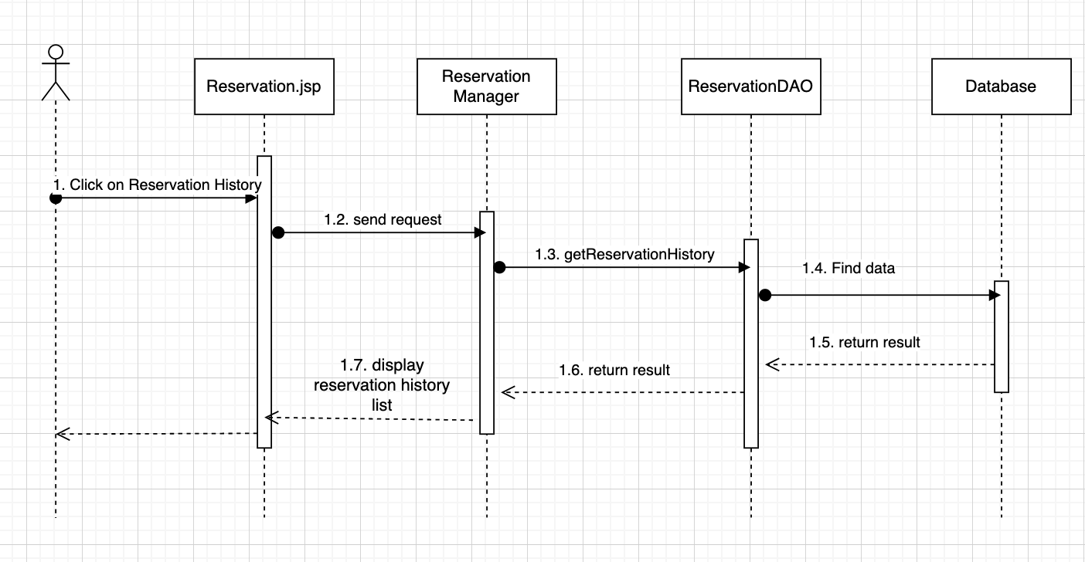

### Database queries

SELECT reservations.reservation_id, users.name, service.title,

reservations.date, reservations.time, reservations.status, service.fee FROM reservations

inner join service on reservations.service_id = service.service_id

inner join patient on reservations.patient_id = patient.patient_id

inner join users on patient.username = users.username where reservations.patient_id = ?

III. Database Design

## 1. Database Schema

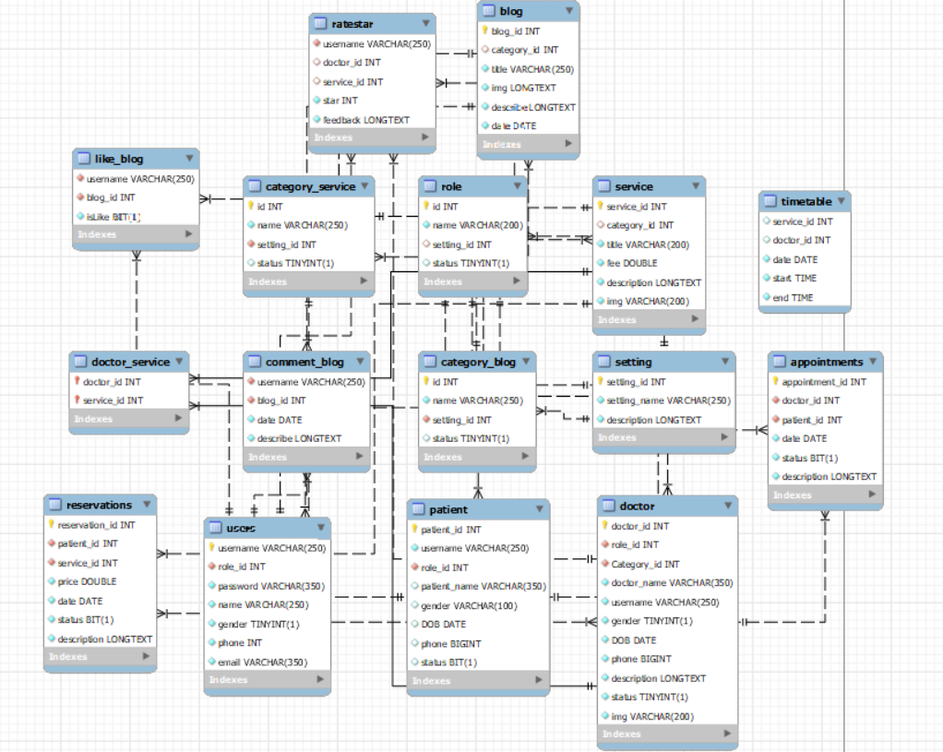

## 2. Table Description

|  |  |  |
| --- | --- | --- |
| No | Table | Description |
| 1 | User | username: VARCHAR  role_id: INT  password: VARCHAR  name: VARCHAR  gender: TINYINT  phone: INT  email: VARCHAR  - Primary keys: username  - Foreign keys: role_id |
| 2 | patient | patient_id: INT  username: VARCHAR  role_id: INT  patient_name:VARCHAR  gender:INT  DOB: DATE  phone: BIGINT  status: BIT  - Primary keys: patient_id  - Foreign keys: role_id |
| 3 | doctor | doctor_id: INT  role_id: INT  doctor_name: VARCHAR  username: VARCHAR  gender: BIT  DOB:DATE  phone:BIGINT  descriptionLONGTEXT  status:TINYINT  img:VARCHAR  - Primary keys: doctor_id  - Foreign keys: role_id |
| 4 | setting | setting_id: INT  setting_name:VARCHAR  description:LONGTEXT  - Primary keys: setting_id |
| 5 | service | service_id: INT  category_id: INT  title: VARCHAR  fee:DOUBLE  description: LONGTEXT  - Primary keys: service_id |
| 6 | blog | blog_id: INT  category_id: INT  title: VARCHAR  img: VARCHAR  describe: LONGTEXT  date: DATE  - Primary keys: blog_id |
| 7 | like_blog | username: VARCHAR  blog_id: INT  isLike: BIT  - Foreign keys: username |
| 8 | category_blog | id: INT  name: VARCHAR  setting_id: INT  status: TINYINT  - Primary keys: id  - Foreign keys: setting_id |
| 9 | comment_blog | username: VARCHAR  blog_id: INT  date: DATE  describe: LONGTEXT  - Foreign keys: setting_id |
| 10 | role | id: INT  name: VARCHAR  setting_id: INT  status:TINYINT  - Primary keys: id |
| 11 | category_service | id: INT  name: VARCHAR  setting_id: INT  status: TINYINT  - Primary keys: id  - Foreign keys: setting_id |
| 12 | reservations | reservation_id: INT  patient_id: INT  service_id: INT  price: DOUBLE  date: DATE  status: BIT  description: LONGTEXT  - Primary keys: reservation_id  - Foreign keys: patient_id, service_id |
| 13 | doctor_service | doctor_id: INT  service_id: INT  -Foreign - keys: doctor_id, service_id |
| 14 | ratestar | username: VARCHAR  doctor_id: INT  service_id: INT  star : INT  feedback: LONGTEXT  -Foreign - keys: username |
| 15 | appointments | appointment_id:INT  doctor_id: INT  patient_id: INT  date: DATE  status: BIT  description: LONGTEXT  - Primary keys: appointment_id  - Foreign keys: patient_id, doctor_id |
| 16 | timetable | service_id: INT  doctor_id: INT  date: DATE  start: TIME  end: TIME |