

**CLINIC SYSTEM**

**Software Requirement Specification**

– Hanoi, January 2022 –

**Table of Contents**

**I. Overview** **6**

1. Introduction 6

2. System Functions 8

Screen Flow 8

Screen Details 8

User Authorization 12

Non-Screen Function 13

3. Common Requirements 14

**II. Functional Requirements** **14**

1. Public Feature 14

a. Home Page 14

b. Web Blog List 15

c. Web Blog Details 16

d. Web Doctor List 17

e. Web Doctor Details 18

f. Web Services List 19

g. Web Service Details 20

2. Common Feature 21

a. Sign in 21

b. Register 22

C. ChangePassword 23

d. Forgot Password 24

e. User profile 25

3. Admin Feature 26

a.Settings List 26

b.Setting Details 27

c. Account List 29

d. Account Detail 30

e. DashBoard 31

4. Marketing Feature 32

a.Doctors List 32

b.Doctor Details 33

c.Doctor Edit 34

d.Patients List 34

e.Patient Details 35

f.Patient Edit 36

g.Service List 37

h.Service Details 38

j. Service Feedbacks 41

i. Blog List 41

l. Blog Detail 42

5. Staff Feature 43

a. Appointments List 43

b. Appointments Details 44

c. Reservations List 45

d. Reservations Detail 46

6. Doctor Feature 46

a. My Patients 46

b. My Patient Details 47

c. My Appointments 48

d. My Appointment Details 49

e. My Feedbacks 50

7. Patient Feature 51

a. Book Appointment 51

b. Reserve a Service 52

c. Appointment History 53

d. Reservation History 54

**​​RECORD OF CHANGE**

*A - ADDED M - MODIFIED D - DELETED

|  |  |  |  |  |
| --- | --- | --- | --- | --- |
| **Effective Date** | **Changed Items** | **A\***  **M, D** | **Change Description** | **New Version** |
| **05/1/2021** | Create new SRS | **A** | Create new | **1.0** |
| **13/01/2022** | Khương Văn Hùng | **A** | Home Page | **1.1** |
| **13/01/2022** | Phan Trương Thảo | **A** | User Login | **1.1** |
| **13/01/2022** | Trần Thành Lam | **A** | User Register | **1.1** |
| **13/01/2022** | Hà Hữu Việt | **A** | Settings List | **1.1** |
| **13/01/2022** | Nguyễn Văn Trung | **A** | Setting Details | **1.1** |
| **26/01/2022** | Khương Văn Hùng | **M** | Home Page | **1.2** |
| **26/01/2022** | Phan Trương Thảo | **M** | User Login | **1.2** |
| **26/01/2022** | Trần Thành Lam | **M** | User Register | **1.2** |
| **26/01/2022** | Hà Hữu Việt | **M** | Settings List | **1.2** |
| **26/01/2022** | Nguyễn Văn Trung | **M** | Setting Details | **1.2** |
| **26/01/2022** | Trần Thành Lam | **A** | Web Blogs List | **1.2** |
| **26/01/2022** | Trần Thành Lam | **A** | Web Blog Details | **1.2** |
| **26/01/2022** | Phan Trương Thảo | **A** | Forgot Password | **1.2** |
| **26/01/2022** | Phan Trương Thảo | **A** | Change Password | **1.2** |
| **26/01/2022** | Hà Hữu Việt | **A** | User Profile | **1.2** |
| **26/01/2022** | Hà Hữu Việt | **A** | Patients List | **1.2** |
| **26/01/2022** | Nguyễn Văn Trung | **A** | Patient Details | **1.2** |
| **26/01/2022** | Nguyễn Văn Trung | **A** | Patient Edit | **1.2** |
| **26/01/2022** | Đinh Thị Tươi | **A** | Accounts List | **1.2** |
| **26/01/2022** | Đinh Thị Tươi | **A** | Account Details | **1.2** |
| **26/01/2022** | Khương Văn Hùng | **A** | Doctors List | **1.2** |
| **26/01/2022** | Khương Văn Hùng | **A** | Doctor Details | **1.2** |
| **26/01/2022** | Khương Văn Hùng | **A** | Doctor Edit | **1.2** |
| **19/02/2022** | Phan Trương Thảo | **A** | Web Doctors List | **1.3** |
| **19/02/2022** | Phan Trương Thảo | **A** | Web Doctor Details | **1.3** |
| **19/02/2022** | Hà Hữu Việt | **A** | Web Services List | **1.3** |
| **19/02/2022** | Hà Hữu Việt | **A** | Web Service Details | **1.3** |
| **19/02/2022** | Khương Văn Hùng | **A** | Appointments List | **1.3** |
| **19/02/2022** | Khương Văn Hùng | **A** | Appointment Details | **1.3** |
| **19/02/2022** | Khương Văn Hùng | **A** | Reservations List | **1.3** |
| **19/02/2022** | Đinh Thị Tươi | **A** | Reservation Details | **1.3** |
| **19/02/2022** | Đinh Thị Tươi | **A** | Services List | **1.3** |
| **19/02/2022** | Nguyễn Văn Trung | **A** | Service Details | **1.3** |
| **19/02/2022** | Nguyễn Văn Trung | **A** | Service Feedbacks | **1.3** |
| **19/02/2022** | Trần Thành Lam | **A** | Blogs List | **1.3** |
| **19/02/2022** | Trần Thành Lam | **A** | Blog Details | **1.3** |
| **06/03/2022** | Phan Trương Thảo | **A** | User Authorization | **1.4** |
| **06/03/2022** | Khương Văn Hùng | **A** | Dashboard | **1.4** |
| **06/03/2022** | Hà Hữu Việt | **A** | My Appointments | **1.4** |
| **06/03/2022** | Hà Hữu Việt | **A** | My Appointment Details | **1.4** |
| **06/03/2022** | Nguyễn Văn Trung | **A** | My Patients | **1.4** |
| **06/03/2022** | Nguyễn Văn Trung | **A** | My Patient Details | **1.4** |
| **06/03/2022** | Phan Trương Thảo | **A** | My Feedbacks | **1.4** |
| **06/03/2022** | Trần Thành Lam | **A** | Book Appointment | **1.4** |
| **06/03/2022** | Trần Thành Lam | **A** | Reserve a Service | **1.4** |
| **06/03/2022** | Đinh Thị Tươi | **A** | Appointment History | **1.4** |
| **06/03/2022** | Đinh Thị Tươi | **A** | Reservation History | **1.4** |
| **06/03/2022** | Khương Văn Hùng | **A** | Appointment,Reservation payment | **1.4** |

# I. Overview

General information about the project:

* Project name: **Clinic System**
* Project code: **CS**
* Group name: **Group 3**
* Software type: **Website**

## 1. Introduction

Today, many diseases are born due to the influence of environmental pollution, diseases that spread quickly and widely, such as the current Covid-19 pandemic. It is extremely dangerous for us to go to public places such as hospitals and clinics to queue up, potentially posing a risk of infection. The Clinic system is expected to help patients who come to the clinic to limit their close contact in public places, especially the system has services to help visitors quickly book an appointment with a doctor that is effective and safe.

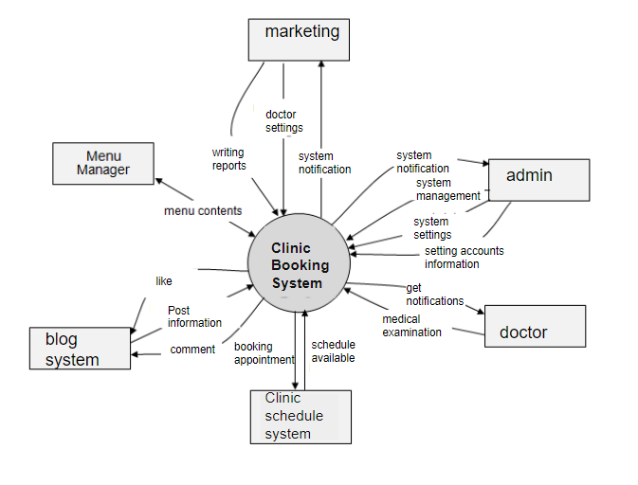

## 2. System Functions

### Screen Flow

***Image 1.2****: Screen flow of Clinic system* 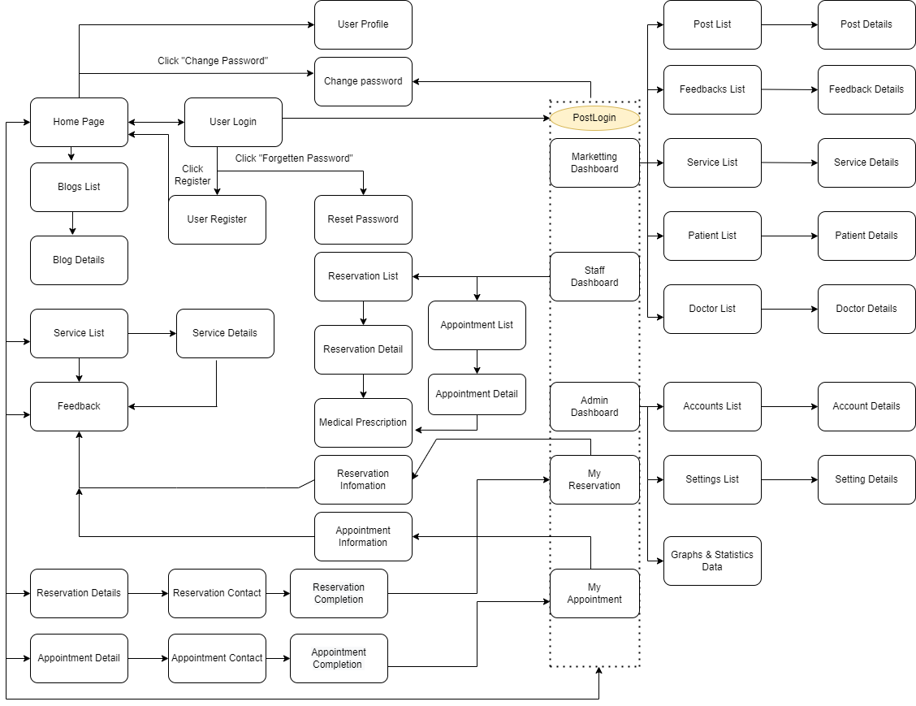

### Screen Details

|  |  |  |
| --- | --- | --- |
| **Feature** | **Screen** | **Description** |
| Public | Home Page | the starting page of the system |
| Public | Blogs List | list of shared posts |
| Public | Blog Details | detail of the shared post |
| Public | Services List | list of the active type of services |
| Public | Service Details | Details of the selected service |
| Public | Reservation Details | details of the user reservations (the list of selected services to reserve) |
| Public | Reservation Contact | screen that allows user to input/edit the reservation receiver |
| Public | Reservation Completion | reservation completion screen |
| Common | User Login | authenticate the user to give him/her to access authorised features later on |
| Common | User Register | register a new user into the system, verified by the registered email |
| Common | Reset Password | use in case the user forgot his/her password |
| Common | Change Password | change user’s login password |
| Common | User Profile | view & edit/update user profile |
| Common | User Authorization | Authorization user into the system functions based on his/her role |
| Patient | My Reservation | for the customer to view his/her submitted reservations |
| Patient | Reservation Information | to show Patient reservation details, the Patientcan edit or cancel the reservation when it is still in the submitted status |
| Patient | My Appointment | for customer to view his/her submitted Appointment |
| Patient | Appointment Information | to show Patient Appointment details, the Patientcan edit or cancel the Appointment when it is still in the submitted status |
| Staff | Services List | list, filter, search, view service(s) |
| Staff | Service Details | view the details of a specific service |
| Staff | Reservation List | list, filter, search, show, hide, view reservation(s) that are assigned for this staff. |
| Staff | Appointment List | list, filter, search, show, hide, view reservation(s) that are assigned for this staff. |
| Staff | Reservation Details | view the details of a specific assigned reservation. |
| Staff | Appointment Details | view the details of a specific assigned Appointment. |
| Staff | Medical examination | list, filter, search, show, hide, view the history examination of a customer that is assigned for this staff. |
| Staff | Services List | list, filter, search, show, hide, view service(s) |
| Staff | Service Details | view the details of a specific service |
| Staff | Customers List | list, filter, search, show, hide, view customer/contact(s) |
| Staff | Customer Details | view the details of a specific customer |
| Staff | Feedbacks List | list, filter, search, show, hide, view feedback(s) |
| Staff | Feedback Details | view the details of a specific feedback |
| Staff | Medical Prescription | (Used for doctor) list, filter, search, show, hide, view, add new prescription |
| Marketing | Posts List | list, filter, search, show, hide, view, add new or edit existing post(s) |
| Marketing | Post Details | view & edit the details of a specific post |
| Marketing | Feedback List | list feedback |
| Marketing | Services List | list, filter, search, show, hide, view, add new or edit existing service(s) |
| Marketing | Service Details | view & edit the details of a specific service |
| Marketing | Patient List | list, filter, search, show, hide, view, add new or edit existing Patient (s) |
| Marketing | Patient Details | view & edit the details of a specific Patient |
| Marketing | Doctor List | list, filter, search, show, hide, view, add new or edit existing Doctor (s) |
| Marketing | Doctor Details | view & edit the details of a specific Doctor |
| Admin | Admin Dashboard | view general statistics & trends about the management-related data |
| Admin | Accounts List | list, filter, search, show, hide, view, add new or edit existing Accounts (s) |
| Admin | Accounts Details | view & edit the details of a specific Accounts |
| Admin | Settings List | list, filter, search, show, hide, view, add new or edit existing system setting(s) |
| Admin | Setting Details | view, add new, delete & edit the details of a specific system setting |
| Admin | Graphs & Statistic Data | Graphs & Statistics of Doctors, Patients, Appointments, and Revenue |

***Table 1.1****: Screen detail table of clinic system*

### User Authorization

|  |  |  |  |  |  |  |
| --- | --- | --- | --- | --- | --- | --- |
| **Screen** | **Admin** | **Marketing** | **Staff** | **Doctor** | **Patient** | **Guest** |
| **Home Page** | X | X | X | X | X | X |
| **Doctors List** | X | X | X | X | X | X |
| **Doctor Details** | X | X | X | X | X | X |
| **Active/Deactive a doctor** |  | X |  |  |  |  |
| **View his/her appointments** |  | X |  | X |  |  |
| **Doctor Edit** |  | X |  |  |  |  |
| **Services List** | X | X | X | X | X | X |
| **Add new service** |  | X |  |  |  |  |
| **Service Details** | X | X | X | X | X | X |
| **Edit service information** |  | X |  |  |  |  |
| **Service Feedbacks** |  | X |  |  |  |  |
| **Blogs List** | X | X | X | X | X | X |
| **Add new blog** |  | X |  |  |  |  |
| **Update blog** |  | X |  |  |  |  |
| Show/hide an existing post |  | X |  |  |  |  |
| **Blog Details** | X | X | X | X | X | X |
| **User Login** | X | X | X | X | X | X |
| **User Register** | X | X | X | X | X | X |
| **Forgot Password** | X | X | X | X | X | X |
| **Change Password** | X | X | X | X | X | X |
| **User Profile** | X | X | X | X | X | X |
| **Dashboard** | X |  |  |  |  |  |
| **Accounts List** | X |  |  |  |  |  |
| **Account Details** | X |  |  |  |  |  |
| **Patients List** |  | X |  |  |  |  |
| **Patient Details** |  | X |  |  |  |  |
| **Patient Edit** |  | X |  |  |  |  |
| **Appointments List** |  |  | X |  |  |  |
| **Appointment Details** |  |  | X |  |  |  |
| **Reservations List** |  |  | X |  |  |  |
| **Reservation Details** |  |  | X |  |  |  |
| **Settings List** | X |  |  |  |  |  |
| **Setting Details** | X |  |  |  |  |  |
| **My Appointments** |  |  |  | X |  |  |
| **My Appointment Details** |  |  |  | X |  |  |
| **My Patients** |  |  |  | X |  |  |
| **My Patient Details** |  |  |  | X |  |  |
| **My Feedbacks** |  |  |  | X |  |  |
| **Book Appointment** |  |  |  |  | X |  |
| **Reserve a Service** |  |  |  |  | X |  |
| **Appointment History** |  |  |  |  | X |  |
| **Reservation History** |  |  |  |  | X |  |

***Table 1.2****: User authorization table of clinic system*

### Non-Screen Function

|  |  |  |  |
| --- | --- | --- | --- |
| **#** | **Feature** | **System Function** | **Description** |
| 1 | Common | Sign out | Users sign out of the system |
| 2 | Common | User Authorization | This is the authorization mechanism in the system, |

***Table 1.3****: Non-screen function table of clinic system*

#### 

## 3. Common Requirements

The web displays Vietnamese characters.

# II. Functional Requirements

## 1. Public Feature

#### a. Home Page

● Function trigger: This function is triggered when the user visits the website or the system homepage

● Function description: Users see briefs about introduction, top 10 services, top 10 doctors, the system's specialities.

● Screen layout: simulated prototype of the screen, the sample below is for the home screen

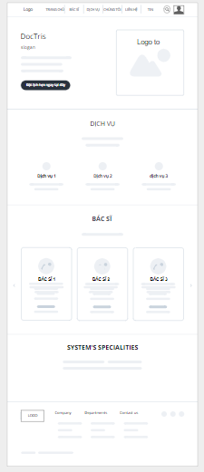

● Function Details: When users access the system, the homepage will appear and show information about the system

#### b. Web Blog List

● Function trigger: This function is triggered when the user clicks blogs in navbar

● Function description: Show the paginated list of blogs

● Screen layout: mock-up prototype of the screen, sample below is for the Blog screen

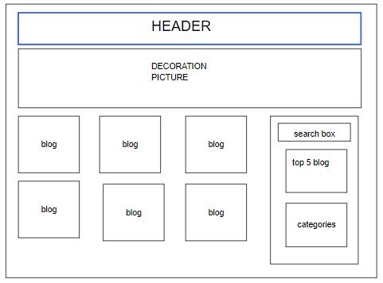

● Function Details:

* Show the posts pagination (sorted by updated date)
* The right sider with the post search box, post categories, five featured posts (thumbnail, title)
* Post information includes its thumbnail, title, category, post date, brief-info

#### c. Web Blog Details

● Function trigger: This function is triggered when the user clicks to Read More or Title

● Function description: Show detail information of blog

● Screen layout: mock-up prototype of the screen, sample below is for the Details screen

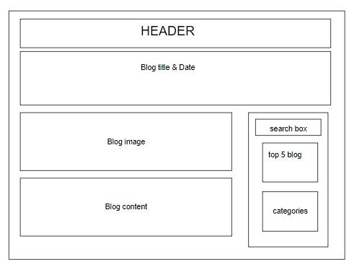

● Function Details:

* Show post details (including title, author, updated date, brief info, and post content)
* The right sider with the post search box, post categories, five featured posts (thumbnail, title)

#### d. Web Doctor List

● Function trigger: This function is triggered when the user clicks to Doctor List

● Function description: Show detail information of Doctor

● Screen layout: mock-up prototype of the screen, sample below is for the Doctor List screen

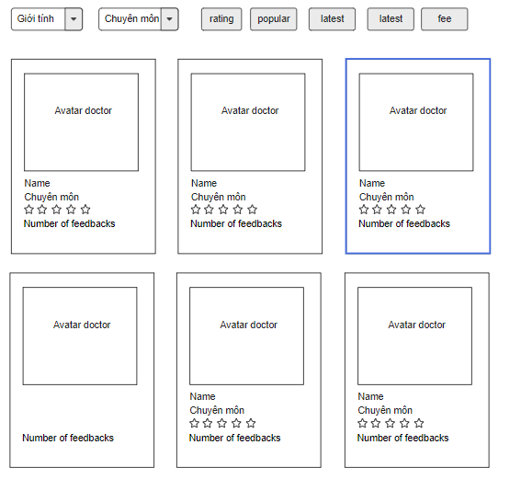

● Function Details:

* List of doctors in the system:
* Shown information of each doctor: avatar, role, speciality, rated star, and number of feedbacks
* User can filter by gender & speciality; sort by rating, popular, latest, consulting fee
* User can choose to view Doctor Details or Book Doctor

#### e. Web Doctor Details

● Function trigger: This function is triggered when the user clicks to Doctor

● Function description: View doctor's overview information

● Screen layout: mock-up prototype of the screen, sample below is for the Doctor Details screen

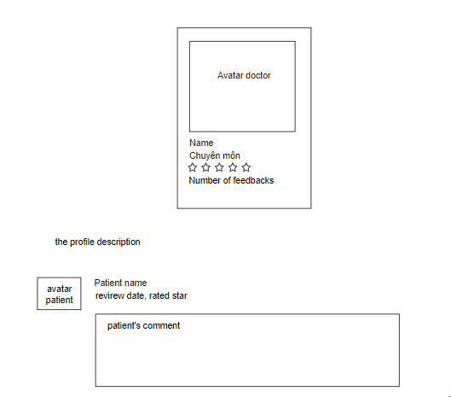

● Function Details:

the profile description, and the patients' reviews (each include patient avatar, patient name, review date, rated star and patient's comment)

#### f. Web Services List

● Function trigger: This function is triggered when the user clicks to Services List

● Function description: Show detail information of Services

● Screen layout: mock-up prototype of the screen, sample below is for the Services List screen

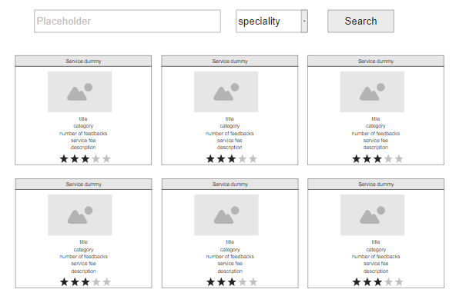

● Function Details:

List of services in the system:

- Shown information for each service include: title, category, rated star, number of feedbacks, service fee and description

- User can search by name; filter by speciality; sort by the fee or the name

#### g. Web Service Details

● Function trigger: This function is triggered when the user clicks to a service in Services List

● Function description: View service's overview information

● Screen layout: mock-up prototype of the screen, sample below is for the Service Details screen

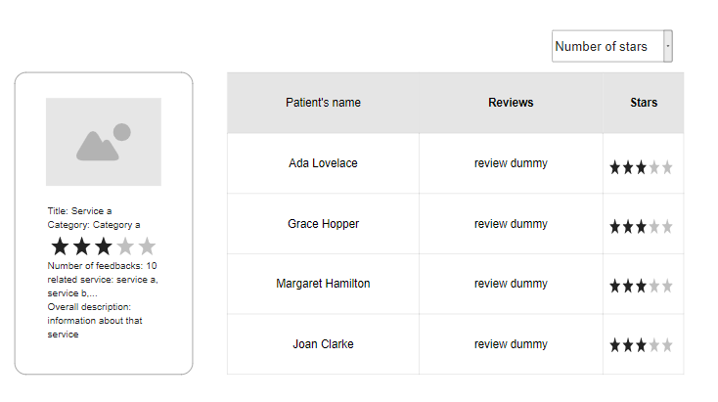

● Function Details:

View the details of the chosen service, including the introduction information (title, category, rated star, number of feedbacks, related services), overall description, and the reviews from patients (filtered by the rated star)

## 2. Common Feature

#### a. Sign in

● Function trigger: This function is triggered when the user clicks Sign in from Homepage

● Function description: User sign in into the system.

● Screen layout: mock-up prototype of the screen, sample below is for the Sign in screen

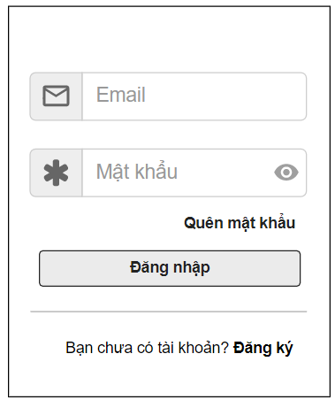

Function Details: When the user is in the state not logged in, at the home page there will be a Sign in button after signing in into the system, the Sign in button will become Sign out.

#### b. Register

● Function trigger: This function is triggered when the guest goes to login and choose to register

● Function description: The guest can create an account.

● Screen layout: mock-up prototype of the screen, sample below is for the Register.

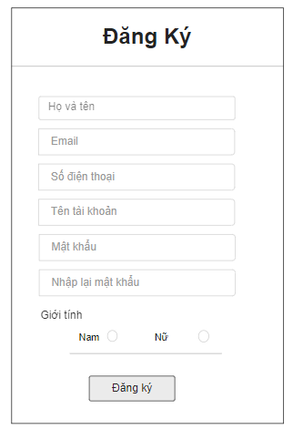

Function Details: After going to the login, the guest can create an account.

#### C. ChangePassword

* Function trigger: This function is triggered when the user clicks “Tài khoản của tôi” from avatar in Homepage
* Function description: Show profile
* Screen layout: simulated prototype of screen, below sample is for ChangePassword screen

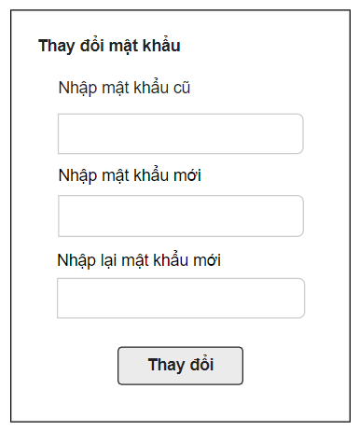

Function Details: Allows the user to change his/her password by inputting his current password as well as new password (twice)

#### d. Forgot Password

* Function trigger: This function is triggered when the user clicks “Quên mật khẩu” from Đăng nhập
* Function description: The user can Forgot Password to an account.
* Screen layout: simulated prototype of screen, below sample is for ForgotPassword screen

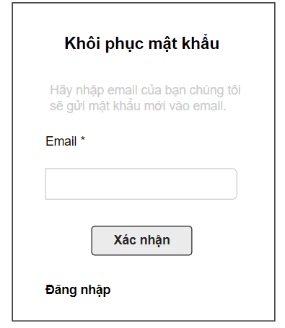

**Function Details**:The user can input his/her email to receive the reset password link.

#### e. User profile

* Function trigger: This function is triggered when the user clicks “Tài khoản của tôi” from Home
* Function description: The user can edit his/her profile information, including the registered user information and the avatar image.
* Screen layout: simulated prototype of screen, below sample is for User profile screen

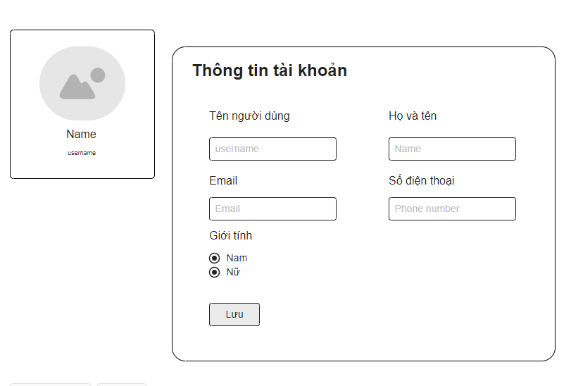

**Function Details**:The user can edit his/her profile information.

## 3. Admin Feature

#### a.Settings List

● Function trigger: When a user logs in as admin, the page is automatically redirected here

● Function description: Show the paginated list of settings

● Screen layout: simulated prototype of screen, below sample is for admin setting screen

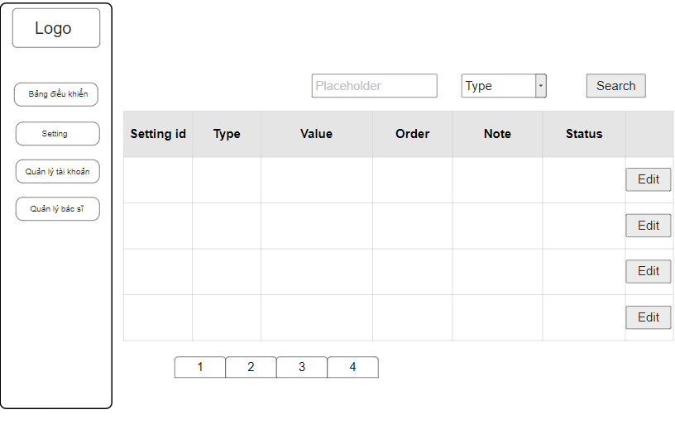

**Function Details**: Allow the admin to search settings by value, from each setting, the admin can choose to view, activate/deactivate, or edit it

#### b.Setting Details

**b.1: Edit**

● Function trigger: This function is activated when the user clicks on button edit

● Function description: Edit setting information

● Screen layout: simulated prototype of screen, below sample is for edit setting screen

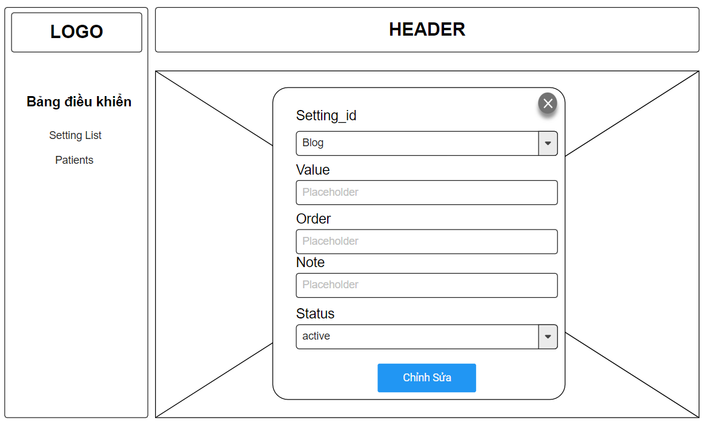

**Function Details**: Edit Setting information which include: value, order, note, status

**b.2: add**

● Function trigger: This function is activated when the user clicks on button add

● Function description: add new setting

● Screen layout: simulated prototype of screen, below sample is for add setting screen

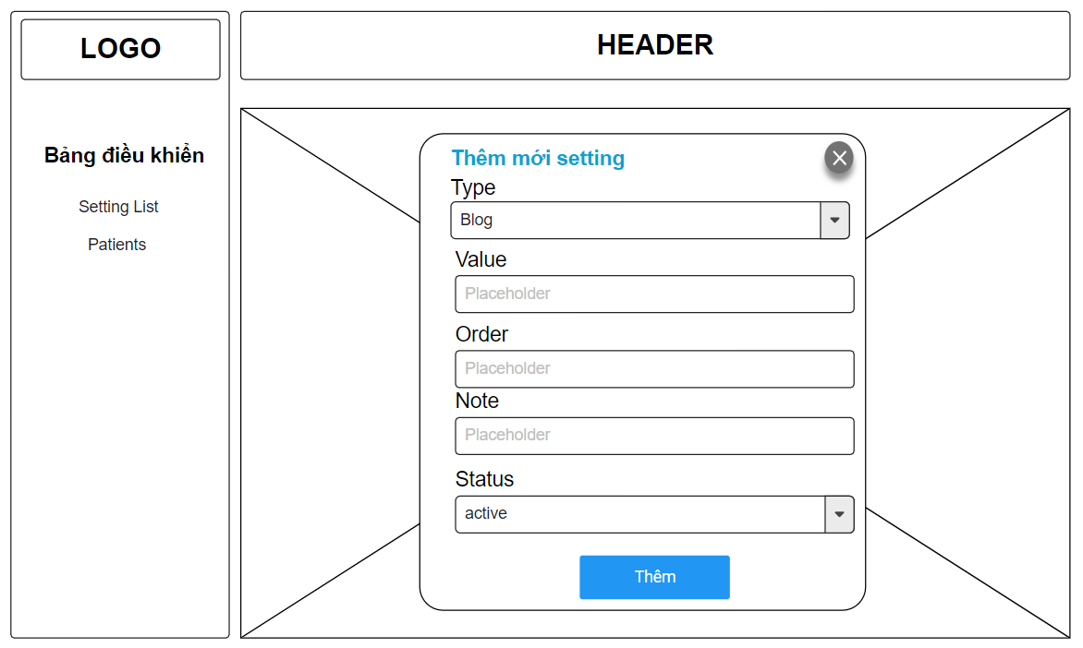

**Function Details**: the user can add new setting

#### c. Account List

* **Function trigger**: When a user logs in as admin, the user chooses “Quản lý tài khoản” feature
* **Function description**: Account list feature displays a list of all accounts created on the system including Admin, Patient, Doctor.
* **Screen layout**: simulated prototype of screen, below sample is for admin setting screen

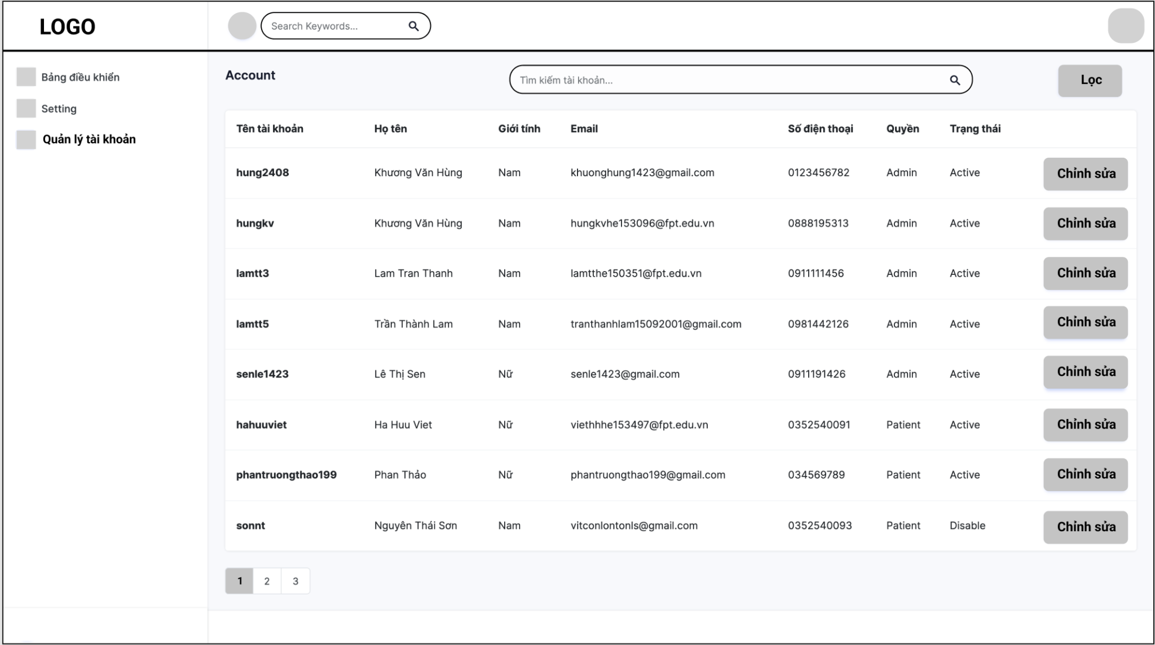

*Image: The mockup of Account list in Doctris system*

* **Function Details**: Allow the admin to search account name, display list account and edit account of admin, patient or doctor

#### d. Account Detail

* **Function trigger**: When a user logs in as admin, the user chooses “Quản lý tài khoản” feature and click on an account in list account to see detail information
* **Function description**: Account detail feature displays user details information
* **Screen layout**: simulated prototype of screen, below sample is for admin setting screen

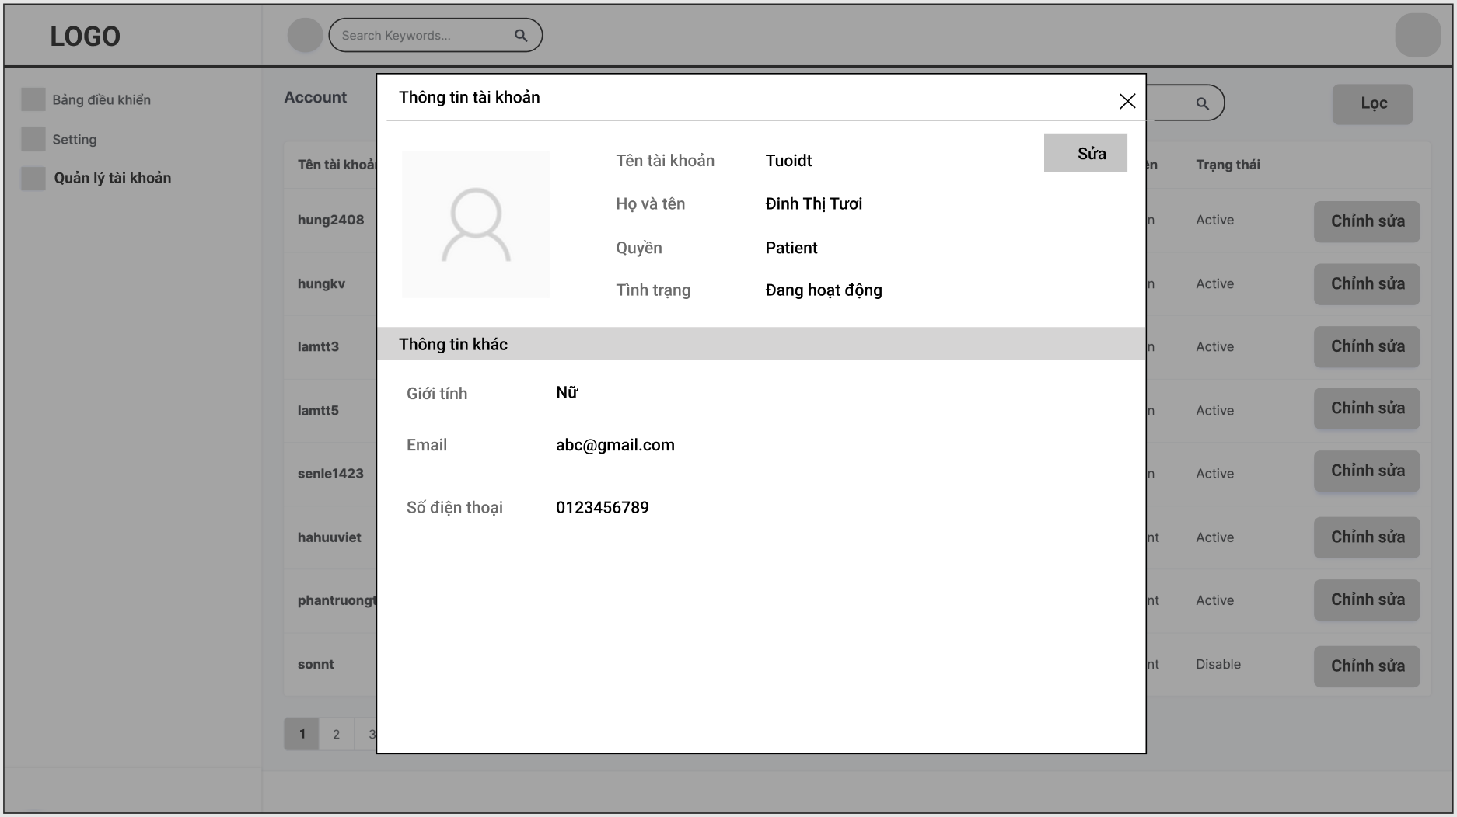

* **Function Details**: Allow the admin can view and edit user accounts in the Doctris system includes “Họ và tên”, “Quyền”, “Tình trạng”, “Giới tính”, “Email”, “số điện thoại”

#### e. DashBoard

* **Function trigger**: When a user logs in as admin, the user chooses “Bảng điều khiển”
* **Function description**: Show dashboard
* **Screen layout**: simulated prototype of screen, below sample is for dashboard screen

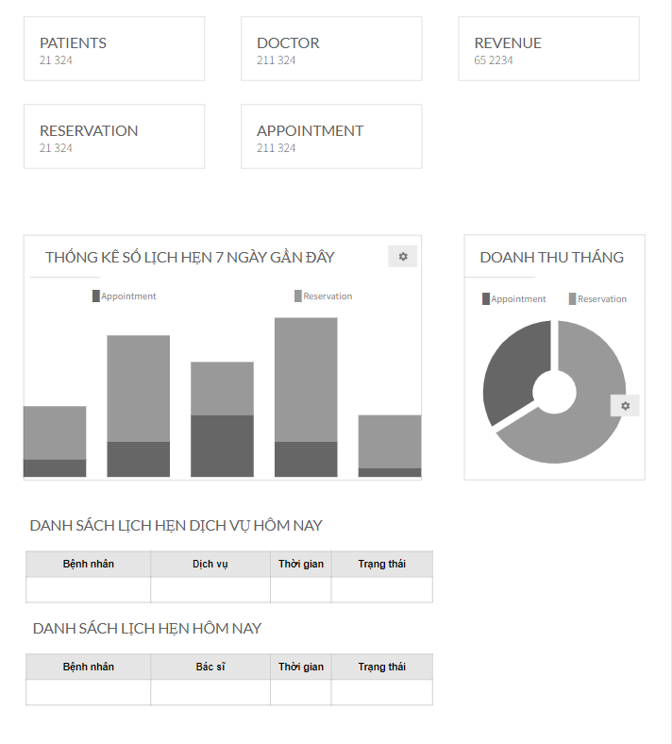

* **Function Details**:

- Graphs & Statistics of Doctors, Patients, Appointments, and Revenue

- List of today related appointments (Patient name, doctor name, date/time, Status

## 4. Marketing Feature

#### a.Doctors List

* Function trigger: When a user logs in as marketing, the page is automatically redirected here
* Function description: Show the doctors list
* Screen layout: simulated prototype of screen, below sample is for doctor list screen

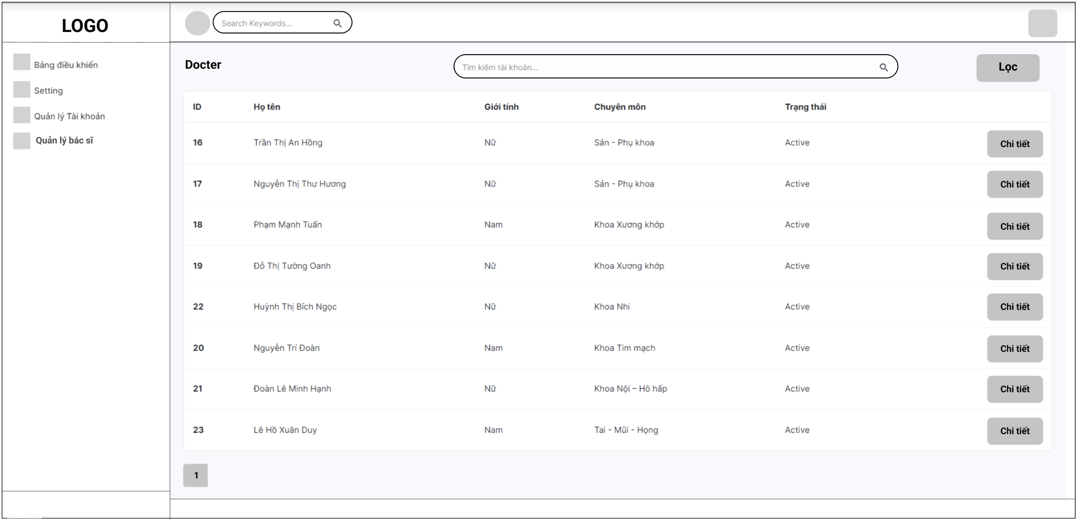

* **Function Details**: List of doctors in the system:

- Shown columns: Id, doctor name, gender, speciality, Status

- The user can search the doctors by name, filters them by gender & speciality

#### b.Doctor Details

* Function trigger: This function is activated when the user clicks on manage 1 button Patient
* Function description: display detailed installation information
* Screen layout: simulated prototype of screen, below sample is for doctor detail screen

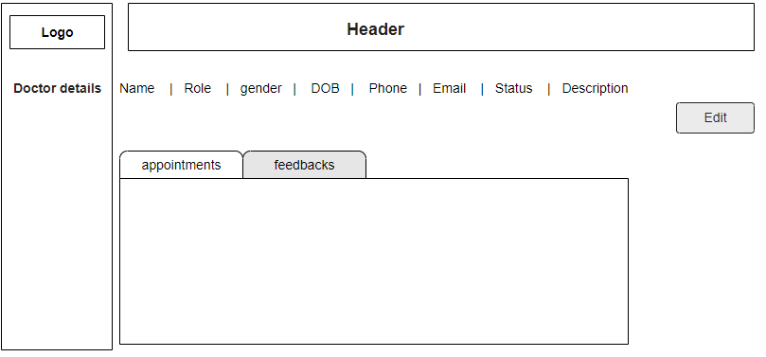

* **Function Details:** "View details of a specific doctor (chosen from the Doctors List screen);

- The following information of the doctor is shown: name, Role, gender, DOB, Phone, Email, Status, Description

- From this screen, the user can also activate or deactivate a doctor + view his/her appointments + view feedbacks (both rate & comments) about him/her

- The user can also choose to edit the doctor information via the Doctor Edit screen"

#### c.Doctor Edit

* Function trigger: This function is activated when the user clicks button edit
* Function description: Edit doctor information
* Screen layout: simulated prototype of screen, below sample is for doctor edit screen

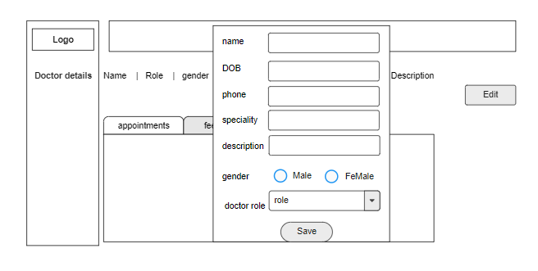

* **Function Details:** Edit doctor information which include: name, gender, DOB, Phone, doctor role, speciality, description

#### d.Patients List

* Function trigger: This function is activated when the user clicks on button Patient
* Function description: List of patients in the system
* Screen layout: simulated prototype of screen, below sample is for list patients screen

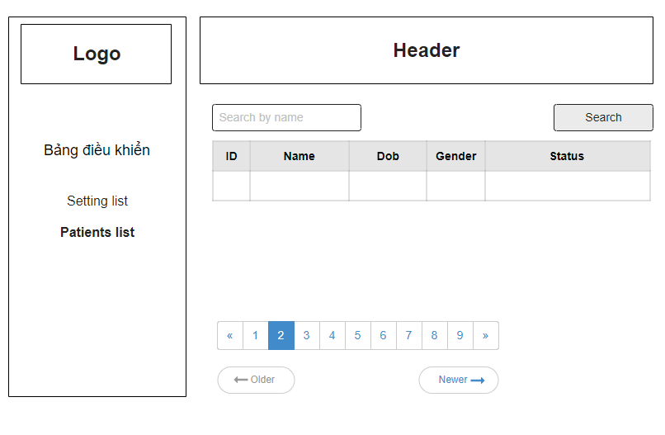

**Function Details**: search by name with following columns: Id, patient name, gender, date of birth, and status

#### e.Patient Details

* Function trigger: This function is activated when the user clicks on manage 1 button chi tiết
* Function description: display detailed installation information
* Screen layout: simulated prototype of screen, below sample is for admin patients screen

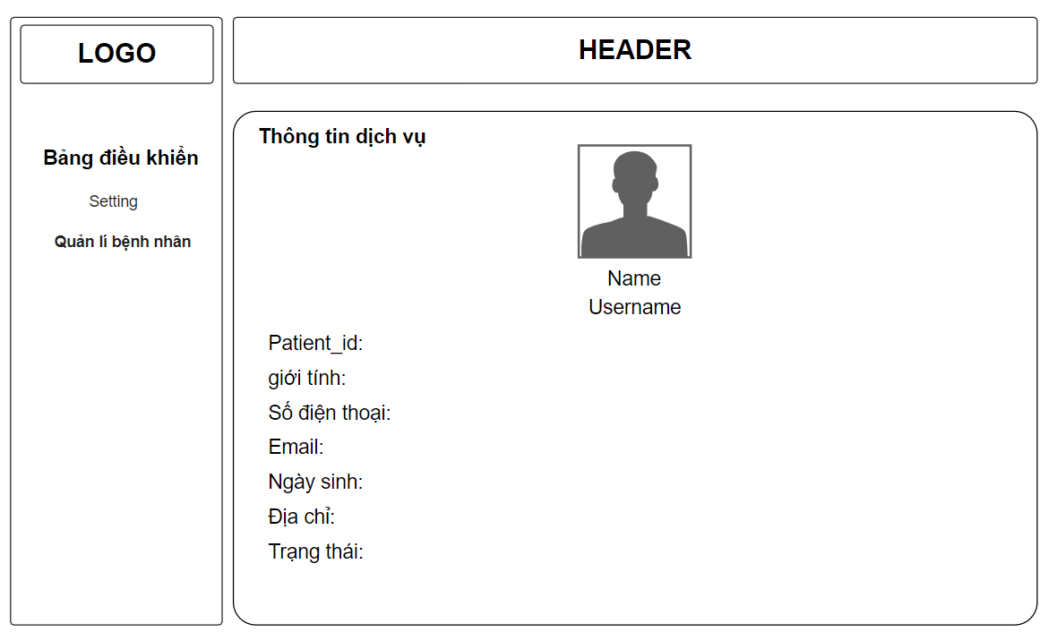

**Function Details**: when user enters Patients user can see information them

#### f.Patient Edit

* Function trigger: function works when user edit info in edit info box and press cập nhật button
* Function description: Edit Patient information, including name, gender, DOB, Phone, Address
* Screen layout: simulated prototype of screen, below sample is for admin Patients screen

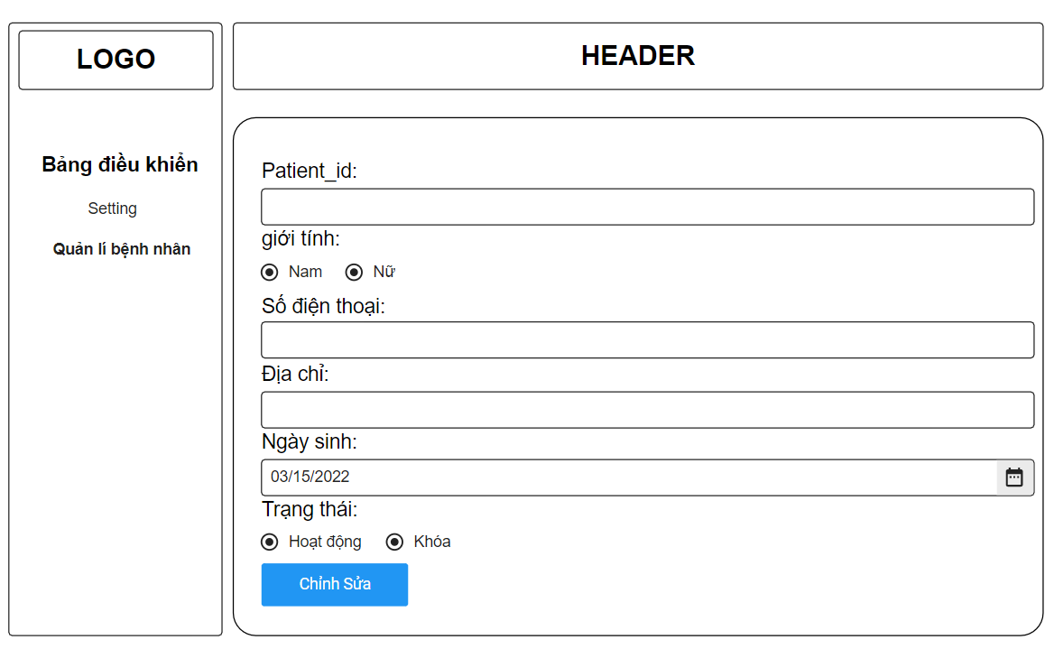

**Function Details**: when the user is to the use of the chi tiết button can edit patient information in it

#### g.Service List

* Function trigger: function works when user click on Service button
* Function description: The admin can view list of service on system
* Screen layout: simulated prototype of screen, below sample is for admin account screen

#### 

The feedback screen



**Function Details**:

* View list of service in system includes: ID, tên dịch vụ, loại, giá, trạng thái, chỉnh sửa dịch vụ
* The admin can add new service
* The admin can search service by name or category
* The user can view feedback of other patents when click double on a service in service list

#### h.Service Details

Function trigger: This function is activated when the user clicks on manage 1 button chi tiết

* Function description: display detailed installation information
* Screen layout: simulated prototype of screen, below sample is for admin Services screen

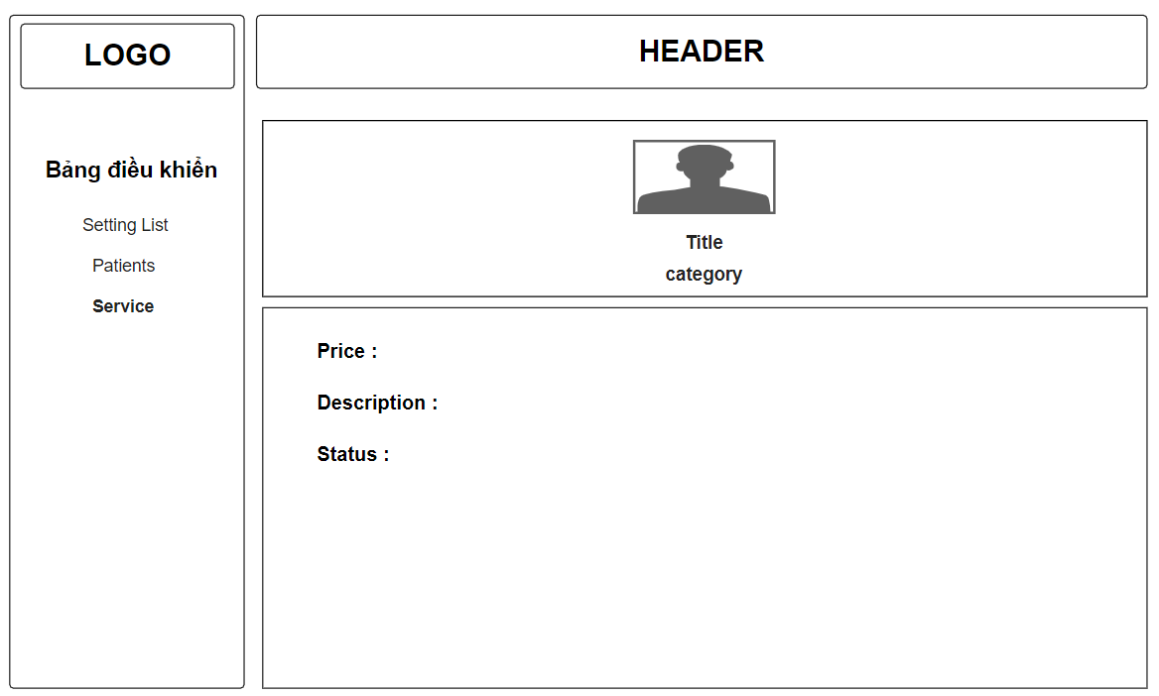

**Function Details**: when the user is to the use of the chi tiết button can view service information in it

**g.2: *Service add***

● Function trigger: This function is activated when the user clicks on button add

● Function description: add new Service

● Screen layout: simulated prototype of screen, below sample is for add Service screen

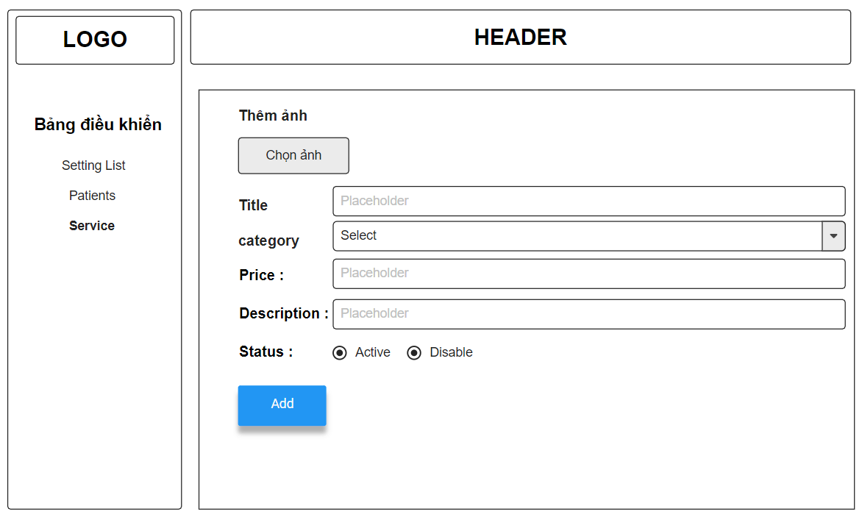

**Function Details**: the user can add new Service

**g.3: *Service edit***

* Function trigger: This function is activated when the user clicks button edit
* Function description: Edit Service information
* Screen layout: simulated prototype of screen, below sample is for Service edit screen

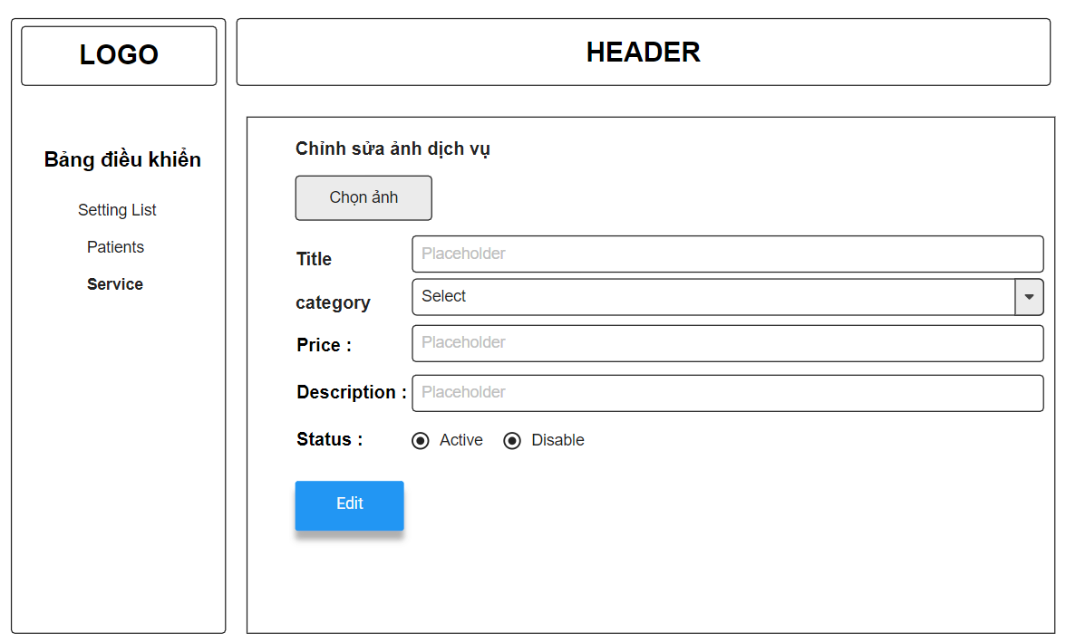

**Function Details**: the user can edit Service information

#### j. Service Feedbacks

* Function trigger: This function is activated when the user clicks on button Feedbacks
* Function description: View feedbacks from patients to the service
* Screen layout: simulated prototype of screen, below sample is for Feedback service screen

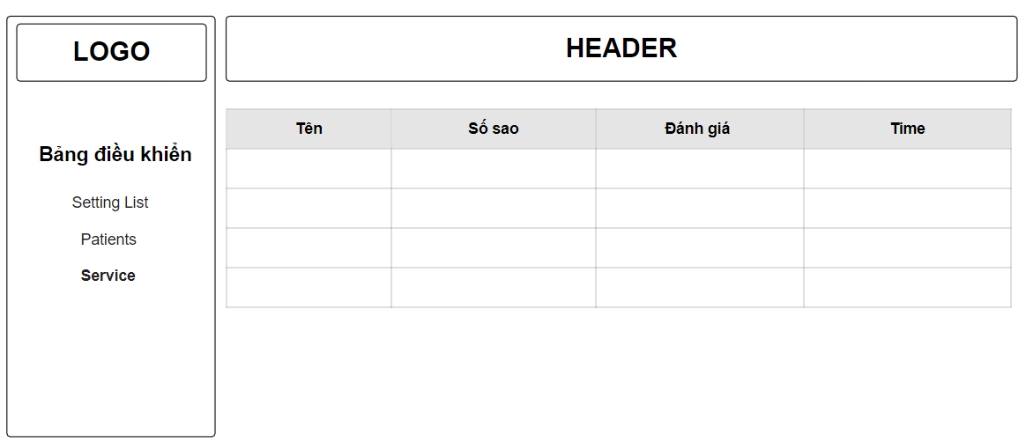

**Function Details**: the user can view Feedback Service

#### i. Blog List

● Function trigger: This function is triggered when the user clicks blogs in navbar

● Function description: Show the paginated list of blogs

● Screen layout: mock-up prototype of the screen, sample below is for the Blog screen

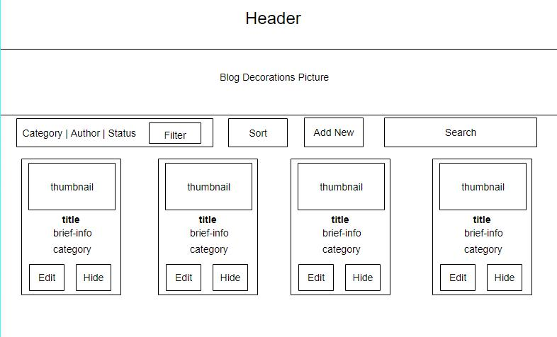

* Function details:

- Show the paginated list of posts (include posts' id, thumbnail, title, category, author, featured, and status information):

- The user can filter the post by category, author, status; also the user can search the post by title

- The list can be sortable by title, category, author, featured, or status

- The page also have the button/link that allows the user to add new or choose to view/update/show/hide an existing post

#### l. Blog Detail

● Function trigger: This function is triggered when the user clicks to Title

● Function description: Show detail information of blog

● Screen layout: mock-up prototype of the screen, sample below is for the Details screen

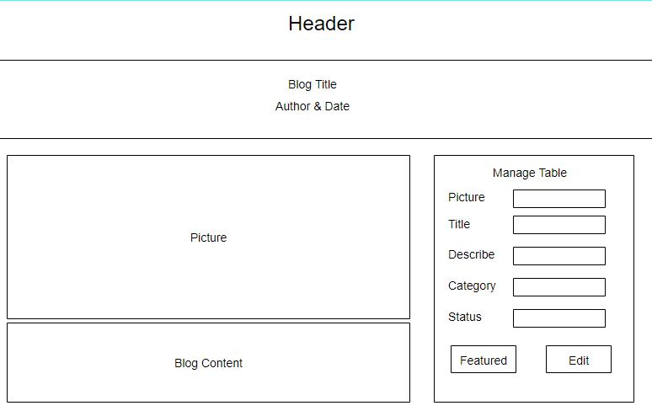

* Function details: Show detailed post information (thumbnail, category, title, brief information, content, flag to turn the featurning on/off, status), from that allow the user to input new post information, view or edit existing post information.

## 5. Staff Feature

#### a. Appointments List

● Function trigger: This function is triggered when the user clicks to “Quản lý lịch hẹn”

● Function description: Show list appointments

● Screen layout: mock-up prototype of the screen, sample below is for the appointment list screen

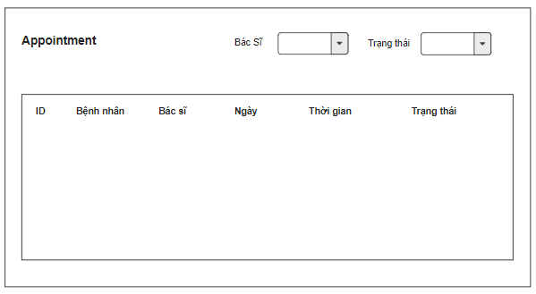

* Function details:
* View list of appointments in the system, which include following columns: Id, Patient Name, Doctor Name, Time, Status. From this, the user can filter the list by the doctor name and/or status
* The admin can see all the appointments while the staff can only see his/her in-charged appointments

#### b. Appointments Details

● Function trigger: This function is triggered when the user clicks to “chi tiết”

● Function description: Show detail appointment

● Screen layout: mock-up prototype of the screen, sample below is for the appointment details screen

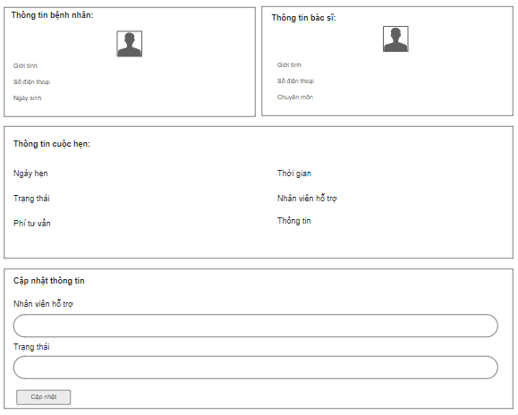

* Function details:

View details of a specific appointment (chosen from the Appointments list) which include:

- Patent information: avatar, name, mobile, gender, date of birth

- Doctor information: avatar, name, mobile, gender, speciality,

- Appointment information: date, time, status, description, in-charged staff

On this screen, user can input/edit the consulting fee and change appointment status from Pending to Assigned or Cancelled; ; the admin can change the in-charged staff to a specific staff

#### c. Reservations List

● Function trigger: This function is triggered when the user clicks to “Quản lý dịch vụ”

● Function description: Show list reservations.

● Screen layout: mock-up prototype of the screen, sample below is for the reservations list screen

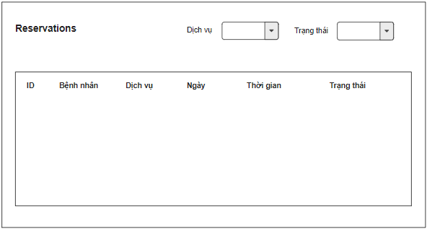

* Function details:
* View list of reservations in the system, which include following columns: Id, patient name, service name, time, status; From this, user can filter the list by the service name and/or status
* The admin can see all the appointments while the staff can only see his/her in-charged reservations

#### d. Reservations Detail

● Function trigger: This function is triggered when the user clicks to “Chi tiết” on “Quản lý lịch hẹn” Screen

● Function description: he user can also see the detailed information of the patent as well as the booked service

● Screen layout: mock-up prototype of the screen, sample below is for the reservations detail screen

## 6. Doctor Feature

#### a. My Patients

● Function trigger: This function is triggered when the user clicks to “My Patients”

● Function description: Show list of doctor's patients

● Screen layout: simulated prototype of screen, below sample is for My Patients screen

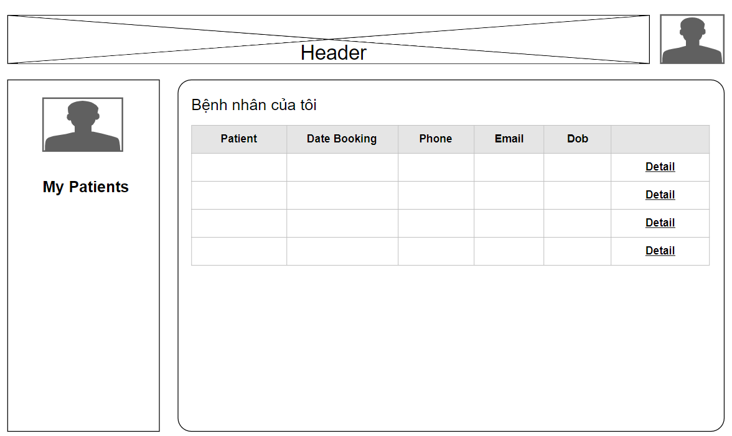

* Function details:
* View list of doctor's patients includes: avatar, name, last booking date, date of birth, email, phone

#### b. My Patient Details

● Function trigger: This function is triggered when the user clicks to “Detail”

● Function description: Show detailed information of the doctor's patient along with the list of appointments with him/her

● Screen layout: simulated prototype of screen, below sample is for My Patient Details screen

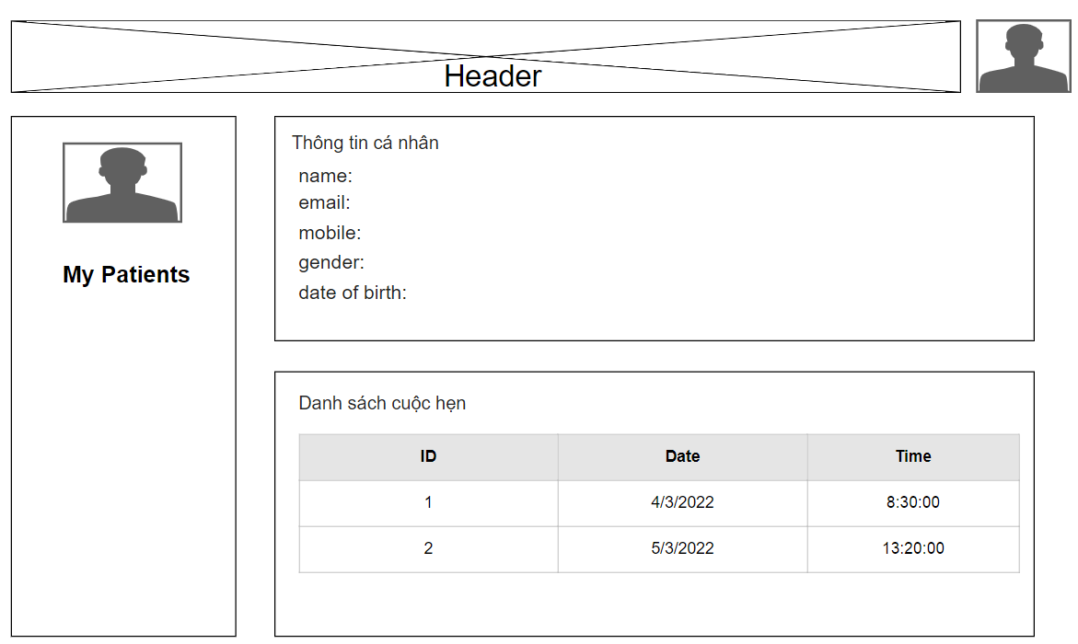

* Function details:
* View detailed information of the doctor's patient (name, email, mobile, gender, date of birth) along with the list of appointments with him/her

#### c. My Appointments

● Function trigger: This function is triggered when the user clicks to “My Appointments”

● Function description: Show list of doctor's appointments

● Screen layout: simulated prototype of screen, below sample is for My Appointments screen

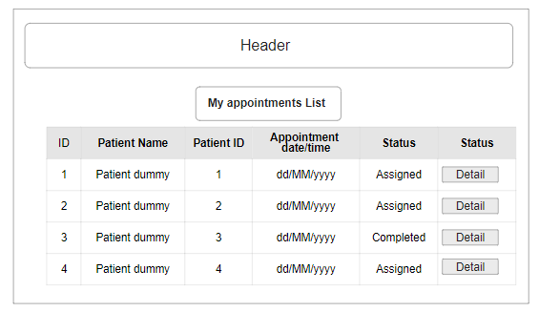

* Function details:
* View doctor's list of assigned appointments paginated which includes the following column: Id, patient name, patient Id, appointment date/time, Status. From this screen, the user can choose to view detailed information of the appointment (via the My Appointment Details page)
* The data is shorted by the appointment date/time (the latest one is on the top)

#### d. My Appointment Details

● Function trigger: This function is triggered when the user clicks to one of “My Appointments”

● Function description: Show detailed information of a single Appointment

● Screen layout: simulated prototype of screen, below sample is for My Appointment Details screen

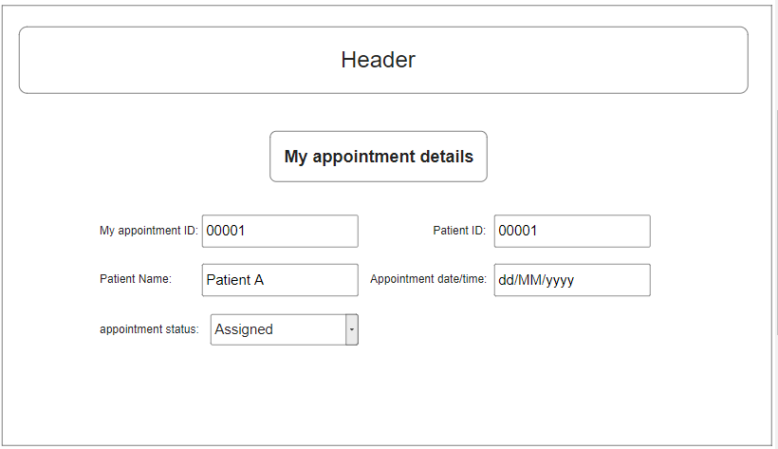

* Function details:
* View detailed information of the appointment. On this form, the doctor is allow to change the appointment status from Assigned to Completed

#### e. My Feedbacks

● Function trigger: This function is triggered when the user clicks to “Feedback”

● Function description: View feedbacks from patients to the doctor

● Screen layout: simulated prototype of screen, below sample is for Feedback screen

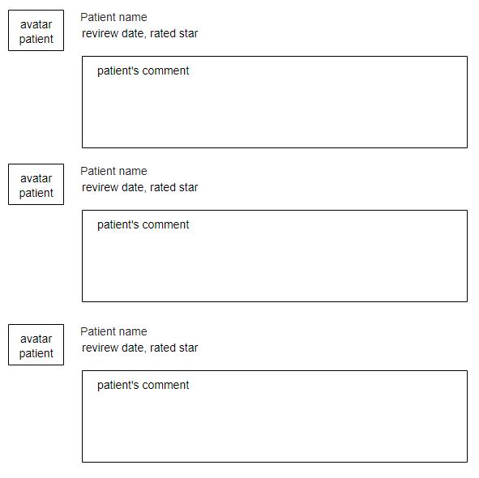

* **Function details:**
* Each feedback include following information: patient avatar, patient name, rated start and comments; The data list is shorted by the feedback date/time (the latest feedback is on the top of the list)

## 7. Patient Feature

#### a. Book Appointment

* Function trigger: This function is triggered when the user clicks to “Bác sĩ” on headmenu of home page , they can choose doctor that they want then click to “Đặt Lịch”.
* Function description: Patients can book appointments with a doctor and date time that they want.
* Screen layout: simulated prototype of screen, below sample is for Book Appointment screen:

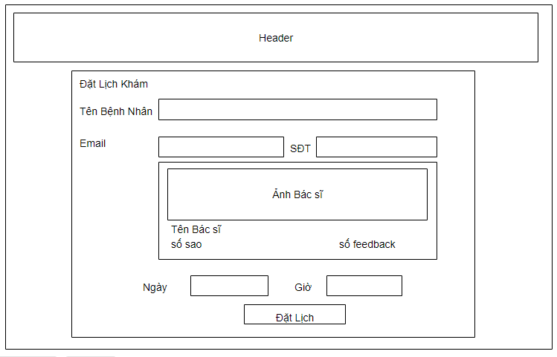

* Function details:
  + his current information (name, email, phone),
  + the to-be-booked doctor information (avatar, name, rated star, number of feedbacks)
  + input the booking details (date, time, description)
  + The newly booked appointment would be assigned automatically to the staff who has been assigned appointment or reservation for the longest time

#### b. Reserve a Service

* Function trigger: This function is triggered when the user clicks to “Dịch vụ” on headmenu of home page , they can choose doctor that they want then click to “Đặt Lịch”.
* Function description: Patients can reserve a service and date time that they want.
* Screen layout: simulated prototype of screen, below sample is for Reserve a Service screen

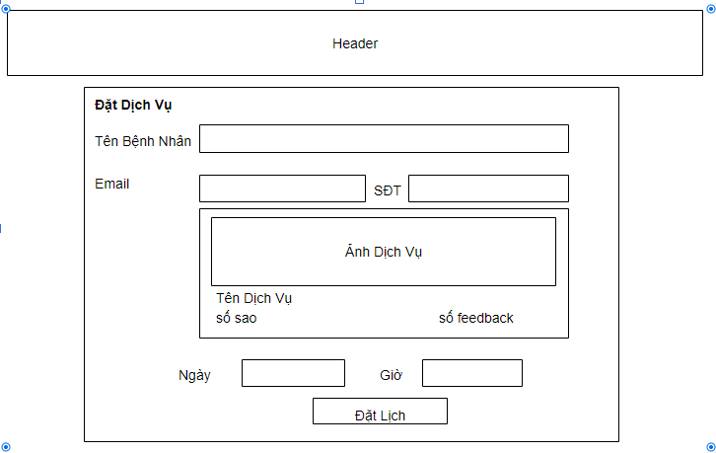

* Function details:
  + his current information (name, email, phone),
  + the to-be-reserved service information (avatar, name, rated star, number of feedbacks, service fee)
  + input the booking details (date, time, description)
  + The newly booked appointment would be assigned automatically to the staff who has been assigned appointment or reservation for the longest time

#### c. Appointment History

* Function trigger: This function is triggered when the user clicks to “ lịch sử đặt lịch”
* Function description: Patients can view history appointments
* Screen layout: simulated prototype of screen, below sample is for appointments history screen

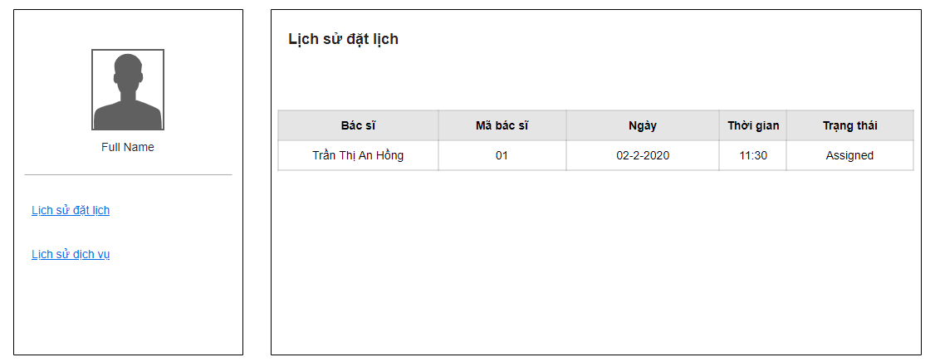

* Function details:
* View user's list of booked appointments paginated which includes the following column: Id, doctor avatar, doctor name, doctor Id, appointment date/time, status.
* The data is shorted by the appointment date/time (the latest one is on the top)

#### d. Reservation History

* Function trigger: This function is triggered when the user clicks to “ lịch sử dịch vụ”
* Function description: Patients can view history reservation
* Screen layout: simulated prototype of screen, below sample is for Reservation history screen

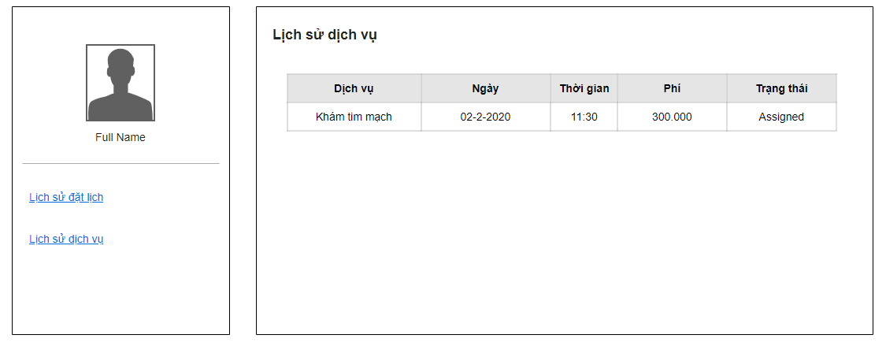

* Function details:
* View list of reservations of the user, which include following columns: Id, service name, service date/time, price, status