**Data Dictionary Index**

**UserProfile Table:**

* LastName
* FirstName
* Username
* Password
* Email
* SecurityQuestion
* SecurityAnswer

**UserCart Table:**

* ItemName
* ItemPlatform
* ItemCount
* ItemPrice

**UserProps Table:**

* Username
* CardNumber
* ShippingAddress
* BillingAddress

**Table Screenshots:**

* UserProfile
* UserCart
* UserProps

**UserProfile Table**

**LastName:**

Definition: The last name of the user

Value: 15-character string

Function: Serves as the user’s last name

**FirstName:**

Definition: The first name of the user

Value: 10-character string

Function: Serves as the user’s first name

**Username:**

Definition: The created name of the user

Value: 20-character string

Function: Identifies the user when they login, reset password, or purchase items

**Password:**

Definition: The created password for the user

Value: 20-character string

Function: Confirms the user when they login

**Email:**

Definition: The personal email of the user

Value: 40-character string

Function: Used as a link for the confirmation email’s destination

**SecurityQuestion:**

Definition: The created security question for the user

Value: 20-character string

Function: Serves as the user’s security question

**SecurityAnswer:**

Definition: The created security answer for the user

Value: 20-character string

Function: Serves as the answer to the user’s security question

**UserCart Table**

**ItemName:**

Definition: The name of the selected store product

Value: 20-character string

Function: Serves as the name of the selected store product in cart

**ItemPlatform:**

Definition: The type of platform of the selected store product

Value: 20-character string

Function: Tells the user what gaming platform their selected store product can be used on

**ItemCount:**

Definition: The number of the selected store product

Value: Int

Function: Tells the user how many of that item they have in their cart

**ItemPrice:**

Definition: The price of the selected store product

Value: Int

Function: Tells the user how much that individual product cost

**UserProps Table**

**Username:**

Definition: The same username as the initially created username

Value: 20-character string

Function: Identifies the user when they login, reset password, or purchase items

**CardNumber:**

Definition: The registered card number for the user

Value: 30-character string

Function: Used by the user for purchasing products

**ShippingAddress:**

Definition: The registered shipping address for the user

Value: 30-character string

Function: Tells the company where to send the user’s purchased products

**BillingAddress:**

Definition: The registered billing address for the user

Value: 30-character string

Function: Tells the company where to send the user’s billing information

UserProfile:

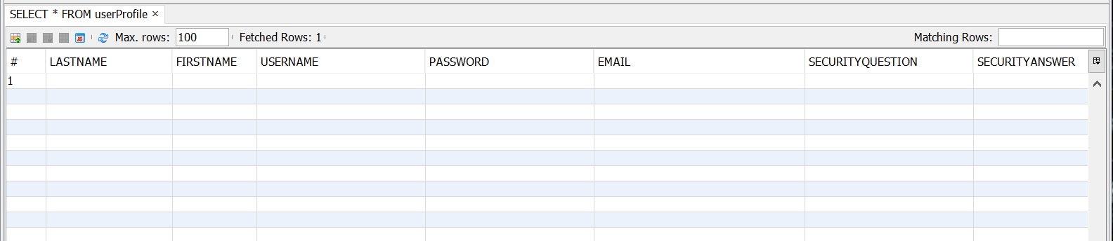

UserCart:

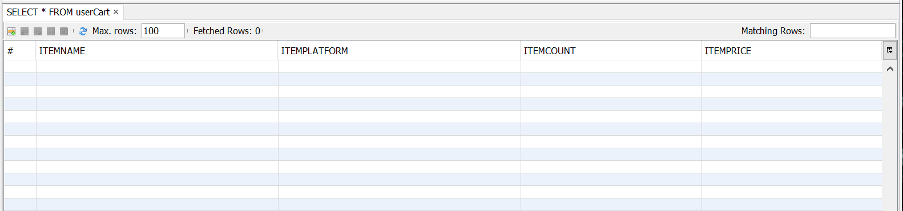

UserProps:

