1. To enable the Gaming Domain App on your device you must first visit GitHub through this link: [CLICKME!](https://github.com/vanhoofa3995/CSC-289-Gaming-Domain-Project/tree/main/Prototypes/ApplicationStartPage)
2. Once at GitHub you must download the “db-derby-10.14.2.0-lib.zip” database file, and extract the data to a created folder named “MyDataBase”. Then you must download the source code zip file named “ApplicationStartPage” and extract the data to a separate folder in the same location that you stored your “MyDataBase” folder.

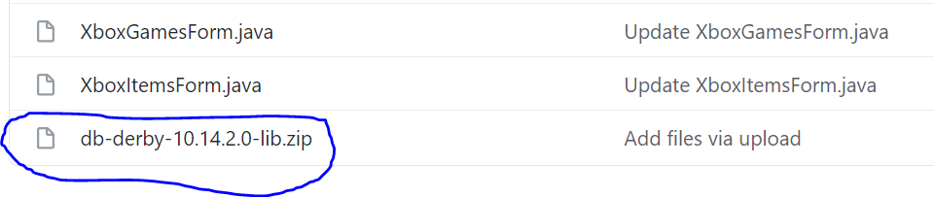

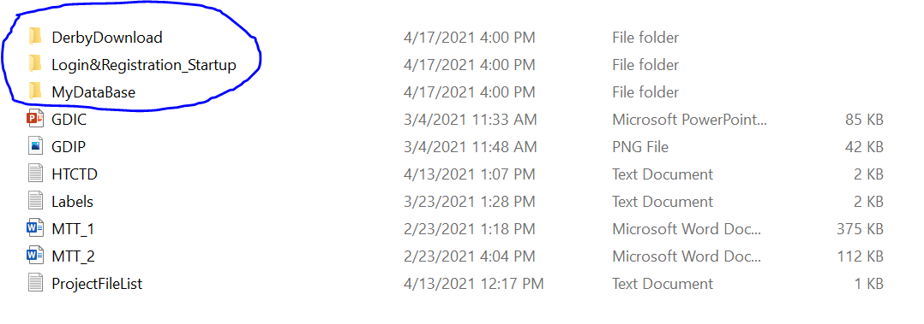

1. After downloading both zip files and storing the data in the correct locations, you need to open NetBeans IDE. If you do not have NetBeans IDE on your device you can download it from this link: [CLICKME!](https://netbeans-ide.informer.com/8.2/)

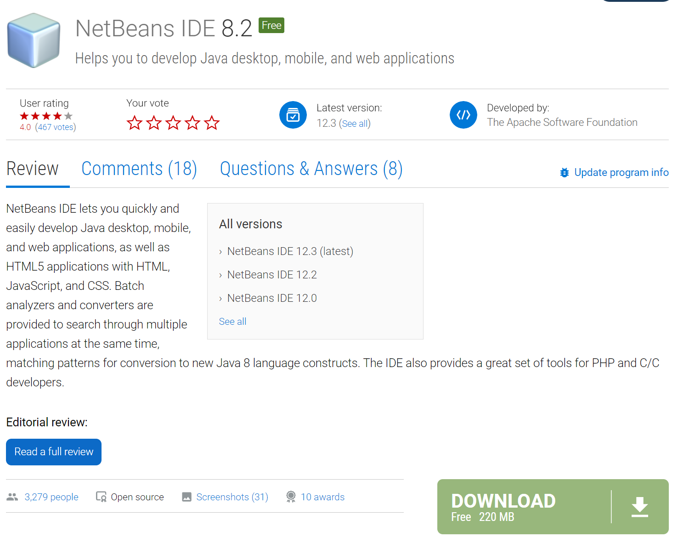

1. Once you have NetBeans downloaded and opened, you need to open the java project file named “ApplicationStartPage” that you extracted from the downloaded zip file.

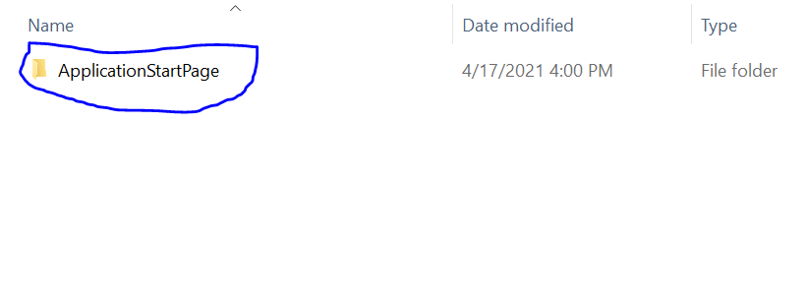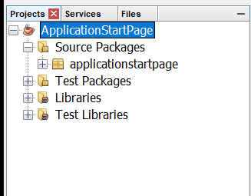

1. Then you need to make sure that the library files are there by clicking the plus sign next to the libraries label. If the two libraries named “derby.jar” and “derbyclient.jar” aren’t there then you need to redownload the “db-derby-10.14.2.0-lib.zip” from GitHub, and make sure that it’s in a folder named “MyDataBase”.

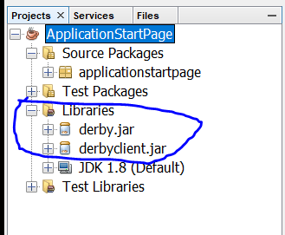

1. Once you’ve verified that both libraries are there you need to click the services tab and connect to the derby database. To do this you must first click the plus sign next to the databases label to see your current databases. Then you can click the properties button underneath the “Java DB” label, and connect your folders to the database. If you have stored your folders correctly it should look something like this:

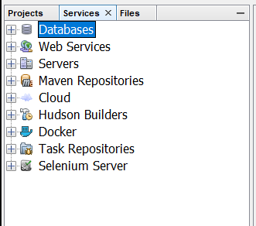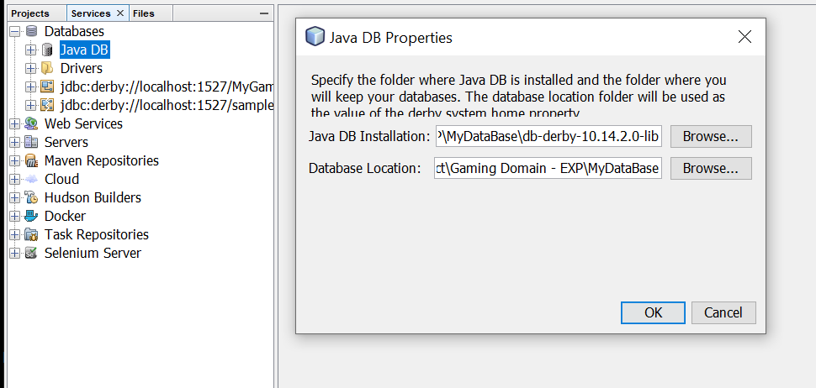

1. After your folders are connected your going to have to create a new database file named “MyGamingDomainDataBase”. To do this you must right click the “Java DB” label and click “Create Database”. Then you must set the name of the database to “MyGamingDomainDataBase”, set the user name to your lastname + firstname, and set the password to whatever you would like. I would pick something easy to remember, like “MyPassword”.

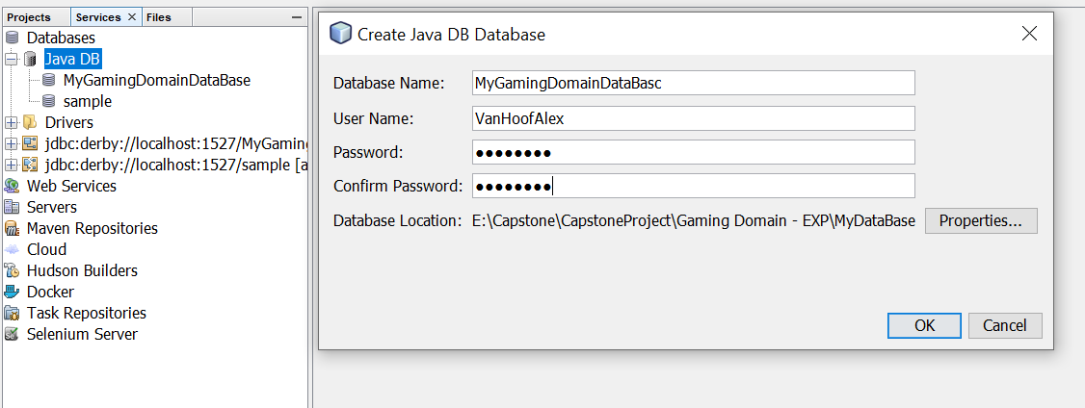

1. Next your going to have to create the tables for the database. To do so, all you have to is copy the code from the file named “HTCTD.txt” and past it into the command prompt page that you’ve already opened up. It should look something like this:

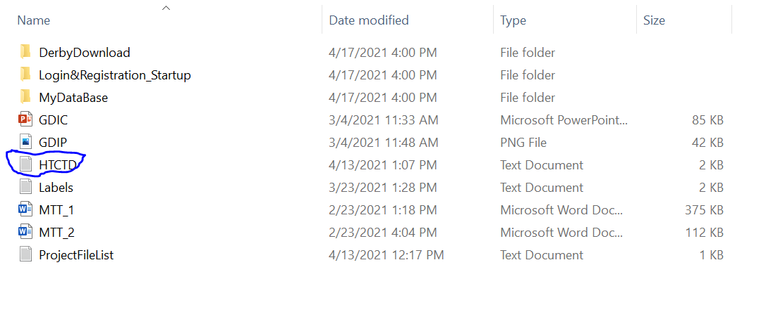

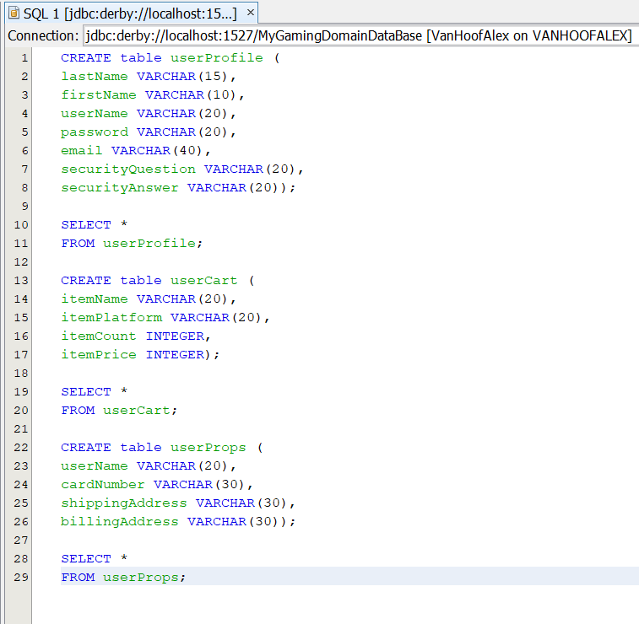

1. To run the program, you can click the green arrow at the top of the NetBeans console.

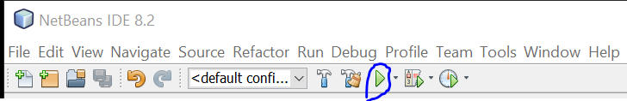

1. Once you’ve started the program, you must create a user account. To do so, you can click the “Create Account” tab and register your information as labeled. This is the only way to have access to the program!

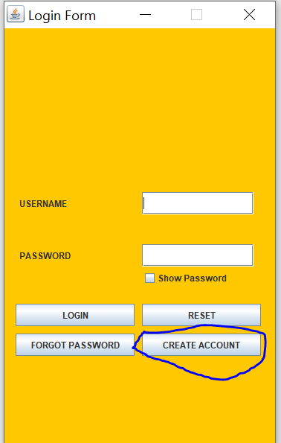

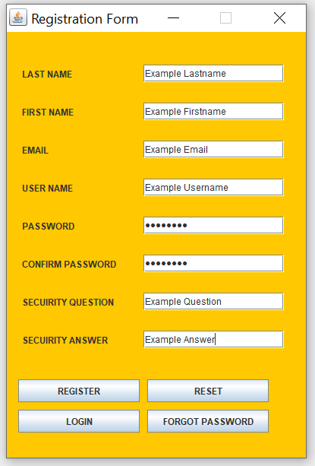

1. Then you can go to the login screen by clicking the “Login” tab and enter your created username and password. If you had managed to forget your password within 30 seconds of creating it you can go to the “Forgot Password” tab and enter your username and a new password to replace the old one.

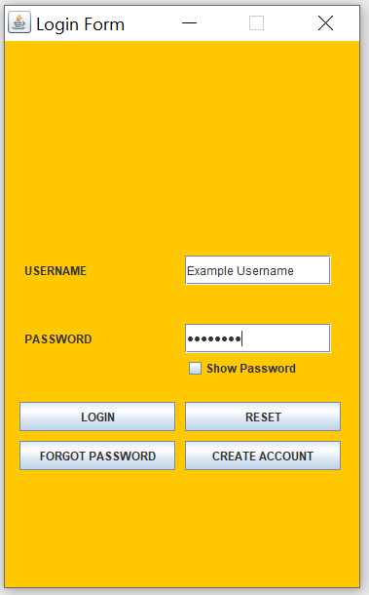

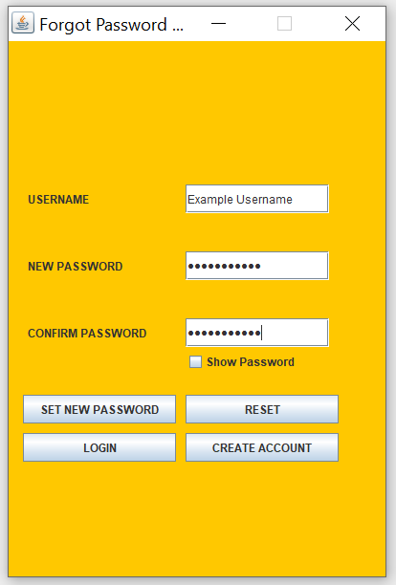

1. After logging in to the app you can browse a variety of items and games for Xbox, PlayStation, Pc, and Nintendo Switch. Each item has three buttons “Description”, “Add”, and “Remove”. The “Description” button shows a short-detailed description of the product and lists the products price. The “Add” button add that item to your shopping cart, and the “Remove” button removes that item from your shopping cart. You can have more than one of the same items, all you have to do is add the same item again.

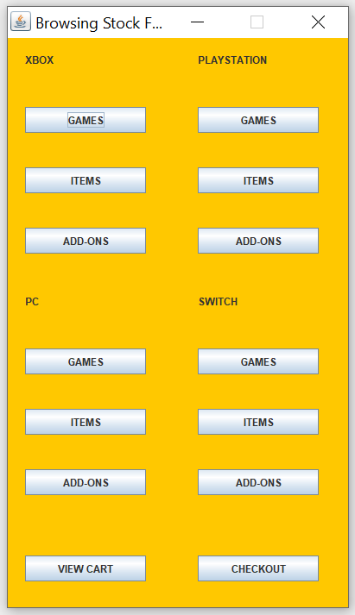

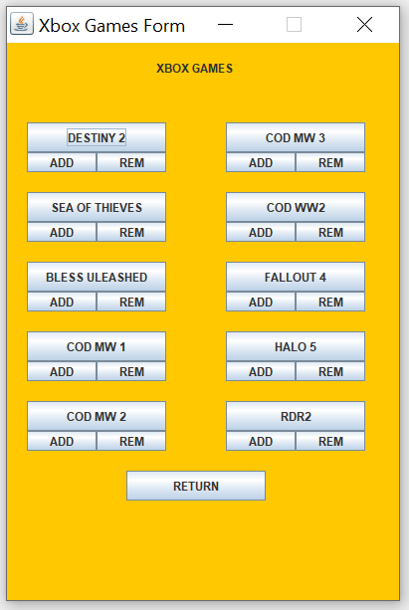

1. To view all of the items you wish to purchase you can view you your shopping cart by clicking the “View Cart” tab to make sure you have all the correct items.

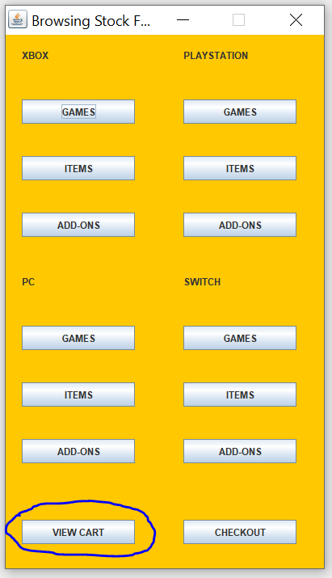

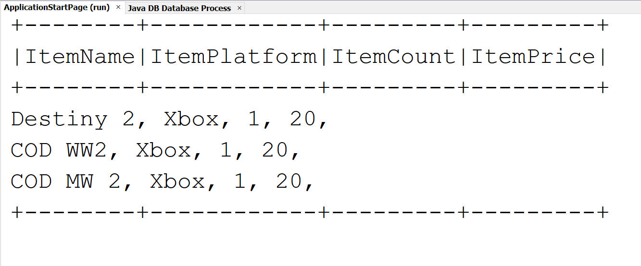

1. To complete your order and purchase your selected items you can click the “Checkout” tab.

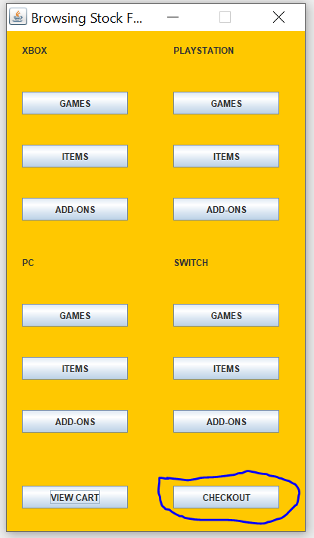

1. Once in the checkout process you must register your payment information as listed. It should look something like this:

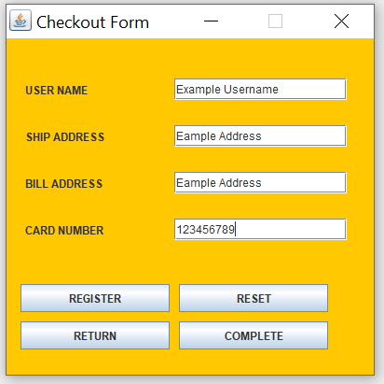

1. Finally, to complete your order you would have to click the “Complete” tab which will then close the program and give you a completed message. After completing your order, you should receive an email confirmation for your order with the email link you registered. It should look like this:

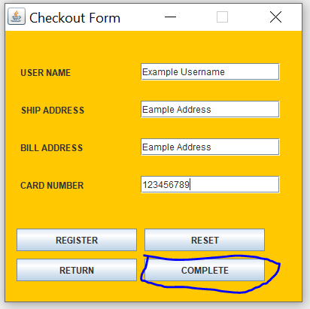

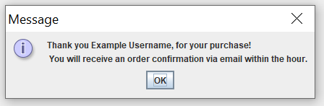

1. If you wish to purchase more Gaming Domain Merchandise, just run the app again.



1. Gaming Domain thanks you for using our app!

