III. Theoretical Background
1. MIMO(Multiple Input Multiple Output)
MIMO (Multiple-Input Multiple-Output) is a technique that uses multiple antennas on both the input and output sides to transmit and receive signals simultaneously on the same frequency band.The 2x2 MIMO (Multiple-Input Multiple-Output) system is fundamental to analyzing the data transmission capabilities and reliability of modern radio systems. This system uses two antennas at the transmitter (NT>=2) and two antennas at the receiver (NR=2) to create independent interfacial communication channels.
- Mathematical Model (2×2 MIMO): The relationship between the transmitted and received signals in a flat-fading environment is represented by the matrix equation:
y=Hs+η
- Where:
  - y=[y1 ,y2] T is the received signal vector.
  - s=[s1 ,s2 ] T is the transmitted symbol vector.
  - H is the 2×2 channel matrix containing complex path gains hij between transmit antenna j and receive antenna i.
  - η is the additive white Gaussian noise (AWGN) vector.
In the first time slot, it transmits the symbols s1, s2 on antenna 1 and antenna 2, in the next time slot it transmits -s2*, s1* on antenna 1 and antenna 2.
Time slot 1: Antenna 1 transmits x1Antenna 2 transmits x2
. The received signal is:
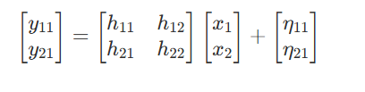
Time slot 2: Antenna 1 transmits −x 2* , Antenna 2 transmits x 1*. The received signal is:
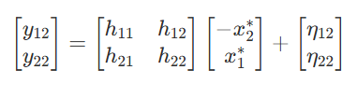
In which:
$\left[\begin{matrix}{\text{y}}_{\text{1}}^{\text{1}} \\ {\text{y}}_{\text{2}}^{\text{1}}\end{matrix}\right]$This is the signal received in the first time slot at the two receiving antennas. y
$\left[\begin{matrix}{\text{y}}_{\text{1}}^{\text{2}} \\ {\text{y}}_{\text{2}}^{\text{2}}\end{matrix}\right]$This is the signal received in the second time slot at the two receiving antennas. Y
hij is the channel gain, j is the transmitting antenna number, and i is the receiving antenna
$\left[\begin{matrix}{\text{η}}_{\text{1}}^{\text{1}} \\ {\text{η}}_{\text{2}}^{\text{1}}\end{matrix}\right]\text{v}\text{à}\left[\begin{matrix}{\text{η}}_{\text{1}}^{\text{2}} \\ {\text{η}}_{\text{2}}^{\text{2}}\end{matrix}\right]$This is noise interference from the receiver
- MIMO-OFDM System
The receiver and transmitter structure of a MIMO-OFDM system includes the MIMO system Transmit and Nr receiving antennas are combined with OFDM technology using Nc subcarriers.
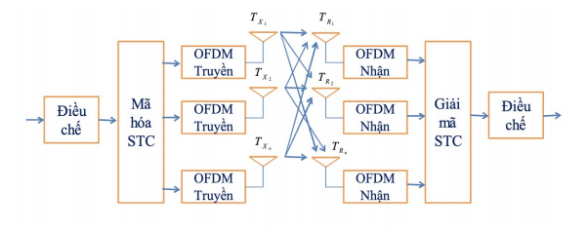
The signal received from the i-th receiving antenna, at the subcarrier, is represented as follows:

$${\text{y}}_{\text{1}}\text{(}\text{k}\text{)=}{\text{h}}_{\text{11}}{\text{x}}_{\text{1}}\text{(}\text{k}\text{)+}{\text{h}}_{\text{12}}{\text{x}}_{\text{2}}\text{(}\text{k}\text{)+…+}{\text{h}}_{\text{1}{\text{N}}_{\text{t}}}{\text{x}}_{{\text{N}}_{\text{t}}}\text{(}\text{k}\text{)+}{\text{n}}_{\text{1}}\text{(}\text{k}\text{)}$$
$${\text{y}}_{\text{2}}\text{(}\text{k}\text{)=}{\text{h}}_{\text{21}}{\text{x}}_{\text{1}}\text{(}\text{k}\text{)+}{\text{h}}_{\text{22}}{\text{x}}_{\text{2}}\text{(}\text{k}\text{)+…+}{\text{h}}_{\text{2}{\text{N}}_{\text{t}}}{\text{x}}_{{\text{N}}_{\text{t}}}\text{(}\text{k}\text{)+}{\text{n}}_{\text{2}}\text{(}\text{k}\text{)}$$
……………………………………………………………………
$${\text{y}}_{{\text{N}}_{\text{r}}}\text{(}\text{k}\text{)=}{\text{h}}_{{\text{N}}_{\text{r}}\text{1}}{\text{x}}_{\text{1}}\text{(}\text{k}\text{)+}{\text{h}}_{{\text{N}}_{\text{r}}\text{2}}{\text{x}}_{\text{2}}\text{(}\text{k}\text{)+…+}{\text{h}}_{{\text{N}}_{\text{r}}{\text{N}}_{\text{t}}}{\text{x}}_{{\text{N}}_{\text{t}}}\text{(}\text{k}\text{)+}{\text{n}}_{{\text{N}}_{\text{r}}}\text{(}\text{k}\text{)}$$
$x_{j}(k)$is the symbol broadcast on the k-th carrier wave in the symbol OFDM
${\text{n}}_{\text{i}}\text{(}\text{k}\text{)}$) is Gaussian interference at the i-th receiving antenna
${\text{h}}_{\text{ij}}\text{(}\text{k}\text{) }$is the channel factor from the j-th transmitting antenna to the i-th receiving antenna.
The MIMO-OFDM system channel can be described through the matrix H as follows

$$H=\left[\begin{matrix}h_{11} & h_{12} & … & h_{1N_{t}} \\ h_{21} & h_{22} & … & h_{2N_{t}} \\ ⋮ & ⋮ & ⋱ & ⋮ \\ h_{N_{r}1} & h_{N_{r}2} & … & h_{N_{r}N_{t}}\end{matrix}\right]$$
In this case, the channel matrix H is estimated at the receiver.
the transmitter: The signal to be transmitted will be passed through a channel encoder for encoding Error detection and correction codes, combined with the inexpensive IL(interleaved) interleaver to avoid displaying errors city statue Group 6 Large Assignment Report 19 Radio information cluster. Continuing the above sequence of bits will be passed through an S/P converter and arranged to form bit groups for M-PSK or M-QAM modulation, which will then become complex number sequences:
$$C_{i}=[c_{0,i};c_{1,i};c_{2,i};…;c_{Q-1,i}]$$
With
Q: the number of bits of a group used for preparation Q = log 2 M .
i: is the i-th complex character number of the M-PSK or M-QAM modulation.
Distributed on the complex plane as follows:
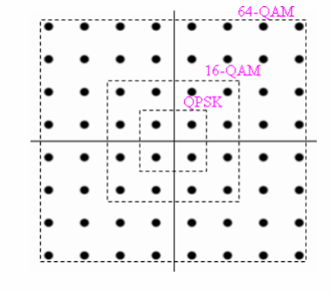
The modulated string will be converted from serial to 2N characters parallel relative corresponding to N subcarriers as follows:
$$D_{n,m}=[d_{0,m};d_{1,m};d_{2,m};…;d_{2N-1,m}]$$

Where m: is the m-th character of OFDM. Next, we feed the modulated string Dk into the STC encoder. The STC encoder works as follows: It will split the OFDM Dk character string into a group of 2 characters parallel ] relative D1, D2 respectively, then through The STC encoder produces the characters s1,s2,-s2*,s1*
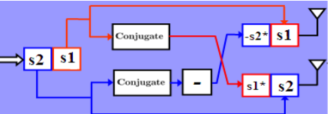
Mathematical description
$${\text{X}}_{\text{n}\text{,}\text{J}\text{,}\text{m}}\text{(}\text{t}\text{)=[}{\text{x}}_{\text{0}}\text{,}{\text{x}}_{\text{1}}\text{,}{\text{x}}_{\text{2}}\text{,…,}{\text{x}}_{\text{N}\text{-1}}\text{]}$$
Where
m: is the mth block of OFDM (1 block corresponds to 2 OFDM characters)
n: is the number of nth characters modulated on the subcarrier n
J: is the transmitting antenna sequence number J=1.2
T: is the corresponding time slot t=1.2
Considering the k-th block with 2 OFDM characters:
$$S_{1,n}=[s_{1,0};s_{1,1};s_{1,2};…;s_{1,N-1}]$$
$$S_{2,n}=[s_{2,0};s_{2,1};s_{2,2};…;s_{2,N-1}]$$
We have the following signal after passing through the STC.
$$X_{1,n(1)}=[s_{1,0};s_{1,1};s_{1,2};…;s_{1,N-1}]$$
$$X_{2,n(1)}=[s_{2,0};s_{2,1};s_{2,2};…;s_{2,N-1}]$$
$$X_{1,n(2)}=-X_{2,n(1)}^{*}$$
$$X_{2,n(2)}=X_{1,n(1)}^{*}$$
Xm is then IFFT-transformed to modulate the carrier wave and insert CP into the winter. It is transmitted via two antennas as analyzed above
$$x_{n,m[j]}^{(t)}=\frac{1}{\sqrt{N}}\sum_{k=0}^{N-1}{X_{m[j]}^{(t)}}exp\left(\frac{j2πkn}{N}\right)$$
$$Với n∈\{-N_{g},…,0,…,N-1\}vớiN_{g} là độ dài của CP$$
$$J=1,2 tươngđươngvớianten1,2$$
$$t=1,2 tươngđươngvớikhethờigian1,2$$
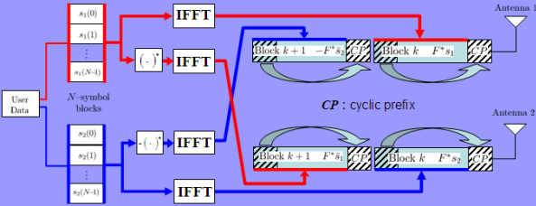
At the receiver: The signal is transmitted through an AWGN (additive white gausian) channel and fading
$$Type equation here.$$
$$r_{1,m(1)}=h_{11,m}x_{1,m(1)}+h_{12,m}x_{2,m(1)}+n_{1,m(1)}$$
$$r_{1,m(2)}=h_{11,m}x_{1,m(2)}+h_{12,m}x_{2,m(2)}+n_{1,m(2)}$$
$$r_{2,m(1)}=h_{21,m}x_{1,m(1)}+h_{22,m}x_{2,m(1)}+n_{2,m(1)}$$
$$r_{2,m(2)}=h_{21,m}x_{1,m(2)}+h_{22,m}x_{2,m(2)}+n_{2,m(2)}$$

Where rJ,m(t),xJ,m(t),nj,m(t) la received signal،transmitted signal،and interference act at antenna J (J=1,2) in the time slot t (t=1,2) of the corresponding OFDM m. hj,k,m are the channel coefficients from the transmitting antennas to the antennas OFDM m-th , it remains unchanged across 2 time slots. obtain the corresponding character Here, for simplicity, we consider the OFDM character with a flat fading environment. At the CP splitter receiver, we get:
$$y_{n,m}=\sum_{l=0}^{L-1}{x_{n,m[1]}}h_{l,n,m[1]}+x_{n,m[2]}h_{l,n,m[2]}+z_{n,m}$$
$$r_{1}(1)=\left(h_{11,1}x_{1,n-1}(1)+h_{12,m,l}x_{2,n-1}(1)+n_{1}(1)\right)$$
$$r_{1}(2)=\sum_{l=0}^{L-1}{\sum_{n=0}^{N-1}{.}}\left(h_{11,1}x_{1,n-1}(2)+h_{12,m,l}x_{2,n-1}(2)+n_{1}(2)\right)$$
$$r_{2}(1)=\sum_{l=0}^{L-1}{\sum_{n=0}^{N-1}{.}}\left(h_{21,1}x_{1,n-1}(1)+h_{22,m,l}x_{2,n-1}(1)+n_{2}(1)\right)$$
$$r_{2}(2)=\sum_{l=0}^{L-1}{\sum_{n=0}^{N-1}{.}}\left(h_{21,1}x_{1,n-1}(2)+h_{22,m,l}x_{2,n-1}(2)+n_{2}(2)\right)$$
In this case: n=0,…,N-1 is equivalent to the subcarriers. Then, using the FFT system, we get
$$R_{J}^{(t)}=\frac{1}{\sqrt{N}}\sum_{n=0}^{N-1}{r_{J}^{(t)}}e^{-j2πkn/N}$$
$$R_{J}^{(t)}=H_{J,1}X_{1}^{(t)}+H_{J,2}X_{2}^{(t)}+Z_{J}$$
$$h_{11}=\frac{1}{\sqrt{N}}\sum_{l=0}^{L-1}{\sum_{n=0}^{N-1}{.}}h_{l,11}e^{-j2πnl/N}$$
$$h_{12}=\frac{1}{\sqrt{N}}\sum_{l=0}^{L-1}{\sum_{n=0}^{N-1}{.}}h_{l,12}e^{-j2πnl/N}$$
$$h_{21}=\frac{1}{\sqrt{N}}\sum_{l=0}^{L-1}{\sum_{n=0}^{N-1}{.}}h_{l,21}e^{-j2πnl/N}$$
$$h_{22}=\frac{1}{\sqrt{N}}\sum_{l=0}^{L-1}{\sum_{n=0}^{N-1}{.}}h_{l,22}e^{-j2πnl/N}$$
$$Z_{k}=\frac{1}{\sqrt{N}}\sum_{n=0}^{N-1}{z_{n,m}}e^{-\left(\frac{j2πkn}{N}\right)}$$
After CP removal and Fast Fourier Transform (FFT) processing for subcarrier de-multiplexing, the signal is fed into the STC decoder. Here, the decoder performs decoding across two time slots to estimate the transmitted symbols
$$\left[\begin{matrix}{\tilde{s}}_{1} \\ {\tilde{s}}_{2}\end{matrix}\right]=H^{H}\left[\begin{matrix}R_{1}^{(1)} \\ R_{1}^{(2)*} \\ R_{2}^{(1)} \\ R_{2}^{(2)*}\end{matrix}\right]\left[\begin{matrix}|h_{11}|^{2}+|h_{21}|^{2}+|h_{12}|^{2}+|h_{22}|^{2} & 0 \\ 0 & |h_{11}|^{2}+|h_{21}|^{2}+|h_{12}|^{2}+|h_{22}|^{2}\end{matrix}\right]\left[\begin{matrix}s_{1} \\ s_{2}\end{matrix}\right]+H^{H}Z$$

At the receiver using the maximum likelihood detection (ML) method, M-PSK or M-QAM complex symbols can be recovered and subsequently decoded to find the required information bits.

$${\hat{\text{s}}}_{\text{1}}\text{=}\text{arg}\underset{}{\text{min}}{{\left|{\tilde{\text{s}}}_{\text{1}}\text{-}{\text{s}}_{\text{1}}\sum_{\text{i}\text{=1}}^{{\text{N}}_{\text{r}}}{\sum_{\text{j}\text{=1}}^{{\text{N}}_{\text{t}}}{}}\text{|}{\text{H}}_{\text{i}\text{,}\text{j}}{\text{|}}^{\text{2}}\right|}^{\text{2}}}$$

$${\hat{\text{s}}}_{\text{2}}\text{=}\text{arg}{\underset{}{\text{min}}{}}{\left|{\tilde{\text{s}}}_{\text{2}}\text{-}{\text{s}}_{\text{2}}\sum_{\text{i}\text{=1}}^{{\text{N}}_{\text{r}}}{\sum_{\text{j}\text{=1}}^{{\text{N}}_{\text{t}}}{}}\text{|}{\text{H}}_{\text{i}\text{,}\text{j}}{\text{|}}^{\text{2}}\right|}^{\text{2}}$$
With $$s_{1}$ and $s_{2}$$ being complex numbers in the complex plane that are sequentially substituted to find the closest value, the above system model can be utilized with $N_{r}$ receive antennas

