PE_FE201M_SU23

SUMMER 23

Subject: FE201M

Duration: 85 minutes

**INSTRUCTIONS**

**Please read the instructions carefully before doing the questions.**

* You are **Not allowed** to use any device to share data with others.
* You must use IDE as **Visual Studio Code,** for your development tools.
* You must use **Material design (MUI)**.

Create a new React application using npx create-react-app your-roll-number.

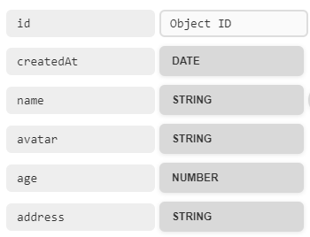***Task 1. Create a new resource and supply data for your application.***

1. (0.25 mark) Create a new resource named staffManagement in *mockapi.io* and **declare a Schema**.
2. (0.25 mark) Edit/replace data for staffManagement resource. Copy the content of **data.json** file.

***Task 2.***



1. (1.0 mark) Create a Navbar for navigating all the routes in your application. Including: **Home**, **Dashboard**, **Contact**. (*install react-router-dom library*)
2. (2 marks) At **Home** route, display all the Staffs in data which order *age* descending. Each Staff must contain some information such as: **Name**, **Address**, **Age, Image**. When you click the detail button or title link, the view switches to **Detail** route.
3. (1.5 marks) At **Detail** route, display all the information of staff: **Name**, **Address**, **Age, Image** and Created Date . Design and arrange this component as good as possible.

***Task 3.***

1. (1.0 mark) At **dashboard** route, it displays the list of staffs by table. Each row must contain the links or icons for CRUD actions.
2. (1.5 marks) Create a Add route with the requirements:

* Create a form and validate all data.
* All fields are required.
* Name must more than 2 words
* Avatar can be a URL
* *CreatedAt* is a Date Create of Staff

1. (1.0 mark) At **Dashboard** route implement the *delete* action.

With *delete* function, you must **confirm** before implementing. After deleting successful, showing a notice (modal, alert, toast…) and the list of staff will render the new list.

1. (1.5 marks) Implement the *update* action. With *the update* function, the same validation requirements as the a*dd* function.

***-The end of test-***