Hardware Concurrency, Memory Models & Lock-Free Design
Down to the wire: reordering, fences, cache lines and lock-free scale. Explained in simple words.
The whole story in one paragraph
Compilers and CPUs shuffle memory operations to run faster, and every CPU core keeps a small store buffer and invalidate queue that make its view of memory a little out of date. Correct code uses release/acquire (or seq_cst) to say exactly where order matters, so the hardware only pays for ordering in those places. Fast code makes sure each cache line has only one writer, because the cache protocol (MESI) passes a line back and forth between cores whenever two cores write to it, even if they write different variables.

1. Why instructions get reordered
Two separate things reorder your code. Both are legal as long as a single thread cannot notice.
- The compiler may move, merge or remove loads and stores. For example, while (!ready) {} on a plain variable can turn into an endless loop, because nothing in that thread changes ready, so the compiler reads it only once.
- The CPU runs instructions out of order, as soon as their inputs are ready. More importantly, it buffers memory operations. A write waits in the store buffer before it reaches the cache. A message saying another core changed a line waits in the invalidate queue before it is applied.
- Why tests miss it: the window is a few nanoseconds wide, x86 hides many bugs, and logging or a debugger adds a fence as a side effect, so the bug disappears when you look at it.
Which reorderings does each CPU allow? x86 is strong. ARM and POWER are weak, so bugs show up there first.
Reordering | x86 (strong, called TSO) | ARM / POWER (weak)
Load then Load | Not allowed | Allowed
Load then Store | Not allowed | Allowed
Store then Store | Not allowed | Allowed
Store then Load | Allowed (because of the store buffer) | Allowed

2. Memory barriers (fences): what they physically do
A memory model says which reorderings are allowed. A fence, or an acquire/release operation, forbids some of them. In hardware terms, it gives orders to the store buffer and the invalidate queue.
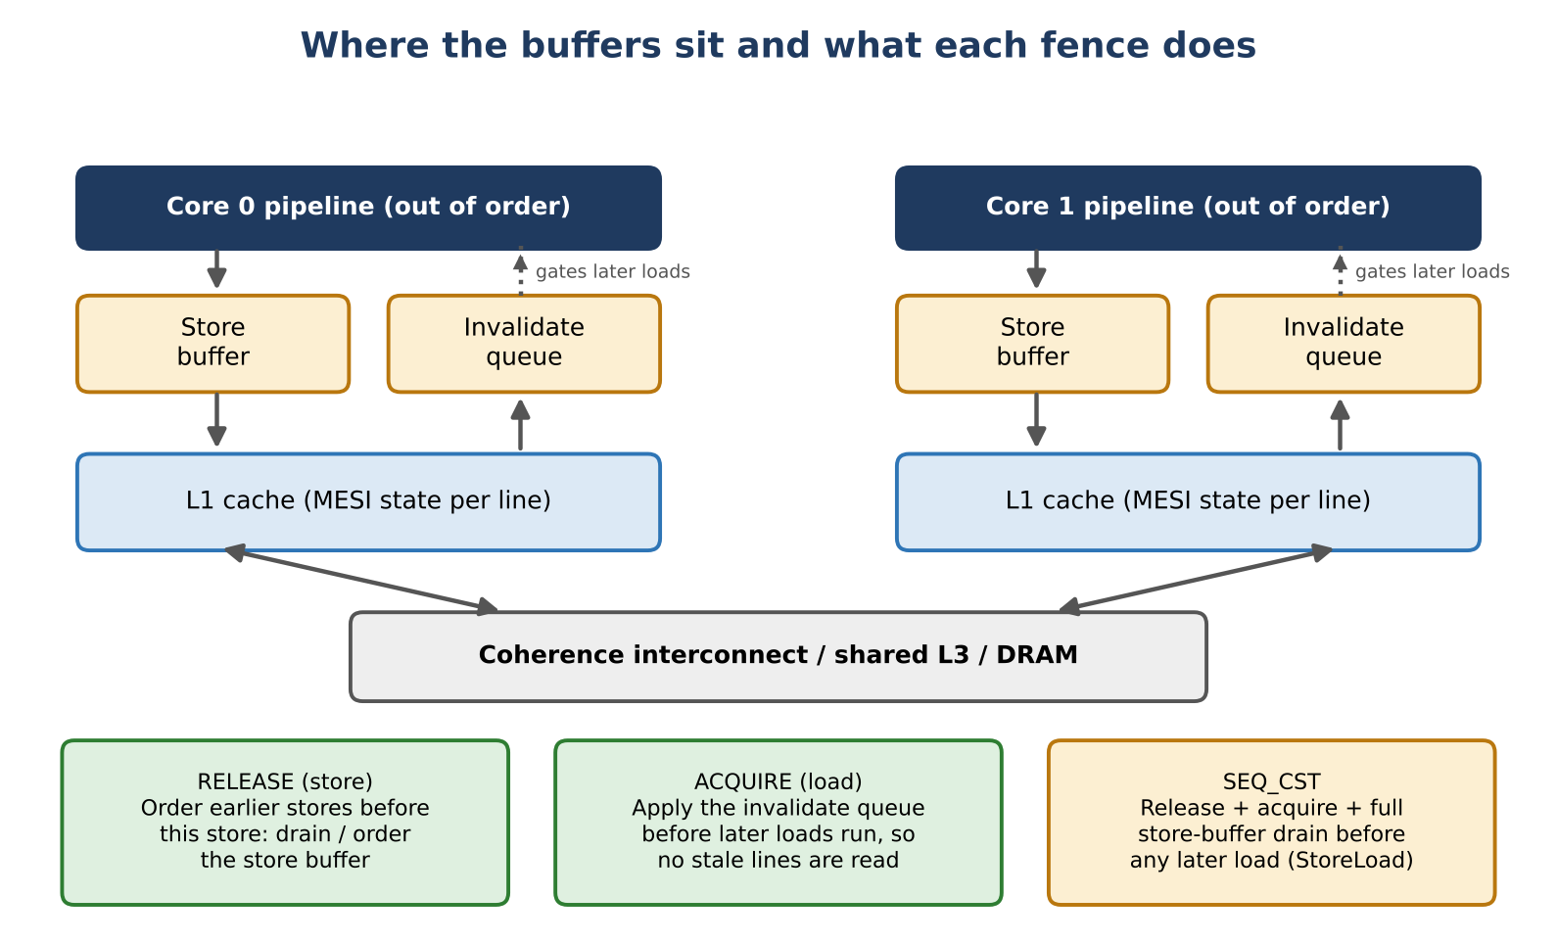
Figure 1. Store buffer and invalidate queue in each core, and the fences that act on them
Barrier | Typical instruction | What the hardware does | Plain meaning
Release (on a store) | ARM: stlr, or dmb ish before the store | Earlier writes must become visible before this write. Store buffer is ordered or drained first. | "Everything I did before is ready."
Acquire (on a load) | ARM: ldar | Applies waiting invalidations before later reads run, so they cannot return an old copy. | "I will see everything done before the release."
seq_cst (full fence) | x86: xchg, or mov + mfence | Does both, and also drains the store buffer before any later load. This adds the one thing acquire/release cannot give: StoreLoad ordering. | "Everyone agrees on one order."

- Acquire/release works between two threads: the acquire must read the value that the release wrote, and both must be on the same variable.
- Sequential consistency gives one global order for all threads. It is the safest option but costs more.
Model caveat
The store buffer plus invalidate queue picture is the standard teaching model (see Paul McKenney, "Memory Barriers: a Hardware View for Software Hackers"). Real chips reach the same guarantees in other ways, for example by guessing loads and replaying them. Use the diagram to understand the rules, not as a literal floor plan of one chip.

Why x86 hides bugs
On x86, stores already leave the store buffer in order and loads are not reordered with each other, so acquire and release compile to ordinary mov instructions. Only StoreLoad is left. Code that works on x86 can still be wrong by the language's rules, and it breaks when moved to ARM or when the compiler reorders it. Never rely on x86 behaviour alone.

A StoreLoad example (needs seq_cst)
T1: x = 1; r1 = y; T2: y = 1; r2 = x;
// r1 == 0 && r2 == 0 is possible, even on x86

Each store waits in its own core's store buffer while the load reads the other variable from cache, so both threads read 0. Acquire/release does not stop this. Only seq_cst, which drains the store buffer, does.

3. Quest: the memory race, step by step
This is the classic message-passing bug. One thread prepares data and raises a flag. The other waits for the flag and reads the data.
int data = 0; int ready = 0;

// Core 0 (producer) // Core 1 (consumer)
data = 42; while (!ready) ;
ready = 1; assert(data == 42); // can fail

Thread 2 can read data = 0 on ARM, or after the compiler reorders. Here is why, traced through the hardware. Core 1 starts with the data line in Shared state (value 0).
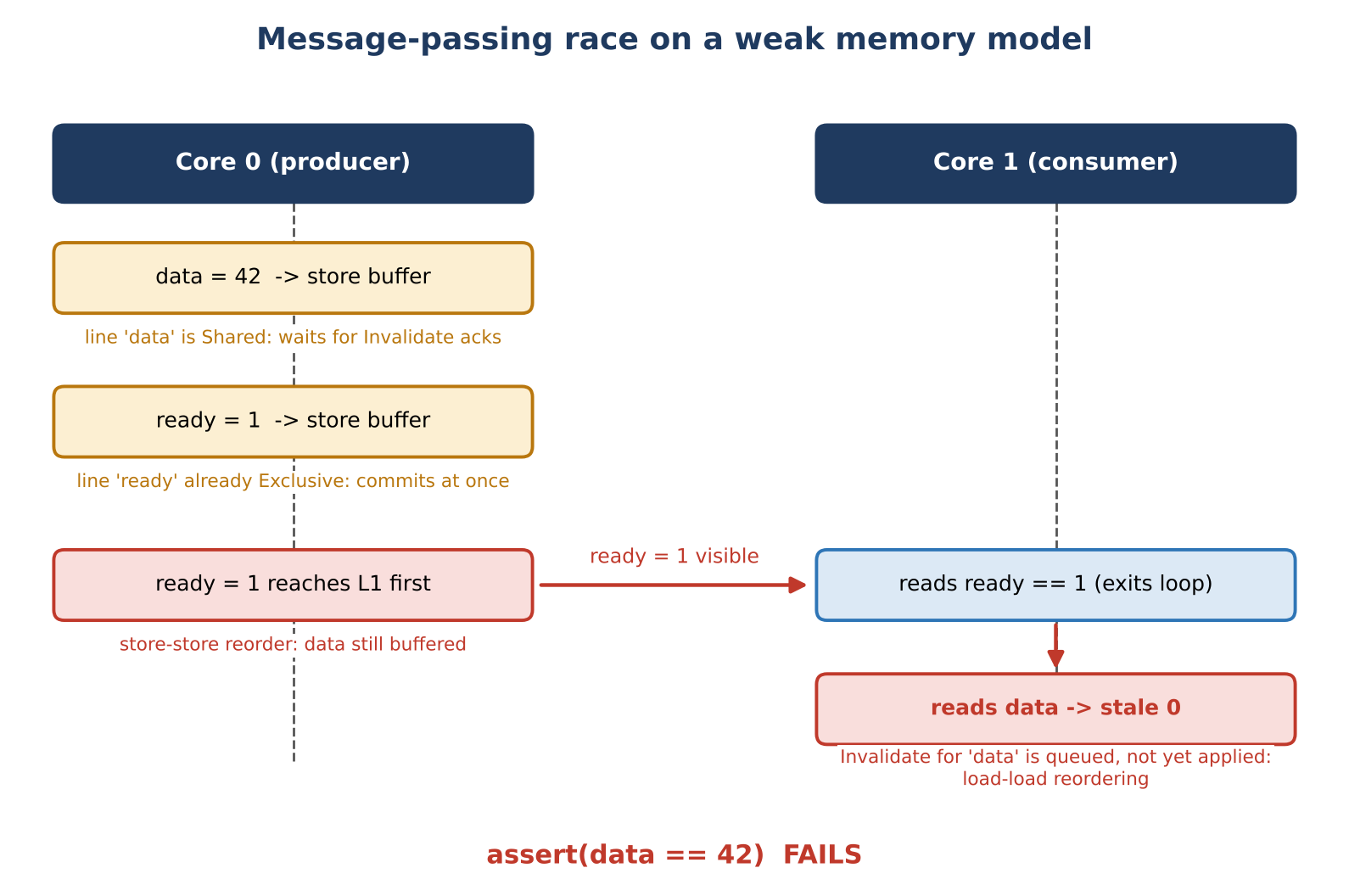
Figure 2. State transitions of the message-passing race
Step | What happens | Result
1 | Core 0 writes data = 42. It goes into the store buffer, waiting for ownership of the line. | Other cores still see 0.
2 | Core 0 writes ready = 1. Its line is already owned, so it commits at once. | ready becomes visible before data.
3 | Core 1 sees ready = 1. The loop exits. | Looks fine so far.
4 | Core 1 reads data from its old Shared copy. The "your copy is old" message is still waiting in the invalidate queue. | Reads 0 (bug).
5 | The invalidate is applied and the store buffer drains, but too late. | The race has already happened.

Two different hardware mechanisms break the program, each on its own: (a) *store-store reordering* in the store buffer, and (b) *load-load reordering* through the invalidate queue.

The fix, and why both halves are needed
// producer
data = 42;
atomic_store_explicit(&ready, 1, memory_order_release);

// consumer
while (!atomic_load_explicit(&ready, memory_order_acquire)) ;
assert(data == 42); // guaranteed

- The release store forces step 1 to finish before step 2 becomes visible, so data is always out before ready.
- The acquire load forces waiting invalidations to be applied before the read in step 4, so the old copy cannot be used.
- Both halves are needed, on the same variable. A fence on only one side fixes nothing. That shared variable is the "contract" between the two threads.

4. Cache coherence: MESI, MOESI and false sharing
Cores share data through cache lines of 64 bytes. The MESI protocol tracks the state of every line. A core may write a line only when it holds it in M or E. Writing from S needs a "read for ownership", which invalidates every other copy first.
State | Meaning
Modified | Only this core has the line, and it has been changed.
Exclusive | Only this core has the line, unchanged.
Shared | Several cores have a clean copy.
Invalid | The copy is not usable.
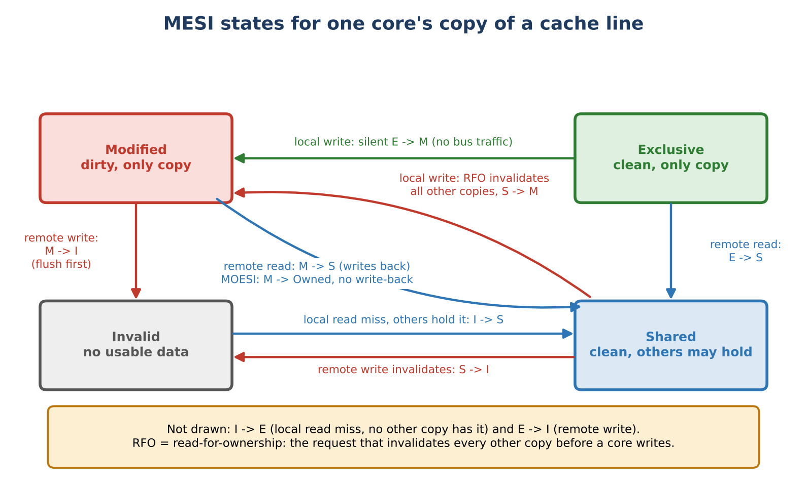
Figure 3. MESI states and the main moves for one core's copy of a line
MOESI (AMD) adds an Owned state, so a changed line can be shared without writing to memory first. This lowers the cost of sharing but does not remove the ping-pong.

False sharing
Two threads change two different variables that happen to sit on the same 64-byte line. The variables are unrelated, but the cache protocol cannot see that. It only sees one line, so:
Core 0 writes a -> line in Core 0 (M), Core 1 copy invalid
Core 1 writes b -> line moves to Core 1 (M), Core 0 copy invalid
Core 0 writes a -> line moves back ... (a and b share one line)
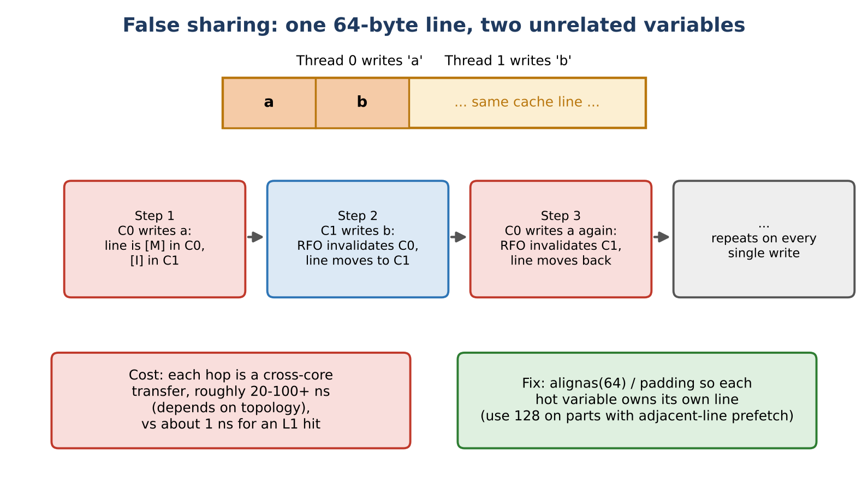
Figure 4. One cache line bouncing between two cores on every write
Each hop between cores costs tens of nanoseconds, compared with about 1 ns for a hit in the core's own cache. Throughput can drop several times, and it gets worse as threads are added.
Fix: give each hot, separately written variable its own line, using padding or alignment, or use per-thread counters.
// C++: 64 bytes on most x86; use 128 on Apple Silicon
struct alignas(64) PaddedCounter { std::atomic<uint64_t> v; };
// Java: @Contended

5. Lock-free design and the Disruptor ring buffer
- CAS (compare-and-swap): "if the value is still what I expect, replace it", done as one atomic step. If it fails, loop and try again.
- Why avoid the kernel: a blocked lock sends the thread to sleep through the OS (microseconds, cold caches). A CAS on a cached line takes nanoseconds.
- Lock-free means some thread always makes progress. Wait-free means every thread does.
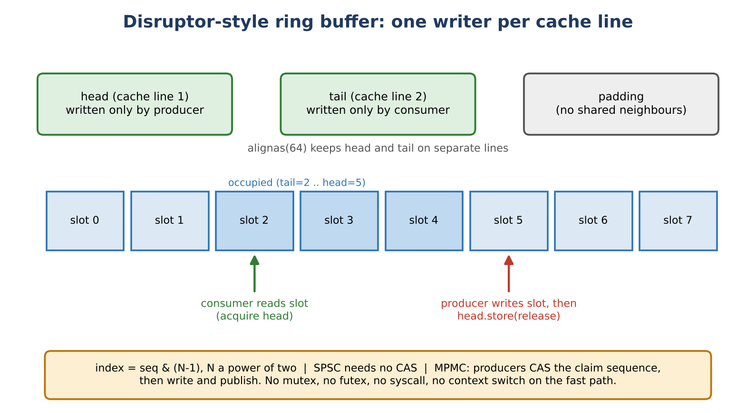
Figure 5. Single-writer counters on separate lines around a power-of-two ring
Each Disruptor design choice comes straight from a hardware fact above:
Design idea | Why it helps
Pre-allocated ring, size a power of two | No memory allocation or garbage collection on the fast path. Index is found with a cheap bit mask: slot = seq & (size - 1).
Single writer per variable | The line stays in M on one core. No lock and no CAS needed, only a release store.
Cache-line padded counters | Stops false sharing between the producer and the consumers.
Release/acquire publication | This is the message-passing fix from Section 3. Consumers always see complete data without a full fence.
CAS only for multiple producers | Producers CAS a shared claim counter to reserve a slot, then write and publish. It is still a user-space instruction: no mutex, no system call, no context switch.
Batching and wait strategies | Fewer hand-offs. Choose busy-spin or yield for low latency, or back-off for low CPU use. Sleeping in the kernel is the fallback, not the fast path.

struct Ring {
alignas(64) std::atomic<uint64_t> head{0}; // written only by producer
alignas(64) std::atomic<uint64_t> tail{0}; // written only by consumer
alignas(64) Slot buf[N]; // N is a power of two
};

bool push(Ring& r, Slot s) { // one producer, one consumer
auto h = r.head.load(relaxed);
if (h - r.tail.load(acquire) == N) return false; // full
r.buf[h & (N-1)] = s; // plain write
r.head.store(h + 1, release); // publish
return true;
}

The producer cannot lap the slowest consumer, so no slot is overwritten before it is read.

Things that can still go wrong
- ABA problem: a value changes from A to B and back to A, so a CAS wrongly succeeds. Fix with tagged pointers, hazard pointers or epoch-based reclamation.
- Safe memory reclamation: knowing when freed memory is no longer used by another thread.
- Heavy CAS contention: many cores CAS-ing one line is "true sharing", the cousin of false sharing. The line still bounces, and you also retry.

6. Asymmetric partition: the network version of the same race
A network can fail in one direction only. Here the leader can reach the follower, but the follower cannot reach the leader. Each side now sees a different "truth", just like two cores with different views of memory.
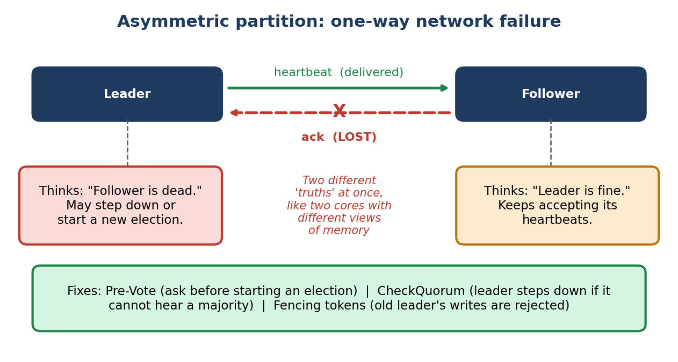
Figure 6. Asymmetric partition between a leader and a follower
Idea | Hardware race | Network race
Cause | Delayed visibility (store buffer, invalidate queue) | Delayed or lost messages (one-way link failure)
Symptom | Consumer sees flag but old data | Leader thinks follower is dead, follower thinks leader is fine
Fix | Release/acquire, fences | Pre-Vote, CheckQuorum, fencing tokens
Principle | Make the order explicit | Make the order explicit

- Pre-Vote: a node asks others first before starting an election, so a cut-off node cannot disturb a healthy leader.
- CheckQuorum: the leader steps down if it cannot hear from a majority.
- Fencing tokens: every leader gets an increasing number, and storage rejects writes from an older number. This is the network version of a fence.

7. Team insights
- Single-thread tests are not proof. Reordering is invisible to one thread, so concurrent code needs careful reasoning and tools, not only unit tests.
- Memory ordering is a contract, not a speed knob. Use acquire/release for hand-offs and seq_cst when you need one global order. Never rely on x86 alone.
- Release publishes, acquire consumes. One without the other fixes nothing. They must pair on the same variable.
- Hardware thinks in cache lines, not variables. False sharing can cut throughput several times even when no data is logically shared.
- Lock-free is a design style. Single writer, padding, pre-allocation and batching (the Disruptor way) matter more than CAS alone.
- Lock-free is not always faster. It makes latency steadier. Under heavy contention a good mutex can win, so measure first.
- Hardware races and distributed races are the same problem. Both come from delayed visibility, and both are solved with explicit ordering (fences, quorums, fencing tokens).
- Good habits: test on ARM as well as x86, run ThreadSanitizer, use jcstress or herd7 for litmus tests, and use perf c2c to find false sharing.

Code review checklist
Question to ask | What it catches
Is every cross-thread flag or pointer an std::atomic (or equivalent)? | Compiler hoisting and stale reads. Plain variables give no ordering.
For each atomic publish, is there a matching acquire on the same variable? | A release with no acquire reader gives no ordering at all.
Does any algorithm rely on StoreLoad (Dekker, Peterson, flag-then-check)? | Needs seq_cst or a full fence.
Was the code tested only on x86? | Weak-memory bugs that x86 hides. Stress test on ARM.
Are hot fields written by different threads on separate cache lines? | False sharing. Check with perf c2c.
Does the fast path call a lock, allocator or system call? | Hidden kernel switches in a design meant to be lock-free.
Does every pointer CAS have an ABA defence? | Memory reuse corruption.

Key takeaway
Correctness comes from the ordering rules you declare, not from luck with timing. Speed comes from keeping each cache line owned by one writer. A good lock-free design gets both: minimal ordering (release/acquire, with seq_cst only for StoreLoad) and a layout that stops lines from bouncing.
Q1. Why do compilers and CPUs reorder instructions, and why do tests miss the resulting bugs?
Memory is slow and CPUs are fast. To avoid waiting, the compiler and the CPU are allowed to change the order of reads and writes, as long as one thread alone cannot tell. Other threads can tell, and that is a data race. Tests miss it because the timing window is tiny, x86 hides many problems, and adding a log line or a debugger changes the timing so the bug vanishes. (Section 1)
Q2. What does a memory fence physically tell the CPU to do?
Each core has a store buffer (writes wait here before other cores can see them) and an invalidate queue ("your copy is old" messages wait here before being applied). A release tells the core: push my earlier writes out of the store buffer before this write becomes visible. An acquire tells it: apply the waiting invalidations before running my later reads. seq_cst does both and also empties the store buffer before any later read, so everyone agrees on one global order. (Section 2)
Q3. Why does false sharing slow things down when threads write different variables?
The cache protocol tracks whole 64-byte lines, not single variables. To write, a core must own the line exclusively, which throws away every other core's copy. If two variables sit on the same line, the line keeps travelling between the cores and every write becomes a slow cache miss. Padding each hot variable onto its own line fixes it. (Section 4)
Q4. How do lock-free structures like the Disruptor avoid kernel context switches?
A normal lock that is busy puts the thread to sleep through the operating system, which costs microseconds and cools the CPU caches. A lock-free design stays in user space: each counter has one writer (no lock needed), counters are padded onto separate lines, and writers publish with a release store. CAS (compare-and-swap) is used only when several producers must share one counter, and it is a single CPU instruction that takes nanoseconds on a cached line. (Section 5)
Q5. Quest: deconstruct a memory race and an asymmetric partition
Section 3 traces a memory race through the hardware with diagrams. Section 6 shows the network version (asymmetric partition) and why it is the same problem. Section 7 has the team insights.

Q6. Explain why memory ordering protection are critical ?
Memory ordering protections are critical because modern CPUs use multiple layers of optimization: compiler transformations, out-of-order execution, speculative execution, private caches, and cache-coherence protocols. Correct concurrent programs must use a memory model and synchronization operations to define which observations are allowed.
Without proper ordering | With proper ordering
Threads may observe shared state unexpectedly. | Required visibility relationships are established.
Compiler/CPU may reorder operations where allowed by the memory model. | Synchronization restricts the reorderings that would break the algorithm.
Stale or surprising values may be observed. | The program can rely on defined synchronization relationships.
Debugging becomes difficult because failures may be rare. | Behavior is constrained by explicit synchronization rules.

Q7. Diagram the state transition
A state transition is the movement of a system from one defined state to another as a result of an event, operation, or synchronization action. In concurrent systems, state transitions help describe how shared data and synchronization variables change over time

7.1 State transition diagram
STATE 0 — Initial
---------------------
data = 0
ready = false
|
| Producer writes data
v
STATE 1 — Data prepared
------------------------
data = 100
ready = false
|
| Producer publishes signal
| (release)
v
STATE 2 — Data published
-------------------------
data = 100
ready = true
|
| Consumer observes signal
| (acquire)
v
STATE 3 — Data consumed
------------------------
Consumer safely reads data = 100

7.2 Race scenario
STATE A
data = 0
ready = false
|
| Producer starts
v
STATE B
data = 100
ready = false
|
| Reordering / insufficient synchronization
v
STATE C
Consumer sees:
ready = true
data = 0 <-- stale/unexpected observation
This is the type of situation memory-ordering protections are designed to prevent
when the algorithm requires a happens-before relationship.

7.3 Happens-before
A happens-before relationship means the memory model guarantees that certain operations are ordered before others for the purpose of visibility and synchronization.
Producer:
write data
|
| release
v
write signal
|
| observed by acquire
v
Consumer:
read signal
|
v
read data
Conceptually:
write data → release signal → acquire signal → read data

