III Semester B.Tech., Computer Science
Data Analytics – CES2103
Internal Assessment - Mini Project Report
School of Computer Engineering
Manipal Institute of Technology, MAHE
on
“Distinguishing Malignant from Benign Breast Masses Using Cell-Nucleus Measurements: An EDA and CDA Study of the Wisconsin Diagnostic Breast Cancer Dataset”
Submitted by:
Name: Vani Mallya
Roll No: 1
Registration Number: 251090050006
Section: I
Branch: Computer Science

Name: Anoothi Nayar
Roll No: ______________________
Registration Number: _______________________
Section: ___________________
Branch: Computer Science

Name: Prabhanjan Joshi
Roll No: ______________________
Registration Number: _______________________
Section: ___________________
Branch: Computer Science

Name: Shailja Jhajharia
Roll No: 28
Registration Number: 251090051214
Section: I
Branch: Computer Science

Team Number: 12 Date of submission: 25 October 2026

Table of Contents

1. Introduction 2
2. Objectives 2
3. Problem Statement 2
4. Literature Review / Background Study 2
5. Methodology 3
5.1 Data Collection 3
5.2 Tools and Technologies Used 4
6. Implementation / Experimentation 4
6.1 Exploratory Data Analysis 4
6.2 Confirmatory Data Analysis 5
7. Results and Discussion 7
8. Conclusion and Future Work 7
9. Team Member's Contribution 8
10. References 8
11. Appendix 9

1. Introduction
Breast cancer is one of the most common cancers worldwide, and accurate discrimination between malignant and benign breast masses is central to timely treatment. In the Wisconsin Diagnostic Breast Cancer (WDBC) programme, digitised images of fine-needle aspirates (FNA) were segmented by computer and the outlines of the cell nuclei were measured, turning a subjective visual impression into numbers such as nucleus radius, texture and concavity.
This mini project treats those measurements as a data-analytics problem: dataset validation, preprocessing, exploratory data analysis (EDA) and confirmatory data analysis (CDA), culminating in tests of two clear claims: that malignant masses have larger cell nuclei, and that malignancy is associated with irregular nuclear boundaries. The data are real, well documented and clean enough to focus on analytical reasoning, and the labels are medically meaningful.

2. Objectives
- Validate, clean and transform the WDBC data (missing values, duplicates, invalid values, outliers, skewness, collinearity).
- Describe the distributions of the nucleus measurements and identify which ones differ most between malignant and benign masses (EDA).
- Test two statistical hypotheses with appropriate tests, assumption checks and robustness checks (CDA): whether mean nucleus radius differs between diagnoses (Welch t-test), and whether diagnosis is associated with the level of boundary irregularity (chi-square test of independence).
- Quantify effect sizes, control for multiple testing across all 30 features, and check how well the features discriminate between diagnoses.
- Report findings, limitations and future scope clearly and reproducibly (notebook, raw and cleaned data).

3. Problem Statement
Problem statement: To test whether malignant breast masses have larger and more irregular cell nuclei than benign ones using statistical tests on the Wisconsin Diagnostic Breast Cancer data.
Visual cytological assessment of FNA samples depends on the observer’s experience and is hard to standardise. Computer-measured nucleus features are objective, but it is not obvious which features matter, whether their differences between benign and malignant masses are real or due to chance, and how large they are. Many studies of this dataset report only prediction accuracy, not formal hypothesis tests, effect sizes, or the effect of testing 30 correlated features at once.
Problem: (1) Is the mean nucleus radius of malignant breast masses statistically different from that of benign masses, and how large is the difference? (2) Is diagnosis associated with the level of nuclear boundary irregularity (concave points)? (3) Which other nucleus characteristics show comparable differences once multiple testing and redundancy among features are taken into account?

4. Literature Review / Background Study
The WDBC data and its predecessors were produced by the University of Wisconsin group of W. H. Wolberg, O. L. Mangasarian and W. N. Street. The following peer-reviewed papers form the background for this study.
- Wolberg and Mangasarian (1990), PNAS [1] used cytological characteristics of FNA samples, each graded 1–10 at collection, and separated benign from malignant cases with planes found by linear programming. Their method separated 369 of 370 samples correctly (201 benign, 169 malignant), establishing that FNA characteristics carry a strong diagnostic signal.
- Bennett and Mangasarian (1992), Optimization Methods and Software [2] introduced robust linear-programming discrimination of two linearly inseparable sets, the multisurface approach later applied to the Wisconsin breast-cancer data.
- Mangasarian, Street and Wolberg (1995), Operations Research [3] applied linear programming to breast cancer diagnosis and prognosis from measured FNA features.
- Wolberg, Street, Heisey and Mangasarian (1995), Archives of Surgery [4] reported computerised diagnosis and prognosis from fine-needle aspirates in the surgical literature.
- Wolberg, Street and Mangasarian (1995), Analytical and Quantitative Cytology and Histology [5] combined image analysis and machine learning for breast cancer diagnosis and prognosis; the nuclear-feature extraction behind the ten WDBC characteristics was introduced by Street, Wolberg and Mangasarian (1993) [6].
Gap addressed here: these works concentrate on classifier construction. This project emphasises transparent statistical inference - assumption checks, a primary hypothesis test with robustness checks, effect sizes, multiple-testing control and treatment of collinear features.

5. Methodology

5.1 Data Collection
Dataset: Breast Cancer Wisconsin (Diagnostic) - WDBC, created by W. H. Wolberg, W. N. Street and O. L. Mangasarian (1993); UCI Machine Learning Repository, id 17, DOI 10.24432/C5DW2B, CC BY 4.0 (https://archive.ics.uci.edu/dataset/17/breast+cancer+wisconsin+diagnostic). The identical 569-row copy distributed with scikit-learn 1.8 (load_breast_cancer) was exported unchanged to raw_wdbc.csv; it has no patient-ID column. Date accessed: 25 October 2026.
Each row describes one breast mass examined by FNA. The file has 569 observations and 31 columns: 30 numeric image features and the diagnosis (212 malignant, 357 benign). Ten nucleus characteristics are each reported as the mean, the standard error and the “worst” (mean of the three largest) value.
Variable group | Meaning and measurement
diagnosis (target) | Malignant or benign; categorical (stored as 0/1 in the source)
radius, perimeter, area | Nucleus size: centre-to-boundary distance, boundary length, enclosed area (numeric)
texture | Standard deviation of grey-scale values in the nucleus (numeric)
smoothness, compactness | Local variation in radius lengths; perimeter² / area - 1 (numeric)
concavity, concave points | Severity and number of concave portions of the outline; 0 = convex (numeric)
symmetry, fractal dimension | Nucleus symmetry; boundary roughness (“coastline approximation” - 1)
mean / error / worst | Each characteristic above is given in three forms = 30 features
Preprocessing steps performed. (1) Missing values: none. (2) Duplicates: no exact duplicate rows or feature vectors. (3) Validity: no negative or non-positive size/texture values; zeros occur only in concavity and concave-point columns (13 rows, all benign), where 0 correctly means a convex outline, so they were kept. (4) Outliers: the 1.5×IQR rule flagged 67 masses (11.8%) in at least one “mean” feature (e.g. 25 for mean area, all malignant); these are genuine large tumours and were retained. (5) Transformation: mean area (skewness 1.64) and mean radius (0.94) were log-transformed (0.28 and 0.31). (6) Derived variables: diagnosis label and 0/1 indicator, size group (terciles of mean radius), concavity flag (median split of mean concave points, used in CDA 2) and texture band. (7) Collinearity: radius, perimeter and area correlate at r = 0.99 - 1.00 and 15 of 435 feature pairs exceed |r| = 0.95, so features were standardised only inside model pipelines to avoid leakage.
Table 1. Preprocessing summary
Aspect | Before | After
Records | 569 | 569 (nothing removed)
Columns | 31 | 38 (7 derived)
Missing values / duplicates | 0 / 0 | 0 / 0
Outliers (1.5×IQR) | 67 rows flagged | Retained (genuine tumours)
Skewness of mean area | 1.64 (raw) | 0.28 (log scale)

5.2 Tools and Technologies Used
Python 3.12 in a Jupyter Notebook (WDBC_Analysis.ipynb): pandas/NumPy for data handling, SciPy for the Shapiro-Wilk, Levene, Welch t, Mann-Whitney, chi-square and Fisher exact tests, scikit-learn 1.8 for standardisation, PCA, logistic regression and stratified cross-validation, and Matplotlib/seaborn for figures. The permutation tests (10,000 shuffles) and bootstrap (5,000 resamples) use a fixed random seed (42).

6. Implementation / Experimentation

6.1 Exploratory Data Analysis
Table 2 summarises six key features overall and by diagnosis; medians fall well below means for area, concavity and concave points (right skew), and malignant masses are larger and more irregular on every measure.
Table 2. Descriptive statistics (n = 569) and group means
Variable | Mean | Median | SD | Min | Max | Skew | Malignant mean | Benign mean
Mean radius | 14.13 | 13.37 | 3.52 | 6.98 | 28.11 | 0.94 | 17.46 | 12.15
Mean texture | 19.29 | 18.84 | 4.30 | 9.71 | 39.28 | 0.65 | 21.61 | 17.92
Mean area | 654.9 | 551.1 | 351.9 | 143.5 | 2501 | 1.64 | 978.4 | 462.8
Mean smoothness | 0.096 | 0.096 | 0.014 | 0.053 | 0.163 | 0.46 | 0.103 | 0.092
Mean concavity | 0.089 | 0.062 | 0.080 | 0.000 | 0.427 | 1.40 | 0.161 | 0.046
Mean concave points | 0.049 | 0.034 | 0.039 | 0.000 | 0.201 | 1.17 | 0.088 | 0.026
Univariate analysis. Diagnosis is moderately imbalanced: benign 62.7% (357) and malignant 37.3% (212). Mean radius is roughly bell-shaped within each class but the bells are far apart: benign is centred near 12 and narrow (SD 1.78), malignant near 17.5 and wider (SD 3.20) with a long right tail up to 28. Mean concave points show the same pattern with almost no overlap between interquartile ranges.
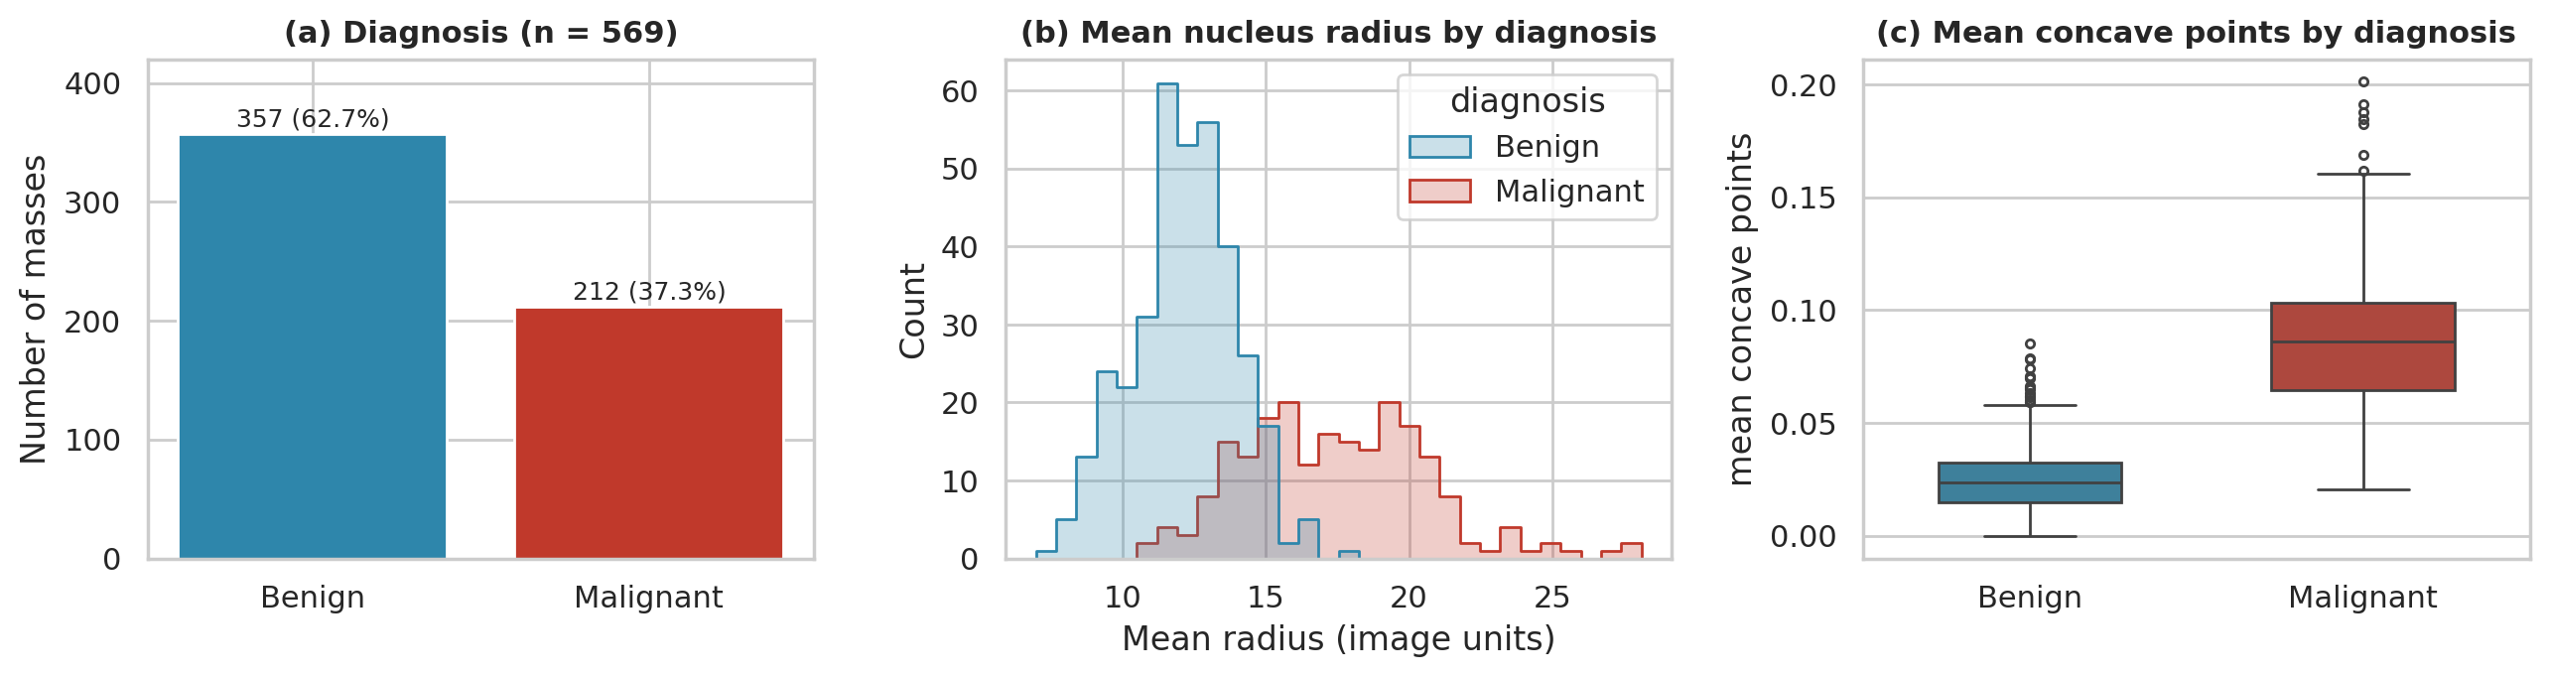
Figure 1. (a) Class balance, (b) mean nucleus radius and (c) mean concave points by diagnosis.
Bivariate and multivariate analysis. Mean radius and mean concave points are strongly related (r = 0.82), and malignant masses occupy the upper-right region of Figure 2(a). Correlations with diagnosis are 0.73 for radius, 0.78 for concave points, 0.70 for concavity and 0.60 for compactness; fractal dimension is unrelated (-0.01). Concavity, concave points and compactness form a correlated “irregularity” block (r = 0.83 - 0.92). Two principal components of all 30 standardised features capture 63.2% of the variance (84.7% with five) and already separate the classes. Malignancy rates climb with size (3.1%, 20.7% and 87.9% across radius terciles), with concave points (3.9% low vs 70.8% high) and with texture (4.4% below 15 vs 65.1% for 20 - 25).
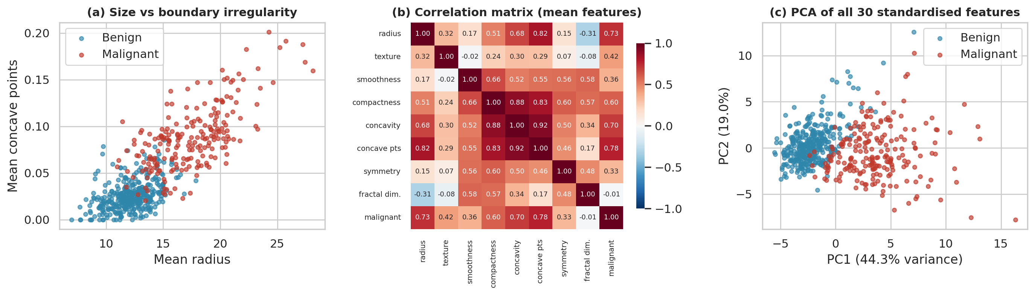
Figure 2. (a) Size versus boundary irregularity, (b) correlation matrix of mean features, (c) PCA projection of all 30 features.
Key EDA observations: (i) size and irregularity separate the classes best, 20 of the 30 features have a large standardised difference (|Cohen’s d| ≥ 0.8) and only 5 have |d| < 0.2; (ii) radius, perimeter and area are one underlying “size” construct (r ≈ 0.99); (iii) texture is a clear but weaker signal; (iv) all of this is descriptive, in a sample with 37% malignant cases, not population prevalence or causation.

6.2 Confirmatory Data Analysis
CDA 1 - Research question 1: Do malignant and benign breast masses differ in mean nucleus radius? H₀: μ(malignant) = μ(benign). H₁: μ(malignant) ≠ μ(benign) (two-sided). Significance level: α = 0.05.
Choice of test. Mean radius is continuous and diagnosis defines two independent groups (212 malignant, 357 benign), so an independent two-sample t-test is appropriate. Shapiro-Wilk indicates mild non-normality in the malignant group (W = 0.978, p = 0.002; benign W = 0.997, p = 0.668) and Levene’s test strongly rejects equal variances (W = 90.5, p < 0.0001). We therefore used Welch’s t-test, which does not assume equal variances; with at least 212 observations per group the Central Limit Theorem makes the sampling distribution of the mean approximately normal. A Mann-Whitney U test, a permutation test and a bootstrap confidence interval serve as distribution-free robustness checks.
Table 3. Results for mean radius, malignant versus benign
Statistic | Value | p-value | Decision / interpretation
Welch t (df ≈ 289.7) | t = 22.21 | 1.7 × 10⁻⁶⁴ | Reject H₀
Mean difference (malignant − benign) | 5.32; Welch 95% CI [4.85, 5.79]; bootstrap 95% CI [4.83, 5.80] | — | 17.46 vs 12.15; intervals agree
Effect size | Cohen’s d = 2.21; Hedges’ g = 2.20 | — | Very large (> 0.8)
Mann-Whitney U | U = 70,955; rank-biserial r = 0.875 | 2.7 × 10⁻⁶⁸ | Same conclusion; 93.8% chance a random malignant radius exceeds a benign one
Permutation test (10,000 shuffles) | observed 5.32; largest shuffled |diff| = 1.14 | < 0.0001 | Same conclusion
Ratio on log scale | ×1.43 (95% CI 1.39 to 1.47) | 2.1 × 10⁻⁷⁸ | Malignant radius about 43% larger
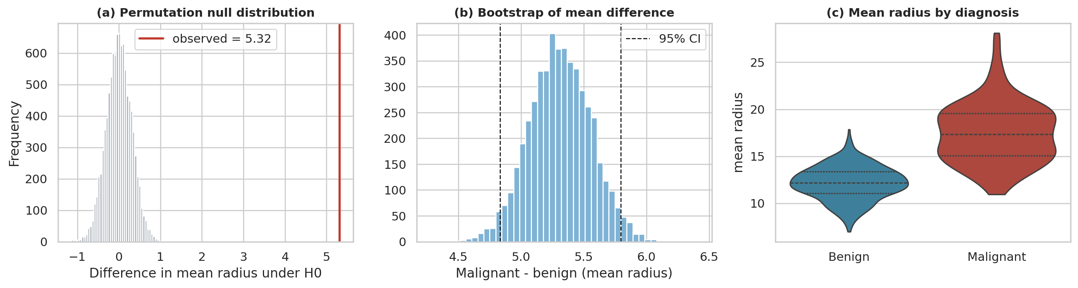
Figure 3. (a) Permutation null distribution, (b) bootstrap distribution of the mean difference, (c) mean radius by diagnosis.
CDA 2 - Research question 2: Is diagnosis associated with the level of nuclear boundary irregularity, measured by mean concave points (High = above the sample median of 0.0335, Low = at or below)? H₀: diagnosis and irregularity level are independent. H₁: they are associated. Significance level: α = 0.05.
Choice of test. Both variables are categorical with two levels (a 2 × 2 table) and each mass appears once, so observations are independent; the Pearson chi-square test of independence is appropriate. Every expected count is at least 105.8 (Table 4), far above the usual minimum of 5, so the large-sample approximation is valid. Yates’ continuity correction, Fisher’s exact test and a permutation test (10,000 shuffles of the diagnosis labels) were run as checks, and the odds ratio and φ report the effect size.
Table 4. Observed (expected) counts, irregularity level × diagnosis
Irregularity level | Malignant | Benign | Total | % malignant
High (mean concave points > 0.0335) | 201 (105.8) | 83 (178.2) | 284 | 70.8%
Low (≤ 0.0335) | 11 (106.2) | 274 (178.8) | 285 | 3.9%
Total | 212 | 357 | 569 | 37.3%
Table 5. Results of the chi-square test and checks
Statistic | Value | p-value | Decision / interpretation
Pearson χ² (df = 1) | χ² = 272.47 | 3.3 × 10⁻⁶¹ | Reject H₀
Yates-corrected χ² | χ² = 269.61 | 1.4 × 10⁻⁶⁰ | Same conclusion
Fisher’s exact test | odds ratio = 60.3 | 7.4 × 10⁻⁷⁰ | Same conclusion
Odds ratio | 60.3; 95% CI [31.3, 116.1] | — | High-irregularity masses have about 60 times the odds of being malignant
Difference in proportions | 66.9 points; 95% CI [61.2, 72.7] | — | 70.8% vs 3.9% malignant
Effect size | φ = 0.69 | — | Strong (> 0.5)
Permutation test (10,000 shuffles) | observed χ² = 272.5; largest shuffled χ² = 14.8 | < 0.0001 | Same conclusion
Other cut-offs (25th / 75th percentile) | χ² = 109.2 / 290.7; malignant 49.5% vs 0.7% / 97.2% vs 17.3% | 1.5 × 10⁻²⁵ / 3.5 × 10⁻⁶⁵ | Conclusion unchanged
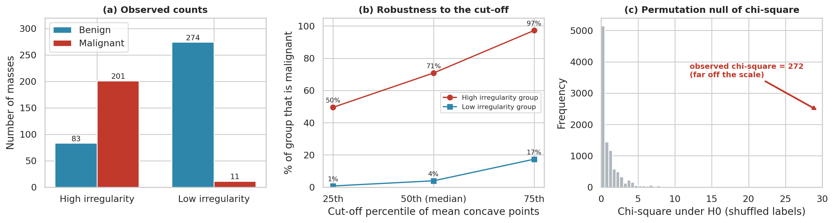
Figure 4. (a) Observed counts, (b) malignant share by group at three cut-offs, (c) permutation null distribution of the chi-square statistic (the observed value of 272 lies far outside it).
Interpretation (CDA 2). Since p ≪ 0.05 we reject H₀: diagnosis and boundary irregularity are strongly associated. 70.8% of high-irregularity masses are malignant versus 3.9% of low-irregularity masses, a difference of about 67 percentage points, and the conclusion is the same under Yates’ correction, Fisher’s exact test, the permutation test and at the 25th and 75th percentile cut-offs. The association is observational and the median cut-off is data-driven, so it describes a pattern in this sample, not a causal or clinical rule.
Supporting analyses. (i) Multiple testing: Welch t-tests on all 30 features with Holm correction (Table 6). (ii) Predictive check: 5-fold stratified cross-validation of standardised logistic regression (Table 7).

7. Results and Discussion
Primary result (CDA 1). Since p ≪ 0.05 we reject H₀. Malignant masses have a larger mean nucleus radius by about 5.3 units (≈ 44%; 95% CI 4.85 to 5.79), and the effect is very large (d ≈ 2.2). The shuffled differences never come close to the observed value (largest 1.14 versus 5.32), and the rank-based, permutation and bootstrap methods agree, so the result does not depend on the t-test assumptions. The data are observational and come from one research programme, so this shows association, not that larger nuclei cause malignancy.
Second result (CDA 2). We also reject H₀ for boundary irregularity (χ²(1) = 272.47, p ≈ 3.3 × 10⁻⁶¹, φ = 0.69): the odds of malignancy are about 60 times higher for high-irregularity masses (95% CI 31.3 to 116.1). Because mean radius and mean concave points are correlated (r = 0.82), the two tests are not independent confirmations; together they show that both nucleus size and boundary irregularity separate the two diagnoses.
Which features matter. After Holm correction 25 of the 30 features differ significantly between diagnoses; the five that do not are texture error, smoothness error, symmetry error, fractal-dimension error and mean fractal dimension. The largest effects belong to size and irregularity measures (Table 6).
Table 6. Five largest effects among the 30 features (Holm-adjusted Welch tests)
Feature | Malignant mean | Benign mean | Cohen’s d | Holm p
Worst concave points | 0.182 | 0.074 | 2.69 | < 0.0001
Worst perimeter | 141.37 | 87.01 | 2.60 | < 0.0001
Mean concave points | 0.088 | 0.026 | 2.55 | < 0.0001
Worst radius | 21.13 | 13.38 | 2.54 | < 0.0001
Mean perimeter | 115.37 | 78.08 | 2.29 | < 0.0001
Table 7. Cross-validated discrimination of malignant masses (5-fold, stratified)
Model | AUC | Accuracy | Sensitivity | Specificity
Mean radius only | 0.935 | 0.880 | 0.788 | 0.936
Mean radius + mean concave points | 0.976 | 0.909 | 0.849 | 0.944
All 30 features | 0.995 | 0.974 | 0.943 | 0.992
Discussion. The effect is not merely “statistically detectable”: it is very large, the groups overlap only slightly, and radius alone gives AUC 0.935, so the objectives were met. Two cautions apply. Radius, perimeter and area are nearly the same measurement, so “25 of 30 significant” reflects a few underlying constructs, not 25 independent findings. And the 97.4% cross-validated accuracy comes from a small (569), single-programme sample with 37% malignant cases, so values in a screening population would differ; sensitivity (94.3%) matters more than accuracy because a missed malignancy is costlier than a false alarm.

8. Conclusion and Future Work
The project validated and cleaned the WDBC data (no missing or duplicate records; outliers retained as genuine), transformed skewed variables, performed descriptive and graphical EDA, and carried out two confirmatory tests. A Welch t-test with non-parametric, permutation and bootstrap confirmation showed that malignant breast masses have significantly larger cell nuclei than benign ones (t = 22.21, p < 0.0001, Hedges’ g = 2.20, mean difference 5.32, 95% CI 4.85–5.79). A chi-square test of independence showed that malignancy is strongly associated with boundary irregularity (χ²(1) = 272.47, p < 0.0001, φ = 0.69, odds ratio ≈ 60). Nucleus size and boundary irregularity are the strongest separators of the two diagnoses.
Limitations: observational data from one 1990s programme; only 569 masses; no patient IDs (repeat patients cannot be excluded); strongly collinear, segmentation-dependent features; an imbalanced sample; and a data-driven median cut-off in CDA 2. The results describe association and screening support, not a clinical decision rule. Future work: validate on newer multi-centre imaging data; use regularised or tree-based models with calibrated probabilities; choose cost-sensitive thresholds that favour sensitivity; and adjust for patient-level covariates if available.

9. Team Member's Contribution
Sl. No. | Name (Reg. No.) | Contribution
1 |  | Dataset selection and source documentation; data validation and cleaning (missing values, duplicates, outliers, skewness, collinearity); producing the cleaned dataset; standardised cross-validated logistic regression (Table 7)
2 |  | Exploratory data analysis: descriptive statistics, class balance, distributions, correlation matrix, PCA, Figures 1–2; background reading for the literature review
3 |  | CDA 1 – hypothesis test for mean radius: hypotheses, normality and variance checks, Welch t-test, Mann-Whitney, permutation test, bootstrap; Figure 3
4 | Vani Mallya [251090050006] | CDA 2 – chi-square test of independence for boundary irregularity: 2 × 2 table, odds ratio, Fisher’s exact and permutation checks, Figure 4; feature-level analysis of all 30 features with Holm correction (Table 6); notebook integration and a Restart & Run All check; final report assembly, formatting and checklist

10. References
[1] W. H. Wolberg and O. L. Mangasarian, “Multisurface method of pattern separation for medical diagnosis applied to breast cytology,” Proc. Natl. Acad. Sci. USA, vol. 87, no. 23, pp. 9193–9196, 1990. doi: 10.1073/pnas.87.23.9193.
[2] K. P. Bennett and O. L. Mangasarian, “Robust linear programming discrimination of two linearly inseparable sets,” Optimization Methods and Software, vol. 1, no. 1, pp. 23–34, 1992.
[3] O. L. Mangasarian, W. N. Street and W. H. Wolberg, “Breast cancer diagnosis and prognosis via linear programming,” Operations Research, vol. 43, no. 4, pp. 570–577, 1995.
[4] W. H. Wolberg, W. N. Street, D. M. Heisey and O. L. Mangasarian, “Computerized breast cancer diagnosis and prognosis from fine needle aspirates,” Archives of Surgery, vol. 130, pp. 511–516, 1995.
[5] W. H. Wolberg, W. N. Street and O. L. Mangasarian, “Image analysis and machine learning applied to breast cancer diagnosis and prognosis,” Analytical and Quantitative Cytology and Histology, vol. 17, no. 2, pp. 77–87, 1995.
[6] W. N. Street, W. H. Wolberg and O. L. Mangasarian, “Nuclear feature extraction for breast tumor diagnosis,” Proc. IS&T/SPIE Int. Symp. Electronic Imaging, vol. 1905, pp. 861–870, 1993.
[7] W. H. Wolberg, W. N. Street and O. L. Mangasarian, Breast Cancer Wisconsin (Diagnostic) [Dataset], UCI Machine Learning Repository, 1993. https://doi.org/10.24432/C5DW2B (accessed 25 Oct. 2026).
[8] B. L. Welch, “The generalization of ‘Student’s’ problem when several population variances are involved,” Biometrika, vol. 34, pp. 28–35, 1947; J. Cohen, Statistical Power Analysis for the Behavioral Sciences, 2nd ed., 1988; S. Holm, “A simple sequentially rejective multiple test procedure,” Scand. J. Statistics, vol. 6, pp. 65–70, 1979.
[9] F. Pedregosa et al., “Scikit-learn: Machine learning in Python,” J. Mach. Learn. Res., vol. 12, pp. 2825–2830, 2011; P. Virtanen et al., “SciPy 1.0,” Nature Methods, vol. 17, pp. 261–272, 2020.

11. Appendix
A. Project files. WDBC_Analysis.ipynb (all code with outputs); raw_wdbc.csv (569 × 31, unmodified); cleaned_wdbc.csv (569 × 38); figures/ (fig1_distributions.png, fig2_relationships.png, fig3_cda.png, fig4_cda2.png, fig_effect_sizes.png). Run the notebook from the project folder so that data/ and figures/ resolve.
B. Reproducibility. Random seed 42 is used for the permutation test, bootstrap, cross-validation splits and PCA. Required packages: pandas, NumPy, SciPy, scikit-learn, matplotlib, seaborn.
C. Derived variables. log_mean_area, log_mean_radius (natural logs); diagnosis (Malignant/Benign) and is_malignant (1/0); size_group (Small/Medium/Large = terciles of mean radius); concavity_flag (High if mean concave points exceeds the median 0.034); texture_group (<15, 15–20, 20–25, >25 on mean texture).
D. Chi-square assumption check (CDA 2). Expected counts if irregularity level and diagnosis were independent: High 105.8 malignant / 178.2 benign; Low 106.2 / 178.8; all far exceed 5 (see Table 4).

