DATA ANALYTICS PROJECT
Supermarket Sales Analysis
Turning 500 till transactions into operational decisions
YourName
Data Analytics Project Report
September 2026

Table of contents

1. Problem statement
A four-branch supermarket chain records every till transaction but does not currently turn those records into decisions. Stock is ordered on intuition rather than on demand data, the membership programme has never been evaluated against the spending it was meant to generate, and the sizeable performance gap between branches has never been explained.
The aim of this project is to analyse the chain's sales data and extract useful, actionable information about its products, branches, categories, customers, payment methods and service ratings. Six questions frame the analysis:
- Which product generates the highest sales?
- Which branch performs best?
- Which category sells the most?
- What is the most popular payment method?
- Do members spend more than normal customers?
- What is the average customer rating?
Each answer is carried through to a business decision in section 6. An analysis that stops at the answer is a description; the value is in what the business does differently as a result.

2. Dataset
The dataset contains 500 sales transactions recorded between 1 January and 1 July 2026 across four branches: Jaipur, Delhi, Mumbai and Bengaluru. Each row is one invoice and carries thirteen fields covering the product sold, where and when it was sold, who bought it, how they paid and how they rated the visit.

2.1 Schema
Column | Type | Description
Invoice ID | Text | Unique identifier, INV0001 to INV0500
Date | Date | Transaction date
Branch | Text | Branch code A to D
City | Text | Jaipur, Delhi, Mumbai, Bengaluru
Customer Type | Text | Member or Normal
Gender | Text | Male or Female
Product | Text | One of 19 products
Category | Text | One of 8 categories
Quantity | Integer | Units sold, 1 to 10
Unit Price | Decimal | Price per unit in rupees
Payment | Text | UPI, Card, Cash or Net Banking
Rating | Decimal | Customer rating, 1.0 to 5.0
Sales | Decimal | Quantity multiplied by Unit Price

Source: SUPER MARKET DATA, shared Google Sheet. The working copy used for this analysis is supermarket_sales_500_rows.csv, supplied alongside this report.

3. Steps used for analysis
The analysis follows a six-stage pipeline, implemented in a single Jupyter notebook so that it can be re-run against a new export without code changes.

3.1 Collect and load
The CSV is read into a pandas DataFrame with the Date column parsed as a datetime so that time-based grouping works correctly rather than treating dates as strings.

3.2 Check the data
Four checks run before any analysis. Skipping them risks building conclusions on an unsound base, and the fourth check in particular is the one that most analyses omit:
- Missing values: zero across all thirteen columns.
- Duplicates: zero duplicated Invoice IDs and zero fully duplicated rows.
- Category validity: Branch, City, Customer Type, Gender, Category and Payment each contain only their expected set of values, with no stray casing or whitespace variants.
- Derived column integrity: Sales was recomputed as Quantity multiplied by Unit Price and compared against the stored column. It matches on all 500 rows, with a largest absolute difference of zero.
Range checks confirm Quantity falls between 1 and 10, Unit Price and Sales are positive, Rating falls between 1 and 5, and every date lands in 2026. No imputation, correction or row removal was needed.

3.3 Calculate sales
Sales equals Quantity multiplied by Unit Price. Because the column already existed in the source, the calculation was used as a validation step rather than a creation step.

3.4 Group and summarise
The data was aggregated by product, branch, category, payment method, customer type, gender and month using totals, counts and averages. Pivot tables were used for the two-dimensional views, branch against category and payment method against branch.

3.5 Create charts
Each question is paired with the chart type that answers it most directly: horizontal bars for rankings, a stacked column for composition, a donut for share of a whole, a box plot for distribution comparison, a histogram for spread, a heatmap for a two-way count, and a dual-axis line for the time series.

3.6 Interpret
Every result is read back as a business decision. Where a result contradicted expectation, it was tested statistically before being reported as a finding.

4. Analysis and results

4.1 Headline figures
Measure | Value
Total sales | Rs 2,44,885.34
Transactions | 500
Units sold | 2,756
Average sale | Rs 489.77
Units per basket | 5.5
Average rating | 3.99 out of 5
Period covered | 1 Jan to 1 Jul 2026

4.2 Which product generates the highest sales?
Cheese generates the highest sales at Rs 27,906.30, which is 11.4% of all revenue, earned across just 25 transactions at an average sale of Rs 1,116.25.
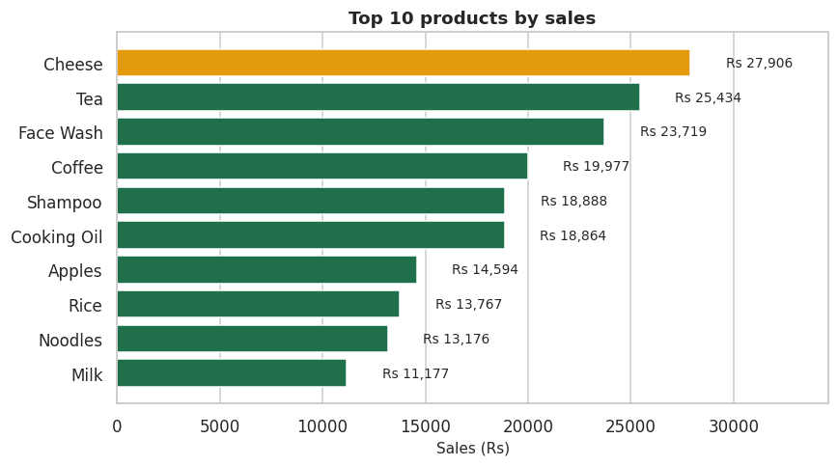
Figure 1: Top 10 products by sales
The ranking separates two different kinds of product. Cheese tops revenue on 25 transactions while Noodles sells on 43 transactions and contributes roughly half as much. Cheese is a high-value, low-frequency item that protects margin; Noodles and Soap are low-value, high-frequency items whose real job is drawing customers through the door. Treating them with the same stocking logic would be a mistake.

4.3 Which branch performs best?
Branch C in Mumbai performs best with sales of Rs 72,469.45, 29.6% of the chain total and 52.3% ahead of the weakest branch, Jaipur, on Rs 47,570.38.
Branch | Sales (Rs) | Transactions | Avg sale (Rs) | Rating
C - Mumbai | 72,469.45 | 149 | 486.37 | 4.02
D - Bengaluru | 63,818.63 | 121 | 527.43 | 4.04
B - Delhi | 61,026.88 | 133 | 458.85 | 3.94
A - Jaipur | 47,570.38 | 97 | 490.42 | 3.95

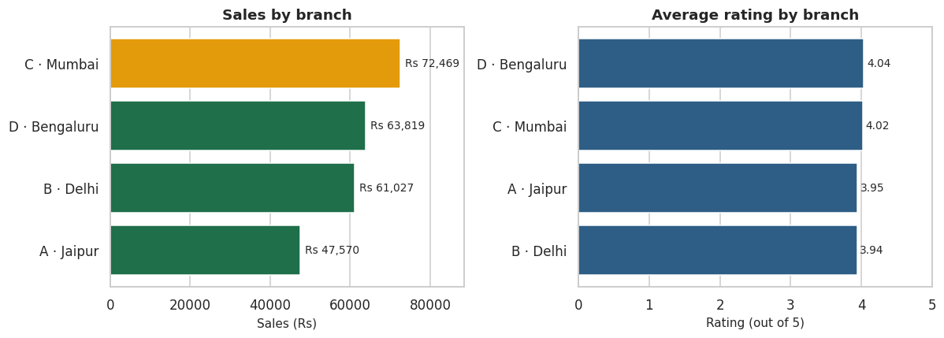
Figure 2: Sales and average rating by branch
Revenue and satisfaction do not move together. Mumbai leads on revenue but Bengaluru rates marginally higher on service, and Bengaluru also has the largest average basket despite 28 fewer transactions. Mumbai's advantage is therefore built on footfall rather than on either service quality or basket size, which points at catchment, layout or opening hours rather than at staff performance.

4.4 Which category sells the most?
Beverages sells the most at Rs 56,108.24, 22.9% of revenue, ahead of Personal Care on Rs 52,878.66 and Grocery on Rs 45,807.17.
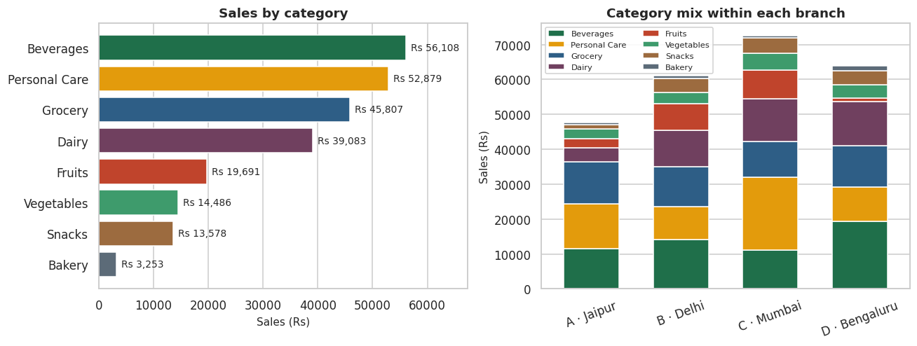
Figure 3: Category totals, and the category mix within each branch
The stacked view on the right explains part of the branch gap. Mumbai's revenue leans unusually heavily on Personal Care, the category with the highest average sale value, while Bengaluru leans on Beverages. The branches are not simply larger and smaller versions of each other; they are selling different mixes, and a range decision taken centrally will land differently in each.

4.5 What is the most popular payment method?
UPI is the most used payment method with 127 transactions, 25.4% of the total. Cash follows on 124, Net Banking on 125 and Card on 124.
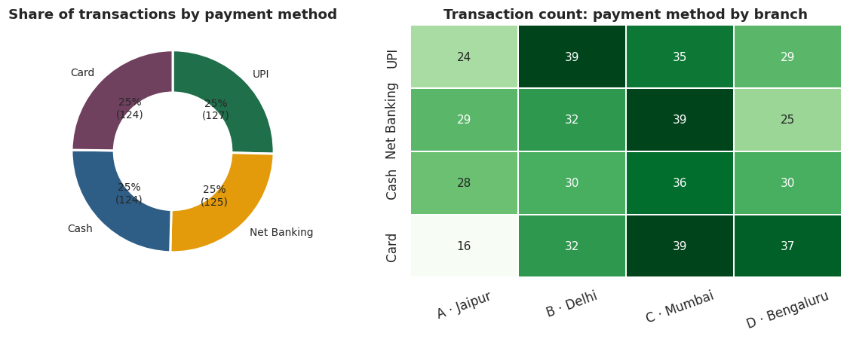
Figure 4: Payment method share, and payment method by branch
The headline answer is technically correct but operationally thin. The four methods sit within three transactions of each other, a gap that would not survive a different sample of the same size. The honest reading is that payments are evenly split and no rail can be deprioritised. The branch breakdown is more useful: Jaipur is markedly light on Card usage, which is worth checking as a terminal reliability issue rather than a customer preference.

4.6 Do members spend more than normal customers?
No. The average Member transaction is Rs 483.14 while Normal customers average Rs 497.07, a difference of Rs 13.93 against the membership.
Customer type | Transactions | Total sales (Rs) | Avg sale (Rs) | Rating
Member | 262 | 1,26,582.68 | 483.14 | 3.95
Normal | 238 | 1,18,302.66 | 497.07 | 4.03

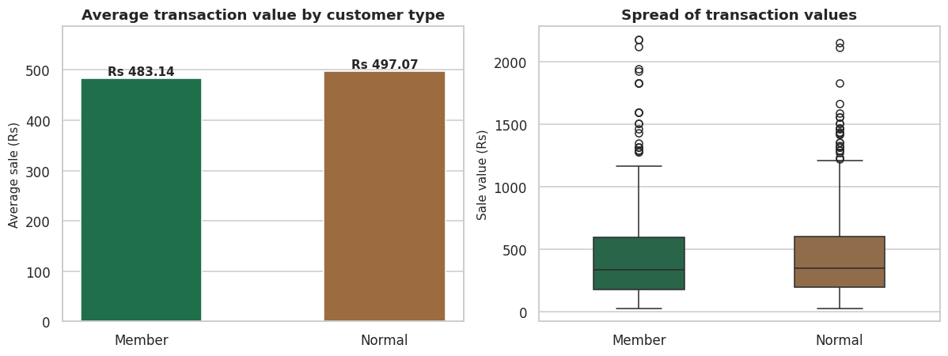
Figure 5: Average transaction value and full distribution by customer type
Because this result contradicts the expected effect of a membership programme, it was tested rather than simply reported. A Welch's t-test on transaction value returns t = -0.353 and p = 0.724, so at the 5% level the difference is not statistically significant. The box plot shows why: the two distributions overlap almost completely, with near-identical medians, quartiles and outlier tails.
The correct conclusion is not that members spend less. It is that the membership programme is having no measurable effect on basket size at all, which for a programme whose purpose is to increase spending is a failure rather than a neutral result.

4.7 What is the average customer rating?
The average customer rating is 3.99 out of 5, with a median of 4.00 and a range from 3.0 to 5.0.
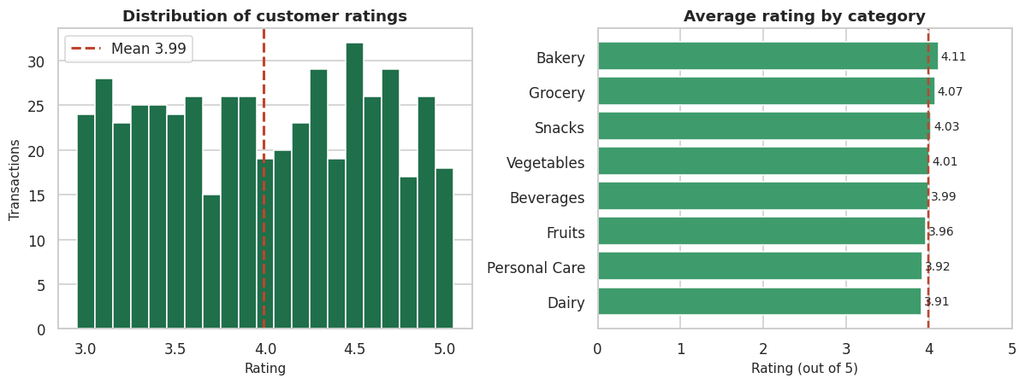
Figure 6: Rating distribution, and average rating by category
The distribution matters more than the mean. Ratings are spread close to uniformly between 3.0 and 5.0 rather than clustering near the top, and a quarter of all visits score below 3.5. A store with genuinely strong service produces a left-skewed distribution bunched at 4.5 and above. This one does not, which makes 3.99 a mediocre score rather than a comfortable one. Personal Care and Dairy, the two highest-value categories, both rate below the chain average.

4.8 Sales over time
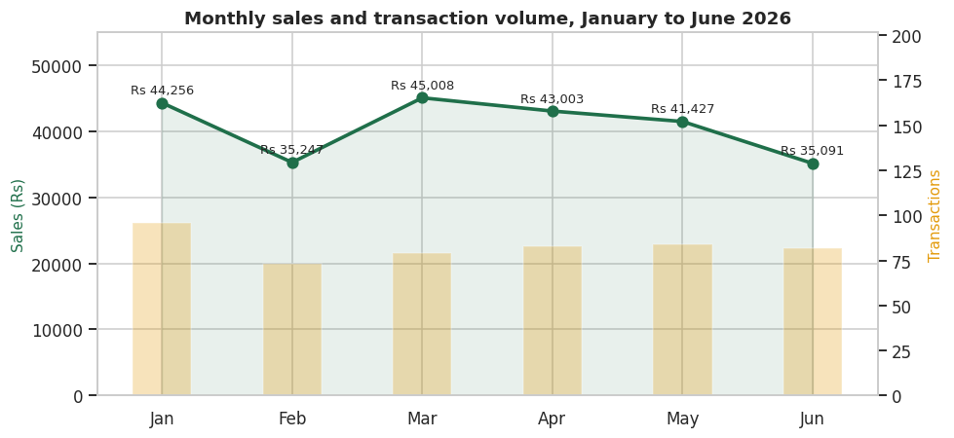
Figure 7: Monthly sales and transaction volume, January to June 2026
Revenue moves between roughly Rs 35,000 and Rs 45,000 a month with no trend and no visible seasonality across the window. February and June are the soft months, and in both cases the shortfall comes from transaction count rather than from average basket size, which makes it a footfall problem rather than a pricing problem. July is excluded from the chart because the data covers only 1 July, three transactions, and is not a comparable period.

5. Summary of findings
Question | Answer | Supporting figure
Highest selling product | Cheese | Rs 27,906.30, 11.4% of revenue
Best performing branch | Branch C, Mumbai | Rs 72,469.45, 29.6% of revenue
Highest selling category | Beverages | Rs 56,108.24, 22.9% of revenue
Most used payment method | UPI | 127 of 500 transactions, 25.4%
Higher spending customer type | Normal customers | Rs 497.07 vs Rs 483.14, p = 0.724
Average customer rating | 3.99 out of 5 | median 4.00, range 3.0 to 5.0

6. Business decisions

6.1 Stock to the revenue curve, not the transaction curve
Cheese and the Beverages category carry a disproportionate share of revenue on a modest number of transactions. Deepen stock on both and protect their shelf position. The fast-moving low-value lines should be managed for availability rather than margin, because their function is footfall, and a stock-out on Soap costs more in lost visits than it does in lost margin.

6.2 Audit Mumbai before writing off Jaipur
Mumbai is 52.3% ahead of Jaipur on revenue without rating better on service, so the gap is structural rather than a matter of staff performance. Establish how much of it comes from catchment, which cannot be transferred, and how much from range, layout and opening hours, which can. Jaipur's average basket is in fact slightly higher than Mumbai's, so the problem there is getting customers through the door, not what they buy once inside.

6.3 Keep all four payment rails supported
The payment split is close to even, so no method can be deprioritised and any checkout change that slows one rail will be felt by roughly a quarter of customers. The one item worth investigating is Jaipur's low Card usage, which is more likely to be a terminal problem than a genuine local preference.

6.4 Rebuild the membership offer around basket size
This is the most actionable finding in the analysis. Members are statistically indistinguishable from non-members in what they spend per visit, which means the programme is not doing the job it exists to do. A flat percentage discount produces exactly this outcome, because it reduces the value of baskets that would have been bought anyway.
Replacing it with a spend or volume threshold, for example a benefit that unlocks above a basket value of Rs 600, gives members a reason to add to the basket rather than subtract from the bill. The effect can be measured with the same test used here: re-run the comparison after one quarter and look for a significant difference where there currently is none.

6.5 Treat the rating as the cheapest available lever
A quarter of visits rate below 3.5, and the two highest-value categories rate below the chain average. Service quality costs neither stock nor margin to improve, and it is the only variable in this dataset that affects repeat visits and branch performance at the same time. Start with Personal Care and Dairy, where the weakest ratings coincide with the highest basket values and therefore the most revenue at risk.

7. Conclusion
Five hundred transactions were validated, aggregated and visualised to answer six operational questions. The analysis confirms where revenue concentrates, in one product, one category and one branch, and converts each of those observations into a stocking, staffing or investigation decision.
The more valuable outcome is the finding that contradicted expectation. The membership programme, which exists to increase spending, shows no measurable effect on basket size, and testing that result rather than simply reporting the difference in means is what turns it from a curiosity into a recommendation the business can act on.
The pipeline built here is repeatable. Run against next quarter's export it produces the same six answers with no code changes, which converts a one-off study into a monitoring tool. This is the practical point of the project: sales data becomes useful only when the route from raw transaction to business decision is short enough to travel every month.

7.1 Limitations
- Six months of data with no prior year, so seasonality cannot be separated from ordinary variation.
- No cost or margin data, so highest selling means highest revenue rather than most profitable. A high-margin product ranking sixth on revenue could matter more than Cheese.
- No customer identifier, so repeat-visit behaviour, purchase frequency and customer lifetime value cannot be measured. This is the single most valuable field missing.
- Ratings are unlabelled as to what they score, whether service, product or store, which limits how precisely the service-quality recommendation can be targeted.

8. Tools used
Tool | Purpose
Python 3.11 | Language
pandas | Loading, cleaning, grouping, pivot tables
NumPy | Numeric arrays and histogram bin edges
Matplotlib | Bar, line, pie, histogram and dual-axis charts
seaborn | Box plot, heatmap and chart theme
SciPy | Welch's t-test on member and normal spend
Jupyter Notebook | Analysis environment
Power BI Desktop | Optional interactive dashboard layer

