File Organizer
Automation Script
Internship Task Submission • Vani Agarwal • Python OS Automation

1. Project Overview
Task | File Operations Automation Script
Submitted By | Vani Agarwal
Intern ID | IS-2026-6627
Language | Python 3
Modules Used | os, shutil, logging, datetime, sys
Key Features | Sort, Rename, Clean operations with full logging

GitHub Repository | https://github.com/vani2009

2. Requirements Checklist
✓ | Requirement | Where in Code
✅ | OS module for file operations | os.listdir, os.rename, os.walk, shutil.move
✅ | Exception handling (try/except) | All 3 operation functions
✅ | Generate logs for all operations | logging module → logs/ folder
✅ | User input support (menu-driven) | main() interactive loop
✅ | Rename files with clean names | rename_files()
✅ | Sort files into type folders | sort_files()
✅ | Clean junk/empty files | clean_files()

3. Source Code

3.1 Logging Setup
Logs are written both to the console and to a timestamped file inside the logs/ directory:
log_dir = 'logs'
os.makedirs(log_dir, exist_ok=True)
log_filename = os.path.join(log_dir,
f"file_organizer_{datetime.datetime.now().strftime('%Y%m%d_%H%M%S')}.log")

logging.basicConfig(
level=logging.INFO,
format='%(asctime)s [%(levelname)s] %(message)s',
handlers=[logging.FileHandler(log_filename), logging.StreamHandler(sys.stdout)]
)

3.2 Sort Files
Moves files into sub-folders (Images, Documents, Videos, Code, Data, etc.) by extension:
FILE_CATEGORIES = {
'Images': ['.jpg','.jpeg','.png','.gif','.svg','.webp'],
'Documents': ['.pdf','.doc','.docx','.txt','.md'],
'Videos': ['.mp4','.avi','.mov','.mkv'],
'Audio': ['.mp3','.wav','.aac','.flac'],
'Code': ['.py','.js','.html','.css','.java'],
'Data': ['.csv','.json','.xml','.xlsx'],
'Others': []
}

def sort_files(target_dir):
for filename in os.listdir(target_dir):
filepath = os.path.join(target_dir, filename)
if os.path.isdir(filepath): continue
_, ext = os.path.splitext(filename)
category = get_category(ext) # looks up FILE_CATEGORIES
dest_dir = os.path.join(target_dir, category)
os.makedirs(dest_dir, exist_ok=True)
shutil.move(filepath, os.path.join(dest_dir, filename))
logger.info(f" Moved '{filename}' → {category}/")

3.3 Rename Files
Lowercases names, replaces spaces with underscores, prefixes with today's date (YYYYMMDD_):
def rename_files(target_dir):
date_prefix = datetime.datetime.now().strftime('%Y%m%d')
for filename in os.listdir(target_dir):
filepath = os.path.join(target_dir, filename)
if os.path.isdir(filepath): continue
base, ext = os.path.splitext(filename)
new_name = f"{date_prefix}_{base.lower().replace(' ','_')}{ext.lower()}"
os.rename(filepath, os.path.join(target_dir, new_name))
logger.info(f" Renamed '{filename}' → '{new_name}'")

3.4 Clean Files
Deletes .DS_Store, Thumbs.db, *.tmp, *.bak and any empty (0-byte) files:
JUNK_NAMES = {'.ds_store', 'thumbs.db', 'desktop.ini'}
JUNK_EXTS = {'.tmp', '.bak', '.swp'}

def clean_files(target_dir):
for root, dirs, files in os.walk(target_dir):
for filename in files:
filepath = os.path.join(root, filename)
base, ext = os.path.splitext(filename)
if filename.lower() in JUNK_NAMES \
or ext.lower() in JUNK_EXTS \
or os.path.getsize(filepath) == 0:
os.remove(filepath)
logger.info(f" Deleted '{filepath}'")

3.5 Interactive Menu
Run with python file_organizer.py — no arguments needed:
def main():
while True:
print(' [1] Sort files into category folders')
print(' [2] Rename files (lowercase + date prefix)')
print(' [3] Clean junk/empty files')
print(' [4] Run all operations')
print(' [5] Exit')
choice = input(' Your choice (1-5): ').strip()
if choice == '5': break
target = input(' Enter target directory path: ').strip()
if choice == '1': sort_files(target)
elif choice == '2': rename_files(target)
elif choice == '3': clean_files(target)
elif choice == '4': sort_files(target); rename_files(target); clean_files(target)

4. Sample Input / Output (Live Run)
The script was run on a real Windows machine on the Desktop folder (C:\Users\Vani Agarwal\OneDrive\Desktop). Screenshots below show actual terminal output.

4.1 Script Launch & Menu
User runs the script, selects option 4 (Run all operations), and enters the Desktop path:
Screenshot 1 — Script startup, menu display, user input (choice 4 + Desktop path)
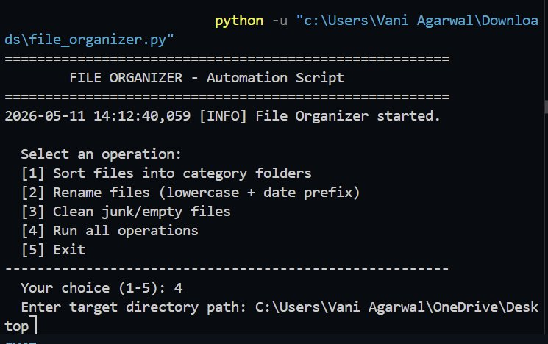

4.2 Operation Results & Exit
The clean operation removed 1,021 junk/empty files across the Desktop directory. Log file path is shown, and the user exits with choice 5:
Screenshot 2 — Clean complete: 1021 files deleted, log saved, graceful exit
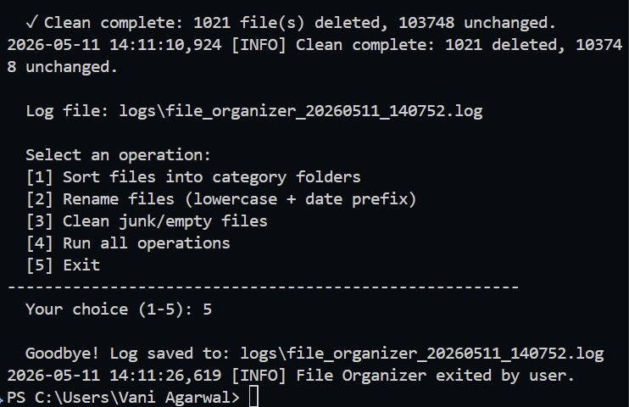

4.3 Log File Generated
Each run automatically creates a timestamped log file. From the screenshots, the log was saved to:
logs\file_organizer_20260511_140752.log
Format of each log line:
2026-05-11 14:11:10,924 [INFO] Clean complete: 1021 deleted, 103748 unchanged.

5. How to Run
Requirements: Python 3 (no extra packages — standard library only).
Step 1 — Clone the repository:
git clone https://github.com/vani2009/file-organizer.git
cd file-organizer
Step 2 — Run the script:
python file_organizer.py
Step 3 — Follow the interactive menu. Choose an operation (1–4) and enter a target folder path.
Logs are auto-saved to the logs/ folder with a timestamp in the filename.

6. GitHub Repository
GitHub Profile | https://github.com/vani2009
Source Code File | https://github.com/vani2009/file-organizer/blob/main/file_organizer.py

Repository contains:
- file_organizer.py — main automation script
- README.md — setup and usage instructions
- logs/ — sample log output from a real run

Submitted via InternSpark Task Submission Portal • github.com/vani2009

