USER FLOW DIAGRAM
TasteTrail – Smart Restaurant Discovery & Recommendation Platform
A Web-Based Platform for Discovering, Comparing and Navigating to Restaurants
Project | TasteTrail – Smart Restaurant Discovery & Recommendation Platform
Student | Vania Marwah
Program | B.Tech CSE
University | GLA University
Project Guide | Mr. Gautam Mukherjee
Document | User Flow Diagram
Based On | TasteTrail SRS – Version 1.0
About This Diagram
This document presents the primary User Flow Diagram for TasteTrail, illustrating how a user moves through the platform — from entering the application and setting a location, through restaurant discovery, filtering and viewing details, to map navigation, comparison, saving favourites and receiving recommendations. The flow is based directly on the functional requirements and primary use-case flow defined in the TasteTrail SRS (Version 1.0). The diagram spans two pages: Page 1 covers the core discovery flow, and Page 2 covers the restaurant-level actions available from the Restaurant Details Page.

User Flow Diagram – Page 1 of 2: Core Discovery Flow
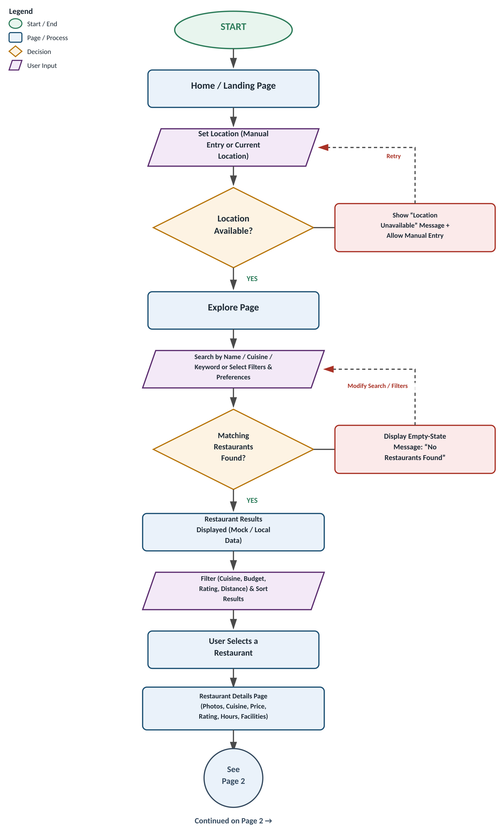

User Flow Diagram – Page 2 of 2: Restaurant Detail Actions
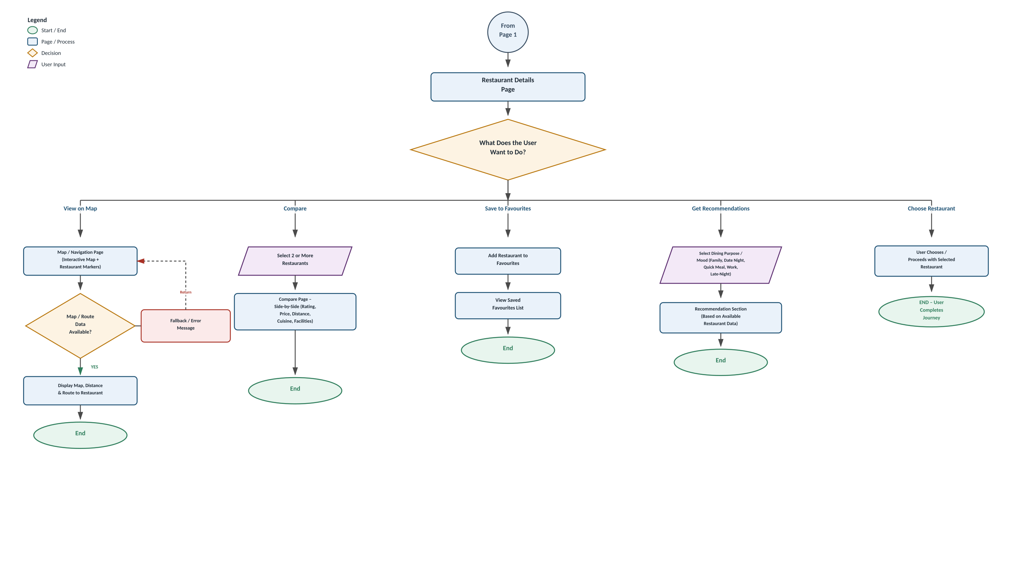

User Flow Description
1. User enters the platform via the Home / Landing Page.
2. User provides a location — either manually or by allowing current-location access.
3. If location access is denied or unavailable, the system displays a clear message and allows manual entry before proceeding.
4. On the Explore Page, the user searches by name, cuisine or keyword, or selects filters and preferences.
5. Matching restaurants are displayed; if none match, an empty-state message is shown and the user can modify the search or filters.
6. User filters and sorts the results (by cuisine, budget, rating, distance or price) and selects a restaurant.
7. User opens the Restaurant Details Page to view photos, cuisine, price range, rating, address, hours and facilities.
8. From the Restaurant Details Page, the user can: view the restaurant on the Map / Navigation Page and get route information; compare two or more restaurants on the Compare Page; save the restaurant to Favourites; explore dining-purpose or mood-based recommendations; or choose the restaurant to complete the journey.
9. If map or route data cannot be loaded, a fallback message is displayed and the user returns to the Restaurant Details Page.
10. Appropriate error and empty-state messages are shown throughout the flow whenever required data or permissions are unavailable.
Scope Notes
• User authentication (login/signup) is not shown as a mandatory step, consistent with the SRS academic scope.
• Payment, food ordering and table reservation are out of scope (listed as future enhancements in the SRS).
• Recommendations are generated from available mock/local restaurant data and selected preferences, not from an implemented AI/ML backend.
• The flow reflects a frontend-centered academic implementation, as described in the TasteTrail SRS.

