Assignment 1
Name: Vania Marwa

Q1. HTTP Request–Response Cycle
The HTTP Request–Response Cycle is the process through which a client (browser) communicates with a web server to fetch a resource such as a webpage, image, or file. It follows the Hypertext Transfer Protocol (HTTP), which defines how requests and responses are formatted and exchanged.
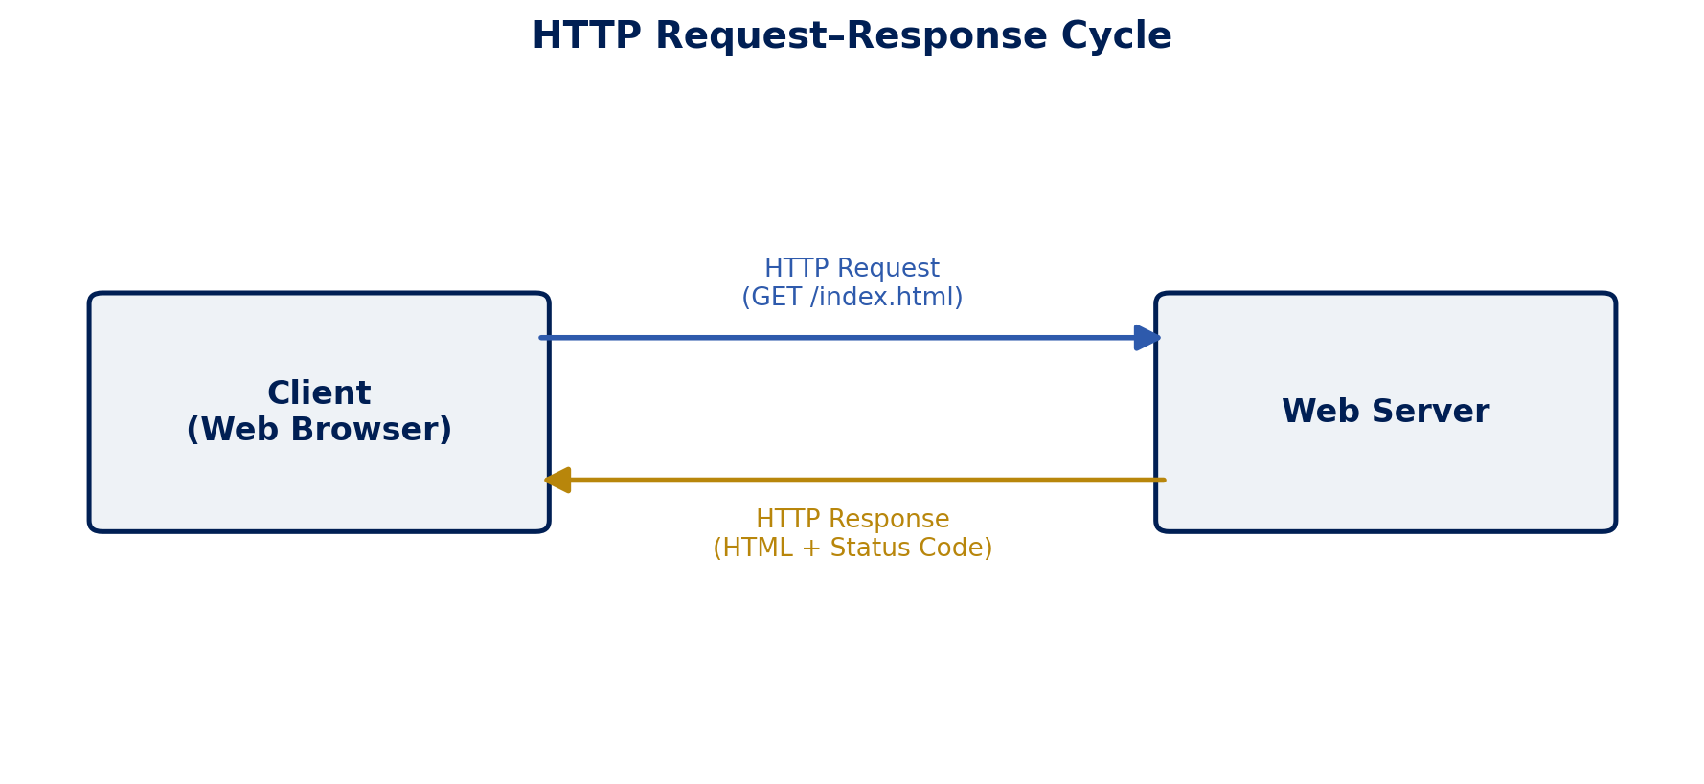
Steps involved:
- URL Entry: The user types a URL (e.g., www.example.com) into the browser's address bar and presses Enter.
- DNS Resolution: The browser contacts a DNS server to translate the human-readable domain name into an IP address.
- TCP Connection: The browser establishes a TCP connection with the web server at that IP address (usually via a three-way handshake).
- HTTP Request Sent: The browser sends an HTTP request (e.g., GET /index.html) to the server, which includes the request method, headers, and sometimes a body.
- Server Processing: The web server receives the request, processes it (may involve querying a database, running server-side code, etc.), and prepares a response.
- HTTP Response Sent: The server sends back an HTTP response containing a status code (e.g., 200 OK, 404 Not Found), response headers, and the requested content (HTML, JSON, image, etc.).
- Rendering: The browser receives the response and renders the content on the screen for the user.
- Connection Closed: Once the transfer is complete, the TCP connection is closed (or kept alive for further requests, depending on HTTP settings).

Q2. Introduction to Web Technologies
1. HTML (HyperText Markup Language)
Purpose: Provides the basic structure and content of a webpage.
Key Features: Uses tags/elements to define headings, paragraphs, links, images, tables, and forms; platform-independent; forms the skeleton on which CSS and JavaScript work.
2. CSS (Cascading Style Sheets)
Purpose: Controls the presentation and visual styling of HTML elements.
Key Features: Separates content from design; supports colours, fonts, layouts (Flexbox, Grid); enables responsive design through media queries.
3. JavaScript
Purpose: Adds interactivity and dynamic behaviour to webpages.
Key Features: Client-side scripting language; can manipulate the DOM, handle events, validate forms, and communicate with servers (AJAX/Fetch) without reloading the page.
4. Bootstrap
Purpose: A CSS framework used to quickly build responsive, mobile-first websites.
Key Features: Pre-built CSS classes and components (navbars, buttons, grids, modals); consistent design across browsers; speeds up development.
5. jQuery
Purpose: A fast, lightweight JavaScript library that simplifies DOM manipulation and event handling.
Key Features: Simplified syntax ($ selector); cross-browser compatibility; built-in animations and AJAX support.
6. React.js
Purpose: A JavaScript library for building fast, interactive user interfaces, especially single-page applications (SPAs).
Key Features: Component-based architecture; Virtual DOM for efficient updates; reusable UI components; one-way data binding.

Q3. Client-Side vs. Server-Side Technologies
Client-side technologies run in the user's browser and are responsible for what the user sees and interacts with directly. Server-side technologies run on the web server and handle data processing, business logic, and database operations before sending results to the client.
Aspect | Client-Side | Server-Side
Runs on | User's browser | Web server
Purpose | Presentation & interactivity | Data processing & logic
Examples | HTML, CSS, JavaScript, React.js | PHP, Node.js, Python (Flask/Django), Java
Visibility | Source code visible to user | Code hidden from user
Speed | Faster response for UI changes | Depends on server & network

Q4. Block-Level Elements in HTML
Block-level elements are HTML elements that always start on a new line and take up the full width available, pushing subsequent content to the next line.
Characteristics:
- Start on a new line and stretch to fill the width of their parent container.
- Can contain other block-level and inline elements.
- Respect width, height, margin, and padding properties fully.
Examples:
- <div> – generic container for grouping content
- <p> – defines a paragraph
- <h1> to <h6> – heading elements
- <table>, <ul>, <li> – additional common examples

Q5. Semantic HTML Elements
Semantic elements are HTML tags that clearly describe their meaning and the type of content they contain, both to the browser and the developer.
Importance:
- Improves code readability and maintainability for developers.
- Helps search engines understand page structure, improving SEO.
- Improves accessibility for screen readers used by visually impaired users.
Examples:
- <header> – introductory content or navigation links
- <nav> – section containing navigation links
- <article> – independent, self-contained content
- <section> – groups related content together
- <footer> – footer information for a page or section

Q6. Creating a Table Using HTML
<table border="1" cellpadding="8" cellspacing="0">
<thead>
<tr>
<th>Sr. No.</th>
<th>Name</th>
<th>Designation</th>
<th>Department</th>
</tr>
</thead>
<tbody>
<tr>
<td>1</td>
<td>John</td>
<td>Manager</td>
<td>Sales</td>
</tr>
<tr>
<td>2</td>
<td>Smith</td>
<td>Sr. Manager</td>
<td>Marketing</td>
</tr>
<tr>
<td>3</td>
<td>Jane</td>
<td>Manager</td>
<td>HR</td>
</tr>
</tbody>
</table>

Rendered Output:
Sr. No. | Name | Designation | Department
1 | John | Manager | Sales
2 | Smith | Sr. Manager | Marketing
3 | Jane | Manager | HR

Q7. Creating a Nested List Using HTML
Since 'River' is a category and the items under it (Ganga, Yamuna, Brahmaputra, Narmada) are unordered examples belonging to it, a nested unordered list (<ul>) is the appropriate structure.
<ul>
<li>River
<ul>
<li>Ganga</li>
<li>Yamuna</li>
<li>Brahmaputra</li>
<li>Narmada</li>
</ul>
</li>
</ul>

Rendered Output:
- River
  - Ganga
  - Yamuna
  - Brahmaputra
  - Narmada

Q8. Types of CSS
1. Inline CSS
Applied directly to a single HTML element using the style attribute. Useful for quick, one-off styling but not reusable.
<p style="color: blue; font-size: 16px;">Hello World</p>
2. Internal (Embedded) CSS
Written inside a <style> tag within the <head> section of an HTML document. Applies to the whole page but not to other pages.
<head>
<style>
p { color: blue; font-size: 16px; }
</style>
</head>
3. External CSS
Written in a separate .css file and linked to the HTML document using the <link> tag. Most maintainable option, as one file can style multiple pages.
<head>
<link rel="stylesheet" href="style.css">
</head>

/* style.css */
p { color: blue; font-size: 16px; }

Q9. Practical Understanding — HTML vs CSS vs JavaScript
Technology | Role | Contribution to Website
HTML | Structure | Defines the content and skeleton — headings, paragraphs, images, forms, links.
CSS | Presentation | Styles the structure — colours, fonts, spacing, layout, responsiveness.
JavaScript | Behaviour | Adds interactivity and dynamic functionality — form validation, animations, API calls.

In short: HTML is the skeleton of a webpage, CSS is the skin and clothing that makes it look presentable, and JavaScript is the muscles and nervous system that make it interactive and responsive to user actions.

Q10. Short Answers
a) Role of Bootstrap in web development
Bootstrap is a front-end CSS framework that provides a ready-made grid system, pre-styled components (buttons, forms, navbars, cards), and responsive utilities. It helps developers build consistent, mobile-friendly websites quickly without writing extensive custom CSS from scratch.
b) What is jQuery and why was it widely used?
jQuery is a lightweight JavaScript library that simplifies tasks like DOM manipulation, event handling, animations, and AJAX calls using a short and simple syntax. It became widely popular because it solved cross-browser compatibility issues (different browsers handling JavaScript differently) and reduced the amount of code developers had to write for common tasks.
c) What is React.js and what problem does it solve?
React.js is a JavaScript library developed by Meta (Facebook) for building fast and interactive user interfaces, particularly for single-page applications. It solves the problem of inefficient UI updates by using a Virtual DOM, which updates only the parts of the page that actually change instead of reloading the entire page. It also promotes reusable, component-based development, making large applications easier to build and maintain.

