**Can We Reduce N Rates and Improve ROI?**

# Farmer cooperators:

* Fred Abels (Holand, IA)
* Alec & Rachel Amundson (Osage, IA)
* Nathan Anderson (Aurelia, IA)
* Terry Aukes (Larchwood, IA)
* Jon Bakehouse (Hastings, IA)
* Pete Bardole (Jefferson, IA)
* Sam Bennett (Galva, IA)
* Vaughn Borchardt (Fenton, IA)
* Jack Boyer (Reinbeck, IA)
* Joe Bragger (Independence, WI)
* Sean Dengler (Urbandale, IA)
* Robert Harvey (Redfield, IA)
* Josh Hiemstra (Brandon, WI)
* JD Hollingsworth (Packwood, IA)
* Keaton Krueger (Ogden, IA)
* Ross McCaw (Marengo, IA)
* Mark Peterson (Stanton, IA)
* Kevin Prevo (Bloomfield, IA)
* John Van Horn (Glidden, IA)
* Kevin Veenstra (Grinnell, IA)

**Year:** 2023

**PFI Contact:** Gina Nichols, [virginia.nichols@gmail.com](mailto:virginia.nichols@gmail.com); Stefan Gailans, (515) 232-5661, [stefan.gailans@practicalfarmers.org](mailto:stefan.gailans@practicalfarmers.org)

**Funding:** USDA-NRCS; FFAR

# In a Nutshell:

* Nineteen farmers performed 22 replicated strip trials testing their typical nitrogen (N) rate against that rate reduced by an amount of their choosing
* Farmers chose to test N reductions ranging from 20-60 lb N/ac (reducing 12-50% of typical rate)
* Most farms routinely used cover crops in the past five years (14), while some used a diversified crop rotation (4), applied manure (7) or incorporated grazing (6). Farms were predominantly in no-till with some occasionally including strip-till.
* Key Findings
  + All sites experienced warmer-than-average and drier-than-average growing seasons.
  + Nineteen of the 22 trials potentially saved money when reducing their N rates.

**PHOTO: IMG_0154**

Location: https://practicalfarmers.sharepoint.com/:f:/s/Research/EoH-AWkDSyVbmjLM4BKXPKQBbNMBrctM_BF2OwVpnDFW3w?e=B7Qtax

Caption: Corn growing through a mulch of cereal rye cover crop residue at Kevin Veenstra’s on June 15, 2022. Kevin has been using cover crops and no-till on his farm near Grinnell for over six years.

# Background

In 1987 Practical Farmers of Iowa (PFI) formally established the Cooperators’ Program, which continues to be a hallmark of PFI programming. Many farmers at that time wanted to know if they were applying too much nitrogen (N) fertilizer to their corn crops – the newly minted Cooperators’ Program provided the framework for farmers to scientifically answer this question. From 1988-1993 farmer cooperators conducted 57 trials that compared corn yields and financial outcomes at their typical nitrogen (N) fertilizer rate with those at a reduced N rate of their choosing. Across sites, the average difference between typical and reduced rates was 56 units of N per acre, corresponding to an average 42% reduction from farmers’ typical rates. In 88% of those trials (50 of the 57), the farmers found they could save money by applying the lower N rate.

**Thirty years later, farmers are again interrogating their N rates.** In this round, farmers are wondering if the soil health-building practices they have implemented (reduced tillage, cover crops, diversified rotations, etc.) will allow them to reduce their typical N rates.

One of my biggest questions for several years has been whether I was being too aggressive with the amount of nitrogen I was using. This trial will allow me to explore that important question. - Chris Deal

While many farmers wonder if they can leverage healthier soils to reduce their N rates, few have had the opportunity to test lower N rates in a structured setting.

This newest round of 2022/2023 N trials builds on trials conducted in Iowa in the 2021/2022 season (see report here). This second year expanded eligibility to the larger Midwest, and included farmers recruited by PFI staff who self-identified as using soil health-promoting practices for at least five years. Using a replicated strip-trial design, farmers compared yields and finances at their usual N rate with those observed at a reduced rate. Farmers chose their own reduction rates, while PFI staff encouraged farmers to be aggressive. One goal of the trial was to push farmers to explore N rates outside of their comfort zone.

[The most valuable aspect of conducting this trial is that I] normally wouldn’t have even tried reducing by 50 units. -Jon Bakehouse

If farmers can maintain corn yields and/or save money at the reduced N rate, results might spark confidence to reduce (or at least question) fertilizer rates going forward, much like what happened for the original cohort of farmers who trialed fertilizer rates. If the reduced N rate lowers corn yields and loses money, farmers will still have gained valuable information: They can be more confident that their typical rate is the right rate for their farm, but maybe new long-term practices could help reduce it in the future. Additionally, while individual trials are immensely useful for farmers, aggregating many trial results can provide a more powerful dataset to help farmers evaluate their N rates.

We get one shot at the best crop every year, and the logical thing to do seems to be to give the crop everything it needs (and more) to maximize yields. This trial will put together a good set of farm-scale data to give farmers the confidence to dial in their N rate to improve profitability and water quality.

-Sam Bennett

# Methods

## *Design*

Cooperating farms were located across Iowa and Wisconsin with at least one farm in each of the four largest landform regions (Des Moines Lobe [north-central]; Iowan Surface [northeast]; Northwest Iowa Plains; Southern Iowa Drift Plain).

All farmers used two treatments:

1. Typical - Their typical N fertilizer rate applied to a corn crop.
2. Reduced - An N fertilizer rate less than the typical rate.

Treatments were applied in strips starting in fall 2022 to fields destined to be planted in corn for the 2023 growing season (**Figure 1**). All treatments were replicated at least four times, resulting in a total of at least eight plots in each farmer’s trial.

FIGURE 1

**Figure 1. An example of a farmer’s treatment layout testing two nitrogen (N) fertilizer treatments for this trial.** In 2023 strips averaged 39 feet wide and 1,275 feet long resulting in an average strip size of 1.1 acres.

## *Measurements*

Farmers recorded the timing, type (chemical, organic), amount of N applied, and price paid per unit N for each treatment. Corn yields were measured and reported by each farmer, along with the percent moisture of the harvested grain. All yields were converted to 15.5% moisture for this report. Additionally, most farmers reported approximate prices received per bushel of corn.

## *Data Analysis*

More details regarding methods of data analysis can be found in the **Appendix T. Detailed Methods** section at the end of this report.

### Weather

To provide context for the results, weather data was downloaded from the National Aeronautics and Space Administration (NASA) Prediction of Worldwide Energy Resources (POWER) project (<https://power.larc.nasa.gov/>) for each farmer’s trial.

### Yields

At each trial, differences in yields at the typical and reduced N rate were assessed for statistical significance using a statistical model. The model tested for the effect of the N treatment, while accounting for possible natural yield gradients in the field and, in some cases, missing data. Significance was assigned using a 95% confidence level threshold, meaning we are 95% sure the differences observed were ‘real’.

### Finances

Nitrogen prices depend on several factors including the form of N, the timing of the purchase and the location of the purchase. Similarly, the price received for corn fluctuates throughout the year. Due to this variation, as well as the limited control farmers have over the price paid for N and the price received for corn, we used three price scenarios to compare financial outcomes of the typical and reduced N treatments: best-case savings, midpoint savings, and worst-case savings (**Table 1**). Using the data provided by the farmers, we took the lowest and highest farmer reported prices for the N source they adjusted to create their two rate treatments, and the lowest and highest reported price received for corn – these values were used to construct the price scenarios.

|  |  |  |  |
| --- | --- | --- | --- |
| TABLE 1. Summary of price scenarios constructed using farmer data. | | | |
|  | **DESCRIPTION** | **N COST** | **CORN PRICE RECEIVED** |
| Best-case savings | Expensive N, low corn revenue | $1.40/lb N | $4.53/bu |
| Midpoint savings | Midpoint N, midpoint corn revenue | $0.86/lb N | $5.02/bu |
| Worse-case savings | Cheap N, high corn revenue | $0.31/lb N | $5.50/bu |

A partial budget using a given price scenario was performed for each treatment. Costs were estimated as the amount of N applied in that treatment multiplied by the assumed N cost, which depended on the scenario (**Table 1**). If the yields of each treatment were statistically different, each treatment’s yields were used for corn revenue calculations. If there was no statistical difference in treatment yields, the overall mean yield for the trial was used for corn revenue calculations. Partial net revenue for each treatment was calculated by subtracting the costs (N applied multiplied by N cost) from the revenue (yield multiplied by corn price). The difference between partial net revenues for the ‘reduced’ and ‘typical’ treatments were calculated and reported. A positive value therefore represents a financial savings at the reduced N rate. This process was done separately for the three price scenarios.

### Greenhouse gas emissions

When a farmer reduces the amount of chemical N fertilizer applied to a field, two sources of greenhouse gas (GHG) emissions associated with crop production are avoided: the GHGs (expressed as carbon dioxide equivalents, CO2e) released during fertilizer manufacturing processes, and the nitrous oxide (N2O) released from the soil due to biological processes driven by N application. To convert N2O to CO2e, a 100-year time horizon was assumed (IPCC 2007). Over the period of 100-years, 1 pound of N2O will have a forcing potential equal to 298 pounds of CO2e (IPCC 2007).

The CO2e released during fertilizer manufacturing was estimated using two values: (1) energy used to manufacture nitrogen fertilizers as reported from the 2022 GREET® (Greenhouse gases, Regulated Emissions, and Energy use in Technologies) model, developed by the Department of Energy’s Argonne National Laboratory (GREET 2024; 58 MJ/kg N), and (2) the amount of CO2e released per MJ of energy used as reported by the Environmental Protection Agency (EPA 2024a). The avoided N2O as a result of decreased N application was estimated using the Intergovernmental Panel on Climate Change (IPCC) methodologies for both direct and indirect agricultural N2O emissions (IPCC 2000). All above calculations can be simplified to a constant conversion factor: the pounds of N reduced per acre from the typical rate can be multiplied by 7.82 to get pounds of CO2e avoided per acre.

The acres needed to reduce a given amount of N application to equate to the emissions generated by a single United States (US) vehicle were calculated using the EPA’s estimates for vehicle emissions (EPA 2024b). The EPA uses statistics to represent an average US gasoline vehicle (22 miles per gallon, driven 11,500 miles per year), and estimates the emissions from one vehicle using those values (estimated to be 10,141 lb CO2e/year; EPA 2024b).

# Results and Discussion

## *Treatments*

Nineteen farmers conducted a total of 22 independent N trials. The chosen treatments reflected the diversity in farming systems, with typical N rates ranging from 120-232 lb N/ac and reduced N rates ranging from 60-180 lb N/ac (**Figure 2**). When averaged over all trials, typical and reduced N rate treatments were 170 lb N/ac and 131 lb N/ac, respectively, for an average reduction of 39 lb N/ac.

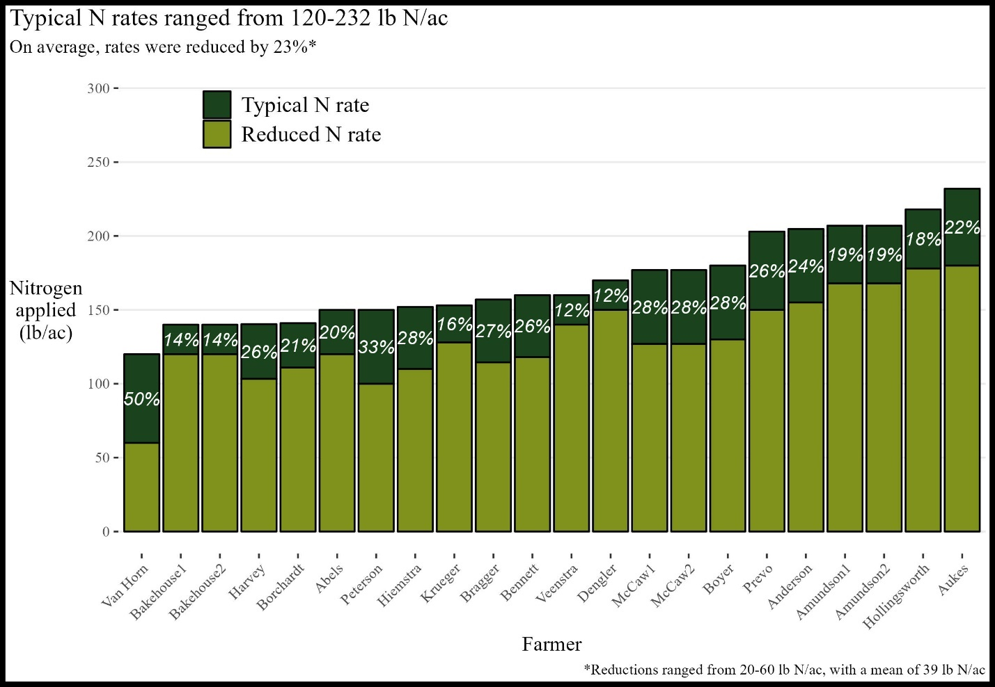

**FIGURE 2**

**Figure 2. Twenty-two trials tested two nitrogen (N) application treatments in the 2023 growing season.** A cooperator’s typical N rate (**dark green** bar), chosen reduced N rate (**light green** bar), and the reduction relative to the typical rate (white text).

Farmers utilized a variety of N application timings in their production systems, with most utilizing sidedressing. For the reduced N treatment, sixteen of the 22 trials chose to reduce N rates during sidedressing, while holding other applications constant.

|  |  |  |  |
| --- | --- | --- | --- |
| TABLE 2. Majority of farmers adjusted sidedress nitrogen applications for their reduced N rates in 2023. | | | |
| **TIMING** | **DESCRIPTION** | **Utilized** | **Adjusted** |
| Fall | After crop harvest - Dec 14 | 6 | - |
| Winter | Dec 15 - March 14 | 4 | - |
| Pre-plant | March 15 - three days before planting | 13 | 1 |
| At plant | Two days before planting - one week after corn planting | 11 | 1 |
| Sidedress | Eight days after corn planting - corn canopy closure | 19 | 16 |
| Top dress | After corn canopy closure | 7 | 4 |

### Weather

All 22 trials saw progressively warmer- and drier-than-average growing seasons (**Figure 3**).

FIGURE 3

**Figure 3. Individual cooperator site weather compared to 30-year historical averages for that site. (**Left) Average monthly air temperature deviations and (right) cumulative precipitation deviations.

Overall, although all sites experienced a hot and dry growing season, the diversity in N application amounts, sources, methods, and timing as well as cropping system history contributed to varied outcomes for each cooperator.

### Yields

Seven of the 22 trials (32%) saw statistically significant reductions in corn yields at the reduced N rate. However, it is important to note that statistical significance in yield declines is not related to financial outcomes (**Figure 4, left panel**). Statistical significance is a function of both the magnitude of the difference in treatments, as well as how variable the yields in the field were. It helps readers and farmers decide how much to ‘trust’ the yield changes, and therefore how to calculate financial outcomes. For example, Kevin Prevo’s reduced N treatment yielded 5.8 bu/ac less than his typical N treatment corn, and the reduction was statistically significant, so he can be confident that reduction was real. For comparison, Alec & Rachel Amundson’s first trial (Amundson1) saw a similar reduction in corn yield at the reduced N rate as Prevo (5.2 bu/ac), but the reduction was not statistically significant, meaning there was more variation between strips at the Amundsons’ trial location compared to Prevo’s, and they may question how ‘real’ the yield reduction was. While Prevo and the Amundsons may have different conclusions about the impact of the reduced N treatment on corn yields, they both saw potential financial savings at the reduced N rate (**Figure 4, right panel**).

FIGURE 4

**Figure 4. Impact of reducing nitrogen (N) rates on corn yields and finances.** The x-axis labels present each farmer and the amount they reduced their typical N rate to achieve the reduced N treatment (see **Figure 3**), ordered by their change in corn yield when reducing N rates. *(Left)* The y-axis presents the change in corn yields in the reduced N treatment relative to yields in the typical N treatment, with the color indicating whether the change was statistically significant (green with *) or not significant (tan). *(Right)* The x-axis presents the farmers, still ordered by their yield change, and the y-axis presents the financial outcome in the reduced N treatment relative to the typical N treatment assuming best-case (top of vertical bar), worst-case (bottom of bar) and midpoint 2023 price scenarios **(white triangles**). B**lue bars** indicate a financial savings in the midpoint price scenario, **orange bars** indicate a financial loss in the midpoint price scenario, and lighter colored bars indicate the financial outcome was sensitive to the price scenario considered.

### Finances

The financial outcomes of reducing applied N varied by trial and price scenario (**Figure 4 right panel**). Fifteen trials saved money in the reduced N treatment compared to the typical N treatment regardless of the price scenario considered (see **Table 1**). An additional four trials showed potential for savings under at least one price scenario. For example, in the best-case scenario Terry Aukes saved $14/ac, but lost $20/ac in the mid-point scenario and lost $55/ac in the worst-case scenario. Three trials (Bennett, Bakehouse1, and Krueger) lost money in every price scenario. In this set of trials, the worst potential financial loss observed was $89/ac (Bennet’s worst-case scenario), and the best potential financial savings was $84/ac (Van Horn’s best-case scenario).

### Greenhouse gas emissions

Reducing N applications will always reduce GHG emissions associated with corn production. In 2023, avoided GHGs ranged from 150-470 lb CO2e/ac. However, using midpoint price scenarios (**Table 1**), in 16 trials (73%) those avoided emissions co-occurred with a financial savings, while in six trials the reduced GHG emissions came at a financial loss (**Figure 5, left panel**).

FIGURE 5

**Figure 5. Some farmers lost money while reducing GHG emissions, but the majority (73%) potentially saved money.** (Left) All trials avoided GHG emissions and 16 of the 22 trials also saved money assuming mid-point price scenarios (dark blue), while six trials lost money in the mid-point price scenario (orange). (Right) Based on the Environmental Protection Agency (EPA 2024b) estimated GHG emissions for one average gasoline vehicle (22.2 miles per gallon, driven 11,500 miles per year), reducing N applications by 20-60 lb/ac would offset one vehicle’s emissions if utilized on 22-65 acres.

To put these avoided GHG emissions into perspective, one vehicle emits around 10,000 lb CO2e/year (EPA 2024b). Using each trial’s selected N reduction, we back-calculated how many acres the farmer would need to apply their reduced N treatment to in order to offset one vehicle. For example, John Van Horn chose to reduce his typical N application by 60 lb/ac. Van Horn could offset one vehicle’s emissions by using his reduced N rate on 22 acres (**Figure 5, right panel**). Using his midpoint price scenario savings of $51/ac (**Figure 4, right panel**) he would potentially also save around $1,000. However, if, for example, Mark Peterson applied his reduced N treatment (50 lb/ac reduction) to 26 acres, he could offset one vehicle’s emissions but would also lose $32/ac, or around $800.

### Reflections

Of the 17 trials conducted, seven (41%) likely saved money in the reduced N treatment (dark blue bars in **Figures 4 and 5**). Ten (59%) likely lost money in the reduced N treatment, and those farmers may want to gain another year of data at the aggressive reduction rate or explore a less aggressive rate.

I thought the yield reduction would be higher. -Pete Bardole

It is clear these results were valuable for the farmers. Many expected the yield reductions to be larger. The weather certainly played a part in the results - in general dry conditions render corn less responsive to N inputs, so it is important to remember 2022 results are not necessarily predictive of future outcomes. It is clear the farmers conducting these trials fully embrace this caveat.

This was one trial on one farm for one year. The real value comes by increasing the "n" (i.e. number of samples) for these trials. – Chris Deal

However, all the farmers gained useful experience in exploring the impact of reducing N rates on their finances. As the first year of a multi-year project wraps up, farmers are already looking forward to increasing the number of datapoints collected under this project’s umbrella in the coming years. As more farmers contribute their data to this project, the power of the results will only continue to grow.

My search for optimum N rates isn't over yet. – Bill Frederick

# Appendix A. Fred Abels

“[We] had some understanding of how to cut N when planting into clover,

this was a great way to verify our thinking.”

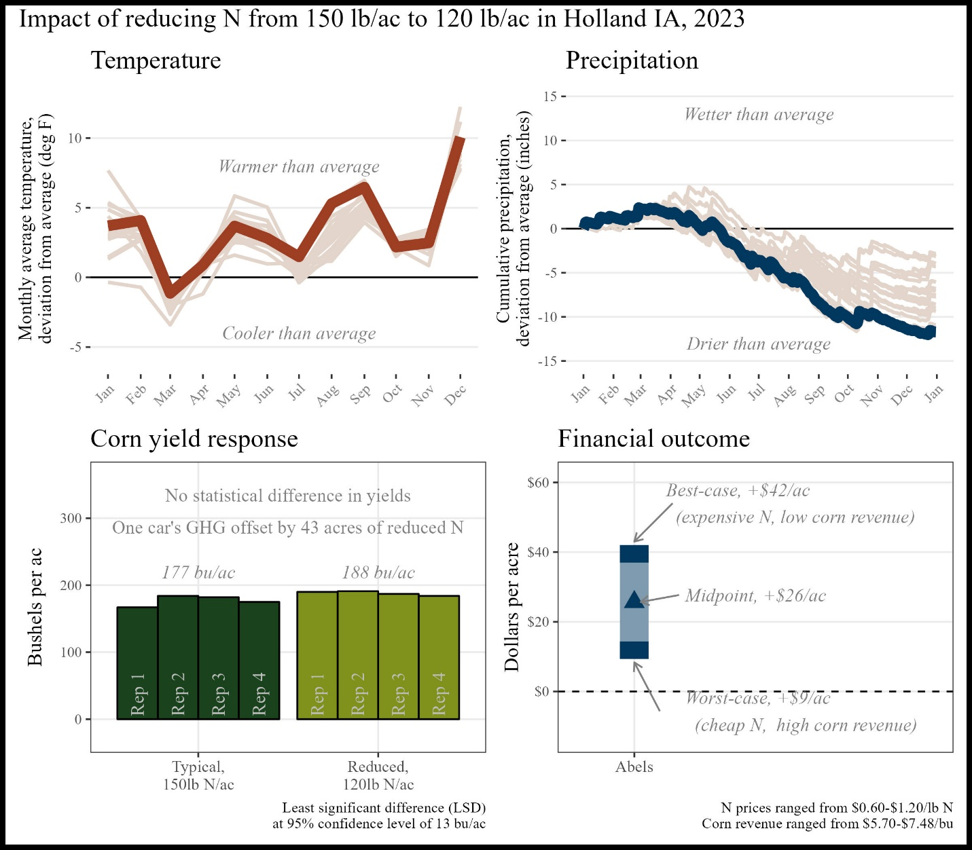

Figure A1. Summary of trial results

*Historical cropping system (5 year):* Strip-till corn, no-till soybeans, cereal rye cover crop

*Previous crop:*  Oats/red clover cover crop

*Replications and plot size:* 4 reps, 1.7 acres per replicate

*Corn planting/harvest date:*  May 14, 2022/October 23, 2022

*Corn row spacing/planting density:* 30 inch; 33,000 seeds/ac

*Nitrogen sources and timing:*  Chemical sources; fall, spring, and side-dress

# Appendix B. Rachel and Alec Amundson

“I hope my research site, combined with other farmer-cooperator sites…can reform the narrative around nitrogen fertilization and use for the benefit of farmers and the environment.”

The financial outcome at the reduced N rate was likely a **financial savings** compared to the typical N rate. A 53 lb N/ac reduction saved money this year, however this was likely influenced by the drought which rendered yields less responsive to N.

Figure B1. Summary of trial results

*Historical cropping system (5 year):* No-till corn, no-till soybeans, cereal rye cover crops, grazing

*Previous crop:*  Corn and cereal rye cover crop

*Replications and plot* size: 4 reps, 2.11 acres per rep

Corn planting/harvest date: May 19, 2022/October 14, 2022

Corn row spacing/planting density: 30 inch; 35,500 seeds/ac

Nitrogen sources and timing: Organic, chemical; winter, at planting, side-dress

# Appendix C. Nathan Anderson

“[These trials will] give me confidence to either reduce N rates or be secure in the knowledge we aren’t over-applying nutrients”

The financial outcome at the reduced N rate was likely a **financial loss** compared to the typical N rate. A 56 lb N/ac reduction was likely too large this year, but there may be potential for financial savings with a smaller N reduction.

Figure C1. Summary of trial results

*Historical cropping system (5 year):* No-till corn, no-till soybeans, cereal rye cover crop, grazing

*Previous crop:*  Soybeans

*Replications and plot size:*  4 reps, 0.8 acres per rep

*Corn planting/harvest date:* May 11, 2022/September 29, 2022

*Corn row spacing/planting density:* 30 inch; 34,000 seeds/ac

*Nitrogen sources and timing:* Chemical; pre-plant, side-dress

# Appendix D. Terry Aukes

“I thought the yield reduction would be higher.”

The financial outcome at the reduced N rate was likely a **financial loss** compared to the typical N rate. A 50 lb N/ac reduction was likely too large this year, but there may be potential for financial savings with a smaller N reduction.

Figure D1. Summary of trial results

*Historical cropping system (5 year):* Strip-till corn, no-till soybeans, oats/turnip cover crop

*Previous crop:*  Soybeans and oats + turnip cover crop

*Replications and plot size:*  4 reps, 0.8 acres per rep

*Corn planting/harvest date:*  April 23, 2022/October 3, 2022

*Corn row spacing/planting density:* 30 inch; 34,000 seeds/ac

*Nitrogen sources and timing:* Chemical; fall, side-dress

# Appendix E. Jon Bakehouse

“I knew we could grow good corn with less N, but knowing what happens when corn runs out of N, I habitually over apply fertilizer. This trial helped give me the confidence to take a deeper look at what rates I'm planning to apply.”

The financial outcome at the reduced N rate was likely a **financial savings** compared to the typical N rate. A 50 lb N/ac reduction saved money this year, however this was likely influenced by the drought which rendered yields less responsive to N.

Figure E1. Summary of trial results

*Historical cropping system (5 year):* Strip-till corn, no-till soybeans, cereal rye cover crop

*Previous crop:*  Soybeans

*Replications and plot size:*  4 reps, 0.8 acres per rep

*Corn planting/harvest date:* May 8, 2022/October 18, 2022

*Corn row spacing/planting density:* 30 inch; 34,000 seeds/ac

*Nitrogen sources and timing:* Chemical; fall, side-dress

# Appendix F. Sam Bennett

**“**Probably should've had an additional 20# check.”

The financial outcome at the reduced N rate was likely a **financial loss**. A 20 lb N/ac reduction was likely too large this year, but there may be potential for financial savings with a smaller N reduction.

Figure F1. Summary of trial results

*Historical cropping system (5 year):* Strip-till corn, no-till/strip-till soybeans

*Previous crop:*  Soybeans

*Replications and plot size:*  4 reps, 1.63 acres per rep

*Corn planting/harvest date:* May 11, 2022/October 25, 2022

*Corn row spacing/planting density:* 30 inch; 33,500 seeds/ac

*Nitrogen sources and timing:* Chemical, organic; fall, at planting, side-dress

# Appendix G. Vaughn Borchardt

When asked what was the most valuable aspect of conducting this trial, Jack replied simply: “Cost reduction.”

The financial outcome at the reduced N rate was likely a **financial savings** compared to the typical N rate. A 50 lb N/ac reduction saved money this year, however this was likely influenced by the drought which rendered yields less responsive to N.

Figure G1. Summary of trial results

*Historical cropping system (5 year):* No-till rye, no-till soybeans, multispecies cover crops

*Previous crop:*  Rye/soybean relay crop

*Replications and plot size:*  4 reps, 1.4 acres per rep

*Corn planting/harvest date:* May 15, 2022/October 18, 2022

*Corn row spacing/planting density:* 30 inch; 34,000 seeds/ac

*Nitrogen sources and timing:* Chemical; Fall, at planting, side-dress

# Appendix H. Jack Boyer

“One of my biggest questions for several years has been whether I was being too aggressive with the amount of N I was using. This trial allowed me to explore that important question.”

The financial outcome at the reduced N rate was likely a **financial loss** compared to the typical N rate. A 50 lb N/ac reduction was likely too large this year, but there may be potential for financial savings with a smaller N reduction.

Figure H1. Summary of trial results

*Historical cropping system (5 year):* No-till soybean, no-till corn, cereal rye/wheat cover crops

*Previous crop:*  Soybean

*Replications and plot size:*  4 reps, 2.8 acres per rep

*Corn planting/harvest date:* May 17, 2022/October 26, 2022

*Corn row spacing/planting density:* 30 inch; 36,400 seeds/ac

*Nitrogen sources and timing:*  Chemical; fall, at-planting, side-dress

# Appendix I. Joe Bragger

**“**[I] need to continue testing the hypothesis, perhaps at lower ratios of difference.”

The financial outcome at the reduced N rate was likely a **financial loss** compared to the typical N rate. A 65 lb N/ac reduction was likely too large this year, but there may be potential for financial savings with a smaller N reduction.

Figure I1. Summary of trial results

*Historical cropping system (5 year):* No-till soybeans, no-till oats, no-till corn, no-till cereal rye, clover cover crop, multi-species cover crop, grazing

*Previous crop:*  Rye and multi-species summer-planted cover crop

*Replications and plot size:*  4 reps, 0.3 acres

*Corn planting/harvest date:*  May 17, 2022/November 11, 2022

*Corn row spacing/planting density:* 30 inch; 33,000 seeds/ac

*Nitrogen sources and timing:*  Chemical; at planting, side-dress

# Appendix J. Sean Dengler

“My search for optimum N rates isn't over yet.”

The financial outcome at the reduced N rate was likely a **financial savings** compared to the typical N rate. A 50 lb N/ac reduction saved money this year, however this was likely influenced by the drought which rendered yields less responsive to N.

Figure J1. Summary of trial results

*Historical cropping system (5 year):* No-till corn, no-till soybeans, wheat cover crop, wheat/turnip cover crop, grazing

*Previous crop:* Soybeans and winter wheat cover crop (aerially applied)

*Replications and plot size:* 4 reps, 50 feet wide, length not reported

*Corn planting/harvest date:* May 22, 2022/October 13, 2022

*Corn row spacing/planting density:* 20 inch; 37,000 seeds/ac

*Nitrogen sources and timing:*  Organic, chemical; fall

# Appendix K. Robert Harvey

Wayne Fredericks is ‘very likely’ to refer participating in PFI research trials to a friend or other farmers.

The financial outcome at the reduced N rate was likely a **financial loss** compared to the typical N rate. A 50 lb N/ac reduction was likely too large this year, but there may be potential for financial savings with a smaller N reduction.

Figure K1. Summary of trial results

*Historical cropping system (5 year):* No-till soybeans, strip-till corn, cereal rye cover crops

*Previous crop:*  Soybeans and cereal rye/winter camelina cover crop

*Replications and plot size:*  4 reps, 0.6 acres

*Corn planting/harvest date:* May 7, 2022/October 19, 2022

*Corn row spacing/planting density:* 30 inch; 34,680 seeds/ac

*Nitrogen sources and timing:*  Chemical; fall, at planting, side-dress

# Appendix L. Josh Hiemstra

“I'm hoping to involve my daughter and use this experience as an opportunity to interest her in the farm operation.”

The financial outcome at the reduced N rate was likely a **financial loss** compared to the typical N rate. A 49 lb N/ac reduction was likely too large this year, but there may be potential for financial savings with a smaller N reduction.

Figure L1. Summary of trial results

*Historical cropping system (5 year):* No-till soybeans, strip-till corn, cereal rye cover crops

*Previous crop:*  Soybeans and cereal rye cover crop

*Replications and plot size:*  4 reps, 0.4 acres

*Corn planting/harvest date:*  April 27, 2022/October 19, 2022

*Corn row spacing/planting density:* 30 inch; 32,000 seeds/ac

*Nitrogen sources and timing:* Chemical; winter, at-planting, side-dress

# Appendix M. J.D. Hollingsworth

While Kevin wanted to help others, he also “gained knowledge and had fun!”

The financial outcome at the reduced N rate was likely a **financial loss** compared to the typical N rate. A 46 lb N/ac reduction was likely too large this year, but there may be potential for financial savings with a smaller N reduction.

Figure M1. Summary of trial results

*Historical cropping system (5 year):* No-till soybeans, no-till corn, wheat or cereal rye cover crops, grazing

*Previous crop:*  Soybeans and cereal rye cover crop

*Replications and plot size:*  4 reps, 1 acre

*Corn planting/harvest date:* May 9, 2022/September 25, 2022

*Corn row spacing/planting density:* 30 inch; 32,000 seeds/ac

*Nitrogen sources and timing:* Organic, chemical; fall, side-dress

# Appendix N. Keaton Krueger

“[My satisfaction with this trial’s results] was limited by the dry conditions.”

The financial outcome at the reduced N rate was likely a **financial savings** compared to the typical N rate. A 50 lb N/ac reduction was likely too large this year, however there may be potential for financial savings with a smaller N reduction.

Figure N1. Summary of trial results

*Historical cropping system (5 year):* Strip-till corn, no-till soybeans, cereal rye cover crop, grazing

*Previous crop:*  Soybeans and cereal rye cover crop

*Replications and plot size:*  4 reps, 20 feet wide, length not reported

*Corn planting/harvest date:*  May 9, 2022/October 24, 2022

*Corn row spacing/planting density:* 30 inch; 36,000 seeds/ac

*Nitrogen sources and timing:* Organic, chemical; fall, spring, at-planting, side-dress

# Appendix O. Ross McCaw

Without [this trial], I may have cut back nitrogen too much too soon.

The financial outcome showed **losses** in one trial, and **savings** in another.

Figure O1. Summary of trial results

*Historical cropping system (5 year):* No-till corn, no-till soybeans, cereal rye cover crop, rye/turnip/rape cover crop, rye/turnip cover crop

*Previous crop:*  Soybeans and cereal rye cover crop

*Replications and plot size:*  4 reps, 1 acre

*Corn planting/harvest date:* May 13, 2022/October 26, 2022

*Corn row spacing/planting density:* 30 inch; 34,000 seeds/ac

*Nitrogen sources and timing:* Chemical; at-planting, side-dress

# Appendix P. Mark Peterson

Oftentimes, side-dressing is just assumed to be necessary for an in-season N supply. It was eye-opening to see no significant yield difference.  
between manure-only and manure + side dressing.

The financial outcome at the reduced N rate was likely a **financial savings** compared to the typical N rate. A 74 lb N/ac reduction saved money this year, however this was likely influenced by the drought which rendered yields less responsive to N.

Figure P1. Summary of trial results

*Historical cropping system (5 year):* No-till soybean, no-till corn, cereal rye, cereal rye cover crop, summer mix cover crop, grass/legume early-seeded cover crop

*Previous crop:*  Soybeans and cereal rye cover crop

*Replications and plot size:*  4 reps, 20 feet wide, length not reported

*Corn planting/harvest date:* May 14, 2022/not reported

*Corn row spacing/planting density:* 60 inch; 34,000 seeds/ac

*Nitrogen sources and timing:* Chemical, organic; at planting, side-dress

# Appendix Q. Kevin Prevo

Oftentimes, side-dressing is just assumed to be necessary for an in-season N supply. It was eye-opening to see no significant yield difference.  
between manure-only and manure + side dressing.

The financial outcome at the reduced N rate was likely a **financial savings** compared to the typical N rate. A 74 lb N/ac reduction saved money this year, however this was likely influenced by the drought which rendered yields less responsive to N.

Figure P1. Summary of trial results

*Historical cropping system (5 year):* No-till soybean, no-till corn, cereal rye, cereal rye cover crop, summer mix cover crop, grass/legume early-seeded cover crop

*Previous crop:*  Soybeans and cereal rye cover crop

*Replications and plot size:*  4 reps, 20 feet wide, length not reported

*Corn planting/harvest date:* May 14, 2022/not reported

*Corn row spacing/planting density:* 60 inch; 34,000 seeds/ac

*Nitrogen sources and timing:* Chemical, organic; at planting, side-dress

# Appendix R. John Van Horn

Oftentimes, side-dressing is just assumed to be necessary for an in-season N supply. It was eye-opening to see no significant yield difference.  
between manure-only and manure + side dressing.

The financial outcome at the reduced N rate was likely a **financial savings** compared to the typical N rate. A 74 lb N/ac reduction saved money this year, however this was likely influenced by the drought which rendered yields less responsive to N.

Figure P1. Summary of trial results

*Historical cropping system (5 year):* No-till soybean, no-till corn, cereal rye, cereal rye cover crop, summer mix cover crop, grass/legume early-seeded cover crop

*Previous crop:*  Soybeans and cereal rye cover crop

*Replications and plot size:*  4 reps, 20 feet wide, length not reported

*Corn planting/harvest date:* May 14, 2022/not reported

*Corn row spacing/planting density:* 60 inch; 34,000 seeds/ac

*Nitrogen sources and timing:* Chemical, organic; at planting, side-dress

# Appendix S. Kevin Veenstra

Oftentimes, side-dressing is just assumed to be necessary for an in-season N supply. It was eye-opening to see no significant yield difference.  
between manure-only and manure + side dressing.

The financial outcome at the reduced N rate was likely a **financial savings** compared to the typical N rate. A 74 lb N/ac reduction saved money this year, however this was likely influenced by the drought which rendered yields less responsive to N.

Figure P1. Summary of trial results

*Historical cropping system (5 year):* No-till soybean, no-till corn, cereal rye, cereal rye cover crop, summer mix cover crop, grass/legume early-seeded cover crop

*Previous crop:*  Soybeans and cereal rye cover crop

*Replications and plot size:*  4 reps, 20 feet wide, length not reported

*Corn planting/harvest date:* May 14, 2022/not reported

*Corn row spacing/planting density:* 60 inch; 34,000 seeds/ac

*Nitrogen sources and timing:* Chemical, organic; at planting, side-dress

# Appendix T. Detailed Methods

All data and code are available in a publicly available github repository: <https://github.com/vanichols/PFI_CanWeReduceN>2

### Weather data

Each cooperator chose a US Census-recognized town with which to associate their trial. The latitude and longitude of the chosen town were used to retrieve weather data from the National Aeronautics and Space Administration (NASA) Prediction of Worldwide Energy Resources (POWER) project using the *nasapower* package[1] for R software[2]. Data was downloaded for the period spanning January 1, 1994 through December 31, 2024. Two weather variables were used: (1) cumulative daily precipitation values and (2) the average daily air temperature at two meters above ground level. The weather data was separated into two data sets: one comprising the entire 30 years of data (historical weather data), and one containing only data from January 1 – December 31, 2024 (trial year data).

To provide context for each trial’s temperatures, the historical mean temperature for month at a given site was calculated using the historical weather dataset. The historical value was subtracted from the trial year average temperature for that month to provide an estimate of the deviation from average conditions.

### GHG Emissions

Both direct and indirect (volatilization, leaching) N2O emissions were considered in these calculations. Additionally, although N2O emissions do vary by the form of N fertilizer used, in this trial farmers only adjusted chemical forms of N fertilizer, and the variation between chemical fertilizer types was small compared to the absolute estimates (~1%), so an average of the fertilizer types was used.

# Funding Acknowledgement

This material is based upon work supported by the U.S. Department of Agriculture, under agreement number NR216114XXXXG003, and by The Foundation for Food & Agriculture Research (FFAR). Any opinions, findings, conclusions, or recommendations expressed in this publication are those of the author(s) and do not necessarily reflect the views of the U.S. Department of Agriculture or FFAR. In addition, any reference to specific brands or types of products or services does not constitute or imply an endorsement by the U.S. Department of Agriculture or FFAR for those products or services. USDA is an equal opportunity provider, employer, and lender.

# References

**GREET 2024.** [**https://www.energy.gov/eere/greet. Accessed February 2024**](https://www.energy.gov/eere/greet.%20Accessed%20February%202024)**.**

**IPCC 2007.** [**https://archive.ipcc.ch/publications_and_data/ar4/wg1/en/ch2s2-10-2.html**](https://archive.ipcc.ch/publications_and_data/ar4/wg1/en/ch2s2-10-2.html)**.**

**EPA 2024a.** [**https://www.epa.gov/energy/greenhouse-gases-equivalencies-calculator-calculations-and-references**](https://www.epa.gov/energy/greenhouse-gases-equivalencies-calculator-calculations-and-references)**.**

**EPA 2024b. https://www.epa.gov/greenvehicles/greenhouse-gas-emissions-typical-passenger-vehicle**

# IPCC 2000. Good Practice Guidance and Uncertainty Management in National Greenhouse Gas Inventories https://www.ipcc-nggip.iges.or.jp/public/gp/english/