# Goal(s)

Determine the potential for irrigated Californian alfalfa to be climate-neutral

# End user target

Producers (energy + carbon payments)

Policy makers (GHG emissions)

# Functional unit(s):

One hectare of land

One Mg of dry matter

# System boundaries:

Cradle to roadside (defend with percent that is sold)

# Notes:

Lots of warnings about picking one impact category and calling it an LCA

A need to distinguish between uncertainty and variability

Energy is pretty easy. GHG start to require lots of assumptions (what fuel are you using, etc.)

# Components of alfalfa production needing GHG estimates

## Energy

Direct

1. Energy consumed by tractor for field operations
   1. Energy requirement is based on physics
   2. Energy actually used depends on fuel and how efficiently it transforms energy into work
      1. Diesel transforms 30% of it’s energy release into work
      2. Electricity transforms 90%
      3. FTM ignores these inefficiencies, NRCS tool does not
2. Energy consumed by pump for irrigation, depends on fuel used

Indirect

1. Energy consumed to manufacture fuel used by tractor/irrigation pump
   1. Fossil fuels require less energy to produce compared to electricity
      1. This is because often electricity is produced by burning fossil fuels
      2. Could find generation-specific values (a hydropower plant, a coal-fired plant)
      3. Currently estimates are based on a region’s electricity source profile
2. Energy used to manufacture applied pesticides
3. Energy used to manufacture applied fertilizer
   1. I think there must be a better source for this, GREET has a value for N, PO5, etc. and you just add those values up. So UAN-32 and ammonia have the same embedded N energy value
4. Energy used to manufacture planted seed

## GHG Emissions

Direct

1. CO2 released from combustion of fuel in tractor (none if electric)
2. CO2 released from combustion of fuel in irrigation pump (none if electric)
3. CO2 sequestered in soil
4. N2O formed and released from soil

Indirect

1. CO2 released during fuel/energy manufacturing
2. CO2 released during pesticide manufacturing
3. CO2 released during fertilizer manufacturing
4. CO2 released during seed production
5. N2O produced from downstream soil N leaching
6. N2O NOT produced due to reduced fertilizer needs of next crop

**Tulare back-of-envelope example**

|  |  |  |
| --- | --- | --- |
|  | **Flow** | **kg co2e per ha per year** |
| 1 | Fuel combustion for field operations | 1,000 |
| 2 | Fuel manufacturing | 1,000 |
| 3 | Insecticide/herbicide manufacturing | 100 |
| 4 | Seed production | 10 |
| 5 | Fertilizer manufacturing | 200 |
| 6 | Irrigation energy | 2,000 |
| 7 | Nitrous oxide emissions | 200 |
| 8 | Avoided emissions from reduced fertilizer in next crop | 200 |
| 9 | Carbon sequestered | 500 |

# Energy consumed by tractor for field operations

The USDA (I actually don’t know who developed these fuel estimates) has a dataset they use for running erosion models. The dataset includes different types of field operations, with each operation assigned a fuel consumption value (in liters of diesel consumed per acre). These estimates were created in the 1980s.

Getting the amount of energy required for tractor operations requires some back calculations. We know the amount of diesel it uses, but diesel engines don’t transfer 100% of the energy into mechanical work. Table 19.1 of the irrigation book shows thermal efficiencies of each fuel type. There is also an inefficiency as the energy powers a PTO, alternator, etc. which doesn’t transfer energy perfectly to doing the work (see Jon Chilcote’s email). So these efficiencies are a best-case scenario for tractors, and are a good estimate for irrigation pumps.

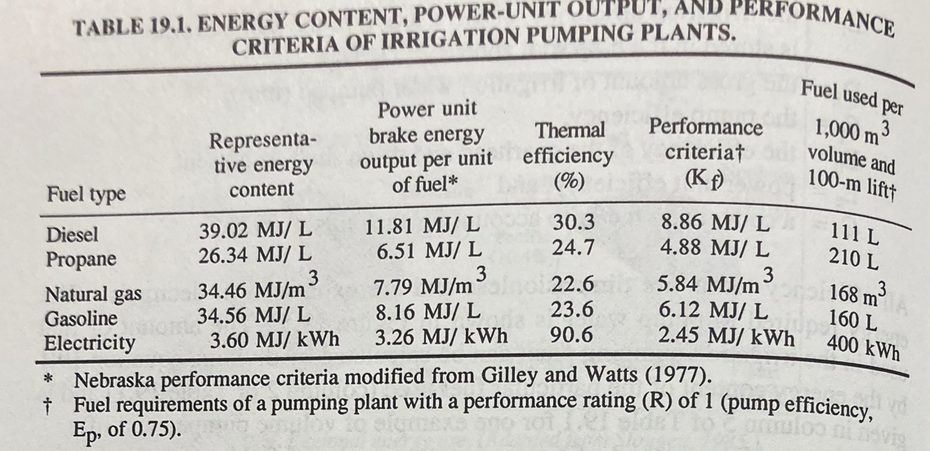

Since we know the amount of diesel being used, we can back-calculate the actual energy requirement. Don’t stress about the units here, it’s just for demonstration:

Energy output from diesel-based system (EO_dies) =

gallons of diesel used per hectare * 138,000 BTUs/gal diesel

Only 30.3% of that energy is actually being used to do work.

Energy required to do the work (ER) = EO_dies * 0.303

Once you have the energy required, you can see how much energy is output based on the user-entered fuel source. So if a producer is using an electric motor, for example, the energy output from that system would be:

ER = Energy output from an electric-based system (EO_elect) * 0.906

Converting from fuel used to CO2 emissions should have two components: the CO2 released from the actual burning of the fuel, and the CO2 released during the manufacturing of the fuel. The following reference includes the amount released from combustion (which I confirmed in the Alfalfa notes R project – the 10.21 kg CO2 is literally just the amount of carbon contained in a gallon of diesel).

https://www.epa.gov/climateleadership/ghg-emission-factors-hub

I don’t know where to get information on the GHG associated with the manufacture of fuels. Probably GREET?

# Fuel manufacturing

From a paper, it said ethanol’s carbon intensity is 50 gco2e per MJ ethanol. Conversions (45 MJ/kg ethanol) comes out to 6.6 kg co2e/gal. The paper says this is 40% lower than other fuels. So let’s say 10 kg co2e/gal. This is roughly equivalent to the amount released upon combustion.

# Pesticide manufacture

Look at that Audsley paper.

They say:

214 MJ/kg ai for insecticides

168 for fungicides

454 for preglone + glyphosate

264 for not preglone + glyphosate

Tulare applied 2 pints per acre of Roundup PowerMaxx which has 5.88 lbs glyphosate per gallon.

2 pints is 0.25 gallons, so that is 1.47 lbs of glyphosate per acre, or 1.65 kg/ha.

To get the maximum, let’s say it is 454 * 1.65 = 750 MJ/ha.

Now it depends where the energy to create this chemical comes from. If it comes from a coal-fired power plant then 1MWh releases 850 kg co2e. 1 MJ is 0.0002777 MWh. This could mean 177 kg co2e/ha per Roundup application?

# Fertilizer manufacture

**~200 kg CO2e/ha**

From the FTM Table 2 (which I’m unsure how it was created, seems to be loosely taken from the Greet ag-chemicals info. Not sure how they converted BTUs to CO2e).

For MAP, they list 6,521 BTUs/lb product. In Tulare they applied 200 lbs per ac, so 1,304,200 btus/ac, or roughly 20 gallons of diesel used per hectare. FTM says ther are 22.7 lbs of co2 eq in a gal of diesel (again, only combustion?), so ~200 kg co2e/ha.

# Seed production

# Irrigation energy

The NRCS energy estimator tool (<https://ipat.sc.egov.usda.gov/Default.aspx>) gives gallons of diesel (or whatever fuel you choose), but uses state-wide estimates for the depth of well and amount of water applied. Those can be overwritten, we just need good data to support those over-writings. For this exercise I put in a zipcode in Tulare County, and it estimated a 200+ foot depth well and 50 ac-in of water application for alfalfa. Assuming flood irrigation, this produced an estimate of 67 gallons of diesel used per acre. Using FTM’s conversions, this equated to 1,700 kg co2e per hectare. I made a github repo comparing the FTM estimates to the NRCS estimates. FTM estimates are much, much lower but I think they have a units problem.

# Nitrous oxide emissions

Using IPCC dry-area estimates, the range in CO2eq from N2O emissions avoided per kg N applied is 0-0.005 Mg CO2eq/kgN. The kg N is supposed to include the N applied as fertilizer, the N contained in above ground biomass left in the field, and the N contained in below-ground biomass.

The Tulare example applied 200 lbs of 11-52-0, meaning there was 22 pounds of N applied per acre, roughly 22 kg/ha. This equates to 110 kg co2e/ha from the fertilizer.

A paper from Serbia estimated there was 150 kg root N per ha in an alfalfa field (Vasileva et al. 2015). Not the best source, but fine for estimating. It seems a bit high? They say there is 3 Mg of root material, which would mean the roots are 5% nitrogen.

Another method, if you are adding 500 kg of co2 (see carbon sequestered), that is 130 kg of C. If soil has a C:N ratio of 10, that would mean you are adding 13 kg of N per year to the soil. So root N could be anywhere from 10 to 100 kg N per ha per year. So anywhere from 50-500 kg co2e/ha.

# Avoided emissions

IPCC has direct and indirect emissions. Additionally, you could account for the reduced fertilizer manufacturing emissions.

Direct

Using IPCC dry-area estimates, the range in CO2eq from N2O emissions avoided per kg N applied is 0-0.005 Mg CO2eq/kgN avoided.

Indirect

Need to investigate. Not sure how big of a problem nitrate leaching is in dry areas?

Manufacturing

See fertilizer manufacture for details on that component. Assuming the farmer uses the most GHG-intensive N source of ammonium nitrate, for every kg N avoided they would get a credit of 0.007 Mg CO2eq/kgN.

Best case scenario: 0.012 Mg CO2eq avoided per kg N not applied. About 10 kg.

# Carbon sequestered

Using the ‘Healthy Soils’ estimates in Tulare county for adding a perennial crop to a basic rotation, they estimate 26 metric tons (Mg?) of co2e will be sequestered per 100 acres of implementation.

26000 kg co2 per 100 acres = 260 kg co2 per acre is roughly 500 kg co2e per ha per year.