Multiple criteria evaluation of fall vegetation highlights tradeoffs in cover crop, tillage and residue management systems

Virginia A. Nichols¹ Marco Gentili¹ Emma Randahl-Beltran¹ Mette Sønderskov¹, Simon Riley¹, Bo Melander¹

¹Department of Agroecology, Aarhus University, 1 Forsøgsvej, 4200 Slagelse, Denmark

Correspondence
Virginia A. Nichols
Email: gina.nichols@agro.au.dk
Marco…
Emma Randahl-Beltran, esrb@agro.au.dk
Mette
Bo Melander
Email: bo.melander@agro.au.dk

Funding information
[This research was funded by the European Union’s Horizon 2020 research and innovation program under grant agreement No. 727321 (project acronym, IWMPRAISE); we thank the funding body for its financial support. ]

Word count = 7000 maximum (including all tables, legends and references)
Abstract (250 words max)
In certain contexts, non-crop vegetation in agricultural fields may offer opportunities to support positive environmental outcomes without compromising productivity. Over three growing seasons in Denmark, we evaluated the ecological, environmental and agronomic performance of fall vegetation communities in a spring barley (Hordeum vulgare)–oat (Avena sativa)–faba bean (Vicia faba) sequence grown under thirty management systems. Five cover crop systems—grass/clover (Lolium perenne/Trifolium repens) mixtures sown early (MixE) and mid-season (MixM), radish (Raphanus sativus) sown mid-season (RadM) and post-harvest (RadL), and a no-cover control (NoCC)—were implemented in a long-term trial with three tillage systems (no-till, surface, inversion) and two straw managements (retained, removed). Measured responses included cash crop yield, fall biomass and species cover, spring weed counts, and pesticide use; ecological values and pesticide impacts were estimated using published indices. The study coincided with extreme weather years. Fall soil cover remained stable (~75%) across treatments and years, while fall biomass varied. Radish cover crops consistently increased fall biomass relative to NoCC, whereas mixtures did not. Ecological value was highest in radish systems. RadM contributed >50% of total fall biomass, while other communities were dominated by crop volunteers. RadM systems exhibited the highest yields, fall biomass, and ecological value without increasing perennial weeds or pesticide use compared to NoCC. In contrast, MixE reduced pesticide use but produced low and variable biomass and low-value plant communities, and without tillage exhibited high perennial weed legacies. Overall, radish cover crops provided more consistent benefits than grass/clover mixtures or NoCC but did not reduce pesticide toxicity.

1 INTRODUCTION
Environmental pressures resulting from population growth and climate change have led to a significant decline in global biodiversity (Ceballos et al., 2017; Dirzo et al., 2014). Given that >40% of habitable land is used for agriculture (Ritchie & Roser, 2019), agricultural management plays a crucial role in shaping biodiversity levels (Burns et al., 2016; Gaba et al., 2020; Petit et al., 2011). Consequently, there is a growing need for agricultural systems that integrate ecosystem health and biodiversity conservation with commercial production objectives (Henle et al., 2008; Labeyrie et al., 2021). In response, researchers are increasingly assessing non-crop plant communities (e.g., weeds) and their attendant management strategies for their potential ecological and environmental implications in tandem with agronomic impacts (Esposito et al., 2023; Petit et al., 2015; Storkey & Westbury, 2007; Yvoz et al., 2020).
As a corollary, identifying spatial and temporal niches where the potential negative impacts of non-crop vegetation on production are minimized is a promising line of research (Bensch et al., 2025; Blaix et al., 2018; Schatke et al., 2024). Fallow periods between cash crops may offer such an opportunity. In temperate agricultural systems that utilize tillage and/or herbicides, several studies have found that fall vegetation between cash crops has a minimal impact on subsequent spring crops due to the strong filters exerted by spring tillage and/or spring herbicide application (Adeux et al., 2021, 2023; Leskovšek et al., 2025; Rouge et al., 2023). It follows that fall vegetation may present a unique opportunity for optimization, allowing the expression of ecologically beneficial communities that also provide ecosystem services without increasing the probability of future agronomic harm (Esposito et al., 2023). In this context, fall plant communities have the potential to offer a range of ecological supports and ecosystem services: the communities may serve as important promotors of plant diversity conservation (Fanfarillo & Kasperski, 2021), provide food sources for a high diversity of organisms (Balfour & Ratnieks, 2022; Marshall et al., 2003), reduce fall nitrate leaching (Miranda-Vélez et al., 2026; Sullivan et al., 2017), contribute to soil organic carbon (Jian et al., 2020), and mitigate soil erosion (Moreau et al., 2020). While direct measurements of benefits are the most reliable, such measurements are not always available nor feasible. Accordingly, several methodologies for estimating the potential values and/or services as well as potential harms of non-crop vegetation have been proposed (Gentili et al. (in review)). Each approach has different data requirements and produces outcomes that vary in scope, scale, and applicability. This lack of a universally accepted methodology precludes comparisons between studies, but within the context of a single study if the goals and assumptions of the estimating procedure are clearly articulated, estimating potential services and disservices of vegetation communities can provide valuable insight (Bensch et al., 2025; Yvoz et al., 2020).
Pesticides are key contributors in shaping non-crop vegetation communities, and the need for their use varies in different cropping systems. Given the well-documented externalities of pesticide use (Rani et al., 2021; Sharma et al., 2019; Wan et al., 2025), accounting for both the benefits and harms of pesticide use can contribute to a more comprehensive evaluation of cropping systems. While site-specific estimates of risks resulting from pesticide use are possible, they require detailed data and specialized knowledge that may not be available (CITE Rainford). Indices or characterization factors based on the potential impacts such as the Pesticide Load Indicators (Kudsk et al., 2018; Vandevoorde et al., 2025) or the USEtox database (Westh et al., 2015) can provide reliable and scientifically based estimates based only on active ingredients and application rates (Lewis et al., 2021).
When considering fall vegetation, the interactions between cover crops, tillage and residue management are complex. While previous studies have looked at these interactions’ impacts on non-crop vegetation, it is most often within the framework of reducing the presence of weeds and their disservices (e.g.,(Shrestha et al., 2002; Swanton et al., 1999; Weber et al., 2017)). It is therefore unclear how these factors might be combined to optimize the potential services that could be provided by fall plant communities between cash crops.
To better understand the tradeoffs and potential for optimizing fall non-crop vegetation services, we utilized a long-term (>20 years) study platform with six combinations of tillage and residue managements(Gómez-Muñoz et al., 2021). We applied four cover cropping systems plus a no-cover control to this platform (for a total of 30 cropping system treatments). These treatments were applied to a three-year sequence of crops. The goal of the study was to examine how addition of cover crops to different tillage/residue cropping systems impacted:
- Cash crop yields
- Soil protection (e.g., coverage)
- Potential to reduce nitrate leaching (e.g., biomass)
- Potential plant community ecological value (e.g., pollinator and food web support)
- Potential to cause future agronomic harm (e.g., perennial weed legacies)
- Potential pesticide toxicity loads to human health, ecosystems, environment
These outcomes were chosen to promote understanding of how cover cropping systems interact with tillage, residue removal, and weather in provision of various services and dis-services. We hypothesized there would be tradeoffs between outcomes, with no single system offering the best performance in all desired areas, but that clear accounting using multicriteria evaluation methods would aid in identifying systems that optimize outcomes.
We chose not to include the costs associated with cover crop implementation and labor requirements due to the complexity and highly contextual nature of such estimates. For example, in Denmark, cover crop implementations may be mandatory depending on a given farm’s crop compositions and nutrient balance (Dalgaard et al., 2014), or may be required for receipt of subsidies that also vary by farm (Kathage et al., 2022), rendering the complexity of the actual cost calculations beyond the scope of this study. We also focused on short-term outcomes, as longer term changes in outcomes such as soil carbon accrual, changes in soil nitrogen status, and greenhouse gas emissions are difficult to evaluate robustly over a period of three years (Cusser et al., 2020; Smith, 2004).

2 MATERIALS AND METHODS

2.1 Field site
This study was conducted within a larger long-term crop rotation/tillage experiment which was established in 2002 on a sandy loam at Flakkebjerg Research Centre, Denmark (latitude 55.317, longitude 11.400). The 30-year average air temperature and precipitation for this site are 8.9 degrees Celsius and 589 mm, respectively. Averaged across the trial site, soil texture in the top 25 cm layer is 15% clay (<2 mm), 14% silt (2-20 mm), 43% fine sand (20-200 mm), and 28% coarse sand (200-2000 mm), with 1.2% organic carbon content (0-25 cm)(Scherner et al., 2016). The overall experimental design of the long-term experiment is a split-split plot with four replications. The main plot factor is cropping system (four levels), the subplot is primary tillage system (four levels). Sub-subplots (six levels) were established to accommodate various sub-treatments within rotation and tillage combinations [see for example (Melander et al., 2008)].
2.1.1 Study design
For the purpose of the present study, two main plot treatments were selected that had the same sequence of crops. The cash crop sequence during the present study was spring barley (Hordeum vulgare L. v. Evergreen) sown 19 April 2018 (300 plants m⁻²), spring oat (Avena sativa L. v. Poseidon) sown 4 April 2019 (300 plants m⁻²) and faba beans (Vicia faba L. v. Boxer) sown 15 April 2020 (50 plants m⁻²). The two main plot treatments differed in management of the small grain straw, reflecting two common systems in Denmark: straw removed or retained. Therefore, in the present study, straw management composed the main-plot treatment. Three of the four tillage regimes were used for this study because they have been under consistent management for the longest period of time (more details below). Tillage subplots were 5 meters wide and 40 m long. Each tillage subplot was divided into two columns with three sub-subplots arranged within each column for a total of six sub-subplots that were 2.5 m wide and 12.5 m long (see supplementary material for a visual aid). One of the six sub-subplots was reserved for other sampling efforts, and a cover crop system treatment (five levels) was applied randomly to the remaining five sub-subplots. In summary, this experiment included all combinations of two straw-managements, three primary tillage systems, and five cover crop systems for a total of 30 treatments replicated in four blocks.
2.1.2 Straw and tillage treatments
The same straw managements and categorical tillage system treatments (no tillage, surface tine cultivation, inversion) have been in the same subplots since 2002. In the straw-removal treatments, following harvest of a small grain the residue (e.g., straw) was removed using a two-pass system wherein the straw was removed from the plots using a weed harrow. , This resulted in removal of approximately 60% of the biomass (Hansen et al., 2015). In the straw-retained treatments, following harvest of the grain the residue was allowed to remain in the field. The exact machinery and timing of operations for each categorical tillage treatment have varied since 2002 (Scherner et al., 2016; Hansen et al., 2010). In the present experiment (2018-2020), plots under the inversion tillage treatment were moldboard plowed to a depth of 20 cm in the late fall and seedbed harrowed to 3-4 cm depth in the spring before cash crop planting; all crops were then sown with a traditional seed drill (Nordsten Lift-o-matic CLH300) with row spacings of 12.5 cm. For the surface tillage system (non-inversion), a Horsch Terrano 3 FX stubble tine cultivator was used to till to a depth 8-10 cm in the spring before cash crop planting, and harrowed to a depth of 3-4 cm before planting the fodder radish cover crop after harvest (see Table 1). In both the no-till and surface tillage systems, crops were sown with a chisel coulter (Horsch Airseeder CO 3) with row spacings of 17.5 cm for all crops. Row spacings were different for the inversion tillage system due to differences in the equipment representing typical production environments for each tillage system.
2.1.3 Cover crop treatments
Starting in the spring of the 2018 growing season, five cover crop systems were randomly applied to the sub-subplots (Table 1). The same sub-subplot treatments were maintained for 2018, 2019 and were tracked until faba bean harvest in 2020. The sampling area for all measurements was located in the inner 1.5 m x 10 m area of the sub-subplots.

Table 1. Summary of the five cover crop systems
Cover crop system abbreviation | Cover crop | Seeding rate | Seeding method and timing
MixE | Perennial ryegrass (grass; Lolium perenne) and red clover (clover; Trifolium pratense) | 3 kg ha⁻¹ grass + 8 kg ha⁻¹ clover | Sown 1 cm deep in between cash crop rows (12.5 cm or 17.5 cm, see section 2.1.2) shortly after cash crop planting
MixM |  | 3 kg ha⁻¹ grass + 8 kg ha⁻¹ clover | Broadcast into standing crop approximately 14 days before expected cash crop harvest
RadM | Fodder radish (Raphanus sativus) | 14 kg ha⁻¹ | Broadcast into standing crop approx. 14 days before expected crop harvest
RadL | Fodder radish (Raphanus sativus) | 14 kg ha⁻¹ | Broadcast into the crop stubble post crop harvest
NoCC | None | - | -

2.1.4 Fertilizer and herbicides
Mineral fertilizer was broadcast on spring barley plots on 17 April 2018 (126 kg N ha⁻¹, 24 kg P ha⁻¹ and 60 kg K ha⁻¹); on spring oat plots on 3 April 2019 (80 kg N ha⁻¹, 15 kg P ha⁻¹ and 38 kg K ha⁻¹ ); and on faba beans on 15 April 2020 (32 kg P ha⁻¹ and 80 kg K ha⁻¹).
Herbicide treatments reflected best practices and constraints imposed by both the tillage and cover crop system treatments (Table 2).

Table 2. Summary of trial’s herbicide applications; each herbicide package (HP) is described in detail in supplemental material
Year | Date of application | Cover crop treatment |  |  | Herbicide package
Year | Date of application | No-till | Surface | Inversion | Herbicide package
2018 (spring barley, sown 19 April) | Before cash crop planting (xx) | All | All | - | HP1
2018 (spring barley, sown 19 April) | After emergence (16 May) | MixE | MixE | MixE | HP3
2018 (spring barley, sown 19 April) | After emergence (16 May) | NoCC, MixM, RadM, RadL | NoCC, MixM, RadM, RadL | NoCC, MixM, RadM, RadL | HP4
2018 (spring barley, sown 19 April) | In-season (29 May) | NoCC, MixM, RadM, RadL | NoCC, MixM, RadM, RadL | NoCC, MixM, RadM, RadL | HP5
2019  (spring oat, sown 4 April) | Before cash crop planting (xx) | All | All | - | HP1
2019  (spring oat, sown 4 April) | After emergence (14 May) | MixE | MixE | MixE | HP3
2019  (spring oat, sown 4 April) | After emergence (14 May) | NoCC, MixM, RadM, RadL | NoCC, MixM, RadM, RadL | NoCC, MixM, RadM, RadL | HP6
2020  (faba bean, sown 15 April) | Before cash crop planting (xx) | All | All | - | HP2
2020  (faba bean, sown 15 April) | After emergence (6 May) | All | All | All | HP7
2020  (faba bean, sown 15 April) | In-season (20 May) | All | All | All | HP7
2020  (faba bean, sown 15 April) | In-season (2 June) | All | All | All | HP8

In the no-till and surface tillage treatments, all plots were sprayed with HP1 (2018, 2019) or HP2 (2020) before cash crop planting. For the inversion tillage treatments, no herbicide was sprayed before cash crop planting. In 2018 (spring barley), to accommodate the presence of the grass and clover present in the Mix-early plots, those plots were sprayed on 16 May 2018 with an herbicide package that does not affect clover or grasses (HP3); all other plots were sprayed the same day with a different herbicide package (HP4). On 29 May 2018, all plots except the Mix-early plots were sprayed (HP5) to control Canada thistle (Cirsium arvense (L.) Scop.); Mix-early plots were not sprayed because HP5 would have terminated the cover crop. In 2019 (spring oat), on 14 May the Mix-early plots were again sprayed with the same herbicide package used in 2018 (HP3) while all other plots were sprayed with a different ‘stronger’ package (HP6) to control more weeds, based on early spring surveys.
Following faba bean planting in 2020, all plots were sprayed with HP7 on 6 May 2020 and again on 20 May 2020. On 2 June 2020, all plots were sprayed (HP8) to control wild oat (Avena fatua L.). All plots were managed identically for diseases and insect pests according to Danish standard recommendations and policies. Herbicide use data was translated into potential toxicity loads using the Danish Pesticide Load Indicator values [PLI; (Kudsk et al., 2018)].
The long-term experiment is rainfed, but in 2018 an exception was made due to an extremely hot and dry early growing season. In order to maintain the long-term viability of the experiment, all plots were irrigated with 25 mm in early June to ensure the establishment of all treatments. Irrigation was done with sprinklers mounted on a boom that was dragged through the experiment. This was also done on production fields in Denmark with access to irrigation structure.
Weather data for the present study was obtained from the Danish Meteorological Institute's (DMI) Open Data API for the Flakkebjerg station (55.322, 11.388). The 30-year (1990-2020) mean annual temperature and precipitation for the site are 8.9 degrees Celsius and 589 mm, respectively.

2.2 Measurements
2.2.1 Crop yields
Each sub-subplot (net size 10 m x 1.5 m) was harvested for grain yield with a plot combiner (spring barley: 8 August 2018, oat: 15 August 2019, faba bean: 24 August 2020 faba bean). Dry matter content was determined by a near-infrared spectroscopy analyzer [InfraTec™ 1241 Grain Analyzer, Foss A/S; (Büchmann et al., 2001)]). Grain yields are reported on a dry matter basis.
2.2.2 Fall vegetation
Three categories of vegetation measurements were taken (Table 3) and are described in detail below.
Table 3. Summary of all vegetation measurements
Measurement | Levels of measurement resolution
Fall ground cover (%) | Soil  Species (AVESA*, CAPBP, CIRAR, EPHEX, HORVW, LOLPE, MATIN, PAPRH, RAPSR, TAROF, TRFRE)  Genus (GERSS, LAMSS, SENSS, VERSS)
Fall biomass (g m-2) | Cover crop  Other (all other biomass)
Spring weed counts (number m⁻²) | CIRAR  EQUAR  Dicot  Monocot
*EPPO code, see supporting information for Latin names

Ground cover composition was estimated from digital images taken in the fall (9 November 2018 and 1 November 2019) as done in (Melander et al., 2013). Briefly, a 0.5 m² quadrat was placed in the plot, and an image was taken from a height of 1 m above the center of the quadrat. Three images were taken in each plot, meaning 10% of the sub-subplot area was sampled (1.5 m² per 15 m² plot). Each image was subsequently overlaid with a grid consisting of 17 vertical and 17 horizontal lines, resulting in 289 intersections per image (Supporting information). Each intersection was classified as a soil or plant. Plant intersections were further classified to the species (12) or genus (4) level (Table 2). Percent coverage of each type was then calculated by dividing the number of touched intersections in that category by 289 intersections. For categorical analyses of percent cover, each species/genus was classified as ‘cover crop’, ‘volunteer’ or ‘other.’ Species/genus coverages were assessed (not including soil as a coverage category) for evenness by dividing Shannon’s diversity index by the natural log of species richness (Pielou, 1966).
The amount of aboveground vegetative biomass in each treatment was measured shortly after image collection for fall ground cover measurements (15 November 2018 and 13 November 2019, respectively). Two 0.5 m2 quadrats were randomly placed in each plot, and all aboveground biomass was cut at ground level and removed. The biomass samples from the two quadrats were separated into three fractions: cover crops, volunteers, and other in 2018. In 2019, biomass was only separated into two fractions (cover crops and other, the latter of which included both weeds and volunteers). Therefore, the categories ‘cover crop’ and ‘other’ were used for all aboveground biomass statistics (Table 2). The biomass fractions were dried in the oven at 80ºC for 24 hours and weighed. Dry biomass for each category was converted to grams per m².
The flora emerging in spring in the experimental plots was assessed on 22 May 2019 and 27 May 2020 after post-emergence weed control but before weeds were visually affected by the herbicides. Four categories were counted in three randomly placed 0.25 m² quadrats per plot. The categories were dicots, monocots, Canada thistle (Cirsium arvense) and horsetail (Equisetum arvense), the latter two being problematic perennial weeds in Denmark (Salonen et al., 2008). The spring counts were made to record whether there were any traceable effects from previous year’s cover crop treatments, with the goal of assessing whether the previous fall vegetation resulted in detectable carry-over effects.
2.3 Quantification of ecological value
Potential ecological value was estimated using a methodology and database from Yvoz et al. 2021, including both pollinator value (the fall vegetation in the present study produced flowers, see photos in supplemental material) and ecological food web support including but not limited to natural enemies (in the form of green plant and/or seed). Details on this calculation are presented in supplementary material but are described here briefly. The first component, potential benefits to pollinators, was comprised of three sub-indices representing (1a) the absolute benefit to bees (LATIN), (1b) bumble bees (LATIN), and (1c) hoverflies (LATIN). The second, potential benefits to food webs, was comprised of three sub-indices representing (2a) absolute contributions to farmland birds, (2b) carabids, and (2c) parasitic wasps. Organ level attributes reported by Yvoz et al. 2021 for 155 plant species were used to assign sub-index values. Out of the 11 species in our study, six had exact matches in the Yvoz et al. database. For the other species and genus (Table 3), the mean value for all species within that genus reported in the database were used. The volunteer crops (barley, oats) did not have values in the database. Cereals are planted on 50% of Denmark’s agricultural land, totalling 1.3M hectares (Statistics Denmark, 2025). The cereal crop volunteers were therefore assigned ecological values of 0 based on an assumption of ‘additional value saturation’ (Bensch et al., 2025), which presumes that the additional value of these plants in the landscape is minimal given the prevalence of winter cereal fields in Denmark. For comparison, winter rapeseed (Brassica napus subsp. Napus) is planted on approximately 0.2M hectares (7% of agricultural land), so the fodder radish cover crop was assumed to contribute to additional ecological value on the landscape. The sensitivity of results to this assumption was tested by excluding the value of fodder radish in the calculations.
Each sub-index was reported in different units, so after each species/genus in the present study was assigned a value for each of the sub-indices, the sub-indices were scaled within the present study such that the maximum corresponded to a value of 1, and the minimum a value of 0. While this has the potential to exaggerate differences between values that are similar on an absolute scale, we observed at least one magnitude of variation in our dataset for each sub-index, suggesting the variation in sub-index values was meaningful (see supporting information). Sub-indices were summed to provide an estimated service value for each of the 16 species/genus observed in our study. These service values were weighted by the species/genus percent cover for each sample to calculate the fall vegetation community’s potential services (benefits to pollinators and contributions to organismal food webs).
2.4 Multi-criteria summaries
Each cropping system was evaluated using the following six metrics, utilizing proxies (in parentheses) when no direct measurement was possible:
- Cash crop yields
- Soil protection (percent soil cover)
- Potential to reduce nitrate leaching (fall biomass)
- Potential plant community ecological value (described above)
- Potential to cause future agronomic harm (perennial weed count in spring)
- Potential pesticide toxicity loads (human health, ecosystems, environment – PLI)
To summarise the performance of each system in our six metrics, we used multi-criteria decision making scaling processes assuming equal weights for each metric (Monat, 2009). First, mean values for each cropping system were extracted from statistical models in the performance metric’s original units. In all metrics, a value of zero had a physical interpretation, so we scaled the performances by dividing by the maximum performance value observed. This retained a meaningful zero interpretation and avoided exaggeration of small differences in absolute performances. The result was normalized values for all performances on a scale from 0 to 1.
In all metrics, a value of zero had a physical interpretation, so we scaled the performances by dividing by the maximum performance value observed, thus retaining a meaningful zero interpretation and avoiding exaggeration of small differences in absolute performances – this scaled all performances in each metric to a scale from 0 to 1. When performance metrics represented a situation wherein a higher value is less desirable (e.g., perennial weed counts), the performances were flipped by taking a value of one and subtracting the performance, creating a mirrored scale such that a value of one always represents the most desirable situation. The total relative value of each system was calculated by assuming equal weights for all metrics, summing the scaled performances together and dividing by six (the maximum performance possible).
2.4 Statistics
All statistics and figures were done using R version 4.3.3 (R Core Team, 2024) relying heavily on the tidyverse meta package (Wickham et al., 2019), and additional packages for data wrangling and visualization (Silge & Robinson, 2016; Wickham et al., 2025; Wickham & Bryan, 2023). Univariate statistical models were built using lme4 (Bates et al., 2015) and glmmTMB (Brooks et al., 2017), and the best fit was chosen based on inspection of residual plots and AIC criteria (Bozdogan, 1987). The best fitting model was summarised using emmeans (Lenth, 2024). Multivariate models were built and analysed using vegan (Oksanen et al., 2024). Specific analyses are described in detail in supporting information, and all R code is available as part of the Github repository for this publication (available upon acceptance of the publication).

3 RESULTS
3.1 Weather and crop yields
The three years of production covered extreme conditions compared to 30-year averages; 2018 was the driest year of the past 30 years, and 2020 was the warmest. All production years started the season with more precipitation than average, but both 2018 (spring barley) and 2020 (faba bean) moved into drought conditions as the season progressed.

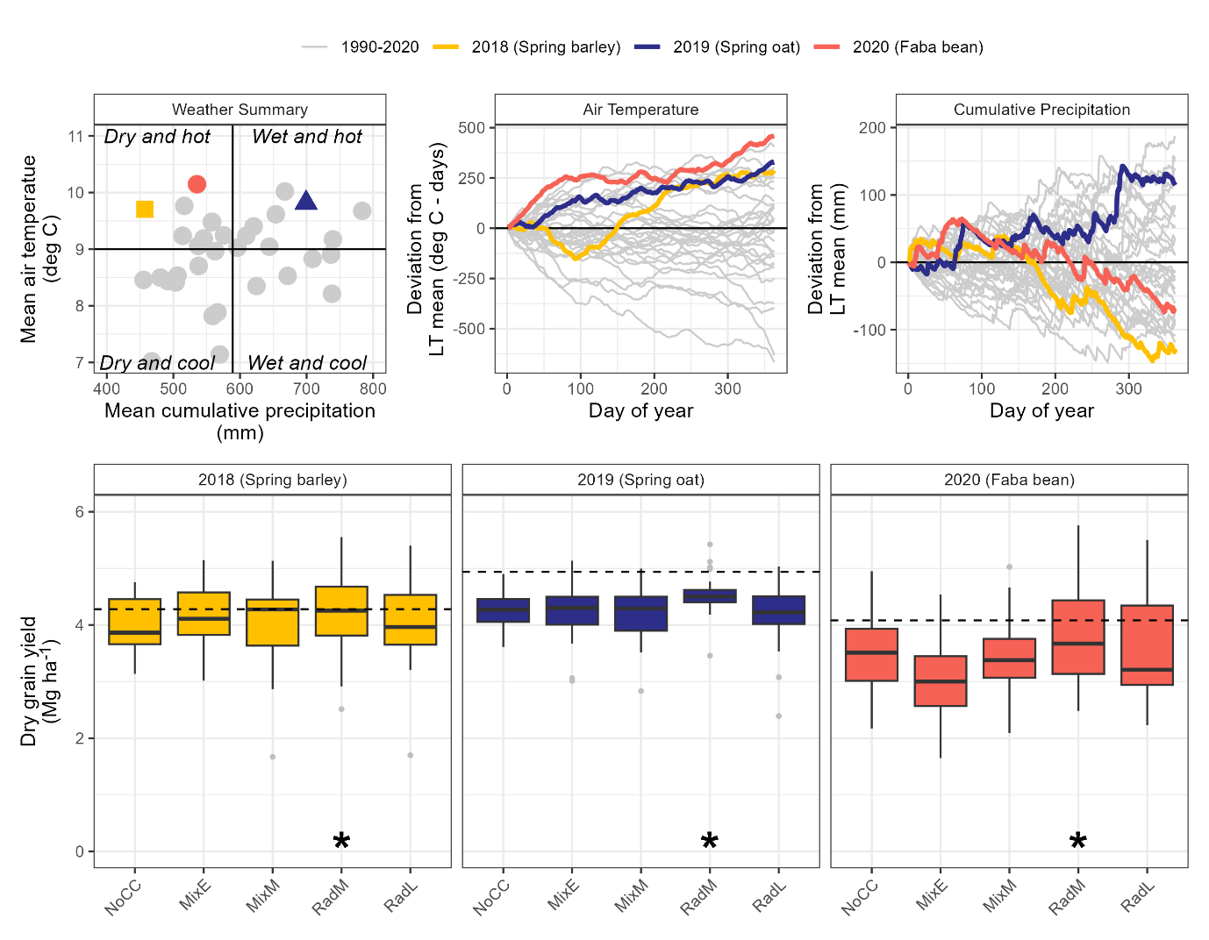

Figure 1. (Top) Weather summaries comparing study years to 30-year averages [long-term (LT) means]. (Bottom) Study yields were comparable to mean yields observed in Denmark for each year (horizontal dashed lines) and were significantly impacted only by cover crop treatment, with the mid-season planted radish (RadM) treatment producing significantly higher yields (asterisk) compared to the other cover crop treatments.

Yields varied significantly by crop (p<0.001) and by cover crop treatment (p<0.001), but did not vary significantly by any other factors or their interactions. In 2018 spring barley yields averaged 4.07 Mg ha⁻¹, in 2019 spring oat yields averaged 4.28 Mg ha⁻¹, and in 2020 faba bean yields averaged 3.47 Mg ha⁻¹. On average, the RadM cover crop treatment exhibited 8% higher crop yields compared to all other cover crop treatments (p<0.001); the other cover crop treatments did not vary significantly from each other at a p=0.05 significance threshold (adjusted for multiple comparisons using the Tukey method).
3.2 Fall vegetation
3.2.1 Biomass
The full statistical model predicting fall biomass showed complex interactions, but year explained the largest magnitude of variation (p<0.001). In 2018, average fall biomass production was 2.27 Mg ha⁻¹, while in 2019 the average fall biomass production was less than half of the 2018 value (0.99 Mg ha⁻¹; Figure 2). Residue treatment had a small but significant (p<0.001) main effect without significant interactions, with residue removal reducing fall biomass by 0.2 Mg ha⁻¹ (SE:0.05). The effects of tillage and cover crop were amplified in 2018 compared to 2019, resulting in significant year interactions. On average, increasing tillage intensity significantly decreased fall biomass by 27% and 9% when moving from no-till to surface tillage, and surface to inversion respectively. Tillage effects on biomass were strongest in the RadM and RadL (p=0.048) compared to other treatments, and this pattern was consistent across years. Growing degree days accumulated from cover crop planting to biomass sampling were not related to fall biomass values (Figure 2).

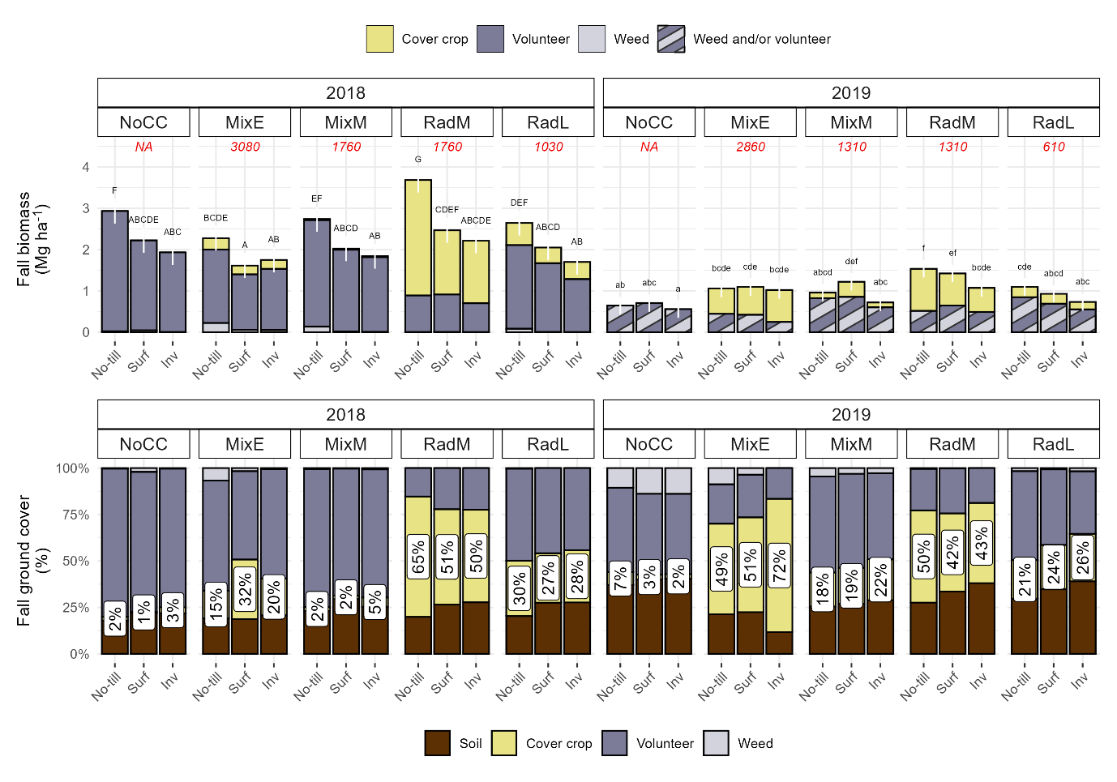

Figure 2 (Top) Fall biomass was not related to growing degree days (GDDs, italic number in red) and exhibited complex treatment interactions (different letters within a year indicate significant differences). (Bottom) Fall ground cover consisted mainly of cash crop volunteers, with cover crop coverage ranging from 1-72% (white labels).

3.2.2 Cover
The percentage of the soil covered by vegetation varied significantly by year (p=0.03) with a mean of 77% (SE:2%) soil coverage in 2018 and 70% (SE:3%) in 2019 (Figure 2). Overall, soil coverage by cover crops averaged 15%, but this varied significantly by cover crop treatment (p<0.001). Tillage, residue, nor their interactions had significant impacts on how the categories (cover crop, other) contributed to coverage. The impact of cover crop treatment on cover crop coverage depended on the year, an effect driven by MixE: in 2018 the MixE cover crops contributed an average of 21% (SE:5%) coverage, while in 2019 they contributed an average of 58% (SE:6%; Figure 2). In the other cover crop treatments, the contributions of the cover crop to coverage did not vary significantly by year, with RadM having the highest cover crop coverage (50%, SE:4%), followed by RadL (25%, SE:4%), MixM (7%, SE:3%) and NoCC (<1%, SE:3%). Cover crop coverage and volunteer/weed coverage was inversely correlated (ρ = -0.88).

3.2.3 Fall vegetation community
Communities were most strongly dictated by year of measurement due to the crop volunteer species varying by year. Model fit, convergence and interpretability were improved when models were fit to years individually, so results are reported for those models (Figure 3). Within a year, cover crop treatment explained 65-70% of the variance and had a significant effect on community structure (p<0.001), with tillage and straw removal treatments explaining less than 1% of the total variance each, respectively. The two cover crop mixture treatments (MixE and MixM) had communities distinct from the two radish treatments (RadM and RadL), with the NoCC communities being more similar to the mixture treatments in both years (Figure 3).
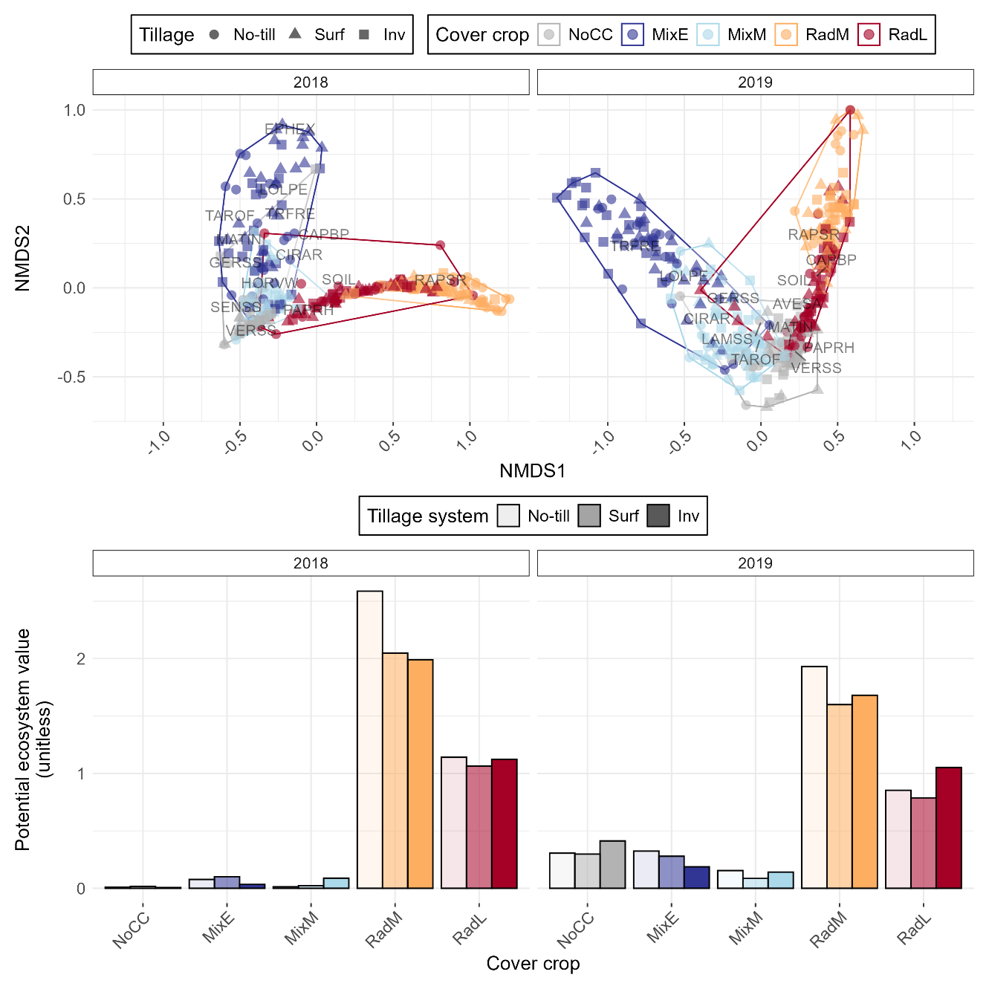

Figure 3 (Top) Cover crop system had the largest impact on fall vegetation communities, with a minor impact of tillage system and straw removal. (Bottom) Radish cover crop systems (RadM, RadL) had the highest potential ecosystem value, with the mixes (MixE, MixM) and NoCC systems having similarly low ecosystem value, due to a high percent coverage of low value crop volunteers in the community (see Figure 2).

Year and cover crop treatment had significant impacts on the number of species observed in a community (p<0.001). The number of species observed ranged from one to eight, with a mode of two in 2018 and three in 2019. The MixE community had 1.4 (SE:0.2, p=0.02) and 1.5 (SE:0.2, p<0.001) times more species compared to the RadL and RadM communities, respectively, but the number of species in all other cover crop treatment comparisons were not significantly different. The evenness of the communities ranged from 0.09 to 1, and there was an amplifying interaction between cover crop treatment and year (p<0.001). Evenness was generally higher in the radish cover crop treatments, followed by the early-planted mix, followed by the mid-planted mix and no cover treatments; this pattern was true regardless of tillage system, straw management, and year (supporting information).
Radish species were estimated to have the highest ecological value while spring barley and spring oat volunteers had no value (supporting information), resulting in treatments with high percent RAPSR coverage exhibiting the highest potential ecosystem value (Figure 3). While the mixes’ communities contained species with high ecological value (e.g., TAROF, LAMSS) that were absent in the radish systems, these high-value species had small contributions to the percent coverage, and therefore did not result in high estimated ecosystem support potential. The value of the radish systems was driven by the RAPSR value – when this value was set to zero, those communities had very low ecological value (see supplemental material).
3.3 Spring weed counts
Total spring weed counts ranged from 9-533 plants m⁻², with a median of 99 plants m⁻². There were complex treatment interactions, with a significant three-way interaction between year, tillage, and cover crop (p<0.001) and a significant two-way interaction between year and residue (p<0.001). Within the no-till system, MixE had significantly more weeds compared to all other treatments (p<0.001), while in all other tillage systems there were no differences between cover crop treatments; this effect was significantly more pronounced in 2019 (2.6-3.7 times more weeds) compared to 2020 (1.6-1.7 times more weeds), but the patterns were the same. On average there were twice as many weeds in 2019 (mean:163, SE:10) compared to 2020 (mean:76, SE:5). On average, the total number of weeds was highest in the inversion tillage systems (mean:174 plants m⁻², SE:14), followed by surface tillage systems (mean:109 plants m⁻², SE:9), with the no-till systems having the smallest number of total weeds (mean:55 plants m⁻², SE:5; Figure 4). This pattern was consistent in both years, but was magnified in 2019 (when there were more weeds). The largest observed differences in total spring weed counts were in the no-till system, with MixE having 1.5-1.7 times more weeds compared to the other cover crop treatments.

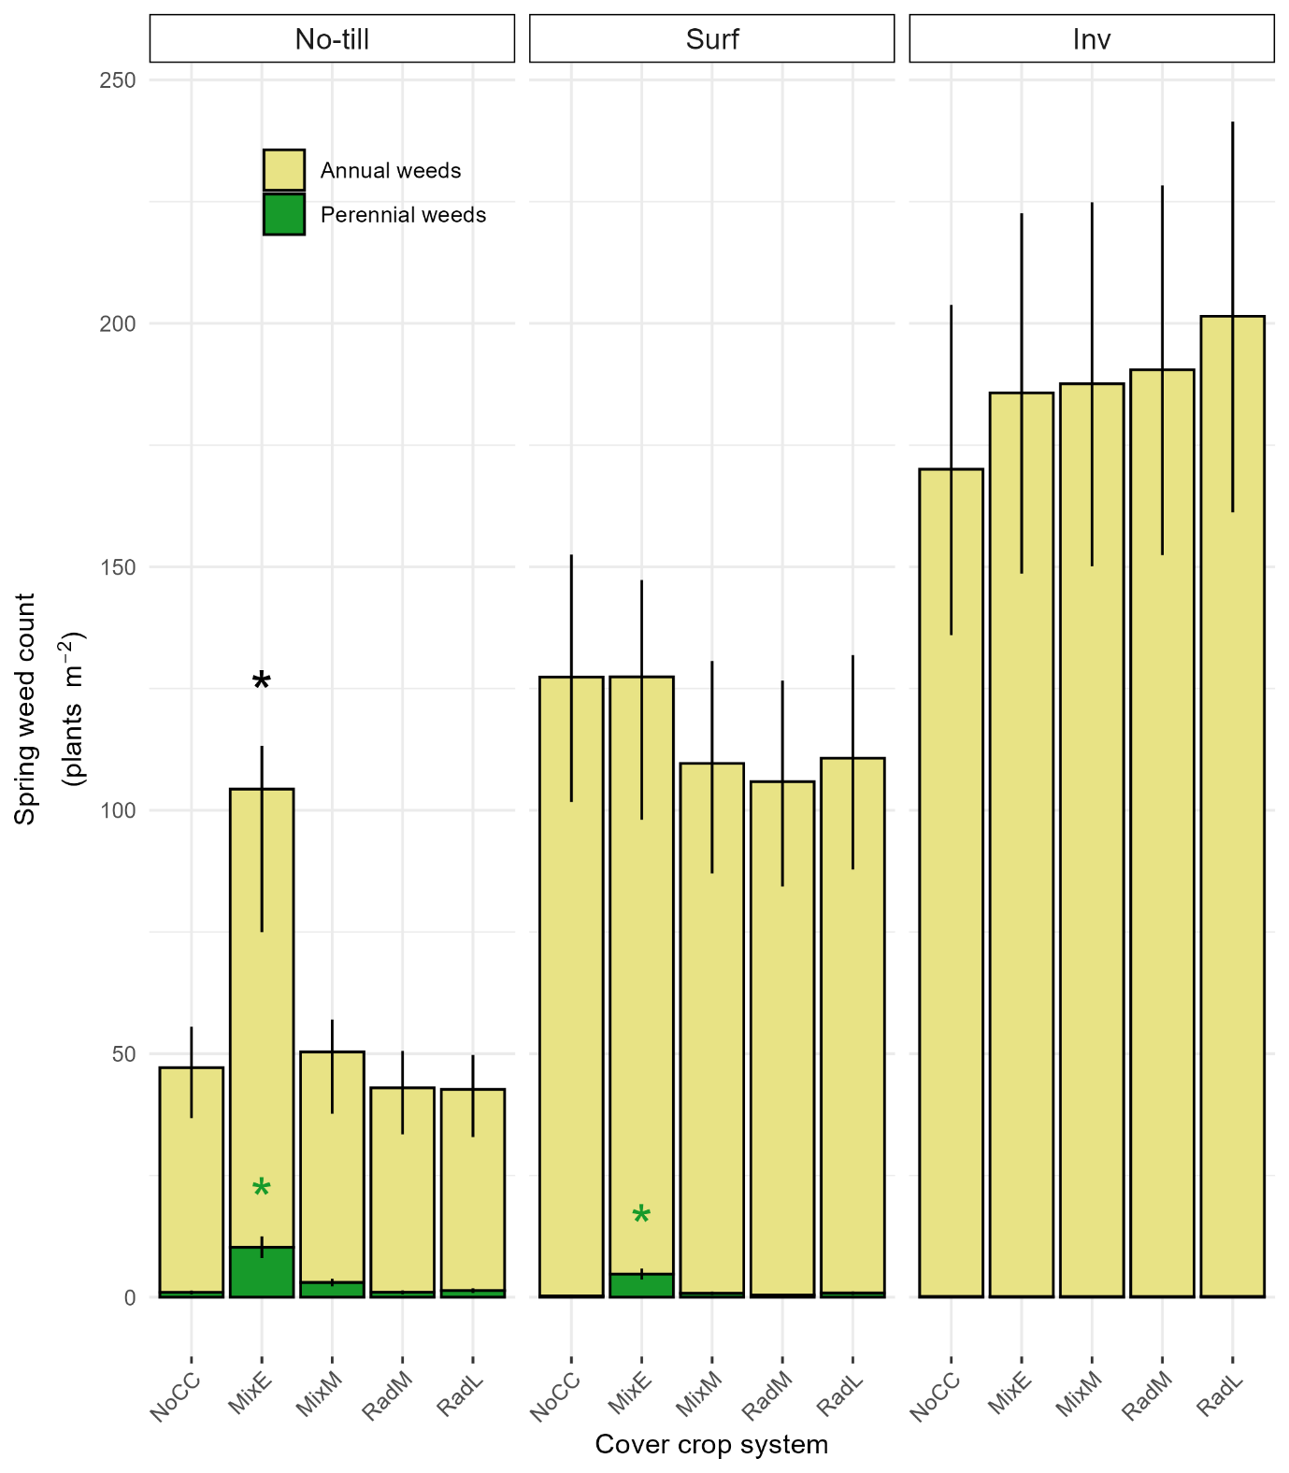
Figure 4. There were no differences in total or perennial weed counts within the inversion tillage treatment (Inv), but in the no-till and surface (Surf) tillage systems the early-planted mix had significantly higher perennial weed counts, reflecting its different herbicide program compared to other cover crop systems (Table 2).

Despite having less total weeds, both no-till and surface tillage had significantly increased numbers of perennial weeds compared to inversion tillage. The perennial weeds were mainly CIRAR (82%, versus 18% EQUAR). Averaged over no-till and surface tillage treatments, the number of perennial weeds in the MixE was 11 times higher (SE:6; p<0.001) compared to the the NoCC treatment, and 2.6-8.6 times higher than the other cover crop treatments; these effects were erased in the inversion tillage treatment. The MixM had a borderline significant increase in perennial weeds compared to the NoCC in the no-till system (p=0.05), but all other treatments were not significantly different from the NoCC. There was an inverse relationship between faba bean yields and perennial weeds, with more perennial weeds corresponding to lower faba bean yields (see supporting information).
3.3 Pesticide toxicity loads
Pesticide usage (and therefore pesticide toxicity loads) differed by year, tillage system, and cover crop system; straw retention had no impact on the system’s pesticide use. Inversion tillage had lower pesticide loads compared to no-till and surface tillage. In all systems and years, pesticide loads were lowest in the MixE treatments compared to the other cover crop treatments (supporting information).
3.4 Multi-criteria summary
The system with the highest overall value (assuming equal weighting for all metrics) was the mid-season planted radish (RadM) implemented in a no-till system with retained residue (Figure 5), while the system with the lowest overall value was the mid-season planted mixture (MixM) implemented in a no-till system with residue removal. Across tillage and residue management systems, the RadM was the best performing cover crop treatment, and the MixM the worst. The early-planted mixture (MixE) performed well in the inversion tillage system, but poorly in the other tillage systems. The impact of residue management on the total value was marginal in the inversion tillage system, but residue retention in the surface and no-till systems increased total value.
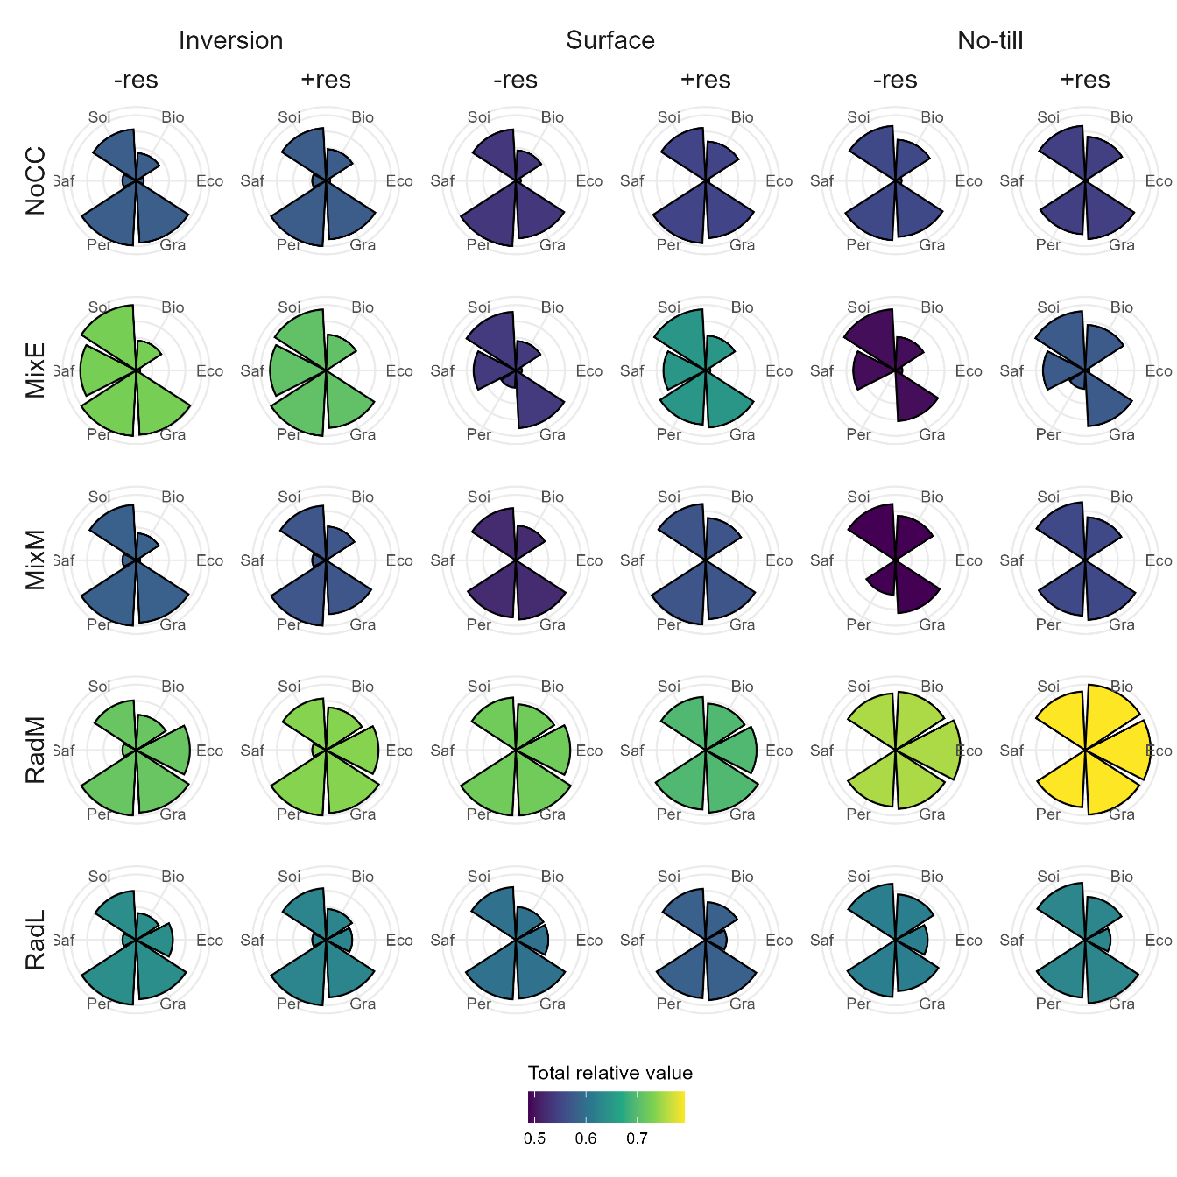

Figure 5. Summary of cropping systems’ performance in protecting soil (Soi), mitigation of fall nitrate leaching via fall biomass production (Bio), supporting ecosystems (Eco), grain production (Gra), perennial weed suppression (Per), and promoting human health and environmental safety (Saf); rows represent cover crop treatments, and columns represent tillage and small grain residue management systems.

4 DISCUSSION
4.1 Representativeness of results
The average grain yields in each year of the present study were lower than national averages for the same crops in the same years [4.28 Mg ha-1 spring barley, 4.94 oats, and 4.08 Mg ha-1 faba bean, respectively (FAO, 2023)], but the maximum grain yields observed each year exceeded the national averages, demonstrating the study results are reasonably representative of production environments. While the study was only in place for three cash crop cycles, the weather years represented a range of conditions that provide a reasonable amount of inference space (Figure 1) wherein our results are informative.
4.2 Interactions between management practices
Our results suggest radish cover crops, especially when planted mid-season, are a robust cover cropping system that performed well in the majority of performance metrics across tillage systems, straw managements, and weather years in a temperate oceanic climate (Peel et al., 2007). Other temperate areas in Europe have likewise found radish cover crop systems perform well in a variety of contexts (Elhakeem et al., 2023; Leskovšek et al., 2025). In Northern latitudes where available heat units reduce quickly following August cash crop harvests, species that establish and grow quickly such as radish likely provide more reliable performance compared to slower growing grass and clover species, which may only perform well under certain conditions (CITE).
While year had a strong impact on all outcomes in this study, it interacted with management practices by amplifying or dampening effects, rather than inducing cross-over interactions. A notable exception is performance of the early-planted cover crop mixture – in one year the resulting fall biomass contained very little contribution from the planted cover crop, while in another year it contributed over half of the total fall biomass (Figure 2). However, in both cases the absolute amount of cover crop biomass produced was still low.
The tillage system also amplified differences between cover crop treatments, but in general did not change cover crop systems’ biomass and coverage rankings, and had only minor impacts on fall communities compared to the cover crop treatment.
Of the management practices investigated, straw management (retention or removal) had the weakest impacts on the outcomes evaluated in this study. This could be due to the incomplete removal of straw using a two-pass system wherein the straw is removed after grain has been harvested, resulting in around 60% of the straw being removed (CITE). A layer of straw mulch is therefore present in both systems, and the impact of the layer thickness may only manifest under certain environmental conditions.
In our study the cover crop mixtures performed poorly in the majority of performance metrics employed. The presence of the cover crop mixture early in the season prevented the use of herbicides effective against Canadian thistle, and in reduced tillage systems this allowed the agronomically harmful perennial weed to establish, which impacted grain yields. The mixtures’ performance was not resilient against weather variation, and varied strongly between management systems. This adds to a growing body of research suggesting the use of cover crop mixes must be carefully and thoughtfully implemented, and the goals for the use of the mixes must be clearly articulated, as desirable outcomes are not guaranteed through diversity alone (Florence & McGuire, 2020; MacLaren et al., 2019; McKenzie-Gopsill et al., 2022; Smith et al., 2020).

4.3 Fall community compositions
In our study, fall vegetation was mainly comprised of cash crop volunteers, which effectively competed with weeds (Figure 2). Previous studies in Denmark have shown that although fall communities dominated by cash crop volunteers reduce nitrate leaching compared to fallow land, radish cover cropping systems consistently reduce nitrate leaching compared to systems relying on spontaneous vegetation such as crop volunteers and weeds due to higher biomass production (CITE). Our results show that in addition to supporting higher biomass production that effectively competes with other vegetation (Lawley et al., 2012), radish cover crops may also support fall vegetation communities with higher potential ecological value compared to vegetation resulting from both no-cover and cover crop mixtures. In our study, this was largely due to the radish cover crop replacing low-ecological value cash crop volunteers in the communities (Figure 3). While the other treatments supported more diverse fall communities, the communities were less even than the radish treatments; the contributions of species to soil cover was small compared to the cash crop volunteers, resulting in small contributions to the potential ecological value of the communities. Our research suggests that while policies currently support radish cover crops for reducing fall nitrate leaching, they may also be promoting vegetation that provides value to ecosystems more broadly. However, the methods available for calculating potential ecosystem value are generalized and do not reflect local landscape compositions and ecologies, and more robust methods are needed to truly evaluate this hypothesis. Additionally, the potential for radish cover crops to provide winter bridges for disease and insect pest propagation requires consideration.
4.4 Multiple criteria optimization
Through multicriteria analysis, we were able to highlight systems with good performance, while identifying areas for improvement. In this study we gave equal weight to each category – in reality these weights would differ according to farmer values and priorities, as well as policy and financial contexts. Utilizing different weightings to represent these different contexts could help identify systems best suited to certain farm ideotypes, or identify policy levers to promote certain outcomes. Datasets such as the one produced in the present study could also be combined to utilize machine learning techniques to design systems that optimize outcomes.

5 CONCLUSIONS
Will write after getting everyone’s edits…

ACKNOWLEDGEMENTS

The study formed part of the EU Project XXX led by XX of XX University. The authors acknowledge the contributions of Eugene Driessen, Karen XX, XXX who collected all data presented and whose field and laboratory expertise contributed significantly to this work.

CONFLICT OF INTEREST

Please state any conflicts of interest.

Supporting Information
REFERENCES
Adeux, G., Cordeau, S., Antichi, D., Carlesi, S., Mazzoncini, M., Munier-Jolain, N., & Bàrberi, P. (2021). Cover crops promote crop productivity but do not enhance weed management in tillage-based cropping systems. European Journal of Agronomy, 123, 126221. https://doi.org/10.1016/j.eja.2020.126221
Adeux, G., Rodriguez, A., Penato, C., Antichi, D., Carlesi, S., Sbrana, M., Bàrberi, P., & Cordeau, S. (2023). Long-term cover cropping in tillage-based systems filters weed community phenology: A seedbank analysis. Field Crops Research, 291, 108769. https://doi.org/10.1016/j.fcr.2022.108769
Balfour, N. J., & Ratnieks, F. L. W. (2022). The disproportionate value of ‘weeds’ to pollinators and biodiversity. Journal of Applied Ecology, 59(5), 1209–1218. https://doi.org/10.1111/1365-2664.14132
Bates, D., Mächler, M., Bolker, B., & Walker, S. (2015). Fitting Linear Mixed-Effects Models Using lme4. Journal of Statistical Software, 67(1), 1–48. https://doi.org/10.18637/jss.v067.i01
Bensch, J., de Mol, F., Gerowitt, B., & Zhang, H. (2025). Integrating Biodiversity Benefits of Weeds into the Economic Threshold Concept. Journal of Crop Health, 77(3), 96. https://doi.org/10.1007/s10343-025-01165-1
Blaix, C., Moonen, A. C., Dostatny, D. F., Izquierdo, J., Le Corff, J., Morrison, J., Von Redwitz, C., Schumacher, M., & Westerman, P. R. (2018). Quantification of regulating ecosystem services provided by weeds in annual cropping systems using a systematic map approach. Weed Research, 58(3), 151–164. https://doi.org/10.1111/wre.12303
Bozdogan, H. (1987). Model Selection and Akaike’s Information Criterion (AIC): The General Theory and its Analytical Extensions. Psychometrika, 52(3), 345–370. https://doi.org/10.1007/BF02294361
Brooks, M. E., Kristensen, K., Benthem, K. J. van, Magnusson, A., Berg, C. W., Nielsen, A., Skaug, H. J., Maechler, M., & Bolker, B. M. (2017). glmmTMB Balances Speed and Flexibility Among Packages for Zero-inflated Generalized Linear Mixed Modeling. The R Journal, 9(2), 378–400. https://doi.org/10.32614/RJ-2017-066
Büchmann, N. B., Josefsson, H., & Cowe, I. A. (2001). Performance of European Artificial Neural Network (ANN) Calibrations for Moisture and Protein in Cereals Using the Danish Near-Infrared Transmission (NIT) Network. Cereal Chemistry, 78(5), 572–577. https://doi.org/10.1094/CCHEM.2001.78.5.572
Burns, F., Eaton, M. A., Barlow, K. E., Beckmann, B. C., Brereton, T., Brooks, D. R., Brown, P. M. J., Fulaij, N. A., Gent, T., Henderson, I., Noble, D. G., Parsons, M., Powney, G. D., Roy, H. E., Stroh, P., Walker, K., Wilkinson, J. W., Wotton, S. R., & Gregory, R. D. (2016). Agricultural Management and Climatic Change Are the Major Drivers of Biodiversity Change in the UK. PLOS ONE, 11(3), e0151595. https://doi.org/10.1371/journal.pone.0151595
Ceballos, G., Ehrlich, P. R., & Dirzo, R. (2017). Biological annihilation via the ongoing sixth mass extinction signaled by vertebrate population losses and declines. Proceedings of the National Academy of Sciences, 114(30), E6089–E6096. https://doi.org/10.1073/pnas.1704949114
Cusser, S., Bahlai, C., Swinton, S. M., Robertson, G. P., & Haddad, N. M. (2020). Long-term research avoids spurious and misleading trends in sustainability attributes of no-till. Global Change Biology, 26(6), 3715–3725. https://doi.org/10.1111/gcb.15080
Dalgaard, T., Hansen, B., Hasler, B., Hertel, O., Hutchings, N. J., Jacobsen, B. H., Jensen, L. S., Kronvang, B., Olesen, J. E., Schjørring, J. K., Kristensen, I. S., Graversgaard, M., Termansen, M., & Vejre, H. (2014). Policies for agricultural nitrogen management—Trends, challenges and prospects for improved efficiency in Denmark. Environmental Research Letters, 9(11), 115002. https://doi.org/10.1088/1748-9326/9/11/115002
Dirzo, R., Young, H. S., Galetti, M., Ceballos, G., Isaac, N. J. B., & Collen, B. (2014). Defaunation in the Anthropocene. Science, 345(6195), 401–406. https://doi.org/10.1126/science.1251817
Elhakeem, A., Porre, R. J., Hoffland, E., Van Dam, J. C., Drost, S. M., & De Deyn, G. B. (2023). Radish-based cover crop mixtures mitigate leaching and increase availability of nitrogen to the cash crop. Field Crops Research, 292, 108803. https://doi.org/10.1016/j.fcr.2022.108803
Esposito, M., Westbrook, A. S., Maggio, A., Cirillo, V., & DiTommaso, A. (2023). Neutral weed communities: The intersection between crop productivity, biodiversity, and weed ecosystem services. Weed Science, 71(4), 301–311. https://doi.org/10.1017/wsc.2023.27
Fanfarillo, E., & Kasperski, A. (2021). An index of ecological value for European arable plant communities. Biodiversity and Conservation, 30(7), 2145–2164. https://doi.org/10.1007/s10531-021-02191-x
FAO. (2023). Crop and Livestock Products [Dataset]. Food and Agriculture Organization of the United Nations. https://www.fao.org/faostat/en/#data/QCL
Florence, A. M., & McGuire, A. M. (2020). Do diverse cover crop mixtures perform better than monocultures? A systematic review. Agronomy Journal, 112(5), 3513–3534. https://doi.org/10.1002/agj2.20340
Gaba, S., Cheviron, N., Perrot, T., Piutti, S., Gautier, J.-L., & Bretagnolle, V. (2020). Weeds Enhance Multifunctionality in Arable Lands in South-West of France. Frontiers in Sustainable Food Systems, 4. https://doi.org/10.3389/fsufs.2020.00071
Gómez-Muñoz, B., Jensen, L. S., Munkholm, L., Olesen, J. E., Møller Hansen, E., & Bruun, S. (2021). Long-term effect of tillage and straw retention in conservation agriculture systems on soil carbon storage. Soil Science Society of America Journal, 85(5), 1465–1478. https://doi.org/10.1002/saj2.20312
Hansen, E. M., Munkholm, L. J., Olesen, J. E., & Melander, B. (2015). Nitrate Leaching, Yields and Carbon Sequestration after Noninversion Tillage, Catch Crops, and Straw Retention. Journal of Environmental Quality, 44(3), 868–881. https://doi.org/10.2134/jeq2014.11.0482
Henle, K., Alard, D., Clitherow, J., Cobb, P., Firbank, L., Kull, T., McCracken, D., Moritz, R. F. A., Niemelä, J., Rebane, M., Wascher, D., Watt, A., & Young, J. (2008). Identifying and managing the conflicts between agriculture and biodiversity conservation in Europe–A review. Agriculture, Ecosystems & Environment, Special Section: Problems and Prospects of Grassland Agroecosystems in Western China, 124(1), 60–71. https://doi.org/10.1016/j.agee.2007.09.005
Jian, J., Du, X., Reiter, M. S., & Stewart, R. D. (2020). A meta-analysis of global cropland soil carbon changes due to cover cropping. Soil Biology and Biochemistry, 143, 107735. https://doi.org/10.1016/j.soilbio.2020.107735
Kathage, J., Smit, B., Janssens, B., Haagsma, W., & Adrados, J. L. (2022). How much is policy driving the adoption of cover crops? Evidence from four EU regions. Land Use Policy, 116, 106016. https://doi.org/10.1016/j.landusepol.2022.106016
Kudsk, P., Jørgensen, L. N., & Ørum, J. E. (2018). Pesticide Load—A new Danish pesticide risk indicator with multiple applications. Land Use Policy, 70, 384–393. https://doi.org/10.1016/j.landusepol.2017.11.010
Labeyrie, V., Antona, M., Baudry, J., Bazile, D., Bodin, Ö., Caillon, S., Leclerc, C., Le Page, C., Louafi, S., Mariel, J., Massol, F., & Thomas, M. (2021). Networking agrobiodiversity management to foster biodiversity-based agriculture. A review. Agronomy for Sustainable Development, 41(1), 4. https://doi.org/10.1007/s13593-020-00662-z
Lawley, Y. E., Teasdale, J. R., & Weil, R. R. (2012). The Mechanism for Weed Suppression by a Forage Radish Cover Crop. Agronomy Journal, 104(2), 205–214. https://doi.org/10.2134/agronj2011.0128
Lenth, R. V. (2024). emmeans: Estimated Marginal Means, aka Least-Squares Means. https://CRAN.R-project.org/package=emmeans
Leskovšek, R., Eler, K., & Zamljen, S. A. (2025). Weed suppression and maize yield influenced by cover crop mixture diversity and tillage. Agriculture, Ecosystems & Environment, 383, 109530. https://doi.org/10.1016/j.agee.2025.109530
Lewis, K., Rainford, J., Tzilivakis, J., & Garthwaite, D. (2021). Application of the Danish pesticide load indicator to arable agriculture in the United Kingdom. Journal of Environmental Quality, 50(5), 1110–1122. https://doi.org/10.1002/jeq2.20262
MacLaren, C., Swanepoel, P., Bennett, J., Wright, J., & Dehnen-Schmutz, K. (2019). Cover crop biomass production is more important than diversity for weed suppression. Crop Science, 59(2), 733–748.
Marshall, E. J. P., Brown, V. K., Boatman, N. D., Lutman, P. J. W., Squire, G. R., & Ward, L. K. (2003). The role of weeds in supporting biological diversity within crop fields. Weed Research, 43(2), 77–89. https://doi.org/10.1046/j.1365-3180.2003.00326.x
McKenzie-Gopsill, A., Mills, A., MacDonald, A. N., & Wyand, S. (2022). The importance of species selection in cover crop mixture design. Weed Science, 70(4), 436–447. https://doi.org/10.1017/wsc.2022.28
Melander, B., Holst, N., Jensen, P. K., Hansen, E. M., & Olesen, J. E. (2008). Apera spica-venti population dynamics and impact on crop yield as affected by tillage, crop rotation, location and herbicide programmes. Weed Research, 48(1), 48–57. https://doi.org/10.1111/j.1365-3180.2008.00597.x
Melander, B., Nørremark, M., & Kristensen, E. F. (2013). Combining mechanical rhizome removal and cover crops for Elytrigia repens control in organic barley systems. Weed Research, 53(6), 461–469. https://doi.org/10.1111/wre.12042
Miranda-Vélez, J. F., Simpson, G. L., Hansen, E. M., & Munkholm, L. J. (2026). In-season effects of winter cover crops and tillage on soil NO3- and N leaching – Analysis with generalized additive models. Agriculture, Ecosystems & Environment, 396, 110011. https://doi.org/10.1016/j.agee.2025.110011
Monat, J. P. (2009). The benefits of global scaling in multi-criteria decision analysis. Judgment and Decision Making, 4(6), 492–508. https://doi.org/10.1017/S1930297500004034
Moreau, D., Pointurier, O., Nicolardot, B., Villerd, J., & Colbach, N. (2020). In which cropping systems can residual weeds reduce nitrate leaching and soil erosion? European Journal of Agronomy, 119, 126015. https://doi.org/10.1016/j.eja.2020.126015
Oksanen, J., Simpson, G. L., Blanchet, F. G., Kindt, R., Legendre, P., Minchin, P. R., O’Hara, R. B., Solymos, P., Stevens, M. H. H., Szoecs, E., Wagner, H., Barbour, M., Bedward, M., Bolker, B., Borcard, D., Carvalho, G., Chirico, M., Caceres, M. D., Durand, S., … Weedon, J. (2024). vegan: Community Ecology Package. https://CRAN.R-project.org/package=vegan
Peel, M. C., Finlayson, B. L., & McMahon, T. A. (2007). Updated world map of the Köppen–Geiger climate classification. Hydrology and Earth System Sciences, 11(5), 1633–1644. https://doi.org/10.5194/hess-11-1633-2007
Petit, S., Boursault, A., Guilloux, M., Munier-Jolain, N., & Reboud, X. (2011). Weeds in agricultural landscapes. A review. Agronomy for Sustainable Development, 31(2), 309–317. https://doi.org/10.1051/agro/2010020
Petit, S., Munier-Jolain, N., Bretagnolle, V., Bockstaller, C., Gaba, S., Cordeau, S., Lechenet, M., Mézière, D., & Colbach, N. (2015). Ecological Intensification Through Pesticide Reduction: Weed Control, Weed Biodiversity and Sustainability in Arable Farming. Environmental Management, 56(5), 1078–1090. https://doi.org/10.1007/s00267-015-0554-5
Pielou, E. C. (1966). The measurement of diversity in different types of biological collections. Journal of Theoretical Biology, 13(1), 131–144. https://doi.org/10.1016/0022-5193(66)90013-0
R Core Team. (2024). R: A Language and Environment for Statistical Computing. R Foundation for Statistical Computing. https://www.R-project.org/
Rani, L., Thapa, K., Kanojia, N., Sharma, N., Singh, S., Grewal, A. S., Srivastav, A. L., & Kaushal, J. (2021). An extensive review on the consequences of chemical pesticides on human health and environment. Journal of Cleaner Production, 283, 124657. https://doi.org/10.1016/j.jclepro.2020.124657
Ritchie, H., & Roser, M. (2019). Half of the world’s habitable land is used for agriculture. Our World in Data.
Rouge, A., Adeux, G., Busset, H., Hugard, R., Martin, J., Matejicek, A., Moreau, D., Guillemin, J.-P., & Cordeau, S. (2023). Carry-over effects of cover crops on weeds and crop productivity in no-till systems. Field Crops Research, 295, 108899. https://doi.org/10.1016/j.fcr.2023.108899
Salonen, J., Andersson, L., Andreasen, C., & Semb Torresen, K. (2008). Key perennial weeds in arable crops in the Nordic countries.
Schatke, M., Ulber, L., Musavi, T., Wäldchen, J., & von Redwitz, C. (2024). From unwanted to wanted: Blending functional weed traits into weed distribution maps. Weed Research, 64(6), 407–417. https://doi.org/10.1111/wre.12664
Scherner, A., Melander, B., & Kudsk, P. (2016). Vertical distribution and composition of weed seeds within the plough layer after eleven years of contrasting crop rotation and tillage schemes. Soil and Tillage Research, 161, 135–142. https://doi.org/10.1016/j.still.2016.04.005
Sharma, A., Kumar, V., Shahzad, B., Tanveer, M., Sidhu, G. P. S., Handa, N., Kohli, S. K., Yadav, P., Bali, A. S., Parihar, R. D., Dar, O. I., Singh, K., Jasrotia, S., Bakshi, P., Ramakrishnan, M., Kumar, S., Bhardwaj, R., & Thukral, A. K. (2019). Worldwide pesticide usage and its impacts on ecosystem. SN Applied Sciences, 1(11), 1446. https://doi.org/10.1007/s42452-019-1485-1
Shrestha, A., Knezevic, S. Z., Roy, R. C., Ball-Coelho, B. R., & Swanton, C. J. (2002). Effect of tillage, cover crop and crop rotation on the composition of weed flora in a sandy soil. Weed Research, 42(1), 76–87. https://doi.org/10.1046/j.1365-3180.2002.00264.x
Silge, J., & Robinson, D. (2016). tidytext: Text Mining and Analysis Using Tidy Data Principles in R. JOSS, 1(3). https://doi.org/10.21105/joss.00037
Smith, P. (2004). How long before a change in soil organic carbon can be detected? Global Change Biology, 10(11), 1878–1883. https://doi.org/10.1111/j.1365-2486.2004.00854.x
Smith, R. G., Warren, N. D., & Cordeau, S. (2020). Are cover crop mixtures better at suppressing weeds than cover crop monocultures? Weed Science, 68(2), 186–194. https://doi.org/10.1017/wsc.2020.12
Statistics Denmark. (2025). Cropland. https://www.dst.dk/en/Statistik/emner/erhvervsliv/landbrug-gartneri-og-skovbrug/det-dyrkede-areal
Storkey, J., & Westbury, D. B. (2007). Managing arable weeds for biodiversity. Pest Management Science, 63(6), 517–523. https://doi.org/10.1002/ps.1375
Sullivan, C. A. O., Whisson, K., Treble, K., Roper, M. M., Micin, S. F., & Ward, P. R. (2017). Biological nitrification inhibition by weeds: Wild radish, brome grass, wild oats and annual ryegrass decrease nitrification rates in their rhizospheres. Crop and Pasture Science, 68(8), 798–804. https://doi.org/10.1071/CP17243
Swanton, C. J., Shrestha, A., Roy, R. C., Ball-Coelho, B. R., & Knezevic, S. Z. (1999). Effect of tillage systems, N, and cover crop on the composition of weed flora. Weed Science, 47(4), 454–461. https://doi.org/10.1017/S0043174500092079
Vandevoorde, N., Kudsk, P., Agnan, Y., & Baret, P. V. (2025). Five methodological updates of the Danish Pesticide Load Indicator to support EU-wide pesticide risk reduction policies. Environmental Research Letters, 20(12), 124070. https://doi.org/10.1088/1748-9326/ae269b
Wan, N.-F., Fu, L., Dainese, M., Kiær, L. P., Hu, Y.-Q., Xin, F., Goulson, D., Woodcock, B. A., Vanbergen, A. J., Spurgeon, D. J., Shen, S., & Scherber, C. (2025). Pesticides have negative effects on non-target organisms. Nature Communications, 16(1), 1360. https://doi.org/10.1038/s41467-025-56732-x
Weber, J. F., Kunz, C., Peteinatos, G. G., Zikeli, S., & Gerhards, R. (2017). Weed Control Using Conventional Tillage, Reduced Tillage, No-Tillage, and Cover Crops in Organic Soybean. Agriculture, 7(5), 43. https://doi.org/10.3390/agriculture7050043
Westh, T. B., Hauschild, M. Z., Birkved, M., Jørgensen, M. S., Rosenbaum, R. K., & Fantke, P. (2015). The USEtox story: A survey of model developer visions and user requirements. The International Journal of Life Cycle Assessment, 20(2), 299–310. https://doi.org/10.1007/s11367-014-0829-8
Wickham, H., Averick, M., Bryan, J., Chang, W., McGowan, L. D., François, R., Grolemund, G., Hayes, A., Henry, L., Hester, J., Kuhn, M., Pedersen, T. L., Miller, E., Bache, S. M., Müller, K., Ooms, J., Robinson, D., Seidel, D. P., Spinu, V., … Yutani, H. (2019). Welcome to the Tidyverse. Journal of Open Source Software, 4(43), 1686. https://doi.org/10.21105/joss.01686
Wickham, H., & Bryan, J. (2023). readxl: Read Excel Files. https://CRAN.R-project.org/package=readxl
Wickham, H., Pedersen, T. L., & Seidel, D. (2025). scales: Scale Functions for Visualization. https://CRAN.R-project.org/package=scales
Yvoz, S., Petit, S., Biju-Duval, L., & Cordeau, S. (2020). A framework to type crop management strategies within a production situation to improve the comprehension of weed communities. European Journal of Agronomy, 115, 126009. https://doi.org/10.1016/j.eja.2020.126009

