SUPPLEMENTAL MATERIAL 1 (SM1)

- Supplemental material for Methods and Materials section

  - Measurements and management

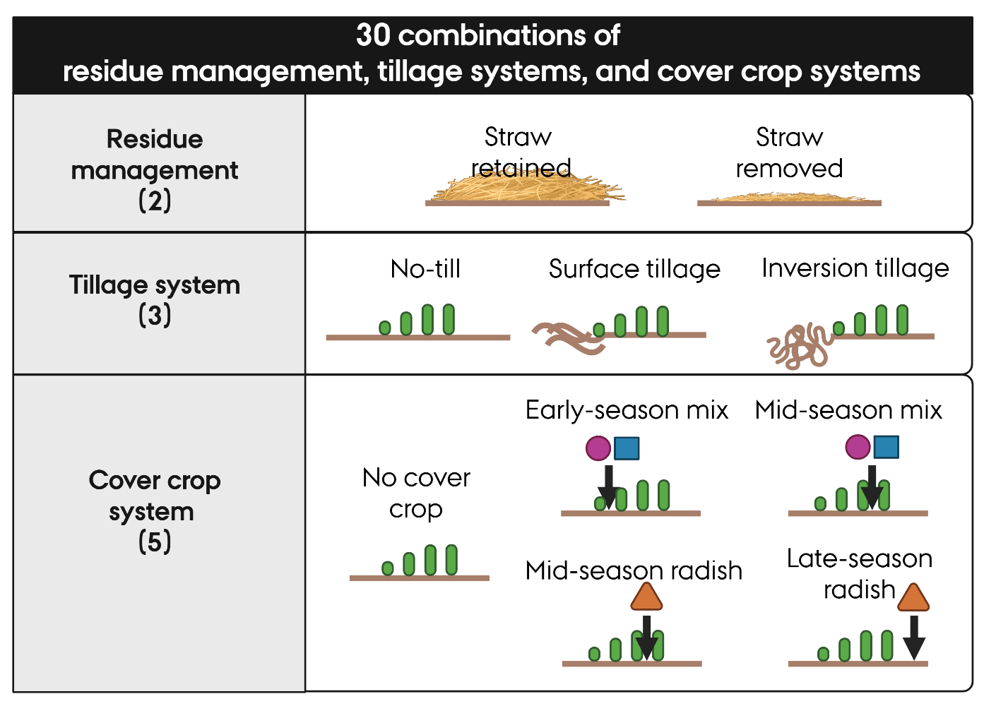
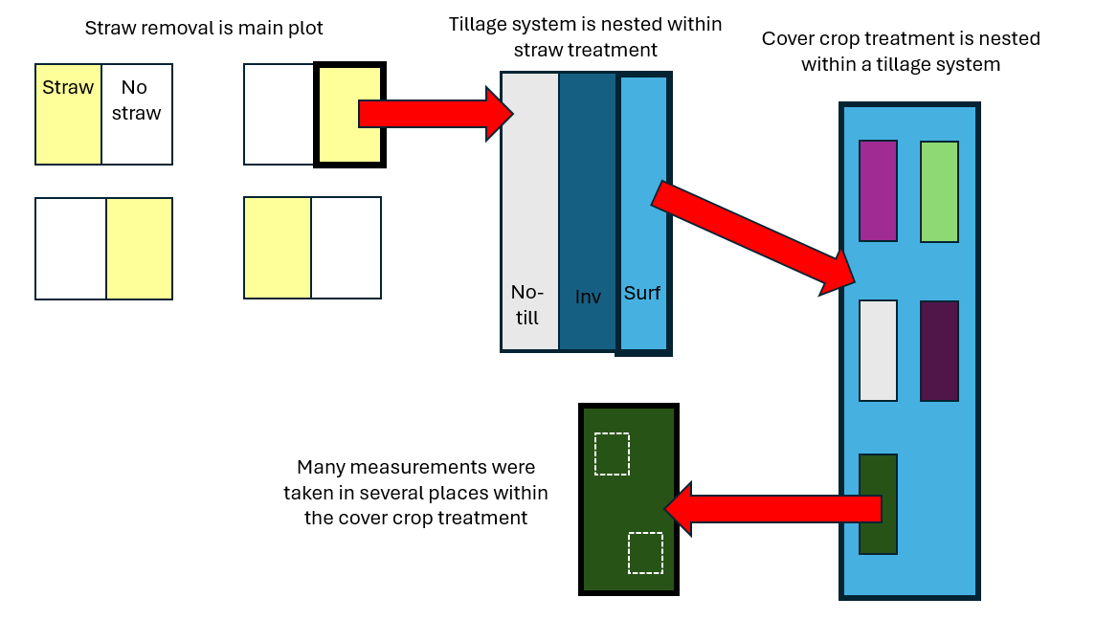
Figure S1. (Top) Visual summary of the treatment levels (Bottom)Visualization of the nested plot structure of the trial, with residue management comprising the main plot treatment, tillage treatment the subplot, and cover crop treatment the micro-plot. Inv = inversion tillage, Surf = surface tillage.

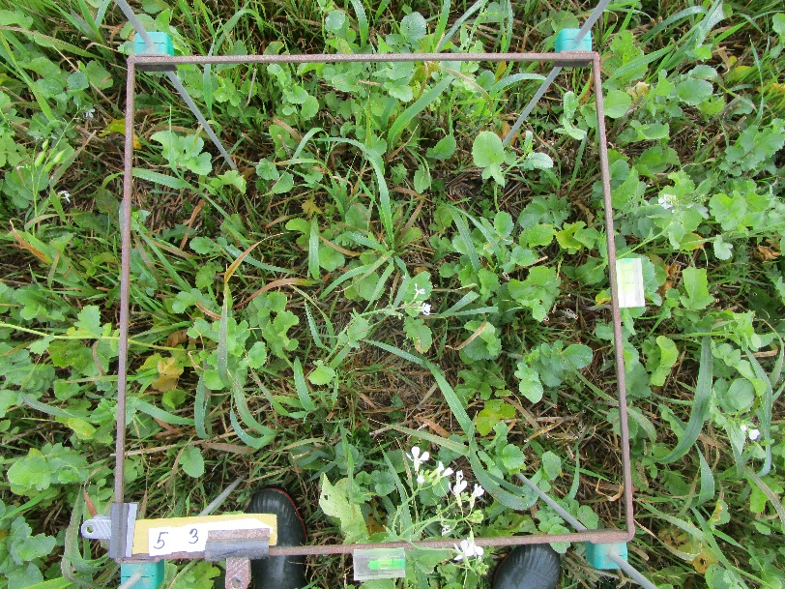 | 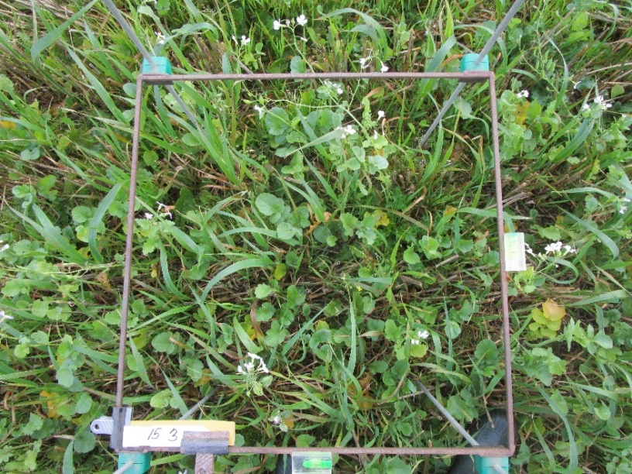

Figure S2. Two examples of photos taken which were used for estimating percent coverage of each species. RAPSR can be seen flowering.

Supplemental table S1. Product, active ingredient, and resulting Pesticide Load Index (Kudsk et al., 2018) for each herbicide package applied.
Herbicide Package (HP) | Product name and application amount | Active ingredient name, CAS identification number, and application amount in grams per hectare (g ha-1) | Pesticide Load per unit of product | Pesticide Load per hectare (PL per unit multiplied by units applied)
HP1 | 2 L ha-1 Roundup Flex XXL | 1000 g ha-1 glyphosate (CAS 1071-83-6) | 0.0992 | 0.19840
HP2 | 2.5 L ha-1 Roundup Flex XXL | 1000 g ha-1 glyphosate (CAS 1071-83-6) | 0.0992 | 0.24800
HP3 | 12 g ha⁻¹ Harmony SX + | 6 g ha-1 thifensulfuron-methyl (CAS 79277-27-3) | 0.0106 | 0.12720
HP3 | 0.15 L ha-1 Agropol (a surfactant) | - | - | -
HP4 | 0.25 L ha⁻¹ Starane 333 HL plus | 83 g ha-1 fluroxypyr (CAS 69377-81-7) | 0.6230 | 0.28600
HP4 | 0.03 L ha⁻¹ Hussar OD | 3 g ha-1 mefenpyr-diethyl (CAS 135590-91-9) and 1 g ha-1 iodosulfuron-methyl-Na (CAS 144550-36-7) | 0.3840 | 0.01152
HP4 | 0.5 L ha-1 Renol (a penetrating oil) | - | - | -
HP5 | 1 L ha⁻¹ Metaxone | 750 g ha-1 MCPA (CAS 94-74-6) | 1.0300 | 1.0300
HP6 | 0.5 L ha⁻¹ Starane XL | 90 g ha-1 Fluroxypyr (CAS 69377-81-7) | 0.5720 | 0.286
 | 10 g ha⁻¹ Trimmer SG | 5 g ha-1 tribenuron-methyl (CAS 101200-48-0) | 0.0018 | 0.018
 | 0.15 L ha-1 Agropol (a surfactant) | - | - | -
HP7 | 0.5 L ha⁻¹ Stomp CS | 228 g ha-1 pendimethalin (CAS 40487-42-1) | 1.3700 | 0.685
 | 0.4 L ha⁻¹ Fighter 480 | 192 g ha-1 bentazone (CAS 25057-89-0) | 0.9620 | 0.38480
HP8 | 0.93 L ha⁻¹Agil 100 EC | 93 g ha-1 propaquizafop (CAS 111479-05-1) | 0.6680 | 0.62124

1.2 Calculation of potential ecological value
Supplemental Table S2. Summary of the indices derived from Yvoz et al. 2021 used in the present study. The reader is directed to the publication for more information.
Ecological service category | Sub-category | Description | Components, in brief
Potential benefit to pollinators | Pol1 | Benefit to bees | Value to pollinators group (Table 3 from (Ricou et al., 2014)) flower diameter, average number of flowers per plant, etc.
Potential benefit to pollinators | Pol2 | Benefit to bumble bees | Same as above
Potential benefit to pollinators | Pol3 | Benefit to hoverflies | Same as above
Potential contribution to organisms | Cont1 | Contribution to farmland birds | Seed lipid content, seed mass, average number of seeds per plant
Potential contribution to organisms | Cont2 | Contribution to carabids | Seed lipid content, seed mass, seed accessibility (size), average number of seeds per plant
Potential contribution to organisms | Cont3 | Contribution to parasitoid wasps | Nectar quantity, flower form, corolla depth, flower number, extra floral nectar production

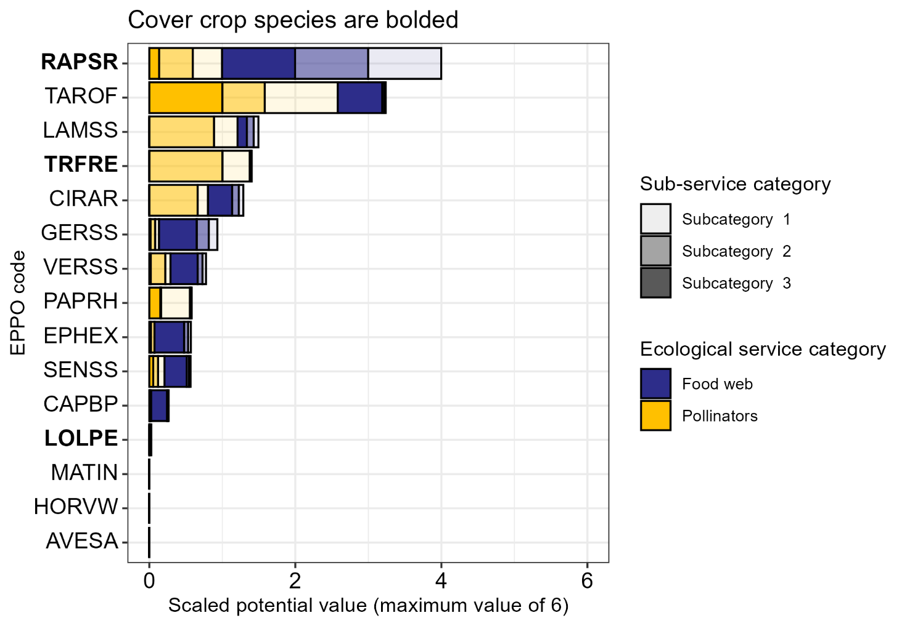
Figure S3. Potential benefit of each species/genus as a sum of each sub-category (Table S2) from the database provided in Yvoz et al. 2021

Supplementary Table S3. Scaled and summed values for ecosystem food webs and pollinator support, with the maximum value being used to represent a given species/genus in potential fall vegetation benefit calculations
EPPO code | Latin name | Foodweb contribution* | Pollinator* support | Potential benefit**
AVESA | Avena sativa | 0 | 0 | 0
CAPBP | Capsella bursa-pastoris | 0.24 | 0.03 | 0.27
CIRAR | Cirsium arvense | 0.48 | 0.80 | 1.28
EPHEX | Euphorbiaceae | 0.50 | 0.07 | 0.57
GERSS | Geranium species | 0.80 | 0.13 | 0.93
HORVW | Hordeum vulgare | 0 | 0 | 0
LAMSS | Lamium species | 0.29 | 1.21 | 1.50
LOLPE | Lolium perenne | 0.02 | 0 | 0.02
MATIN | Tripleurospermum inodorum | 0 | 0 | 0
PAPRH | Papaver rhoeas | 0.03 | 0.56 | 0.59
RAPSR | Raphanus sativus | 3.00 | 1.00 | 4.00
SENSS | Senecio species | 0.36 | 0.21 | 0.57
soil | - | 0 | 0 | 0
TAROF | Taraxacum officinale | 0.66 | 2.58 | 3.24
TRFRE | Trifolium repens | 0.03 | 1.38 | 1.41
VERSS | Veronica species | 0.49 | 0.29 | 0.78
*Maximum possible value is 3
**Benefit is the summed value of Foodweb contribution and Pollinator support values, with a maximum value of 6

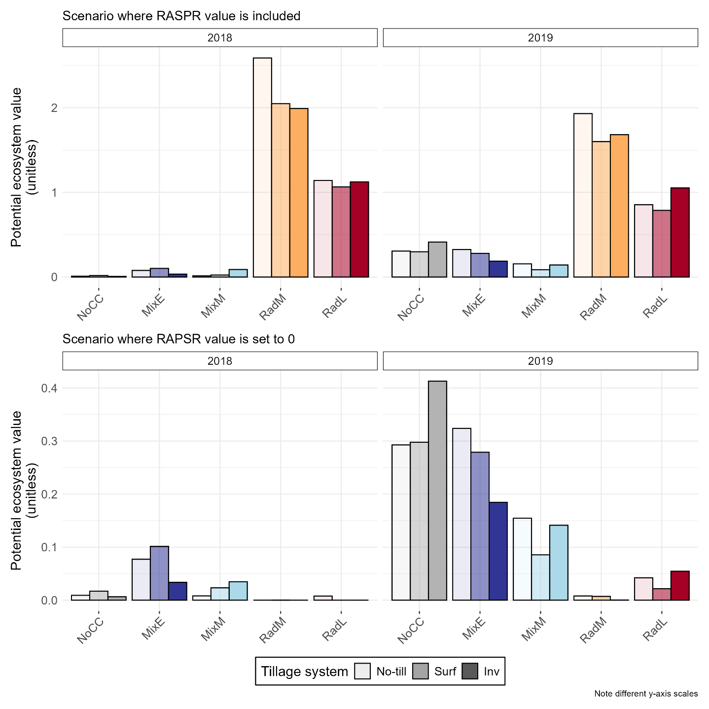
Figure S4. Sensitivity of vegetation community value to RAPSR ecological value

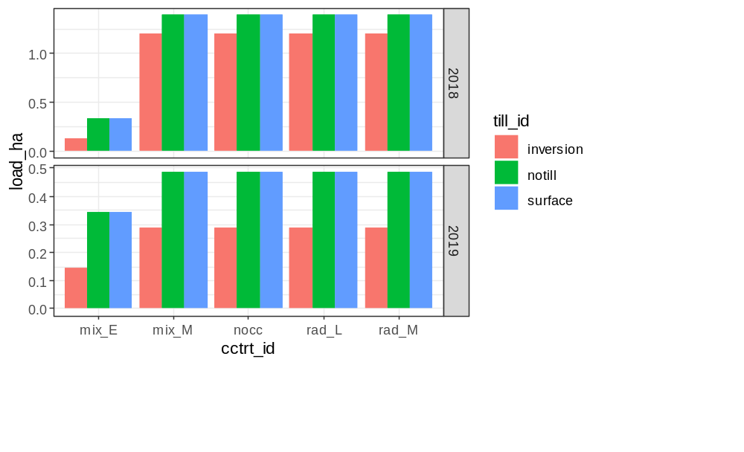
Figure S5. Pesticide loads as calculated using the Danish Pesticide Load Index system.

