From methods and materials in manuscript:

Potential ecological services
Potential ecological value was estimated using a methodology derived from that of Yvoz et al. 2021, including both pollinator value (as the fall vegetation did contain flowering plants) and ecological food web support (as the fall vegetation did contain plants that went to seed). Details on this calculation are presented in supplementary material but is described here briefly. The first component, potential benefits to pollinators, was comprised of three sub-indices representing (1a) the absolute benefit to bees (LATIN), (1b) bumble bees (LATIN), and (1c) hoverflies (LATIN). The second, potential benefits to food webs, was comprised of three sub-indices representing (2a) absolute contributions to farmland birds, (2b) carabids, and (2c) parasitoid wasps. Organ level attributes reported by Yvoz et al. 2021 for 155 plant species were used to assign sub-index values. Out of the 11 species in our study, six had exact matches in the database. The volunteer crops (barley, oats) did not have values in the database, and were assigned values of 0. For the other species and genuses (Table 2), the mean value for all species within that genus reported in the database were used. Each sub-indice was reported in different units, so after each species/genus in the present study was assigned a value for each of the sub-indices, the sub-indices were scaled within the present study such that the maximum corresponded to a value of 1, and the minimum a value of 0. While this has the potential to exaggerate differences between values that are similar on an absolute scale, we observed at least one magnitude of variation in our dataset, suggesting the variation in sub-index values was meaningful (see supplemental material). Sub-indices were summed to provide an estimate for each of the two indices (on a scale of 0-3) for each of the 16 species/genuses observed in our study, and the maximum of the two categories was assigned to each species/genus, representing the maximum ecological services that could be potentially provided by that species’ presence. These service values were weighted by the species/genuses’ percent cover for each sample to calculate the fall vegetation community’s potential benefit to pollinators and contributions to organismal food webs.

From supplemental material:

Supplemental Table S2. Summary of the indices derived from Yvoz et al. 2021 used in the present study. The reader is directed to the publication for more information.
Index | Sub-index | Description | Components, in brief
Potential benefit to pollinators | Pol1 | Benefit to bees | Value to pollinators group (Table 3 from (Ricou et al., 2014)) flower diameter, average number of flowers per plant, abundance xx
Potential benefit to pollinators | Pol2 | Benefit to bumble bees | Same as above
Potential benefit to pollinators | Pol3 | Benefit to hoverflies | Same as above
Potential contribution to organisms | Cont1 | Contribution to farmland birds | Seed lipid content, seed mass, average number of seeds per plant
Potential contribution to organisms | Cont2 | Contribution to carabids | Seed lipid content, seed mass, seed accessibility (size), average number of seeds per plant
Potential contribution to organisms | Cont3 | Contribution to parasitoid wasps | Nectar quantity, flower form, corolla depth, flower number, extra floral nectar production

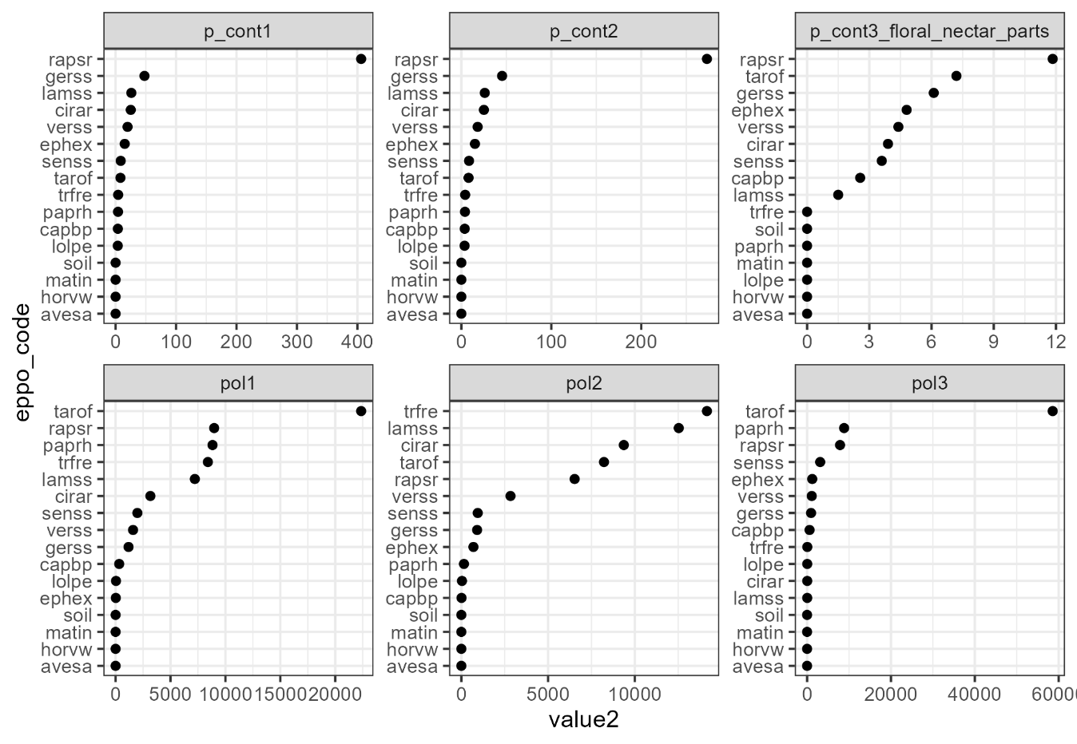
Figure S1. Absolute values of each sub-index calculated for the fall vegetation using the database from Yvoz et al. 2021

Supplementary Table S3. Scaled and summed values for ecosystem food webs and pollinator support, with the maximum value being used to represent a given species/genus in potential fall vegetation benefit calculations
EPPO code | Latin name | Foodweb contribution* | Pollinator* support | Benefit**
AVESA | Avena sativa | 0 | 0 | 0
CAPBP | Capsella bursa-pastoris | 0.24 | 0.03 | 0.24
CIRAR | Cirsium arvense | 0.48 | 0.80 | 0.80
EPHEX | Euphorbiaceae | 0.50 | 0.07 | 0.50
GERSS | Geranium species | 0.80 | 0.13 | 0.80
HORVW | Hordeum vulgare | 0 | 0 | 0
LAMSS | Lamium species | 0.29 | 1.21 | 1.21
LOLPE | Lolium perenne | 0.02 | 0 | 0.02
MATIN | Tripleurospermum inodorum | 0 | 0 | 0
PAPRH | Papaver rhoeas | 0.03 | 0.56 | 0.56
RAPSR | Raphanus sativus | 3.00 | 1.00 | 3.00
SENSS | Senecio species | 0.36 | 0.21 | 0.36
soil | - | 0 | 0 | 0
TAROF | Taraxacum officinale | 0.66 | 2.58 | 0.66
TRFRE | Trifolium repens | 0.03 | 1.38 | 1.38
VERSS | Veronica species | 0.49 | 0.29 | 0.49
*Maximum possible value is 3
**Benefit is the maximum value of Ecosystem contribution and Pollinator support values
***Presented only to help interpretation, this value was not used in any subsequent calculations

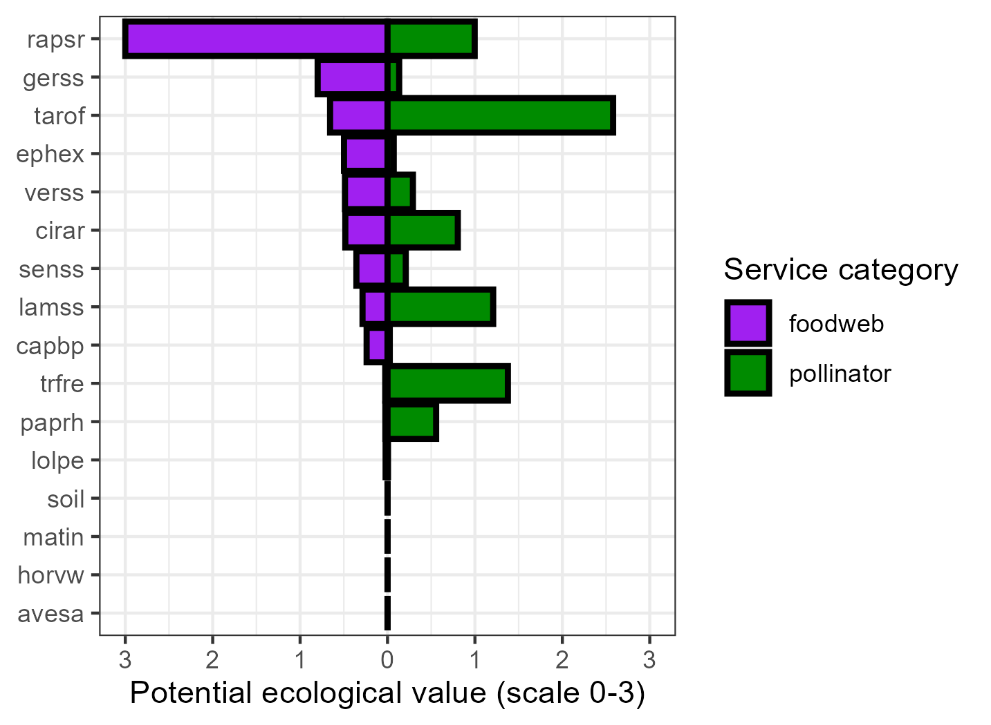

Figure S2. Resulting species/genus ecological service values – values had low correlation with each other (0.28)

