SUPPLEMENTAL MATERIAL FOR

A multi-criteria evaluation of fall vegetation services and dis-services in 30 cropping systems varying in cover crop system, tillage and residue management

Virginia Nichols¹, Emma Randhal-Beltran¹, Marco Gentili¹, Mette Sonderskov¹, Bo Melander³
¹Aarhus University, Department of Agroecology, Crop Health Section,
Forsøgsvej 1, 4200 Slagelse, Denmark
gina.nichols@agro.au.dk

Methods and materials

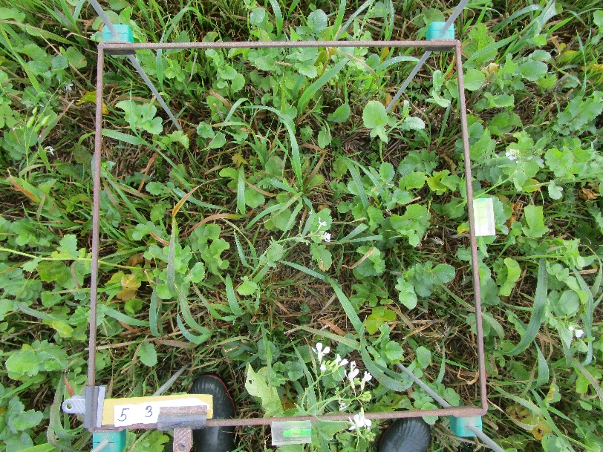 | 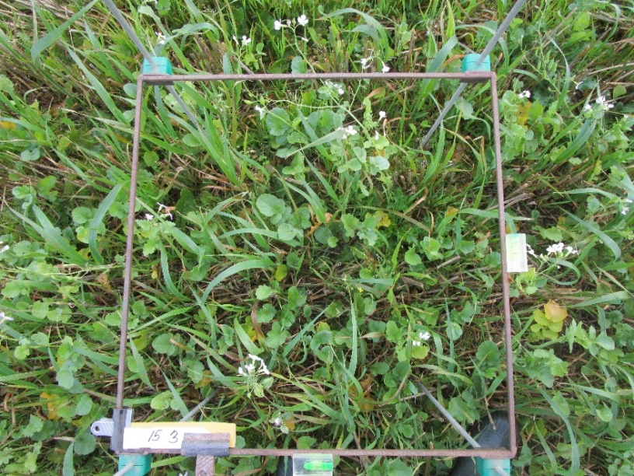

Figure S1. Two examples of photos taken which were used for estimating percent coverage of each species. RAPSR can be seen flowering.

Supplemental table S1. Product, active ingredient, and resulting Pesticide Load Index (Kudsk et al., 2018) for each herbicide package applied.
Herbicide Package (HP) | Product name and application amount | Active ingredient name, CAS identification number, and application amount | Pesticide Load Index
HP1 | 2.1 L ha-1 Roundup Flex XXL | 1000 g ha-1 glyphosate (CAS 1071-83-6)
HP2 | 2.5 L ha-1 Roundup Flex XXL | 1200 g ha-1 glyphosate (CAS 1071-83-6)
HP3 | 12 g ha⁻¹ Harmony SX + | 6 g ha-1 thifensulfuron-methyl (CAS 79277-27-3)
 | 0.15 L ha-1 Agropol (a surfactant) | -
HP4 | 0.25 L ha⁻¹ Starane 333 HL plus | 83 g ha-1 fluroxypyr (CAS 69377-81-7)
 | 0.03 L ha⁻¹ Hussar OD | 3 g ha-1 mefenpyr-diethyl (CAS 135590-91-9) and 1 g ha-1 iodosulfuron-methyl-Na (CAS 144550-36-7)
 | 0.5 L ha-1 Renol (a penetrating oil) | -
HP5 | 1 L ha⁻¹ Metaxone | 750 g ha-1 MCPA (CAS 94-74-6)
HP6 | 0.5 L ha⁻¹ Starane XL | 90 g ha-1 Fluroxypyr (CAS 69377-81-7)
 | 10 g ha⁻¹ Trimmer SG | 5 g ha-1 tribenuron-methyl (CAS 101200-48-0)
 | 0.15 L ha-1 Agropol (a surfactant) | -
HP7 | 0.5 L ha⁻¹ Stomp CS | 228 g ha-1 pendimethalin (CAS 40487-42-1)
 | 0.4 L ha⁻¹ Fighter 480 | 192 g ha-1 bentazone (CAS 25057-89-0)
HP8 | 0.93 L ha⁻¹Agil 100 EC | 93 g ha-1 propaquizafop (CAS 111479-05-1)

Calculating potential ecological value
Supplemental Table S2. Summary of the indices derived from Yvoz et al. 2021 used in the present study. The reader is directed to the publication for more information.
Index | Sub-index | Description | Components, in brief
Potential benefit to pollinators | Pol1 | Benefit to bees | Value to pollinators group (Table 3 from (Ricou et al., 2014)) flower diameter, average number of flowers per plant, abundance xx
Potential benefit to pollinators | Pol2 | Benefit to bumble bees | Same as above
Potential benefit to pollinators | Pol3 | Benefit to hoverflies | Same as above
Potential contribution to organisms | Cont1 | Contribution to farmland birds | Seed lipid content, seed mass, average number of seeds per plant
Potential contribution to organisms | Cont2 | Contribution to carabids | Seed lipid content, seed mass, seed accessibility (size), average number of seeds per plant
Potential contribution to organisms | Cont3 | Contribution to parasitoid wasps | Nectar quantity, flower form, corolla depth, flower number, extra floral nectar production

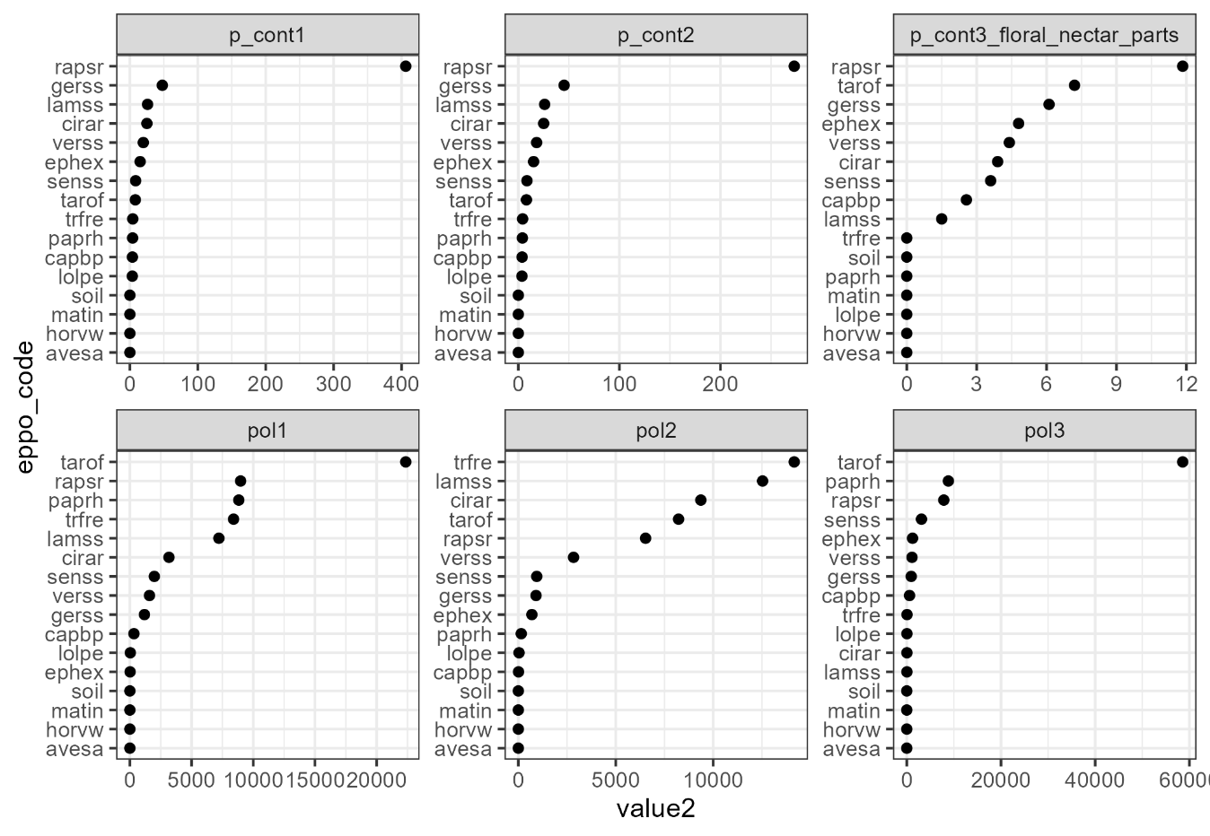
Figure S1. Absolute values of each sub-index calculated for the fall vegetation using the database from Yvoz et al. 2021

Supplementary Table S3. Scaled and summed values for ecosystem food webs and pollinator support, with the maximum value being used to represent a given species/genus in potential fall vegetation benefit calculations
EPPO code | Latin name | Foodweb contribution* | Pollinator* support | Benefit**
AVESA | Avena sativa | 0 | 0 | 0
CAPBP | Capsella bursa-pastoris | 0.24 | 0.03 | 0.24
CIRAR | Cirsium arvense | 0.48 | 0.80 | 0.80
EPHEX | Euphorbiaceae | 0.50 | 0.07 | 0.50
GERSS | Geranium species | 0.80 | 0.13 | 0.80
HORVW | Hordeum vulgare | 0 | 0 | 0
LAMSS | Lamium species | 0.29 | 1.21 | 1.21
LOLPE | Lolium perenne | 0.02 | 0 | 0.02
MATIN | Tripleurospermum inodorum | 0 | 0 | 0
PAPRH | Papaver rhoeas | 0.03 | 0.56 | 0.56
RAPSR | Raphanus sativus | 3.00 | 1.00 | 3.00
SENSS | Senecio species | 0.36 | 0.21 | 0.36
soil | - | 0 | 0 | 0
TAROF | Taraxacum officinale | 0.66 | 2.58 | 0.66
TRFRE | Trifolium repens | 0.03 | 1.38 | 1.38
VERSS | Veronica species | 0.49 | 0.29 | 0.49
*Maximum possible value is 3
**Benefit is the maximum value of Ecosystem contribution and Pollinator support values
***Presented only to help interpretation, this value was not used in any subsequent calculations

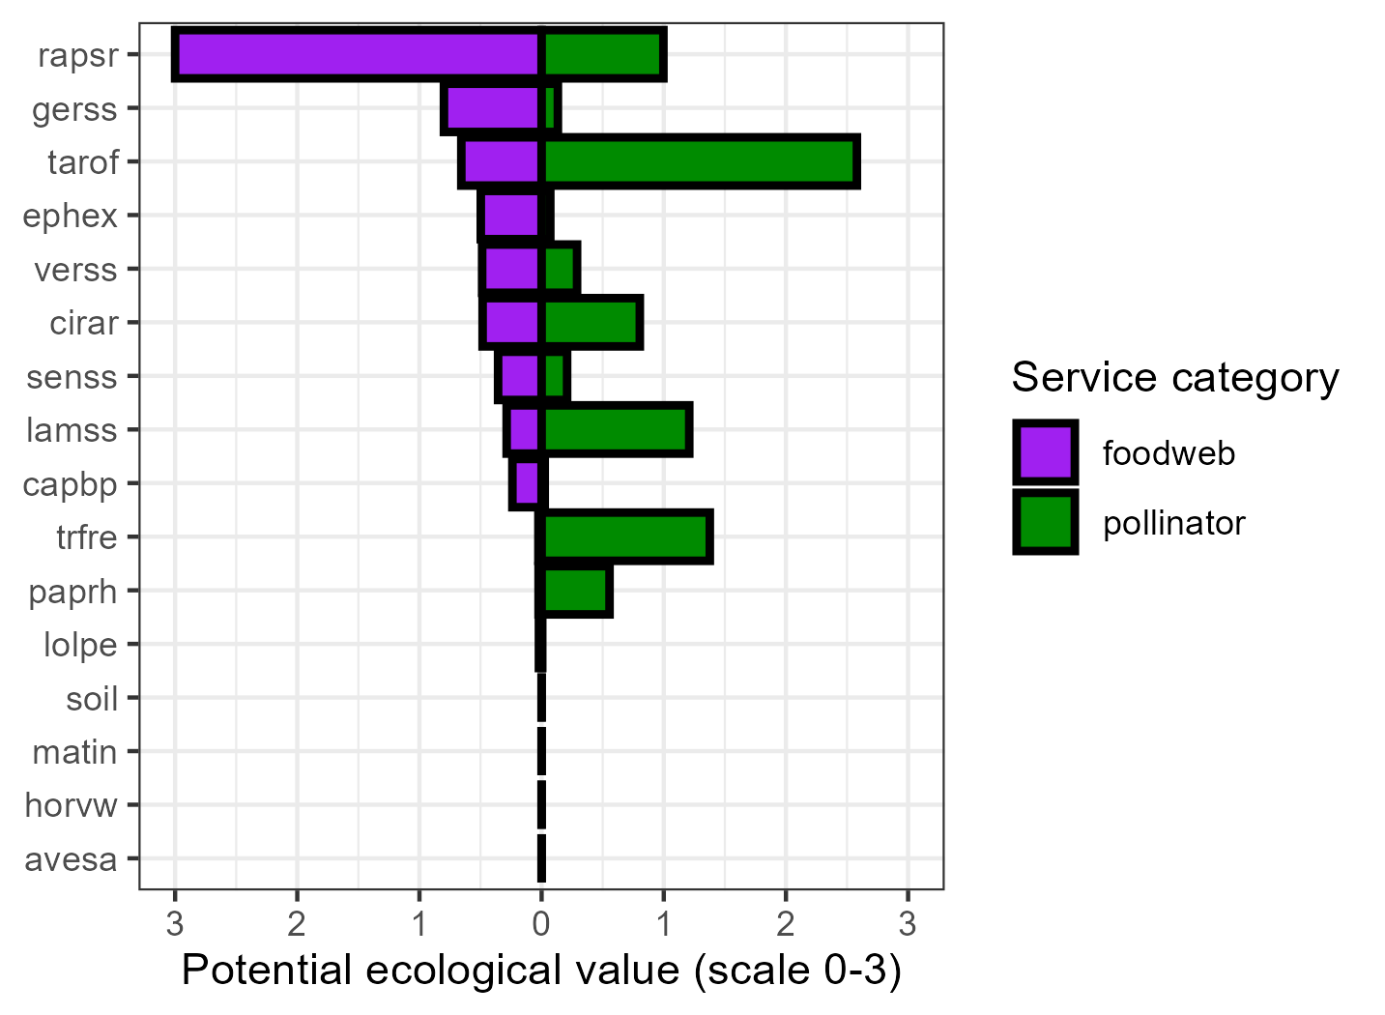

Figure S2. Resulting species/genus ecological service values – values had low correlation with each other (0.28)

STOPPED-------------------------needs fixed from here on out, 11 aug 2025

Potential benefit calculations
The potential benefit provided by the fall vegetation community was calculated by weighing each species/genus value (Table S3) by its respective percent cover contribution in a given sample.
The mean community values for ‘Benefit’ were calculated for each tillage, cover crop, and residue treatment across years. The resulting values were scaled from 0-1 with 0 representing the lowest observed community ‘Benefit’ value (0, several systems), and 1 representing the maximum observed community ‘Benefit’ value (0.67 in the notill/mixE/-res).

Potential harm
The same procedure was used for assigning potential Harm to each fall vegetation community.

Yield
The total grain yields for each tillage, cover crop, and residue combination were summed to get a total yield accrued over the three years. These values were then scaled from 0 to 1 with 0 representing the lowest observed cumulative grain yield (12.5 in the notill/mixE/-res), 1 representing the highest (13.1 in the noninv/radM/-res).

Fall biomass
The biomass for each tillage, cover crop, and residue combination in a given year were summed to get a total biomass produced over the three years. These values were then scaled from 0 to 1 with 0 representing the lowest observed cumulative biomass production (226 in the inv/radL/-res) and 1 representing the highest (552 in the notill/radM/+res).

Pesticide toxicity load
The pesticide load index for each tillage, cover crop, and residue combination was summed over the three years. The values were then scaled from 0 to 1, with 0 as the lowest observed pesticide load (0.272 in the inv/mixE) and 1 as the highest observed pesticide load (1.48, several systems).

Perennial weed legacy
The average spring counts of perennial weeds (CIRAR, EQUAR) were summed over the two samplings for each tillage, cover crop, and residue treatment. The values were then scaled from 0 to 1, with 0 as the lowest observed cumulative count (0, several systems) and 1 as the highest observed cumulative count (110, notill/mixE/-res).

Statistics
  - Yields
Yields varied significantly by crop (p<0.001) and by cover crop treatment (p<0.001), but did not vary significantly by any other factors or their interactions. In 2018 spring barley yields averaged 4.07 Mg ha⁻¹, in 2019 oat yields averaged 4.28 Mg ha-1, and in 2020 faba bean yields averaged 3.47 Mg ha-1. The average grain yields of the present study were lower than national averages for the same crops in the same years [4.28 Mg ha-1 spring barley, 4.94 oats, and 4.08 Mg ha-1 faba bean, respectively (FAO, 2023)], but the maximum grain yields observed each year exceeded the national averages. On average, the MidRad cover crop treatment exhibited 8% higher crop yields compared to all other cover crop treatments (p = XXX); all other cover crop treatment yields did not vary significantly from each other.
- 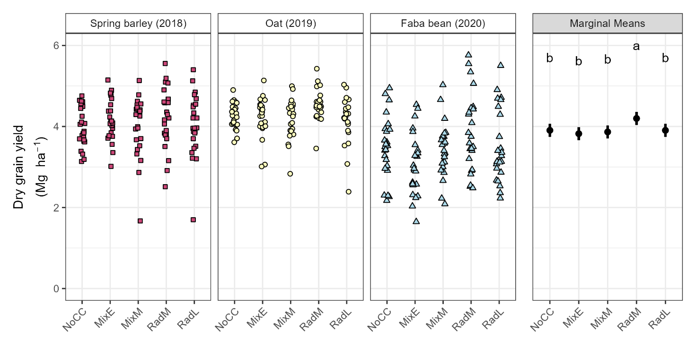

  - Biomass
Put in marginal means by cover crop, tillage, year (in tables folder under data)

  - Community ecological value

- 