**A multi-criteria evaluation of fall vegetation services and dis-services in 30 cropping systems varying in cover crop system, tillage and residue management**

Virginia Nichols1, Emma Randhal-Beltran1, Marco Gentili1, Mette Sonderskov1, Bo Melander3

*1Aarhus University, Department of Agroecology, Crop Health Section,*

*Forsøgsvej 1, 4200 Slagelse, Denmark*

[*gina.nichols@*](mailto:gina.nichols@)*agro.au.dk*

# Abstract

With increasing environmental pressures from population growth and climate change, there is growing interest in assessing both the potential benefits and drawbacks of in-field, non-crop vegetation. This study evaluated fall vegetation communities and attendant agronomic metrics in 30 replicated cropping systems over two consecutive years in Zealand, Denmark. Treatments included five cover crop systems (Lolium perenne and Trifolium repens mixture sown early- and mid-season, Raphanus sativus (radish) sown mid-season and post-harvest and a no cover crop control) embedded within every combination of three tillage approaches (no-till, surface, inversion) and two residue managements (retained, removed).

X indices were used to capture biophysical, ecological and agronomic services and dis-services.

Four metrics were used to capture vegetation potential services and harms: (1) percent soil cover (soil protection), (2) total aboveground biomass (potential soil carbon input and nitrate leaching mitigation), (3) species-based potential ecological benefits (six indices), (4) potential future agronomic harm (four indices). Additional metrics captured system impacts including crop yields and pesticide toxicity loads.

The study coincided with the site’s driest (2018) and wettest (2019) growing seasons in 30 years. Results showed that soil cover remained stable (~75%) across treatments and years. Only radish cover crops consistently increased fall biomass compared to the no-cover control (is this true?) Radish cover crops consistently contributed over 50% of total fall biomass, while the mixes’ contributions varied (0–80%) within both planting timings. Radish treatments produced neutral vegetation communities, with neither high potential benefits nor harms. In contrast, the mixes and no cover crop treatments displayed both high potential ecological benefits and high potential agronomic harm. Regardless of tillage, residue, or weather, the mid-season planted radish exhibited the highest fall biomass, low pesticide toxicity, high crop yields, but produced fall vegetation with low potential ecological value. The early planted mix had low to moderate fall biomass, moderate crop yields, higher pesticide toxicity loads, and x times more perennial weeds compared to other treatments, but supported fall vegetation that had high potential ecological value. These results underscore the complexity of defining ‘beneficial’ vegetation in agricultural systems, highlighting the interplay between multiple biophysical, ecological and agronomic indices.

# Introduction

Environmental pressures resulting from population growth and climate change have led to a significant decline in biodiversity (CITE). Given the extensive land area dedicated to arable agriculture, agricultural management plays a crucial role in shaping biodiversity levels (CITE). Consequently, there is a growing need for agricultural systems that integrate ecosystem health and biodiversity conservation with commercial production objectives. In response, researchers are increasingly assessing non-crop plant communities (e.g., weeds) and their attendant management strategies for their impacts on biodiversity. This requires estimating both the ecological value of these communities within and beyond agro-ecosystems, their possible negative impacts on crop production, and the ecological impacts of their management (Esposito et al., 2023; Petit et al., 2011; Storkey and Westbury, 2007).

Non-crop communities embedded within production fields may offer a range of ecological benefits. They may serve as important promotors of plant diversity (CITE), provide food sources for a high diversity of organisms (Balfour and Ratnieks, 2022; Marshall et al., 2003a), offer habitat (CITE), reduce nitrate leaching *(Blaix et al., 2018; Huang et al., 2018b)* (Sullivan et al., 2017), contribute to soil organic carbon (Jian et al., 2020), or mitigate soil erosion (Moreau et al., 2020)

*However, weeds also provide services for agroecosystems, promoting plant biodiversity and feeding other organisms potentially valuable to crop production (e.g pollinators, beneficial predators such as carabid beetles) (Petit et al., 2011; Kulkarni et al., 2015; Rollin et al., 2016).*

In agricultural systems that utilize tillage and/or herbicides, studies have found fall cover cropping has a minimal impact on subsequent weed pressure due to the strong filters exerted by spring tillage or herbicide application (Adeux et al., 2023; Rouge et al., 2023) (Adeux et al., 2023, 2021) OTHERS. It follows that fall non-crop vegetation may present a unique opportunity for optimization, allowing the expression of ecologically beneficial weeds in addition to providing services such as soil cover and soil nitrate retention (CITE). The interaction between cover crops, tillage and residue management is complex, and it is unclear how these factors might be combined to optimize the services provided by fall non-crop vegetation. To better understand the potential for optimizing fall non-crop vegetation services, we embedded five cover cropping systems within six combinations of tillage and residue managements, resulting in 30 unique cropping systems. Using these 30 systems as a platform, the objectives of this study were to:

1. Quantify the services resulting from management combinations
   1. Soil protection
   2. Reduction of nitrate leaching
   3. Ecological value
2. Quantify the dis-services resulting from management combinations
   1. Reduced cash crop yields
   2. Pesticide toxicity loads to the environment
   3. Future agronomic harm potential
3. Understand how cover cropping systems interact with tillage, residue removal, and weather in provision of these services and dis-services

Organic systems likewise experience complex interactions and tradeoffs between cover crop use, tillage, and weed management (Melander et al., 2016). To our knowledge there are few assessments of the fall vegetation communities that include metrics

Non-crop vegetation can provide value. Especially fall vegetation, as it will be controlled in the spring before planting with tillage or herbicides

* Cover crops
* Volunteers
* Weeds can provide services
  + Especially fall vegetation, as it will be controlled in the spring before planting with Tillage or herbicides
  + Protect soil from erosion
  + Reduce nitrate leaching
  + Plant diversity
    - Paper I reviewed showed weedy control had more diversity

Ways of quantifying value

* Often location specific
* Nothing that is particularly easy
* Used Yvoz, they provided field-based values to drive their estimates
  + Need to understand more here

Values needed from fall coverage

* Soil cover to protect from erosion
  + Root structure may also contribute (cover crop and erosion paper (De Baets et al., 2011) but difficult to predict roots in mixed stand
  + Soil cover of weeds (Moreau et al., 2020)
* Contributions to soil carbon
  + Soil organic carbon increases positively associated with biomass (Jian et al., 2020)
* Contributions to reduced nitrate leaching
  + CC shoot biomass, fall biomass in general (Thapa et al., 2018; Wortman, 2016)

Which are the species capable of setting seeds during the fallow period? Adeux et al. 2023

Need to add info on each of the 16 weed species. Flowering time, germination season

# Materials and Methods

## Field management

This study was conducted within a larger long-term crop rotation and tillage continuous experiment which was established in 2002 on a sandy loam at Flakkebjerg Research Centre, Denmark (55.317, 11.400). Averaged across the trial site, soil texture is 14.7% clay (<2 mm), 13.7% silt (2-20 mm), 42.6% fine sand (20-200 mm), and 27% coarse sand (200-2000 mm), with 1.2% organic carbon content (0-25 cm). The overall experimental design of the long-term experiment is a split-split plot with four replications. The main plot factor is cropping system (four levels), the sub-plot is primary tillage system (four levels) and the sub-sub-plot (six levels) was established to accommodate various sub-treatments within rotation and tillage combinations (see for example Melander et al. (2008)). The cash crop sequence during the present study was spring barley (*Hordeum vulgare* L.) sown 19 April 2018, spring oat (*Avena sativa* L.) sown 4 April 2019 and faba beans (*Vicia faba* L.) sown 15 April 2020.

### Study design

For the purpose of the present study, two cropping systems were selected that had the same sequence of crops but with different straw management reflecting common systems in Denmark: straw removed or retained. Therefore, in the present study, straw management composed the main-plot treatment. Tillage sub-plots were 5 meters wide and 40 m long. Each tillage sub-plot was divided into two columns with three sub-subplots arranged within each column for a total of six sub-sub-plots that were 2.5 m wide and 12.5 m long (see supplementary material for a visual aid). One of the six sub-subplots was reserved for other sampling efforts, and a cover crop system treatment (five levels) was applied randomly to the remaining five sub-subplots. In summary, this experiment included all combinations of two straw-managements, three primary tillage systems, and five cover crop systems for a total of 30 treatments.

### Straw and tillage treatments

The same straw managements and categorical tillage system (no tillage, non-inversion, inversion) have been in the same sub-plots since 2002. In the straw-removal treatments, following harvest of a small grain the residue (e.g., straw) was removed using a MACHINE, resulting in removal of approximately 60% of the biomass (do we have any pictures of the straw retained and straw removed treatments, so we can see how the ground was still covered by little bits of straw after straw removal? CITE a CENTS modelling study for this 60% assumption). In the straw-retained treatments, harvest residue was allowed to remain in the field. The exact machinery and timing of operations for each categorical tillage treatment have varied since 2002 (Scherner et al., 2016; Hansen et al., 2010). In the present experiment (2018-2020), plots under the inversion tillage treatment were moldboard plowed to a depth of 20 cm in the fall and harrowed to 3-4 cm depth in the spring before cash crop planting; crops were then sown with a traditional seed drill (Nordsten Lift-o-matic CLH300) with row spacings of 12.5 cm. For the surface tillage system (non-inversion), a Horsch Terrano 3 FX stubble tine cultivator was used to till to a depth 8-10 cm in the spring before cash crop planting. In both the no-till and non-inversion tillage systems, crops were sown with a chisel coulter (Horsch Airseeder CO 3) with row spacings of 17.5 cm for spring oats, spring barley, and faba beans. Row spacings were different for the inversion tillage system due to equipment representing typical production environments for each tillage system (CITE).

### Cover crop treatments

Starting in 2018, five cover crop systems were randomly applied to the sub-sub-plots (**Table 1).** The same sub-sub-plot treatments were maintained for 2018 and 2019. The sampling area for all measurements was located in the inner 1.5 m x 10 m area of the sub-sub-plots.

Table 1. Summary of the five cover crop systems

|  |  |  |  |
| --- | --- | --- | --- |
| Cover crop system name | Cover crop | Seeding rate | Seeding method and timing |
| Mix-early | Perennial ryegrass *(grass; Lolium perenne)* and red clover *(clover; Trifolium pratense)* | 3 kg ha-1 grass + 8 kg clover ha-1 | Sown 1 cm deep in 12.5 cm rows between cash crop rows shortly after cash crop planting |
| Mix-mid | Broadcast into standing crop approximately 14 days before expected cash crop harvest |
| Radish-mid | Fodder radish *(Raphanus sativus)* | 14 kg ha-1 | Broadcast into standing crop approx. 14 days before expected crop harvest |
| Radish-late | Broadcast into the crop stubble post crop harvest |
| No CC | - | - | - |

### Fertilizer and herbicides

Mineral fertilizer was broadcast on spring barley plots on 17 April 2018 (126 kg N ha-1, 24 kg P ha-1 and 60 kg K ha-1); on spring oat plots on 3 April 2019 (80 kg N ha-1, 15 kg P ha-1 and 38 kg K ha-1 ); and on faba beans on 15 April 2020 (32 kg P ha-1 and 80 kg K ha-1).

Herbicide treatments reflected best practices and constraints imposed by both the tillage and cover crop system treatments. Each herbicide package (HP) is described in detail in supplementary material. In the non-inversion and no-till treatments, all plots were sprayed with HP1 (2018, 2019) or HP2 (2020) before cash crop planting. For the inversion tillage treatments, no herbicide was sprayed before cash crop planting. In 2018 (spring barley), to accommodate the presence of the grass and clover present in the Mix-early plots, those plots were sprayed on 16 May 2018 with an herbicide package that does not affect clover or grasses (HP3); all other plots were sprayed the same day with a different herbicide package (HP4). On 29 May 2018, all plots except the Mix-early plots were sprayed (HP5) to control Canada thistle (*Cirsium arvense*). In 2019 (spring oat), on 14 May the Mix-early plots were again sprayed with the same herbicide package used in 2018 (HP3) while all other plots were sprayed with a different package (HP6) to….. Following faba bean planting in 2020, all plots were sprayed with HP7 on 6 May 2020 and again on 20 May 2020. On 2 June 2020, all plots were sprayed (HP8) to control wild oat (*Avena fatua*). All plots were managed identically for diseases and insect pests according to Danish standard recommendations and policies. Herbicide use data was translated into potential toxicity loads to society using the Danish Pesticide Load Indicator (PLI; (Kudsk et al., 2018)).

Supplemental table 1. Product and active ingredients in each herbicide package applied.

|  |  |  |  |
| --- | --- | --- | --- |
| **Herbicide Package (HP)** | **Product name and application amount** | **Active ingredient name, CAS identification number, and application amount** | **Pesticide Load Indice** |
| HP1 | 2.1 L ha-1 Roundup Flex XXL | 1000 g ha-1 glyphosate; CAS 1071-83-6 |  |
| HP2 | 2.5 L ha-1 Roundup Flex XXL | 1200 g ha-1 glyphosate; CAS 1071-83-6 |  |
| HP3 | 12 g ha-1 Harmony SX + | 6 g ha-1 thifensulfuron-methyl; CAS 79277-27-3 |  |
|  | 0.15 L ha-1 Agropol (a surfactant) | - |  |
| HP4 | 0.25 L ha-1 Starane 333 HL plus | 83 g ha-1 fluroxypyr (CAS 69377-81-7) |  |
|  | 0.03 L ha-1 Hussar OD | 3 g ha-1 mefenpyr-diethyl (CAS 135590-91-9) and 1 g ha-1 iodosulfuron-methyl-Na (CAS 144550-36-7) |  |
|  | 0.5 L ha-1 Renol (a penetrating oil) | - |  |
| HP5 | 1 L ha-1 Metaxone | 750 g ha-1 MCPA (CAS 94-74-6) |  |
| HP6 | 0.5 L ha-1 Starane XL | 90 g ha-1 Fluroxypyr (CAS 69377-81-7) |  |
|  | 10 g ha-1 Trimmer SG | 5 g ha-1 tribenuron-methyl (CAS 101200-48-0) |  |
|  | 0.15 L ha-1 Agropol (a surfactant) | - |  |
| HP7 | 0.5 L ha-1 Stomp CS | 228 g ha-1 pendimethalin (CAS 40487-42-1) |  |
|  | 0.4 L ha-1 Fighter 480 | 192 g ha-1 bentazone (CAS 25057-89-0) |  |
| HP8 | 0.93 L ha-1Agil 100 EC | 93 g ha-1 propaquizafop (CAS 111479-05-1) |  |

The long-term experiment is rainfed, but in 2018 an exception was made due to an extremely hot and dry early growing season. In order to maintain the long-term viability of the experiment, all plots were irrigated with 25 mm in early June to ensure the early establishment of all treatments. Irrigation was done with sprinklers mounted on a boom that was dragged through the experiment.

## Weather data for the present study was obtained from the Danish Meteorological Institute's (DMI) Open Data API for the Flakkebjerg station (55.322, 11.388). The 30-year (1990-2020) mean annual temperature and precipitation for the site are 8.9 degrees Celsius and 589 mm, respectively. Measurements

### Crop yields

Each plot (net size 10 m x 1.5 m) was harvested for grain yield with a plot combine (8 August 2018 barley, 15 August 2019 oat, 24 August 2020 faba bean). Dry matter content was determined by a near-infrared spectroscopy analyzer (InfraTec™ 1241 Grain Analyzer, Foss A/S; [Buchmann et al., 2001](https://www-sciencedirect-com.ez.statsbiblioteket.dk/science/article/pii/S0167198710000541" \l "bib4)). Grain yields are reported on a dry matter basis.

### Vegetation measurements

Table 2. Summary of vegetation measurements

|  |  |
| --- | --- |
| **Measurement** | **Units of identification** |
| Fall ground cover (%) | Soil  Species (AVESA*, CAPBP, CIRAR, EPHEX, HORVW, LOLPE, MATIN, PAPRH, RAPSR, TAROF, TRFRE)  Genus (GERSS, LAMSS, SENSS, VERSS) |
| Fall biomass (g m-2) | Cover crop  Other (all other biomass) |
| Spring weed counts (number m-2) Bo, just making sure the data you gave me is on a per m2 basis | CIRAR  EQUAR  Dicot  Monocot |
| *EPPO code, see supplemental material for Latin names |  |

#### Fall ground cover

Ground cover composition was estimated from digital images taken in the fall (9 November 2018 and 1 November 2019) as done in Melander et al. (2013). Briefly, a 0.5 m2 quadrat was placed in the plot, and an image was taken from a height of 1 m above the center of the quadrat. Three images were taken in each plot. Each image was subsequently overlaid with a grid consisting of 17 vertical and 17 horizontal lines, resulting in 289 intersections per image. Each intersection was classified as a soil or plant. Plant intersections were further classified to the species (12) or genus (4) level (Table 1). Percent coverage of each type was then calculated by dividing the number of touched intersections in that category by 289 intersections. For categorical analyses, species/genus were classified as ‘cover crop’, ‘volunteer’ or ‘other.’

#### Fall biomass

The amount of aboveground vegetative biomass in each treatment was measured following image collection for fall ground cover measurements (15 November 2018 and 13 November 2019, respectively). Two 0.5 m2 quadrats were randomly placed in each plot, and all aboveground biomass was cut at ground level and removed. The biomass samples from the two quadrats were combined, then separated into three fractions: cover crops, weeds and volunteers in 2018. In 2019, only the fractions cover crops and other (weeds plus volunteers) were obtained, so the categories ‘cover crop’ and ‘other’ were used for all statistical analyses (Table X). The biomass fractions were dried in the oven at 80oC for 24 hours and weighed. Dry biomass for each category was converted to grams per m2.

#### Spring weed counts

The weed flora emerging in spring in the experimental plots was assessed on 22 May 2019 and 27 May 2020 after post-emergence weed control. Four weed categories were counted in three randomly placed quadrats (0.25 m2) per plot. The categories were dicots, monocots, Canada thistle (*Cirsium arvense*) and horsetail (Equisetum arvense). The spring counts were made to record whether there were any traceable effects from previous year’s cover crop treatments. The weed counts in spring were of course affected by the earlier herbicide spring applications, and the goal was to assess whether the previous fall vegetation resulted in carry-over effects that were detectable even after weed control measures.

#### Potential ecological value, agronomic harm, pesticide toxicity

Herbicide use data was translated into potential pesticide load index (PLI) using the Danish-PLI methodology (Kudsk et al., 2018). Ecological harm was estimated using a methodology derived from that of Yvoz et al. 2021. Three main indices were estimated: (1) potential benefits to pollinators (three sub-indices representing the absolute benefit to bees (LATIN), bumble bees (LATIN), and hoverflies (LATIN), (2) potential benefits to organisms (three sub-indices representing absolute contributions to farmland birds, carabids, and parasitoid wasps), and (3) potential harm (three sub-indices representing competition with crops, contribution to harvest difficulties, and contribution to future weed infestations; see supplemental material). Plant level attributes reported by Yvoz et al. 2021 for 155 species were used to assign sub-indice values to each of the 12 species in our dataset. For the four genuses in our dataset, the median value for all species reported in the database within that genus were used. After each species/genus in the present study was assigned a value for each of the nine sub-indices, the sub-indices were scaled such that the maximum observed value in this study was assigned a value of 1, and the minimum a value of 0. Sub-indices were summed to provide an estimate for each of the three indices on a scale of 0-3. The vegetation community’s potential benefit to pollinators, contributions to organisms, and agronomic harms was assessed separately. The value of each species present was summed, weighted by its contribution to the percent cover. To summarise ‘ecological benefits’ of a community for the synthesis, the maximum value between the benefit to pollinators and contribution to organisms was taken.

Supplemental table 2. Summary of the indices derived from Yvoz et al. 2021 used in the present study. The reader is directed to the publication for more information.

|  |  |  |  |
| --- | --- | --- | --- |
| Indice | Sub-indice | Description | Components, in brief |
| Potential benefit to pollinators | Pol1 | Benefit to bees | Value to pollinators group (Table 3 from (Ricou et al., 2014)) flower diameter, average number of flowers per plant |
| Pol2 | Benefit to bumble bees | Same as above |
| Pol3 | Benefit to hoverflies | Same as above |
| Potential contribution to organisms | Cont1 | Contribution to farmland birds | Seed lipid content, seed mass, average number of seeds per plant |
| Cont2 | Contribution to carabids | Seed lipid content, seed mass, seed accessibility (size), average number of seeds per plant |
| Cont3 | Contribution to parasitoid wasps | Nectar quantity, flower form, corolla depth, flower number, extra floral nectar production |
| Potential agronomic harm | Harm1 | Competition with crop | Germination period, flowering period, relative height, relative Ellenberg N, relative specific leaf area, survival success in crop |
| Harm2 | Contribution to harvest difficulties | Maximum height, proportion of plants green at harvest, synchrony between flowering period and crop harvest |
| Harm3 | Contribution to future weed infestations | Seed longevity, average seed number per plant |

*The problem is these all depend on flowers being present, or seeds becoming present. The value of the green thing is not…included…except in the case of harm. I will just have to ignore that I think.*

# Results

## Weather

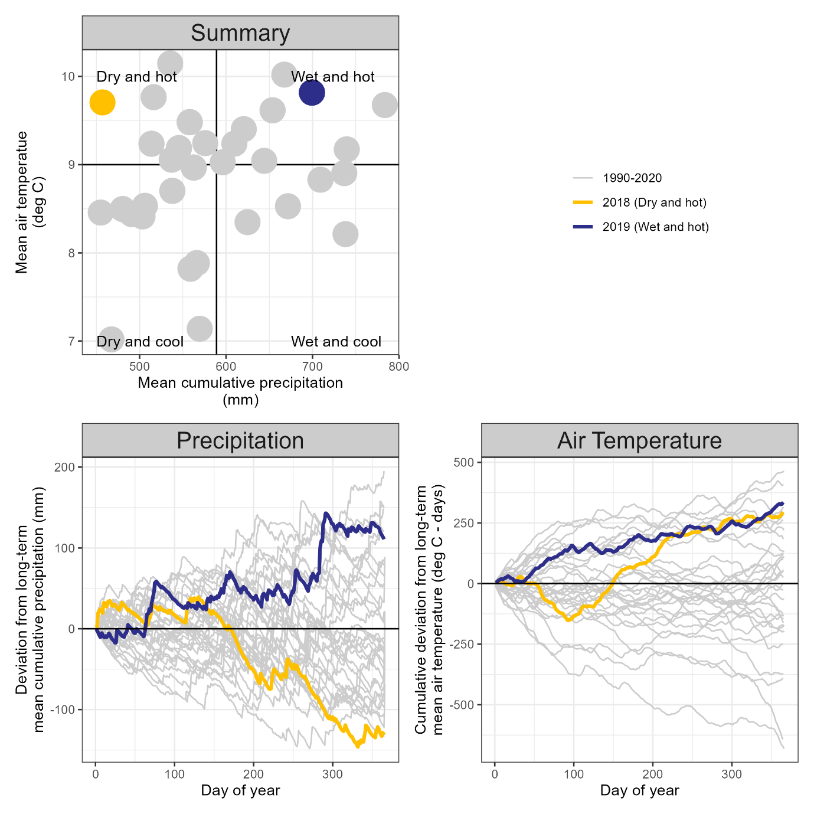

## Individual metrics

### Yields

As would be expected, yields varied significantly by crop (p= xx). Cover crop treatment had a significant (p = xx) impact on crop yields, and was not moderated by crop, tillage, residue management, or any of their interactions. The MixEarly treatment yielded the lowest, the MidRadish the highest, with all other treatments falling in between. Tillage and residue management had a significant interaction (p = xx), with no-till yields being higher than both xxxxx.

### Fall biomass

Cropping system had some influence on total aboveground biomass (increasing biomass with decreasing tillage intensity), but more strongly affected the proportion of biomass attributed to cover crops. What do I mean by this???

Radish cover crops consistently contributed over 50% of total biomass, while the mixes’ contributions varied (0–80%) within both planting timings.

The total fall biomass was blha blha.

### Soil cover (and value)

Percent soil cover did not vary by treatment or year (p = x-x), averaging 75% (Figure 2). Overall, volunteers contributed the highest coverage percent, followed by cover crops (X%) with minimal weed coverage (X%), but the relative contribution of each category varied by cover crop treatment (p = xx), year (p, ), blah blah.

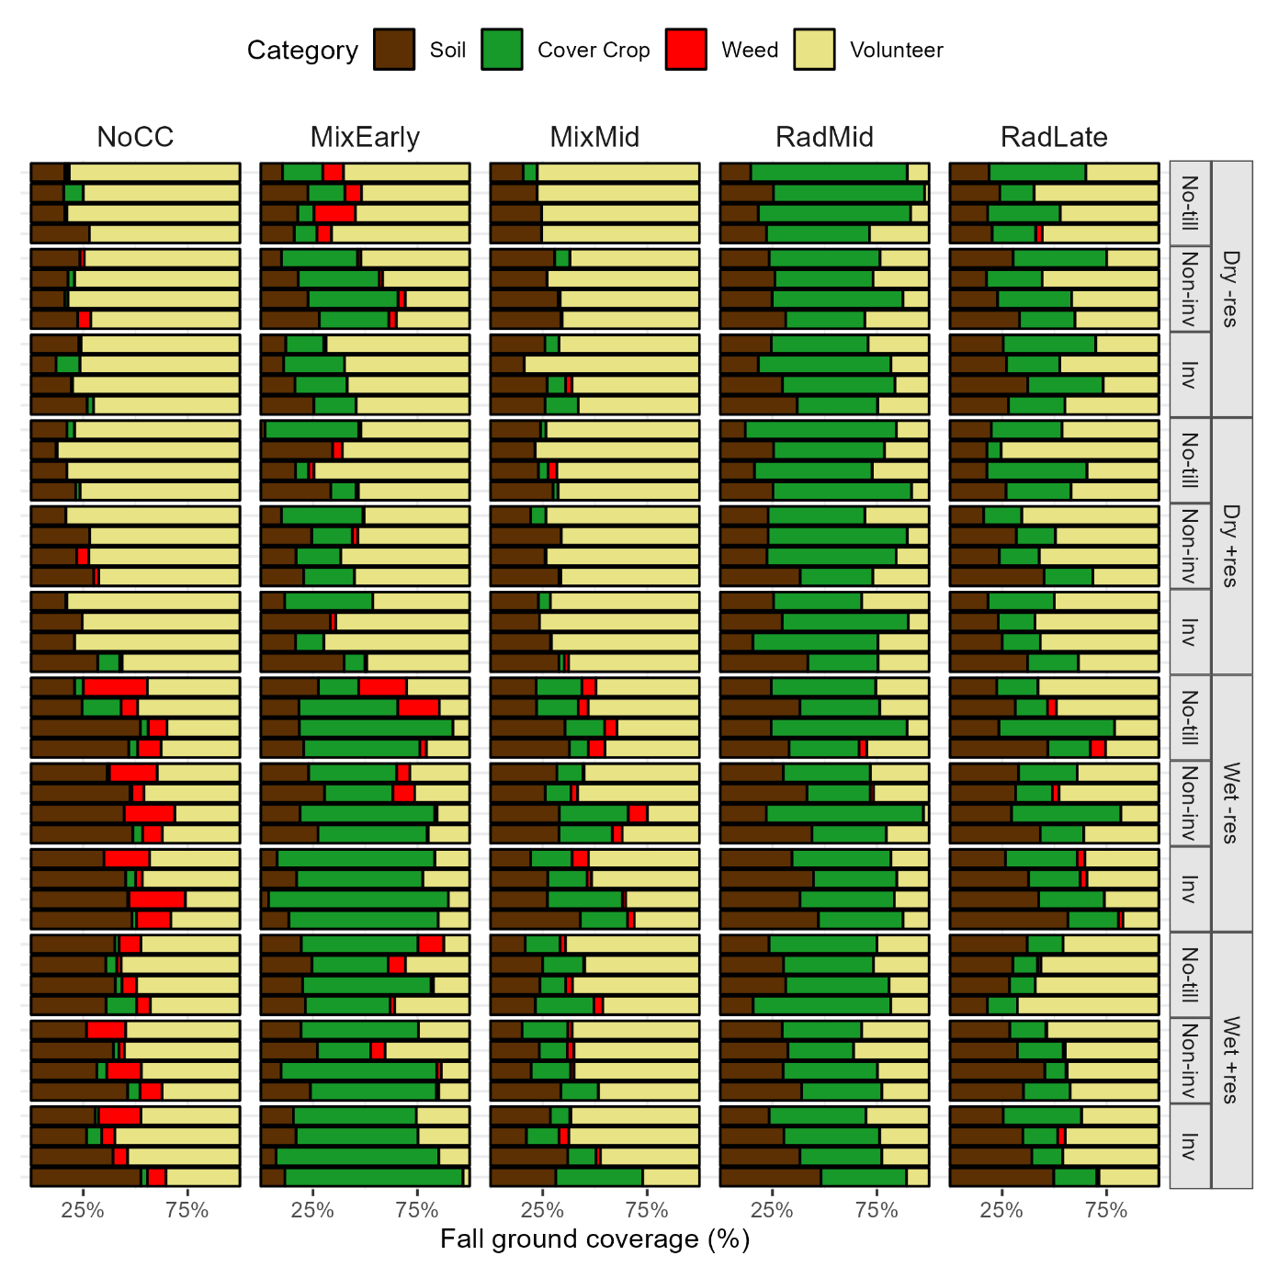

The volunteers (barley or oat), the radish, and the grass cover crop were neutral with regards to both potential ecological contributions, as well as potential agronomic harm. Therefore, and the

Volunteer crops and radish are neutral vegetation types that offer low services, but also low potential dis-services, while the X weed species/genuses offered a range of services and dis-services. When analyzed on a community level, the treatments resulting in the highest weed coverage therefore corresponded to the treatments with the highest potential services (Figure 2).

Figure

Radish treatments produced neutral vegetation communities, with neither high potential benefits nor harms. In contrast, the mixes and no cover crop treatments displayed both high potential harm and high potential benefit.

## Synthesis

Potential contributions to pollinators and ecosystems were calculated by multiplying the value of an individual species/genus by the percent cover. The maximum value (either pollinators or ecosystems) was assigned as the estimate of potential benefits from the fall vegetation, and agronomic harm was used as the estimate of potential disservices. The number of stems of Canadian thistle present after two

|  |  |
| --- | --- |
|  |  |

# Discussion