**A multi-criteria evaluation of fall vegetation services and dis-services in 30 cropping systems varying in cover crop system, tillage and residue management**

Virginia Nichols1, Emma Randhal-Beltran1, Marco Gentili1, Mette Sonderskov1, Bo Melander1

*1Aarhus University, Department of Agroecology, Crop Health Section,*

*Forsøgsvej 1, 4200 Slagelse, Denmark*

[*gina.nichols@*](mailto:gina.nichols@)*agro.au.dk*

# Abstract

With increasing environmental pressures from population growth and climate change, there is growing interest in assessing both the potential benefits and drawbacks of in-field, non-crop vegetation. This study evaluated fall vegetation communities and attendant agronomic performance in 30 replicated cropping systems over three growing seasons in Zealand, Denmark. Treatments included five cover crop systems [*Lolium perenne* and *Trifolium repens* mixture sown early- and mid-season, *Raphanus sativus* (radish) sown mid-season and post-harvest and a no cover crop control] embedded within every combination of three tillage approaches (no-till, surface, inversion) and two residue managements (retained, removed). Seven indices were used to capture biophysical, ecological and agronomic services and dis-services. Four were used to capture fall vegetation potential services and harms: (1) percent soil cover (soil protection), (2) total aboveground biomass (potential soil carbon input and nitrate leaching mitigation), (3) species-based ecological benefits, (4) species-based agronomic harm. Three metrics captured system impacts including (5) crop yields, (6) change in perennial weed abundance, and (7) pesticide toxicity loads.

The study coincided with the site’s driest (2018) and wettest (2019) growing seasons in 30 years. Soil cover remained stable (~75%) across treatments and years. Only radish cover crops consistently increased fall biomass compared to the no-cover control (is this true?) Radish cover crops always contributed over 50% of total fall biomass, while the mixes’ contributions varied by year, cropping system, and planting date (0–80%). Radish treatments produced neutral vegetation communities, with neither high potential benefits nor harms. In contrast, the mixes and no cover crop treatments displayed both high potential ecological benefits and high potential agronomic harm. Overall, across tillage, residue, and weather the mid-season planted radish exhibited the highest fall biomass, moderate pesticide toxicity, high crop yields, and produced fall vegetation with low potential ecological value. The early planted mix had low to moderate fall biomass, moderate crop yields, high pesticide toxicity loads, and x times more perennial weed increases compared to other treatments, but supported fall vegetation that had high potential ecological value. Depending on producer goals, mid-season planted radish cover crops may exhibit more consistent benefits across cropping systems and weather conditions compared to grass/clover mixtures. These results underscore the complexity of defining ‘beneficial’ vegetation in agricultural systems, highlighting the interplay between multiple biophysical, ecological and agronomic outcomes.

# Introduction

Environmental pressures resulting from population growth and climate change have led to a significant decline in biodiversity (CITE). Given the extensive land area dedicated to arable agriculture, agricultural management plays a crucial role in shaping biodiversity levels (CITE). Consequently, there is a growing need for agricultural systems that integrate ecosystem health and biodiversity conservation with commercial production objectives. In response, researchers are increasingly assessing non-crop plant communities (e.g., weeds) and their attendant management strategies for their impacts on biodiversity. This requires estimating both the ecological value of these communities within and beyond agro-ecosystems, their possible negative impacts on crop production, and the ecological impacts of their management (Esposito et al., 2023; Petit et al., 2011; Storkey and Westbury, 2007).

Non-crop communities embedded within production fields may offer a range of ecological benefits. They may serve as important promotors of plant diversity (CITE), provide food sources for a high diversity of organisms (Balfour and Ratnieks, 2022; Marshall et al., 2003), offer habitat (CITE), reduce nitrate leaching *(Blaix et al., 2018; Huang et al., 2018b)* (Sullivan et al., 2017), contribute to soil organic carbon (Jian et al., 2020), or mitigate soil erosion (Moreau et al., 2020)

*However, weeds also provide services for agroecosystems, promoting plant biodiversity and feeding other organisms potentially valuable to crop production (e.g pollinators, beneficial predators such as carabid beetles) (Petit et al., 2011; Kulkarni et al., 2015; Rollin et al., 2016).*

In agricultural systems that utilize tillage and/or herbicides, studies have found fall cover cropping has a minimal impact on subsequent weed pressure due to the strong filters exerted by spring tillage or herbicide application (Adeux et al., 2023; Rouge et al., 2023) (Adeux et al., 2023, 2021) OTHERS. It follows that fall non-crop vegetation may present a unique opportunity for optimization, allowing the expression of ecologically beneficial weeds without resulting in future agronomic harm, in addition to providing services such as soil cover and soil nitrate retention (CITE). The interaction between cover crops, tillage and residue management is complex, and it is unclear how these factors might be combined to optimize the services provided by fall non-crop vegetation. To better understand the potential for optimizing fall non-crop vegetation services, we embedded five cover cropping systems within six combinations of tillage and residue managements, resulting in 30 unique cropping systems. Using these 30 systems as a platform, the objectives of this study were to:

1. Quantify the services resulting from management combinations
   1. Soil protection
   2. Reduction of nitrate leaching
   3. Ecological value
2. Quantify the dis-services resulting from management combinations
   1. Reduced cash crop yields
   2. Pesticide toxicity loads to the environment
   3. Future agronomic harm potential
3. Understand how cover cropping systems interact with tillage, residue removal, and weather in provision of these services and dis-services

# Materials and Methods

## Field management

This study was conducted within a larger long-term crop rotation and tillage continuous experiment which was established in 2002 on a sandy loam at Flakkebjerg Research Centre, Denmark (55.317, 11.400). Averaged across the trial site, soil texture is 14.7% clay (<2 mm), 13.7% silt (2-20 mm), 42.6% fine sand (20-200 mm), and 27% coarse sand (200-2000 mm), with 1.2% organic carbon content (0-25 cm). The overall experimental design of the long-term experiment is a split-split plot with four replications. The main plot factor is cropping system (four levels), the subplot is primary tillage system (four levels) and the sub-subplot (six levels) was established to accommodate various sub-treatments within rotation and tillage combinations [see for example Melander et al. (2008)]. The cash crop sequence during the present study was spring barley (*Hordeum vulgare* L.) sown 19 April 2018, spring oat (*Avena sativa* L.) sown 4 April 2019 and faba beans (*Vicia faba* L.) sown 15 April 2020. Detailed tables and a visual of the study’s agronomic management are presented in supplemental material, but are described here briefly.

### Study design

For the purpose of the present study, two cropping systems were selected that had the same sequence of crops but with different small grain straw managements that reflect common systems in Denmark: straw removed or retained. Therefore, in the present study, straw management composed the main-plot treatment. Three of the four tillage regimes were used for this study (more details below). Tillage subplots were 5 meters wide and 40 m long. Each tillage subplot was divided into two columns with three sub-subplots arranged within each column for a total of six sub-subplots that were 2.5 m wide and 12.5 m long (see supplementary material for a visual aid). One of the six sub-subplots was reserved for other sampling efforts, and a cover crop system treatment (five levels) was applied randomly to the remaining five sub-subplots. In summary, this experiment included all combinations of two straw-managements, three primary tillage systems, and five cover crop systems for a total of 30 treatments.

### Straw and tillage treatments

The same straw managements and categorical tillage system treatments (no tillage, surface, inversion) have been in the same subplots since 2002. In the straw-removal treatments, following harvest of a small grain the residue (e.g., straw) was removed using a MACHINE, resulting in removal of approximately 60% of the biomass (do we have any pictures of the straw retained and straw removed treatments, so we can see how the ground was still covered by little bits of straw after straw removal? CITE a CENTS modelling study for this 60% assumption). In the straw-retained treatments, harvest residue was allowed to remain in the field. The exact machinery and timing of operations for each categorical tillage treatment have varied since 2002 (Scherner et al., 2016; Hansen et al., 2010). In the present experiment (2018-2020), plots under the inversion tillage treatment were moldboard plowed to a depth of 20 cm in the fall and harrowed to 3-4 cm depth in the spring before cash crop planting; crops were then sown with a traditional seed drill (Nordsten Lift-o-matic CLH300) with row spacings of 12.5 cm. For the surface tillage system (non-inversion), a Horsch Terrano 3 FX stubble tine cultivator was used to till to a depth 8-10 cm in the spring before cash crop planting. In both the no-till and surface tillage systems, crops were sown with a chisel coulter (Horsch Airseeder CO 3) with row spacings of 17.5 cm for spring oats, spring barley, and faba beans. Row spacings were different for the inversion tillage system due to equipment representing typical production environments for each tillage system.

### Cover crop treatments

Starting in the 2018 growing season, five cover crop systems were randomly applied to the sub-subplots (**Table 1).** The same sub-subplot treatments were maintained for 2018, 2019 and were tracked until faba bean harvest in 2020. The sampling area for all measurements was located in the inner 1.5 m x 10 m area of the sub-subplots.

Table 1. Summary of the five cover crop systems

|  |  |  |  |
| --- | --- | --- | --- |
| Cover crop system name | Cover crop | Seeding rate | Seeding method and timing |
| MixE | Perennial ryegrass *(grass; Lolium perenne)* and red clover *(clover; Trifolium pratense)* | 3 kg ha-1 grass + 8 kg clover ha-1 | Sown 1 cm deep in 12.5 cm rows between cash crop rows shortly after cash crop planting |
| MixM | Broadcast into standing crop approximately 14 days before expected cash crop harvest |
| RadM | Fodder radish *(Raphanus sativus)* | 14 kg ha-1 | Broadcast into standing crop approx. 14 days before expected crop harvest |
| RadL | Broadcast into the crop stubble post crop harvest |
| NoCC | None | - | - |

### Fertilizer and herbicides

Mineral fertilizer was broadcast on spring barley plots on 17 April 2018 (126 kg N ha-1, 24 kg P ha-1 and 60 kg K ha-1); on spring oat plots on 3 April 2019 (80 kg N ha-1, 15 kg P ha-1 and 38 kg K ha-1 ); and on faba beans on 15 April 2020 (32 kg P ha-1 and 80 kg K ha-1).

Herbicide treatments reflected best practices and constraints imposed by both the tillage and cover crop system treatments. Each herbicide package (HP) is described in detail in supplementary material. In the no-till and surface tillage treatments, all plots were sprayed with HP1 (2018, 2019) or HP2 (2020) before cash crop planting. For the inversion tillage treatments, no herbicide was sprayed before cash crop planting. In 2018 (spring barley), to accommodate the presence of the grass and clover present in the Mix-early plots, those plots were sprayed on 16 May 2018 with an herbicide package that does not affect clover or grasses (HP3); all other plots were sprayed the same day with a different herbicide package (HP4). On 29 May 2018, all plots except the Mix-early plots were sprayed (HP5) to control Canada thistle (*Cirsium arvense*); Mix-early plots were not sprayed because HP5 would have terminated the cover crop. In 2019 (spring oat), on 14 May the Mix-early plots were again sprayed with the same herbicide package used in 2018 (HP3) while all other plots were sprayed with a different package (HP6) to….. Following faba bean planting in 2020, all plots were sprayed with HP7 on 6 May 2020 and again on 20 May 2020. On 2 June 2020, all plots were sprayed (HP8) to control wild oat (*Avena fatua*). All plots were managed identically for diseases and insect pests according to Danish standard recommendations and policies. Herbicide use data was translated into potential toxicity loads using the Danish Pesticide Load Indicator (PLI; Kudsk et al. 2018).

The long-term experiment is rainfed, but in 2018 an exception was made due to an extremely hot and dry early growing season. In order to maintain the long-term viability of the experiment, all plots were irrigated with 25 mm in early June to ensure the early establishment of all treatments. Irrigation was done with sprinklers mounted on a boom that was dragged through the experiment.

Weather data for the present study was obtained from the Danish Meteorological Institute's (DMI) Open Data API for the Flakkebjerg station (55.322, 11.388). The 30-year (1990-2020) mean annual temperature and precipitation for the site are 8.9 degrees Celsius and 589 mm, respectively.

## Measurements

### Crop yields

Each sub-subplot (net size 10 m x 1.5 m) was harvested for grain yield with a plot combine (8 August 2018 barley, 15 August 2019 oat, 24 August 2020 faba bean). Dry matter content was determined by a near-infrared spectroscopy analyzer (InfraTec™ 1241 Grain Analyzer, Foss A/S; [Buchmann et al., 2001](https://www-sciencedirect-com.ez.statsbiblioteket.dk/science/article/pii/S0167198710000541" \l "bib4)). Grain yields are reported on a dry matter basis.

### Vegetation measurements

Three categories of vegetation measurements were taken (Table 2), and are described in detail below.

Table 2. Summary of vegetation measurements

|  |  |
| --- | --- |
| **Measurement** | **Levels of measurement resolution** |
| Fall ground cover (%) | Soil  Species (AVESA*, CAPBP, CIRAR, EPHEX, HORVW, LOLPE, MATIN, PAPRH, RAPSR, TAROF, TRFRE)  Genus (GERSS, LAMSS, SENSS, VERSS) |
| Fall biomass (g m-2) | Cover crop  Other (all other biomass) |
| Spring weed counts (number m-2) Bo, just making sure the data you gave me is on a per m2 basis | CIRAR  EQUAR  Dicot  Monocot |
| *EPPO code, see supplemental material for Latin names | |

#### Fall ground cover

Ground cover composition was estimated from digital images taken in the fall (9 November 2018 and 1 November 2019) as done in Melander et al. (2013). Briefly, a 0.5 m2 quadrat was placed in the plot, and an image was taken from a height of 1 m above the center of the quadrat. Three images were taken in each plot, meaning 10% of the sub-subplot area was sampled (1.5 m2 per 15 m2 plot). Each image was subsequently overlaid with a grid consisting of 17 vertical and 17 horizontal lines, resulting in 289 intersections per image. Each intersection was classified as a soil or plant. Plant intersections were further classified to the species (12) or genus (4) level (**Table 2**). Percent coverage of each type was then calculated by dividing the number of touched intersections in that category by 289 intersections. For categorical analyses, each species/genus was classified as ‘cover crop’, ‘volunteer’ or ‘other.’

#### Fall biomass

The amount of aboveground vegetative biomass in each treatment was measured shortly after image collection for fall ground cover measurements (15 November 2018 and 13 November 2019, respectively). Two 0.5 m2 quadrats were randomly placed in each plot, and all aboveground biomass was cut at ground level and removed. The biomass samples from the two quadrats were combined, then separated into three fractions: cover crops, weeds and volunteers in 2018. In 2019, biomass was only separated into two fractions (cover crops and other, the latter of which included both weeds and volunteers). Therefore, the categories ‘cover crop’ and ‘other’ were used for all statistical analyses (**Table 2**). The biomass fractions were dried in the oven at 80oC for 24 hours and weighed. Dry biomass for each category was converted to grams per m2.

#### Spring weed counts

The weed flora emerging in spring in the experimental plots was assessed on 22 May 2019 and 27 May 2020 after post-emergence weed control. Four weed categories were counted in three randomly placed 0.25 m2 quadrats per plot. The categories were dicots, monocots, Canada thistle (*Cirsium arvense*) and horsetail (*Equisetum arvense*). The spring counts were made to record whether there were any traceable effects from previous year’s cover crop treatments. The weed counts in spring were affected by the earlier herbicide spring applications, and the goal was to assess whether the previous fall vegetation resulted in carry-over effects that were detectable even after weed control measures.

#### Pesticide toxicity, potential ecological value, and agronomic harm

Herbicide use data was translated into potential pesticide load index (PLI) using the Danish-PLI methodology (Kudsk et al., 2018). Potential ecological value and agronomic harm were estimated using a methodology derived from that of Yvoz et al. 2021. For ecological value, two indices were estimated. The first, potential benefits to pollinators, was comprised of three sub-indices representing (1a) the absolute benefit to bees (LATIN), (1b) bumble bees (LATIN), and (1c) hoverflies (LATIN). The second, potential benefits to organisms, was comprised of three sub-indices representing (2a) absolute contributions to farmland birds, (2b) carabids, and (2c) parasitoid wasps. The agronomic harm index was comprised of three sub-indices representing (3a) competition with crops, (3b) contribution to harvest difficulties, and (3c) contribution to future weed infestations. More details on each sub-index are presented in supplemental material. Plant level attributes reported by Yvoz et al. 2021 for 155 species were used to assign sub-index values to each of the 12 species in our dataset. For the four genuses in our dataset, the median value for all species reported in the database within that genus were used. After each species/genus in the present study was assigned a value for each of the nine sub-indices, the sub-indices were scaled within the present study such that the maximum value was assigned a value of 1, and the minimum a value of 0. Sub-indices were summed to provide an estimate for each of the three indices (on a scale of 0-3) for each of the 16 species/genuses observed in our study. These values were weighted by the species/genuses’ percent cover for each sample to calculate the fall vegetation community’s potential benefit to pollinators, potential contributions to organisms, and potential to cause agronomic harm. For the ‘synthesis’ analysis, the maximum value between the benefit to pollinators and contribution to organisms was used to represent the community’s potential ‘ecological benefits’.

### Statistics

All statistics and figures were done using R version 4.3.3 (CITE) relying heavily on the tidyverse meta package (CITE), and several additional packages (CITE gh4x, readxl, others?). For all statistical models, several models were tested using lme4 (CITE), nlme (CITE), and glmmTMB (CITE), and the best fit was chosen based on inspection of residual plots and AIC criteria (CITE). Only the best fit model is described here, but the R code is available as part of the github repository for this publication (CITE). Marginal means and contrasts were estimated using emmeans (CITE).

Crop yields were modelled using lme4 with main effects of crop, tillage, residue, and cover crop treatment and all possible interactions with a random effect of block, and a random effect of tillage nested within residue nested within block.

For total fall biomass, first a universal model was fit that included fixed effects of a year factor, tillage, residue, and cover crop, but every term had a significant interaction with year. To simplify interpretation, a separate model was then fit separately to each year’s data. In both years, total biomass was modelled using glmmTMB with main fixed effects of tillage, residue, and cover crop and all of their interactions with random effects for block, tillage, and cover crop nested within tillage. Significance letters were assigned to each group within each year using the multcomp package (CITE).

For the proportion of fall biomass, the cover crop proportion was modelled using glmmTMB with fixed effects of tillage, cover crop, residue, and a year factor with a random effect of block using a binomial family with a logit link.

# Results

## Weather

Figure 1. Weather

## Individual metrics

### Yields - DONE

Yields varied significantly by crop (p<0.001) and by cover crop treatment (p<0.001), but did not vary significantly by any other factors or their interactions. In 2018 spring barley yields averaged 4.07 Mg ha-1, in 2019 oat yields averaged 4.28 Mg ha-1, and in 2020 faba bean yields averaged 3.47 Mg ha-1. The average grain yields of the present study were lower than national averages for the same crops in the same years [4.28 Mg ha-1 spring barley, 4.94 oats, and 4.08 Mg ha-1 faba bean, respectively (FAO, 2023)], but the maximum grain yields observed each year exceeded the national averages. On average, the RadM cover crop treatment exhibited 8% higher crop yields compared to all other cover crop treatments, which did not vary significantly from each other.

### Fall biomass

In 2018, average fall biomass production was 2.27 Mg ha-1 there was a significant amplifying interaction between tillage and cover crop treatment (p=0.048). No-till significantly increased fall biomass in all cover crop treatments compared to surface and inversion tillage, but this effect was most amplified in the RadM cover crop (Figure 2). On average, decreasing tillage intensity significantly increased fall biomass by 9% and 27% when moving from inversion to surface, and surface to no-till, respectively. In 2018 removal of residue had no impact on fall biomass. In 2019 average fall biomass production averaged 0.99 Mg ha-1), and while there was a significant three-way interaction between tillage, residue, and cover crop (p= 0.03). The radish cover crops (RadM and RadL) followed the same pattern as in 2018 with regards to tillage (increasing biomass with decreasing tillage intensity), while the other cover crop treatments had varying patterns with small differences that were not physically relevant magnitudes.

Figure 2. Fall biomass

Radish cover crops consistently contributed over 50% of total fall biomass, , while the mixes’ contributions varied (0–80%). The mid-season planted mix (MixM) never contributed more than 20% of the total fall biomass.

### Soil cover (and value)

Percent soil cover did not vary by treatment or year (p = x-x), averaging 75% (Figure 2). Overall, volunteers contributed the highest coverage percent, followed by cover crops (X%) with minimal weed coverage (X%), but the relative contribution of each category varied by cover crop treatment (p = xx), year (p, ), blah blah.

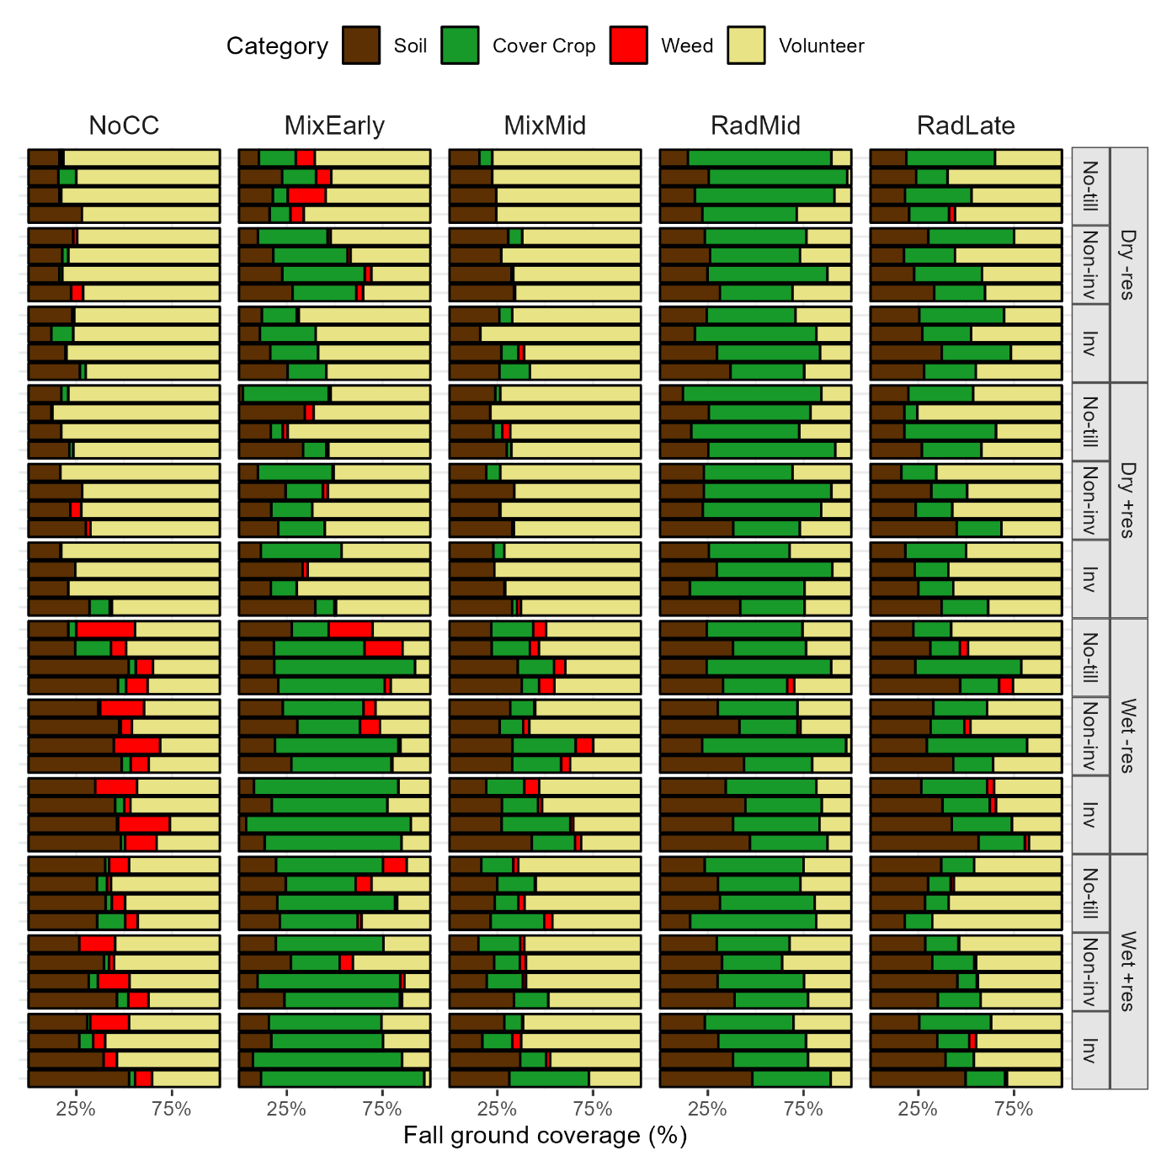

The volunteers (barley or oat), the radish, and the grass cover crop were neutral with regards to both potential ecological contributions, as well as potential agronomic harm. Therefore, and the

Volunteer crops and radish are neutral vegetation types that offer low services, but also low potential dis-services, while the X weed species/genuses offered a range of services and dis-services. When analyzed on a community level, the treatments resulting in the highest weed coverage therefore corresponded to the treatments with the highest potential services (Figure 2).

Figure

Radish treatments produced neutral vegetation communities, with neither high potential benefits nor harms. In contrast, the mixes and no cover crop treatments displayed both high potential harm and high potential benefit.

## Synthesis

Potential contributions to pollinators and ecosystems were calculated by multiplying the value of an individual species/genus by the percent cover. The maximum value (either pollinators or ecosystems) was assigned as the estimate of potential benefits from the fall vegetation, and agronomic harm was used as the estimate of potential disservices. The number of stems of Canadian thistle present after two

|  |  |
| --- | --- |
|  |  |

# Discussion