What do we know about the continuous maize penalty? A modelling study

**Intro stuff, just for myself right now**

However, understanding if genetic improvements have led to changes in the continuous corn penalty over time remains unknown, and could help shed light on possible mechanisms.

Nitrogen-rate trials provide a means of assessing a corn crop’s agronomically-optimum nitrogen rate (AONR), which occurs at the point where application of additional nitrogen fertilizer does not result in increased yields. Two corn-based systems have been traditionally included in many state’s nitrgeon rate trials: corn grown in alteration with soybean (rotated corn), and corn grown continuously (continuous corn). In a given year, at rotated corn’s AONR, continuous corn is likely to yield less compared to the rotated corn’s yields. This yield gap can be partially overcome through additional N fertilization. On average, producers are advised to apply an additional 50 kg/ha of nitrogen above the rotated corn’s AONR (CITE). However, even at high nitrogen rates, continuous corn will often still yield less than rotated corn (CITE). This difference in the maximum yields attainable in rotated- and continuous-corn systems is referred to as the ‘continuous corn penalty’.

The yield penalty can therefore be decomposed into two components: nitrogen-based, and non-birgeon based. Major cropping system models have the ability to simulate the nitrogen-derived portion of the penalty, but not the remaining (CTE). This inability to capture non-N dynamics results in over-predictions of continuous corn yields, which has implications when predicting long-term impacts of cropping systems, including carbon balances, N balances, residue cover, and XX (CITE). In order to accurately assess these systems, and to incorporate the penalty into models, we need a more mechanistic understanding of the two components of the continuous corn penalty. To our knowledge, how the N contribution to the penalty varies based on site or weather, has not been investigated. Likewise, there has been little work concerning the non-N component of the penalty. This is in part due to the complex nature of the penalty, with soil legacies, weather, management, and XX creating complex interactions that are difficult to tease apart with yield data alone. Furthermore, understanding if genetic improvements have led to changes in the continuous corn penalty over time remains unknown, and could help shed light on possible mechanisms.

To address these knowledge gaps, we used XXX site-years of nitrogen rate trials in Iowa and Illinois (i) to explore the variation in the nitrogen component of the continuous corn penalty, and (ii) to calibrate the an Agricultural Production Systems Simuator (APSIM) model to explore the feasibility of non-N contributions to the penalty.

Our objectives were to:

1. Explore the trends in the continuous corn penalty over the past 20 years
2. Quantify variation in the nitrogen and non-nitrogen components of the continuous maize penalty
3. Identify pathways by which the non-nitrogen components may be enacted using models
4. Suggest future research goals

Continuous corn systems are more sensitive than rotated corn systems to nitrogen fertilizer applications above the AONR for that site-year, with small excesses resulting in large increases in nitrate leaching per unit fertilizer applied (Pasley et al. 2021).

**Exploring the continuous corn penalty**

Both satellite and experimental data have shown the continuous corn penalty does not compound with the number of years in corn (Meese et al. 1991, Crookston et al. 1991, Porter et al. 1997, Seifert et al. 2017), with an average yield depression of 15% (Fig X).

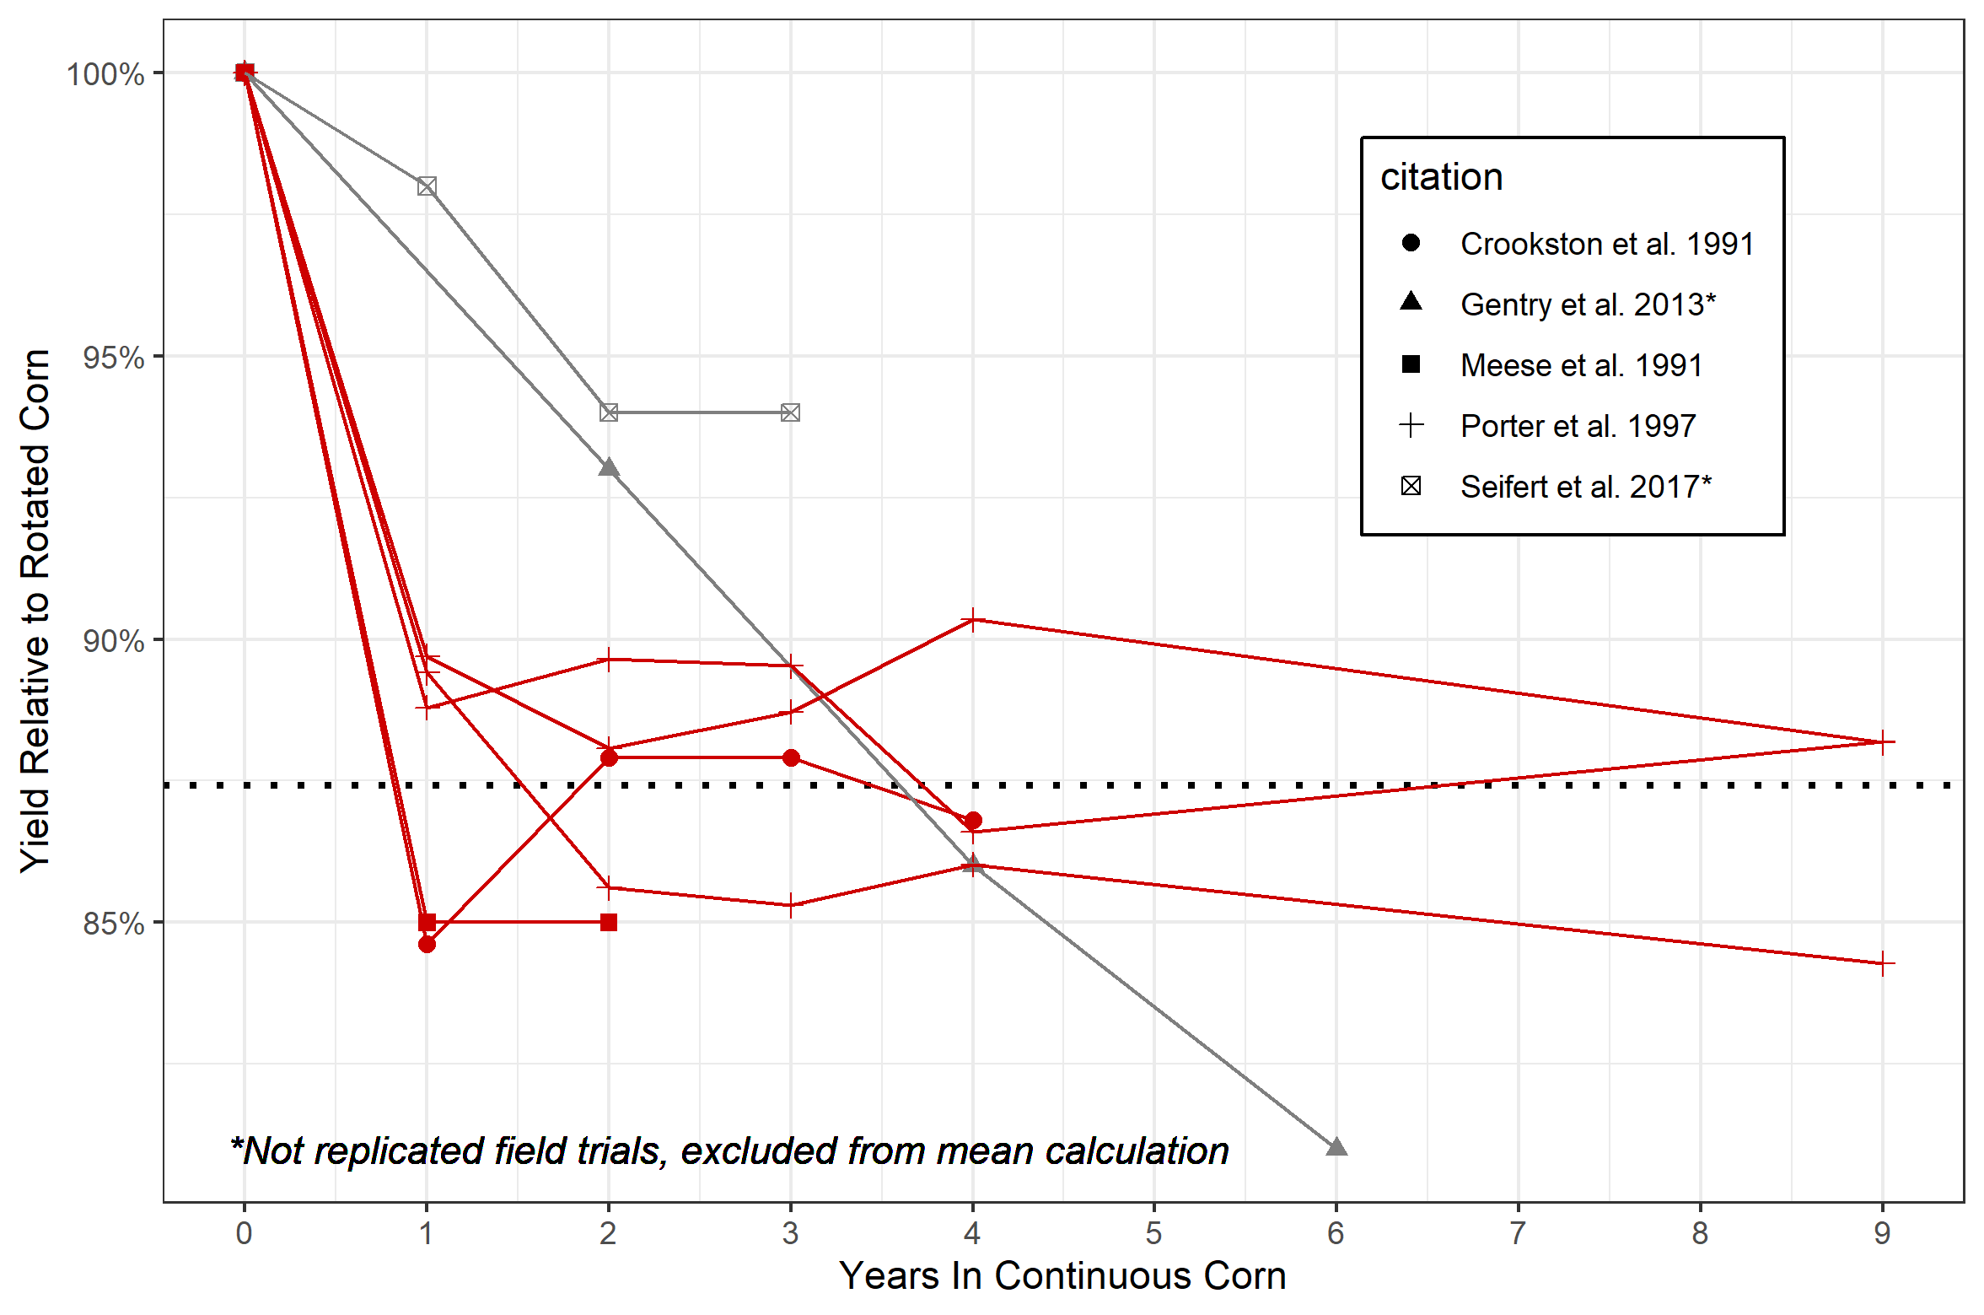

To our knowledge, the longest duration of reported data on the continuous corn penalty spans 9 years, and in order to maintain experimental consistency the studies utilized the same hybrid for the entire duration (Crookston et al. 1991, Porter et al. 1997). Our dataset includes sites with 8-16 years of data at a range of nitrogen fertilizations, with hybrids updated to reflect the most modern genetics, albeit with the same hybrid used for both continuous and rotated corn systems. It is possible by using a different hybrid for continuous corn versus rotated corn systems could reduce the penalty. Indeed, a study using satellite data found a smaller yield penalty than that reported in controlled field studies (7% versus 15%; Fig. 1), suggesting farmers are reducing the penalty through management, which may include hybrid choice. However, even with farmer management the penalty is consistently observed, indicating it cannot currently be overcome with current management options. In our dataset, 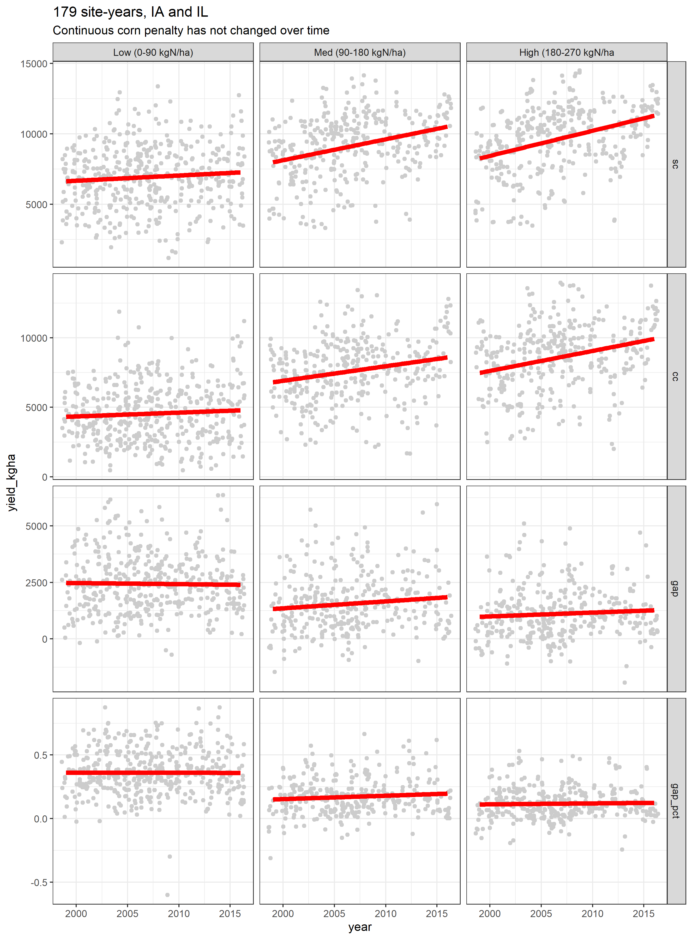both continuous- and rotated-corn yields have remained steady over time at low nitrogen rates, leading to an equally steady penalty at low nitrogen rates. Conversely, at high nitrogen rates, yields of both continuous- and rotated-corn yields have increased at rates of 176 (SE:27) and 174 (SE:23) kg grain yield/year, respectively. As a result of the equal rates of increases, the continuous corn penalty at high nitrogen rates has likewise remained constant over the years, estimated at 2350 (SE:191) and 1035 (SE:145) kg/ha at low and high nitrogen rates, respectively.

It is well-known that the agronomically-optimum nitrogen rate for corn grown following corn is higher than for corn following soybean (CITE). However, to our knowledge the ability of nitrogen application to overcome the yield penalty has not been examined. Using 177 site-years of nitrogen-response curves, we calculated the percentage of the yield gap at the rotated corn’s AONR that could be overcome with fertilization (schematic 1).

Previous research has suggested that lower-yielding environments benefit more from crop rotation, indicating higher-yielding environments have lower penalties (e.g. Seifert et al. 2017, Gentry et al. 2013). Often studies average all rotation’s corn yields to quantify high and low-yielding environments. Our data demonstrate that this approach may be misleading. By taking the rotated corn yields to be more representative of a site-year’s yield potential, the penalty does not decrease as a site-year’s yield potential increases (Fig. X). We found the penalty, either as a percentage or as kg/ha, is, on average, higher and more consistently observed in site-years yielding more than 9000 kg/ha compared to site-years yielding less.

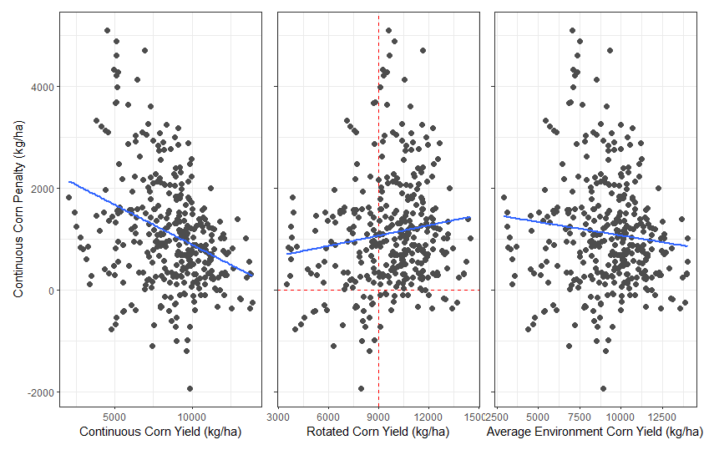

These analyses indicate the continuous corn penalty is both persistent, regardless of improvements in management and genetics, and, contrary to previous findings, may be a bigger concern for producers in high-yielding environments.

**Pathways**

The effect of the previous crop (corn, or soybean) may be mediated through three main mediators: (i) above-ground organic matter (i.e. crop residue), (ii) below-ground organic matter (roots, tilled residue), and (iii) soil nitrogen pool legacies. Each of these mediators provides unique paths for the previous crop to affect the subsequent corn crop’s yield. Additionally, there are path by which mediators interact.

**Pathway contributions**

*Aboveground*

Corn foliar diseases require inoculum to be transferred from corn residue to the above-ground biomass of an activity growing corn plant. As a result, severity of corn foliar diseases are generally related to the amount of residue on the soil surface (cite). However, severity of foliar corn diseases is not only a function of corn residue on the surface, but is also a function of environmental conditions and use of fungicides. In our dataset, the size of the continuous corn penalty was not related to the amount of stover produced (modelled), the amount of residue on the surface at planting (modelled), nor the previous crop’s yield (experimental).

Experimental data collected from 17 sites years in Iowa showed tillage, and therefore residue cover, had no effect on stand counts of continuous corn systems. IN other words, tillage did not change stand counts in continuous corn systems, indicating above-ground residue is not affecting corn seedling establishment.

Speed of emergence – do that math. The previous crop, and therefore the potential amount of residue on the soil surface may affect soil temperatures, subsequently affecting the speed of corn seed germination. Field data shows the effect of corn versus soybean residue on soil temperatures at 4-10 cm depths are inconsistent, and are erased by tillage. When present, the soil temperature differences were less than 1 deg C. This could result in a XX day delay in corn germination in continuous compared to rotated corn systems. Modelling results showed this delay would have small, and inconsistent effects on crop yields, meaning delayed germination in continuous corn is not likely a strong cause of the continuous corn yield penalty. To our knowledge, there are no published studies regarding the effect of soybean rotation on corn emergence dates relative to continuous corn.

Soil moisture….need to read…

*Belowground*

The carbon-to-nitrogen ratio of roots and incorporated stover will impact the soil nitrogen pool throughout the growing season (cite). Additionally, roots can serve as hosts for soil-borne disease that affect the root structure of the growing crops (cite). Compromised root architecture can limit the corn crop’s access to both water and nutrients. Studies in irrigated and high-input systems have shown the continuous corn penalty persists even in those conditions, suggesting the corn crop’s access to resources may be compromised in the continuous corn systems. Field studies in both Minnesota and Wisconsin have shown corn roots are thicker and shallower in continuous corn systems compared to rotated corn, further suggesting this is a potentially major pathway affecting the size of the penalty.

*Soil nitrogen pool*

Need help here.

We used 117 site-years of nitrogen response data to estimate the percentage of the penalty that can be overcome with additional nitrogen application over the rotated corn’s agronomically-optimum rate.

The value varied from year to year. For example in brow 2004, the gap

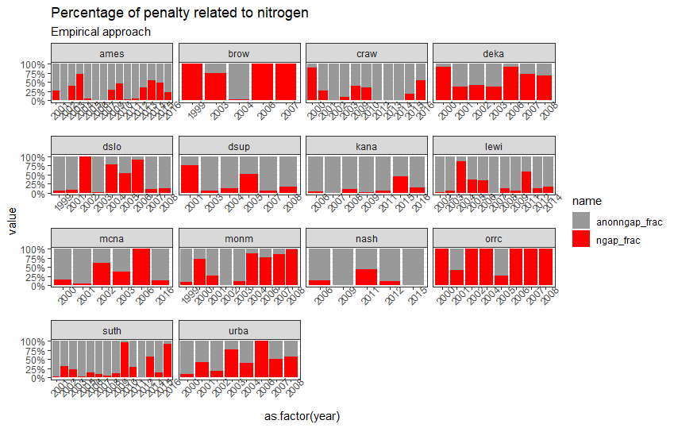

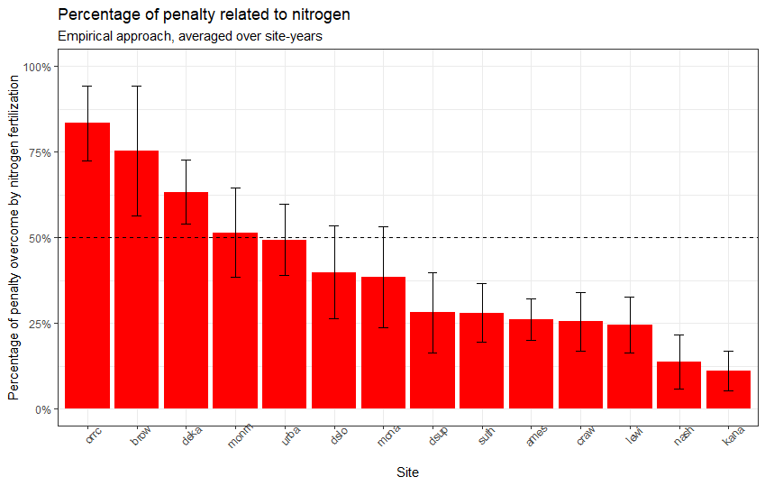

*Interactions*

Residue type (corn versus soybean) has a stronger effect on soil moisture than soil temperature (CITE). Increased soil moisture levels can promote soil-borne diseases, fomenting root disease and it’s affects on root architecture.