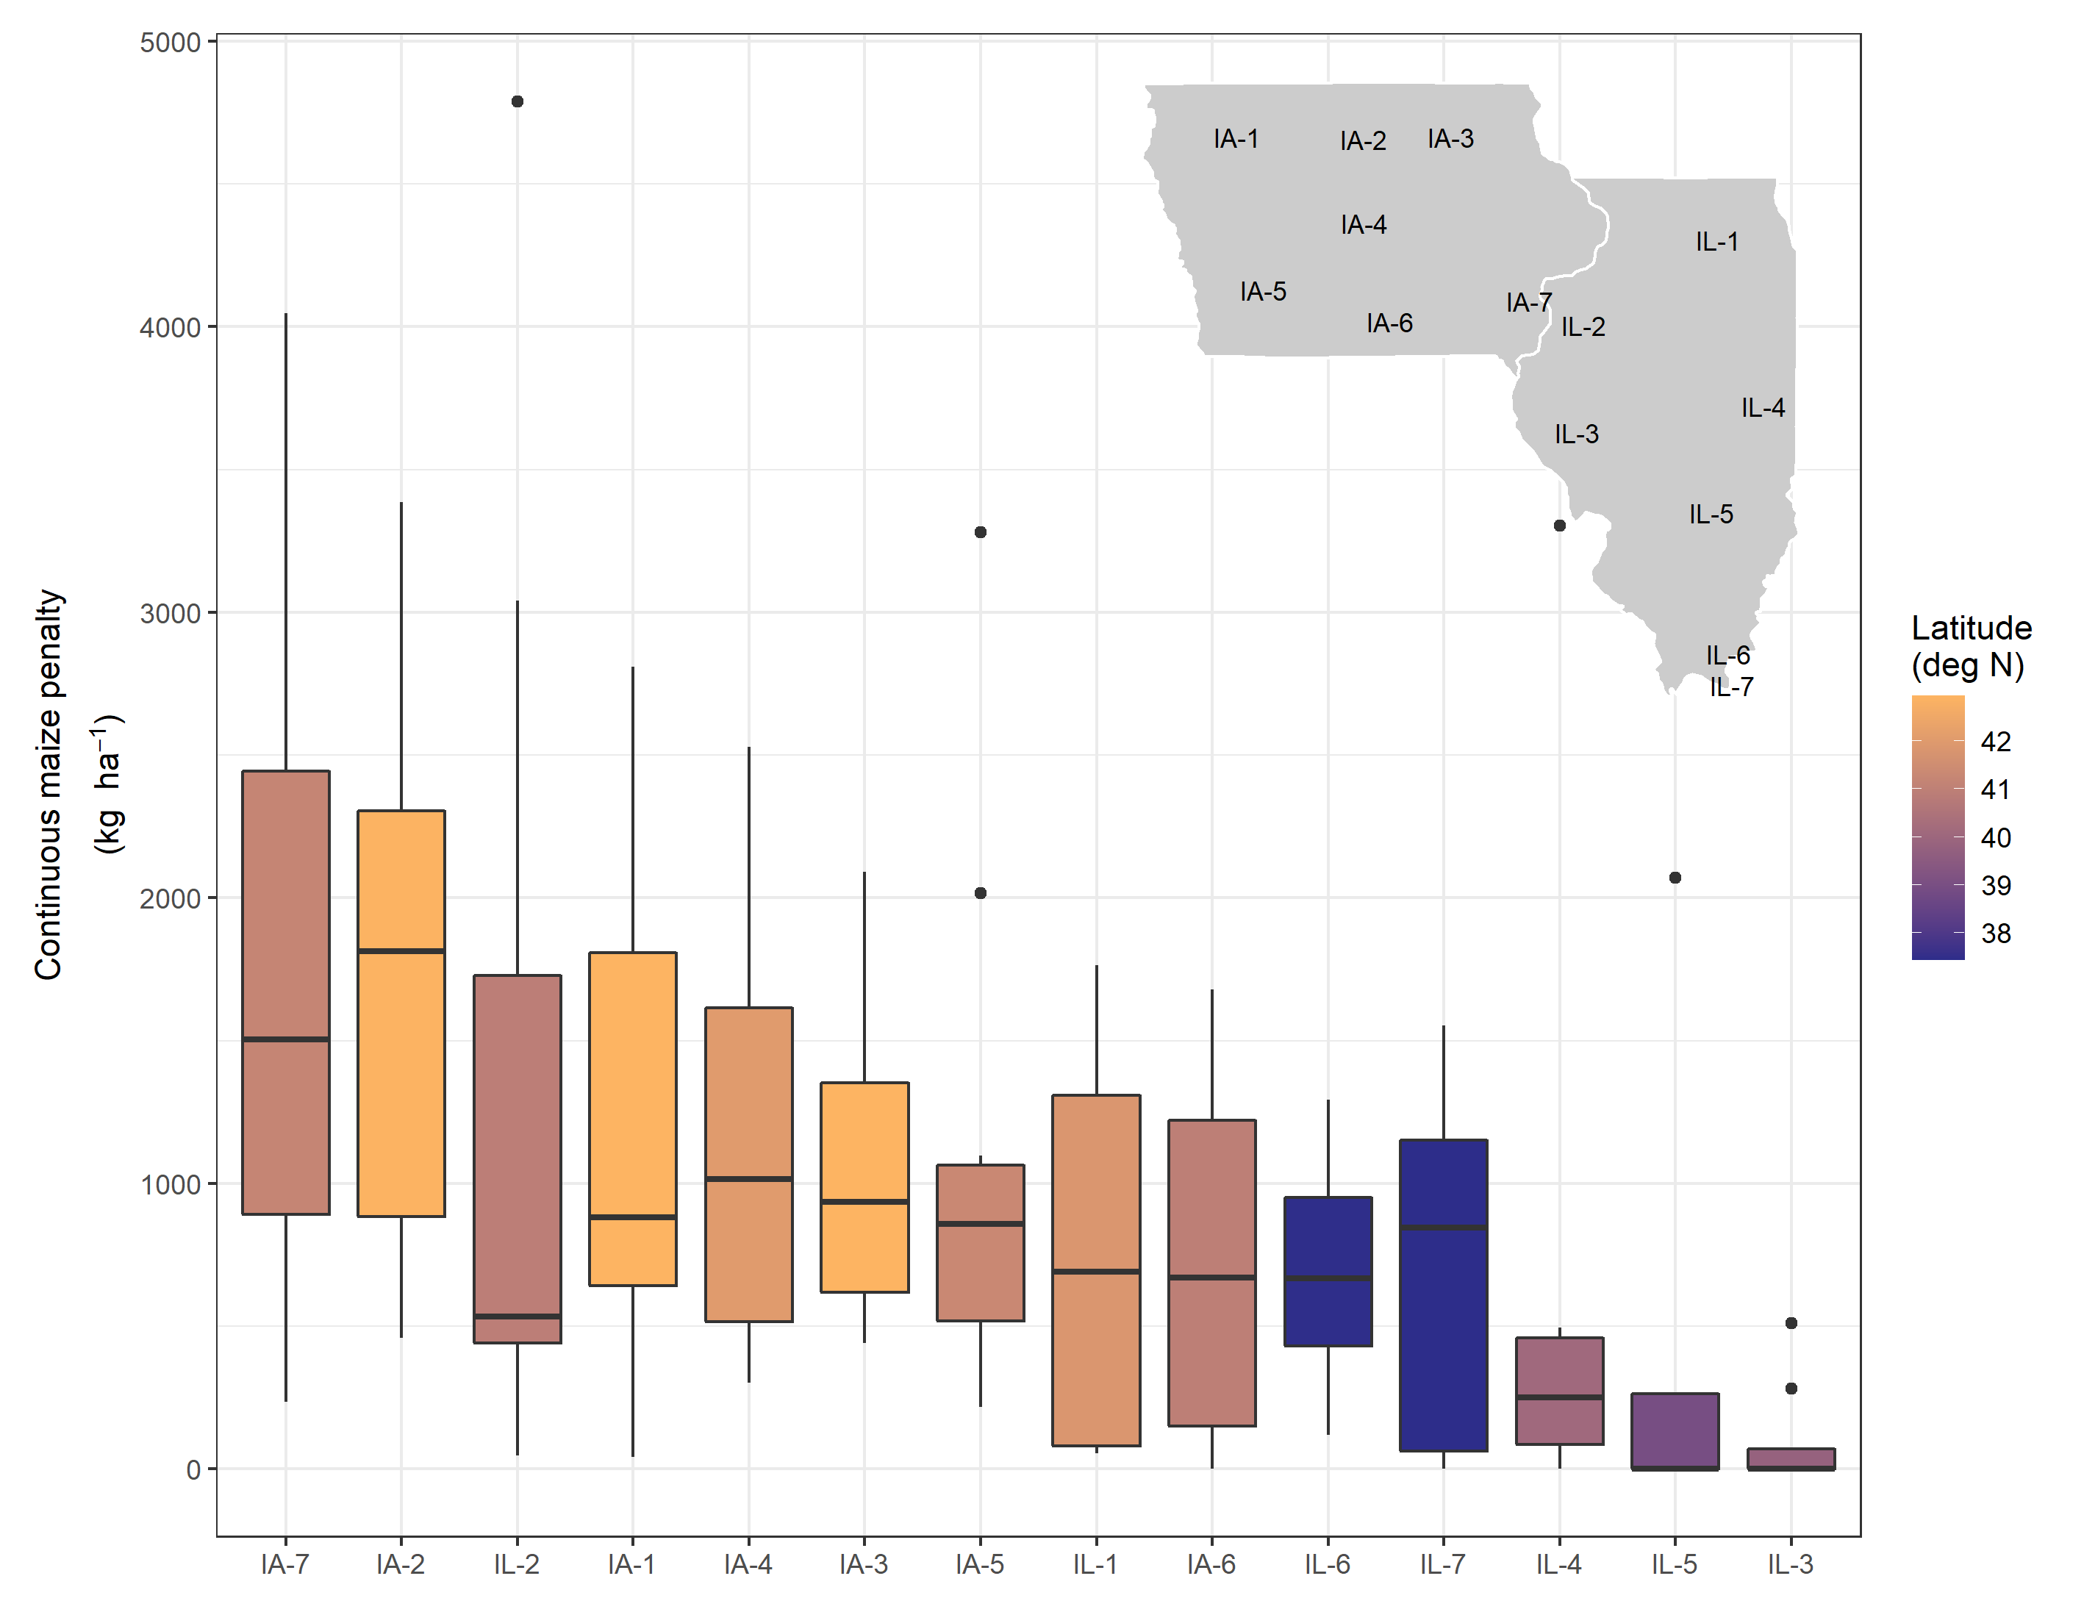

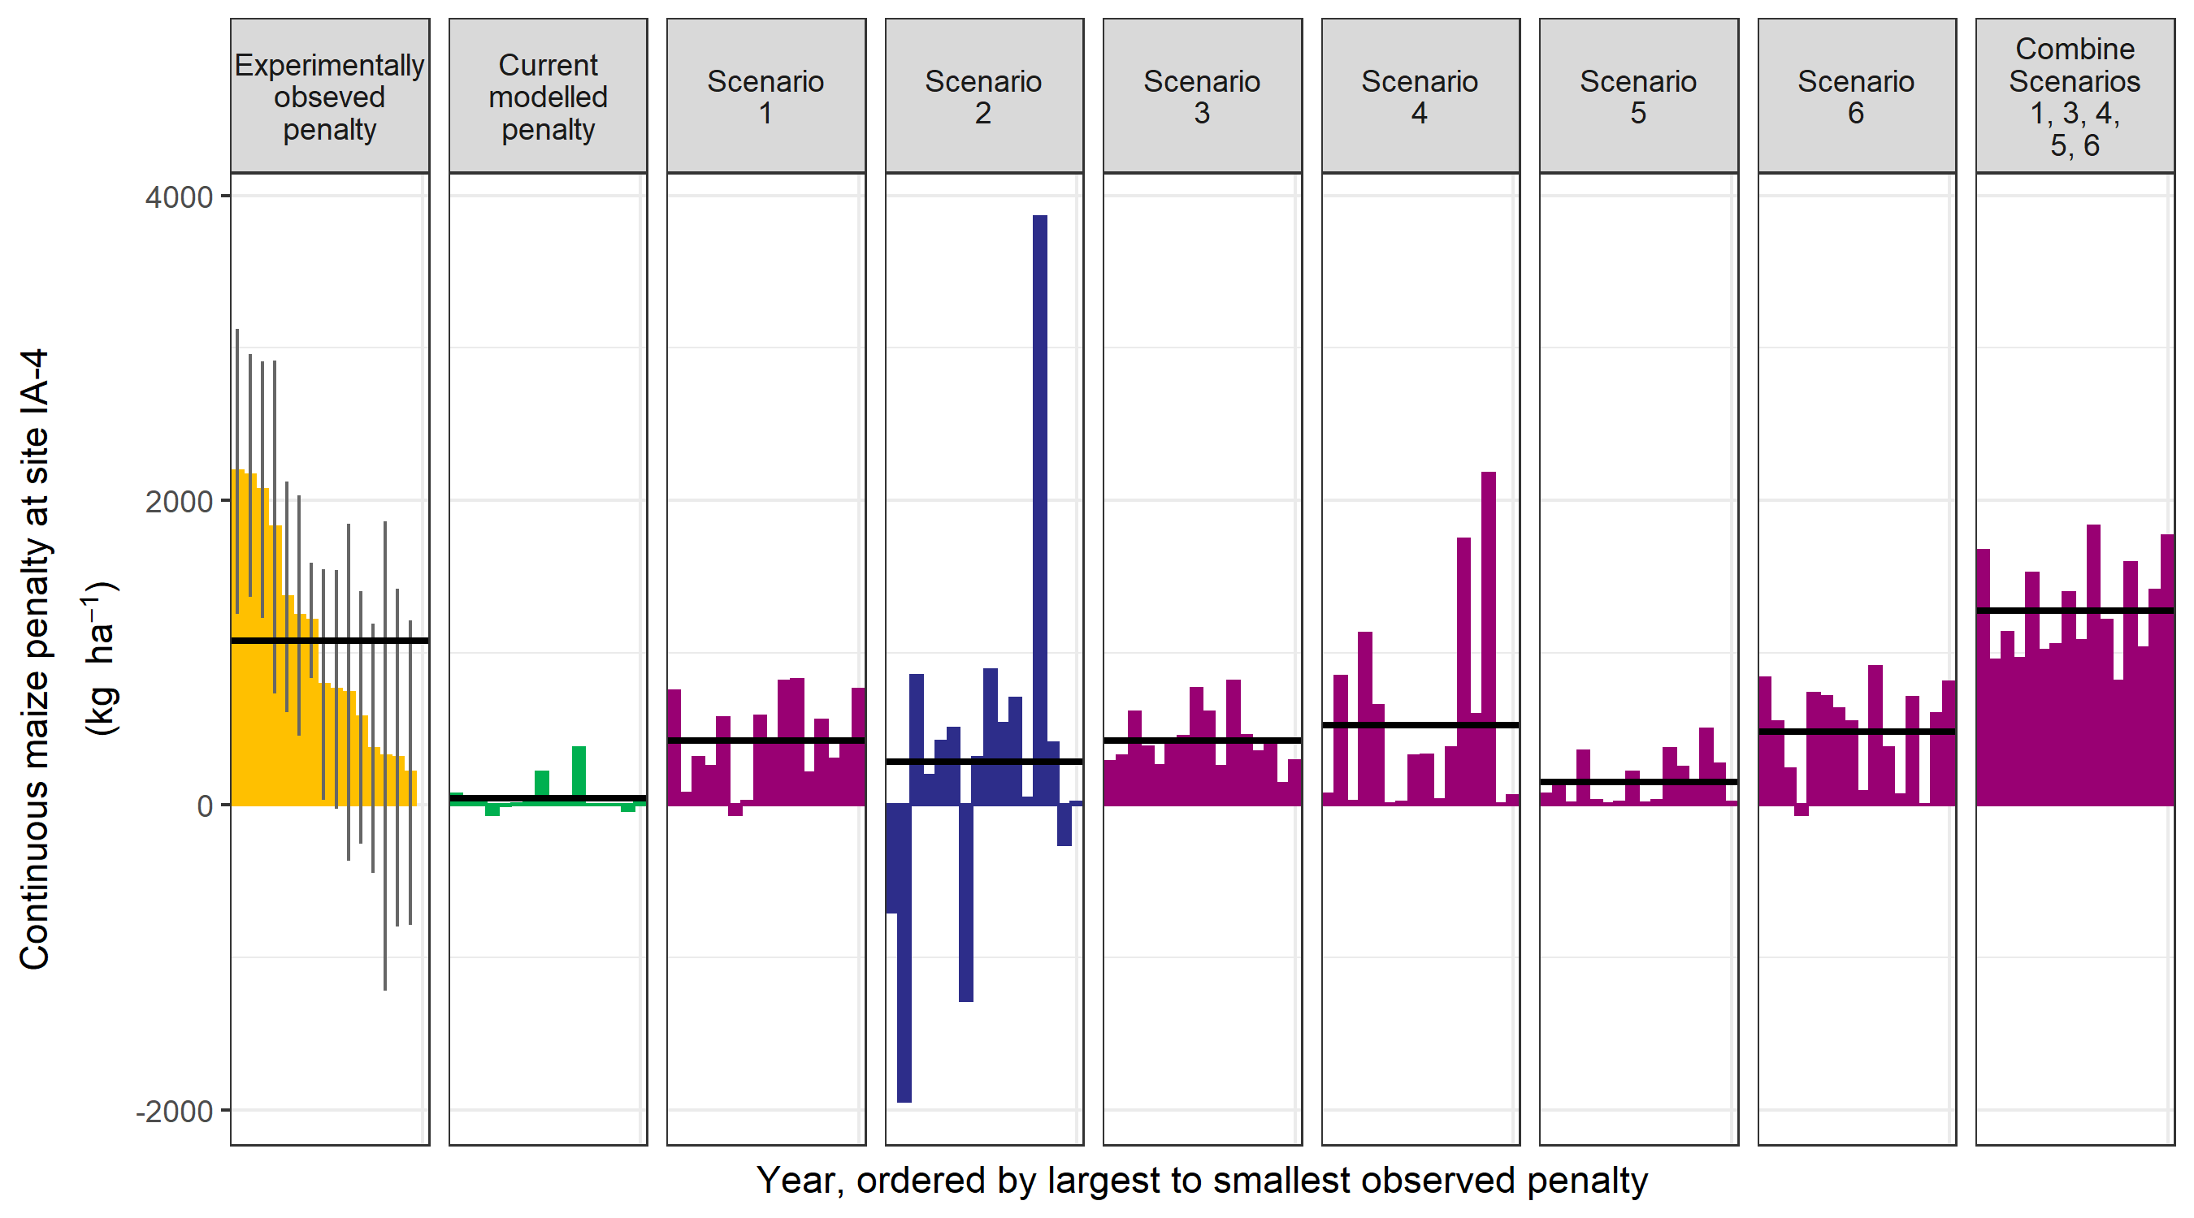

Figure 7 Site IA-3 experimentally observed penalties (yellow bars) with 95% confidence intervals (vertical lines) ordered from largest to smallest compared to baseline model parameters (green bars), scenarios (Table 4), and a combination of scenarios excluding delayed emergence (dark blue bars)

There is limited data available to corroborate the model’s identification of feasible pathways. While reduced plant number was a feasible scenario, several multi-site and multi-year studies have not found significant differences in maize stand counts in monoculture and maize-soybean rotations (Licht, unpublished, Griffith 1988).

Several studies suggest maize roots are indeed different in maize monocultures compared to rotated systems, but the form of that difference is not clear. A Wisconsin study showed more root length, as well as a higher percentage of necrotic roots, in maize monocultures compared to diverse rotations at 0-15 cm depths, with the authors hypothesizing the increased root length was a response to poor root health in maize monocultures (Goldstein). Additionally, the author found the monoculture maize had higher soil residual N at harvest compared to the maize-soybean rotation, suggesting that while N was available it may not have been captured by the maize plant due to compromised root function. A study done in Minnesota, likewise found maize grown in a monoculture had higher root length densities in the top 0-12.5 cm, but had less root length density than maize rotated with soybean below that depth. A recent study in Iowa found XX (Sotiris is that data published?). Studies in Minnesota and Wisconsin showed higher populations of arbuscular mycorrhizae fungi in continuous maize compared to rotated maize, which are negatively correlated with maize yields (Chamerlain2021, Johnson1992).

Surface residue has well-documented effects on the incidence of foliar diseases in maize (Robertson2007).

To our knowledge there are no growth analysis comparisons of maize grown in monoculture compared to in rotation, nor comparisons of yield components of maize grown in the two systems. Therefore, while reduced potential kernel number from lower rates of early season maize growth is feasible, there is limited experimental data to support or refute it as a driver of the penalty.

In addition to APSIM’s predictions that delayed germination is an unlikely consistent driver of the penalty, field studies likewise show negligible effects of maize residue on maize plant germination timing versus soybean residue (Kaspar1990, Shen2018).

### Dynamic script testing

The analysis of the experimental data indicated site-by-year interactions are a major contributor to variation in the observed penalty. We therefore implemented scripts to dynamically change parameter values based on surface residue amounts, soil temperature tracking, and soil moisture tracking. However, we found it difficult to assess whether this dynamicis improved model predictions because of the uncertainty around the measured penalty sizes. While the mean observed penalty was 1.0 Mg ha-1, the average standard deviation for the sites where that information was available was 0.7 Mg ha-1. Therefore, while the dynamic implementation of penalties in the model affected the predicted penalty, and in many cases improved the overall site-average prediction of the penalty (supplementary material), the size of the penalty was not known with enough precision to identify the optimal script parameters for capturing the year-to-year variation.

### Path analysis (need to think if this provides any new insight or not…)

To assess the relative strength of each pathway, we first created a simplified directed acyclical graph for path analysis (SmithSEMpaper). To simplify the diagram into a form that was analyzable using available data but still provided value, we used a combination of the modelling and literature review results (Figure 8).

Figure 8 Causal diagram representing hypothesized effects of a previous maize crop on the following maize yield penalty used for path analysis. Gray boxes indicate unmeasured aspects without indicator metrics available, yellow boxes represent aspects that were either directly measured or have indicator metrics available (pink boxes).

Results from the path analysis show as soil N increases, as represented by continuous maize yields at 0 N, the penalty decreases….no I don’t think this is helpful.

# Discussion

This study used APSIM as a tool to understand a well observed phenomenon, the CC penalty, that impacts x% of the US Corn Belt maize land. Long term field data indicated that the CC penalty remains constant over two decades of farming. Based on the data available, it is not possible to say whether the maize yield increases over time are due to weather, increased yield potential of newer varieties, management changes etc. Exploring the drivers of increases in Midwestern maize yields over time has been the subject of multiple investigations (Tollenar et al. 2017, Assefa et al. 2018, Kucharik 2008, Lobell and Burney 2021) and is outside the scope of this study. However, the consistent increase in both rotated and continuous maize yields is, to our knowledge, a novel finding. Conceptually, it indicates the amount of residue in the continuous maize system is not linearly related to the size of the yield penalty. Additionally, none of the statistical models identified the previous year’s continuous maize yields (a proxy for residue amount) as important, and the literature review found no effect of ‘years-in-maize’. While previous studies have found removing residue in continuous maize systems decreases the amount of N required to reach maximum yields (coulter2008, jose, karlen?), many studies still see a significant continuous maize penalty even with complete residue removal (Jose, Karlen, Crookston1989, I think there’s another), indicating it is not the only contributor to the continuous maize penalty.

The identification of the number of extremely cold days as an important predictor by the statistical model has an unclear interpretation. It may be simply associative, with the true driver being correlated with cold winters. It could also be a proxy for disease dynamics, or may indicate less native soil N mineralization due to cold temperatures. It is consistent with the finding that N fertilization was less effective at reducing the full penalty in more northern sites (Figure 5), as long-term annual air temperatures varied strongly by latitude, ranging from 8.1 deg C at the lowest latitude (IL-7) to 13.3 deg C at the highest (IA-3). Cold and wet soils are highly predictive of soil disease pressure in the Midwest (Robertson2007). The statistical model’s identification of the amount of rain two weeks before planting as being positively associated with the size of the penalty supports the hypothesis that root diseases play a major role in the penalty, and may render maize monocultures less responsive to N fertilizer. Previous studies in Ohio found the penalty was higher in poorly-drained sites (Dick1985, his second paper), which is consistently with the hypothesis of soil disease being magnified by maize monoculture and wet environments.

While the modelled results demonstrate several feasible hypotheses, without data to support or refute them any are reasonable implementations of the continuous maize penalty in models.

While most research has focused on the role of residue in the penalty, our findings suggest factors besides residue may be the main drivers of the penalty. However, measurements of residue amounts at harvest as well as surface residue at planting would aid in understanding the role of residue in the penalty. Growth analyses and yield components of maize in the two systems would provide insight into whether the penalty is most pronounced during a particular phase of growth, or whether the timing of the effect varies by year. Additionally, measurements of the root front velocity (Raziel) and root length and biomass at flowering would provide information on differences in root behavior in the two cropping systems.

Maybe we shouldn’t assume applying more nitrogen is worth it in continuous maize.

**Some other thoughts for text**

**Models applied for N recom, should be updated to account for CC penalalty…**

**While we work on corn, this analysis may be relevant to continuous wheat….**

**We provided a different than common use of the APSIM model – this is to test possible hypothesis and help us understand a phenomeno which causes $ of reducing productivity every year in the US Corn Belt**

**This study moved knowledge of CC a step further and provided a pathway for future research towards closing knowledge gaps and better locating the true mechanism.**

**Lit for ref for me:**

Dick1985 – bigger penalty in poorly-drained soils in Ohio

Griffin1988 – no diff in plant pop or soil temp at 10 cm depth in Ohio

Goldstein – CC has more necrotic roots and more roots 0-15cm, leaves more N in the soil at harvest,

Nickel – CC has more roots 0-12.5 cm, but less below that.

Livingston2015 – rotating is always economically preferable

Farmaha2016 – NE survey, penalty even in irrigated, 0.2 – 0.6 Mg ha (2-5%)

Johnson1992 – AMF in MN rot study

Neupane – roots/microbiome explains soybean rotation effect